UNIVERSITY OF WALES TRINITY SAINT DAVID

Program: BA (Hons) Business Management

Individual Project Report
Global Business Environment

Student: Georgian Valentin Bularda – 2109232
Module: The Global Business Environment LCBB4005
Lecture D. Arinze Ekwem
July 2022

Introduction
Tesco is one of the multinational retailer companies in the UK that offers everyday food, groceries, and retailer services to the customers. The company operates using a multi-format store and owns both physical and online store channels. Tesco is also known for its wide range of food and non-food product offerings. In addition to this, the company also offers consultancy, retail banking and insurance services through Tesco banks (Global Data, 2022). According to ONS (2016), the largest contributor to the UK’s economy is the services sector. This implies that the UK service offerings firms have significance in the country’s economic development and play a major role in the sustainability of the UK market. According to Banks around the world (2022), Tesco Bank is primarily offering services to adults in the United King and the Republic of Ireland. Considering this in view, the present report aims to highlight Tesco’s retail banking and insurance services. It sheds light on the impact of the business environment in which Tesco’s retail banking and insurance services operate. For this purpose, both PESTLE and Porter’s Five Forces Analysis have been conducted for Tesco’s retail banking services.

Overview of selected global business
According to Banks around the world (2022), Tesco Bank is a wholly-owned subsidiary of Tesco Plc. It operates mainly in the United Kingdom and is known as the third-largest retailer in the world. Owing to the operations in almost 14 major markets of Europe, Asia, and North America, Tesco Bank is currently focusing only on customers living in the UK and Ireland. Tesco Bank trades under the name of Tesco Personal Finance Group Ltd. Almost 86 percent of the banking services through Tesco Bank are offered through online channels. The primary services under Tesco Bank include current and savings accounts, credit cards, personal loans, and insurances such as home insurance, pet insurance, travel insurance, and health and dental insurance. Tesco Bank (2022) claims that recently, Tesco has announced its partnership with Onfido – the global identity verification and authentication provider company. Tesco Clubcard Pay+ was the first innovative product of Tesco Bank.
Tesco Bank wants to create banking and insurance more convenient and cost-effective for Tesco customers. In 1997, Tesco Bank assisted more than 5 million consumers with regular financial management. Currently, Tesco Bank is located in three main locations, including Edinburgh, Glasgow, and Newcastle, with over 3,800 employees available 24/7. Tesco Bank also offers services through online and mobile banking. The Chartered Banker Professional Standards Board participation is also ensured by Tesco Bank. In March 2021, Tesco Bank opened more than 45,000 Clubcard Pay+ accounts. Owing to this, more than £24 million was spent on 1.2m transactions using Clubcard Pay+ at Tesco, while 5.25m Clubcard points were generated at the national level. Tesco Bank felt pride in offering more than 213,000 points savings for the customers in their Round up savings accounts (Tesco Bank, 2022).
In addition to this, KPMG (2022), the retail banking and insurance market, is facing numerous challenges at the local and global levels. In 2021, the cyber security risk, tax risk and regulatory risks had increased over time. The focus of retail banking is now on improving cyber security skills, bringing cloud-based technology infrastructure, bringing automation to address security threats and ensuring a strong governance structure for operational resilience (see Appendix I). Likewise, Martinuzzi (2021) claims that due to security challenges, a very limited number of retail banks have been successful in gaining customer satisfaction at the global level. This implies that the business environment in which retail banks like Tesco are operating is becoming tough and challenging mainly because of cyber security and risks.

Discussion
In order to understand the business environment of the retail banking sector, external environmental analysis tools, including PESTLE and Porter’s Five Forces, are being used.

PESTLE Framework

Political
The political environment for the global retail banking and insurance sector seems quite challenging. According to Watson (2021), political factors usually have a minimum impact on the retail banking sector. However, the recent changes in world politics, increases in political conflicts and uncertainty in the political environment have changed the situation. Compaoré et al. (2020) also claim that world politics has a direct impact on the banking and finance institutes, especially the retail banking services.

Economic
According to Martinuzzi (2021), digital banking especially, the retail banking investments, has been badly impacted by the pandemic. The financial crisis has also increased for both commercial and retail banks. Even banks like HSBC, UK-Hong Kong Bank and Citigroup have all highlighted that the economic conditions are dropping due to the pandemic. KPMG (2022) claims that the global capital market has seen high volatility, and especially, the European banks are trading at high discount levels. This implies that for Tesco Bank, the economic environment for the global banking operations is not favorable.

Social
The recent research by Marous (2022) indicates that consumers are demanding different services from retail banks after the pandemic. Consumers now need consistency in the experience which was the major lack during the pandemic (see appendix II). Additionally, the consumer also demands personalization and omnichannel services, which are needed in abundance (See appendix III). This implies that Tesco Bank should focus on two main aspects, including personalization and omnichannel services.

Technological
According to Marous (2022, a), artificial intelligence, cybersecurity, cloud computing, advanced analytics and robotic process automation are the key technologies that retail banking customers are now demanding. This implies that Tesco Bank will have to consider cybersecurity as one of the key areas of consideration to ensure that technology-friendly features are offered to the customers (see Appendix IV).

Legal
The legal requirements for the retail banking sector have been upgraded mainly because of the pandemic. According to Deloitte (2022), the legal system for improved digital asset management is under consideration after retail banks have shown a wider interest in digital currencies. This implies that the overall legal environment for the retail banks is suitable since the governmental regulations in the US, UK, European Union, and Asia-Pacific region, Such as Japan, are upgraded. Magrath (2022) claims that the Federal Deposit Insurance Corporation (FDIC), the Office of the Comptroller of the Currency (OCC) in the USA, Markets in Crypto-Assets Regulation (MiCA) IN the European Union, Financial Action Task Force (FATF)’s “Travel Rule” in Japan while strong customer authentication (SCA) requirements in the United Kingdom are some of the primary examples of the proof of strong legislation.

Environmental
Retail banking has a lot of support in terms of its eco-friendly impact on the planet. According to Nystrom (2021), the European Green Deal Investment Plan (EDGIP), European Green Bond Standard (EU GBS), Sustainable finance disclosure regulation (SFDR) and EU Taxonomy Regulation are some of the primary agendas to support retail banking for sustainable banking services. This implies that for Tesco bank, the environmental aspects could serve as the foundation for the promotion of eco-friendly banking services in the United Kingdom, Ireland and other regions of the world.

Porter’s Five Forces

Bargaining power of suppliers
Generally, there are two types of suppliers of banks. Depositors make up the first category; they are the main source of money. Employees, generally known as labor resources, make up the second category of the suppliers of the retail banking sector. Individual depositors pose a minimal risk, similar to how customers’ purchasing power poses minimal risk. Tesco Bank’s strategy for dealing with this challenge could be based on drawing in more customers while expanding the amount of money that current depositors hold in their accounts and the times they use the bank’s products. Individuals have limited bargaining power when it relates to labor suppliers depending on their executive role (Ghosh, 2012). In order to retain the talented staff, Tesco Bank should increase its overall negotiating strength by providing a competitive wage and compensation structure. This implies that the bargaining power of suppliers for the retail banking brand like Tesco Bank is minimum.

Bargaining power of buyers
The influence of the consumer in the banking sector has significantly expanded mainly due to the internet and digital technology. The convenience and cost-effectiveness with which consumers may now evaluate the costs of opening and holding accounts and the rates provided by different banks have substantially increased. In order to attract clients, Tesco Bank can introduce substantial yield savings products (Ghosh, 2012). The company then took it a step further by making it very simple for users to move their funds from their present Tesco Bank. Tesco Bank was fortunate in its endeavor since they were able to drastically reduce switching costs in terms of both time and money. Thus, the bargaining power of buyers is low for Tesco retail bank.

Competitive rivalry
The banking industry is thought to be quite competitive. Since the financial services industry has been around for many years, almost everyone has access to banking services today. Therefore, banks should work to lure clients away from other businesses. Tesco Bank may beat its rivals by offering lower financing, higher rates, investment goods, and more conveniences in an effort to obtain that edge. The retail banking sector regularly engages in a competition to discover which bank can offer the best and most modern services. However, as a result, banks’ ROA (Return on Assets) has decreased (Adams, 2019). It is more likely that the banking industry would see intense rivalry in the current market, given the composition of the retail banking sector. Major banks frequently prefer purchasing or joining forces with other banks than investing in advertising.

The threat of new entrants
The availability of retail banking services has increased customers’ propensity to trust well-known, large institutions. Due to the growth of the banking industry, major banks are making an effort to handle all of a client’s financial needs under one roof. This integration emphasizes the necessity of trust as a barrier to entry for new banks looking to compete with existing banks since clients are more likely to accept one bank to handle all of their portfolios and fulfill all of their financial needs (Cortina Lorente and Schmukler, 2018). This suggests that Tesco Bank would be the company most unaffected by new competitors in the retail banking space.

Threat of substitute
The main threats to substitution confronting the banking industry are posed by non-financial competitors rather than rival banks. Although there isn’t a significant danger of competition for the company in terms of deposits or withdrawals, there are many banking services that non-banking businesses also offer, such as insurance, alternative investments, and fixed income securities. Furthermore, the threat of alternative payment methods, as well as the firm’s relatively high loan rates, exists (Panetta, 2018). Thus, the threat of substitutes is moderate to high for Tesco retail banking services.

Conclusion
The present study has analyzed Tesco retail bank services considering the PESTLE and Porter’s Five Forces analysis. Tesco Bank mainly targets adults in the United Kingdom and the Republic of Ireland with its services. Under the name Tesco Personal Finance Group Ltd., Tesco Bank conducts business. Nearly 86 percent of the banking services provided by Tesco Bank are accessible online. Tesco Bank’s main offerings include current and savings accounts, credit cards, personal loans, and insurances like house, pet, travel, health, and dental insurance. The PESTLE analysis shows that Tesco retail banking may face highly unfavorable political and economic conditions in the global market. However, the social, technological, legal and environmental conditions seem to be favorable for the Tesco retail bank. On the other hand, Porter’s Five Forces indicate that Tesco retail bank may experience little to no threat of new entrants, low bargaining power of suppliers and buyers, while moderate to high threat of substitutes and intensely high competition in the market. This implies that the two most important global factors that have the most significant impact on Tesco retail bank include the technology and the threat of substitute services and products.

References
Adams, R.M., 2019. Retail commercial banking: An industry in transition. In Industry Studies (pp. 170-193). Routledge.
Banks around the world. 2022. Tesco Bank. [Online] Available at https://www.relbanks.com/europe/uk/tesco-bank Accessed on 6 July 2022
Compaoré, A., Mlachila, M.M., Ouedraogo, R. and Sourouema, S., 2020. The impact of conflict and political instability on banking crises in developing countries. International Monetary Fund.
Cortina Lorente, J.J. and Schmukler, S.L., 2018. The fintech revolution: a threat to global banking?. World Bank Research and Policy Briefs, (125038).
Deloitte. 2022. 2022 banking regulatory outlook. Deloitte. [Online] Available at https://www2.deloitte.com/us/en/pages/regulatory/articles/banking-regulatory-outlook.html Accessed on 7 July 2022
Ghosh, A., 2012. Managing risks in commercial and retail banking. John Wiley & Sons.
Global Data. 2022. Tesco Plc: Overview. Global Data. [Online] Available at https://www.globaldata.com/company-profile/tesco-plc/ Accessed on 6 July 2022
KPMG. 2022. COVID-19: Impact on the banking sector. KPMG. [Online] Available at https://home.kpmg/xx/en/home/insights/2020/07/covid-19-impact-on-banking-m-and-a-2020.html Accessed on 7 July 2022
KPMG. 2022. Global Banking CEO Outlook. KPMG [Online] Available at https://home.kpmg/xx/en/home/insights/2022/01/global-banking-ceo-outlook.html Accessed on 6 July 2022
Magrath, M. 2022. Top Banking Regulations & Security Compliance Requirements [2022]. Onespan [Online] Available at https://www.onespan.com/blog/top-banking-regulations-security-compliance-requirements Accessed on 7 July 2022
Marous, J. 2022, a. Six Retail Banking Technology Trends for 2022. The financial brand. [Online] Available at https://thefinancialbrand.com/125542/2022-retail-banking-technology-trends-ai-api-cloud-rpa-cybersecurity/ Accessed on 7 July 2022
Marous, J. 2022. Banks Not Delivering The Experience Consumers Demand. The financial brand. [Online] Available at https://thefinancialbrand.com/128429/banks-not-delivering-experience-consumers-demand-cx-martech/ Accessed on 7 July 2022
Martinuzzi, E. 2021. Global retail banking: A particular breed heading for extinction. Business Standard. [Online] Available at https://www.business-standard.com/article/international/global-retail-banking-a-particular-breed-heading-for-extinction-121022500027_1.html Accessed on 7 July 2022
Nystrom, J. 2021. Retail Banking Could Save the World. [Online] Available at https://www.finextra.com/blogposting/21414/retail-banking-could-save-the-world Accessed on 7 July 2022
Omarini, A.E., 2018. The retail bank of tomorrow: A platform for interactions and financial services. Conceptual and managerial challenges.
ONS. 2016. Five facts about... The UK service sector. Office for National Statistics [Online] Available at https://www.ons.gov.uk/economy/economicoutputandproductivity/output/articles/fivefactsabouttheukservicesector/2016-09-29 Accessed on 6 July 2022
Panetta, F., 2018. Fintech and banking: today and tomorrow. Speech of the Deputy Governor of the Bank of Italy, Rome, 12th May.
Tesco Bank. 2022. Tesco Bank partners with Onfido to enable secure, streamlined onboarding for Tesco Clubcard Pay+ customers. Tesco. [Online] Available at https://bank.tescoplc.com/news/2022/tesco-bank-partners-with-onfido-to-enable-secure-streamlined-onboarding-for-tesco-clubcard-payplus-customers/ Accessed on 6 July 2022
Watson, M. 2021. How banks can turn political analysis into strategic decision-making. EY. [Online] Available at https://www.ey.com/en_lu/banking-capital-markets-risk-regulatory-transformation/how-banks-turn-political-analysis-into-decision-making Accessed on 7 July 2022

Appendices

Appendix I – Threats to the banking sector in 2021
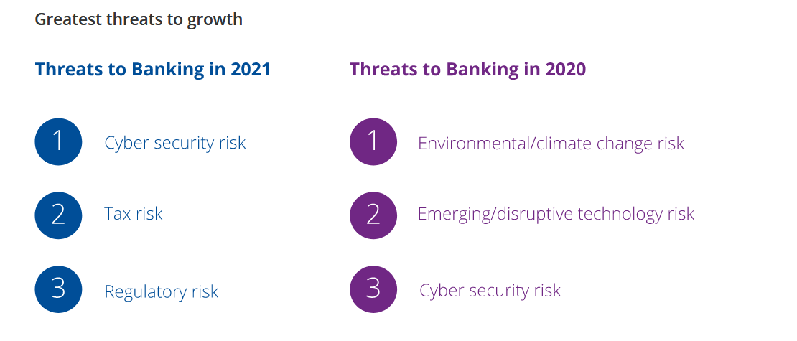

Appendix II – Significant gap – CX delivery
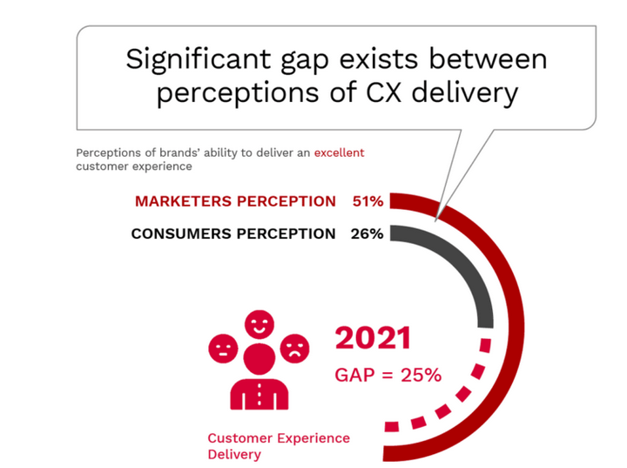

Appendix III – CX dimensions
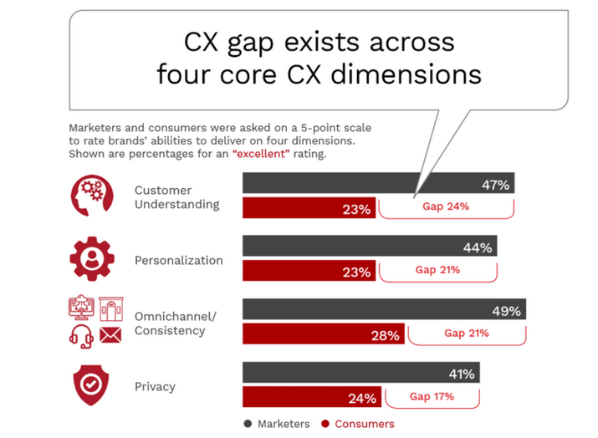

Appendix IV – Key technological advances in the retail banking


