Academic and Employability Skills
Assignment Term 1- Group 3 Weekends 2020

The importance of skills and personal development

Author: Rebeca Romanyuk 1912286 Lecturer: Joanna Walsh

TABLE OF CONTENTS

- Introduction

- Skills

  - Definition of skills
  - Type of skills and definition
  - Problem-solving

- Personal SWOT analysis
- The importance of time management with PPDP
- Conclusion
- References

- Introduction

I always found it essential as an individual to analyse my own communication and written capabilities, skills and personal development. Therefore, you will find highlighted important ideas from the module Academic and Employability Skills referencing my own personal and professional development during this course.
To have a better understanding, I will analyse all the points which helped me to improve myself like opportunities and threats and most important my own strengths and weaknesses. I will also give an insight of my PPDP just to support the idea of how I have achieved my personal and professional goals. As said, to highlight and lose the gap of where I am in life and where I would like to be, I will discuss the importance of reflective working by describing Kolb’s Learning cycle.
- Skills

  - Definition of skills
By Cambridge dictionary (2020), we can understand a skill is a special ability which you gain during the process of training and experience therefore, being very helpful in ending a job well. Specific skills set areas can include soft and hard skills as academic and employability skills.
2.2 Type of skills and definition
a. Soft skills are characterized by being a set of natural abilities which are not depending on secure knowledge. The term “skill” on its own means a specific talent which you need in order to finish a task. The word “soft” is the exact opposite term for “hard” which indicate subjective and unpredictable. In addition, due to the subjectivity, soft skills are hardly reviewed and understood, hence the reason most of employers are not considering them as a set of essential skills. As said, a person with soft skills it is a person with social and emotional intelligence, and most of all character or personality qualities. After getting a better understanding of what and which are the soft skills, I can say I found myself many times using natural abilities when delivering a job at my workplace. I have also used them in creating bonds between me and my work colleagues and I am more than happy to say it have been always successful.
- Hard skills: Michael Tomaszewski (2020), likes to define them as methodical skills which are related to a specific job. This set of skills involves aptitudes in activities which are gained during training. Unlike soft skills, these skills are proven and are considered in professional, technical or academical qualification. Some examples of hard skills would be management skills, writing skills, computer skills and so on. Most of the hard skills I firstly learned in school and after at my workplace. As I own a manager position, I had to use and develop my computer skills. I have push myself to learn the management skills since the beginning of my career so I could reach my goal.

- Academic skills are the set of skills which relates to learning. Examples of academic skills include analytical thinking, problem solving, research abilities, critical thinking, written communication. In order to excel in academic setting, students also need impersonal and organizational skills. I learned a lot since I started Skills at Work Place course, teaching me how I can improve my research skills, analytical thinking and most of all academical writing. I feel these learning outcomes will also help me in my personal life and moreover at my workplace.

- Employability skills: As per STEMNET top 10 employability skills, we can define them as transferable skills which makes you “employable”. Very often, apart of understanding and subject knowledge, employers are asking for a set of skills which they believe will help the employee to deliver the job. Some examples of employability skills are problem solving, working under pressure, team working, communication and so on. From my own experience at all the interviews attended by me I have been asked to solve some imaginary scenarios where I had to use my problem-solving skills. Other employers invited me for a trial where they could have a clear picture if I can work in a team and if I am organized. The main idea which I have extracted from all these experiences is that I need all these aptitudes which was proven necessary for me to develop myself and my career path
  - Problem solving is one of the Hard skills which I am very happy I have developed in time. In theory, problem-solving is defined by being able to adapt and handle new situations. I would like to make reference to my workplace where I could find myself many times in the position where I had to take a spontaneous decision just to improve customer service and to fix or prevent a possible problem. Moreover, as per Career guidance (2020), Even though Problem-solving is considered as its own skill, there are many other skills impacting this ability:

- Active listening
- Analysis
- Research
- Creativity
- Communication
- Dependability
- Decision making
- Team building
I have set a goal in the past to observe others in the process of solving problems. Just for improving myself, communicating and discussing problematic scenarios with the ones more experienced than me, I feel the knowledge which I own became more defined and with it I become more confident.

3.Personal SWOT analysis

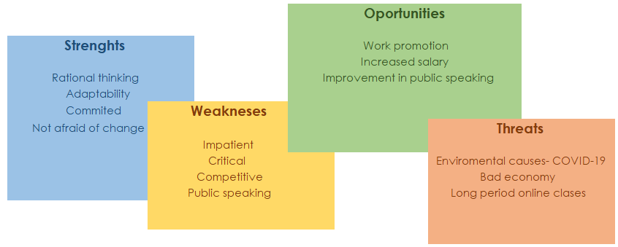

SWOT is the shorter version for Strengths, Weaknesses, Opportunities and Threats. Swot analysis is a structure used to evaluate a company or personal competitive position and to create a strategic plan.
As per my personal SWOT analysis, I believe the adaptability always helped me in learning new things in an efficient time also, helped me bonding with new people. Being committed to my goals I have took the decision in joining university. At the same time, I have changed my job, moving into a new bigger company. Both were radical changes and they both happened at the same time. Even if I have been afraid of failure I was not afraid of the change. Moreover, being introduced to new things in life helped me to move forward and evolving. To highlight my personal experience, you will be able to see a list of points which I am planning to improve in future in regards of myself. As short-term opportunities I have decided to write my goals which are compromised by Environmental causes mentioned in the threats section.
- The importance of time management with PPDP

We cannot control the time, but we can control the way we spend it for the priorities achieving purposes. As we live in a metropolitan city, times tends to move fast, being left with not enough to spend with ourselves or the loved ones. In order to be productive, is very important to create and follow a plan to manage our time. To prioritise what is important it is also very important to allocate some reflective time to assess the outcome lessons of the day.
As I wish to become more productive, I decided to create a personal and professional development plan (PPDP). As a strategy to find the resources available, save and manage time I have decided to use some of the time management procedures. As a better strategy, I have also added the Kholb’s Learning Cycle method so I can get an effective learning and understand the importance of concrete experience. Kolb (2015), model highlights the importance of the thinking component in the understanding cycle. Reflection permits the learner to process what just happened during the experience. For example, when I am at reflective observation stage I can verify and assess my experiences.
Kolbe’s learning cycle plan involves 4 stages of learning: concrete experience, reflective observation, abstract conceptualization, and active experimentation.
Below you will be able to view my short-term, mid-term and long-term period frame plan. I have attached some of my goals and helped by the points of the plan I got a quicker way of reflecting on what could help me to hit my objectives.

- My Goals

- Short-Term Time Frame: Work appraisal
- Mid-Term Time Frame: Passing first year of Unniversity
- Long-Term Time Frame: Using all my skills and incomes earned to open my own business

- Skills and knowledge to be learned

- Short-Term Time Frame: Improving managerial and employability skills;
- Mid-Term Time Frame: Improving my time managing skill in order to start working on my assignments earlier. Improving my academic skills in order to pass the exams.
- Long-Term Time Frame: Focusing on learning out of my and other experiances. Saving money and invest;

- Next steps

- Short-Term Time Frame: Improving report writing and practising more the employability skills.
- Mid-Term Time Frame: Attending all classes. Gathering as much information as possible.
- Long-Term Time Frame: Doing small steps to achieve the goal. Daily spent time in reading and learning business aspects.

- Resources

- Short-Term Time Frame: Help from colleagues, Managing enterprises module learning in class.
- Mid-Term Time Frame: Lecturers help, e-books, discussions with colleagues, internet.
- Long-Term Time Frame: Work mentors, courses, internet.

- Time schedule
- Short-Term Time Frame: 6 months
- Mid-Term Time Frame: 1 year
- Long-Term Time Frame: 3 years

- When will I start

- Short-Term Time Frame: Once the restaurant I am working for re-opens
- Mid-Term Time Frame: I have started this year of February
- Long-term Time Frame: first of June 2020

The first stage, Concrete experience helped me to identify my need of development by reflecting over my experience. At the same time, reflective observation highlighted what I need to carry out my PPDP. The third stage of Kolb’s learning cycle helped me understand what I need and what are the next steps for me to achieve my goals. And in the end, the fourth stage, Active experimentation created a clear image of what I should change or improve in order to accomplish my PPDP. As said, now that I have finished my PPDP plan I have a better understanding of what my next moves are. The first steps would be to set deadlines and also focus on improving my skills. As a second step, I must use all my resources and follow specific schedules. I can confirm I feel more encouraged now, after I have created my own Personal and professional plan.

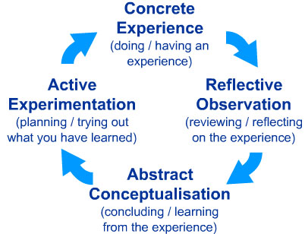

5.Conclusion
I can confirm that now I have a better vison of what it is the importance of skills for individual development. After defining and analysing the skills area of developing I understand the importance of applying my personal skills for improvement purposes. Creating my personal SWOT analysis I realised which Strengths I should use more as are my strongest points. Now I know which are my weaknesses and what is threatening my hunger of achieving my own plans. To understand the importance of time managing I have created a Personal and Professional Development Plan . By analysing my PPDP with Knolb’s cycle learning, I have managed to understand my need of experience, keeping my resources and schedule a starting time to boost my interest in fighting for my own goals. I strongly believe, by practising and sharing the information gained from the subjects above will help me to gain more experience and become more confident in the way I am working towards my objectives.

6. References.
- Definition of skills: Cambridge Dictonary, https://dictionary.cambridge.org/dictionary/english/skill
- Hard skills: Michael Tomaszewski, CPRW, 2020 Article https://zety.com/blog/hard-skills
- Employability skills: STEMNET- Science, technology, Enginering and Mathematics Network-top 10 employability skills article, https://www.exeter.ac.uk/ambassadors/HESTEM/resources/General/STEMNET%20Employability%20skills%20guide.pdf
- Problem solving : Indeed, Career guidance - https://www.indeed.com/career-advice/resumes-cover-letters/problem-solving-skills
- Kolb, D.A. (2015), Experiential learning. Experience as the source of learning and development, Pearson Education Publication, 2nd edition, USA.

