

Computer and Network Architecture

WC February 11, 2013

Faculty of Applied Design and Engineering
School of Applied Computing
Mount Pleasant Campus
Swansea
SA1 6ED

- INTRODUCTION AND OBJECTIVES OF THE Exercises
You learnt about Networks, the history or Networks and Network topology. These exercises are a follow up of what you learnt in class about the topics. They involve knowing different types of network and also the use of Packet Tracer Software to design and familiarize yourself with the Cisco Packet Tracer devices, interface, functions, and features, to build and test the connection of a simple network.
Task 1 - Use your lecture notes to complete the table. The use of Internet can also be used.
- What is a network?

- What are some of the reason for having the network?

- How does networks impact on daily lives?

- Give a historical detail of TCP/IP

- What is the purpose of TCP/IP?

- Labeled the following networks and describe them.
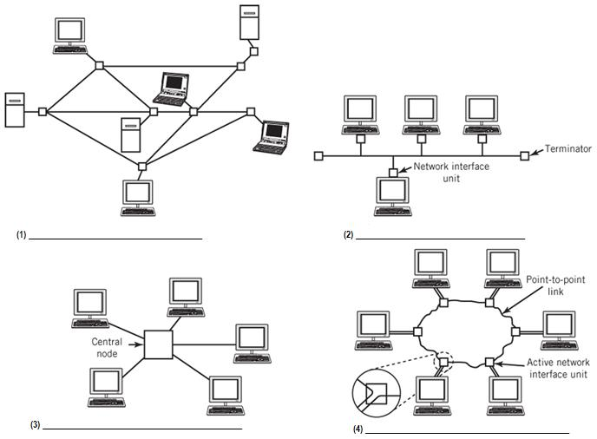

- What are the wired network speeds?

- State the maximum data rate that the following networks can be transmitted?
- 802.11a -
- 802.11b -
- 802.11g -
- 802.11n -

Task 2 – Build a Simple Network

Objectives

- Learn to use Packet Tracer proficiently, e.g. choosing proper devices, renaming devices, placing notes, using colour box, etc. Understand different interfaces of each device, e.g. physical, config, desktop.
- Make simple network configurations similar to any of the networks in question 6. label the devices and links used.
See the example below or Log on to Moodle and download the example file:
- Star-Network.jpg
Be creative, design your own and give meaningful names to your devices and links.
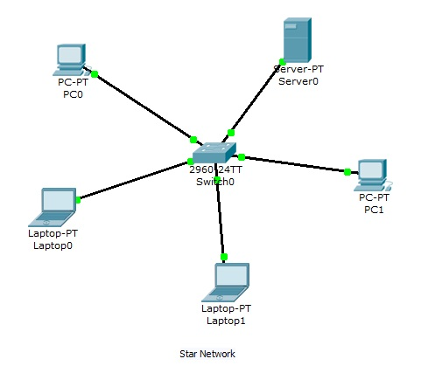
Figure 1

