

LEVEL 6 ASSESSMENT SPECIFICATION

Student name: | Bethan Rogers | Student ID number: | 1706432
Programme: | BA(Ed) QTS
Module: | Yr Iaith ar Daith 3
Module code: | ECAD6006C | Contribution to Overall Module Assessment (%): | 60%
Lecturers: | Rhagoriaith | Internal Verifier:
Assignment Title: | Portfolio – Revised | Word count (or equivalent): | Equivalent – 60%
Submission deadline: | 15th May, 2020; 23.59 | Return date of provisional marks & written feedback: | 8th June, 2020
Submission method: | All written assessments, where practical and possible, must be submitted via Turnitin unless otherwise instructed by the Lecturer. (Please DO NOT put this assessment specification into Turnitin or it will match many similarities with other students’ submissions.)  Alternative submission method (if applicable):  Late submission of the assessment will result in a late penalty mark. Penalties for late submission: Up to one week late, maximum mark of 40%. Over one week late, 0%. Only the Extenuating Circumstances Panel may approve a change to submission dates.
Academic honesty / referencing: | Academic honesty is required. In the main body of your submission you must give credit to authors on whose research and ideas your work is based. Append to your submission a reference list that indicates the books, articles, etc. that you have used, cited or quoted in order to complete this assessment.

Yr Iaith ar Daith – Portfolio
Task 1

For our portfolio task last year, we were asked to record a part of a lesson where the main focus was reading a book and using matching language from within that book during the activity within the lesson. The book I used was in line with what the school suggested due to the time of year and their previous welsh curriculum. During the lesson last year, I read the book ‘Blwydden Newydd China’ by Helen Emmanuel Davies. The book was of a suitable level for the class of children I was teaching and was suggested to me by the class teacher to fit in with the Chinese New Year topic we were covering at that time.

In my reflection last year, I commented on how I felt different aspects of my lesson went. I noted that overall, I was very happy with how the activities went. In regard to both myself and the children taking part. One of the targets I had set for myself prior to the lesson was to work on and improve my pronunciation. To help with this I spent time before the lesson going through the book with the class teacher and checking over any words I struggled with, writing them down in a phonetic manner to help with pronunciation later on. In my own time after school I spent time repeating and repeating these words using the phonetic spellings to embed the correct pronunciation in my brain. This I did multiple times before my lesson and something I continue to do with words I have struggled with during university Welsh lessons. I feel this was a technique that was of great help to me and will continue to be. This technique of repetition is widely used to teach second languages worldwide, Watson and Skinner (Weibell, 2011) and Science Daily (2017).

Since writing that reflective piece last year, I have taken a few steps to improve my own personal Welsh, both inside and outside of university. During the academic year I attended the University led Welsh ‘Yr Iaith ar Daith Lectures’. This year these have been an enormous help in improving my Welsh as the amount of language spoken within the lectures greatly increased. Using an approach closer to the immersion method which is used in many schools across Wales, Estyn (2016) and Weise (2019). After these lectures, the amount of Welsh that was used in my friendship group in university drastically improved as we were all trying to help each other improve our Welsh. This was a great help in improving my personal incidental welsh usage even on a day to day basis.

To further improve my incidental welsh usage, I made flash cards with words and phrases commonly used in the classroom in school and have been looking at and practicing these on a weekly basis, trying to embed these in my memory. This was something that we did as a friendship group also to help each other. Increasing my incidental Welsh usage in School has been a personal target of mine through last School placement and would have been one through this placement, had it have happened. As a teacher in Wales, I believe it is very important to expose the children in your class to as much incidental welsh to allow for a more natural transition as the level of Welsh taught becomes higher.

Another step I have taken to improve my welsh language over the last academic year is to increase the amount of reading and listening I do in Welsh. To support his I have been trying to read short texts and listen to short clips of interest in Welsh and work out the meaning. This could be sometimes watching a TV programme on S4C or finding a shirt story in Welsh to read. While reading I would note down any vocabulary that I was unsure of and use a dictionary to translate to ensure I knew the meaning of what I was reading. I found these tasks introduced me to a much wider range of vocabulary and different styles of writing and speaking that were more relaxed than the formal welsh you are taught. This has allowed me to improve my ability at more relaxed conversational Welsh and given me the confidence to try and use it more in a relaxed setting among friends and first language Welsh speakers.

Following on from the University Welsh lectures I have been allocating more personal study time to my personal Welsh development. This extra time has meant I can focus solely on my Welsh and has allowed me to implement some of the above-mentioned strategies. In the last two years I did not make as much effort to continue my Welsh learning outside of the Welsh language lectures. This then showed in the following language lectures as I had not moved the information from my short-term memory to my long-term memory.

Looking towards the future and how I intend to continue my personal and professional development of the Welsh language there are a few points to consider. Firstly, I intend to continue with my personal reading and listening of the Welsh Language, increasing my vocabulary and ability to understand different forms of written Welsh. Alongside this I aim to continue to use conversational Welsh with First Language friends and colleagues to increase my confidence and allow for this to show in my teaching in school. I am also hoping to continue taking welsh lessons to improve my language development throughout my NQT year and would be interested in taking a high intensity sabbatical course later on in my career. Both of these would be extremely helpful and would allow for me to make connections with other like-minded individuals to help with the learning of the Welsh language. There is a link here to the immersion method of teaching and learning languages alongside other methods such as repetition, Estyn (2017), Weise (2019) and Weibell (2011).

Looking at specific steps to help with using Welsh in the classroom I previously decided that while I was out on third year teaching practice, I would make some incidental welsh posters and reminder cards to place around the classroom. This would aid in me remembering to use this incidental welsh as that is something I struggle with while out on placement alongside everything else. Making myself and the other staff more aware of incidental Welsh that can be used will hopefully increase my usage of it. I have also taken into consideration the pedagogy behind teaching a second language and will try to implement some of those strategies into my lessons. Being aware of such strategies allows for a more impactful way of teaching increasing both the leaners and my own level of Welsh.

Having looked at the Welsh Competency Framework released by the Welsh Government I have assessed my own personal language level, see appendix 4. For the listening portion I have levelled myself at the W4 level, saying I am able to understand when someone is speaking in a natural way. I believe that this is fairly accurate as from my University Welsh lectures my understanding has drastically increased from the last academic year. I have also improved this by listening to clips in Welsh at home on topics I have an interest or understanding in.

For the oral strand I levelled myself as a W3, foundation level with parts of the W4 as I feel like my speaking skills are lower than the rest. I struggle with information recall to have a smooth conversation and panic when it comes to remembering the right sentence patterns and vocabulary. However, I am able to express opinions and given short explanations which is why I have part highlighted level 4.

Within the reading strand I levelled as a W4, intermediary with aspects of W5, higher. I did this as I feel that I have a solid understanding of reading texts at a middle level but when these texts become more specialised then I struggle. However, I am capable of reading aloud with correct punctuation and mostly correct pronunciation even if I am not wholly sure on the meaning behind the text. This is due to being able to read aloud in an interesting and captivating manner in English giving me a good stead to do it in Welsh also.

For the final strand, writing I placed myself at the W4 level, intermediary. It states that you are able to write short paragraphs on known subjects and recognise common errors. Although this is an area, alongside the oral, that I struggle with, it is something that I try really hard to get right. When I write a piece in Welsh it usually takes a few go’s at editing before I am happy with what has been written and I feel that as long as I continue this process then my writing will improve.

TASK 2

Lesson Plan Phase 2

Cynllun Gwers – Cam 2

Student-teacher | Bethan Rogers | Class: | Mixed Year 1 & 2
AoLE/Subject | Welsh 2nd Language | Date: | May 2020
Lesson Focus: | Developing the ‘Mae _____ tost da fi’ sentence pattern
Relevant/meaningful links to:  Curriculum  Cross-curricular responsibilities | Foundation phase Framework  Oracy Range –  - singing Welsh songs  - speaking, substituting words in familiar patterns  - expressing feelings  Oracy Skills –  - speak clearly, using simple words and expressions
Personal Targets  (Linked to QTS and identfied in weekly review) | Professional Learning – Welsh Language skills  The teacher activley seeks opportunities to apply and extend their understandingand skills in the use of the Welsh Language.  - To improve use of incidental Welsh throughout the day  - Utilise the repetition method to learn phrasing.

Learning Objectives | To learn and practise the ‘Mae ___ tost gyda fi’ sentence pattern.
Success Criteria  (process/product) | - I know ‘the body’ in Welsh – Dw I’n gwybod ‘Y Corff’ yn Gymraeg.  - I can say ‘ I have a bad _____’ – Dw I’n gallu dweud ‘Mae ____ tost gyda fi’.  - I can speak in full sentences – Dw I’n gallu siarad un brawddeg hir.

Key Resources Health & Safety | Large dice with pictures of the body on  Powerpoint presentaton with song link and song words on.- Appendix 1  Language Mats/Cheat sheets to help with sentence structure and vocabulary

Class split in half, each half in two groups
Time | Content, Pedagogy & Assessment Opportunities (key teaching points and questions)
Links to Previous Learning | Link to previous knowledge on body parts, recap knowledge quickly during introduction.
Opening Phase  (Introduction)  10 minutes | Gather half of the children on the carpet while the other half complete free challenge time.  Say Bore da and explain that we are going to revise the parts of the body very quickly, take 2/3 minutes when teacher says a body part and the chn respond with the english, using hand actions to show what it is. For example, teacher says ‘bola’ chn reply with belly and rub their stomach.  Teacher to then switch from using Welsh words to using english words and ask the chn to respond with the Welsh.  Use Powerpoint, Show sentence pattern that says ‘Mae bola tost gyda fi’ explain what this sentence pattern means and get the children repeating it back to you.  Click link on the power point to show video of song and teacher join in with singing.  After playing it through once ask children to join in with the lyrics on the screen to allow reinforcement of the sentence pattern
Teaching & Core Learning  15 minutes | Split into two groups after the introduction with the HA chn in one and the LA/MA in the other.  Group 1 -LA  Chn to work in pairs, roll the dice and do another few minutes revision on the parts of the body. Roll dice, tell partner the name of the body part in welsh using hand gestures to help. Partner to guess in english.  Swap partners, still using the dice, chn to roll dice and use sentence patern and fill in with the body part shown on dice. Cheat sheet with sentence pattern and different body parts available for help.  Member of staff to listen and keep watch on pronounciation, correct where necessary and report any recurring issues to class teacher to go over in plenery.  Group 2 - HA  In pairs, chn to roll dice and use what is shown on side of dice to complete the sentence ‘Mae ___ tost gyda fi’. Children to do this in pairs for around 5 minutes.  Teacher to then ask the children ‘Sut wyt ti’n teimlo heddiw?’ and aks the children to answer using words like drist, etc. Teacher to then ask why, pam? Chn to respond achos ‘mae ___ tost gyda fi’. Children to practice this exchange in pairs for a few minutes going back and forth before coming togeter as a group with the teacher and doing it all together.  Teacher to be aware of pronunceation and correct and make note of any misconceptions to go over with whole class during plenary.
Plenary | Gather whole class back on the carpet and sing the first verse of the song used in the introduction.Then ask children to suggest parts of the body to sing next 2 or 3 verses.  If any misconceptions or pronunceation issues have arisne during group activity respond to these now.  Ask the chn from the HA group – ‘Sut wyt ti’n teimlo heddiw?’ ask them to respond with ‘Dw I’n teimlo_____ achos mae ____ tost da fi’  Dismiss children group by group to breaktime.

Lesson Plan Phase 2

Cynllun Gwers – Cam 2

Student-teacher | Bethan Rogers | Class: | Mixed Year 1 & 2
AoLE/Subject | Welsh 2nd Language | Date: | May 2020
Lesson Focus: | Recapping the ‘Mae ______ tost gyda fi sentence pattern and writing full sentences to convey meaning.
Relevant/meaningful links to:  Curriculum  Cross-curricular responsibilities | Foundation phase Framework  Oracy Range –  - singing Welsh songs  - speaking, substituting words in familiar patterns  - expressing feelings  Oracy Skills –  - speak clearly, using simple words and expressions  Writing Range –  - write independently in response to a variety of stimuli  Writing Skills –  - write with increasing confidence, fluency and accuracy  - spell simple words correctly
Personal Targets  (Linked to QTS and identfied in weekly review) | Professional Learning – Welsh Language skills  The teacher activley seeks opportunities to apply and extend their understandingand skills in the use of the Welsh Language.  - To improve use of incidental Welsh throughout the day  - Utilise the repetition method to learn phrasing.

Learning Objectives | To practise saying and writing the ‘Mae ____ tost gyda fi’’ sentence pattern
Success Criteria  (process/product) | - I know ‘the body’ in Welsh – Dw I’n gwybod ‘Y Corff’ yn Gymraeg.  - I can write ‘ I have a bad _____’ – Dw I’n gallu ysgrifennu ‘Mae ____ tost gyda fi’.  - I can write in full sentences – Dw I’n gallu ysgrifennu un brawddeg hir.

Key Resources Health & Safety | Large dice with pictures of the body on  Powerpoint presentaton with song link and song words on.- Appendix 1  Language Mats/Cheat sheets to help with sentence structure and vocabulary.  Work sheets with sentence pattern part written for LA. Appendices 2 and 3

Time | Content, Pedagogy & Assessment Opportunities (key teaching points and questions)
Links to Previous Learning | Link to last lesson where the sentence pattern was introduced and links to prior knowledge on body parts and feelings.
Opening Phase | Gather all of the children together on the carpet and go over the song from last lesson agaon, use link from powerpoint for song and powerpoint slides to help with words for able readers.  Read through the words, pointing as you go along to refresh memories.  After singing through once ask children to suggest body parts for next version of the song.
Teaching & Core Learning | Group 1 - LA  Chn within these groups struggle with writing on their own so will use a work sheet to scaffold to begin with. Worksheet will have sentence pattern with blank spaces for chn to fill in continuing with the pattern learned. After they have completed the sentences provided, children to write two full sentences of ‘mae ___ tost gyda fi’ independently using scaffolding given.  Group 2 - HA  Chn in these groups have a better writing ability and should be able to write these full sentences fairly easily. Example sentence to be written on the whiteboard to allow chn a refernce for what they are expected to do. Chn given a list of sentences to translate inrto welsh and write in their books. Starting off with just the sentence pattern and the increasing in length and challenge to how they are feeling and why. See sheet for example.
Plenary | Usinh overhead viewer show a few pieces of good work and ask the children to peer mark their work, giving a reason why it is good and what could be improved upon next time.  Self assess against success criteria

Appendices

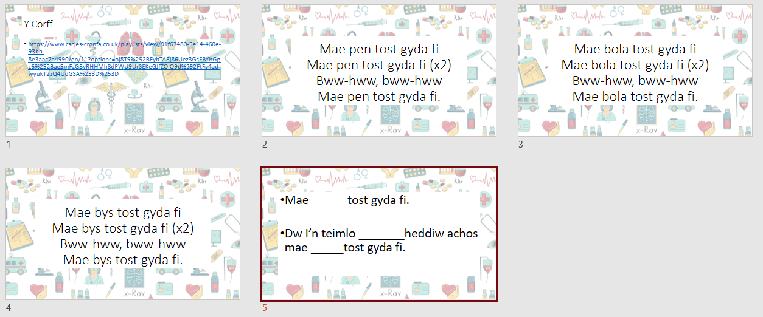
Appendix 1

Appendix 2
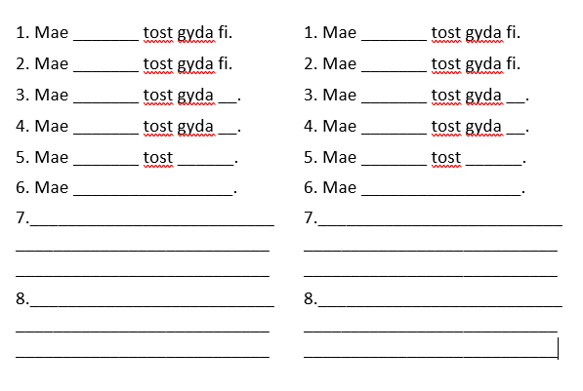
Appendix 3

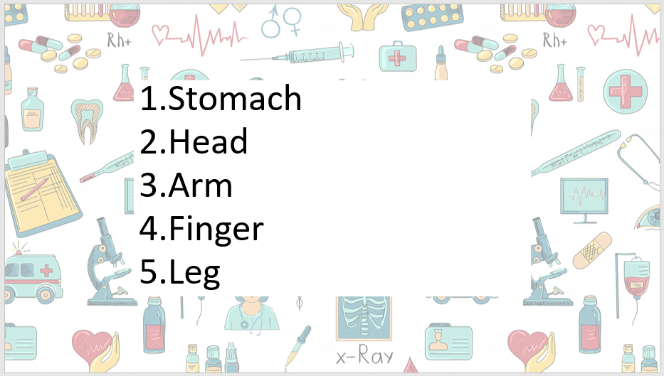

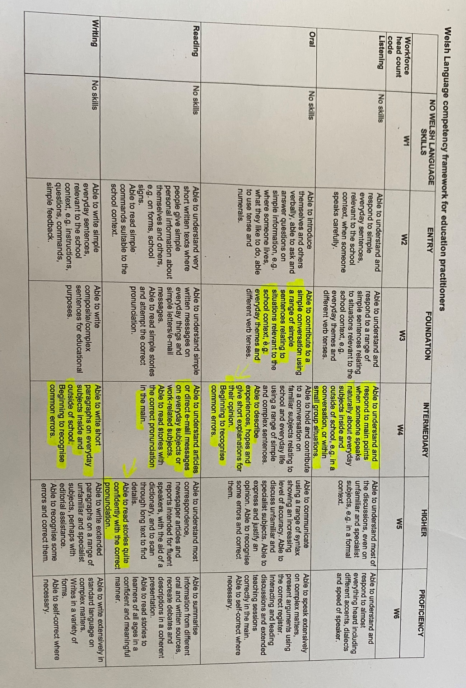
Appendix 4

Reference list
Estyn. (2016) Accelerating Pupil Learning. [Online] Available at: https://www.estyn.gov.wales/effective-practice/accelerating-pupil-learning

Estyn. (2017) Engaging all pupils Welsh Language. [Online] Available at: https://www.estyn.gov.wales/effective-practice/engaging-all-pupils-welsh-language
http://www.jinshaneducation.org/about/how-immersion-works

Science Daily. (2017) Repetition a key factor in language learning. University of Helsinki: Helsinki. [Online] Available at: https://www.sciencedaily.com/releases/2017/05/170502084630.htm

Weibell, C. J. (2011). Principles of learning: 7 principles to guide personalized, student-centered learning in the technology-enhanced, blended learning environment. From https://principlesoflearning.wordpress.com/dissertation/chapter-4-results/themes-identified/repetition/

Weibell, C. J. (2011). Principles of learning: 7 principles to guide personalized, student-centered learning in the technology-enhanced, blended learning environment. From https://principlesoflearning.wordpress.com/dissertation/chapter-3-literature-review-2/the-behavioral-perspective/behaviorism-john-b-watson-1913/

Weise, E. (2019). How Immersion Works - Jinshan Mandarin Education Council. [online] Available at:

Welsh Assembly Government. (2015) Foundation Phase Framework. Cardiff: Welsh Assembly Government. [Online] Available at: https://hwb.gov.wales/curriculum-for-wales-2008/foundation-phase/foundation-phase-framework/

Welsh Assembly Government. (2019) Welsh Language Competency Framework. Cardiff: Welsh Assembly Government. [Online] Available at: https://gov.wales/sites/default/files/publications/2019-06/welsh-language-competency-framework-for-education-practitioners.pdf

Welsh Assembly Government. (2020) Languages, Literacy and Communication Framework. Cardiff: Welsh Assembly Government.[Online] Available at: https://hwb.gov.wales/curriculum-for-wales/languages-literacy-and-communication/

