LCH4003
Introduction to health and social Care
Title: Portfolio Two tasks(Poster and essay)
Student’s Name: Muhammed A Miah
Student’s ID: 2507559
Lecturer’s name: Daniel Haruna
Date :11/02/2026

Task 1: Poster
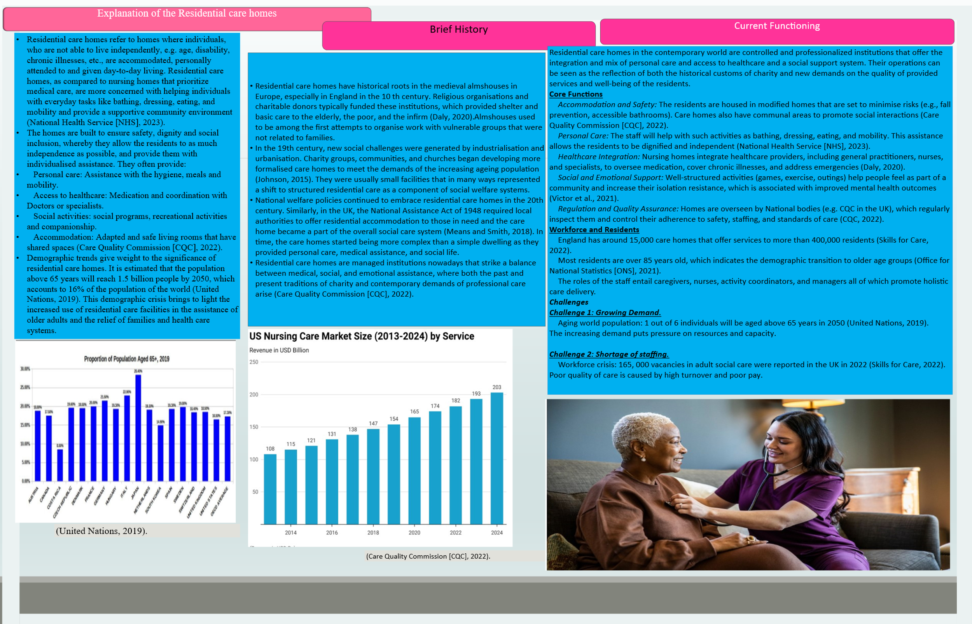
Task 2
Ambulance Services: Historical Development, Contemporary Function, and Significance
Research: Background of Ambulance Services.
The ambulance services were originally developed in military situations, when it was necessary to evacuate the wounded soldiers off battlefields. This was followed by organised systems in the 19th century especially in Europe where horse-drawn carriages were modified to carry patients (Pollock, 2013). Civilian ambulance services were based on the need to evacuate and provide pre-hospital care quickly, which was demonstrated during the Crimean War and the conflicts that followed it.
Discover: The History of Development.
Urbanization and industrial revolution brought more accidents and outbreak of diseases and the cities started deploying civilian ambulances. In the middle of the 20th century, ambulances were no longer simple vehicles of ways of transport, but a specialized emergency medical service (EMS) unit, being equipped with medical supplies and staffed by trained personnel (Pollock, 2013). This change was hastened by wars and technological innovations and entrenched the ambulance services in larger population health systems.
Assessment: Modern Operating.
Strengths
The modern-day ambulance service is part of an EMS service; which runs staffed by paramedics and emergency medical technicians with a level of training that enables them to provide advanced life support. They have defibrillators, oxygen, and monitoring technologies and allow performing immediate interventions with trauma, cardiac arrest, and respiratory emergencies (Ablard et al., 2023). It has been indicated that early pre-hospital care has been shown to significantly increase the survival rates of time-critical events like myocardial infarction and stroke (Ong et al., 2018).
Weaknesses
Although these strengths are present, ambulance services are challenged on a regular basis. The increasing demand, especially among the deprived population, causes a shortage available workforce, response movement, and introduces disparities in access (Ablard et al., 2023). Services are still overloaded by non-emergency calls which are channeling resources towards non-emergency cases and compromising efficiency (Snooks et al., 2011). The coordination between ambulance services and hospital emergency departments is not consistent with each other, which leads to the bottlenecks in the patient handover (Snooks et al., 2011). There is also a tendency to have delayed or low-income populations in rural areas which are part of a wider health disparity (Al-Shaqsi, 2010). Also, there is a problem of staff burnout and retention, and paramedics experienced high rates of occupational stress (Sterud et al., 2011).
Recommendations
A number of strategies are suggested in order to respond to these challenges. To achieve sufficient staffing and decrease burnout, it is important that investment in workforce development and retention is made first (Sterud et al., 2011). Second, combining telemedicine and predictive analytics may improve the efficiency of triage and resource allocation, improving inefficiencies and patient outcomes (Ong et al., 2018).
Significance in Improving Quality of Life.
The quality of life improved by ambulance services include providing access to life-saving measures in a timely manner, increasing the survival of emergency situations, and psychological reassurance of the community. The elderly and chronically ill are vulnerable populations that can be assisted by having access to reliable transportation to healthcare institutions in order to continue receiving care. In addition, ambulance services also help in enhancing the resilience of the population in the context of health promotion during disasters as well as preventive efforts (Ablard et al., 2023).
Conclusion
The innovations of the military have developed into advanced civilian health care costs. In the modern day they deliver vital pre-hospital care and benefits to the overall health of the population, but there are still issues of resource allocation, equity and system integration. Their values do not just extend to save lives but also improve psychological/community resilience as well. It will be important to address the systemic barriers in helping them fulfil their full potential in enhancing quality of life.

References
Ablard, S., Miller, E., Poulton, S., Cantrell, A., Booth, A., Lee, A., Mason, S. & Bell, F. (2023). Delivery of public health interventions by the ambulance sector: A scoping review. BMC Public Health, 23, 2082. doi:10.1186/s12889-023-17082-3 https://link.springer.com/article/10.1186/s12889-023-16473-2
Al‑Shaqsi, S. (2010). Models of international emergency medical service systems. Oman Medical Journal, 25(4), 320–323. doi:10.5001/omj.2010.92 https://pmc.ncbi.nlm.nih.gov/articles/PMC3191661/
Care Quality Commission. (2022). The state of health and adult social care in England 2021/22. London: CQC. https://wbg.org.uk/wp-content/uploads/2022/02/universal-quality-social-care.pdf
Daly, M. (2020). Welfare and social care: Historical perspectives. Oxford University Press. https://scholar.google.com/scholar?q=Daly,+M.+(2020).+Welfare+and+social+care:+Historical+perspectives.+Oxford+University+Press.&hl=en&as_sdt=0&as_vis=1&oi=scholart
Johnson, P. (2015). History of social care in Britain. Routledge. https://api.taylorfrancis.com/content/books/mono/download?identifierName=doi&identifierValue=10.4324/9781315696966&type=googlepdf
Means, R., & Smith, R. (2018). Community care: Policy and practice. Palgrave Macmillan. https://search.ebscohost.com/login.aspx?direct=true&profile=ehost&scope=site&authtype=crawler&jrnl=14720795&asa=N&AN=106617932&h=krf1erfMFC%2BCTSDqC%2FPZpECRuxhPIdfJSOoCyxKO9LhnttbXsmMGrB5VFDTiJld9Ah60dtpW1m%2B1ZkFCg7oSLw%3D%3D&crl=c
National Health Service. (2023). What is a care home? Retrieved from https://www.nhs.uk
Office for National Statistics. (2021). Living longer: Ageing in the UK. London: ONS. https://www.ons.gov.uk/peoplepopulationandcommunity/birthsdeathsandmarriages/ageing/articles/livinglongerhowourpopulationischangingandwhyitmatters/2018-08-13#:~:text=1.,evidence%20on%20the%20themes%20covered.
Ong, M.E.H., Cho, J., Ma, M.H.M., Tanaka, H., Nishiuchi, T., Al‑Shaqsi, S., ... & Shin, S.D. (2018). Comparison of emergency medical services systems in the Pan‑Asian Resuscitation Outcomes Study countries: Report from a literature review and survey. Emergency Medicine Australasia, 30(1), 124–133. doi:10.1111/1742-6723.12857 https://search.ebscohost.com/login.aspx?direct=true&profile=ehost&scope=site&authtype=crawler&jrnl=17426731&asa=N&AN=125218399&h=9Lhd%2BuQki%2Fh4D4qQXe96yE8JspILwQxTGP8mvqtW9C1190lndF5JcPnvu4UZvMTDRiaW2zqQkTA1AIzNikh9dQ%3D%3D&crl=c
Pollock, A. (2013). Ambulance services in London and Great Britain from 1860 until today: A glimpse of history gleaned mainly from the pages of contemporary journals. Emergency Medicine Journal, 30(3), 246–250. doi:10.1136/emermed-2012-201422 https://emj.bmj.com/content/30/5/350.short
Skills for Care. (2022). The state of the adult social care sector and workforce in England. Leeds: Skills for Care. https://scholar.google.com/scholar?hl=en&as_sdt=0%2C5&q=Skills+for+Care.+%282022%29.+The+state+of+the+adult+social+care+sector+and+workforce+in+England.+Leeds%3A+Skills+for+Care.&btnG=
Snooks, H., Evans, A., Wells, B., Peconi, J., Thomas, M. & Cheung, W.Y. (2011). Utilization of emergency medical services in a large urban area: Description of call types and temporal trends. Prehospital Emergency Care, 15(3), 371–379. doi:10.3109/10903127.2011.561401 https://www.tandfonline.com/doi/abs/10.3109/10903127.2011.561401
Sterud, T., Ekeberg, Ø. & Hem, E. (2011). Health status in the ambulance services: A systematic review. BMC Health Services Research, 11, 173. doi:10.1186/1472-6963-11-173 https://www.tandfonline.com/doi/abs/10.3109/10903127.2011.561401
United Nations. (2019). World population prospects 2019: Highlights. New York: UN. https://bristoluniversitypressdigital.com/edcollchap/book/9781447356127/ch007.xml
Victor, C., Rogers, A., & Finlay, J. (2021). Loneliness, social isolation and social care: Policy and practice. Policy Press. https://www.cambridge.org/core/journals/ageing-and-society/article/care-circle-consists-of-me-loneliness-and-social-isolation-for-older-male-spousal-caregivers-a-qualitative-study/9E2E7313F6D3C52293B737CB79D0A385

