Marketing plan for Marriott Courtyard
Exeter

Stefan Andrei Toma
Student number:2207387
Marketing Essentials BMIH4005
Lecturer-Luciana Suardi
Word count-1294

Introduction
The purpose of this paper is to analyse a potential marketing strategy for the Marriott Courtyard Exeter. The hotel has four stars and is in Exeter, United Kingdom. Theories such as SWOT analysis, PESTLE analysis, and a great number of others will be utilised in the process of preparing the marketing plan. Additionally, a Gantt chart is going to be utilised in the process of formulating an action plan for this hotel.

Sandy Park Conference & Banqueting Centre is close to Marriott Courtyard Exeter. It is a few minutes’ drive from Exeter airport (Marriott Courtyard, 2022). Marriott's database was hacked in 2018, exposing 500 million people's sensitive data. The Marriott courtyard Exeter is situated off the M5 and it gives easy access to the ancient city of Exeter. The company's location will attract tourists. Competitive rivalry for Marriott Exeter is fierce. Weeke Barton, Mill on the Exe, and other 4-star hotels may compete with Marriott. Exeter tourists are Marriott Courtyard Exeter's target market. The competitive rivalry for Marriott Courtyard Exeter is high. Weeke Barton, Mill on the Exe, and others are top rivals. Newcomers are unlikely. Luxury hotel companies seldom invest that much. Marriott Courtyard Exeter has several vendors. Poor supplier negotiating power. Buyers haggle. Marriott Courtyard Exeter rivals Weeke Barton, Mill on the Exe, The Raffles, and others. Marriott Courtyard Exeter and other hotels provide equivalent service and rates. Substitution is likely. JW Marriott, Marriott, and others are franchised. UK has a stable government and it has no threat of military invasion (Christodoulou and Cullinanre, 2019). Thus, the political factors have positive impact on Marriott courtyard’s business. The inflation rate in UK is high. As of October 2022, the inflation rate in UK was 11.1% and its increasing constantly (BBC, 2022). Thus, it could be said that the inflation rate of UK has negative impact on Marriott’s business. UK has a high literacy rate. As of 2021 it has a literacy rate of 99% (UNA-UK, 2022). High literacy rates help hotels hire qualified workers (Olawale, 2020). Thus, the literacy uncommon benefits Marriott Courtyard Exeter. Marriott's operation is affected by labour, customer protection, and other laws. The National Minimum Wage Act of 1998 requires UK companies to pay at least the government-set minimum wage, which was recently raised (Legislation, 2022). Marriott's finances will be strained by higher staff wages. Thus, Marriott suffers. Marriott is heavily impacted by environmental laws. UK companies are regulated under the 2021 Environment Protection Act (Legislation, 2022). Marriott may need to update its technology to comply with these requirements and protect the environment. It hurts business.

The marketing strategy of Marriott Courtyard Exeter is designed to attract new customers, with the ultimate objective of elevating the hotel's yearly profit above and above what it has previously been able to accomplish in previous years. In addition, it will make it easier for the hotel to get an advantage over its rivals in the industry.

Marriott follows core values: putting people first, pursuing excellence, embracing new changes, acting with integrity and serving the world. Marriott International always tries to ensure that the customers get the best value for their money (Bowie et al., 2017). In Marriott Courtyard Exeter, the company provides in-room entertainment to customers. In addition, it also has a rooftop bar and a restaurant from where the guests can enjoy the scenic beauty of the Devon countryside and the coastline. The Marriott also provides the customers with some local produce finest seafood, and steaks. The company ensures that the tourists enjoy a fine evening at the hotel while enjoying the scenic beauty (Marriott, 2022). In Bowman's strategy clock, Marriott belongs to the fourth and fifth quadrat, which means it has differentiation in its services (refer to appendix). In addition, it also provides high-value services at a high price.

Marriott International is one of the leading hotel brands worldwide. It tries to provide valued service to the customer for the price they pay. The Marriott Courtyard Exeter provides a different kind of room as per the customer’s preference and budget. It has deluxe rooms containing 1 king bed, the deluxe room containing two single beds, superior rooms, junior suites and many more. Customers can choose from any room as per their budget and necessity. This huge variety of rooms helps Marriott Courtyard Exeter to attract customers. Marriott International is the world’s largest hotel portfolio brand. It has a presence in more than 139 countries worldwide while offering more than 8000 hotels to customers. Marriott Courtyard Exeter is very close to the airport, only a few minutes drive from Exeter airport. In addition, it is close to the historic and vibrant city of Exeter. From its rooftop, the customers can enjoy the coastline's scenic beauty and the Devon countryside's view. Thus, its location can help the hotel to attract new customers. Marriott's pricing strategy varies based on the current market situation. It has a huge range of products for all types of budget customers. It always tries to provide the right product at the right place at the right price. It tries to provide high-value service to the customers for the money they have paid (Olawale, 2020). Its price varies on the customer demand and what the customers are looking for. It has hotel rooms of different prices, which includes Deluxe to superior rooms. As Marriott International is an international bean it has its website, in which the company showcases its different hotel brands and the products it offers. It allows pre-books of hotel rooms through websites (Marriott International, 2022). In addition, it also participates in different social media campaigns and promotes its brand name and discounts through different social media platforms. It has a customer loyalty program named Marriott Bonvoy, which provides special benefits to loyal guests while attracting potential customers.

The action plan for the marketing plan can be shown through Gantt chart
Activities | Week 1 | Week 2 | Week 3 | Week 4 | Week 5 | Week 6 | Week 7 | Week 8 | Week 9
Choosing marketing objectives
Marketing research
Social media marketing
Traditional marketing
Email marketing
Gathering feedback
Table 1: Gantt chart (Source: created by the learner)
Social media is an integral part of modern-age marketing. Through social media, Marriott Courtyard Exeter can effectively reach the mass population. It might use its customer experience and celebrity endorsement to promote its brand. In addition, as the hotel is in a superior location which is only a few minutes’ drive from the airport and provides a view of beautiful scenic beauty, the company might use those to promote its hotel. Thus 3 weeks might be taken for the social media campaign. On the other hand, email marketing and traditional marketing approaches such as newspaper, television and email can take one week.

USP or the unique selling position could be defined as the essence that makes one’s product different from its competitors. As a leading brand in the hotel industry, Marriott International has 30 hotel brands and more than 8000 properties worldwide. It has a unique reward system for loyal customers named Marriott Bonvoy, through which it provides special facilities to those customers. Compared to other hotel brands, the Bonvoy program Marriott has more participants, making its product unique. There are different ways that the company can use to measure its success. The company might measure it by the new customers (Jobber and Ellis-Chadwick, 2020). It can have a look at the customers it has before the campaign and the customers it has after the campaign. In addition, it also keeps an eye on different social media platforms to understand the campaign’s effectiveness on the customer. Change in company profit can also be a good measure of the marketing plan's effectiveness.

In this report, there is a marketing plan for Marriott International, one of the leading hotel brands all over the world. To understand its internal factors, a SWOT analysis has been done, on the other hand, to find out different external factors that can impact its business, a PESTLE analysis has been done too. The company’s value proposition, product differentiation and many more have been discussed in this report.

Digital marketing
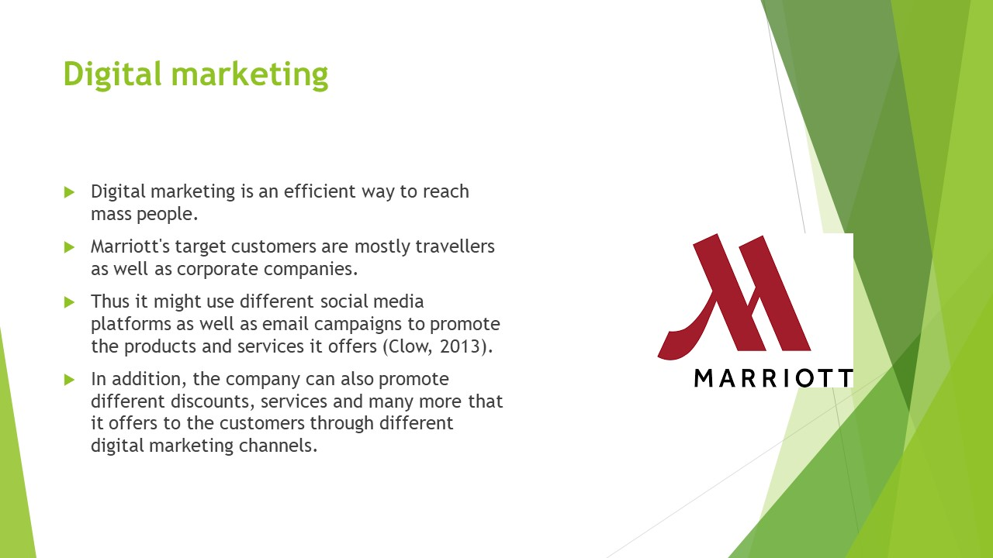
Digital marketing is an efficient way to reach mass people. Marriott's target customers are mostly travellers as well as corporate companies. Thus it might use different social media platforms and email campaigns to promote the products and services it offers (Clow, 2013). In addition, the company can also promote different discounts, services and many more that it offers to the customers through different digital marketing channels.
Creating a value
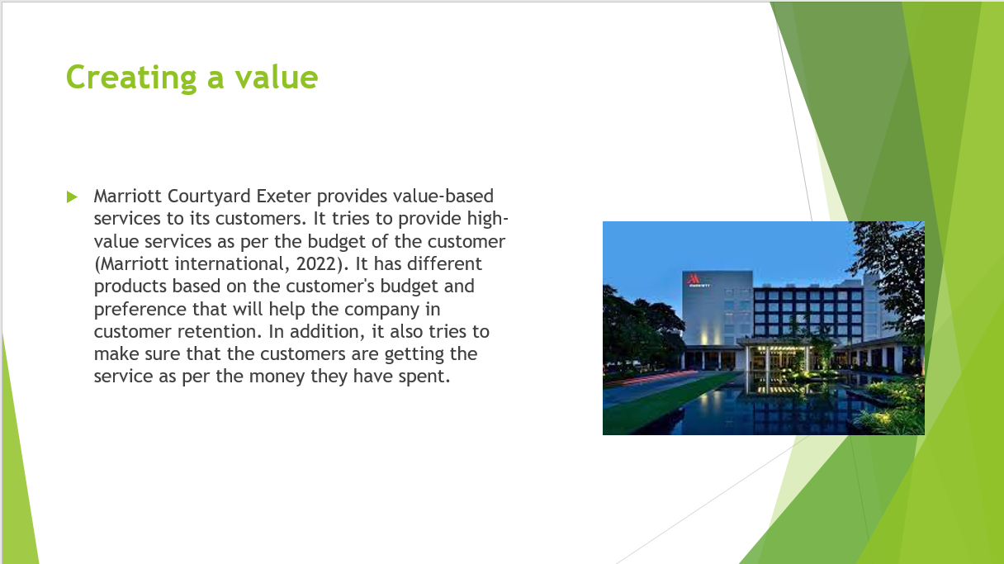
Marriott Courtyard Exeter provides value-based services to its customers. It tries to provide high-value services as per the budget of the customer (Marriott international, 2022). It has different products based on the customer's budget and preference that will help the company in customer retention. In addition, it also tries to make sure that the customers are getting the service as per the money they have spent.
Pricing strategy
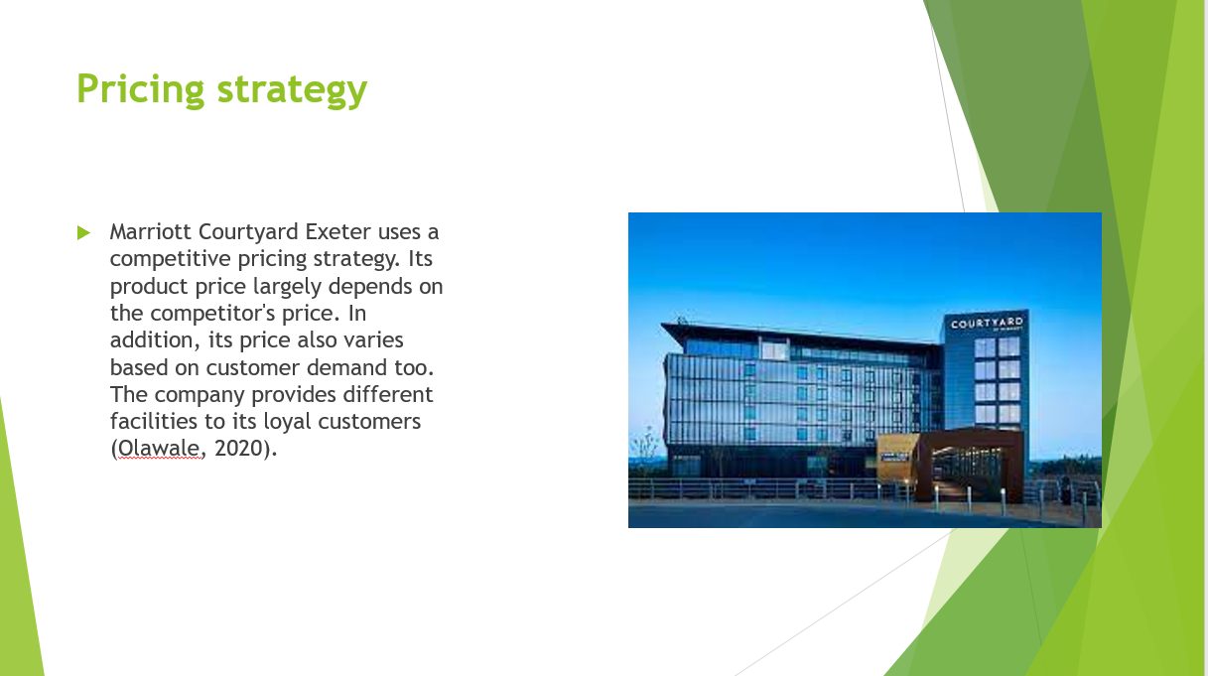
Marriott Courtyard Exeter uses a competitive pricing strategy. Its product price largely depends on the competitor's price. In addition, its price also varies based on customer demand too. The company provides different facilities to its loyal customers (Olawale, 2020). It has a program named Marriott Bonvoy to provide special services to its loyal customers.
Customer feedback
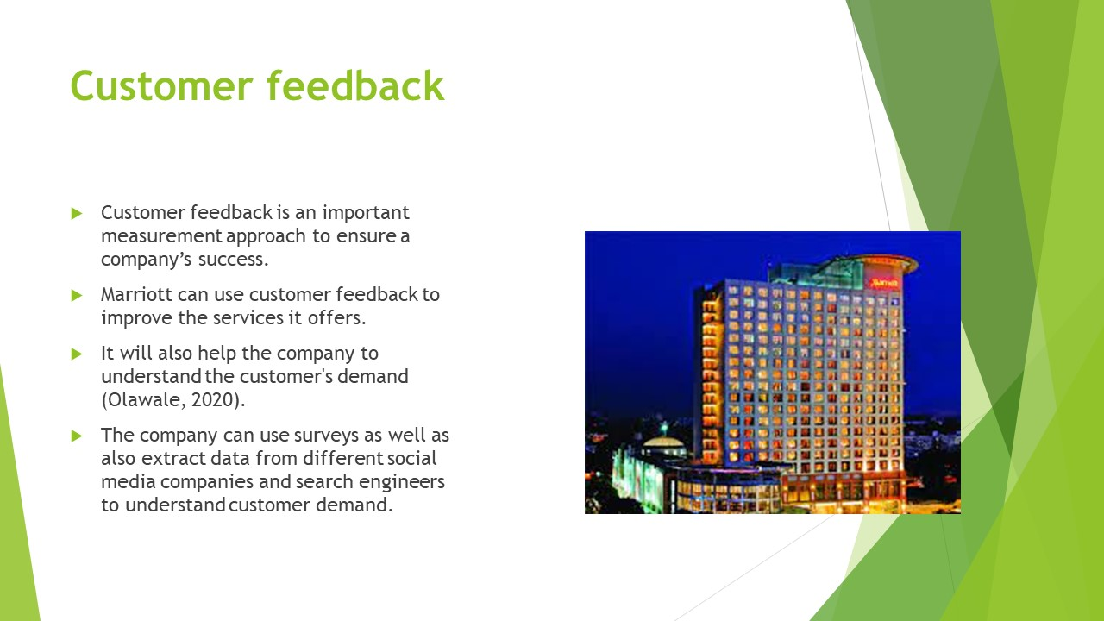
Customer feedback is an important measurement approach to ensure a company’s success. Marriott can use customer feedback to improve the services it offers. It will also help the company to understand the customer's demand (Olawale, 2020). The company can use surveys as well as also extract data from different social media companies and search engineers to understand customer demand.
Reference list
BBC, 2022. What is the UK inflation rate and why is the cost of living rising? [online] available at:< https://www.bbc.com/news/business-12196322>[ accessed on: 04th December 2022]
Bowie, D., Buttle, F., Brookes, M. and Mariussen, A., 2016. Hospitality marketing. Routledge.
Christodoulou, A. and Cullinane, K., 2019. Identifying the main opportunities and challenges from the implementation of a port energy management system: A SWOT/PESTLE analysis. Sustainability, 11(21), p.6046.
Clow, K.E., 2013. Integrated advertising, promotion and marketing communications, 4/e. Pearson Education India.
Jobber, D. and Ellis-Chadwick, F., 2019. EBOOK: Principles and Practice of Marketing, 9e. McGraw Hill.
Legislation, 2022. Environment act 2021 [online] available at:< https://www.legislation.gov.uk/ukpga/2021/30/contents/enacted>[ accessed on: 04th December 2022]
Legislation, 2022. National minimum wage act 1998 [online] available at:< https://www.legislation.gov.uk/ukpga/1998/39/contents#:~:text=National%20Minimum%20Wage%20Act%201998%20is%20up%20to%20date%20with,force%20at%20a%20future%20date.>[ accessed on: 04th December 2022]
Marriott Bonvoy, 2022. Explore our brands [online] available at:<https://www.marriott.com/marriott-brands.mi>[acceseed on: 28th November 2022]
Marriott Courtyard, 2022. Courtyard Exeter Sandy Park [online] available at:< https://www.marriott.com/en-us/hotels/extcy-courtyard-exeter-sandy-park/overview/>[accessed on: 04th December 2022]
Marriott International, 2022. We Are Marriott International [online] available at:<https://www.marriott.com/marriott/aboutmarriott.mi#:~:text=A%20Brand%20Leader,experience%20and%20expand%20their%20world.>[acceseed on: 28th November 2022]
Olawale, S., 2020. The Competitive Position of Marriott International Inc. and Starwood Worldwide: An Assessment using Porter's Five Forces and PESTLE-Analysis. GRIN Verlag.
UNA-UK, 2022. International Literacy Day [online] available at:< https://una.org.uk/international-literacy-day-factsheet>[ accessed on: 04th December 2022]
Villagrasa, J., Sánchez, F. and Donaldson, C., 2022. HOW TO TEACH THE STRATEGIC CLOCK WITH A NUMERICAL METHODOLOGY: MAKE IT REAL, MAKE IT HAPPEN. In INTED2022 Proceedings (pp. 35-44). IATED.
Appendix-A
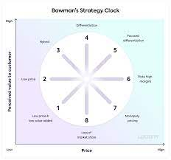
Picture 1: Bowman clock
(Source: Villagrasa et al., 2022)

Appendix-B

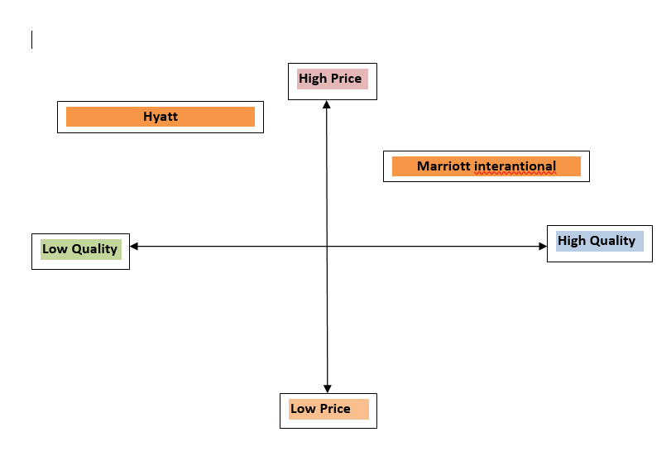
Figure 1: Market position
(Source: Created by the learner)

