Assignment Title: Thyroid Disease 2000 words
Student Name: Naveeda Aziz
Student Number: 2128414
Module Code: LCHS4004
Module Name: Introduction to Public Health
Lecturer Name: Dr Muhammad Hossain

Contents:
- Introduction ……………………………………………………………………………….….3
- Levels of occurrence that demonstrate the severity of the health problem (Both worldwide and UK statistics)………………………………………………………………..4
- Symptoms of high and low thyroids…………………………………………………………5
- How is hypothyroidism tread?......................................................................................6
- What happen if hypothyroidism is not treated?............................................................6
- Public health measures available for Thyroid?.......................................................6 to 7
- Challenges……………………………………………………………………………………7
- Understand the factors influencing the health and well-being of individuals in a health or social setting………………………………………………………………………………8
- What are the danger factors for creating hyperthyroidism?.........................................8
- World Thyroid Day…………………………………………………………………………...8
- Know the various approaches and strategies for measuring, monitoring, and controlling disease incidence in communities…………………………………………….8
- How to monitor an underactive thyroid?......................................................................9
- Hypothyroidism monitoring parameters…………………………………………………...9
- How to control the incidence of thyroid?......................................................................9
- Regularly check thyroid …………………………………………………………………...9
- Drink plenty of water…………………………………………………………………………9
- Eat selenium, tyrosine and antioxidants rich food………………………………………10
- Try not to smoke or drinking liquor……………………………………………………….10
- No macronutrients………………………………………………………………………….10
- Avoid sugar and caffeine………………………………………………………………….10
- No self-treatment……………………………………………………………………10 to 11
- Could thyroid return typical?......................................................................................11
- Conclusion………………………………………………………………………………….12
- References……………………………………………………………………………13 to 14

Introduction:
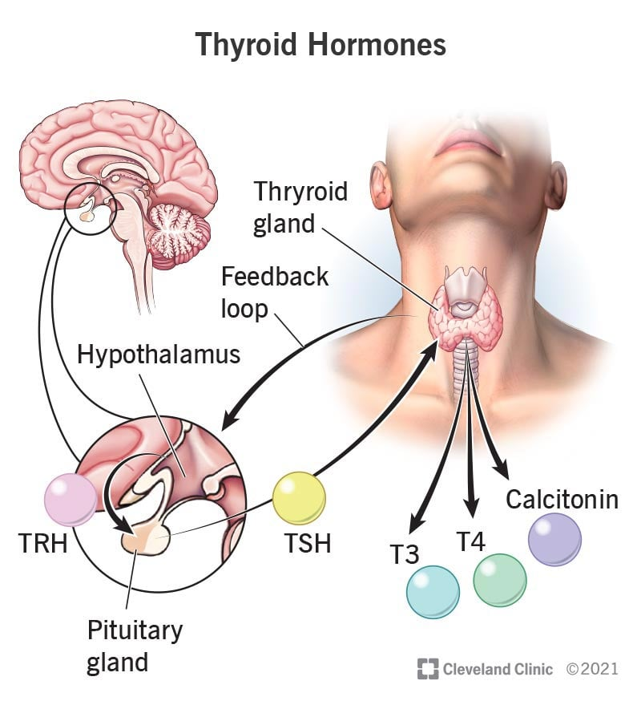
The thyroid organ is a small organ located near the front of the neck, folded over the windpipe. (windpipe). It's moulded like a butterfly, more modest in the centre with two broad wings reaching around the side of your throat. The thyroid is an organ. You have organs all over your body that produce and deliver substances that help your body do something. Your thyroid produces chemicals that aid in the regulation of many vital body functions.
When your thyroid isn't working properly, it can have an effect on your entire body. On the off chance that your body makes an excess of thyroid chemical, you can foster a condition called hyperthyroidism. On the off chance that your body makes too minimal thyroid chemical, it's called hypothyroidism. The two situations should be handled by your medical care provider because they are serious. (Degroot, P Reed Larsen and Georg Hennemann, 1996).

Levels of occurrence that demonstrate the severity of the health problem (Both worldwide and UK statistics)
More than 12 percent of the U.S. According to the American Thyroid Association, one-third of the population will develop a thyroid condition at some point in their lives (ATA). One out of every eight women will develop a thyroid disorder during their lifetime.
According to the NHS, one in every 50 women has hyperthyroidism, or an overactive thyroid gland. In 2019, there were between 60,500 and 74,000 monthly searches for 'underactive thyroid.' In one month alone (April 2019), there were 32,185 prescriptions for levothyroxine at a cost of £4,942,451. (www.btf-thyroid.org., n.d.)
- Thyroid disease is a widespread health issue that can have a significant negative influence on wellbeing, especially during pregnancy and childhood.
- Thanks to ubiquitous testing for thyroid function and very low criteria for the start of treatment, the prevalence about undetected thyroid disease is declining in industrialised nations.
- Iodine nutrition continues to be a major factor in determining thyroid function globally, thus it is crucial to maintain watch against the reappearance of iodine deficit in previously sufficient places.
- Further research in developing countries, particularly in Africa, is needed to comprehend how racial differences in iodine diet and disease patterns interact.

Symptoms of high and low thyroid:

Hypothyroidism  Not making enough thyroid hormones | Hypothyroidism  Producing too much thyroid hormones
Weight gain | Anxiety
Muscle aches | Rapid weight loss
Depression | Irritability
Slowe heart rate | Increased heart rate
Sensitivity to cold | Restlessness
Weakness | Difficulty sleeping
Dry skin | Increased sweating
(Parsley Health, n.d. 2019)

How is hypothyroidism tread?
By and large, treating hypothyroidism involves replacing the excess hormone that your thyroid is no longer producing. A medicine is typically used to treat this. Levothyroxine is a medication that is frequently used. This tablet, when taken orally, increases the amount of thyroid hormones your body produces, balancing your levels.
Portion of your medicine can really change over the long run. At various places in your day-to-day existence, you might have to have the measures of medication changed so it deals with your side effects. This could be due to factors such as weight gain or loss. Your levels should be checked all through your life to ensure your medicine is working accurately.
Hypothyroidism is a reasonable sickness. In any case, you should constantly accept medicine to standardize how much hormone inside of you until you've lived. You can lead a normal, healthy life with careful administration and follow-up consultations with your healthcare provider to make sure your treatment is working as intended.
What happen if hypothyroidism is not treated?
Hypothyroidism can turn into a serious and hazardous ailment on the off chance that you don't seek treatment from a medical services supplier. On the off chance that you are not treated, your side effects can turn out to be more extreme and can include:
• Creating emotional wellness issues.
• Experiencing difficulty relaxing.
• Not having the option to keep an ordinary internal heat level.
• Having heart issues.
• Fostering a goitre (growth of the thyroid organ).
You can likewise foster a serious ailment called myxoedema extreme lethargies. This can happen when hypothyroidism isn't dealt with.
Public health measures available for Thyroid?
There's absolutely no chance of forestalling an underactive thyroid. Most cases are caused either by the safe framework going after the thyroid organ and harming it, or by harm to the thyroid that happens during certain therapies for an overactive thyroid or thyroid cancer.
Treatment for an underactive thyroid includes taking everyday medicine substitution tablets, called levothyroxine, to raise your thyroxine levels. You'll have regular blood tests at first to ensure you're getting the right amount of levothyroxine. This can take some time to perfect.
When you're taking the recommended dosage, you typically undergo a blood test once a year to check for disease activity. Typically, you'll need medical care till the end of your life. In any case, with legitimate treatment, you ought to have the option to have a typical, solid existence.
All kinds of people can have an underactive thyroid, in spite of the fact that it's more normal in ladies. Kids can build too an underactive thyroid & a few babies are born with it.
On the off chance that an underactive thyroid isn't dealt with, it can prompt confusions, including coronary illness, goitre, pregnancy issues and a hazardous condition called myxoedema unconsciousness.

Challenges:

In spite of the fact that with a normalized rate of 0.54 cases per 100,000 persons,1 differentiated thyroid cancer (DTC) is an uncommon sickness in youngsters and youths; it regardless concern ~1.4% of every paediatric danger. Moreover, its frequency is rising.
AR, Hogan et al (2009)
As paediatric papillary thyroid cancer (PTC) is a relatively uncommon sickness, most therapy ideas for this patient populace are gotten from encounters in the grown-up PTC populace. (Engin, 2019)
Most patients with paediatric PTC will be analysed in light of explicit side effects, like a developing thyroidal knob or a steady lymph hub in the neck. Demonstrative techniques incorporate palpation, thyroid ultrasound, fine-needle biopsy, and assuming need be, symptomatic hemithyroidectomy.
Evaluating for PTC in kids in danger, like youngsters with malignant growth inclination disorders (eg, Cowden) or after openness to ionizing radiation, is an issue of discussion.

Understand the factors influencing the health and well-being of individuals in a health or social setting.
Natural variables are determinant for the presence of immune system thyroid sicknesses (AITD) in helpless subjects. Expanded iodine admission, selenium, and vitamin D inadequacy, openness to radiation, from thermal radiation or because of clinical radiation, are ecological variables expanding AITD.
What are the danger factors for creating hyperthyroidism?
A family history of hyperthyroidism, particularly Graves' disease, is one of the risk factors for hyperthyroidism. An personal history of specific persistent sicknesses, like diabetes 1, malevolent frailty and essential adrenal inadequacy.
World Thyroid Day:
The 25th of May is World Thyroid Day (WTD), which honours thyroid patients and all those who are dedicated to the study and treatment of thyroid diseases worldwide. Thyroid and Communication is this year's key message for 2022. (thyroidfoundation.org.au, n.d.)
It is critical that all thyroid patients understand their thyroid disorder, and that doctors understand how thyroid disorders affect patients and how to improve patient outcomes.
Know the various approaches and strategies for measuring, monitoring, and controlling disease incidence in communities:
It has long existed acknowledge that the clinical proofs of hyperthyroidism (thyrotoxicosis) or hypothyroidism are so different that disease established clinical face lacs sense and precision. Hence, confidence is placed on calculations of flowing thyroid hormones and thyroids birth control method (TSH) to confirm or reject thyroid dysfunction.
Almost all grown nation now have routine protect programs for inborn hypothyroidism utile zing heel prick clean paper ancestry spots.
The worth of aforementioned programs has long been clear (10), but neonatal protect is not still routine in abundant developing countries place however the predominance of neonatal hypothyroidism may be extreme, and frequently guide iodine deficiency. (Delange. F, 1997).

How to monitor an underactive thyroid?
Hypothyroidism is discussed with T4 birth control method supplementation, better known as Levothyroxine. When the disease and welcome aetiology are found, the treatment starts progressively and the hypothyroidism has expected controlled as far as the perfect balance between the dispassionate and biological manifestations of the patient is erect. Thyroid hormone necessities are approximately 1 to 5 ug/kg/d. (Hollowell et al., 2002)
Hypothyroidism monitoring parameters:
This sign maybe used to monitor hypothyroidism. The TSH level is consistently betwixt 0.4 and 2.5 mIU/L and must be inferior 4 effectively cases expected deliberate as normal. For most causes, Hypothyroidism demands lasting monitoring.
In the first place, the treatment will be executed at diminished portion and the specialist will build the sum carefully as per the TSH level to change the medication.
How to control the incidence of thyroid?
In thyroid, the thyroid organ is answerable for the metabolic capability of the body. In this way, when thyroid represents an issue, the whole body endures.
A thyroid patient might encounter despondency, weight gain, weariness, low internal heat level, hair fall, unfortunate light responsiveness and absence of endurance. It means a lot to know how to move toward the treatment of thyroid as well as the significant rules and regulations. (Clinical Management of Thyroid Disease, 2009)

Regularly check thyroid:

It is essential to assess thyroid function consistently whether you do it at home or by means of a lab test. Occasionally, a specialist may totally rely on blood testing for conclusion & neglect thyroid brokenness. This might leave many individuals undiscovered. Thusly, having a candid conversation with your primary care physician and look for clarity is significant.

Drink plenty water:
Thyroid sufferers must regularly drink distillation water. This is on the grounds that chlorine, fluoride and bromine levels are extremely low and it is sans iodine which assists the thyroid with working appropriately.

Eat selenium, tyrosine and antioxidants rich food:
Thyroid patients should consume vitamin B-rich foods such as crab, shellfish, brazil nuts, kidney, and liver. These food varieties contain Selenium-a protein that changes T4 over completely to T3. Tyrosine-based food incorporates almonds, sesame seeds, oats, and so on. Cell reinforcements rich food incorporates every new vegetable and organic products. These sorts of food will diminish irritation and assist with improving wellbeing.
Try not to smoke or drinking liquor:

Thyroid patients, in the event that they smoke or drink liquor, ought to end these right away. This is on the grounds that liquor is a depressant and it stifles the thyroid organ capabilities. Tobacco is also unhealthy as it obstructs the iodide apportion.

No macronutrients:

The three main macronutrients are fats, proteins, and carbohydrates. They are crucial in the body's control of the thyroid. Nevertheless, eating low carb can have a negative impact on the thyroid. Indeed, even low-fat or trans-fat diets might cause postural problems for thyroid patients.

Avoid sugar and caffeine:

Caffeine will in general pressure the body thus sugars. Caffeine in moderation is beneficial because it aids in the management of irritation by opening up the veins. Nonetheless, consuming beyond what the suggested measure of caffeine can modify the TSH levels created by the pituitary organs. (paidforarticles.com, n.d.)

No self-treatment:

Most frequently thyroid patients battle to grasp what's befalling their body and accordingly they go to the web for reference. The web with its great many sources recounts various stories and patients go overboard and begin to relate everything occurring in their body to be a thyroid issue.
It is suggested that one ought to be know all about the side effects and conditions that are thyroid-related yet talk with an authorized specialist and get a legitimate solution before you choose your own treatment. (pharmeasy.in, n.d.)

Could thyroid return typical?
Over period the thyroid generally gets back to its not unexpected state. Since the put away thyroid hormones has been delivered, patients might become hypothyroid (where their thyroid organ delivers too minimal thyroid hormones) for a while until the thyroid organ can develop new stores of thyroid hormones. (Uofmhealth.org, 2008)

Conclusion:

I have written about the awareness of thyroids and tried to explain the harms of thyroids so that anyone can start the treatment after diagnosis of this disease in time. Thyroid can cause changes in your weight, energy, digestion or mood. By recognizing the symptoms of thyroids in time, its treatment can be started.
The thyroid is a tiny but potent gland that is shaped like a butterfly and is situated at the front of your neck. It regulates a lot of the most crucial bodily processes. The hormones that the thyroid gland produces have an impact on your heart rate, digestion, and body temperature. These processes quicken as thyroid hormone concentrations rise. But if the thyroid produces too little or too much hormone, problems occur. Avoid self-treatment of thyroid and speak to a health professional if you see any thyroid illness symptoms. Your doctor can assist you in determining whether more testing or treatment is necessary based on your family history, your symptoms, and the results of your physical.
If you experience unexpected weight loss, a quick heartbeat, unusual sweating, neck swelling, or other hyperthyroidism symptoms, speak with your doctor right once. It's crucial that you describe the changes you've noticed in detail because many hyperthyroidism symptoms and indicators might be linked to a number of different medical disorders.
If you have undergone treatment for hyperthyroidism or are undergoing treatment now, follow your doctor's instructions and schedule regular appointments so that your health may be monitored. (Mayo Clinic, 2018)

References:
Schaefer, A. (2017) ‘The Best Thyroid Disorders Blogs of 2017’, Thyroids disorders, 11 July 2017. Available at: https://www.healthline.com/health/hypothyroidism/best-thyroid-blogs [Accessed 18 Nov. 2022].

American Thyroid Association. (n.d.). Thyroid Patient Information. [online] Available at: http://www.thyroid.org/thyroid-information [Accessed 12 Nov. 2022].

The British Thyroid Foundation. (2007). Nutrition & Food Science, Vol 37(6). doi:10.1108/nfs.2007.01737fab.024.

Hollowell, J.et al. (2002). Serum TSH, T4, and Thyroid Antibodies in the United States Population (1988 to 1994): National Health and Nutrition Examination Survey (NHANES III). The Journal of Clinical Endocrinology & Metabolism, vol 87(2), pp.489–499. https://doi.org/10.1210/jcem.87.2.8182

Engin, O. ed., (2019). Knowledges on Thyroid Cancer. IntechOpen. doi:10.5772/intechopen.77702.

Bunevičius, R. et al. (1999). Effects of Thyroxine as Compared with Thyroxine plus Triiodothyronine in Patients with Hypothyroidism. New England Journal of Medicine, vol 340 (6), pp.424–429. https://www.nejm.org/doi/full/10.1056/NEJM199902113400603

Benedetti, M.S., Whomsley, R. et al. (2005). Alteration of thyroid hormone homeostasis by antiepileptic drugs in humans: involvement of glucuronosyltransferase induction. European Journal of Clinical Pharmacology, vol 61(12), pp.863–872. doi:10.1007/s00228-005-0056-0.

Clinical Management of Thyroid Disease. (2009). Elsevier. doi:10.1016/b978-1-4160-4745-2.x0001-6.

Degroot, L.J., P Reed Larsen and Georg Hennemann (1996). The thyroid and its diseases. New York: Churchill Livingstone.

www.btf-thyroid.org. (n.d.). British Thyroid Foundation. [online] Available at: http://www.btf-thyroid.org. [Accessed 19 Nov. 2022].

thyroidfoundation.org.au. (n.d.). The Australian Thyroid Foundation - Home. [online] Available at: https://thyroidfoundation.org.au/.

Mayo Clinic (2018). Mayo Clinic. [online] Mayoclinic.org. Available at: https://www.mayoclinic.org/.

