An Assignment
On
Introduction to Public Health

Module Code:
Assignment title:polio

Submitted by, shakeel hussain Submitted to,ashiat Student ID: 2127229
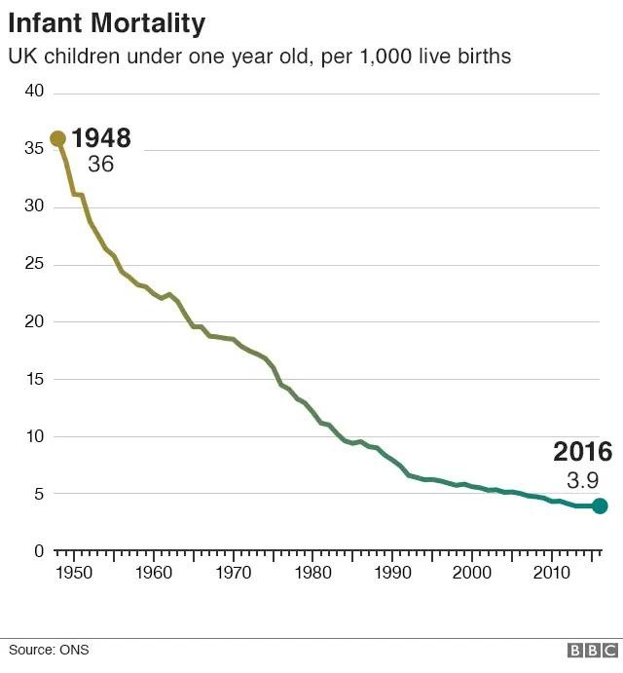

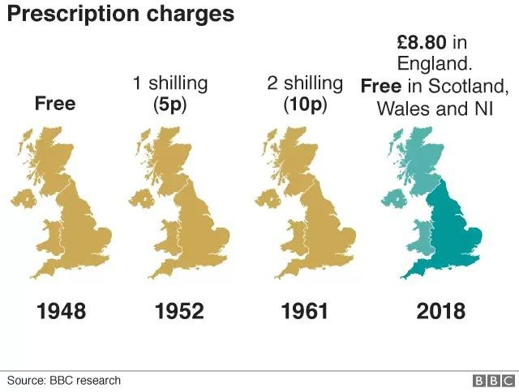
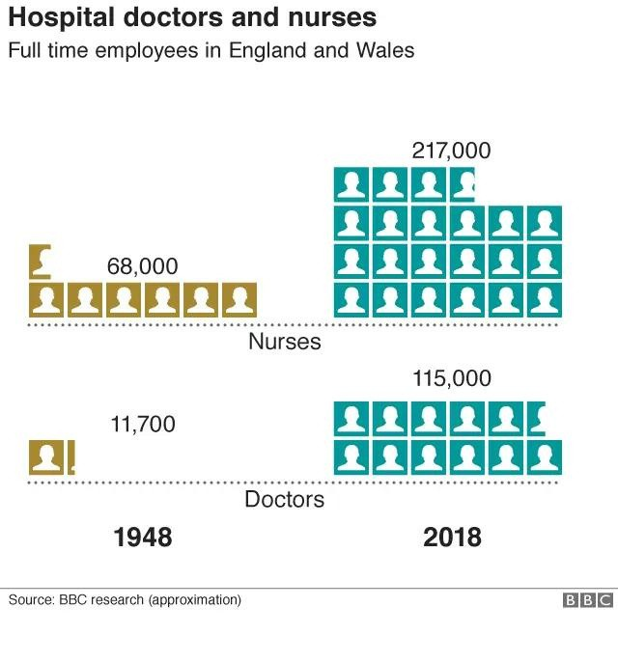
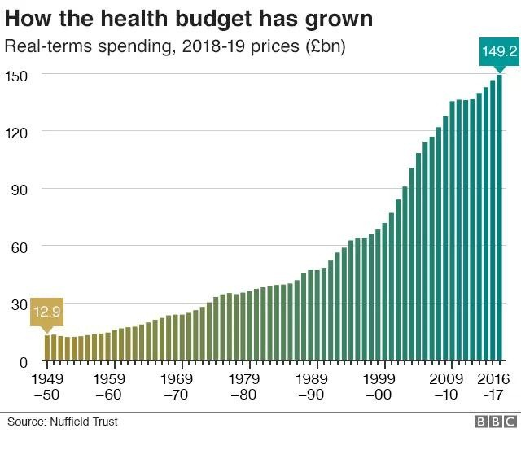
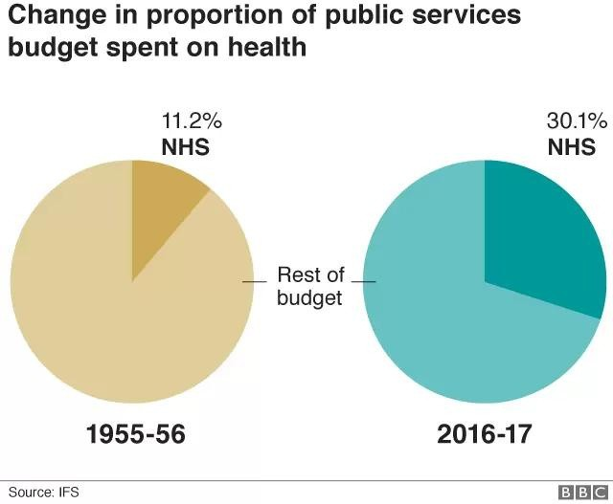
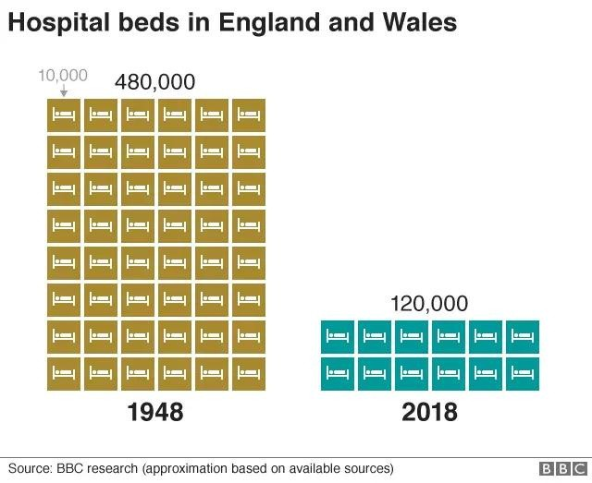
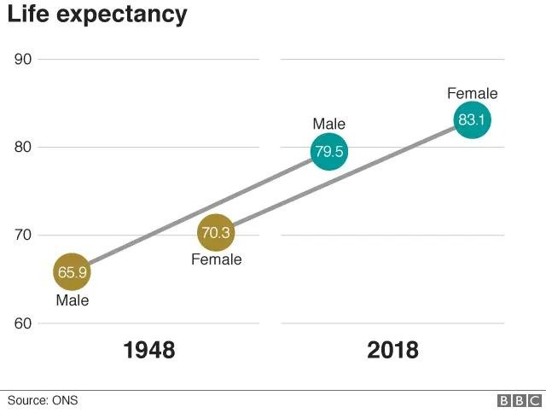
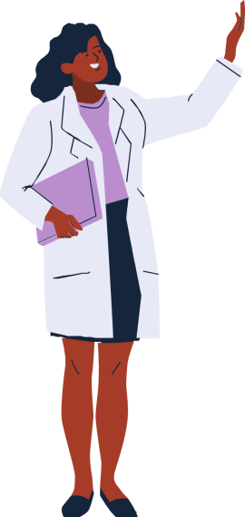
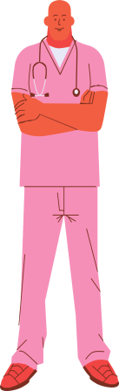
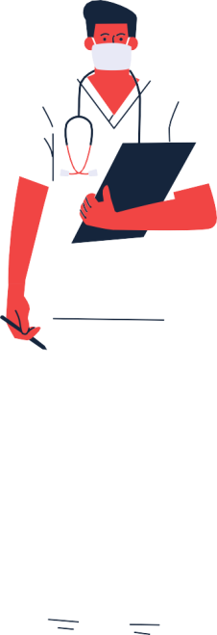
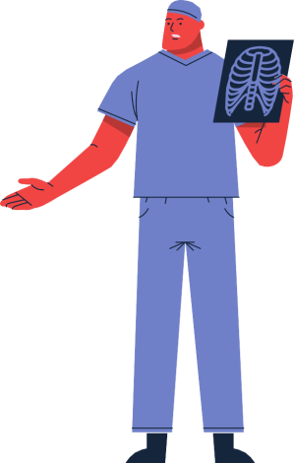


Introduction:
Poliomyelitis, also known as "polio," is a highly contagious illness that can transmit from one person to another and cause paralysis or, in extreme cases, death. Polio can be fatal, occasionally non-paralytic, or abortive. Mild poliomyelitis typically causes sore throats, fevers, exhaustion, muscle spasms, and other symptoms. Spinal polio, Bulbar polio, and Bulbospinal polio are the three types of paralytic polio that can exist. A person becomes paralysed as a result of post-polio symptoms such as muscle weakening and joint pain. Since there was no treatment for polio before the 1950s, many people perished from the disease; nevertheless, in 1953, Jonas Salk created the vaccine.

Strategies used in UK to measure Polio:

The latest polio epidemic since the invention of the vaccine occurred in England in 1984. However, the World Health Organisation (WHO) proclaimed the UK polio-free in 2003. Even if the immunisation is not extensively distributed, there are still battles with this in some nations including Nigeria, Pakistan, and Afghanistan.

The reported cases of paralytic polio from 1980 to 2021 are given in below:
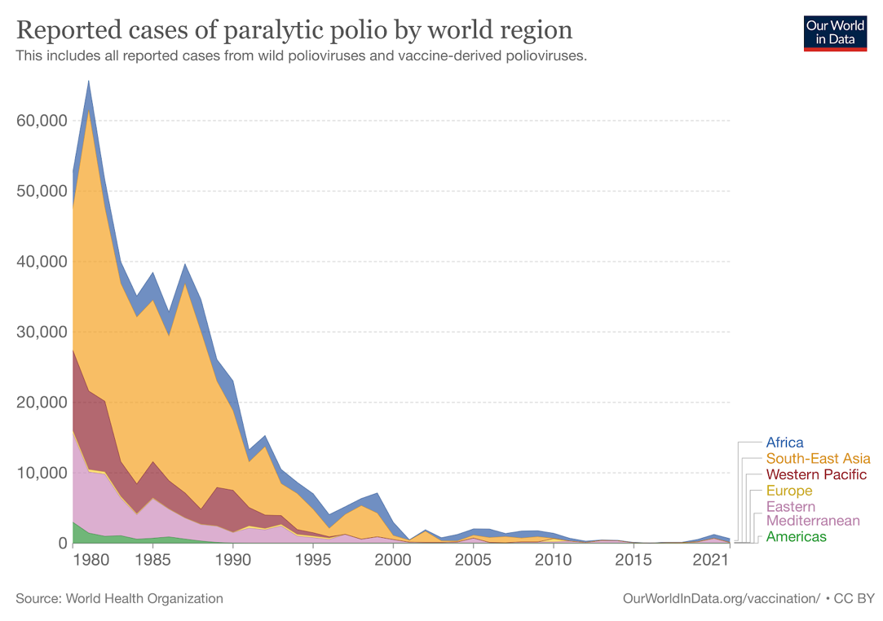

The yearly reports from the European Centre for Disease Prevention and Control, or ECDC, include a series of epidemiological statistics starting in 2015 and published in 2017. According to the records, none of the 30 reporting EU/EEA nations have seen a case of poliomyelitis since 2002. The Global Polio Laboratory Network (GPLN) conducts laboratory surveillance for wild-type and vaccine-type polioviruses in sewage water and patients with acute flaccid paralysis. The GPLN is made up of 145 laboratories operating in 100 countries, including the EU and all six WHO regions. In May 2014, the IHR Emergency Committee—which was tasked with producing quarterly reports—declared a polio Public Health Emergency of International Concern (PHEIC). According to their report, the risk was higher for some sensitive individuals, but the EU/EEA experienced a recovery rate of more than 90% after the polio vaccine was activated. Globally, 223 cases of circulating vaccine-derived poliovirus (cVDPV) and 19 cases of polio caused by wild poliovirus type 1 (WPV1) had been documented as of August 9. 15 nations have reported cVDPV cases in 2022, with 93% of those cases being type 2 instances (cVDPV2). Four fundamental steps have been identified by Acute Flaccid Paralysis (AFP) for polio surveillance.

Finding and reporting kids with acute flaccid paralysis is the first step (AFP)

Transporting stool samples for analysis in step two

Identifying and separating the poliovirus in a lab is step three.

The fourth step is mapping the virus to identify where the strain originated.

Strategies used in UK to monitor Polio:
Monitoring a disease involves looking for any symptoms and indicators, recording the information, and taking preventative action. The impact of immunisation is being observed as part of monitoring activities for the polio campaign in order to identify any gaps or issues. There are some fundamental components to polio monitoring. That is they-
1. To determine how many people are afflicted by the illness.
2. To determine how many kids have received vaccinations and whether they are labelled as such.
3. The percentage of districts under observation.
Once the proportion of immunised children is known, the immunised and unvaccinated children will be identified, making it easier to halt the spread of polio more quickly.
A monitoring system comes in two different varieties. One is house to house monitoring, which refers to data discovered after visiting homes and coming across an independent source. The second is outside monitoring, which is the term for market research gathered through regions and districts.
The monitoring system can be modified over time as technology advances. Before, there was no offline surveillance mechanism. However, the World Health Organisation can now monitor the sickness from home to house by speaking with people over the phone or by using other computerised means.
Although the EU was proclaimed polio-free in 2002, routine surveillance of London's sewage system revealed two strains of polioviruses between February and August of 2022. Although there is evidence of some sort of transmission virus in Northeast and North Central London, luckily no paralytic virus has been detected in the UK since 1984.

Strategies used in UK to control Polio:
The eradication of polio required several key initiatives, including further vaccine campaigns where the world has spend more than US$17 billion over three decades, active surveillance with case-by-case laboratory analysis, and increased partnership coordination. The provision of global resources and other health services continued even after international organisations began eradicating pandemics. Polio was contained with the aid of vaccine, however some other preventive measures are:
1. Steer clear of processed foods that can spread the polio virus.
2. A must-have is cleanliness. Therefore, washing your hands frequently will help you stay healthy.
3. Keeping the mouth covered while sniffling or coughing.
4. Avoid close contact who are sick.
Although there is no cure for polio, it can be temporarily cured with some medications. Parents need to be aware that polio immunisation should be given as soon as the baby is born because the vaccine has now been produced. There are now two vaccines available to prevent polio;
1. Inactivated poliovirus (IPV): This vaccine series lasts from two months after a child is born until they are four or six years old.
2. Oral polio vaccine (OPV): It is a low-cost vaccination that boosts immunity in people.

Sometimes Poliovirus hits the adults who weren’t vaccinated. That’s why an adult vaccine called Revaxis is used in the UK to protect adults against polio.
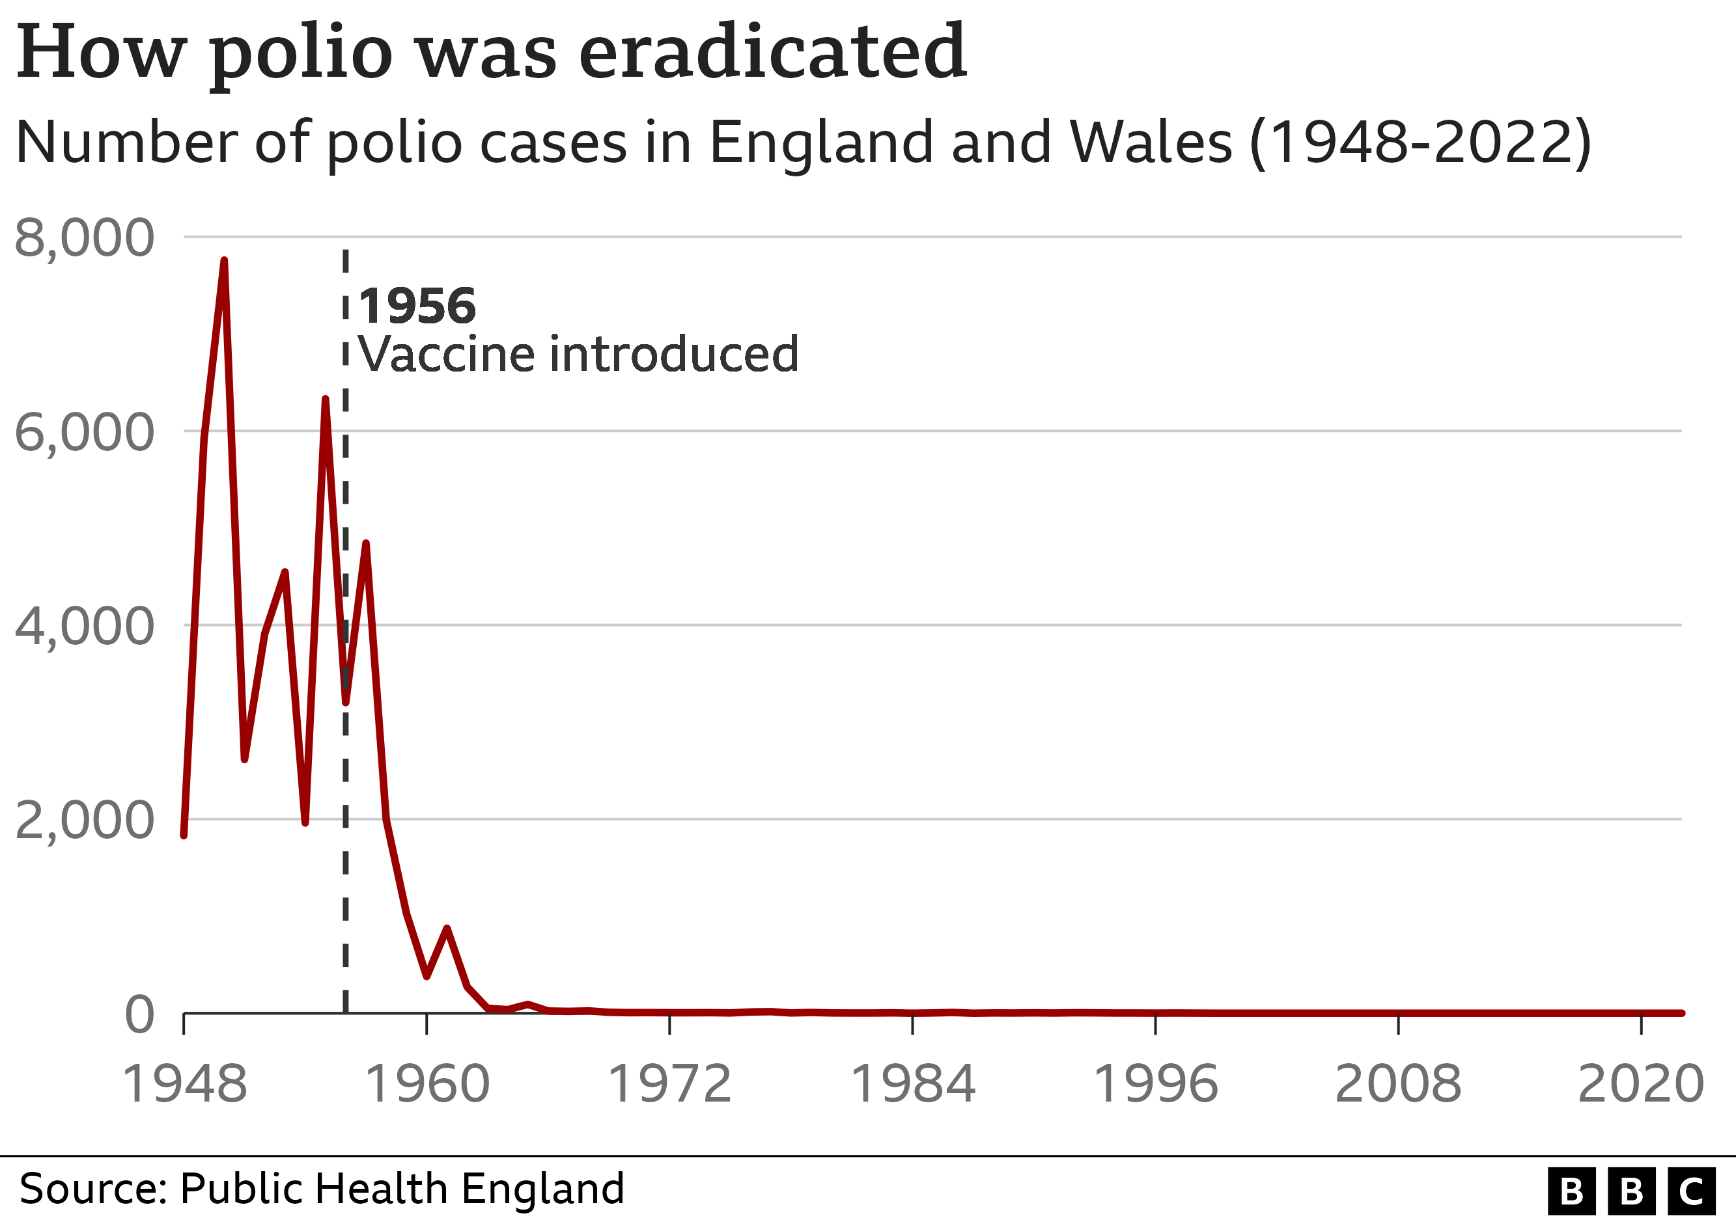

In the UK, vaccination campaigns and programmes are often held for both adults and children. Although a virus was discovered in the sewage of London, the UK Health Security Agency (UKSHA) is not very concerned because 86% of Londoners have received their vaccinations. But a few groups need to be made aware about polio, including
* children.
* expectant mothers.
* visiting countries with an endemic or extensive polio outbreak, including Pakistan and Afghanistan.
* a compromised immune system.
* working in a laboratory where live poliovirus is kept.

Conclusion:
To improve surveillance and encourage extensive vaccination efforts, the Stop Transmission of Polio (STOP) initiative was introduced. However, there are still significant issues with vaccination delivery on a global scale. This could be the result of religious divisions or even severe sanitary problems. A polio outbreak that started in Pakistan with a wild polio strain and spread to China in 2011 was controlled by oral polio vaccination administered there in 5 cycles totalling 43.7 million doses. WHO named the end of the polio epidemic a programmatic emergency in 2012. Hopefully, the disease will soon be completely eradicated.

References:
- Celentano L.P., Carrillo-Santisteve P., O’Connor P., Danielsson N., Huseynov S., Derrough T., et al. (2018) Global polio eradication: Where are we in Europe and what next? Vol. 28;36(36), pp.5449-5453.
- CDC. (2013) The global polio eradication initiative stop transmission of polio (STOP) program—1999-2013. MMWR Morb Mortal Wkly Rep. Vol. 62(24), pp. 501–503.
- European Centre for Disease Prevention and Control (2022), Update on the polio situation in the EU/EEA and the world. Available at: https://www.ecdc.europa.eu/en/news-events/update-polio-situation-eueea-and-world
- Laboratory Surveillance for wild and vaccine-derived polioviruses – worldwide (2008) MMWR weekly. Vol 57 (35). Pp.967 – 970.

