
Effective team work in organizations
How to use teamwork theories to improve the performance of a team in the workplace

June 12, 2020
University of Wales Trinity Saint David

Dragos Sculeac 1913775
UWTSD
12.06.2020
Word count:2593

Contents
Executive Summary 1
Terms of Reference 3
Procedure 3
Introduction 3
Findings 3
Groups versus teams 3
Teamwork theories 5
Teamwork theories and their effect on productivity. 8
Characteristics of effective teams and group dynamics 8
Benefits of effective teamwork for organisations 9
Conflict handling and delegation 10
Conflict 10
Delegation 11
Conclusion 11
References 13
Appendices 14
Acknowledgements 22

Executive Summary

Scope. This report provides an analysis over effective teamworking and how teamwork theories can improve the performance in the workplace.
Findings. The research conducted identified why it is important to distinguish work groups from teams, what the most common work theories are and how they impact the workplace, the characteristics that make an effective team and group dynamics and how leadership is used in dealing with conflict and delegation.
Conclusions.
A real team is where the individuals are given sufficient autonomy and authority to make their own decisions, feel motivated and involved and take accountability for their work.
Along the years there have been identified several factors that make a team to be effective. First of all a team should have a shared vision and a common goal, the members should have trust in each other, work towards continuous improvement, have respect for one another, maintain a good communication and focus on the objectives.
Conflict in an organization is considered inevitable, and although it can be stressful, it is essential in order to create an efficient team and to increase the performance.
Delegation is an important skill every manager should be looking to grow as it will help the organizations to grow. Through this, decision making becomes easier and team members become more engaged which results in a more efficient team.

Terms of Reference
The current report has been requested by Melanie Squire to demonstrate the importance of teamworking and how team work theories can improve the performance of the team in the workplace.
The report has been compiled by Dragos Sculeac and is to be submitted by 12.06.2020.

Procedure
For this report I have analysed the main work theories that have been presented in the classroom along with some additional ones.
I have done this by consulting the online library and other websites recommended by the lecturer.
I have also completed Belbin’s questionnaire and submitted the result in the Findings section to demonstrate how his theory applies in the workplace.

Introduction
The human capital is the biggest asset an organization can have nowadays and the best way people can perform is by being part of a team.
Some of the biggest benefits obtained by teamwork are an increased efficiency, better ideas, mutual support and better outcomes as team members can bring in more resources which then will minimise the risk of poor individual performance.
A good communication is very important today because most of the organisations operate through teams. In order for a team to be efficient the members need to meet regularly to discuss any problems they encounter and be updated on the team’s objectives.
Another main benefit of effective communication is that it builds trust within a company which will then positively impact then the culture, employee engagement and productivity.
Communication is essential in developing strategies for an effective teamwork through which members need to share ideas, thoughts and progress.

Findings

Groups versus teams
When people refer to groups and teams, most of the time they perceive them in the same way, but there are differences between them.
In a group, two or more people work towards the completion of a task, and they share information, they create their own independent goals and responsibilities.
In 2000 Belbin differentiated the groups from the teams using 6 aspects, illustrated below:
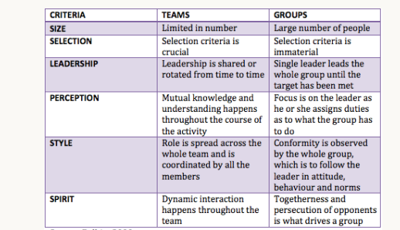
Figure 1. Differences between groups and teams- (adapted from Belbin 2000)

According to Kozlowski and Bell (2003), a team is defined as a group of people who exist to perform organizational tasks, share one or more common goals, interact socially, maintain and manage boundaries and can accomplish specific tasks interdependently.
Other researchers (Katzenbach and Smith, 1993) found that there are ten important differences between working groups and teams, as seen in the table below.
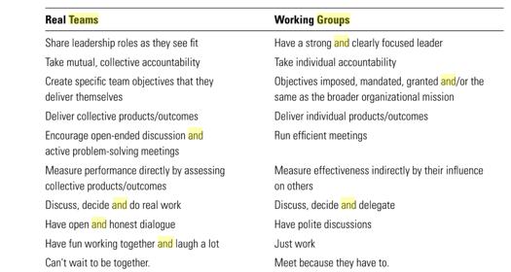

Table 1. 10 differences between groups and teams- (adapted from Katzenbach and Smith)

Teams are usually part of larger organizations where the members posses special skills, knowledge and abilities necessary for completion of their daily tasks.

Teamwork theories

Bruce Tuckman (1965) was the first to identify the stages of a group development known as forming, storming, norming, performing and adjourning.
In the first stage the members are getting to know each other and are seeking acceptance. They rely on the leader and very cautious as they don’t know yet the role they will play in the team.
The second stage is when conflict arises as the members begin to challenge one another about decisions and the plan they have to follow.
During the norming stage people become more united and trust each other, which makes them to organize better in accomplishing their goals.
The performing stage is when individuals work the most towards their objective and are the most efficient.
The last stage adjourning refers to when people have finished their work and need to prepare to say goodbye. It is important for them to discuss what they have learned.

Work example
In relation to Tuckman’s theory, during my work experience, I went through all stages when being part of a team, but one particular stood up due to the meaning it had, and that is the adjourning one.
Over a year ago I got relocated to Cardiff from the Swansea branch, where I worked for 6 years and when this happened, it left a bittersweet feeling. The team we formed there was very strong, we became very good friends, we always motivated each other and worked together towards our goals no matter how hard it was. Both myself and my colleagues were very sad when I had to leave, but they understood this choice was beneficial also for the company and this way they also became more confident.

Belbin
Whilst Tuckman studied the teams from their origin until the final stage, a few years later Dr. Meredith Belbin began his research observing teams in Cambridge and identified 9 team roles meant to describe the contribution each individual brings in a team.
The team roles identified by Belbin are used by many organisations nowadays because they have proved to be efficient. Not only people become aware of their strengths and get to use them to their advantages, but also they can manage their weaknesses better.
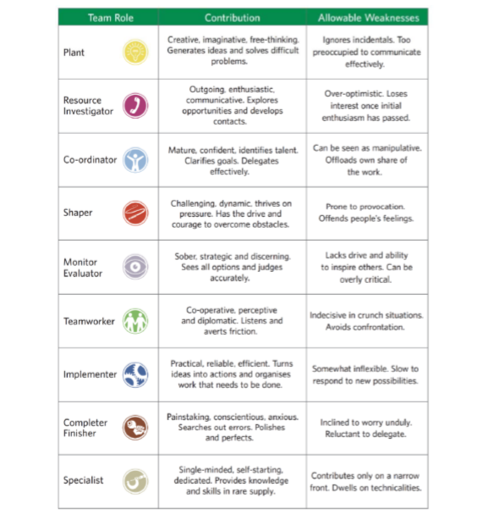
Figure 2. Description of Belbin’s nine team roles (https://www.belbin.com/media/1158/belbin-uk-2014-a-comprehensive-review.pdf)

Work Example
After completing Belbin’s questionnaire (Annex 1), I discovered I act like a Resource Investigator and Team Worker, followed closely by Shaper, while the lowest scores have been equally attributed to Monitor Evaluator and Completer Finisher.
Whilst I find myself in the main roles identified, as I look after the team and I’m supportive, enthusiastic and always look for answers outside the team like a Resource Investigator would, I was surprised to be identified as a Shaper, only because I never looked to be the leader of the team.
Although a leading role was never appealing to me, many times my work colleagues have seen me like one because every time they would have a work problem, they would come to me to discuss about it and also I was able to motivate them to complete their tasks.
In regards to my weaknesses, I can admit that sometimes I do get bored easily and don’t have patience to finish what I have started or I loose my focus.

TEAM Model
After studying the development models of Tuckman and Gersick and other theories, Morgan, Salas and Glickman (1994) created the Team Evolution and Maturation (TEAM) model. This describes nine developmental stages that teams are meant to go through.
As presented in the figure below, the model goes through the first 4 stages of Tuckman and then includes a cyclical process: Performing I-when inefficient performance can be identified, Re-norming-for revaluation and transition, Performing II- refocus to produce effective work and lastly Conforming- when the team finishes the assignments. There is also a preceding stage called Pre-forming that acknowledges the external forces that help the team to form.
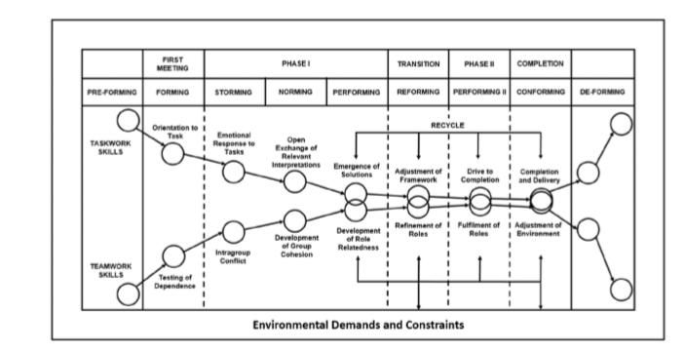 Figure 3. Team model for group development (Adapted from MORGAN, SALAS AND GLICKMAN, 1993)
Hackman’s Five Factor Model
In 1987 Richard Hackman identified 5 conditions that are meant to increase productivity in a team. According to him the effectiveness of a team is achieved when it exceeds the customers expectations, grows the capabilities of the team and satisfies the needs of its members.
The five factors are illustrated in the figure below and refer to:
- Real team-clear team tasks, role distribution
- Compelling direction- clear goals for the team
- Enabling structure- organized management structure
- Supportive context- resources, rewards and support available for an efficient collaboration
- Expert coaching-training and mentoring
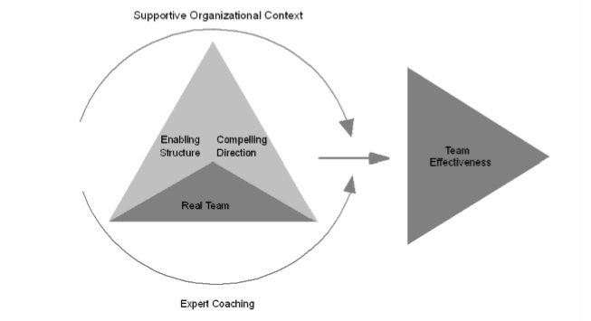
Figure 4. The five factor model adapted from Hackman (2002, p31-32)

Teamwork theories and their effect on productivity.

Although there are many other theories and models of effective teamwork, most of the organisations teams in the present days will show a mix between Tuckman’s five stages and the Five Factor Model developed by Hackman.
Tuckman’s theory has become very popular not only due to its simplicity, but because it helps managers understand that a team evolves and also that during their development, they will encounter different problems.
Once a manager can identify the stages at which his team is operating and also the factors present in the company, it will be easier for him to adopt a suitable leadership style and to offer better support and guidance to the individuals.
It is very likely that at some point a leader can come across an inefficient team that could be stuck on one of the stages and seems unable to progress. A leader that is aware of the teamwork theories will be able to identify the problems, communicate with the members and help them to overcome a storming stage for example and concentrate on the common goals.

Characteristics of effective teams and group dynamics

The term group dynamics can be used in two different ways (Adair 2011, p1-2), first one being used to describe what is happening in all groups and what determines the individuals to behave the way they do. The second meaning is given by the research conducted by the US and British psychologists over groups during 1940 and 1950 which created the Group Dynamics movement.
There have been many researchers along the years that have tried to identify what makes a team to be successful.
According to Druskat and Wolff (2001) there and three essential conditions for team success: trust between the members, a sense of group identity and a sense of group efficacy.
Levi and Slem (1995, p19-42) identified five factors for team success:
-evaluation and rewards
-social relations
-organizational support
-task characteristics
-leadership

In the research conducted by Katzenbach and Smith (1993) they identified that what makes a team efficient is a clear goal, a small number of members, complimentary skills and accountability.
No matter the type of business or organisation a leader operates in, there are several things they need to do in order to make a team work efficiently. They should first set a common goal clear for everyone and clarify the roles each one has, be open to criticism and listen to the individuals, keep the members always engaged and never forget to recognise their achievements and reward them.
These steps will ensure the team members stay motivated and this will have a great positive impact on the performance.

Work example
In regards to what makes a team efficient and high performing is something my manager has done in the past when I got relocated to the Cardiff branch and I was assigned a role I didn’t perform before.
What she has done at that time was to gather a group of people from different branches in Wales who she knew were already high performers and were able to cover individually 3-4 job roles in the company. Once gathered in the same branch, she offered us support and training so that in present every one of us could easily cover 4 or 5 different roles.
For example if we are really busy one day with car deliveries, one person can remain in the whilst the others can go and help the drivers and that one person can at the same act like a front desk agent, fleet controller, damage controller, assistant manager, or even as a car team leader.

Benefits of effective teamwork for organisations
Having an effective team in an organisation is not only beneficial for its members, but also for the organisations.
Among these benefits one can mention an increased creativity level and shared ideas, higher productivity, a motivating environment, better conflict management, cost reduction, lower absenteeism.

Conflict handling and delegation

Conflict

Conflict is a natural phenomenon within teams and usually appears during the storming stage of the team development.
Some of the major causes of conflict are:
- An increase workload
- Poor management
- Unclear job roles
- Unrealistic expectations
- Bullying and harassment
There is no right way when it comes to dealing with conflict, but five approaches, illustrated in the figure below. When leaders decide which approach to use, they need to consider the nature of the conflict, the business ‘culture and the main goal.
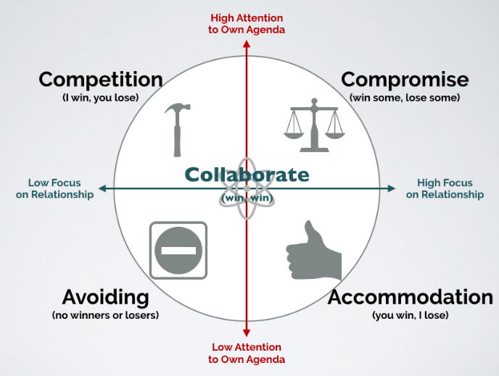
Figure 4. Ways to handle conflict- adapted from http://sixandahalfconsulting.com/blog/5-ways-manage-conflict/
Although conflict can be seen as a stressful situation, it can be beneficial for the teams and the organisation. It can lead to generating creativity and new ideas, can increase productivity for those who can only be efficient when they approach their deadline, increases communication and negotiation and can also reduce stress by getting rid of negative emotions.
Work example
One of the situations I encountered many times since being in this role is when the drivers, after a long day, become frustrated with their colleagues from the office who are responsible with planning their itinerary for each delivery.
The reason it becomes a conflict is because the drivers accuse the fleet controller he hasn’t been efficient in planning the day, which resulted in them working until very late at night. This is where I usually step in and act like a mediator.
What I do is gather the drivers in short meeting and I explain to them what happened in the office during the day to provide a better understanding why things haven’t gone according to plan. I explain how they could have done their job better for that day and remember them that the work situation changes hourly and why it is important for them to work closely and as a team because only this way they can be efficient and finish their duties on time.

Delegation
Delegation has become one of the most important skills that managers can possess and this is thanks to a number of reasons.
A good delegation motivates people, saves time and helps a potential successor grow as it contributes to personal development and encouragement for promotion. Once people are given more tasks to complete they will gain experience and will be more likely to take higher responsibilities. For the delegator the greatest benefit obtained is time, which then provides the benefit of choice. (Thomas G. 2014) By gaining extra time, the leader can then use to it for the business’ growth or his own, can focus on other tasks and take better decisions.
In the book Seven Habits for Highly Effective People (1989), Steven Covey speaks about five areas managers should focus on in order to obtain an effective delegation:
- Desired results
- Guidelines
- Resources
- Accountability
- Consequences
There are times when leaders are unable to provide a good delegation and when this happens the others may feel confused and demotivated and will fail to achieve their tasks

Conclusion
Businesses have become very aware of the importance and potential of performing teams and use them to accomplish their missions.
The terms of groups and teams are most of the time interchangeably because even in a business environment they might be doing the same work, but the main difference comes from how the members are managed and how they interact together.
Along the years there have been identified several factors that make a team to be effective. First of all a team should have a shared vision and a common goal, the members should have trust in each other, work towards continuous improvement, have respect for one another, maintain a good communication and focus on the objectives.
Organizational conflict is considered inevitable and a positive indicator for an efficient team and increased productivity.
A leadership style could not be effective if delegation is not a part of it. In order to make this possible, leaders should always maintain a good level of communication, be approachable but at the same time set some boundaries, make themselves available, allow different solutions, motivate their teams, require regular progress update and most importantly make themselves accountable.
Working in a team sometimes can be quite frustrating for its members and research has shown that some of the most common problems are poor communication, lack of commitment, conflict, poor leadership and productivity losses.

References
- Adair, J (2011), Effective teambuilding Revised Edition: How to make a winning team. Pan Macmillan
- Belbin, M. (2000) Beyond the team, Routledge.
- Covey, S (1989) Seven Habits for Highly Effective People. Free Press
- Druskat, V U and Wolff, S. B. (2001) Building emotional intelligence of groups.
Harvard Business Review
- Griffith, B.A. and Dunham, E.B. (2015) Working in Teams: Moving from high potential to high performance. California: Sage Publications Inc.
- Hackman, R. (2002). Leading Teams: Setting the Stage for Great Performances, Harvard Business Press
- Katzenbach J R and Smith D K (1993), The Wisdom of Teams: Creating the High-Performance Organization, Harvard Business Press
- Kozlowski, B and Bell, B (2001) Work groups and teams in organizations, Cornell University IRL School, available at https://digitalcommons.ilr.cornell.edu/cgi/viewcontent.cgi?article=1396&context=articles, (accessed on 06.06.2020)
- Levi, D (2007) Group Dynamics for teams. Sage
- Levi, D and Slem C (1995), Team work in research and development organizations: The characteristics of successful teams. International Journal of Industrial Economics (16)
- Morgan, B B, Salas, E. and Glickman, A.S. (1993). An analysis of team evolution and maturation. The Journal of General Psychology, 120(3)
- Rahim, A (2010), Managing conflict in organizations, Transaction Publishers
- Thomas, G (2014) The gift of time: How delegation can give you space to succeed. Capstone
- Tuckman, B W (1965) Developmental sequence in small groups. Psychological Bulletin, 63.
- https://www.belbin.com/media/1158/belbin-uk-2014-a-comprehensive-review.pdf
- https://www.nibusinessinfo.co.uk/content/causes-conflict-workplace
- http://sixandahalfconsulting.com/blog/5-ways-manage-conflict/

Appendices

Belbin’s Team Roles - a Self-perception Questionnaire

Instructions

- Below are 7 sections each with 9 statements.
- Circle the 2 or 3 statements from each section which are most relevant and appropriate to you/your personality.
- Your task is to allocate a total of 10 points to the statement(s) you have chosen. The most relevant statement will receive a higher weighting out of 10. You are able to give the full 10 points to 1 statement.

Section 1

“What I believe I can contribute to a team...”

- I can quickly see and take advantage of new opportunities

- I can work well with a very wide range of people

- Producing ideas is one of my natural assets

- I can draw people out whenever I detect they have something of value to contribute to group objectives

- I can be relied on to finish any task I undertake

- My technical knowledge and experience is usually my major asset

- I am always ready to be blunt and outspoken in the cause of making the right things happen

- I can usually tell whether a plan or idea will fit a particular situation

- I can offer a reasoned case for alternative courses of action while maintaining freedom from personal bias

Section 2

“Possible shortcomings I may have in teamwork..”

- I am not at ease unless meetings are well structured and controlled and generally well conducted

- I am inclined to be too generous towards others who have a valid viewpoint that has not been given a proper airing

- I am reluctant to contribute unless the subject deals with a field I know well

- I have a tendency to talk a lot once the group gets on to a new topic

- My objective outlook makes it difficult for me to join in readily and enthusiastically with my colleagues

- I am sometimes seen as forceful and authoritarian when dealing with important issues

- I find it difficult to lead from the front, perhaps because I am over-responsive to group atmosphere

- I am apt to get too caught up in ideas that occur to me and lose track of what is happening

- I am inclined to become preoccupied when I realise that loose ends have not been tied up

Section 3

“When involved in a project with other people..”

- I have an aptitude for influencing people without pressurising them

- I can help prevent careless mistakes or omissions from spoiling the success of an operation

- I like to press for action to make sure that the meeting does not waste time or lose sight of the main objective

- I can be counted on to contribute something original

- I am always ready to back a good suggestion in the common interest

- I am quick to see the possibilities in new ideas and developments

- I try to maintain my sense of professionalism

- I believe my capacity for judgement can help to bring about the right decision

- I can be relied upon to see that all essential work is organised

Section 4

“My characteristic approach to team work is that...”

- I have a quiet interest in getting to know colleagues better

- I contribute where I know what I am talking about

- I am not reluctant to challenge the views of others or to hold a minority view myself

- I can usually find a line of argument to refute unsound propositions

- I think I have a talent for making things work once a plan has to be put into operation

- I prefer to avoid the obvious and to open up lines that have not been explored

- I bring a touch of perfectionism to any job I undertake

- I like to be the one to make contacts outside the group

- While I am interested in all views I have no hesitation in making up my mind once a decision has to be made

Section 5

“I gain satisfaction in a job because..”

- I enjoy analysing situations and weighing up all the possible choices

- I am interested in finding practical solutions to problems

- I like to feel I am fostering good working relations

- I can have a strong influence on decisions

- I have a chance of meeting new people with different ideas

- I can get people to agree on priorities

- I feel in my element where I can give a task my full attention

- I like to find a field that stretches my imagination

- I feel I am using my special qualifications and training to advantage

Section 6

“When I am suddenly given a task with limited time and unfamiliar people..”

- I like to read up as much as I conveniently can on the subject

- I would feel like devising a solution on my own and then trying to sell it to the group

- I would be ready to work with the person who showed the most positive approach

- I would find some way of reducing the size of the task by establishing how different individuals might best contribute

- My natural sense of urgency would ensure that we did not fall behind schedule

- I believe I would keep cool and maintain my capacity to think straight

- In spite of conflicting pressures, I would press ahead with whatever needed to be done

- I would tend to assert myself if I felt the group was making no progress

- I would open discussion with a view to stimulating new thoughts and getting something moving

Section 7

“When I am part of a team which is working on a problem..”

- I am apt to over-react when people hold up progress

- I sometimes find my sense of objectivity has a demotivating effect on theirs

- My desire to check that we get the details right is not always welcome

- I tend to show boredom unless I am actively engaged with stimulating people

- I find it difficult to get started unless the goals are clear

- I am sometimes poor at putting across complex points that occur to me

- I am conscious of demanding from others the things I cannot do myself

- I am inclined to feel I am wasting time and would do better on my own

- I hesitate to express my personal views when difficult or powerful people are around me

A Self-perception Questionnaire Analysis sheet
- Using the answers to your questionnaire, fill in the table below.
- For each of the Sections, look for the statement(s) you have chosen (a– i) and write in the points you awarded, then add up the totals for each column.
Section | IM | Co | SH | PL | RI | ME | TW | CF | SP
1 | h | d | g | c | a | i | b | e | f
1 |  |  |  |  | 4 |  | 6
2 | a | b | f | h | d | e | g | i | c
2 |  |  |  | 7 |  |  | 3
3 | i | a | c | d | f | h | e | b | g
3 |  |  | 4 | 2 | 4
4 | e | i | c | f | h | d | a | g | b
4 |  |  |  |  | 1 | 3 | 3 |  | 3
5 | b | f | d | h | e | a | c | g | i
5 | 3 |  | 3 |  | 4
6 | g | d | h | b | i | f | c | e | a
6 |  | 5 | 5
7 | e | g | a | f | d | b | i | c | h
7 | 4 |  |  |  |  |  | 1 | 3 | 2
Total | 7 | 5 | 12 | 9 | 13 | 3 | 13 | 3 | 5

Acknowledgements
I would like to express my gratitude to my lecturer Mrs Squire who gave me the opportunity to work on this project on a very important topic- Effective Teamwork in Organizations. The research conducted has helped me understand the importance of an effective team for both myself and the company I work for.
I would also like to thank my work colleagues and my manager for allowing me to work more flexibly in the last months in order to accommodate my learning time as well.

