
MBA –Master of Business Administration
International Marketing
Romeo Makiadi
1906720
Tushara Balendran
LCMB7006
21st August 2023

Contents
INTRODUCTION 3
LOUIS VUITTON (LV) 3
MACRO ENVIROMENT OF LOUIS VUITTON 4
Critical analysis of the Hofstede model 11
PORTER 5 FORCES MODEL 12
SWOT ANALYSIS 18
SEGMENTATION TARGETING AND POSTIONING (STP METHOD) 19
Perceptual map 20
MARKETING MIX 7ps 21
Market entry methods 25
DEFINTION OF DIRECTIONAL DEVELOPMENT STRATEGY 27
ANSOFFF MATRIX 27
CRITICAL ANALYSIS 27
RECCOMENDATIONS 27
TOWS MATRIX 28
CONCLUSION 28

INTRODUCTION
I have been entrusted as a marketing analyst with evaluating and contrasting the marketing approaches used by a brand that are conducting sales in two separate nations. I have decided to concentrate my investigation on a high involvement product that is offered for sale in United Arab Emirates and the United Kingdom. This report will be taking into account the STP (Segmentation, Targeting, Positioning) framework, the 4/7 P's of marketing (Product, Price, Place, Promotion, and extra aspects if relevant), and also including the directional development strategy and a critical analysis of my findings. My objective is to assess the similarities and contrasts in their marketing strategies between both nations.
I will provide specific data throughout this report to show the importance of these similarities and differences across numerous factors. I'll also look at how these tactics and organisational methods connect to the mentioned elements. Finally, I'll evaluate the strategies employed and offer my recommendations on whether, I think they're suitable in general and identify areas of improvement and strategies for the growth stage. Let's explore into this investigation and learn important things about how this high participation product is marketed in United Arab Emirates and the UK.

LOUIS VUITTON (LV)
In 1854, Louis Vuitton established the famed luxury fashion label Louis Vuitton (often abbreviated as LV) in Paris, France. The company is well known for its premium leather products, which include ready-to-wear clothes, accessories, luggage, and purses. One of the most prominent and well-known luxury brands worldwide, Louis Vuitton has through the years grown to be associated with luxury, sophistication, and elegance (Louis Vuitton, 2023).
Since its introduction in 1896, the brand's renowned Monogram Canvas, which features the LV logo's interlocking letters, has stood as a timeless representation of luxury and flair. Louis Vuitton provides a variety of additional patterns and styles in addition to the Monogram, making its goods highly sought after by both celebrities and fashion enthusiasts.
In addition to trunks and luggage, Louis Vuitton has added purses, small leather items, accessories, shoes, and ready-to-wear apparel to its product line over the years. Offerings from the company are geared towards both men and women, with a focus on luxury and classic styles. With boutiques and stores situated in important cities all over the world, Louis Vuitton has created a significant worldwide presence. The company's high-end retail locations and elaborate window displays add to its image of luxury and desire (Louis Vuitton, 2023).
Like many luxury firms, Louis Vuitton has demonstrated a growing dedication to ethical and sustainable supply chain practises. The company has taken action to lessen its environmental effect and encourage ethical material procurement. Exclusiveness, aspiration, and legacy are key components of Louis Vuitton's marketing techniques. Through smart alliances with influencers and brand ambassadors, extravagant advertising campaigns, and endorsements from prominent individuals, the company has meticulously developed a premium, aspirational image (Louis vuitton , 2023). In addition, to reach a larger audience and adjust to the shifting retail environment, Louis Vuitton has embraced digital innovation and e-commerce while keeping its traditional premium ideals.

MACRO ENVIROMENT OF LOUIS VUITTON
A macro environment is the collection of circumstances that affect the economy as a whole rather than just one industry or geographical area. The macro environment, in general, comprises developments in the GDP, inflation, employment, expenditure, and monetary and fiscal policy (KHARTIT, 2021).
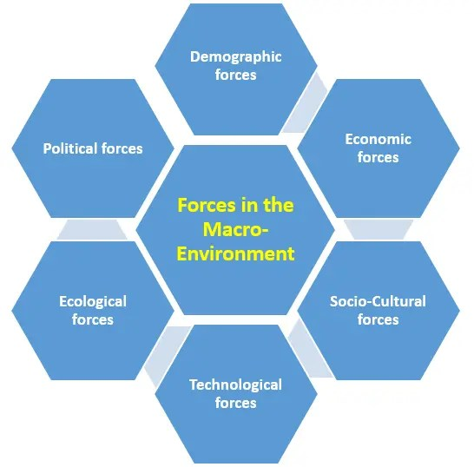

Economical Factors
Unfavourable
United Kingdom- The demand for luxury goods like Louis Vuitton items may be greatly impacted by the UK's general economic health, which includes elements like GDP growth, unemployment rates, inflation, and consumer expenditure. A robust economy may boost consumer confidence and give them more purchasing power, while a weaker one would make them spend less money on things that are not necessities. The current state of affairs in the UK is chaotic as a result of the skyrocketing inflation rates, rising cost of living, and energy crises and the Brexit backlash which has made it challenging for society to adapt to such pressing problems, affecting the average citizen's day-to-day existence (Rabaiotti, 2023). The United Kingdom has experienced 6 prime ministers within the last 5 years which is damming to security and adds to the political stability and uncertainty of the country’s economic future. Making it unfavourable for business for Louis Vuitton organisation at this point in time (Clark, 2023).
Favourable
UAE United Arab Emirates Economic variables have a considerable influence on Louis Vuitton (LV) in the UAE, affecting both customer demand and the company's corporate operations. The control of oil exports and Oil Prices has allowed the UAE to become a significant oil exporter around the globe, the UAE's economy and consumer spending habits may be impacted by changes in oil prices, which might have an influence on LV's sales. However, due to the revenues which has propelled the continent into a main player, it is likely to excel in the near future with new world innovations. The country's economic diversification is led by the emirate of Dubai, whose economy is based more on business than on oil and acts as a regional commercial and financial powerhouse (Crystal & Patterson , 2023).
The UAE is a well-liked vacation spot that draws wealthy tourists. Tourism is important to LV's business because it attracts foreigners, who are frequently important consumers of luxury goods. According to (BTI Transformation index , 2023) The continuation of economic growth, which makes progress observable to everybody, supports the legitimacy of the administration. The 2020 Arab Youth Survey shows that the UAE continues to be a top choice for young people from other Arab nations looking for employment and a place to live. The government also prioritises advancing innovation and best practises and is not averse to adopting fresh concepts to spur advancement. Which is positive for Louis Vuitton brand and revenue.
Political Factors
Unfavourable
United Kingdom- The corporate climate and consumer behaviour can be impacted by political stability and governmental policy. Louis Vuitton's activities and sales in the UK may be impacted by changes in taxation, trade agreements, and luxury goods legislation. A referendum, Brexit, the corona virus, lock down scandals, party gate, bad tax policies, and the war in Ukraine have all contributed to the UK’s political stability being in disarray and having five prime ministers in six years, which is a sign of incompetence has all contributed to the political factors and stability of the U.K being unfavourable to louis Vuitton as an organisation.
Favourable
United Arab Emirates-The UAE will remain politically stable from 2023 to 2027, and Sheikh Mohammed bin Zayed al-Nahyan, who assumed the presidency in May 2022, will keep the country's policies steady as president. Early in 2023, he appointed his son to be the crown prince of Abu Dhabi, solidifying his position. Commercial goals, security worries about Iran and Islamist militancy, as well as a diminished US presence in the area, will all influence foreign policy (Economist intellegence unit, 2023). In an effort to foster more tolerance, a significant revision of the nation's Islamic personal rules was also announced in November 2020, resulting in a wider range of personal liberties. The Abraham Accords, which aimed to normalise ties with Israel, were signed, which is another important milestone. Following that, the UAE said that the nation's first synagogue will debut in 2022 (BTI Transformation index , 2023). Overall making the region favourable for Louis Vuitton to conduct business.
Technological factors
Favourable
United Kingdom- The landscape of retail, especially the luxury market, has changed as a result of the expansion of e-commerce. To appeal to the UK's tech-savvy consumers, LV must adjust to the shifting buying preferences of customers by providing a flawless online shopping experience, secure payment choices, and effective delivery services. To reach its intended demographic in the UK, LV must have a prominent and active presence on websites like Instagram, Facebook, and YouTube. Advanced data analytics enable LV to gather insights into consumer preferences and behaviour, allowing the brand to personalize its offerings, marketing messages, and customer service to better meet the individual needs of UK customers (Rascouet, 2021). In order to ensure prompt delivery to LV shops and consumers across the UK, advanced logistics and supply chain solutions may expedite inventory management, enhance order fulfilment, and optimise distribution networks. (Koerich, et al., 2019)
Favourable
UAE United Arab Emirates- In the United Arab Emirates (UAE), technological variables have a significant influence on the business environment and customer behaviour. This includes how luxury businesses like Louis Vuitton (LV) are affected.
A significant telecommunications provider in the nation is the state-owned Emirates Telecommunications Corporation, often known as Etisalat (Ittilt). There is widespread and widespread use of radio, television, telephone, and cellular telephone service. When Etisalat started offering Internet access in 2000, the emirates quickly surpassed other Middle Eastern nations in terms of the number of subscribers per capita. Emirates Integrated Telecommunications Company (du), a second licenced provider, started offering phone and internet services at high speeds in 2005. In 2006, they came to an arrangement with Etisalat to join their systems (Crystal & Patterson , 2023).Digitalization and online shopping in the UAE have allowed online shopping to become more and more popular among customers in the United Arab Emirates. To cater for the tech-savvy UAE consumers,
Ecological factors
Favourable
United Kingdom- Customers are becoming more environmentally conscious, and luxury companies like LV are being pushed to use eco-friendly procedures. Making use of sustainable materials and green technology can increase the brand's appeal to UK customers who care about the environment. LV are in support of the circular economy concept, in which goods are created to be more robust, repairable, and recyclable, by using sustainable practises. This strategy supports the UK's initiatives to cut waste and encourage sustainable consumption. For many UK customers, especially those who buy luxury items, sustainable practises have become an expectation. Meeting these standards will help LV stay current and appealing. (Louis vuitton , 2023)
UAE United Arab Emirates
Favourable
The UAE generally makes effective use of its organisational, financial, and human resources. Its initiatives are intended to continuously enhance public administration and government services. To track and evaluate government performance in relation to the objectives outlined in Vision 2021, a government performance management system has been put in place. To progressively reduce the country's reliance on a huge number of foreign labourers, a lot of focus is also placed on improving the educational and practical abilities of UAE citizens. A new 10-year golden residence programme for those with unique abilities, such as those in technology, biotechnology, or artificial intelligence, was announced in 2020. In terms of public sector performance, the UAE is ranked fourth overall in the 2019 World Competitiveness Index reducing carbon footprints (BTI Transformation index , 2023). The rate of groundwater usage in the United Arab Emirates is 20 times greater than its capacity for replenishment.
The National Climate Change Plan 2017–2050 provides a thorough framework for addressing climate change's issues. The management of greenhouse gas emissions, the expansion of environmental governance, and the establishment of obligatory and optional objectives for mitigation and adaptation are the main concerns. The UAE administration recognises that there are "immense" environmental difficulties facing the nation, with its high carbon footprint, trash production, air pollution, and problems with land degradation and desertification being some of the most pressing. The UAE aspires to "become a global hub and a successful model of the new green economy, to enhance the country's competitiveness and sustainability, and to preserve its environment for future generations," according to the official government policy (BTI Transformation index , 2023).
Demographic factors
Favourable
United Kingdom- In the UK, net migration accounted for the majority of population change between 1999 and 2011. Nevertheless, during the last 20 years, births have outnumbered deaths, and since 2002, there has been a noticeable rise in the number of births, with 2012 seeing the greatest number since 1972. Both the immigration of women who are now in reproductive age and the increased fertility among women who were born in the UK have contributed to the rise in the number of births. The population of the UK has increased by 7.8 million people (13.8%) since 1980. Due to an increase in birth-rate and an increase in net inward migration following the EU expansion in 2004, around half of this rise has taken place since 2005 (Office of National Statistics , 2015).
United Arab Emirates
Favourable
Although Al-Ain, an oasis hamlet in the interior of the country, has developed into a significant population hub as well, the United Arab Emirates' population is predominantly concentrated in cities along both of its beaches. The federation's infant mortality rate has significantly fallen, and its birth rate is one of the lowest among the Persian Gulf republics. More than two-thirds of the population is male and almost three-fourths of the population is under the age of 45 as a result of the significant number of foreign employees. The country has a far lower death rate than the global norm, and people here live roughly 79 years on average. Cardiovascular disease, poisonings and accidents, and cancer are the leading killers. (Crystal & Patterson , 2023)Due to its tiny population and centralised decision-making, the UAE is able to provide cohesive policies that eliminate competing goals before delivery.
Additionally, there is a focus on ensuring that government departments and agencies operate within the framework of those plans. Annual government retreats and frequent review processes are conducted to evaluate the efficacy of policy initiatives in order to increase coherence (BTI Transformation index , 2023).

Social factors
United Kingdom- Consumer preferences for premium goods and fashion trends can have an influence on Louis Vuitton's market positioning and performance. The UK has a thriving fashion industry, and consumer tastes may shift quickly. As a premium brand, Louis Vuitton must keep conscious of current fashion trends in order to make sure that its merchandise reflects the changing preferences of its target market. Luxury items frequently have symbolic meaning, signifying social standing, money, and achievement.
According to (embapro.com, 2023)In the United Kingdom, gender roles are changing. In order to accommodate and support the changing gender roles in British culture, Louis Vuitton can test a variety of ideas. Owning designer goods like Louis Vuitton bags or accessories can be viewed as a sign of class and refinement in the UK. In addition, the aspects of British weather need to be acknowledged when marketing apparel within the UK as it is known to be unpredictable and could be factor to low sales of certain products with fragile fabrics. Similarly, Customers in the UK are more likely to favour experimental items than standard value propositions in the Consumer Cyclical sector. In order to create goods that offer a better client experience, Louis Vuitton may take advantage of this trend.. (MOMIN, 2023).
United Arab Emirates- The United Arab Emirates' cultural practises have their origins in Islam and are popular across the Arab world, particularly in the Persian Gulf neighbours. The Islamic revival has had an influence on the federation, even though Islam is typically practised less strictly in the emirates than it is in Saudi Arabia. Despite urbanisation and the existence of a sizable expatriate community, tribal identities in the United Arab Emirates are still quite strong, and the family is still seen as the primary and most cohesive social unit (Crystal & Patterson , 2023).
HOFSTEDE CULTURAL DIMENSIONS
Sociologists can clarify how culture affects the beliefs of its inhabitants and how these principles connect to the behaviour of those who live inside a culture using Hofstede's cultural values or dimensions (Nickerson, 2023). Hofstede is one of the major figures in intercultural research and studies thanks to his extensive and varied academic and cultural activities across many nations. His theoretical concepts and research findings are applied globally in management and psychological disciplines (www.hofstede-insights.com, 2023).
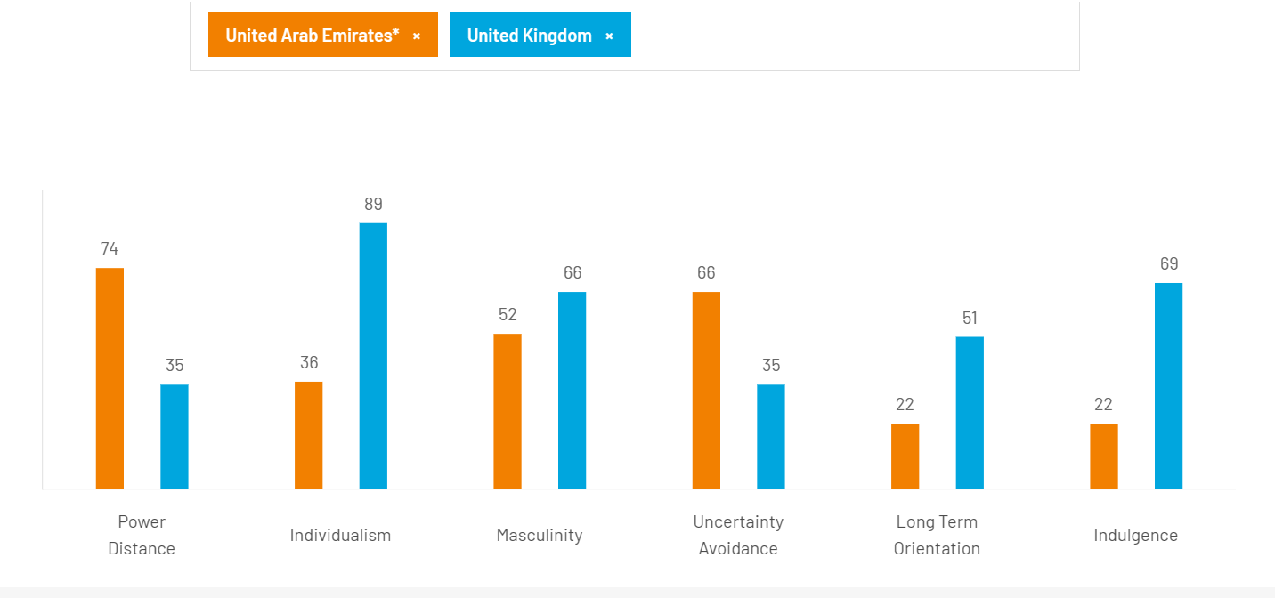
(www.hofstede-insights.com, 2023)

United Arab Emirates Power Distance 74
This component addresses the notion that not all people in civilizations are created equivalent, this also expresses how the culture views these distinctions between people. The degree to which the less powerful members of organisations and associations within a nation believe and consent that power is allocated unequally is known as "power distance."
The United Arab Emirates does well on this dimension (score of 74), indicating that people there are receptive to a hierarchical structure in which everyone has a position and is justified by its existence alone. The ideal boss is a harmless tyrant, centralization is common, employees expect to be told what to do, and authority in an organisation is regarded as reflecting underlying inequities (www.hofstede-insights.com, 2023).
United Kingdom Power Distance 35
At 35, Britain is seen to be a culture where inequities between individuals ought to be kept to a minimum. It's significant to note that analysis indicates that those in the upper socioeconomic strata in Britain have a lower PD index than the lower classes. The crucial role of birth rank on the other side and the ingrained belief that the place where you originate shouldn't limit how far you can go in life on the contrary, are two tensions that the PDI score exposes. The PDI score initially appears inconsistent with the well-established and historical British class system. The idea that people should be regarded as equals in some way is motivated by a sense of fair play.
United Arab Emirates Individualism 36
The degree of interconnectedness a society maintains among its members is the key problem this dimension attempts to solve. Whether or not individuals describe themselves in terms of "I" or "We" is relevant. People in individualised communities are expected to take care of themselves and their immediate family. People in collective societies are members of groups" that look out for each other in return for allegiance.
With a score of 36, the United Arab Emirates is categorised as a collectivist country. This is demonstrated by a strong, ongoing dedication to the member "group," which might be a household, an extended circle of relatives, or a network of close friends. In a collectivist culture, loyalty is of the utmost importance and supersedes the majority of other social norms. In the society, everyone accepts accountability for their fellow group members, fostering deep bonds. Offence results in humiliation and loss of dignity in collectivist societies, employer-employee interactions are seen morally (like a family bond), recruitment and advancement choices take the employee's in-group into consideration, and management is the administration of groups (www.hofstede-insights.com, 2023).
United Kingdom Individualism 89
Only some of the commonwealth nations it gave birth to, such as Australia and the USA, score higher than the UK's 89 on the Individualist scale. The British are a rather solitary and individualistic nation. From an early age, children are encouraged to think independently, discover their own unique life's mission, and discover how their individuality may benefit society. Personal fulfilment is the path to happiness. The emergence of what has been perceived as unrestrained materialism and a strengthening of the "ME" culture has received a lot of attention as Britain's prosperity has expanded over the past ten years, "spreading North," as well.
United Arab Emirates Masculinity 52
The Arab Emirates have a median score on this dimension of 52.A high score (Masculine) on this dimension denotes a society that is motivated by competition, accomplishment, and success, with success being defined by the winner / best in field - a value system that begins in school and lasts throughout organisational life. If the dimension has a low score (Feminine), then quality of life and compassion for others are the dominating social ideals. Living a high-quality life is a sign of success in a feminine culture, and standing out from the crowd is not admired. The core problem here is whether people are motivated by a desire to excel (masculine) or a love of what they do (feminine) (www.hofstede-insights.com, 2023).
United Kingdom Masculinity 66
Britain is a Masculine society at 66, one that places a strong emphasis on accomplishment. The apparent conflict between the British culture of humility and understatement, which is at variance with the society's underpinning success-driven value structure, is a major source of bewilderment for foreigners. The ability to ''read between the lines'' is essential for comprehending the British. Not usually what is stated is what is meant. folks in the UK live to work and have a strong performance aim as opposed to folks in Feminine cultures like Scandinavia.
United Arab Emirates uncertainty avoidance 66
The component of uncertainty avoidance is concerned with how a society responds to the reality that the future is always uncertain: should we strive to influence it or should we just let it happen? This uncertainty causes worry, and other civilizations have discovered various strategies to cope with this uneasiness. The score for uncertainty avoidance reflects how much a culture's citizens feel threatened by ambiguous or unknowable events and how much they have developed structures and beliefs to attempt to avoid them.
Arab Emirates has a strong desire for avoiding inconsistencies with a score of 66 on this dimension. High Uncertainty Avoidance nations uphold strict moral and behavioural standards and are intolerant to unconventional behaviour and ideas. Time is money, people have an inner need to be busy and work hard, accuracy and punctuality are the standard, innovation may be discouraged, and security is a key component in motivating individuals in these cultures, despite the fact that the rules seldom appear to work (www.hofstede-insights.com, 2023).
United Kingdom uncertainty avoidance 35
At 35 the UK has a low score on Uncertainty Avoidance which means that as a nation they are quite happy to wake up not knowing what the day brings and they are happy to ‘make it up as they go along’ changing plans as new information comes to light. As a low UAI country the British are comfortable in ambiguous situations – the term ‘muddling through’ is a very British way of expressing this. There are generally not too many rules in British society, but those that are there are adhered to (the most famous of which of of course the British love of queuing which has also to do with the values of fair play).
United Arab Emirates long term orientation 22
This dimension shows how, despite coping with the problems of the present and the future, every civilization must keep some linkages to its own history. However, cultures prioritise these two existential aspirations differently. Normative cultures, which rank poorly on this metric, favour upholding time-honoured customs and conventions while being wary of societal change. On the other hand, high-scoring cultures adopt a more practical approach: they promote thrift and efforts in contemporary education as a means of future preparation.
The Emeriti society's low score of 22 on this category reveals how normative it is. People in these civilizations are normative in their thinking and strongly concerned with discovering the unchanging Truth. They show a high regard for traditions, a low inclination to invest for the future, and a concentration on getting things done quickly (www.hofstede-insights.com, 2023).
United Kingdom long term orientation 51
It is impossible to identify a prevailing preference in British culture with an intermediate score of 51 on this category.
United Arab Emirates Indulgence 22
With a low score of 22 on this dimension, the United Arab Emirates may be categorised as a Restrained society. Restrained civilizations, in contrast to indulgent societies, place less value on leisure time and restrict the satisfaction of their wishes. People with this perspective feel that enjoying themselves is partly bad and that their activities are constrained by societal standards.
United Kingdom Indulgence 69
With a score of 69, the British culture is rated as Indulgent, which is a high score. People who live in communities with high Indulgence scores typically show a readiness to follow their impulses and inclinations when it comes to having fun and enjoying life. They have a cheerful disposition and a propensity towards optimism. Additionally, they prioritise leisure time more highly, behave whatever they like, and spend money anyway they want (www.hofstede-insights.com, 2023).

Critical analysis of the Hofstede model
Geert Hofstede, a social psychologist from the Netherlands, is the author of the theory of cultural dimensions. The study of cross-cultural communication, which examines how individuals from various social and cultural groups interact with one another and how they trade cultural values based on an individual's behaviour, is related to cultural dimensions (Study.com, 2023).
The advantages
- Understanding various civilizations, cultures, and variety is aided by this model.
- Through removing any cultural barriers, the concept aids in corporate growth on a global scale.
- It motivates individuals to collaborate and go worldwide in order to stabilise the organisation.
The disadvantages
- Various experts disagree with the hypothesis despite it being a successful model since it ignores communities and their ethics.
- The theory is frequently out of date since it lacks information on many social cultures due to its emphasis on the power distance index, masculinity, individualism, short-term vs. long-term orientation, and uncertainty avoidance.
- Due to social and cultural conflicts, a different set of cultural behaviour may be detrimental to an organisation and have an impact on the manager's decision-making.

Similarities and differences between the countries and Favourable or unfavourable factors in Louis Vuitton’s macro environment
There are a few parallels between the UK and the UAE Political stability in the UK has been questioned in light of the country's numerous changes in prime leaders and the uncertainty surrounding Brexit. Even if the governmental system in the UAE is more stable, geopolitical events can still have an effect on the economic climate. the luxury Market Potential within the UK and the UAE both have sizable luxury markets with affluent customers who appreciate Louis Vuitton and other high-end brands. Despite being affected by the economy, demand for luxury goods is still high in both nations.
the distinction from both countries is the UK is now experiencing economic difficulties, such as rapidly rising inflation rates, growing living costs, and energy shortages, which may have a detrimental effect on consumer confidence and spending on luxury products and other non-essential commodities. The UAE, on the other hand, has the potential for continuing development and resilience in the luxury market because to its oil export income and economic diversification initiatives. The UAE has actively worked to diversify its economy away from dependence on oil, with Dubai serving as a regional hub for commerce and finance. For luxury companies like Louis Vuitton, this economic diversity may help create a more stable and supportive corporate climate. Compared to the UK, the business climate for Louis Vuitton seems to be better in the UAE. Consumer spending on discretionary products may be impacted, which might have an impact on LV's UK revenues within the uk due to all the factors causing political uncertainty.

PORTER 5 FORCES MODEL
Porter's Five Forces is a strategic framework used to analyse the competitive forces within an industry and assess an organization's competitive position. Here's an analysis of Louis Vuitton (LV) using Porter's Five Forces (KHARTIT, 2021)
Threat of New Entrants-Low
United Arab Emirates
- Luxury fashion industry barriers to entry are high due to significant brand reputation and customer loyalty.
- High initial capital investments are required to establish a luxury brand and distribution network.
- Established luxury brands like LV have economies of scale, making it difficult for new entrants to compete effectively within the region.
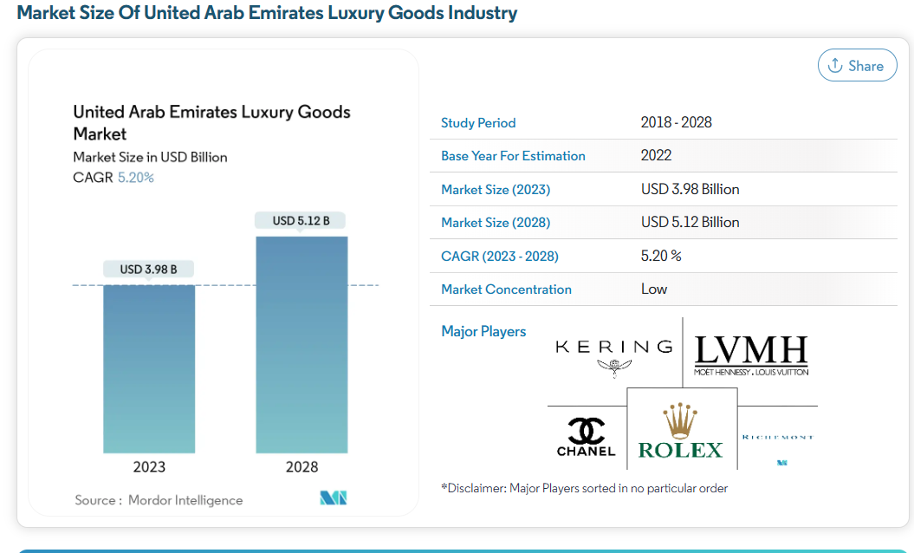 (Mordor Intellegence , 2021)
As the United Arab Emirates has the greatest number of internet users who engage in online commerce, major businesses are now concentrating on social media platforms and online distribution channels for online marketing and branding of their products. At a CAGR of 5.20% over the forecast period (2023-2028), the United Arab Emirates luxury goods market is anticipated to develop from USD 3.98 billion in 2023 to USD 5.12 billion by 2028 (Mordor Intellegence , 2021).Meaning there is more revenue growth for the company.
United Kingdom
Threat of New Entrants-Low
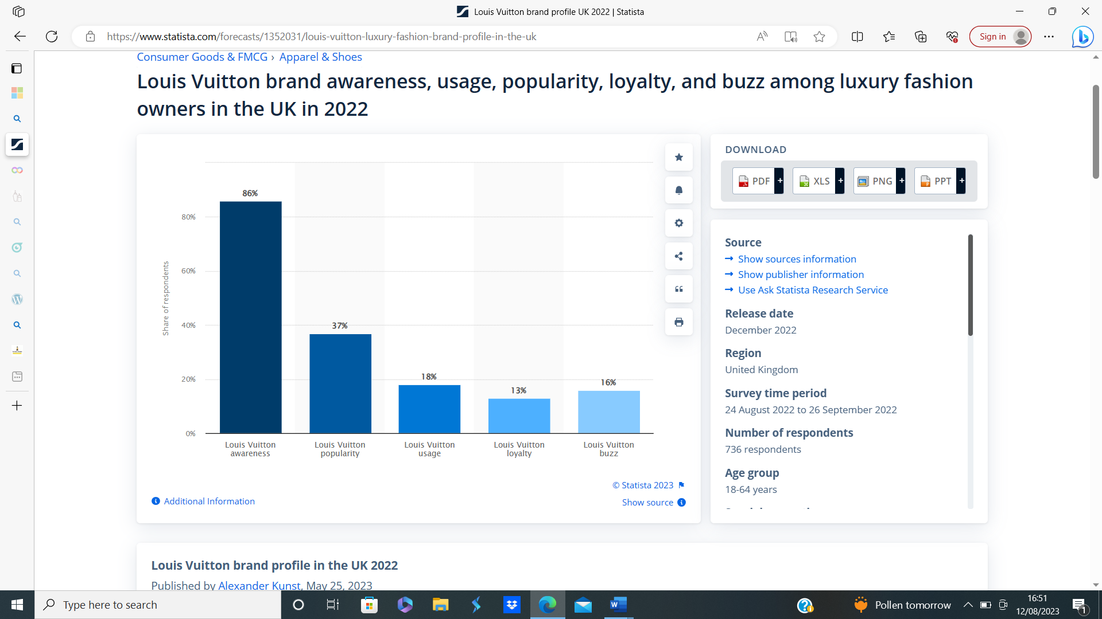

(Kunst, 2023)
According to (Kunst, 2023) in the UK, 86% of luxury fashion consumers are aware of the Louis Vuitton brand. The notion of assisted brand identification was used to conduct the poll, displaying respondents both the business's written name and emblem. In the UK, 13% of those who purchase high-end clothing said they want to use Louis Vuitton again. When compared to the brand's 18% use share, this indicates that 72% of their owners are brand loyal. Their owners are brand loyal to the tune of 72% helping the notion of dominance within brand awareness and the of another notion of an alternative brand entering the market share which is low.
United Arab Emirates, Buyers' Bargaining Power- Medium to High
Despite being affected by the COVID-19 epidemic and the ensuing economic recession, the UAE economy continues to perform effectively across a range of quantitative metrics. At the year's conclusion of 2019, the GDP of the nation was $412.14 billion, showing a meagre 0.2% increase. Due to the coronavirus and the sharp drop in oil prices in the first half of 2020, a contradiction of 6.3% is anticipated in 2020. As a consequence, other metrics have also been influenced, such as governmental debt growth and declines in FDI and GDP per capital. The UAE experienced deflation at rates of 1.9% and -2.2%, respectively, in 2019 and 2020. The entire state of the economy, including price stability and low debt, is positive at the exact same time. stages and current checking accounts balances have stayed steady giving citizens more spending power for luxurious items, at a level of medium to high (BTI Transformation index , 2023).
- Customers of LV, particularly high-end buyers, have a lot of purchasing power because there are other luxury brands to choose from.
- If LV's goods or services fall short of customers' expectations, they may easily move to rival luxury brands.
- However, some purchasers who cherish the brand status may find their negotiating power limited by LV's strong brand image and exclusivity.

United Kingdom Buyers' Bargaining Power- medium
The consumer market for luxurious products in the UK is anticipated to grow at a CAGR of 4.35% from 2022 to 2027. Increased disposable income, internet accessibility, and modern, evolving lifestyles are all having a beneficial impact on how much money people are spending in the market. The British luxury consumer has a significant tendency towards impulsive purchases, which is more pronounced among women and older consumers. The demand for luxury fashion goods including clothing, purses, and shoes is increased by the millennial demographic's considerably more trend-driven rather than routine-oriented. Due to the widely recognised leather production sector, which enables British designers to create high-end bags, clothing, and footwear using premium materials, the market for leather products is anticipated to have substantial development in the long run. (www.mordorintelligence.com, 2023). However, looking at the political downfall and economic hardship scenario reported this prediction may be dated due to such an evolving period of time and uncertainty or tilted towards consumers with financial stability.
.
United Arab Emirates Supplier Negotiating Power- low.
The few suppliers who can fulfil the high requirements of the brand may provide LV's suppliers significant negotiating leverage. However, LV has bargaining leverage over suppliers thanks to their large order volume and solid brand recognition. The dependence on a single source is often reduced in the luxury apparel sector because there are typically several prospective suppliers which can offer the service. All of Louis Vuitton's items are produced by hand in their more than 17 facilities. Alongside such exclusivity arise a variety of logistics. Given the complexity of its supply chain management, Louis Vuitton has been awarded the ISO 14001 accreditation for Environmental Management Systems with a focus on Supply Chain (LVMH, 2016). The workers' supply chain serves as the company's nerve centre, and from the time they buy raw materials until the time they deliver products to retailers, they are focused solely on one goal: keeping consumers happy. According to 2016's Alain Doudard (Essay source , 2021).
United Kingdom Supplier Negotiating Power- low.
Instead of manufacturing its goods, Louis Vuitton outsources them. The majority of the items are imported from countries like Vietnam, Spain, China, and Italy. Since there aren't many companies in the high-end fashion sector that need premium materials like leather, wool, etc., there is a significant concentration of these suppliers, giving Louis Vuitton and its competitor more negotiating leverage. Additionally, to compete in this market, a substantial capital commitment and considerable market knowledge are necessary, which limits the supplier's potential to advance with integration. Due to the limited number of participants (brands) in the luxury fashion market and the widespread availability of current providers of the goods, which diminishes their influence (i.e., suppliers serve only a small number of businesses), switching costs for suppliers are also considerable.
United Arab Emirates Threat of Substitutes- low.
There is a minor threat of replacements for Louis Vuitton. There are less expensive alternatives, but their quality is worse, which sets Louis Vuitton apart from them. Customers have a high switching cost because the value of the brand increases the psychological and financial cost of switching. To combat the danger of alternatives, Louis Vuitton concentrates on offering excellent quality and "high value for money" items. Elite clients who tend to be brand loyalists and do not switch brands frequently offer less of a danger to the business. Louis Vuitton responds to such risks of replacements by differentiating its product offerings and focusing on improved client experience through "attention to detail" and "product of distinguished quality." (www.mbaskool.com, 2023)
- Substitutes in the luxury fashion industry may come from other luxury brands or high-end products from different categories.
- While LV's brand loyalty provides some protection against direct substitutes, luxury consumers can choose from a range of other prestigious brands.
United Kingdom Threat of Substitutes- low.
Inside the UK False goods are still a significant hazard since they can be found on the market for less money, and LV has a difficult time dealing with these dangers. The potential of dilution of brand value has been the company's main concern internationally as the quality of counterfeit goods has increased (www.mbaskool.com, 2023). Although the threat of louis Vuitton substitutes is low.
United Arab Emirates Rivalry between competitors- high
- There is fierce competition among many well-known companies for market share and consumer attention in the luxury apparel sector.
- Gucci, Chanel, Prada, and Hermes are a few competitors that offer serious threats to LV's market leadership.
- For LV to keep its competitive advantage in the luxury market, ongoing innovation and distinction are essential.
The luxury goods market in the UAE is extremely competitive, with both native and foreign businesses present. However, the market is dominated by the major international businesses, such as Rolex SA and LVMH Mot Hennessy Louis (Mordor Intellegence , 2021)
.
United Kingdom Rivalry between competitors-high
Although Louis Vuitton, Gucci, and Hermès compete in the upscale fashion market, each company has a distinct character and set of advantages. Gucci is well-known for its cutting-edge designs and distinctive brand identity, Hermès is renowned for its emphasis on traditional craftsmanship and quality, and Louis Vuitton is well-known for its signature colophon bags and leather products.
Despite the competition, Louis Vuitton is still a significant force in the high-end fashion market. The company continues to innovate and adapt to shifting fashion trends and has a solid reputation for quality and artistry. Additionally, Louis Vuitton has been effective in building a religious customer base with its famous colophon and corporate identity (Rageendrathas, 2023).
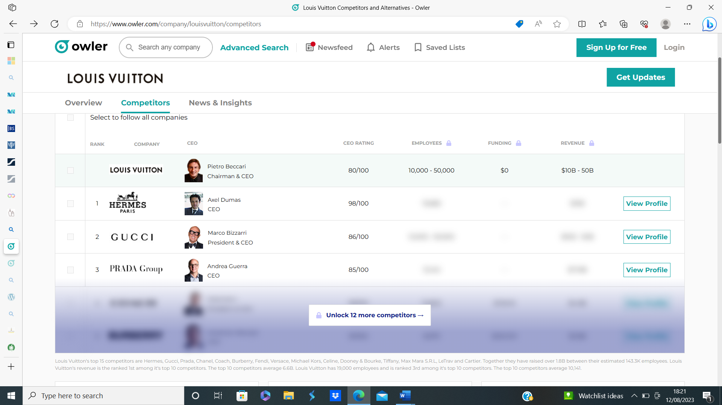
(www.owler.com, 2023)
As a result, Louis Vuitton competes in a high barrier to entry, fiercely devoted customer base, and highly competitive premium fashion market. Even while the brand's reputation and client base are benefits, it still needs to continually concentrate on innovation, exclusivity, and retaining consumer loyalty to stay ahead in the fiercely competitive luxury industry.
Similarities and differences between the countries factors in Louis Vuitton’s market share
Both the UK and UAE offer favourable conditions for Louis Vuitton, driven by the brand's reputation and customer loyalty. However, the UK showcases strong brand awareness and loyalty, posing challenges for new entrants. In contrast, the UAE highlights the brand's adaptability to affluent consumers and a growing luxury market. Buyer bargaining power differs, with the UK influenced by disposable income growth and the UAE maintaining medium to high power due to economic stability.
Supplier negotiation power is generally low in both markets, with Louis Vuitton's strong brand recognition and supply chain management as leverage. Substitutes pose a low threat, though counterfeit goods challenge the UK market. Rivalry among competitors is high in both regions, demanding ongoing innovation.
In essence, both markets favour Louis Vuitton, yet varying buyer power and competitive landscapes necessitate tailored strategies for sustained success. Hermes and Gucci are among the major fashion juggernauts with Louis Vuitton. They pose a serious challenge to Louis Vuitton and, with their cutting-edge designs and unwavering commitment to client pleasure, they may make this particular market much more difficult. In order to meet clients' demands and encourage repeat business, Louis Vuitton must not only rely just on its signature designs. In order to keep their market share, they also need to understand the mindset of their clients.

SWOT ANALYSIS
Strengths  United Kingdom- For its classic yet cutting-edge designs and powerful branding, Louis Vuitton distinguishes out. Further development is encouraged by this strong identity. Additionally, the business collaborates with other premium brands to provide clients more options.  United Arab Emirates-The UAE's luxury market has been developing as a result of the nation's robust economic development, increasing wealth, and expanding middle class. | Weaknesses  United Kingdom-A weakness caused is the prices are greater than those of other premium brands, some buyers might not buy. Additionally, there is a meagre worldwide footprint and no chain outlets in South America or India. Understanding the variety inside the UK might be harmful because many citizens or customers leave this area because to ignorance of other cultures, penetration of those cultures, and foreign IMC.  United Arab Emirates- A weakness is stemming from laws and regulations within the region. All western countries participate in the inclusion of all genders and LGBTQ community even integrating this in their products however this will not be acceptable with the UAE being a weakness for equality on the company’s behalf.  Due tits political differences
Opportunity’s  United Kingdom – If Consumer appetites for luxury products can increase when the economy recovers. Louis Vuitton might add new product categories or add marketing awareness into these areas.  United Arab Emirates With a strengthening economy, demand for luxury products have increased. Louis Vuitton can launch new product lines and enter new developing areas. And develop more branches and brand awareness within the region. | Threats  United Kingdom. The brand may suffer from counterfeiting organisations and imitations. Additionally, reliance on governments and law enforcement is a multinational operation involving many institutions which in fact may result in expensive legal issues. Furthermore, a small impact into stopping the crime in especially in the UK, where it is common for fakes to be sold publicly at jumble sales and car boot/ market areas.  United Arab Emirates fakes and counterfeit products may harm the brand. Additionally, pressure from foreign countries in some nations may result in pricey legal issues.

Similarities and differences between the country’s factors in Louis Vuitton’s SWOT analysis
Both the UK and the UAE share the common threat of counterfeit products affecting Louis Vuitton's brand reputation. The challenge of enforcing laws across various jurisdictions could lead to legal complications in both markets. In terms of advantages, the UK gains from Louis Vuitton's renowned designs and powerful branding, while the UAE takes use of its developing luxury market as a result of its prosperous economy and growing middle class. While the UAE concerns possible conflicts between the brand's principles and local rules, the UK struggles with higher costs and a smaller worldwide footprint. Opportunities-wise, both markets have room to grow. the UK is looking at new product categories, while the UAE is focusing on developing nations and raising brand recognition (www.swotandpestle.com, 2023).

SEGMENTATION TARGETING AND POSTIONING (STP METHOD)
Segmentation
Market segmentation involves dividing a market into parts that reflect different outcomes and wants (Hooley, et al., 2012).
Louis Vuitton's primary focus is on individuals aged 18 to 54, primarily women, with substantial annual incomes exceeding $75,000. This demographic segmentation highlights a significant level of discretionary spending capacity. The brand also serves a wide age range of 16 to 80, encompassing affluent men and women with substantial disposable incomes, including businessmen and businesswomen however this approach would be considered as cultural differences between the UK and UAE resulting in a hard push in UK and soft push in the UAE considering the laws on women in the region to propel its growth strategy.
Louis Vuitton uses psychographic segmentation that considers factors like lifestyle and motivations. Citizens must demonstrate their social status and wealth in countries like China and the UAE. These customers are lured to Louis Vuitton because of its status. Fashionistas and trend-setters make up the following subgroup. The final strategy employed by Louis Vuitton is lifestyle segmentation. The new catchphrase for leading an opulent lifestyle was "The Art of Travelling". Owning a Louis Vuitton item enables you to participate in the art of travel.
Louis Vuitton also categorizes its customers according to their usage patterns, giving particular focus to frequent users. During the point of purchase, customer information is collected and archived in a database. To encourage continued sales and cultivate brand loyalty, frequent users are granted access to seasonal catalogues and exclusive opportunities to acquire distinct product collections (www.edrawmind.com, 2023).
Targeting
The initial segment of Louis Vuitton's target audience comprises affluent middle-aged women aged 35 to 54, while the second segment includes trendy young women aged 18 to 34 who have accumulated sufficient savings for a desired purchase. The typical Louis Vuitton customer belongs to a higher social stratum, prioritizes fashion, and seeks social recognition. Owning Louis Vuitton products bestows significant social status. The brand places paramount importance on the quality of materials, intricate designs, and meticulous craftsmanship of its offerings, leading to a gradual increase in the product's pricing. Louis Vuitton employs a premium pricing strategy to set its product prices, given the brand's focus on an elite and upper-middle-class clientele (www.edrawmind.com, 2023).Overall, Making their targeting strategy differentiated (chernev, 2012).

Positioning
Louis Vuitton (LV) establishes its product positioning around the realm of fashion and the latest trends. The brand crafts its products keeping abreast of the most current market trends and contemporary fashion, enabling customers to explore the freshest trend-driven selections and premium products. Louis Vuitton places a significant emphasis on top-notch quality, with a focus on providing enduring satisfaction through prolonged product usage. To ensure customer contentment, Louis Vuitton established the Repair Service Division (www.edrawmind.com, 2023). Hedonists is another aspect of Louis Vuitton's positioning market. Young individuals who enjoy life, travel the world, and spend their nights at bars. They are hedonists, these guys. Hedonists are highly extroverted and like having a good time. They like sticking out and being quite energetic during large gatherings. consuming booze and going to bars however they are socially wealthy and hold influence throughout society these are also influencers and celebrity endorsers (DARBINYAN, 2021).
The heritage and parent company are also huge factors of LVs positioning being a part of the luxury market history for over 127 years to date. Having a remarkable advantage on the phycological mentality of the user or onlookers as prestige adding value to the brands awareness (Louis Vuitton, 2023)

Perceptual map

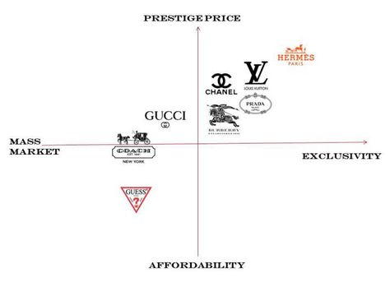
(Goldenberg, 2023)
Similarities and differences in louis Vuitton’s STP model
The renowned global brand Louis Vuitton stands for specialised items made with the highest calibre components, opulent designs, and exceptional workmanship. The style-conscious elite category of people that live a luxurious lifestyle and see Louis Vuitton items as a statement of style that would advance their standing in their social circle is the target demographic. The upper class and wealthy ladies between the ages of 35 and 54 are the major target clients for Louis Vuitton's marketing mix and marketing methods. The exclusive group of young women between the ages of 18 and 34 who don't mind paying extravagant rates for name-brand goods makes up Louis Vuitton's target market regarding travelling is its niche. This is complementary in both countries establishing high prestige to both demographic regions.

MARKETING MIX 7ps
Jerome McCarthy first developed the 4 Ps marketing mix idea in his book "Basic Marketing: A Managerial Approach," which eventually became known as the 7 Ps of marketing. It describes the carefully crafted combination of tactics that a firm use to boost sales and effectively promote its products. These four initial components—Product, Price, Place, and Promotion—were then broadened to include additional factors including People, Packaging, and Process. These are now regarded as the components of the "7 P's" combination (mailchimp.com, 2023).
The marketing mix and approach of Louis Vuitton have been demonstrated to be an effective instrument for promoting opulent luxury goods to the target consumer in the fashion business. Louis Vuitton employs marketing methods to strengthen the brand's reputation, increase its exposure, and create effective and cordial relationships with its clients (Hooley, et al., 2012). The luxury brand's main concerns are how to persuade customers to purchase Louis Vuitton products despite their high prices, guarantee that the distribution network is flawless, keep costs low to boost profits, and increase endorsements from famous people in its marketing plan to stay in the public eye (Bhasin, 2023).
Product Strategy: Marketing Mix of Louis Vuitton
The philosophy of Louis Vuitton is to provide the greatest items. Since the 19th century, all Louis Vuitton product has been made using brown Damiere and Monogram Canvas. All of Louis Vuitton's goods bear the LV letters to make it readily recognisable. The LV Trunk, which is unique in the marketplace and regarded as absolutely iconic, is among the most well-known Louis Vuitton product. Other well-liked items include the Speedy bags, never full bags, and limited-edition bags that are only sold at major Louis Vuitton stores. However, as the demographic is changing trainers as well as men pouches and belts are also now a iconic product to LV understanding that the company uses family branding leaves the consumer with no doubt that all the products are made with the same quality. The product branding strategy revolves around line filling and line extension the way items are seasonally introduced to society and LV does not participate in sales of any type. The items on sell in the UK are exactly identical to products sold in the UAE this due to the corporate umbrella branding which actually benefits the brand and the product designs as the iconic monogram is the highlight.
Belts, designer shoes, leather coats, phone cases, bags, and other leather goods are among the Louis Vuitton products included in this category.
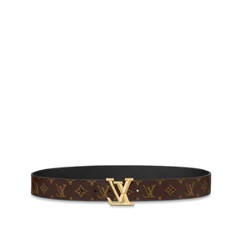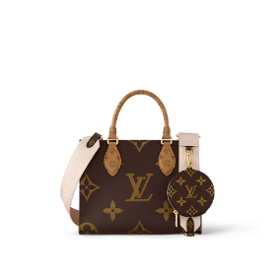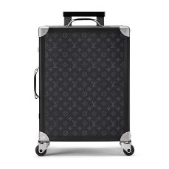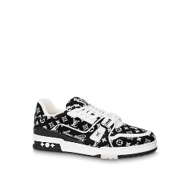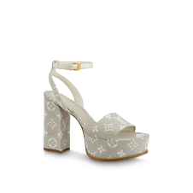


Both men and women may purchase designer shoes, which come in a variety of styles like sneakers, loafers, ballerinas, pumps, platform shoes, boots, sandals, slides and buckled shoes, among other innovations like the 360-speaker developed by LV. 360° Immersive Sound Numerous acoustic advantages are provided by the speaker's unusual form, with various placements permitting either unidirectional sound or an immersive 360°audio experience.


Place Strategy: Marketing Mix of Louis Vuitton
The positioning and distribution plan of Louis Vuitton's marketing mix guarantees the brand's worldwide growth and the dissemination of its product presence. Monogram canvas is used by Louis Vuitton's effective staff to produce premium items of the highest calibre. The premium company Louis Vuitton employs more than 150,000 people to effectively serve its target market and keep a tight rein on its price and product approaches.
The primary objective of Louis Vuitton's location and marketing strategy is on product placement, the distribution channel, and Louis Vuitton boutiques. Distribution strategy, distribution network, and distribution channel are all directly related to one another since without these three, it is impossible to efficiently deliver any Louis Vuitton products to the final consumer. The business's distribution network consists of standalone boutiques, lease department stores located in upscale department stores, Louis Vuitton Stores in prominent places, and the e-commerce section of the business's webpage.
LOUIS VUITTON STORE
As a means of regulating the product's quality and pricing, Louis Vuitton's philosophy is to promote its goods only via its own boutiques. Stores carrying Louis Vuitton can stop the sale of fake goods. The personnel attempt to forge a close connection between the brand and the customers in the company-owned and -operated own stores.
DEPARTMENTAL STORE/ BOUTIQUE
One of the significant luxury companies that seeks to attract clients to its upscale stores is Louis Vuitton. Louis Vuitton sells its items through department shops as part of its marketing plan. The firm also favours renting out prestigious buildings in upscale retail shops.
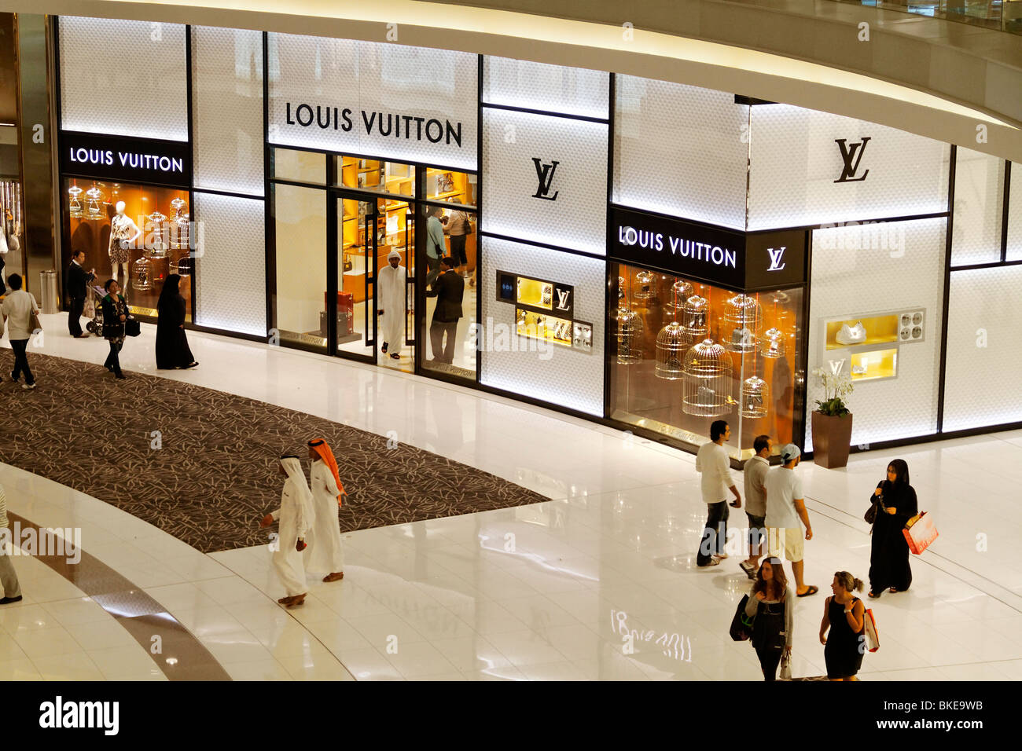
ONLINE STORE
The official website of the organisation, LouisVuitton.com, allows buyers to explore products, acquire in-depth information, and order authentic items. The Market entry methods utilised is only licensing.

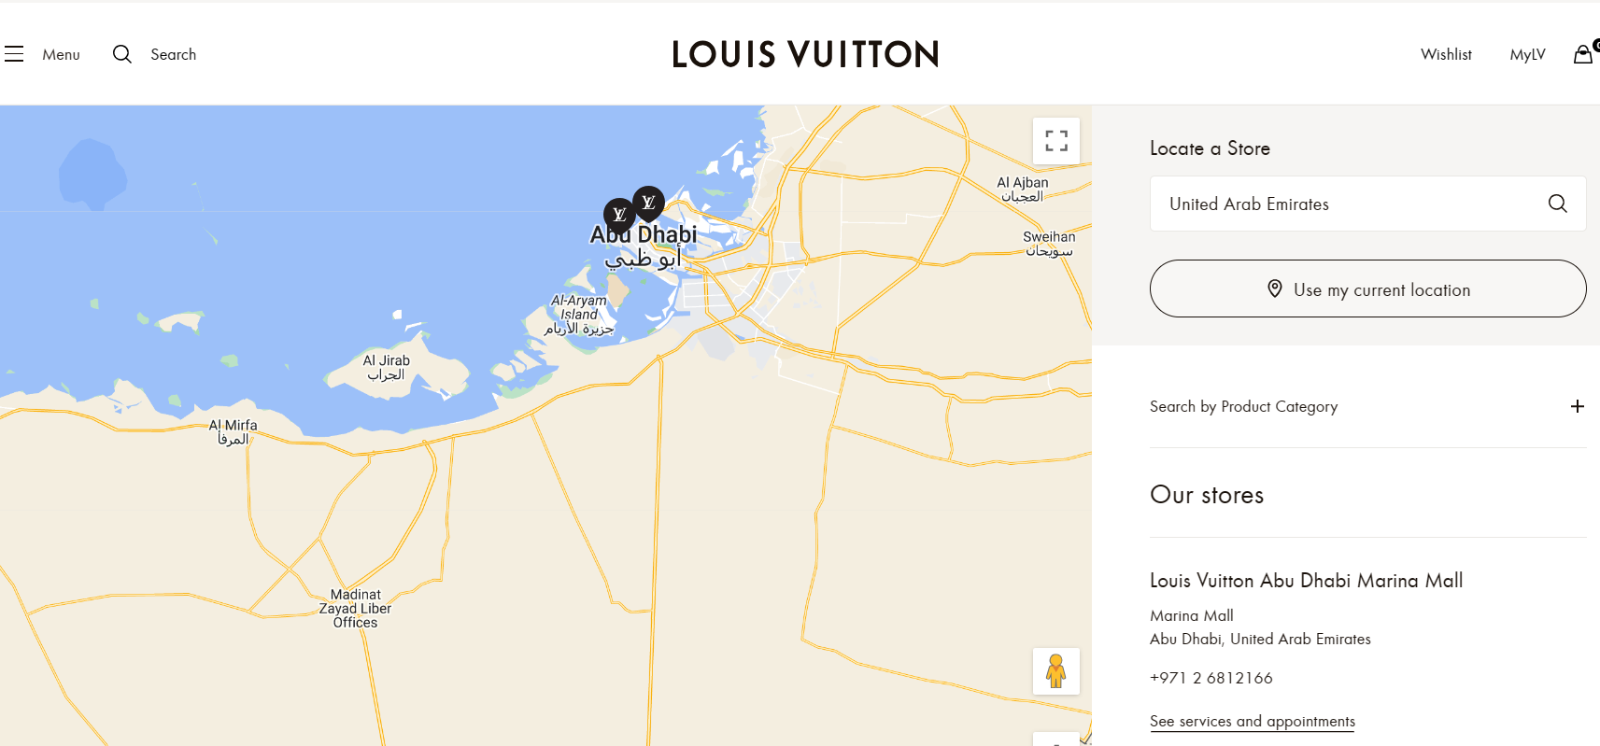

Price strategy: Louis Vuitton Marketing Mix
One of the most expensive luxury brands in the world, Louis Vuitton distributes branded goods to a select set of customers at extravagant costs. It is a well-known brand with a solid position for its products on the market.
Louis Vuitton's marketing mix and strategy make sure that the company's pricing practises are in line with the worth of the goods it sells. Because of the brand's commitment to excellence, the real cost price is high. The company employs an integrity pricing approach to ensure that the exclusivity of its items is preserved without lowering their costs. To sell its products in the market, the corporation has implemented both a premium pricing policy and a value-based pricing strategy.
Premium Pricing Guidelines
Known for producing high-quality goods, Louis Vuitton is a luxury brand. Because its clients are the upper-middle and elite class, who are not concerned with product prices, the marketing approach assures a premium pricing policy for its items.
Price-Based on- economical Value Policy
A value-based pricing approach has been included into Louis Vuitton's marketing plan for certain of the products that are offered on the business website. There are no sales or discounts offered by the brand. This guarantees that the product prices are exactly just on the money.
Phycological pricing
LV are known to use this method of pricing as the brand awareness is extraordinarily high amongst society as the brand has become bigger then the items it sells so in short the product gains more value with logo embedded on it.
Demand and competition and buying power of the target market are all factors which can influence the pricing standards however concerning the United kingdom and United Arab emirates this may already be the case as both countries are financially regarded as wealthy and all three factors mentioned all have an presence within both of the countries.

Market entry methods
Louis Vuitton employs a range of strategies to enter and dominate global markets while upholding its luxury image these Market Entry Strategies involve.
• Flagship Stores- Iconic stores in major fashion capitals provide an immersive luxury shopping experience.
• Franchising and Partnerships- Collaborations with high-end retailers expand reach and presence (louis Vuitton, 2023).
• E-commerce- Online sales through the official website reach a global audience.
These marketing entry methods have helped establish louis Vuitton within the UK and in the UAE both countries have responded positively with LVs operations in the regions.

Promotion strategy: Louis Vuitton Marketing Strategies
Creative challenge
Regulatory challenge
Louis Vuitton employs a comprehensive marketing strategy that encompasses diverse methods to enhance brand visibility and resonate with its target audience. The brand strategically utilizes fashion magazines, billboards, and celebrity endorsements to captivate elite and upper-class individuals. Notably, figures like Angelina Jolie and Kim Kardashian have endorsed Louis Vuitton, contributing to its prominence. The brand's engagement extends to traditional media, evidenced by its cinematic commercial "Where Will Life Take You," directed by Bruno Aveillan and translated into multiple languages. In the digital realm, Louis Vuitton harnesses social media platforms like YouTube, Instagram, and Facebook for broad engagement. Collaborations with artists such as Takashi Murakami and Kanye West yield distinct product collections, enhancing brand uniqueness. The appointment of Lea Seydoux as house ambassador and her high-profile appearances reinforces Louis Vuitton's brand image.

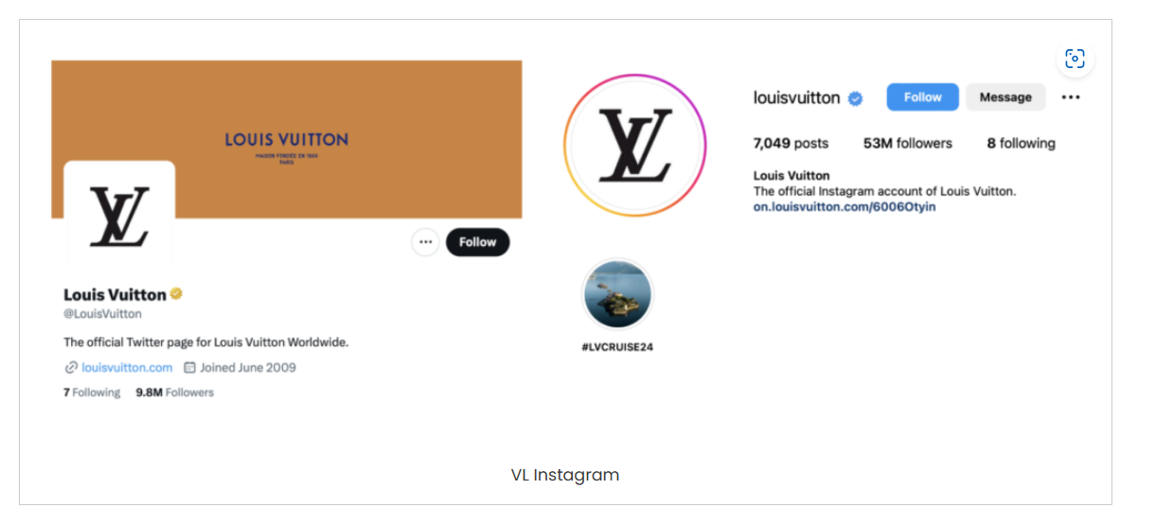
(The brand Hopper, 2023)
Louis Vuitton's success is significantly attributed to its Influencer Marketing strategies. These involve collaborating with advocates who present well-timed sponsored posts, featuring Louis Vuitton bags alongside complementary attire. These strategic presentations occur during peak shopping periods and cultural festivities, bolstering the brand's identity. The emphasis on craftsmanship and technology enhances functionality and durability, elevating the owner's personal image. This approach broadens accessibility and desirability of authentic Louis Vuitton products (The brand Hopper, 2023).
Key digital campaigns include the "Make A Promise" partnership with UNICEF in 2016, showcasing Louis Vuitton's commitment to social responsibility. The Cruise 2017 Show spotlighted limited-edition bag collections, resulting in substantial online traction and profitability. Collaborations with Virgil Abloh and Pharrell Williams appeal to Gen Z preferences and highlight Louis Vuitton's contemporary approach. In summary, Louis Vuitton's multifaceted marketing tactics underscore its agility and innovation in sustaining brand prominence and connecting with diverse audiences.
Theses methods have propelled the company into the main market share holders of luxury in both the united kingdom and the United Arab emirates, 5G is now accessible within the UK and also in specific regions in the UAE which has advanced within technology and internet connection really fast and is continue to develop

People strategy: Louis Vuitton Marketing Strategies
Louis Vuitton utilizes a skilled workforce to craft luxury products of the highest calibre using Monogram canvas material. With a workforce exceeding 150,000 employees, the luxury brand adeptly manages customer interactions, ensuring a harmonious alignment between product offerings and pricing strategies (Bhasin, 2023). The sales staff of Louis Vuitton is always eager to interact with customers and offers knowledgeable advice on how to choose the ideal set of personalised gift combinations for every occasion. The company also regularly releases limited-edition capsule collections that are only available through private appointments or carefully selected pop-up events that are strategically situated to serve particular clienteles looking for a privileged and personalised experience (The brand Hopper, 2023).
The UK and UAE have a very high service outcome as affluent people who reside there need to be catered to the UK this can include celebrities’ royalty, diplomats. However, this is also the case with the UAE as many royal members of the nation currently reside there also, as many of them have important government roles with the society. In addition, the UK has its own trading centre which is connected to the world which makes more affluent people come to city however this also the case with UAE as businessmen and international government officials would like to do business and some celebrities go the region to enjoy a luxurious time
Process strategy: Louis Vuitton Marketing Strategies
Louis Vuitton distinguishes itself from competitors through its unwavering dedication to exceptional after-sales services, fostering lasting customer loyalty. The brand's distinctive feature includes enabling customers to trade in their old bags for new ones, reflecting an understanding of evolving luxury consumer preferences. This offering underscores Louis Vuitton's commitment to ensuring ongoing customer satisfaction. Complementing this, the brand offers complimentary repairs, reinforcing its emphasis on quality craftsmanship and nurturing trust among its clientele. Louis Vuitton's process strategy is founded on a combination of meticulous craftsmanship, innovative design, and a deep understanding of customer needs. The after-sales service, specifically the unique bag exchange and repair services, serves as a pivotal deal breaker in the luxury market. This strategy affirms the brand's dedication to continuous customer delight and fosters strong relationships, influencing customers to remain loyal to Louis Vuitton over the long term.
This process strategy is well embraced in both countries allowing a sense of extra service and value grasping adding more phycological pricing to an consumer mentality.

Physical evidence: Louis Vuitton Marketing Strategies
According to (The brand Hopper, 2023) Merchandising plays a vital role in showcasing Louis Vuitton's premium products while providing distinctive shopping experiences to reinforce the brand's identity and attract fresh clientele. The brand crafts visually captivating retail spaces that harmoniously blend architectural elements with striking interior features, optimizing layout configurations to effectively utilize space for maximum advantage. Recognizing the impact of personalization on building emotional connections, Louis Vuitton offers free personalization and engraving services, enabling customers to create bespoke luxury items. This exclusivity not only elevates the customer's sense of possession but also fuels valuable word-of-mouth promotion (Centaur Interactive , 2023). Compare website content and buildings where the service is carried out. Pictures

Similarities and differences
Louis Vuitton's marketing approach signifies a robust procedural strategy that distinguishes it from competitors. The brand's resolute dedication to exceptional after-sales services not only cultivates allegiance but also effectively addresses distinct regional preferences. In the UK, characterized by economic challenges and evolving consumer dynamics, the brand's emphasis on refurbishing and trading used bags aligns with the market's proclivity for sustainable consumption. Similarly, in the UAE, marked by diverse luxury orientations and economic prosperity, the after-sales service resonates by catering to evolving consumer requisites for convenience and tailored experiences.

DEFINTION OF DIRECTIONAL DEVELOPMENT STRATEGY
Directional strategy is the strategic roadmap that a company formulates and executes to expand its business, enhance profitability, and achieve its intended goals and targets. Businesses of all sizes, from small enterprises to large corporations, can develop customized directional strategies tailored to their specific focus and scale of operations (welp magazine , 2020).`
This strategic framework outlines a clear path for the company to achieve its objectives by focusing on targeted markets, products, or services. A directional development strategy typically involves making deliberate choices about which areas to invest in, which markets to enter or exit, and how to allocate resources to achieve the desired business outcomes. This strategy aims to create a coherent and purposeful direction for the company's growth efforts, ensuring that its expansion aligns with its overall vision and goals.

ANSOFFF MATRIX
Introduced by H. Igor Ansoff and featured in the Harvard Business Review in 1957, the Ansoff Matrix, also referred to as the Corporate Ansoff Matrix and Product/Market Expansion Grid, has provided business leaders and marketers with a straightforward tool for assessing growth risks. The matrix, depicted in Figure 1, outlines four growth strategies, enabling businesses to consider various avenues for expansion while evaluating the corresponding risk levels. As progression occurs horizontally or vertically across the quadrants, the inherent risk escalates with each transition (Mindtools.com, 2022).
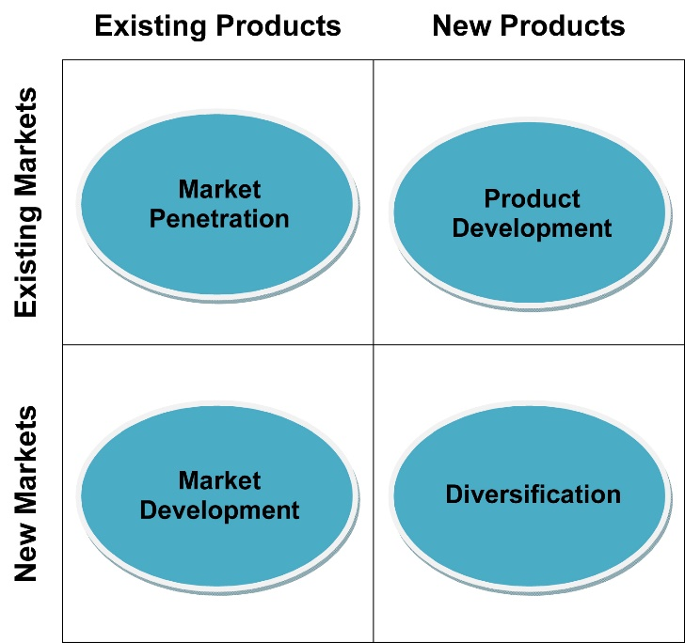
Market penetration
Market penetration involves assessing an organization's ongoing operations within its existing business areas to enhance its market presence by either increasing its share with current products or introducing new offerings. This approach often utilizes strategic advertising through various media channels. Louis Vuitton's implementation of market penetration is evident in its substantial market share expansion. The recommendation suggests diversifying retail locations beyond upscale malls to encompass streets and smaller cities, aligning with broader market reach goals (Kasalia, 2017) (khankasi, 2020).
Product development
Introducing a product development strategy, Louis Vuitton could benefit from expanding its product line to include footwear for both children and adults. This approach aims to attract existing customers who might purchase these shoes not only for themselves but also for their children. The allure of novelty in the market often drives customer interest. Introducing shoes could prompt purchases, potentially boosting Louis Vuitton's sales. While establishing new retail outlets and launching a new product demand considerable financial resource, Louis Vuitton's existing profitability can facilitate funding. Adequate human resources would also be essential for operations and gathering customer feedback on preferences for the new offerings (Kasalia, 2017) (khankasi, 2020) .
Market penetration and product development have worked for LV as both countries consider the company a pillar within their luxury areas in both countries as the company is worldwide known as luxury and is the main market share holder with apparel in luxury with Hermes.

CRITICAL ANALYSIS
The critical analysis of Louis Vuitton's strategies highlights their sensitivity to economic and market nuances. In the UK, economic challenges, and Brexit uncertainties impact consumer spending. Sustainable practices align with eco-conscious consumers, while adapting pricing balances exclusivity and affordability. In the UAE, diversification and regional collaborations resonate with the dynamic market. Introducing footwears for all ages taps into brand appeal. Focus on exceptional after-sales services and technology mirrors commitment to customer satisfaction. Acknowledgment of resource requirements underscores real-world feasibility. Overall, strategies align with global trends and consumer expectations, reflecting insightful market awareness.

RECCOMENDATIONS
In light of the comprehensive analysis conducted, several strategic recommendations can be proposed for Louis Vuitton to enhance its operational approach and market positioning. Firstly, recognizing the robust luxury market in the UAE, the brand should expand its market presence by strategically venturing beyond high-end malls to include streets and smaller urban areas, thereby broadening accessibility. Embracing sustainable practices across its operations would resonate favourably with the environmentally conscious consumer base in both the UK and the UAE, thus aligning with the prevailing trend toward eco-friendly products. Building on its successful collaborations with renowned artists and celebrities, Louis Vuitton should consider regional partnerships to heighten cultural resonance and engagement with diverse consumer segments.
Moreover, the diversification of its product range, particularly into footwear for adults and children, presents a promising avenue for capturing a broader consumer base. This strategy capitalizes on the allure of novelty while accommodating varied consumer preferences. The brand's exemplary after-sales services could be further bolstered through technological enhancements that enrich the customer experience, such as augmented reality applications or personalized recommendations.
In response to the challenging economic landscape in the UK, adaptive pricing strategies could be employed to strike a balance between exclusivity and accessibility, appealing to a wider spectrum of consumers. Furthermore, localized marketing initiatives tailored to specific cultural festivals and customs would demonstrate cultural sensitivity and facilitate deeper consumer connections. Lastly, remaining at the forefront of innovation is pivotal in maintaining the brand's appeal and relevance, necessitating a vigilant approach to evolving consumer trends and technological advancements. These recommendations collectively reflect a holistic and strategic approach that considers various operational dimensions, market dynamics, and consumer behaviour, aimed at advancing Louis Vuitton's competitive standing and market success.

TOWS MATRIX
The TOWS Matrix is a strategic planning tool that builds on the SWOT analysis. It helps organizations develop strategies by combining their internal strengths and weaknesses with external opportunities and threats. The matrix consists of four quadrants:
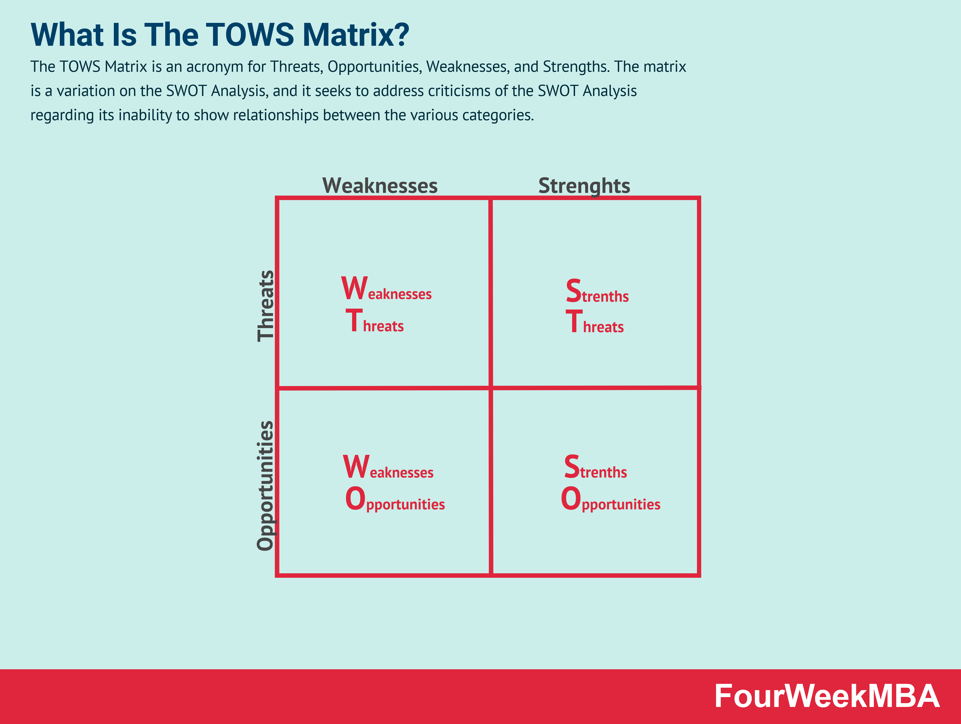
SO (Strengths-Opportunities): Leverage strengths to capitalize on external opportunities.ST (Strengths-Threats): Use strengths to counteract or mitigate external threats.
WO (Weaknesses-Opportunities): Overcome weaknesses by taking advantage of external opportunities.
WT (Weaknesses-Threats): Minimize weaknesses and avoid external threats.
This approach guides organizations to create more effective and comprehensive strategies that consider both internal factors (strengths and weaknesses) and external factors (opportunities and threats)
SO (Strengths-Opportunities): Capitalize on the strong brand reputation to expand into emerging markets where luxury demand is growing. Create sustainable and ethical fashion lines to tap into the increasing consumer interest in such products.
ST (Strengths-Threats): Use the brand's exclusivity to differentiate from competitors during economic downturns, emphasizing timeless luxury. Develop advanced anti-counterfeiting measures to protect the brand's integrity.

WO (Weaknesses-Opportunities): Overcome customization limitations by offering limited-edition collections or personalization services. Extend into lifestyle products to diversify offerings and tap into new market segments.
WT (Weaknesses-Threats): Strengthen brand loyalty through exceptional customer experiences to mitigate competition. Monitor trends closely and adapt designs to stay ahead of changing preferences.
By using the TOWS Matrix, Louis Vuitton can create a more structured approach to their strategic decision-making, leveraging their strengths to address weaknesses and capitalize on opportunities while managing potential threats. Keep in mind that this is a simplified example and may not reflect the actual strategies adopted by Louis Vuitton. (oakspringuniversity.com, 2023)

CONCLUSION
In conclusion, Louis Vuitton's strategies across different markets showcase a keen understanding of economic, cultural, and consumer dynamics. In the UK, economic challenges, and Brexit's aftermath impact consumer behaviour. The brand's eco-conscious efforts and sustainable practices respond aptly to rising environmental concerns. Adapting pricing strategies offers a balanced approach amid economic uncertainties. Similarly, in the UAE, insights into economic variables like oil prices and diversification shape the brand's approach. Extending retail reach to smaller urban areas aligns with market diversity. Personalized products and collaborations with regional influencers reflect consumer preferences and cultural relevance. Introducing footwear for various age groups capitalizes on brand appeal and trend of unique offerings. Commitment to after-sales services and technology integration strengthens customer loyalty. Considering resource implications underscores practicality, grounding recommendations.
Overall, Louis Vuitton's strategies are in sync with global trends and evolving consumer expectations. Moving forward, Louis Vuitton should continue refining and implementing the suggested strategies. Regular market assessment, consumer engagement, and adaptability are essential for ongoing success. By emphasizing sustainability, embracing innovation, and leveraging its brand strength, Louis Vuitton can solidify its position as a leader in luxury fashion across diverse markets.

References
Anon., 20. [Online]
Available at: https://www.britannica.com/place/United-Arab-Emirates/Finance
[Accessed 5 August 2023].
Bhasin, H., 2023. Louis Vuitton Marketing Mix. [Online]
Available at: https://www.marketing91.com/marketing-mix-louis-vuitton/#google_vignette
[Accessed 9 August 2023].
Blakeman, R., 2015. Integrated Marketing Communications creative straegy from idea to implementation. Second ed. London: Rowan & Littlefield .
BTI Transformation index , 2023. United Arab Emirates Country Report 2022. [Online]
Available at: https://bti-project.org/en/reports/country-report/ARE
[Accessed 1 August 2023].
Business Birmingham, 2022. 6 Critical Political Factors Affecting Business in UK in 2022. [Online]
Available at: https://www.businessbirmingham.com/political-factor-affect-business-uk/#:~:text=Four%20political%20parties%20mostly%20dominate%20the%20politics%20of,to%20suffer%20losses%20or%20compromise%20their%20profit%20stream.
[Accessed 25 August 2023].
Centaur Interactive , 2023. Mastering the Art of Luxury Brand Marketing by Louis Vuitton. [Online]
Available at: https://www.linkedin.com/pulse/mastering-art-luxury-brand-marketing-louis-vuitton#:~:text=Louis%20Vuitton%20leverages%20social%20media,and%20desire%20among%20its%20followers.
[Accessed 10 August 2023].
chernev, A., 2012. Identifying Target Customers: Segmentation and Targeting Analysis . In: Seventh, ed. Stratgic Marketing Management . USA: Cerebellum Press, pp. 25-35.
Clark, D., 2023. UK Politics - Statistics & Facts. [Online]
Available at: https://www.statista.com/topics/4666/british-politics/#topicOverview
[Accessed 6 August 2023].
Crystal, J. A. & Patterson , J. E., 2023. United Arab Emirates. [Online]
Available at: https://www.britannica.com/place/United-Arab-Emirates/Languages-and-religion
[Accessed 1 August 2023].
DARBINYAN, M., 2021. Positioning Strategies of Louis Vuitton and Gucci. [Online]
Available at: https://thesocialgrabber.com/positioning-strategies-louise-vuitton-gucci/
[Accessed 17 August 2023].
Economist intellegence unit, 2023. United Arab Emirates. [Online]
Available at: http://country.eiu.com/United%20Arab%20Emirates
[Accessed 2 August 2023].
embapro.com, 2023. Louis Vuitton (United Kingdom) PESTEL / PEST / STEP Analysis. [Online]
Available at: https://embapro.com/frontpage/pestelcoanalysis/17559-louis-vuitton
[Accessed 13 August 2023].
Essay source , 2021. Essay: Louis Vuitton marketing analysis (including Porter’s). [Online]
Available at: https://www.essaysauce.com/marketing-essays/louis-vuitton-marketing-analysis-including-porters/
[Accessed 8 August 2023].
Goldenberg, M., 2023. Perceptual map. [Online]
Available at: https://www.pinterest.co.uk/mor1471993/perceptual-map/
[Accessed 17 August 2023].
Hooley, G., Piercy, N. F. & Nicoulaud, B., 2012. Competing Through the Marketing Mix . In: Fifth, ed. Marketing Strategy & Competitive Positioning. Harlow: Pearsons Education Limited, pp. 294-303.
Hooley, G., Piercy, N. F. & Nicoulaud, B., 2012. Competing Through The New Marketing Mix . In: Fifth, ed. Marketing Strategy & Competitive Postioning . Harlow: Pearsons Education Limited, pp. 306-308.
Hooley, G., Piercy, N. F. & Nicoulaud, B., 2012. Segmentation and Positioning Principles . In: Fifth, ed. Marketing Strategy & Competitive Positioning . Harlow: Pearson education limited , p. 184.
khankasi, a., 2020. Ansoff Matrix of Louis Vuitton. [Online]
Available at: https://ansoffs.com/ansoff-matrix-of-louis-vuitton/
[Accessed 10 August 2023].
KHARTIT, K., 2021. Macro Environment: What It Means in Economics, and Key Factors. [Online]
Available at: https://www.investopedia.com/terms/m/macro-environment.asp#:~:text=What%20Is%20a%20Macro%20Environment,and%20monetary%20and%20fiscal%20policy.
[Accessed 3 August 2023].
Koerich, G. H., Trevisol, N. P. & Luiz de Sousa, R. P., 2019. Luxury and technology: a phenomenological analysis of the Louis Vuitton designer handbags Canvas of the Future. [Online]
Available at: https://www.researchgate.net/publication/342606235_Luxury_and_technology_a_phenomenological_analysis_of_the_Louis_Vuitton_designer_handbags_Canvas_of_the_Future
[Accessed 16 August 2023].
Kotler, P., 2020. Consumer Markets and Buyer Behaviour . In: Eighth, ed. Princeples of Marketing . Harlow: Pearson Education Limited, p. 161.
kotler, P., Armstrong, G., Harris, L. C. & HE, H., 2020. In: Eighth, ed. Principles of Marketing. Harlow: Pearsons Education Limited.
Kunst, A., 2023. Louis Vuitton brand awareness, usage, popularity, loyalty, and buzz among luxury fashion owners in the UK in 2022. [Online]
Available at: https://www.statista.com/forecasts/1352031/louis-vuitton-luxury-fashion-brand-profile-in-the-uk
[Accessed 3 August 2023].
Louis vuitton , 2023. Sustainability. [Online]
Available at: https://uk.louisvuitton.com/eng-gb/magazine/sustainability
[Accessed 17 August 2023].
Louis Vuitton, 2023. A legedary History. [Online]
Available at: https://uk.louisvuitton.com/eng-gb/magazine/articles/a-legendary-history#
[Accessed 17 August 2023].
louis vuitton, 2023. World of Louis Vuitton. [Online]
Available at: https://uk.louisvuitton.com/eng-gb/magazine
[Accessed 19 August 2023].
mailchimp.com, 2023. Marketing Mix & The 7 P’s Of Marketing. [Online]
Available at: https://mailchimp.com/marketing-glossary/marketing-mix-7ps/
[Accessed 8 August 2023].
Mindtools.com, 2022. The Ansoff Matrix. [Online]
Available at: https://www.mindtools.com/pages/article/newTMC_90.htm
[Accessed 4 September 2022].
MOMIN, A., 2023. Louis Vuitton PESTLE Analysis: What Factors Affect a Luxury Fashion Brand?. [Online]
Available at: https://pestleanalysis.com/louis-vuitton-pestle-analysis/
[Accessed 10 August 2023].
Mordor Intellegence , 2021. UAE Luxury Goods Market Analysis. [Online]
Available at: https://www.mordorintelligence.com/industry-reports/uae-luxury-goods-market/market-size
[Accessed 4 August 2023].
Nickerson, C., 2023. Hofstede’s Cultural Dimensions Theory & Examples. [Online]
Available at: https://www.simplypsychology.org/hofstedes-cultural-dimensions-theory.html
[Accessed 4 August 2023].
Office of National Statistics , 2015. The changing UK population. [Online]
Available at: https://www.ons.gov.uk/peoplepopulationandcommunity/populationandmigration/migrationwithintheuk/articles/thechangingukpopulation/2015-01-15
[Accessed 4 August 2023].
Rabaiotti, G., 2023. Business insights and impact on the UK economy: 4 May 2023. [Online]
Available at: https://www.ons.gov.uk/businessindustryandtrade/business/businessservices/bulletins/businessinsightsandimpactontheukeconomy/latest
[Accessed 6 August 2023].
Rageendrathas, 2023. Competing at the Top: Louis Vuitton, Gucci and Hermès in the Luxury Fashion Market. [Online]
Available at: https://medium.com/@rageendrathas/competing-at-the-top-louis-vuitton-gucci-and-herm%C3%A8s-in-the-luxury-fashion-market-94c47154594e
[Accessed 8 August 2023].
Rascouet, A., 2021. Louis Vuitton Owner Embraces Google’s AI to Boost Sales. [Online]
Available at: https://www.bloomberg.com/news/articles/2021-06-16/google-wins-lvmh-cloud-deal-amid-luxury-shopping-boom?leadSource=uverify%20wall
[Accessed 9 August 2023].
Study.com, 2023. Outline advantages and disadvantages of dimensional models of culture. Assess to what extent they only provide sophisticated stereotypes for international managers. [Online]
Available at: https://homework.study.com/explanation/outline-advantages-and-disadvantages-of-dimensional-models-of-culture-assess-to-what-extent-they-only-provide-sophisticated-stereotypes-for-international-managers.html
[Accessed 1 August 2023].
Tamplin, T., 2023. What Is The Macro Enviroment. [Online]
Available at: https://www.financestrategists.com/wealth-management/macroeconomics/macro-environment/
[Accessed 3 August 2023].
The brand Hopper, 2023. Elevating Luxury: Exploring Marketing Strategies Of Louis Vuitton. [Online]
Available at: https://thebrandhopper.com/2023/07/18/elevating-luxury-exploring-marketing-strategies-of-louis-vuitton/
[Accessed 10 August 2023].
theconversation.com, 2022. There’s something wrong with British politics. It’s called the Conservative Party. [Online]
Available at: https://theconversation.com/theres-something-wrong-with-british-politics-its-called-the-conservative-party-192729
[Accessed 27 April 2023].
Ward, A., 2023. Expanding Your Business The Ansoff Way. [Online]
Available at: https://contarmedia.com/expanding-your-business-the-ansoff-way/
[Accessed 29 April 2023].
welp magazine , 2020. A Complete Guide to Directional Strategy. [Online]
Available at: https://welpmagazine.com/a-complete-guide-to-directional-strategy/#:~:text=Directional%20strategy%20is%20the%20game,scope%20of%20each%20individual%20business.
[Accessed 10 August 2023].
www.edrawmind.com, 2023. Louis Vuitton Segmentation, Targeting, and Positioning. [Online]
Available at: https://www.edrawmind.com/article/louis-vuitton-segmentation-targeting-and-positioning.html
[Accessed 19 August 2023].
www.hofstede-insights.com, 2023. ABOUT GEERT HOFSTEDE. [Online]
Available at: https://www.hofstede-insights.com/about-geert-hofstede
[Accessed 3 August 2023].
www.hofstede-insights.com, 2023. COUNTRY COMPARISON TOOL. [Online]
Available at: https://www.hofstede-insights.com/country-comparison-tool?countries=united+arab+emirates*%2Cunited+kingdom
[Accessed 3 August 2023].
www.mbaskool.com, 2023. Louis Vuitton Porter Five Forces Analysis. [Online]
Available at: https://www.mbaskool.com/five-forces-analysis/companies/18279-louis-vuitton.html#:~:text=Bargaining%20Power%20of%20Customers%3A&text=Due%20to%20its%20positioning%20as,due%20to%20its%20brand%20appeal.
[Accessed 7 August 2023].
www.mordorintelligence.com, 2023. UNITED KINGDOM LUXURY GOODS MARKET SIZE & SHARE ANALYSIS - GROWTH TRENDS & FORECASTS (2023 - 2028). [Online]
Available at: https://www.mordorintelligence.com/industry-reports/united-kingdom-luxury-goods-market
[Accessed 5 August 2023].
www.owler.com, 2023. Louis Vuitton Competitors or Alternatives Louis Vuitton's top competitors include Hermes, Gucci and Prada.. [Online]
Available at: https://www.owler.com/company/louisvuitton/competitors
[Accessed 7 August 2023].
www.swotandpestle.com, 2023. louis vuitton swot and pestle analysis. [Online]
Available at: https://www.swotandpestle.com/louis-vuitton/
[Accessed 20 August 2023].

