Oliver Kirkham 2212892
ADCD7001 Coexistant Perspectives
Material Practices: Materialities and Consequences
2830 Words

Roth and the Mattering Body
How agential matterings of materials produce affective ontological identities of art and artist
Introducing Tischmatten

Artist Dieter Roth produced a vast body of work using a range of techniques. Many retrospectives have documented aspects of his varied materiality; from his early Constructivist prints, to his sculptural decay works and handmade books. These works are widely regarded as his most notable contributions to art at the expense of the Tischmatten (referred to as Table Mats), a body of work that despite receiving it’s own survey by Hauser and Wirth in 2010, remains one of the most overlooked and potentially misunderstood of Roth’s projects. Grey bookbinder’s cardboard was fixed to tables in the artist’s home and studio, to protect them from the multi-media residues and accidental spillages during the creation of other artworks at these tables. These mats functioned as pads in two departments of the artist’s life; cooking and eating, painting and pasting (Roth, 2017, p. 212), where they were left on tables for years at a time, accumulating the residues of Roth’s art-life process and forming intricate palimpsests of food smears, marker pen doodles and polaroid photographs (Fig 1, Roth, 1996—1997). These works of art were not totally born out of chance or happenstance, as Deiter made the conscious decision to rework the Table Mats to achieve a style he refers to as ‘flower painting’. The axis of artistic action forms the compositional stem of which the ‘flowers’, or accidental marks, are aesthetically balanced with purposeful symmetrical counter-marks (Roth, 2010, p. 213-215). A performative reading of the work highlights the importance of this axis of artistic action to the ontology of the art-object itself, as later in the text, the notion of the performative helps identify the Tischmatten as indexical documents of the artist’s actions. Amelia Jones’ own definition from her study of similar works, flesh out this reading of Roth’s work, drawing our focus to the Tischmatten’s potential to produce effects and affects after the moment of [the materials] initial manipulation’ (2015, p. 23). Such a specialised kind of art-object implies agency within the performative co-embodiment between the materiality of the Tischmatten and their affective nature. Under the vast umbrella of New Materialism, an agential realist ontology as articulated by Karen Barad, postulates the extent of the Table Mats material agency, if all matter is able to enact its own ontological differentiation using the agential cut (2003, p. 815); the art separating from the artist through its material-discursive state of an apparatus, where ‘matter emerges out of and includes as part of its being the ongoing reconfiguring of [its] boundaries’ (2003, p.822). The impact of this separation is a differentiation between subject and object; the active apparatus enacts the very distinction between the social and the scientific, nature and culture, Deiter and Tischmatten (2007, p. 141). Though as suggested through a performative methodology incorporating New Materialist theory, the total subversion of a Dialectical Materialism cannot totally be achieved when searching for deeper meaning within indexical works such as the Tischmatten. For the subsequent discussion on the artist-body and material-body highlights the problematics of their ontological separation. Thus ‘bodies’ form a new line of enquiry; drawing on the performative undercurrents within the text to consider the extent to which matter is active in its agential capacities, if Roth’s artistic actions are in fact interventions to the material’s state. Deleuze and Guattari will feature toward the final stages of the text, where their Body without Organs opens out new intra-relational scope for the ontological identities of art and artist.

Performative Affects

In recent years, the notion of the performative has gathered sufficient academic attention to allow for it’s conceptual separation from the wider genre of performance art. Once ostensibly limited to the live happening or staged event, performance outside of time has the ability to highlight the active interrelations between people and things, subject and object. Conceptual performativity thus makes us privy to the notion of objects acting; to the precariousness of human and nonhuman states and how social structures can be reciprocally reshaped though ontological destabilisations (Wood, 2018, p. 23). The performative is not an island, but an undercurrent; connecting multiple academic disciplines in a rich theoretical network, with tangible consequences for art-making and art-objects including Roth’s Tischmatten, where the performative is visible instantly through the careful build up of the materials over time. We get a clear sense of how Dieter used his body in the making of the table mats. Fixed to work tables, the Tischmatten describe the radius of Roth’s actions (Walter, 2004, p. 222). In Tischmatte Hegenheimerstrasse (Fig. 2, 1991—1998), the groups of markings give a sense of how the artist worked on the piece from both sides, moving or stretching around the space to achieve the ‘ornamental-symmetrical’ style of adding complimentary markings to accidental ones in order to balance the overall composition (Roth, 2010, p. 214). Palimpsests of the artists presence accumulate, often over many years, forming an disembodied performance between the artist’s personal life and artistic being. Performance is implicit within Roth's art making process, in which the body becomes the tool for creative expression and intent. But this embodiment doesn’t end with the artist, for the phenomena that are produced through the artist-material interaction also cause effects within us as the viewers. Such co-embodiment is described with agential realist New Materialism by Amelia Jones, who understands these indexical kinds of art-objects not only as experiential recordings of the artist’s making process, but whose inherent performativity is the product of ‘materialities clearly manipulated and foregrounded, with the processes of artistic making indicated or marked through these materialities’ (Jones, 2015, p. 20). Thus objects such as the Tischmatten are performative as documents of bodily action, but also exude this performativity within the relational embodiment of the action within the viewer; Karen Barad’s intra-active matter as deployed by Jones, indicating animating movement that at one and the same time affects the inside and outside of the materials activated (2015, p. 28). When we regard the Tischmatten as the viewer we draw on our personal experiences to relate to the indexical nature of the spillages captured and marks made; to recall the anxiety of placing a dripping coffee cup onto a surface in haste or remember the loosing of ourselves in the drawing of a doodle. This is to imagine what it might be like to have made some the marks ourselves (it’s own affective activation of materiality despite that which come from the materials themself under Barad). While this supposition of this co-embodiment supports this viewpoint, a critique along this theme would also posit Roth’s table mats as the artist’s bodily extensions or annexes, housing meaning direct from artistic (human) action. The limit of this interpretation seems obvious in its affiliation with the seventeen century subject-object dialectic, positioning humanity as the rational, intentional, free-moving subject that Cartesianism identified as ontologically ‘other’ than matter (Coole and Frost, 2010, p. 8). Such anthropocentric views are in opposition to our New Materialist analysis. Given the obvious relations between art, artist and viewer implicit within the Tischmatten, we need to consider the object’s materialities as equal participants; to see the artist not as their ontological arbiter of values, but as equal to matter (and thus materialities) in the creation of an art. Matter as causal agents who enact their own agential cuts and perform their own differentiation from conscious bodies such as ours (Barad, 2007, p. 140).

Action as Intervention

To deepen the foray into the relationship between the vitality of the artist and the vibrancy of manipulated matter, a fleshing-out of our New Materialist method is required. Given the focus on the agential possibilities of matter, we can add coexistent perspectives to support a matter-centric critique of Dieter’s Tischmatten.
Jane Bennet’s Neo-Vitalist approach toward materiality, describes object-phenomena as affective, with a kind of ‘thing-power’ that affirms the life of the supposedly inanimate things we encounter on a daily basis. In her book Vibrant Matter, she describes a junk assemblage of discarded objects - a glove, a dead rat, a bottle cap amongst other things - capturing her attention by their phenomenal glinting in the sun. This triggers in her a reaction of disgust at the dead rat, and dismay at the discarded plastic (Bennett, 2010, p, 4-6); the affect caused by these vibrant things calls into question whether matter in its ongoing becoming has the power make us act upon thoughts in a way that aligns to the active potentialities of matter which is agential under new materialism. Applying this thought experiment to the Mats of Dieter Roth, sees artist and materials working co-operatively within the space of creative production, refuting the ostensibility of Roth as sole artist using his ornamental-symmetrical method to create compositional images. To further illustrate the dichotomy between artist-creator and active matter-creator, a personification of the materials the artist used suggests that the creative act is an intervention to the substances activated by agential realist theory (Indeed, noting my use of language here calls out my own capitulation with deeply ingrained subject-object binaries). The materials that, in their aesthetic sense, describe the actions of the artist are now detaching from their status as mere performative extensions of Roth’s working body. Out of this, comes a possible criticism of an agential New Materialism; that the place of human corporeality within apparatuses of ongoing intra-actions is lost in the dismantling of the anthropocentric, the artist subsumed by it’s active material. Though in the indexical works as identified by Amelia Jones, including the mats of Roth, the (phenomenologically) intentional and conscious mark of the maker must be taken into an ontological understanding of their being. Perhaps as a way out of the stickiness of this tangent, then, is the idea that an artistic intervention of materiality and its mattering parts, marries the artist’s mode to create and express with the materiality once regarded as inert, now active. That to intervene is the recognition of the realities of creating art from a human-centric viewpoint, and conversely, the nature of causation that materialities themselves can have on the vision of the artist in the same affective mode of Jane Bennett’s vibrant trash assemblages, should the very production of art’s being exist within an agential realist apparatus of intra-active phenomena (Barad, 2007, p. 146). The extent to which the aesthetic of the materialities (thus the matter itself) guided and shaped Roth’s compositional decisions when producing is hard to define, though his purposeful incorporation of extra marks to balance those already made by happenstance (Roth, 1987?, p. 213-214), posit his ornamental-symmetrical interventions as the product of the material-artist intra-relation, with focus given to the generative capacities of the materials over that of the artist.

Becoming-Body

The elaboration on a new materialist artistic intervention, highlights the materialisation of Dieter’s Table Mats as being part of the apparatus defining it’s physical material boundaries as a material-discursive practice. This has important consequences for our concept of a ‘body’, and thus of the Tischmatten as local bodies (individual works) and general bodies (the ‘body of work’). If the previously mentioned notion of the performative is in actuality the locus of action, the apparatus perspective can be seen as an alternative form of a ‘body’ existing not as flesh, but a network of active matter. The connective tissues of this body being the energetic performativity within continually mattering agents both human and non-human. In this flattened relational hierarchy of production, the Tischmatten-apparatus draws parallels to Deleuze and Guattari’s Body without Organs (referred to as BwO). Much like the matter of agential realism, the BwO is forever in a state of becoming, existing ‘in such a way that it can still be occupied, [though] populated only by intensities’ (Deleuze and Guattari, 2013, p. 177); for the BwO is what remains when you remove all physical ‘organs’ and are left with the binding energy that a new materialist matter both is and of. The ‘energetic’ quality here is of a performative nature itself, and in our New Materialist terms can be described as agency ‘in its ongoing dynamics of intra-activity’ (Barad, 2007, p. 170). A body in this sense is a networked becoming, producing nothing but itself as a condition of it’s mattering state (Deleuze and Guattari, 2013, p. 277). Thus it remains true that ‘a BwO is never mine, or yours, [or theirs]’ (O’Sullivan, 2006, p.115), it exists separately in it’s being, meaning the Tischmatten as a BwO is conception towards the separation of the work from the artist. Daniel Smith interprets the BwO as a machine capable of producing events beyond the confines of the ‘organism’ (the body with organs) and it’s homeostatic self-regulation processes (2018, p106-107). Regarding the physical making process of the Mats, such a machine is thus manipulating material boundaries to record constantly shifting degrees of meaning, evident in the way in which the Table Mats were made by performative intervention. The Tischmatten as a BwO, is an apparatus of matter that has cut itself from the corporeality of Roth, in it’s own state of becoming, generating and regenerating ontologically inseparable phenomena that forms iterations of Dieter’s own becoming through the work. The consequences of this are the formation of layers of differentiated ontological identities born from this causality: the BwO as stagey for accessing that which is normally outside of one’s signifying self, where this outside (world) becomes part of the very production of inside (Self) (O’Sullivan, 2006, p. 47-48). Thus it appears that the presupposed separation of body-of-(art)work from artist-body can never fully materialise in its truest sense due to this blended analysis combining the BwO with agential realism. Now the focus is on mattering materials initiating a productive intra-relation with Roth the artist, moving beyond previous conceptions of materials enacting the extension of the artist-body to their resulting separation. The production of the Tischmatten is contingent on the artist and material working together in the same apparatial space.

Truth to Materials: Conclusion

Our previous forays into the specific ontology of the Tischmatten and subsequent postulations of its productive potential resulted in the body of work becoming an extension of the artist body, with tangential considerations that artistic action is in fact intervention to a matter that’s mattering. Moving the embodiment of this production to the locus of the apparatus, defies any inference that the materials of Roth’s Mats worked for him as the arbiter of composition if subject-object hierarchies are flattened here in our methodology. We now arrive at a point where the material-artist apparatus in its networked becoming, affirms the materials as the body of the artist themselves, for the body is not contingent on it’s flesh to effect it’s existence. This understanding of the Tischmatten shows us that we affect materials as materials affect us; that fully embodied material-discursive practises point towards more ways of ‘knowing’ than what is communicated only through language, and that an anthropocentric epistemology isn’t the only possibility for the production of a work of art. The performative undercurrent thought this text has kept analysis routed in the materials. As articulated by Barad, ‘performativity, properly construed, is not an invitation to turn everything (including material bodies) into words; […] performativity is precisely a contestation of the excessive power granted to language to determine what is real’ (2003, p. 802). Indeed my own complicity with language to give form to the ideas of this text have, at times, problematised aspects of the attempted critique. What remains to say of this is that ideas must somehow be enacted and not only strutted though discourse. The art-objects that exist in the relational ebb and flow of all matter’s agency, is the manifestation of this claim where art-becomes-thought-becomes-power is real. So to, in the various iterations of our understanding of the Tischmatten; what is real has been created by the apparatus of material and artist defining their various boundaries, shifting differentiated physical material states and offering us a window into the life-stuff of Deiter in his final years of practice. The combined approach utilising the BwO in conjunction to agential realism highlighted the deep intra-relations between forms of bodies which continue to produce affects after within us the viewer. Artists can non longer be given full credit or accountability for constructing meanings within their art, though they must demonstrate an awareness of how their synthesis of materials and interpretations of meaning could align to a binary striation of knowledge. If the artistic materials of Dieter Roth, became Dieter Roth through the formation of intra-active portraits produced within the apparatus, to not recognise one’s own affect is to limit the creative potential of materialities becoming and in turn, that of our own potential. An active matter has the potential to (re)generate assemblages in new combinations, infinitely. Our identities as human individuals rest on material shelves in a library of all that exists. Thus as ‘ideas do not die’ (Deleuze and Guattari, 2013, p. 274), nor do those shared with us by the materialities that surround us. Matter makes us who we are. We’d do better to listen to it.

Bibliography

Barad, K. and Alice, F. (2007) Meeting the universe halfway: quantum physics and the entanglement of matter and meaning. Durham: Duke University Press.

Barad, K. (2003) ‘Posthumanist Performativity: Toward an Understanding of How Matter Comes to Matter’, Signs: Journal of Women in Culture and Society, 28(3), pp. 801–831. Available at: https://doi.org/10.1086/345321 (Accessed 1st December 2022).

Bennett, J. (2010) Vibrant matter a political ecology of things. Durham: Duke University Press.

Coole, D. and Frost, S. (2010) 'Introducing the New Materialisms’, in Coole, D. and Frost, S. (ed.) New Materialisms: ontology, agency, and politics. Durham: Duke University Press.

Deleuze, G. and Guattari, F. (2013) A thousand plateaus: capitalism and schizophrenia. London: Bloomsbury Academic.

Walter, B. ‘Mats’. (2004) in Walter, B., Vischer, T and Jenny, C. (ed.) Roth time: a Dieter Roth retrospective. Exhibition held at Schaulager, Basel, May 2003, Museum Ludwig, Cologne 2003-2004 and Museum of Modern Art and Museum of Modern Art PS1, New York, March 2004 [Exhibition Catalogue].

Jones, A. (2015) ‘Material Traces: Performativity, Artistic “Work,” and New Concepts of Agency’, TDR: Drama review, 59(4), pp. 18–35. Available at: https://doi.org/10.1162/DRAM_a_00494 (Accessed 21st November 2022).

O’Sullivan, S. (2006) Art encounters Deleuze and Guattari: thought beyond representation. Basingstoke: Palgrave Macmillan.

Roth, D. (2010) ‘Holderbank’. in Rosen, B. (ed.) Dieter Roth, Björn Roth: work tables & tischmatten. Exhibition held at Hauser and Wirth, New York, October 2010. [Exhibition Catalogue]

Smith, D. (2018) ‘What is the body without organs? Machine and organism in Deleuze and Guattari’, Continental philosophy review, 51(1), pp. 95–110. Available at: https://doi.org/10.1007/s11007-016-9406-0 (Accessed 7th December 2022).

Wood, C. (2018) Performance in Contemporary Art. London: Tate Publishing.

Image List

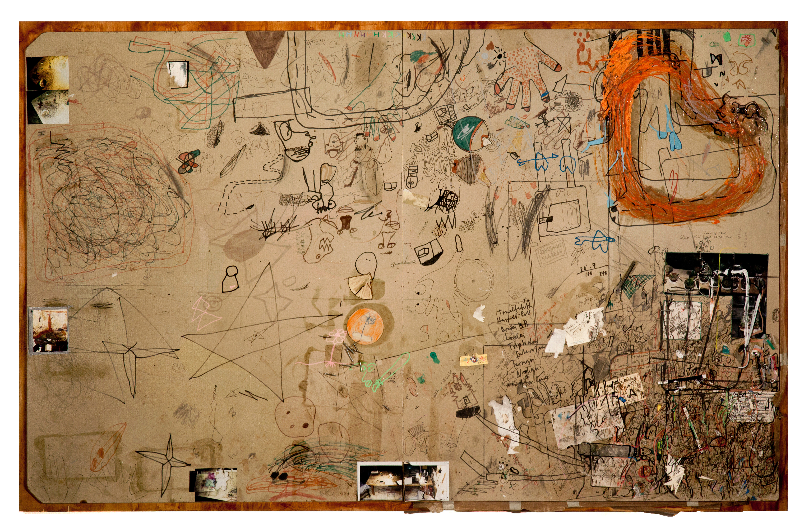
Fig 1
Roth, D. (1996—1997) Matte vom Kaffeetisch, Bali / Mosfellsbær [Graphite, marker pen ink acrylic, oil, glue and collage on paper, glued on plywood]. 41¼ x 64½ x 1⅝ inches. Available at: https://www.contemporaryartdaily.com/project/dieter-roth-and-bjorn-roth-at-hauser-wirth-new-york-6473 (Accessed 12th December 2022).

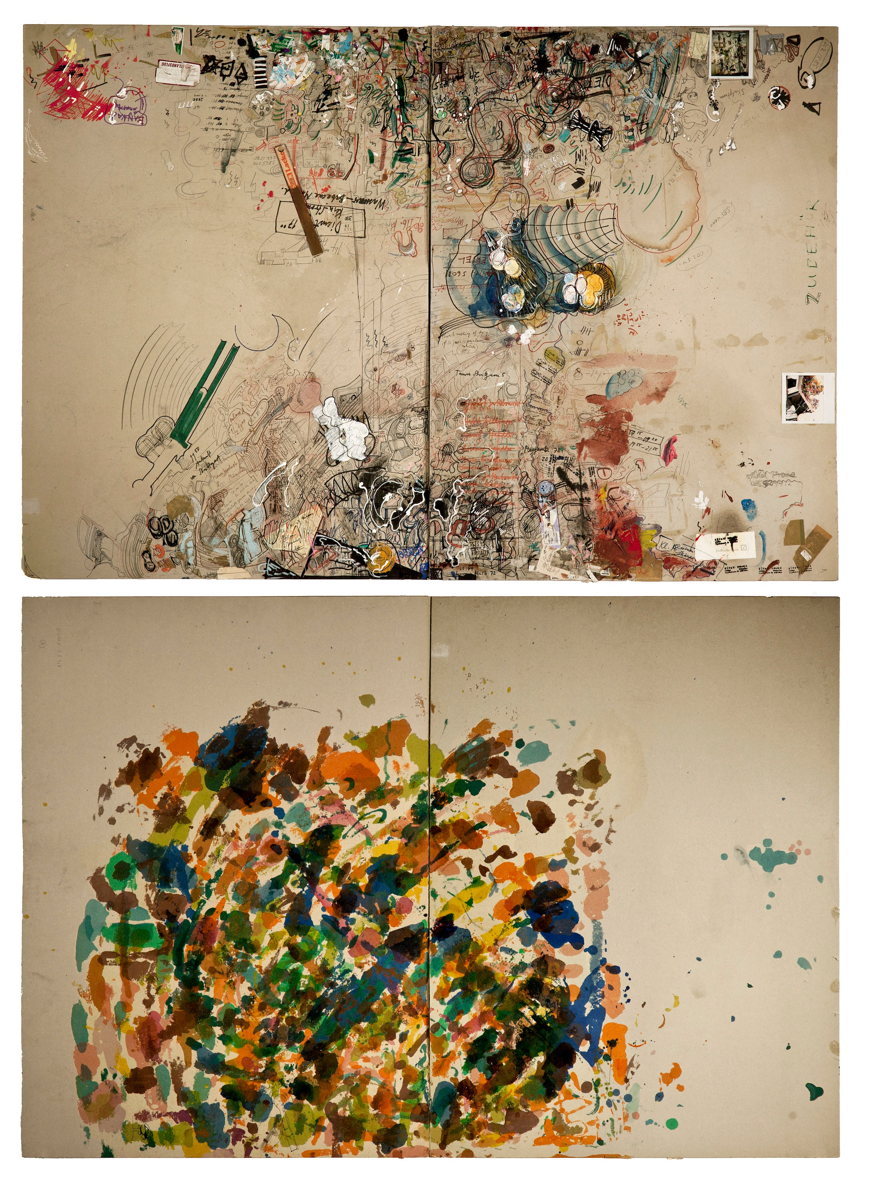
Fig 2
Roth, D and Roth, B. (1991—1998) Tischmatte Hegenheimerstrasse [Graphite, acrylic varnish, watercolour, ink and collage on paper]. 2 parts (recto/verso), each 43½ x 63⅜ inches. www.contemporaryartdaily.com/project/dieter-roth-and-bjorn-roth-at-hauser-wirth-new-york-6473 (Accessed 12th December 2022).

