
[Document title]



SUBMITTED BY:Shanaz Begum Seikh nesa
Lecturer: Dale Clarke
Module Code:BMIH5007

Executive Summary
This report has been prepared to analyse zero-based budget and its advantages over the traditional budgeting procedure. The first chapter holds an introduction as to what is zero-based budget and why a hotel might need it. In the second part, the main aspects of ZBB, the process of this budgeting and its implications on the company have been analysed. Then, why ZBB is more advantageous than traditional budgeting is analysed. In the last part of the discussion, how the company may introduce ZBB in their hotel has been analysed. It was identified that, due to the detail-oriented nature of ZBB, a proper plan is needed to achieve cost cutting. Lastly, a sample zero-based budget has been calculated.

Table of Contents
Executive Summary 1
1. Introduction 3
2. Zero- Based Budgeting 4
2.1 Zero- Based Budgeting 4
2.2 Advantages of Zero-based Budgeting over Traditional Budgeting 6
2.3 How the Organisation Might Introduce Zero-based Budgeting 8
3. Conclusion 10
4. Budget Calculations 11
References 12

Introduction
In the past, organisations only tended to specify some specific costs to make budgets and assumed that things are not needed to be double-checked. This led them to re-check previous years’ budgets that may have constituted several unwanted cost headings. The lack of the need for the approval of each of the spending content of the budget drew faults in the traditional system, which has brought about the importance of zero-base budgeting into the front (Ibrahim, 2019). Today’s hotel industries are more dynamic in every aspect. Being in a cyclical industry, this is prone to different economic, social and cultural aspects. The traditional method of budgeting, such as incremental budgeting sometimes may go out of control and may show significantly higher or lower costs (Beredugo et. Al., 2019). Zero-based budgeting removes these issues as it analyses all the revenue and cost prospects one by one.

Zero- Based Budgeting

Zero- Based Budgeting
Zero-based Budgeting (ZBB) is an approach to making a budget from scratch every time. This process allocates the funds of a business based on the relevancy and necessity in each period (Coyte et. Al., 2020). As the name goes, this budget gets started from a ‘Zero Base’, which means that, at the start of the budget preparation process, all account balances are zero. This budgeting method has seen exponential growth among the world’s 85 largest companies at a rate of 57% every year (Accenture Strategy, 2018). The goal of this budgeting process is to allocate the resources based on their effectiveness, which is most likely not present in the traditional budgeting styles. At the beginning of proposing zero- based budgets, the budgeter reviews every expenditure source and tries to justify them concerning the business (Oraca et. Al, 2016). Any kind of costs- operating expenses, capital expenditures, sales, cost of goods sold, general and administrative costs, marketing costs, etc. are part of the plan. If the budgeting is done appropriately, it is assumed that all the unjustified expenses will stop, which will increase revenue (Zhang et. Al., 2021). For example, the supply department of a hotel usually has $10 million, in general, every year. Due to the covid-19 pandemic, the hotel needs to identify ways of cost-cutting. Through zero-based budgeting, it will calculate all the expenses of departments and justify all to see if it can remove or minimize cost in any sections. Maintenance costs may be lessened than before due to frequent lockdowns, which may lower the expenses.
Process of Zero-based Budgeting
This budgeting process helps the companies to assign the importance and relevancy of the costs to be incurred to make the elimination process easier. To adopt a successful ZBB, the following procedure is followed:
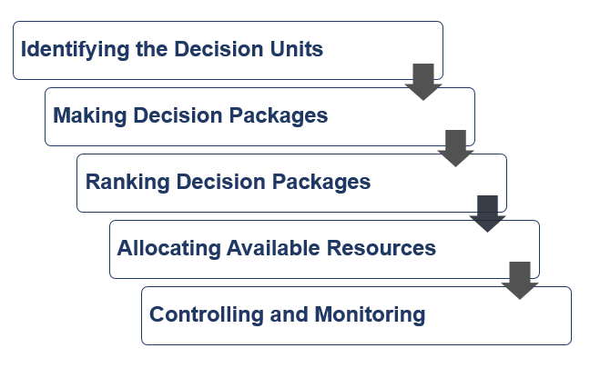
Figure 01: Zero-based Budgeting Process
Source: Adapted from Alamry et. Al, 2020
The first step is to define decision units, which can be operated independently or in a clustered way. Marketing, production, HR, research and development, service department, etc generally act as decision units. Managers of each department need to justify each of the cost items they proposed.
Secondly, decision packages will define the activities, functions and operations of the proposal (Al-attara et. Al., 2020). It may contain the goals of the unit, the decision package, technical and operational relevancy etc. Then based on this importance, each of the decision packages will be ranked to select the cost-effective options.
After the ranking, the most viable package will be allocated the best funding, the other amounts will be eventually going to the lower-ranked packages. The final process is monitoring the packages, for their performances. After measuring it, the manager can identify whether it was good enough or not and can propose to revise plans.

2.2 Advantages of Zero-based Budgeting over Traditional Budgeting
Despite the increasing trend of zero-based budgeting, many firms still use traditional budgeting (Fitzpatrick & Hawke, 2015). These budgeting includes, incremental, fixed or flexible budgeting. Generally, a specific percentage is allocated for each of the cost sectors and these incremental percentages are supposed to increase or decrease that cost in the recent year. Within a range of 1% to 10%, these percentages are the main source of increments (Lund, 2022).
As ZBB is much different from the traditional budgeting process, it holds several advantages. Those are:
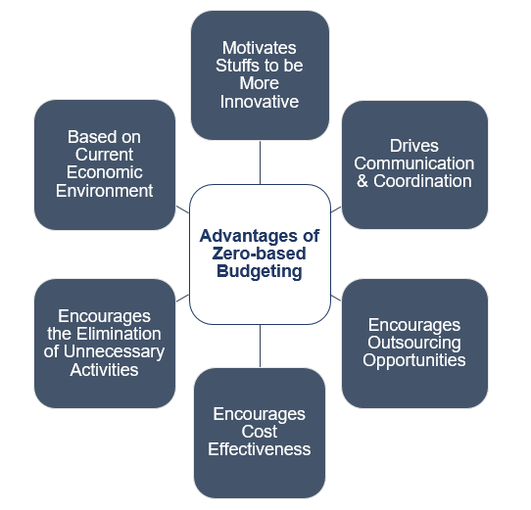
Figure 02: Advantages of Zero-based Budgeting
Source: Adapted from Woo, 2019
These advantages are shown concerning traditional budgeting system:
- The zero-based budget starts from scratch each year with no influence on the past costing (Fernando, 2016). So, if the company follows zero based budgeting, it may easily identify which costs are most needed and which should be eliminated from the cost list. This helps to reduce unwanted and irrelevant costs, which is not possible while implementing traditional budgeting.
- As ZBB motivates the managers to find out more effective ways to enhance their operations, they have no other way than to increase their efficiency. All the operating and financial expenses are to be justified by them, so they cannot bring in any cost out of proper calculations and estimations. This, at last, helps them be a better manager (Bunget, 2021).
- Communication and coordination are a must for ZBB. For example, the supply division of a hotel needs to be in coordination with the front desk management division. Without that, the customer needs cannot be tracked and in effect, their demands of them will not be identified by the supply team. Based on the team’s communication, the probable needs and probable costs can be identified and incorporated (Lauth, 2014).
- The effectiveness of zero-based budgeting is manifold, which also helps the company to outsource its ability to reduce cost and increase revenue. As ZBB is a detail-oriented process, much time is needed for its completion (Porter and Yeh, 2021). So, the companies with expertise in this budgeting can outsource their capabilities.
- The managers of each department need to verify each cost item and its projection. In the traditional system, they have to perform less projection and valuation process as in there, they only need to set a percentage based on assumption. In ZBB, legacy costs are always being checked.
So, all these advantages show that ZBB helps to eliminate unwanted and outdated costs and makes a clear link between organizational goals and budgets, which traditional budgets fail to do.

2.3 How the Organisation Might Introduce Zero-based Budgeting
Traditional budgeting is largely different from the zero-based one as traditional ones follow previously made budgets for the current year’s one, while zero-based budgets start from scratch. Despite having numerous chances and benefits from zero-based budgeting, a firm that has been following traditional budgeting for years cannot change the budgeting procedure overnight (Vadapalli, 2021). Due to the nature of ZBB, it takes much more time and professionalism than traditional budgeting.
So, if the hotel management decides to introduce zero-based budgeting, they need to take the following steps:
- Being Clear about the Goals and Objectives- The replacement of ZBB requires a complete restructuring of the existing budgeting system (traditional). So, consultation with the experts, identification of what is needed and proper research are necessary to provide the idea which the hotel wants to improve (Réka et. Al., 2014).
- Using the most Appropriate Technology Available- Sometimes excel cannot provide the best template for the budget. In such a case, the need for sophisticated tools and technology helps will be needed. The hotel needs to identify them and nake a projection of how much the installation might cost.
- Developing Threshold for Organisational Requirements- The scrutinisation should be based on materiality. Not every cost needs to have the same level of importance of being investigated. For example, a £75 expense budget for office supply does not need the same level of scrutinisation as a £10 million expense budget for refurnishing the whole hotel. The right technology will identify which costs need more help (Keramat et. Al., 2016).
- Knowing the Cost Drivers- Due to changes in the global environment due to several causes, such as Covid-19, the cost and revenue drivers have been changed largely. The hotel needs to identify the most relatable cost drivers. For example, the maintenance fee, catering costs and advertisement fees etc. are the most important costs (Glass et. Al., 2014). But due to frequent lockdown, many of such costs might be lowered and many new costs may emerge.
- Training of the Company Budgeter- To adapt well to the rigorous process of ZBB, the staff are needed to be trained properly. A failure to do this will lead to wrong cost and revenue estimation.
- Developing a changed Management Plan- Many of the managers are supposed to be resistant to ZBB at first. So, the way to convince them should be planned. Considering the advice of an outside expert or arranging a session with him/ her with the managers might be effective (Black, 2019).
So, these are the initial stages through which the company might introduce zero-based budgeting in the hotel.

Conclusion
Zero-based budgeting holds the ability to point out the most relevant costs and revenue sources, which is hardly found in the traditional budgeting method. The extensive characteristics of this type of budgeting require clear knowledge about the organization, expertise in scrutinizing the cost aspects and willingness to make it relatable. Despite having several advantages over the problems of traditional budgeting, it may become cumbersome due to its detail-oriented and time-consuming manner. So, the hotel management should make a proper plan ahead as they need to change their budgeting method from the traditional one to ZBB.

Budget Calculations

Continental Hotel Budget
 | in (£ '000)
Income | 2022
Operating Income | 148,600.00
System Fund Revenue | 56.00
Other Income | 29.00
Total Revenue | 148,685.00
Expenses
Cost of Sales | 70,600.00
Administrative & General | 54,000.00
Control | 1,500.00
Insurance | 3,000.00
Depreciation | 2,000.00
Impairment Charges | 250.00
Payroll | 600.00
Dues | 200.00
Rental | 200.00
Total Expenses | 132,350.00
Net Income | 16,335.00

References
Accenture Strategy (2018). Beyond the Buzz: ZBx: The Zero-Based Mindset Page 02, Accessed: March 17, 2022.
Alamry, Saoud J. & Abbas, Hayder & Al-Attar, & Mashkour, Saoud & Hassan, Majid. (2020). Zero-Based Budget System and its Active Role in Choosing the Best Alternative to Rationalise Government Spending. 13. 2020.
Al-attara, H. A., Mashkourb, S. C., & Hassanc, M. G. (2020). Zero-based budget system and its active role in choosing the best alternative to rationalise government spending. International Journal of Innovation, Creativity and Change, 13, 244-265.
Beredugo, S. B., Azubike, J. U., & Okon, E. E. (2019). Comparative analysis of zero-based budgeting and incremental budgeting techniques of government performance in Nigeria. International Journal of Research and Innovation in Social Science, 3(6), 238-243.
Black, W. K. (2019). The budget as a planning tool. In Catalysts for Change (pp. 171-188). Routledge.
Bunget, O. C. (2021). Reconsidering Budgeting after the COVID-19 Outbreak. The Audit Financiar journal, 19(162).
Coyte, R., Messner, M., & Zhou, S. (2020). The revival of zero‐based budgeting: drivers and consequences of firm‐level adoptions. Accounting & Finance.
Fernando, A. (2016). APLICATION OF ZERO BASE BUDGETING IN SRI LANKAN PUBLIC SECTOR. te of Cost, 82.
Fitzpartick, M., & Hawke, K. (2015). The Return of zero-base budgeting. McKinsey & Company. Pobrano z: http://www. mckinsey. com/business-functions/strategy-and-corporate-finance/our-insights/the-return-of-zero--base-budgeting (7.03. 2017).
Glass, V., Stefanova, S., & Prinzivalli, J. (2014). Zero-based budgeting: Does it make sense for universal service reform?. Government Information Quarterly, 31(1), 84-89. doi: 10.1016/j.giq.2013.05.022

Ibrahim, M. M. (2019). Designing zero-based budgeting for public organizations. Problems and Perspectives in Management, 17(2).
Keramat, A., Soltani, H., & Jamali, A. H. (2016). FEASIBILITY OF IMPLEMENTATION OF PERFORMANCE-BASED BUDGETING IN FARS GAS COMPANY. IIOAB JOURNAL, 7, 46-58.
Lauth, T. P. (2014). Zero‐Base Budgeting Redux in Georgia: Efficiency or Ideology?. Public budgeting & finance, 34(1), 1-17.
Lund, D. (2022). Zero Based Expenses – How to Plan and Manage | By David Lund. Retrieved 18 March 2022, from https://www.hospitalitynet.org/opinion/4093947.html
Oraka, A. O., Sopekan, S. A., & Udeh, F. N. (2016). Zero-based budgeting: Pathway to sustainable budget implementation in Nigeria.
Porter, J., & Yeh, P. (2021). Investing in a Post-COVID Budgeting Process: Using Past Performance Has Gone Out the Window. American Bankruptcy Institute Journal, 40(11), 24-57.
Réka, C. I., Ştefan, P., & Daniel, C. V. (2014). TRADITIONAL BUDGETING VERSUS BEYOND BUDGETING: A LITERATURE REVIEW. Annals of the University of Oradea, Economic Science Series, 23(1).
Vadapalli, R. (2021). A STUDY ON THE CASES OF ABRUPT SHIFTING FROM CONVENTIONAL BUDGETING TO ZERO BASED BUDGETING (ZBB) UNDER COVID 19 PANDEMIC SITUATION IN THE SMALL SCALE PACKAGED FOOD INDUSTRY AND SMALL SCALE NATURAL RESOURCE INDUSTRY IN INDIA. Management Accountant, 30-30.
WOO, W. (2019). A Revisit to Zero Based Budgeting. The International Journal Of Business & Management, 7(5). doi: 10.24940/theijbm/2019/v7/i5/bm1905-010
Zhang, L., Wu, Y., & Huang, K. (2021, August). Driving Benefit Based on the Zero-base Budget Under the 3G (Garantia) Capital Model. In 1st International Symposium on Innovative Management and Economics (ISIME 2021) (pp. 247-254). Atlantis Press.

