Biomechanical analysis of the football passing movement

Introduction
In football passing is a huge and an important fundamental within game is frequently used during skills too. It underlines a team’s quality and performance due to its great ball possession and enables progress further up the pitch, facilitates tactical play, and creates chances such as goal scoring opportunities. Due to the multiple different types of techniques and passes the technique that players frequently use the most is the side foot pass as it provides much more stability in terms of accuracy and control within short and medium distances and help is provided with this due to its pace. Although the movement looks relatively simple, the movement when passing the ball requires very complex coordination of multiple joints and muscle groups, precise control and the force and weight production, to maximise the effectiveness of balance on a single supporting limb.
The aim of this report is to identity using biomechanics of the inside-foot pass for football with the respect of performance efficiency, mechanical effectiveness and the potential injury risks. Specifically, the report aims to identify the analysis by using biomechanical principles such as kinematics (joint angles, velocity, sequencing), kinetics (force production, ground reaction forces, impulse), Newton’s law of motion, and lever systems within the musculoskeletal system. The investigation of this analysis will aim to identify how force efficiency is created and developed further and transferred through the kinematic chain, identify mechanical limitations, and analyse the common injury risks that occur during repetitive passing movements. Evidence recommendations will then be mentioned to increase and enhance the chances of performance and lower injury likelihood.
Biomechanically, the inside-foot pass involves a big display of open kinematic chain movement of the kicking limb combined with closed kinematic chain stabilization to therefore support the limb. Additionally, Newton’s law (force=mass x acceleration) provides the greater acceleration of the foot as it comes closer to contact to the ball velocity increases. The impulse-momentum relationship determines how force is applied over time and therefore has and increased effect on ball speed. Additionally, the lower limb functions primarily as a third-class lever during the knee extension, focusing to prioritize speed and range of motion over force output. Effective and efficient proximal-to-distal sequencing (hip, knee, ankle) is a huge key around optimal mechanical energy transfer.
This report will also add the methodology used for biomechanical analysis of the movement/action for data collection, analyse each phase of the passing movement, evaluate performance demands (whether they are high or low) and injury risks, and developed a structed plan to prevent injuries and to boost performance enhancement.

Methodology
Participant
One male university level football player (age 20, predominantly right footed, injury free at the time of testing) participated in the analysis.
Data tools
Biomechanical tools that were used for analysis:
- High-speed video recording
- Sagittal and frontal plane recordings
- Camera placed 5m from the performer
- White line markers used for distance (1m)

- Observational movement analysis framework
- Joint angle estimation (the knee, the hip and ankle)
- Centre of mass positioning
- Segment sequencing

- Kinovea motion analysis software
- Measurement of the joint angles
- Angular velocity estimation
- Phase breakdown

The movement was divided into 5 separate phases for the most accurate analysis possible:
- Approach
- Plant phase
- Backswing
- Ball contact (contact phase)
- Follow-through

Biomechanical analysis of the inside-foot pass
Approach phase
The approach consisted of angle between 30 or 45 degrees with a slight angled run up.

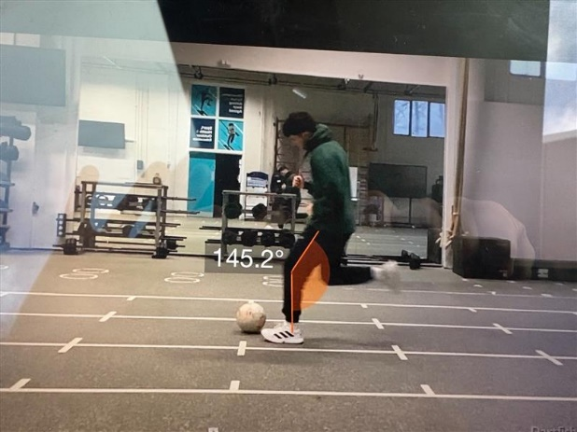
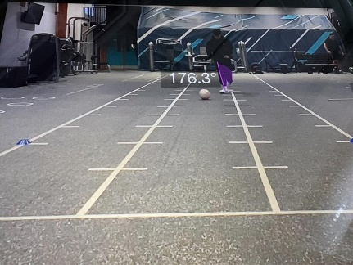
Here is the examples of the slight angled run up of the approach phase accelerating towards the target.

Observations:
- Moderate approach velocity
- Upright trunk posture
- Visual fixation alternating between ball and the target

Biomechanical considerations:
- Controlled momentum whilst being slightly horizontal
- Stable centre of mass
- Reduced unnecessary upper body rotation
An effective approach speed ensures a great amount of momentum without compromising accuracy.
Plant phase (support leg mechanics)
The left foot that is the non-kicking foot was placed in line with the ball approximately being 2-3 cm of the ball laterally.
Measured data
- Knee flexion of the supporting leg
- Trunk lean: slight opening to the right with the support leg
- Ankle dorsiflexed at contact

Mechanical efficiency:
The flexed knee provides a lower centre of mass, that helps support the increase of stability. A more wider base of support provides more increased balance and allows force transfer to work more effectively. According to research (Hamill, Knutzen and Derrick, 2022, p. 357) we can determine that biomechanically focus on the factors such as cadence, stride duration, and duration of the stance or support phase (when the body is supported by a limb).
Performance demands:
- Single-leg stability
- Eccentric quadriceps control
- Hip abductor activation for pelvic stability

Backswing phase:
The right foot (the kicking leg) used hip extension and knee flexion.
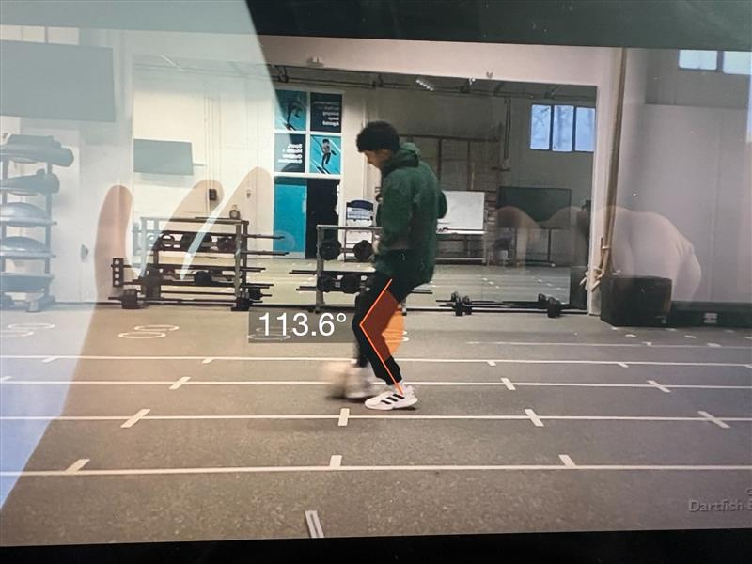
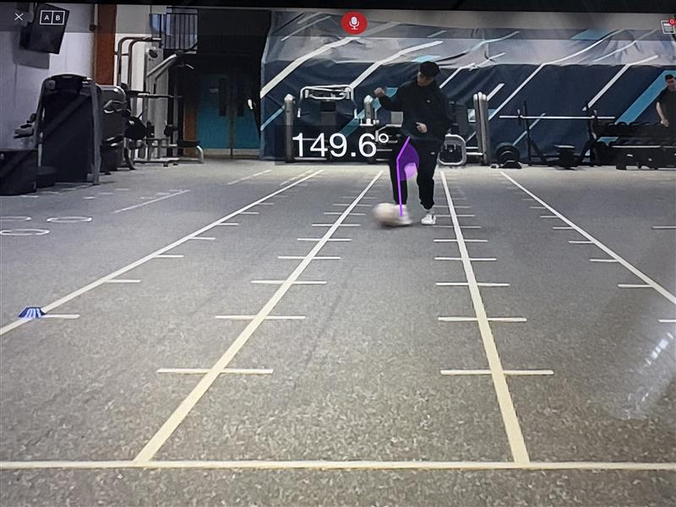

Here is the examples of the backswing phase just as contact with the ball is made.

Measured Angles:
- Hip extension
- Knee flexion
This is the phase where elastic energy is stored within the hip flexors and also the quadriceps.

Mechanical efficiency:
A much greater backswing provides a huge increase of angular displacement, which ensures a lot higher angular velocity during acceleration of the movement. On the other hand, overdoing the backswing may reduce the timings precision and control of the movement. According to (Hamill, Knutzen and Derrick, 2022, p. 410) we can determine that individuals with hemiplegia may show a reduction in range of motion at the ankle and excessive hip and knee motion during swing phase which suggest that timing and precision control is key.
Acceleration phase:
Fast paced hip flexion and knee extension occurred.
Joint actions:
- Hip flexion
- Knee extension (Acceleration the main contributor)
- Ankle locked in eversion and dorsiflexion
Peak knee extension is a pivotal part for the velocity of ball speed. Sequential proximal-to-distal movement was also observed:
Hip-Knee-Ankle- Foot
This kinetic chain demonstrated effectively the efficient force summation
Ball contact phase
Contact occurred in terms of the medial part of the foot.
Observations:
- Ankle locked
- Knee flexed
- Head facing forward just slightly behind the ball
- Trunk slightly opened and leaning towards the right

Mechanical efficiency:
A rigid foot at impact has a quite considerable boost for effective mass whilst also increases the chance of the impulse transfer. According to (Burkett, 2019, p. 58) we can determine that this is true as impulse is the combination of time and velocity of this force suggesting that a lighter athlete, running faster can generate faster momentum and come out on top to a heavier opponent. The impulse- momentum builds its relationship with the force and the ball velocity:
Impulse= Force x Time
Longer and controlled contact allows more improved directional accuracy.

Follow through phase
The kicking leg continued towards its target.
Observations:
- Continued hip flexion
- Slightly balanced landing
- Trunk stable but bit of a lean backwards and slight lean right
A proper follow-through indicates that a smooth deceleration will occur and reduces joint stress. According to the research (Burkett, 2019, p. 43) we can determine that when athletes or objects are on the move varying oppositional forces, ranging from opponents to air resistance therefore causes acceleration or deceleration.
Mechanical efficiency
Mechanical efficiency was based on these outcomes:
- Kinetic chain sequencing
- Stability of the support leg
- Energy transfer
- Movement economy
Positive findings:
- Effective proximal-to-distal sequencing
- Stable support base
- Appropriate ankle rigidity
- Controlled follow through
Minor efficiency:
- Slight trunk rotation at impact
- Limited hip extension in backswing (providing a slight reduction of ball velocity).

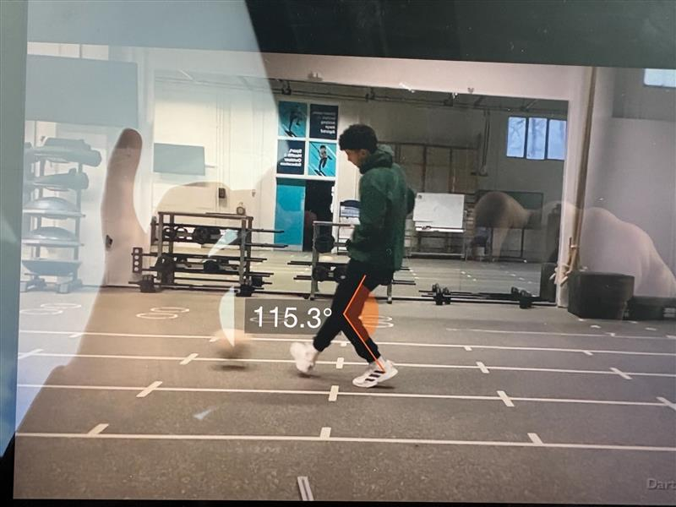
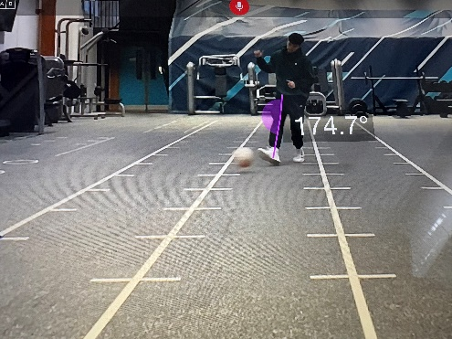
Here is a few other examples of how the trunk leans during the athletes through the follow through phase.

Performance demands of passing
Passing requires the following:
Muscular strength
- Quadriceps (knee extension)
- Hip flexors
- Gluteus medius (stability)
- Core stabilisers
Neuromuscular coordination
- Timing between hip and the knee extension
- Ankle locked in at the correct timing
Balance and proprioception
- Single leg stance control
- Dynamic pelvic alignment

Injury risks and safety considerations
Although passing can provide a much lesser risk compared to shooting, repetitive execution can present injury concerns. According to research (Abernethy, 2013, p. 354) we can determine that repetition exposes the athlete, especially the growing athlete, to the danger of overuse injuries of the musculoskeletal system.
Common injury risks
- Adductor strain
- Due to repetitive hip abduction/external rotation
- Quadriceps strain
- High-speed knee extension
- Patellofemoral stress
- Repeated deceleration in follow-through
- Ankle instability
- Poor locking during point of impact
Observed risk factors
- Slight trunk lean laterally may provide a boost for increasing hip joint stress
- Reduced hip mobility can significantly have limitations on force production and increases compensation at the knee

Evidence-based recommendations
Technique improvements
- Increase hip extension during backswing
= A significant enhancement of angular velocity and ball speed

- Reduce excessive trunk rotation
= Drastic increase of directional accuracy

- Maintain ankle rigidity at impact
= applies maximum force transfer

Strength and conditioning
Hip flexor strengthening
- Resistance band drives
Eccentric quadriceps training
- Decline squats
Gluteus medius strengthening
- Lateral band walks
Core stability training
- Pallof press
- Dead bugs
These types of exercises provide a huge room for improvement in terms of force production and pelvic stability. According to the research (Abernethy, 2013, p. 92) we can determine that importance of the centre of mass and rotational motion of the body applies a lot more stability for the athlete.

Injury prevention strategies
- Adductor strengthening (Copenhagen planks)
- A dynamic warm-up with stretches before training/games
- Mobility work for hip internal/external rotation
- Gradual progression within loads during training sessions.

Rehabilitation Considerations
If returning from lower body injury long term or short term:
- Begin with small/medium length static passing drills
- Progress to dynamic passing
- Reintroduce pressure building situations gradually
- Monitor asymmetries between limbs

Conclusion
This biomechanical investigation of the inside of the foot pass has provided a positive and successful outcome as execution relies on the following:
- Effective proximal-to-distal sequencing
- Stable support-leg mechanics
- Controlled trunk alignment
- Ankle positioning at impact
Mechanical efficiency plays a huge role in improving performance while reducing the risks of injuries. The use of biomechanical tools has allowed the analysis to be much clearer and more technical with things such as strength training, technical coaching, and injury prevention strategies providing a comprehensive framework for major improvements for passing performance in football. According to research (Abernethy, 2013, p. 314) we can determine that sensory factors can have a huge negative to play Aswell as positive as athletes fitness levels need to be considered, but also the individual’s perceptions of the exercise as injuries can occur.
From a mechanical point of view, the stability of the limbs was a big factor in determining how important trunk rotation is making sure to maximizing accuracy while maintaining balance. According to research (Burkett, 2019, p. 112) we can determine that the turning effect of a torque is sufficient to set an athlete which therefore describes the stability of rotary stability of the athlete. Reduced technical deviation including hip extension during backswing or excessive trunk lean- were proven to be reduced possible force output and have shown a key part of improvement compensatory loading at the knee and hip. This emphasises the negative impact minor inefficiencies have on the affect of performance outcomes and long-term joint health.
This examination identifies the importance of considerations regarding injuries. Additionally repetitive passing places can have a major impact of cumulative stress on the adductor group which is the following, quadriceps, and patellofemoral joint, particularly if technique decreases massively when fatigued. Therefore, strength development, neuromuscular control training, and mobility work are a considerably key area in terms of performance enhancement and additionally Injury prevention. The combining of biomechanical feedback for coaching practice identifies early dysfunctioning of patterns of movement before reaching the latter stages and more serious stages and become chronic issues.
Importantly, this biomechanical usage of tools reinforces the key data that is needed to provide a clear and accurate set of data collection in sport. Video analysis is vital in terms of assessing the angles of the joints and therefore provide a clear identity to gain a measurable insight on performance variables that is next to impossible through visible coaching alone. When attached variables such as strength and conditioning principles, biomechanical assessment forms a extensive framework for a major enhancement of football passing performance.
Overall, the inside of the foot pass identifies a major requirement of motor skill and mechanical efficiency, neuromuscular precision, and physical robustness. Continued analysis using biomechanical tools, have provided a clear insight especially under match-realistic fatigue conditions, would gain a massive enhancement and therefore improve performance sustainability and long-term injury risk management.

Reference list
Abernethy, B. (2013a). Biophysical foundations of human movement. Champaign, Il: Human Kinetics.
Abernethy, B. (2013b). Biophysical foundations of human movement. Champaign, Il: Human Kinetics.
Abernethy, B. (2013c). Biophysical foundations of human movement. Champaign, Il: Human Kinetics.
Burkett, B. (2019a). Applied sport mechanics. 4th ed. Champaign, Il: Human Kinetics.
Burkett, B. (2019b). Applied sport mechanics. 4th ed. Champaign, Il: Human Kinetics.
Burkett, B. (2019c). Applied sport mechanics. 4th ed. Champaign, Il: Human Kinetics.
Hamill, J., Knutzen, K. and Derrick, T.R. (2022a). Biomechanical basis of human movement. Philadelphia: Lippincott Williams And Wilkins.
Hamill, J., Knutzen, K. and Derrick, T.R. (2022b). Biomechanical basis of human movement. Philadelphia: Lippincott Williams And Wilkins.

Nyle Grahame-Sports and exercise science- word count (2,069) not including reference list

