Global Business Environment Assessment 2

Student Name: Valentina Stefanovska
Student ID: 2123930

Table of Contents
Introduction 3
Impact of Covid – 19 3
Automobile Industry 3
The company: Toyota Motor Corporation 5
Business Environment Analysis 6
Megatrends and its Utilization 7
Conclusion 9
Recommendation 10
References: 11

List of Figures:
Figure 1:Car registrations rate in 2020 and 2021 4
Figure 2: Figure 2:Economic Forecasts deteriorating globally for 2020 while remaining stable for 2021 5
Figure 3: Figure 3:Current Megatrends of the Automotive Industry 8

Introduction
The covid-19 outbreak put a halt on every other aspect of human life. The outbreak has disrupted regular life activities such as going to school or offices, shopping even any human contact. Along with the regular lives, the pandemic has damaged the entire condition of the international business and changed the paths of operating businesses. This novel coronavirus has impacted every different industry in the business world. The unemployment rates have risen to 7.3% all around the EU, and the stock market took a significant hit of this pandemic situation in the first few months of 2020 (How has COVID-19 Impacted International Business? 2022). The pandemic impacts the business industries like hospitality, service, food, automobile, garment, Etc.
Along with the regular lives all around the world. As the chosen business for this report is Toyota, this report will analyze the overall impact of covid -19 on the automobile industry along with the chosen business. Also, the report will allow readers to identify the megatrends of this particular industry and critically analyze the current scenario of the global business trends and how the selected company will utilize the megatrends within the industry to develop the success and survival factors.

Impact of Covid – 19

Automobile Industry
Car sales had been improving before the pandemic and were about to set new records within the industry. The UK alone managed to sell only 16 to 17 million units in 2020. However, by March, the all-consuming COVID-19 paused daily activity. After the Financial Crisis of 2008, the corona situation has been the worst for the global economy (The economy amid COVID-19 than during Great Recession, 2021). The pandemic has had a significant impact on the economy, and the automobile, which has been struggling since 2019, took a significant hit during the spread of the coronavirus. Sales fell by 15% globally between March and May of 2020, when several countries worldwide, including Italy, were experiencing lockdown and entire production restrictions (Covid-19’s impact on the automotive industry worldwide, 2022). In 2020, a 16% drop was seen in the manufactured vehicles from 2019, even though the industry has produced around 77 million vehicles that year. (2020 Statistics, 2020). The COVID-19 pandemic has spread panic and distress around all the other industries. However, the automobile industry has suffered by excellent means. In April 2020, the first month of the lockdown in the UK, new vehicle registrations nearly ended with a 97% year-on-year drop. (Vehicle Data - SMMT, 2022).
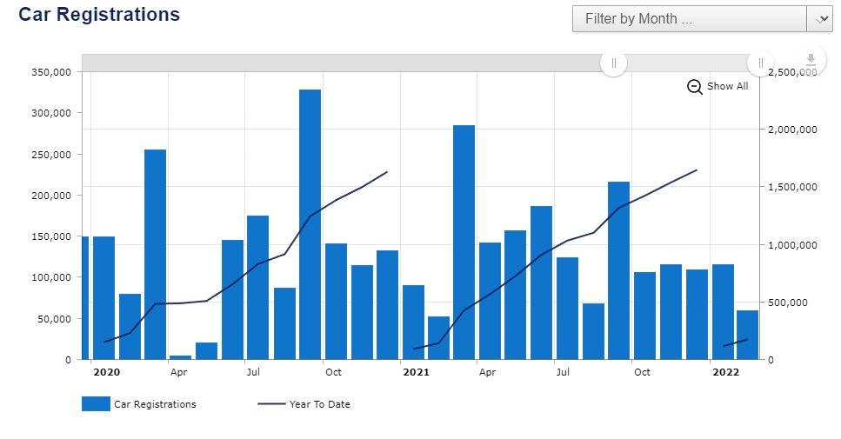
Figure 1:Car registrations rate in 2020 and 2021
Source: (Vehicle Data - SMMT, 2022.
With the lockdown restriction being eased and guidelines imposed again, the sales level has dropped even further than the pre-covid state. Potential automotive buyers who did not think to buy before have dropped the demand by 18%. Last year, Japan, Germany, and China were the world's top vehicle producers, with China claiming a first place as the most prominent global vehicle manufacturer, with over 21 million automobiles rolling off the mass production in 2020, accounting for about a third of global automobile supply (Covid-19’s impact on the automotive industry worldwide, 2022).

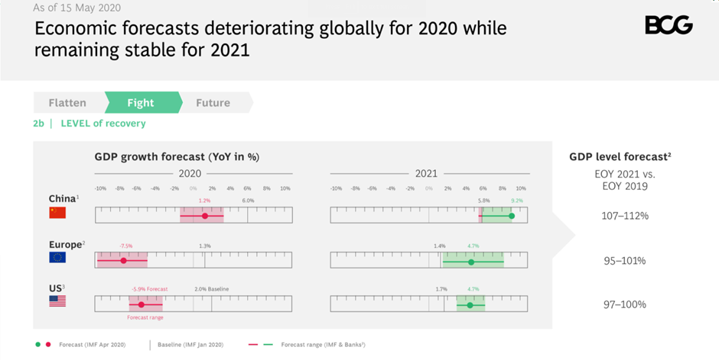
Figure 2: Figure 2:Economic Forecasts deteriorating globally for 2020 while remaining stable for 2021
Source: (COVID-19’s Impact on the Automotive Industry, 2022)
The industry has shown some incredible durability as it has been able to recover from the economic recession in recent months by selling newly manufactured vehicles in countries like China, the USA and Europe (Li et al., 2020). The pandemic condition around the world has not yet phased out entirely. Some considerable risks suggest that Europe and the USA still need time to recover from the pre-covid situation, possibly by 2023. However, China's economic recovery has progressed, with new vehicle sales expected to surpass 30 million by 2025. (COVID-19’s Impact on the Automotive Industry, 2022).

The company: Toyota Motor Corporation
The company faced disruptions and inactivity during the spread of the coronavirus worldwide. After roughly a dozen workers contracted COVID-19 at a plant in Japan, Toyota Motor Corp. paused most operations, contributing to the chaos in China, where a significant plant has been closed for more than a week to cope with the country's widespread testing efforts (Toyota Motor Corporation, 2022). Toyota Motor Corp. reduced its production projection for the financial year across March by approximately 3%, to 9 million units from 9.3 million, reflecting the coronavirus outbreak in Southeast Asia. In September, Toyota altered its production plan while maintaining its financial year profitability ratio projection of $2.5 trillion ($22.7 billion) (Toyota COVID-19 disruptions deepen with another plant hit by the virus, 2022). In 2020 during the spread of the coronavirus, 70,000 units’ worth of production reduced in September and 330,000 units in October. Prior to the statement, the company's stock had edged up 0.6% (Toyota Motor Corporation, 2022). Due to continuing chip shortages afflicting the auto industry, Toyota is very unlikely to reach its goal of producing 9 million units this financial year. The company's stock dropped 5% on March 2022, its worst drop since December 2018. In order to increase the sales level, the production and manufacturer have to be innovative, creative and imaginative. As consumers are gradually adopting digitalization in the coming years, effortless digitalization may also become a realistic approach for corporations to gain market share (The economy amid COVID-19 than during the Great Recession, 2021). The world is changing, and as the pandemic has brought some changes into the lives of humankind, vehicle manufacturers should invest in the improved efficiency of the global supply chain and automated vehicles production (COVID-19’s Impact on the Automotive Industry, 2022).

Business Environment Analysis
In order to analyze the business environment for Toyota Motor Corporation, it is necessary to conduct a thorough PESTEL analysis that allows identifying the key factors such as political, environmental, technological, social, Etc. that have been influencing or affecting the business operations of Toyota.
Political Factors – As Toyota is a global brand, the company has to keep in mind that it encounters global influences. The company has to plan their strategies and movements based not only on the political influences of the home country but also the global political situation. For instance, Toyota planned to invest around 70m in Thailand in 2014; however, due to political instability, they had to readjust their investment plans and focus on investing in other countries (Davis, 2021). Also, the conflict between China and Japan impacts the business environment for Toyota on the global aspects as China has one of the largest tech and industrial economies currently.
Economic Factors – The automotive industry is a very competitive field; Toyota has to compete with global brands like Ford, BMW, Tesla Etc. in order to survive within the market. Due to the pandemic, by the end of 2020, Toyota's annual revenue had dropped 13.59% to $241.196b. The company generated around $13.280b of the net profit, a 23.47% drop from the previous year (Davis, 2021). The frequent fluctuations in fuel prices also make people shift their interest in electric vehicles, an excellent opportunity for Toyota.
Social Factors – Due to faulty fuel pumps, Toyota recalled around 700,000 units globally. Apart from this, when the safety features on some Toyota automobiles failed due to a malfunctioning accelerator and pedal system endangering some customers, it damaged the brand credibility of Toyota. However, the company introduced the "Innova" model in the economic market like the Indian market, which helped recover the brand image as it was a low priced model for a price-conscious market (CORPORATION, 2022). Apart from this, there is an opportunity for Toyota if they can shift to electronic vehicles at low prices.
Technological Factors – Toyota brought the first hydrogen car in the industry. The goal was to satisfy the market's expectations. It is constantly on the top point of innovation. It has enabled the organization in maintaining a competitive advantage in the worldwide market. Above all, by committing to the basic formula of constant progress, which has been possible only by the advancement of technology. (Fernando, 2011).
Environmental Factors – The company is very familiar with the global and environmental challenges it might face in the future. As the business always wanted to address the environmental factors and issues, they are producing hydrogen, hybrid and electric vehicles. In 2015, the company published its long-term sustainability strategy for 2050, which includes measures like zero carbon emission, maximizing the water usage optimization and recycling-based sustainable system (SCHAFFER, 2020).
Legal Factors – Recalling the faulty vehicles enraged the customers, and they filed a lawsuit against the company, which eventually cost the company around $1.2b to settle this dispute. The company must abide by the legal rules and regulations globally and in the home country (Lusthaus, 2021). Any legal dispute can affect the company financially and impact its brand image within the market.

Megatrends and its Utilization
Megatrends refer to the idea of a substantial macro-environmental growing factor that is projected to have a significant impact on the types of items buyers would desire to buy, which is referred to as a movement, pattern, or trend. For millennia, megatrends are huge, revolutionary factors that can potentially affect the world economy, business, and society that have transformed the way of life (Megatrends, 2022). The megatrends have been influencing the structure and the future production plans of the automobile industry. In order to improve the impact of the pandemic, the current megatrends that are affecting companies like Toyota and how these factors are going to help the company in order to develop their success and survival factors are discussed below –
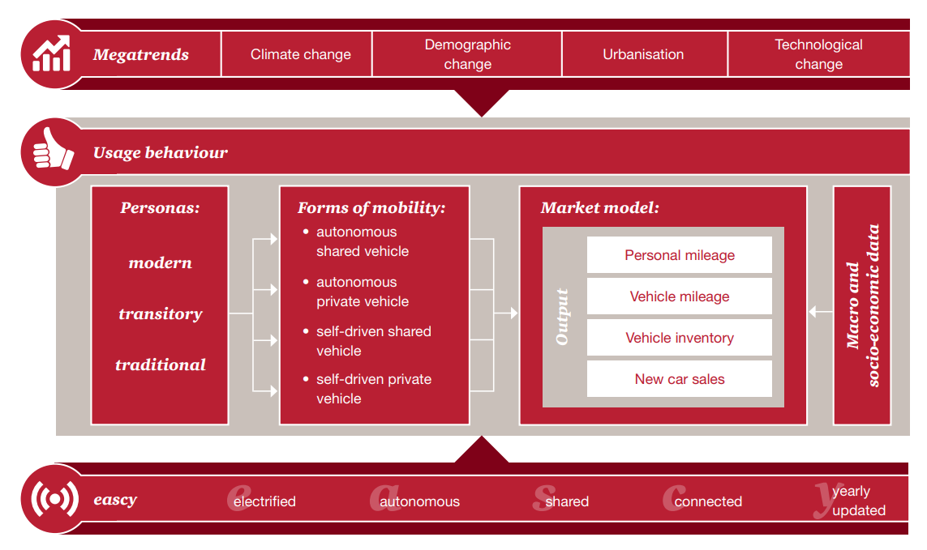
Figure 3: Figure 3:Current Megatrends of the Automotive Industry
Source: (Five trends transforming the Automotive Industry, 2022)
Climate Change – With the increasing population worldwide, the usage of vehicles is also increasing simultaneously. Which is eventually contributing to global carbon emission. The car manufacturers are innovative and figuring out strategies to reduce carbon increases on the earth's surface due to the heavy usage of vehicles. Toyota has already contributed to reducing carbon emissions by introducing hydrogen and hybrid cars to their consumers. In order to further improve their position in the global market, they need to adopt eco-friendly measures to manufacture their products which will help them ensure success and increase their rate of survival within the industry (Climate Change Reshapes the Automobile Sector, 2022).
Demographic Change – In the era of globalization, lifestyles are constantly changing worldwide. Toyota has always prioritized the user experience among the other factors. In order to compete with the global demographic change, they need to analyze the change in demographics properly, what their users require and what measures they can take to increase their brand loyalty (Gao, Kaas, Mohr and Wee, 2022). As they have a brand image of providing budget-friendly vehicles to their consumers, analyzing consumer behaviour and the current market trends will allow them to ensure their success within the industry.
Urbanization – People around the globe is more focused on mobility as the increasing use of eco-friendly and electric vehicles. The urban areas are the main target for this megatrend. Toyota has reached almost all the major cities of the world. They have a brand image with a considerable number of consumers. With the increasing urbanization worldwide, Toyota has a competitive advantage within this sector. It is an opportunity for the company to attract new consumers with their sustainable, environment-friendly vehicles. This will help increase their success rate and ensure their survival within the automotive industry (Gao, Kaas, Mohr and Wee, 2022).
Technological Changes – The world is changing through the eyes of ever-evolving technologies. The mass people are adopting the technology changes, and the reliability of technology will increase a lot in the coming future. By digitalizing their manufactured vehicles, Toyota will have a competitive advantage within the market, which will guide their paths to success, and there are no other alternatives in order to survive within the industry other than digitalizing their vehicles along with their manufacturing processes (Automotive Megatrends and Markets, 2022). The megatrend connection includes two essential aspects: automated driving and AI technology. Completely automated driving is a primary technological target for all automotive manufacturers. This implies the adoption of new technologies such as AI and machine learning in the automotive industry. Although it can be a slow process, however, Toyota has a brilliant opportunity in this sector to manufacture more sustainable vehicles considering the improving eco-system (Five trends transforming the Automotive Industry, 2022).

Conclusion
There is a huge opportunity waiting for Toyota to grow more prominent; however, the completion within the industry will be more intense. Even though the world is being more reliant on technology and Toyota has an excellent opportunity to survive and be successful within the industry, these opportunities come with a handful of challenges. For instance, following the megatrends and achieving the industrial goals can be very time consuming, and the company needs to be consistent with its improvements despite the falling margins. The changes will allow the company to ensure safety and security to their loyal consumers even though there will be loads of complexity and controlling issues. These megatrends are the future of this industry; the company should already develop techniques and strategies to reach its sustainable goals. Ensuring their quality and adapting to the changes through the challenges will allow Toyota to leave a mark in the industry and ensure their success.

Recommendation
After completing the report and analyzing the entire business environment for Toyota few recommendations are mentioned below in order to survive and increase the success rate within the global market –
- They are developing new and sustainable business models to adapt to changing economies and trends.
- They are adopting new technologies and implementing them in their business models.
- Ensuring quality of the vehicles, they are manufacturing
- Introducing more fuel-efficient cars in order to utilize the Asian market potential.
- They are focusing on the Asian market by expanding their production plants to reduce production costs.

References:
2022. Five trends are transforming the Automotive Industry. 1st ed. [ebook] Available at: <https://www.pwc.at/de/publikationen/branchen-und-wirtschaftsstudien/eascy-five-trends-transforming-the-automotive-industry_2018.pdf> [Accessed 20 March 2022].
BCG Global. 2022. COVID-19’s Impact on the Automotive Industry. [online] Available at: <https://www.bcg.com/publications/2020/covid-automotive-industry-forecasting-scenarios> [Accessed 20 March 2022].
BlackRock. 2022. Megatrends. [online] Available at: <https://www.blackrock.com/sg/en/investment-ideas/themes/megatrends> [Accessed 20 March 2022].
Blog | EU Business School. 2022. How has COVID-19 Impacted International Business? [online] Available at: <https://www.euruni.edu/blog/how-has-covid-19-impacted-international-business/> [Accessed 20 March 2022].
CORPORATION, T., 2022. Company | Toyota Motor Corporation Official Global Website. [online] Toyota Motor Corporation Official Global Website. Available at: <https://global.toyota/en/company/?padid=ag478_from_header> [Accessed 20 March 2022].
Davis, R., 2021. Toyota cuts production forecast by 300,000 cars on COVID-19 and chips shortage. [online] The Japan Times. Available at: <https://www.japantimes.co.jp/news/2021/09/10/business/corporate-business/toyota-production-slow/> [Accessed 20 March 2022].
Encyclopedia Britannica. 2022. Toyota Motor Corporation. [online] Available at: <https://www.britannica.com/topic/Toyota-Motor-Corporation> [Accessed 20 March 2022].
Faistgroup.com. 2022. Covid-19’s impact on the automotive industry worldwide. [online] Available at: <https://www.faistgroup.com/news/covid-19-impact-automotive-industry/> [Accessed 20 March 2022].
Fernando, A., 2011. Business Environment. Pearson India.
Gao, V., Kaas, H., Mohr, D. and Wee, D., 2022. Automotive revolution – perspective towards 2030. [online] https://www.mckinsey.com/. Available at: <https://www.mckinsey.com/industries/automotive-and-assembly/our-insights/disruptive-trends-that-will-transform-the-auto-industry/de-DE> [Accessed 20 March 2022].
Li, X., Wang, B., Liu, C., Freiheit, T. and Epureanu, B., 2020. Intelligent Manufacturing Systems in COVID-19 Pandemic and Beyond: Framework and Impact Assessment. Chinese Journal of Mechanical Engineering, 33(1).
Ltd, R., 2022. Automotive Megatrends and Markets - Global Sector Overview and Forecast (Q3 2021 Update). [online] Researchandmarkets.com. Available at: <https://www.researchandmarkets.com/reports/5448611/automotive-megatrends-and-markets-global-sector?utm_source=BW&utm_medium=PressRelease&utm_code=4xzm7r&utm_campaign=1601628+-+Global+Automotive+Megatrends+and+Markets+Sector+Overview+Report%2c+Q3+2021+Edition&utm_exec=chdo54prd> [Accessed 20 March 2022].
Lusthaus, C., 2021. Organizational assessment. Ottawa: International Development Research Centre.
Oica.net. 2020. 2020 Statistics. [online] Available at: <https://www.oica.net/category/production-statistics/2020-statistics/> [Accessed 20 March 2022].
Pew Research Center. 2021. The economy amid COVID-19 than during Great Recession. [online] Available at: <https://www.pewresearch.org/fact-tank/2020/09/14/in-many-countries-people-are-more-negative-about-the-economy-amid-covid-19-than-during-great-recession/> [Accessed 20 March 2022].
SCHAFFER, R., 2020. INTERNATIONAL BUSINESS LAW AND ITS ENVIRONMENT. [S.l.]: CENGAGE LEARNING.
SMMT. 2022. Vehicle Data - SMMT. [online] Available at: <https://www.smmt.co.uk/vehicle-data/> [Accessed 20 March 2022].
Spglobal.com. 2022. Climate Change Reshapes the Automobile Sector. [online] Available at: <https://www.spglobal.com/marketintelligence/en/news-insights/blog/climate-change-reshapes-the-automobile-sector> [Accessed 20 March 2022].
The Japan Times. 2022. Toyota COVID-19 disruptions deepen with another plant hit by the virus. [online] Available at: <https://www.japantimes.co.jp/news/2022/01/20/business/corporate-business/toyota-covid-disruption/> [Accessed 20 March 2022].

