Lecturer: Lizeta Demetriou

Student Name: Winston Morrison
Candidate Number /Student Number:2337238
Module Code: LCLM4001
Module Title: Academic Skills

Reflective Report
22/08/2024

Table of Contents
0
1 Introduction 2
2 REFLECTION 3
2.1 Note-Taking 3
2.2 Paraphrasing 4
2.3 Reflection 5
Conclusion 6
Bibliography 7
Appendices 8

1 Introduction

In this report I will be writing about my experiences and feelings towards, note taking, paraphrasing and reflection. I will describe how I approached my note taking in a manner that would make it easier for me to be able to clearly understand the notes I have taken, to be able to refer to these notes when needed and to be able to use and retain important information from my notes. I will also discuss how I learnt that paraphrasing is one of the most important steps in academic skills in order not to unintentionally plagiarise or copy someone else’s work and be able to summarise in my own words according to my understanding. Finally, I will discus how important reflection is in academic setting and how reflecting can lead to wanting to ask more questions and finding more answers as well as giving time to better understand the topic of my reflections. I have chosen to use the Gibbs model which contains 6 stages for learning from experience (Gibbs, 1988) for this task as I find it to be a clear and concise way to explain my thoughts and experiences in my learning thus far.

2 REFLECTION

2.1 Note-Taking

My journey with note taking began with my current course in week 2. We learnt about different note talking methods and ways such as Diagrammatic, tabular, Linear and Cornell notes (Brookes, 2015).

I found the different methods and tools of note taking to be very interesting but unfortunately, I sometimes felt lost, confused or even frustrated with some of the tasks.

Despite having mixed experiences and thoughts on these methods, I am glad to have learnt and see them all as a couple have become my routine in note taking

The reason I think my experience at first was mixed and sometimes a little unstable is because I have not studied or needed to take notes like this for a long time. I felt as though the vocabulary was at times tricky which caused me to be a little slow and feeling unproductive. That made me frustrated but as much of a challenge this proved to be, I quickly realised how much learning these methods could help me moving forward in my studies.

From this viewpoint, I learnt that perseverance is a must and that being able to see how this could be useful to me gave me an extra push to learn how to make at least one of these methods work for me in class and with my home studies.

I am now able to transfer this skill to my other classes and I know they will always be helpful to me going forward especially using the method I found more effective for me, the Linear (see appendix 1).

2.2 Paraphrasing

In week 4 of the academic skills module we learned the topic of paraphrasing. Paraphrasing is the act of explaining another person’s idea in your own word.
Paraphrasing I found to be challenging as I didn’t understand at first why paraphrasing is so important. I did however realise how necessary it is to provide clarity when relaying information of how much I understood from what I read or heard.

My challenge with paraphrasing was vocabulary. I need to broaden my vocabulary to explain written or spoken work that will show my level of understanding and how I am able to explain in my own words without unintentionally plagiarising or just repeating.

I got to understand that paraphrasing is an essential part of everyday communication and of which we use very often to state something that was either written or spoken in altered words, especially to shorten and make the meaning clearer (TUS, 2024). We all seem to use paraphrasing without even noticing through speech.
I decided I needed to read more and use a thesaurus, to help develop my vocabulary, to be able to summarise in my own words, which will sometimes give a shorter but an effective explanation or information in classes or in any written work I must provide. Please see appendix 2.

Moving forward I will continue to improve my vocabulary and read material thoroughly to show how much I understand and for clarity in my work.

2.3 Reflection

Preparing this assignment required a lot of reflection from me. Currently, going through the topics above have shown me how far I have come and how proud I feel of myself. Reflection is the act of looking at something that happened in the past and in the process learn from it.

Reflection was a much-needed tool learning my academic skills. It is incredibly useful when going back through all my notes and all that we have learned in this module.

Being able to reflect has proven to be a major part in the process of learning. It made me think of how I was going to approach this task and opened the question to how much I have learned and understood this module or if there is anything I need to work on in my studies further, what I can change, what more can I add or if there are any other method or tool I can implement to help me grow as a student.

I read through my notes and used some of the tools I learnt in note taking to prepare and plan which topics I would write about. Doing that helped to make my reflection process easier.

To grasp even further the concept of reflection I aim to read more resources highlight the important information, aim to use that important information to help construct any work I must do in a style which is more coherent or help me to prepare for quizzes and in class work.

Conclusion

On reflection, academic skills have so many different topics, areas and methods which will be instrumental in my studies going forward. Looking back at how unaware I was about most of these skills and how much learning them has helped me so much already makes me want to approach more of the methods that I haven’t yet tried and mastered. For example, the other methods of note taking such as Tabular or Diagrammatical notes. Even just realising that almost daily, we use paraphrasing without even realising made me less fearful and more confident using it in written work. Seeing how all these topics flow together and need each other through my own reflection on academic skills is helping me to be more open to learning how I also can use them to mould my future actions as a student. I will be using what I have learnt in all areas as they are not limited.

Bibliography
Brookes, O 2015. Oxford Brookes University. [Online]
Available at: https://shop.brookes.ac.uk/product-catalogue/oxford-centre-for-staff-learning-development/books-publications/ebooks/learning-by-doing-a-guide-to-teaching-and-learning-methods-by-graham-gibbs-ebook
[Accessed 20 august 2024].
Gibbs, G., 1988. Learning by doing: A Guide to Teaching and Learning Methods. 1st ed. Oxford: Further Education Unit at Oxford Polytechnic.
TUS, 2024. Library Guides. [Online]
Available at: https://lit.libguides.com/paraphrasing
[Accessed 20 August 2024].

Appendices

Appendix 1
class work notes on Note-taking (Linear)
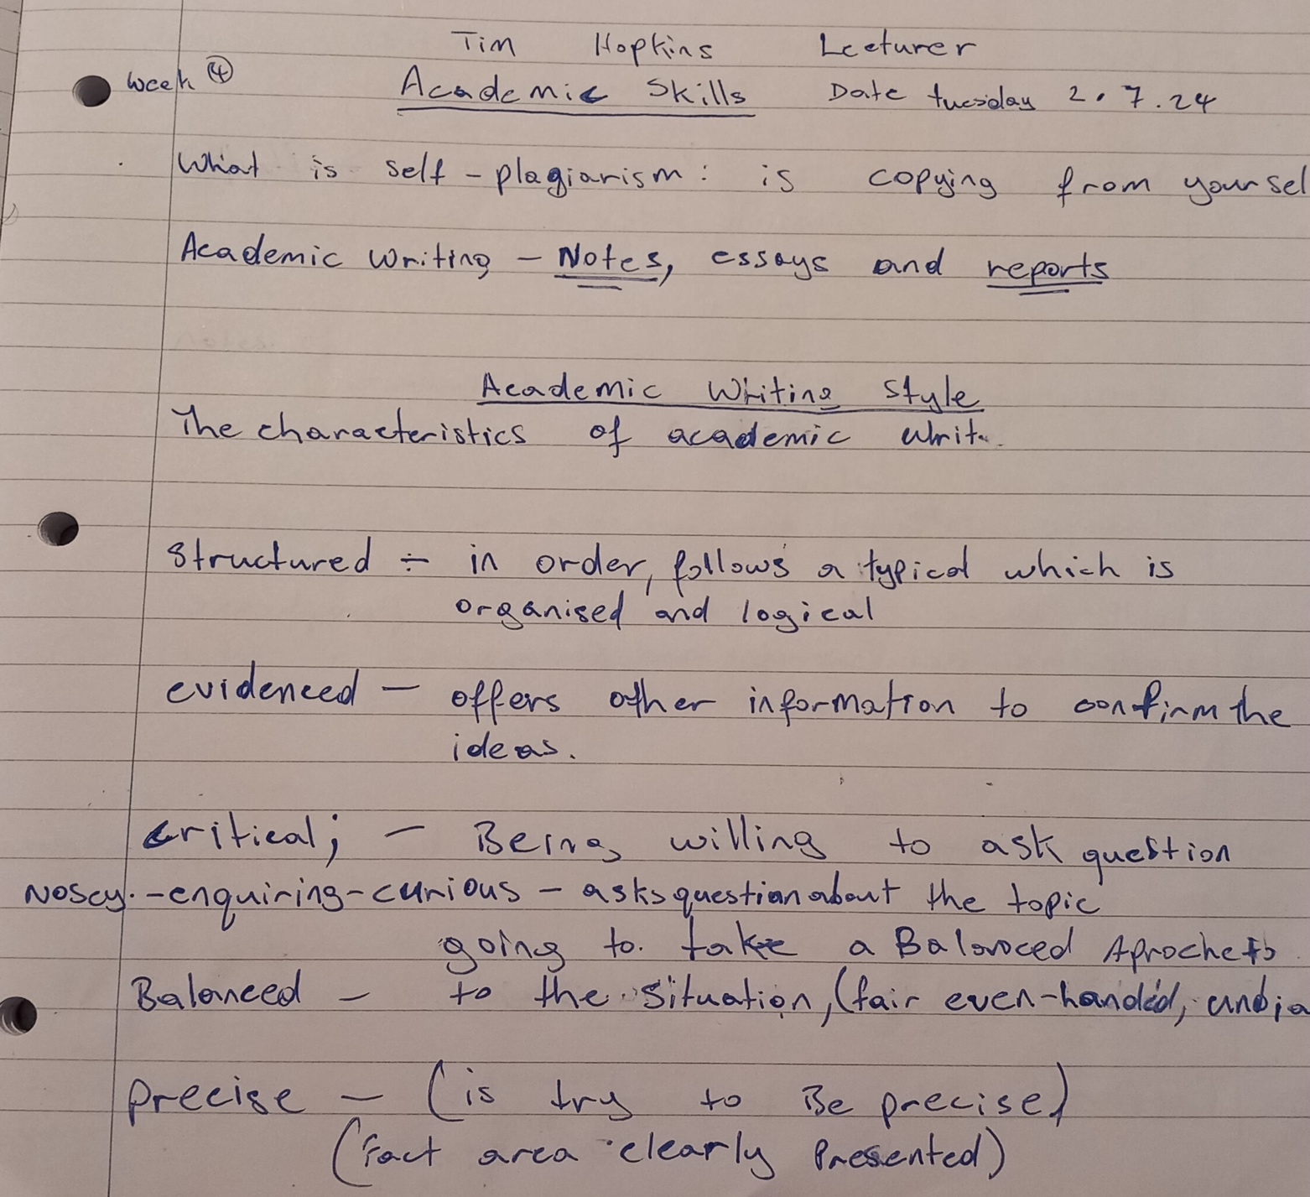

Appendix 2. note-taking on Paraphrasing


