Cynllun Gwers / Lesson Plan
Dosbarth:  Bl./Yr. 5 |  | Dyddiad/Date:  3/ 5/ 2024 | Nifer o ddisgyblion/No of pupils: 10  Mixed Ability / Gallu Cymysg |  | Hyd y wers (mins)/Length of time for lesson: 45min |  | Subject specific language / Geirfa pwnc penodol  English
Adnoddau: flags and stamps, stamping cards, maps of university, symbol cards, compass trails |  |  |  |  |  |  |  | Asesiad risg yn atodol / Health and Safety Attached
Deilliant Dysgu / Learning Outcome: To understand the basics of a compass and orentering.

Lesson Structure / Strwythur Gwers
Time  Amser | Activity Sequence / Trefn y gweithgareddau |  |  | Organisation / Trefniant |  | Teaching and learning  Methods  Dulliau Dysgu ac Addysgu |  |  | Points to Remember  Pethau i gofio | Assessment Focus  Ffocws yr Asesu
15-20 Minuites | Warm-Up/Introduction / Cynhesu a Chyflwyniad  - Pulse Raiser and an introduction to compass points. Encouraging movement to various compass points by running and hopping for example and gaining an understanding of students current knowledge. Add additional compass points (NW, SW for example to further knowledge.  2) Applying new knowledge of compass points to navigating a small course by working individually and in pairs. Teachers offer support yet also encourage individual work.  3) Finally an introduction to map symbols before heading into the main activity. Allow teamwork and individual work to learn about symbols often found on a map. Repeat this 2-3 times (depending on speed of groups).  All children are expected to engage if able to and knowledge will be assessed by asking question such as “where is north?” before it is explained.  The warmup provides students with knowledge that will be suited to the main task. For example, if a required point within the main task is by a pond they will learn that symbol in the warm up game and therefore may allow them to find it with more ease. |  |  | Resourses, whos leading ect  - Maddie Leads  - Signs with North, East, South and West  - EllisLeads  - 9 Cones  - N, E, S, W signs  - Cards with directions  - Nia  - Symbol relay kit |  | - Command Teaching Method – what does this teaching method include?  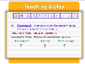  - Practice Teaching method – what does this teaching method include?  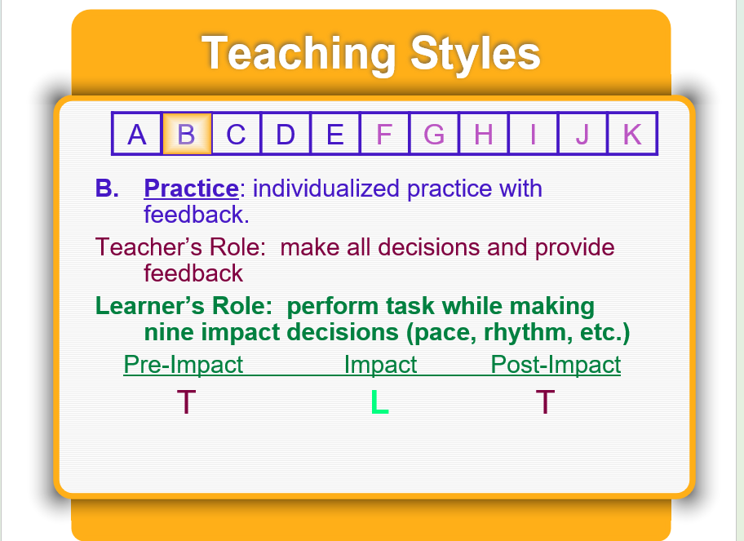  - Reciprocal and command teaching method – what does this teaching method include?  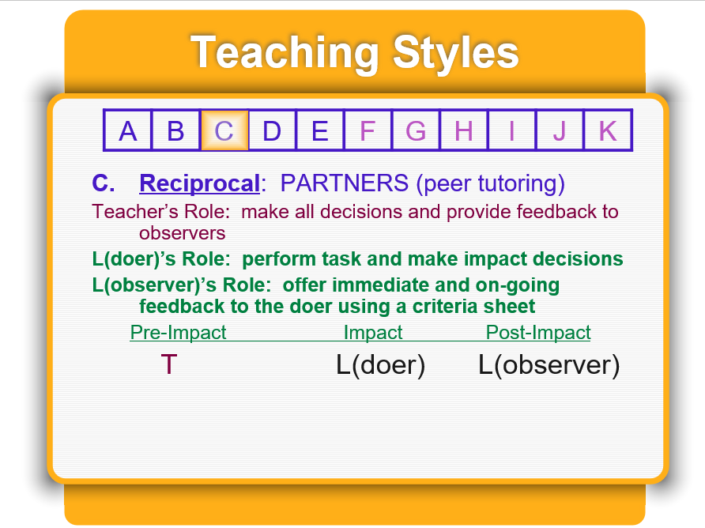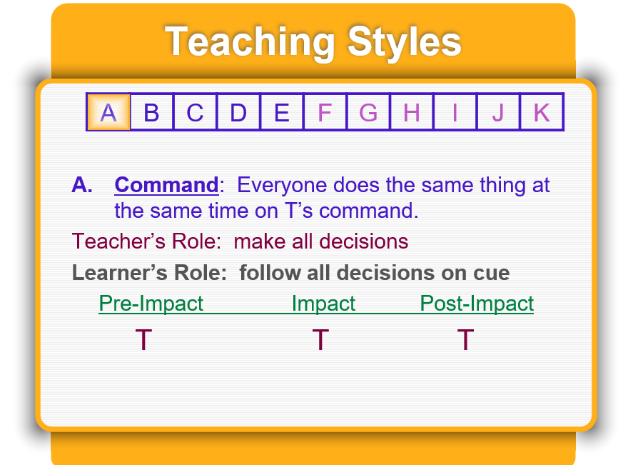 |  |  | - Intro into compass points and map symbols  - Keep it fun  - Keep it engaging  - Introduce nw/ sw/ ne ect so it leads to game 2 | Questions throughout and at the end of the sessions to ensure learning objective is met
 | Development / Datblygiad  The maps were marked with ten different locations  The students were split to pairs and given a marked-out mat between them  At each location we had the stamping cards for each partner to show they had been to every station as each stamp is a different symbol  Encourage looking at the symbols on map and use compass work to be able to find the exact location from using knowledge learnt from the previous activity's |  |  | Nia and Maddie explain the task.  Maddie hands out maps and whole punchers.  Elis explains safety risks. |  | Command style approach to ensure that students understand the task and can execute it safely  Also used individual learning as they guided themselves and their group to the locations we set |  |  | - Symbols  - Compass directions | Reading and understanding how to follow a map
 | Warm Down / Conclusion/ Review /  Gather students together and question knowledge previously learnt For example, what is the symbol for a tree? Where is a pond on the map?  Did knowledge of this help you find your designated points? Have a group discussion surrounding this.  Then discuss how they found the session. Did they enjoy it? What was their favourite part? What would they change? How could they bring orienteering back to school? |  |  | Led by all to work together
Contingency Activity (what if?)

If there was rain, possibly extend the indoor activities and make the main activity shorter to prevent students getting wet and cold for a prolonged period. Alternatively, all indoor warm up activities can be completed outdoors.

Risk Assessment
Hazard | Who is at risk | Severity | Likelihood | Controlled Measure | Controlled Risk
Collisions | Participants | 2 | 2 | - Make everyone be extra careful.  - Allow lots of room between each group for running games.  - Split groups up | 1
Roads | Participants | 3 | 2 | - Set clear boundaries.  - Strict rules to not go on the road | 1
Trips | Participants | 2 | 3 | - Encourage sensible behaviour | 1
Exclusion | Participants | 3 | 2 | - Be inclusive.  - Have games that everyone can take part in  - Set appropriate groups (no more than 3s) | 1
Lost child | Participants | 3 | 2 | - Everyone must have a partner when outside.  - Multiple staff members keeping an eye on children.  - Staff members in positions of most usefulness | 1
Dehydration | All Involved | 3 | 3 | - Ensure access to water.  - Ensure everyone had water bottles/ cups | 1
Weather | All Involved | 2 | 2 | - Have back up plan  - Have appropriate Clothing | 1
Punches | Participants | 1 | 3 | - Brief them properly on how to use the punches.  - What not to do | 11
Wet Feet | Participants and staff | 2 | 3 | - Ensure they have appropriate footwear and clothing. | 1

Reference list

Spectrum of teaching styles (2021) Learning focuses. Available at: Command Style-A (spectrumofteachingstyles.org) Accessed: 20/04/2024

Teach thought (2021)What Is Reciprocal Teaching? Available at: Reciprocal Teaching: A Definition (teachthought.com) Accessed: 24/04/2024

The PE project (2023) Teaching styles. Available at: Teaching Styles In Physical Education | The PE Project Accessed: 20/04/2024.

The sport EDU( 2021) The Spectrum of Teaching Styles: The Command Style. Available at: The Spectrum of Teaching Styles: The Command Style (a) (thesportsedu.com)
Accessed: 20/04/2024

T

