
Fuji (Chinese Spirit-Writing) 扶乩


Sylvie Lu
(2124842)

Grassroots Chinese Religions
Essay # 1

Fuji(Chinese:扶乩; pinyin:fújī;Wade–Giles:fu chi) is Chinese spirit-writing, a form of divine revelation in Chinese popular religion. The whole process of fuji is a way of communication with gods or deities through the spirit medium who is possessed by the spirit of divine. Though the communication is mostly with gods or deities, there are also cases where the aim is to communicate with one's deceased family member. The messages from divine through the spirit medium will be written on a sandbox or on sheets of paper. People usually go to spirit-writing for inquiry on career, healing, and knowledge of future events from gods or deities.
Fuluan (扶鸞) is another term for spirit-writing which metaphorically refers to the holding onto the messenger of divine. Luan (鸞) is a mythical bird of the species of phoenix. It was considered a divine bird and a messenger of gods in Han (202 BCE- 9AD, 25-220 AD) and Jin (266–420 AD) dynasties. In the Chinese mythology ‘Classic of Mountains and Rivers’ (山海經), “luan is the spirit of God with a form of chicken in five colors including red. Luan produces five different tones when crowing.” Thus, the term luan is the metaphor of the messenger of gods.
The Spirit-writing ritual
Ritual is important in spirit-writing. It involves the setup, spirit medium, reciter and logger in the ritual. Before the spirit-writing ritual begin, a table (鸞臺) with a sandbox or sheets of paper on top is set up in front of an alter with a Y-shaped pen (鸞筆), which is made of peach or willow wood. Nowadays, regular pens are also used. The spirit-writing group consists of one or two mediums (鸞生) standing in front of the table holding the Y-shaped wooden pen with the head pointing to the altar. Only the worthy to serve the god’s spirit-writer be chosen to wield and inscribe god’s messages. (Liu 42)
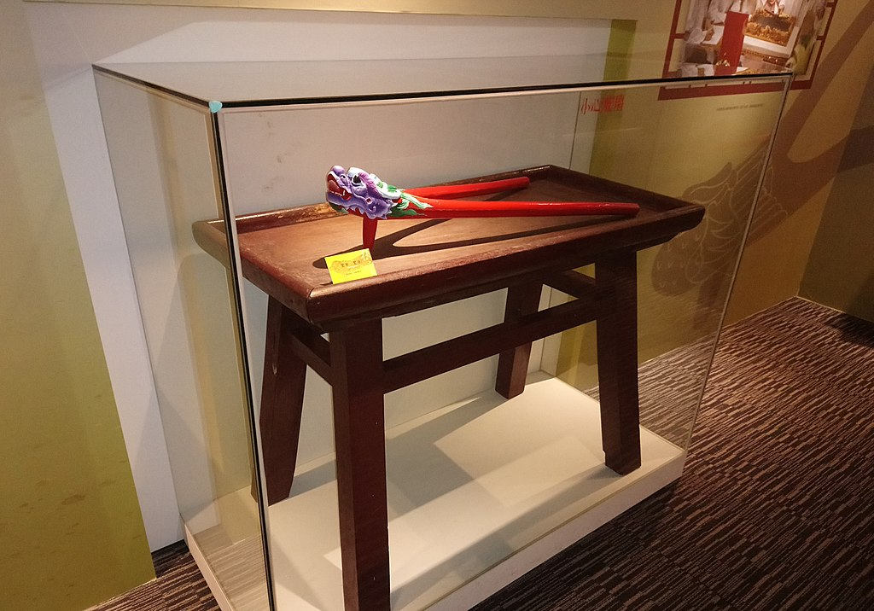
Fig. 1 - The wooden luan pen
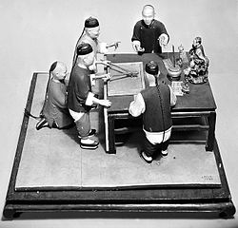
Fig. 2 - Spirit-writing ritual
Incense offering is made by the medium to invite the god or deity whom the medium is affiliated with. The séance starts when the spirit of the invited god or deity enters and possesses the medium’s body. The inquirer would consult the spirit, and the spirit will move the arm of the medium and print words on the sandbox or paper with the pen. The reciter read out loud word by word written on the sandbox. The scribe records the scribbles or messages into a notebook. Nowadays, transcribing can be done digitally onto a computer. (Liu 28-30)
The Modalities of spirit-writing
There are many religious frameworks or models for understanding religion. Most of them are generic frameworks that cover for a good range of religions from Abrahamic religions to different Buddhist traditions. Adam Chau’s five modalities of ‘doing religion’ is a religious framework tailored for the study of the diversity of religions in China. They are:
- Discursive/scriptural modality.
- Personal cultivation modality.
- liturgical modality.
- immediate-practical modality.
- Relational modality. (Chau, Ties 25)
Spirit-writing is the core of the deity-worshipping popular religion in China. Studying spirit-writing helps to understand the nature and functions of popular religion. Chau’s modalities of immediate-practical, scriptural and liturgical apply to spirit-writing. The key concepts of the immediate-practical modality are ‘magic’, ‘efficacy’ and ‘quick result’. (Chau, Ties 29) Spirit-writing can be said to aim at quick results using simple ritual and magical techniques. Some temples of popular religion offer spirit-writing divination to those who seek to foreknowing the future events, to cure ailments, etc. to solve their immediate problems. The ritual can be considered magic with a séance that invites the spirit to possess the body of the medium. In a trance, the spirit of god through the body of the spirit medium answers questions from the inquirers by writing answers on the sandbox or sheets of paper.
The efficacy of the spirit is based on the accuracy of the outcomes from the spirit’s prediction or advice. The advice from the spirit sometimes can help change the course of actions of the inquirers which can lead to a more accurate outcomes from the prediction of the spirit medium. It is a pre-emptive move from the inquirer to avoid undesirable or disastrous things to happen. In this case efficacy is not important to the inquirers, whether the spirit medium is genuine or bogus. It also helps the inquirer to solve the problem quickly by modifying actions and situations. The efficacy of the spirit also determines the funding for a temple. In Shaanbei village, for instance, villagers would build a temple to worship a deity, but the maintenance and expansion of the temple would depend on how efficacious the deity is. (Chau, Miraculous 52)
Spirit-writing can be a scriptural modality. While a lot of spirit-writing groups mainly interested in providing divination to individual needs, some spirit-writing groups took on the task of producing religious texts (寶卷) and morality books (善書). Texts produced by spirit-writing groups varied from liturgies texts such as liturgies for funerals, to self-cultivation books, to morality books that provide guidance on moral actions, and to religious sutras with a full-fledged doctrine of salvation integrating different Buddhist, Confucian and Daoist elements. (Goossaert 105)
In the 19th century, spirit-writing also produced increasingly eschatological texts on saving humanity from the turning of the kalpa. These texts have shown that some of the people involved in spirit writing groups believed 1816 should have been the date of the great apocalypse. The texts also revealed that Guayin Bodhisattva and Doaist gods of Wenchang di and Lord Lu had pleaded with the Jade emperor to avert the apocalypse. Some texts also credited Guandi (關帝) for the aversion. (Wang 655) Unlike the Confucian, Daoist, and orthodox Buddhist scriptures which were teachings compiled by the disciples of their great leaders or sages, religious texts, morality books and eschatological texts were penned with logs from the spirit-writing ritual session, which can be accounted to the modality of liturgy.
The Psychology of Spirit-writing
Compared to the unity mystical experience as oneness with God or ultimate reality which described as blissful and joyful in Abrahamic or other Eastern religions, the religious experience of the medium in spirit-writing is different and powerful when the body of the medium is possessed by the spirit of god. Anthropologist Mayfair Yang took on the phenomenological approach to the spirit possession phenomenon and presented it exactly what the psychological impact of spirit possession had on the medium by interviewing the subject. Bronisław Malinowski (1884-1942) and Alfred Radcliffe-Brown (1881-1955) are both anthropologists and functionalists. The Malinowski’s psychological functional approach can explain the psychological aspects of the inquirers who attended the spirit-writing ritual, and the Radcliffe-Brown’s structural functional approach can apply to explain the fear of the inquirers in the ritual.
There is very little documentation on the psychological aspects of and impacts on the medium during and after his/her experience of being possessed by a god in a spirit-writing ritual. Their physical well-being, and conscious and psychological states from the mystical experiences are scarcely documented. Only messages from the spirit of the affiliated god will be recorded and compiled into texts. However, an interview of a female shaman Cao Jinling by anthropologist Mayfair Yang in January 2012 in Wenzhou China brings light to the harm that the possession of the spirit can cause to the medium’s mental and physical health.
With little education Cao started the shamanic divination when she was young. She is what Yang called the ‘reluctant spirit medium’. Yang recounted Cao’s spirit possession experience as the following:
Cao described the sensation of possession as ‘going crazy’ or ‘like getting drunk.’ When she awoke from her possessed state, people described her as looking ‘crazy and unsteady’. During her possession, her eyes were closed, as if sleeping, but her body was not shaking convulsively, nor did she have saliva or foam flowing out of her mouth. However, following each possession, she “hurt in her stomach and intestines,” and since she started getting possessed, she has lost a lot of weight. In her possessed state, people would talk with her, and she would reply, in a strange, eerily low voice, that she was the goddess Mother Chen the Fourteenth. Sometimes a voice would also tell Cao that she was the goddess Li the Thirteenth, the “shamanic sister” of Mother Chen. Cao was also possessed by Mother Chen’s two brothers, Fatong and Faqing; and by the Earth God, who often led the way for the other gods who possessed her. Each time she woke up from being possessed, she felt exhausted and could not remember what she did or said while possessed. (Yang 82-83)
Cao became ill at the age of fifteen. Her leg hurt and her whole body was weak that she could not work. Both Western and Chinese traditional doctors could not diagnose her illness. They saw nothing wrong with her. She moved to Taiyuan Shanxi province with her husband at the age of thirty-five to do business, but she fell seriously ill and started being possessed by spirits again, even though they were far from home. Cao’s husband discovered that in Taiyuan there were local people who also got possessed by local Wenzhou gods. (Yang 82) Cao said, “I never wanted to be a shaman, but for some reason, this is my fate.” (Yang 83)
To an inquirer in a spirit-writing ritual for divine consultation, the psychological impact is minimum. Instead, the spirit-writing ritual is psychologically functional for inquirers. Bronislaw Malinowski argued that ritual was a psychological tool to help us cope with life’s uncertainties (Hedges 280). This applies to inquirers who seek to foreknowing future events, to cure ailments, etc.… For acquiring religious or moral texts, spirit-writing is only functional for obtaining teachings from the spirit.
Does the spirit-writing ritual create fear as Radcliffe-Brown argued that rituals have a role in creating fears (Hedges 282)? It depends on the outcomes from the spirit-writing ritual. If the spirit gives propitious predictions, the ritual will dispel fear from the inquirers. Otherwise, it will not resolve the uncertainty, but increase fear, like Radcliffe-Brown said. The fear is personal for it relates to the inquirer only. Spirit-writing for acquiring religious texts would create fear and panic in larger groups of people, such as the eschatological texts obtained from the spirit-writing.
The Sociology of Spirit-writing
Spirit-writing has lost its lustre in the twentieth century as China became a secular state after the fall of the Qing Dynasty in 1911. The practice has been considered superstitious and banned by the Nationalist and Communist governments for social and political security issues. The advance in science and technology that changed people’s life and beliefs may lead to the decline of spirit-writing. Criticism from the Buddhist communities also had an impact on the spirit-writing practice. As sociologist Emil Durkheim (1858-1917) saw an inevitable linear progression from magic to science (Hedges 281), the decline in the practice of spirit-writing is also inevitable. Wong Tai Sin spirit-writing group in Hongkong and the Taiwan’s Unity Sect (Yiguandao) exemplified the decline of spirit-writing.
Leung Yan Ngam (Renan Liang) Started the Wong Tai Sin spirit-writing group in Guanzhou China in 1897. Since then, he had compiled revelations into two volumes of Jing Mimeng (驚迷夢) and Xing Shi Yao Yan (醒世要言), which means ‘Awake from Illusory Dreams’ and ‘Important Words to Awaken the World’ respectively. Since the situation in China deteriorated after the 1911 revolution, Leung brought his spirit-writing practice to Hongkong in 1915 and set up a temple with a spirit-writing altar of the Daoist immortal Wong Tai Sin，whose real name was Huang Chi Song (黃赤松). (Lang 315-316) Today, the temple no longer provides any spirit-writing ritual, and a Buddhist academy was set up for people to practice the Pure Land tradition, focusing on reciting the Buddha’s name. (zhang 3)
Another reason that spirit-writing has been abandoned in Wong Tai Sin temple was to give way of mass worship and other activities that respond to the changing market for supernatural consultation in the metropolis. Nowadays, fortune telling has replaced spirit-writing in the temple. People go there to pray and inquire the immortal Wong Tai Sin directly by shaking out a fortune-stick (簽) from a bamboo cylinder that will give them a poem. Some of them would go to the fortune teller to decipher the poem for answers. (Lang 326)
The Unity Sect, Yiguandao, is a syncretistic and salvific popular religion. It has its origin in the "Great Way of Former Heaven" (Xiantian Dadao) sect from which it branched out under the leadership of the fifteenth patriarch Wang Jueyi (1821 -1884). Unity Sect worships the "Unborn Venerable Mother" (無生老母), who is the cosmic mother that gave birth to everything in existence. A series of Buddhas is commissioned by the Unborn Venerable Mother to save humanity. Maitreya Buddha is the next savior to humankind. The difference between the Unity Sect with other sects is its heavy reliance on spirit-writing. (Clart 9-10)
Unity Sect first entered Taiwan in 1946 from mainland China as individual missionaries. With the collapse of Nationalist rule on the mainland, many more Unity Sect members followed the Nationalist government to Taiwan. Unity Sect was still banned in Taiwan for the accusation of being superstitious and a threat to national security. There was a battle to legalize the Unity Sect in Taiwan, and the ban was later lifted. Unity Sect became a legal institution in the 1980’s. (Jordan & Overmyer 217 & 247)
There are several causes to the decline of spirit-writing in the Unity Sect in Taiwan. Clart argued that secularization in Taiwan, as one larger process of modernization, has produced significant changes in institutionalization and commercialization of the popular religious sector (Clart 154). He also pointed out that the membership’s involvement of spirit-writing is low due to a large amount of time spent at spirit-writing séance, which takes up to ten days every month (Clart 153). In Taiwan, nearly all Unity Sect divisions discard the practice of spirit writing due to the skepticism of the validity of spirit-written messages. The most important factor contributed to the gradual decline of spirit-writing in the Unity Sect is that new revelation can easily cause religious schism. (Lu 100-101)
The criticism from Buddhist communities also helped to speed up the decline of spirit-writing in China at the turn of the twentieth century. The development and spread of heterodox Buddhist popular religions with spirit-writing had drawn criticism from scholars and Buddhist Sangha. Liang Qi Chao (梁啟超) (1873-1929), a famous contemporary revolutionary, thinker and educator, criticized spirit-writing as a superstition and poison to the mind of people (Fan 263). Buddhist monk Dharma master Yin Guang(印光大師) said, “spirits in the spirit-writing are spirits of ghost who disguised as certain Buddha or Boddhisattva or deity… If a benign ghost is invited [to the séance], it can be harmless. But if a malicious ghost is invited, there will be great troubles.” (Fan 282) Buddhist monk Dharma master Tai Xu(太虛法師), on the other hand, was more tolerant to the heterodox Buddhist popular religions. He argued that, allowing common people to become heterodox Buddhist adherents, then they will [one day] become Theravadins, and Theravadins will become Mahayanans. By following this way step by step, people can eventually generate proper wisdom to understand the Buddha dharma. (Fan 279)

Works Cited

Chau, Adam Yuet. “Introduction: Relationality at the Heart of Religion in China.” Religion in China: Ties That Bind. Cambridge: Polity Press, 2019.
Chau, Adam Yuet. Miraclous Response: Doing Popular Religion in Contemporary China. Stanford, California: Stanford University Press, 2006.
Clart, Philip. “The Phoenix and the Mother: The Interaction of Spirit Writing Cults and Popular Sects in Taiwan.” Journal of Chinese Religions, vol. 25, no. 1, 1997, pp. 1–32.
Fan Chun-wu - 范純武. “Jin Xiandai Zhongguo Fojiao yu fuluan”. 近現代中國佛教與扶乩[Buddhism and Planchette in Modern China]. Yuan Guang Buddhist Journal 圓光佛學學報. Vol. 3 (1992/02): 261-291.
Goossaert, Vincent. “Spirit Writing, Canonization, and the Rise of Divine Saviors: Wenchang, Lüzu, and Guandi, 1700–1858.” Late Imperial China, vol. 36, no. 2, 2015, pp. 82–125.
Hedges, Paul Michael. Understanding Religion: Theories and Methods for Studying Religiously Diverse Societies. 1st ed., Berkeley: University of California Press, 2021.
Jordan, David K., and Daniel L. Overmyer. The Flying Phoenix: Aspects of Chinese Sectarianism in Taiwan. Princeton: Princeton University Press, 1986.
Lang, Graeme, and Lars Ragvald. “Spirit-Writing and the Development of Chinese Cults.” Sociology of Religion, vol. 59, no. 4, 1998, pp. 309–28.
Liu Chih-Hao 劉智豪. “chuantong yu xiandai — lun taiwan luantang fuluan yishi ji qi bianqian yinsu” 傳統與現代—論台灣鸞堂扶鸞儀式及其變遷因素 Tradition and Modernity: A Study on the Rituals of Spirit Writing and its factors of change in Taiwan Phoenix Halls. 2009. University of Truth. MA dissertation.
Lu, Yunfeng. The Transformation of Yiguan Dao in Taiwan: Adapting to a Changing Religious Economy. Lanham, MD: Lexington Books, 2008.
Wang, Chien-ch’uan. “Spirit Writing Groups in Modern China (1840-1937): Textual Production, Public Teachings, and Charity.” Modern Chinese Religion II, vol. 32, 2016, pp. 649–84.
Yang, Mayfair Mei-Hui. “Popular Religiosity: Deities, Spirit Mediums, Ancestors, Ghosts, and Fengshui.” Re-Enchanting Modernity: Ritual Economy and Society in Wenzhou, China, Duke University Press, 2020, pp. 51–91. JSTOR, https://doi.org/10.2307/j.ctv11sn3xd.6. Accessed 20 Mar. 2023.
Zhang, Xue Song張雪松. “yinguang fashi yu xianggang huang da xian xinyang de duanzan yin yuan" 印光法師與香港黃大仙信仰的短暫因緣 The Short and Temporary Encounter of Dharma Master Yin Guang and the belief of Hongkong’s Huang Tai Sin. 田野與文獻South China Research Center. Vol. 48 (2007/07), pp. 1-8. https://schina-publication.hkust.edu.hk/zh/node/68.

《山海經》: “鸞，神靈之精也赤色五彩，雞形, 鳴中五音。
A kalpa (劫) is a long period of time (aeon) in Hindu and Buddhist cosmology, generally between the creation and recreation of a world or universe.

