Harnessing digital marketing for business growth: strategies and impact in the modern digital environment: A case study of Tesla and the electric vehicle industry

Lecturer : Dr Seyed Nasirpourosgoei

STUDENT: STEFAN-CRISTIAN COSTACHE
STUDENT ID: 2126833

Table of contents

1. Introduction 3
1.1. Research aims and objectives 4
1.2. Research questions 5
1.3. Justification 5
2. Literature review 5
3. Research methodology 8
3.1. Data collection 8
3.2. Data analysis 8
3.3. Limitations 9
3.4. Conclusion 9
4. Gantt Chart 10
References 11

Introduction

In the sea of continuous change in the digital environment, digital marketing has emerged as one of the most important means for enterprise growth. While social media, mobile technologies, and e-commerce have almost revolutionised conventional ways of marketing, making interaction with customers far livelier and offering very correct measures of the efficiency of a marketing campaign,. Digital marketing skills become relevant with changed consumer behaviour regarding the growth in the use of technological advancement and expose business in a dynamic competitive environment (Hennigs, Wiedmann and Klarmann, 2019).
It would, therefore, be able to identify how different ways enterprises can try to make use of digital marketing in development and then evaluate how such methods are effective in the present digital era. This research seeks to explain how businesses can leverage digital channels to analyse successful case studies, especially those related to acting, besides well-established industry best practices and emerging trends that will be of help in bringing improvement to online visibility, development of customer relationships, and creating new income (Saunders, Lewis and Thornhill, 2015).
This paper also embarks on the exposition of some of the challenges faced by organisations in implementing digital marketing strategies and some of the metrics that may be applicable in the measurement of effectiveness. The result of this research will give a guideline for any organisation that wants to strive in digital marketing, meet the ever-changing needs of customers, and grow in a sustainable way in the increasingly digital economy (O’Gorman and MacIntosh, 2015).

Research aims and objectives

This research aims to explore the variety of digital marketing strategies that can lead to excellent opportunities for growth, enabling businesses to stay ahead in the rising competition in the digital environment. This is especially because more and more companies transition to being online-based at an increased speed, hence establishing the importance of understanding digital marketing in creating sustainable growth (Saunders, Lewis and Thornhill, 2015).
The goals set forth in the research consequences are underlined below:
- Objective 1: To analyse the digital marketing strategies of Tesla and their efficacy in propelling brand awareness and customer engagement within the EV industry. This above objective sets out to look into the ‘how’ as far as Tesla’s digital marketing is concerned. Precisely, the digital marketing strategies that the company employs are social media engagement, content marketing, influencer partnerships, and personalised digital experiences. The intention is to assess the role of these strategies in enhancing brand visibility and building a loyal customer base for Tesla with little reliance on traditional publicity. This study aims to identify the innovative nature of the Tesla marketing strategy by teasing out some methods that set it apart from competitors in the EV market.
- Objective 2: Tracking the effectiveness of business expansion and customer acquisition following Tesla’s online marketing activities in a digital era. This objective examines what measurable outcomes on growth have been attained from Tesla’s digital marketing efforts in sales, customer acquisition, and market share. It further looks at how far digital marketing has facilitated the breaking of new frontiers in terms of reaching out to new potential clients and demographically expanding in the global market. The analysis will shed light on how digital marketing could be supporting the business’s strategic goals in fostering sustainable growth for the highly contested industry.
- Objective 3 Analyzing Tesla’s techniques in digital marketing. Through this objective, this research intends to draw out some useful applications for the rest of the electric vehicle sector regarding increasing market accessibility and customer engagement (Chaffey, 2022).

Research questions

What are a few highly effective digital marketing strategies that can help organisations drive superior customer engagement and much faster revenue growth in the new digital economy?
How does the digital marketing campaigns will drive brand awareness and customer loyalty and what metrics are being used?

Justification

Digital marketing has become very important for modern organisations in finding pathways to growth and building better competitive positioning. The digital revolution, together with the wide reach of the internet, has drastically altered consumer behaviour and enables the appropriate establishment of a sector of business for a target audience. Without adjusting their models to the new dynamics, firms will be losing their market relevance and, as a result, will lose their customers. Hence, the ability to feel the subtle elements of digital marketing is invaluable for any organisation that wants to prosper in the rapidly developing realities of modern society.
It is within this context that increased application within various industries has made it relevant. It will be required to engage an ever increasingly technological consumer. These have thrown up several challenges for businesses in terms of change in consumer preference, saturation in markets, and demands for personalisation, thereby forcing the researcher to seek effective digital marketing strategies that can be adopted for growth. This research, therefore, will study case studies and best practices of the industry to draw valuable inferences for the organisations in pursuit of improvement in their digital marketing efforts (Chaffey, 2022).

Literature review

This is a fast-moving competitive scenario where much emphasis is put on digital technologies in methodology for the purpose of improvement of brand visibility. Digital technologies integrate the profile of brands, but it has also been observed to be very informational for the customers. This paper therefore does a critical review of the literature on various digital marketing strategies employed and the impact they have on business development by summarising the key findings of the studies, pinpoints gaps in the literature.
According to Chaffey (2022), digital marketing involves the use of various techniques such as search engine optimization, content marketing, social media marketing, email marketing, and pay-per-click advertising to improve the visibility of products and services through digital means. It is against this background that the importance of information to the digital platforms heightens consumer pressure, thus impacting decision-making in business-related strategies.
SEO has been considered a crucial part of digital marketing, which fundamentally deals with making the presence of any website visible on the SERP. According to a study by Tuten & Solomon (2019), effective SEO can manifold organic traffic, hence helping a firm with both customer acquisition and customer retention. Some ways one can achieve high search rankings and visibility include optimisation of website content, increasing the speed of the site, and using apt key words.
Content marketing is an approach to creating content that is extremely useful and relevant to obtain and retain a well-defined audience. On the one hand, Pulizzi (2020) believes that the importance of content marketing is that it promotes brand loyalty and trust. This is an assurance that by creating good quality content over time, a company proves its worth in generating more leads and improving website traffic. This also proved to be very useful in terms of SEO support, apart from keeping customers informed without intrusion: it keeps them more engaged for a longer period of time by having access to relevant information.
According to Ryan (2020), it is quite crystal how social media use has really revolutionized the operations in terms of how businesses used to have communications with customers. The approach of social media marketing will let brands speak in an upfront manner with the consumers out there, creating channels of communication and response. For example, Tesla uses social media to create brand loyalty and engage its customers, and in turn, it shows the efficiency of direct communication to create a vibrant brand.
E-mail marketing is one of the effective and imperative approaches toward digital marketing for maintaining customer relationships. According to Campaign Monitor (2021), an e-mail marketing campaign, if it were not personal, could always tend to deliver more value than an investment in other forms of marketing. Further, according to Dholakia (2019), segmentation and personalisation are the two key determinants toward e-mail marketing efficiencies through which open and click-through rates are obtained.
Pay per click also includes the placement of text or contextual ads in the results page along with additional contextual networks to reach out to the target audience. According to Chaffey (2022), this method could bring flow into the websites and leads within a very short period; hence, this approach is more attractive to those companies that are looking forward to quick outcomes. It takes active management, however, to realise a return on investment with PPC campaigns and make certain that they are continually analysed and optimised.
This would influence business growth at many aspects-at the level of customers' involvement in building and thereby generating revenue. Further support to the fact that effective digital marketing programs yield more customers' engagement thereby leading to an increase in brand loyalty and hence repeat purchases is given by Kumar et al., (2016). It means, for instance, that through the power of tracking consumer interactions, organisations can actually adjust their marketing to focus on what will drive desired outcomes.
Digital marketing has also enabled the organisations to expand into foreign markets. According to Tiago and Veríssimo (2014), the internet provides an opportunity for the geographical barrier curtailment. Thus, any given organisation is able to reach out to customers who may be located in any country anywhere in the world. In regard to this, they insist that it is also most vital for small and medium-sized enterprises since it gives them a chance to compete for customers with bigger organisations.
However, undeniably, challenges exist as well. The rapid dynamics of digital marketing urge all businesses to buckle up to the emergent technologies and trends as soon as possible. In such a context, a study by Hennigs et al. (2019) showed that firms can often fail to cope with such rapid development of digital channels that can also hamper their scope of practicing good marketing effectively.
Even though various studies are available in the context of digital marketing strategy and its consequences in terms of business development, various limitations are still obvious in the context. Most of the available literature is related to the context of large firms; hence, literature on the adoption of digital marketing practices by SMEs still remains largely a gap in the literature. Since SMEs often face special challenges and resource limitations, it is indeed pertinent that further exploration be done to find out specific strategies and related findings for them.
Furthermore, while many different types of digital marketing strategies have been thrown out, there seems to be a complete lack of in-depth research that could piece all these together into one broad framework. More comprehensive research along this aspect would shed greater light on how companies can effectively integrate all the channels within digital marketing to enhance all the benefits offered by any single strategy.

Research methodology

This research has adopted a qualitative secondary research approach. The methods will be employed to get an idea of the various strategies that can be associated with successful digital marketing and the methods that further help in expanding the business. Furthermore, the study attains insight from available literature, reports, case studies, and internet sources to develop an in-depth understanding of the present perspective related to digital marketing. Also, information about Tesla and its digital marketing strategy will be gathered through secondary research (Saunders, Lewis and Thornhill, 2015).
Saunders’ Onion methodology offers a clear, structured route to research the impact of business growth with particular reference to Tesla and the EV industry. The process begins with the research philosophy, which, in this case, is pragmatism since both quantitative and qualitative data will be analysed; strategy choices follow the same line – a case study, and finally, particular data collection techniques are dictated. The above model allows for a more solid understanding of the online marketing strategies undertaken by Tesla and how they can be gauged (Saunders, Lewis and Thornhill, 2015).

  - Data collection

Data will be collected through materials on various aspects of digital marketing from scholarly journals, industry publications, and known online sources. Relevant studies or statistics about those domains were searched for using Google Scholar in addition to the industry analyses from HubSpot and Statista. Also case studies such as “A Study of Tesla’s International Marketing Strategy Based on the STEPPS Model” by Gao (2023), “A Case Study of Marketing at Tesla Based on the 4V Theory” by Liang (2022) and “Analysis of Tesla’s Marketing Strategy Model” by Li (2023). Researcher in the paper will further analyse different case studies of Tesla that were successful in the choice of digital marketing strategies to identify the mechanisms through which the best practices and approaches work (Chaffey, 2022).
These might be supplemented with whitepapers and e-books from digital marketing agencies, usually informative pieces about current trends and technologies apropos to the research topic. The sources should be diverse to bring inclusive understanding of how digital marketing strategies are contributing to the growth of a business in light of the information to be obtained from these various sources (Duignan, 2016).

  - Data analysis

The given analysis will, therefore, adopt the method of thematic coding, underlining key themes and trends associated with the varied strategies applied in digital marketing and their respective impacts. This would help in further understanding how different kinds of strategies concerning SEO, content marketing, social media marketing, e-marketing, and pay-per-click affect varied facets of business growth-namely, customer engagement, brand awareness, and sales performance (O’Gorman & MacIntosh, 2015).

  - Limitations

The present study will be limited to the availability and timeliness of the information used in that it depends on secondary sources. While the results of this study are highly relevant, there is every possibility that these may not reflect current developments regarding state-of-the-art digital marketing strategies and innovations for business markets. Any finding has to be understood within that respect (Saunders, Lewis & Thornhill, 2015).

  - Conclusion

This is where a qualitative approach to secondary research will finally give way to investigate effective digital marketing strategies and how they affect business growth. Such a literature review and case study approach would develop practical insights useful for any enterprise that is willing to use the power of digital marketing.

Gantt Chart

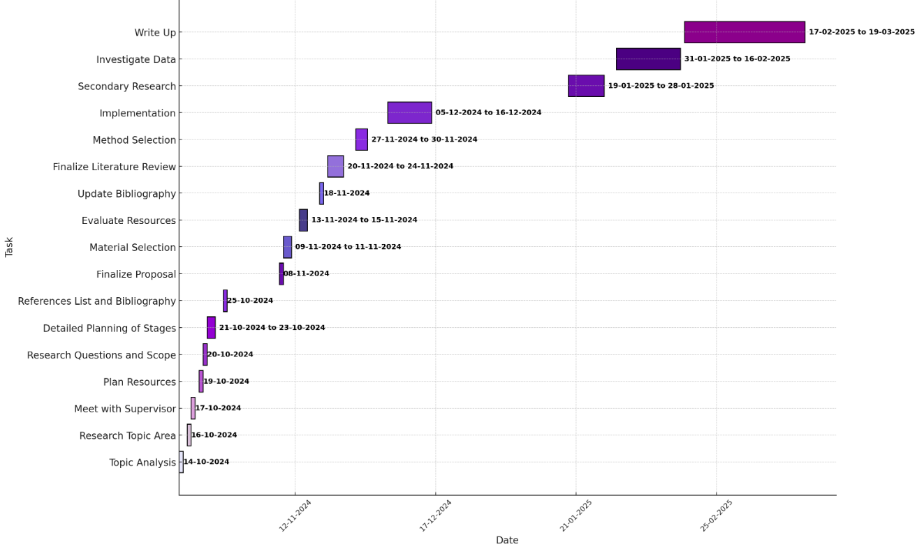

References

- Campaign Monitor, (2021). Email Marketing Benchmarks. [online] Available at: https://www.campaignmonitor.com/resources/guides/email-marketing-benchmarks/ (Accessed 12 October 2024).
- Chaffey, D., (2022). Digital Marketing: Strategy, Implementation and Practice. 8th ed. Harlow: Pearson Education.
- Dholakia, U.M., (2019). The New Age of Marketing: Integrating Digital Marketing Strategies into Businesses. Business Horizons, 61(5), pp.733-742.
- Duignan, J. (2016). A Dictionary of Business Research Methods. Oxford University Press.
- Gao, Y. (2023). A Study of Tesla’s International Marketing Strategy Based on the STEPPS Model. Highlights in Business, Economics and Management, 23(1), 110-190
- Hennigs, N., Wiedmann, K.P. and Klarmann, C., (2019). The Role of Digital Marketing in Shaping Customer Experience: A Conceptual Framework. Journal of Business Research, 98, pp.414-423.
- Kumar, V., Sharma, A. and Gupta, S., (2016). The Role of Digital Marketing in Business Growth: A Study of Indian SMEs. International Journal of Business and Management, 11(5), pp.96-104.
- Li, Y. (2023). Analysis of Tesla’s Marketing Strategy Model. 2nd International Conference on Financial Technology and Business AnalysiS, 23(1), 120-145
- Liang, J. (2022). A Case Study of Marketing at Tesla Based on the 4V Theory. Business and Management Research, 215(1), 130-177
- O’Gorman, K. and MacIntosh, R. (2015). Research Methods for Business and Management: A Guide to Writing Your Dissertation. 2nd ed. Goodfellow Publishers Limited
- Pulizzi, J., (2020). Content Inc.: How Entrepreneurs Use Content to Build Massive Audiences and Create Radically Successful Businesses. 2nd ed. New York: McGraw-Hill Education.
- Ryan, D., (2020). Understanding Digital Marketing: Marketing Strategies for Engaging the Digital Generation. 3rd ed. London: Kogan Page Publishers.
- Saunders, M., Lewis, P. and Thornhill, A. (2015). Research Methods for Business Students (7th Edition). Pearson.
- Tiago, M.T.P.M.B. and Veríssimo, J.M.C., (2014). Digital Marketing and Social Media: Why Bother? Business Horizons, 57(6), pp.703-708.
- Tuten, T.L. and Solomon, M.R., (2019). Social Media Marketing. 3rd ed. Thousand Oaks: SAGE Publications.
- Wymbs, C., (2019). Digital Marketing: A Strategy for Growth in the Age of Disruption. Marketing Intelligence & Planning, 37(5), pp.514-528.

