
Skills for the Workplace
Module Assignment Submission
Student Name: | Mark Evans
Student Number: | 1403013
Module No: | BMSK4007
Module Title: | Digital Skills and Personal Branding

Statement of Confirmation of Authenticity
By the act of making this submission, the student declares that this is the work of the student named above. The work has not, in whole or in part, been knowingly presented elsewhere for assessment, or where assessment has been built on a previous assessment, this has been identified. Where materials have been used from other sources it has been properly acknowledged. If this statement is untrue, the student acknowledges that an assessment offence has been committed.
Attention is drawn to the plagiarism and unfair practice policies of both the University and of ILM.
Permission for ILM to use this script
ILM uses learners’ submissions – on an anonymous basis – for assessment standardisation. By submitting, both the centre and the learner agree that ILM may use this script on condition that identifying information is removed. However, if you are unwilling to allow ILM use this script, please refuse by ticking the box: □
Table of Contents

Demonstrate the ability to evaluate the appropriate use of modern technology to improve workplace efficiency and employability, supported by criteria leading to an evaluation 2
Demonstrate the appropriate use of social media for creation of own personal brand (and its applications in the workplace), through the creation of own professional online presence on LinkedIn, supported by evidence. 6
Explore the impact of personal branding on own 11
employability 11
References 14
Appendix 1 16
Appendix 2 17
Appendix 3 ……………………………………………………………………………………………18

Demonstrate the ability to evaluate the appropriate use of modern technology to improve workplace efficiency and employability, supported by criteria leading to an evaluation

The report writer would firstly like to discuss on how mobiles devices have impacted the modern workplace. These being: Laptops, Tablets/iPad, smart phones, mobile scanners, and many more.

Mobile Devices

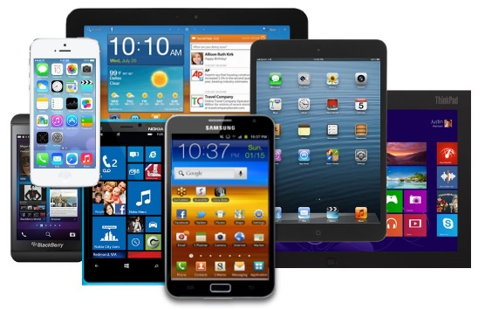

Mobile devices have changed the face of modern workplaces making them more productive, portable, efficient and accessible. The devices allow businesses to be able to download two-way communication applications onto mobile devices. This supports flexible remote working at any location and prevents the need of having to be hardwired to a desk or workstation. The report writer found that Employees can bring their own mobile devices, tablets, and even laptops into the workplace, this enables employees to connect their devices to the organisation’s network and retrieve business data to their personal apps and also to upload sensitive information to their devices. A bring your own device (BYOD) policy affords companies and employees greater flexibility, but that flexibility can put important business data at risk. (Scott 2020)
The examples below demonstrate how modern technology has improved working practice in different sectors.
For example: In retail departments, some supermarkets have introduced mobile scanners enabling customers to scan whilst shopping from start to end. Mobile scanners can also help to manage stocks levels instead of having to manual count.
Another example would be that in airports, passengers are now able to download their boarding passes onto their smart phones. This reduces the amount of printing equipment and reduces the risk of customers losing paper documents.
In an office setting, workers are now able to move freely around the office using their laptops to work remotely.


WIFI

Devices in the modern workplace have improved dramatically in the way in which a business or individual can connect to the internet. Devices now come with WIFI enabled allowing equipment to connect wirelessly using 3G, 4G and most recently 5G. This prevents the need of having to run long cables across office spaces and needing to be hardwired to landlines and internet modems.
The report writer found:
“Search no more ‒ BT has more than five million free Wi-Fi spots around the country, so you never need to panic again. Remote workers can breathe easy”. (Middleton 2017)
The report writer also found evidence from research as to how internet has improved practises in the workplace:
“It is well known that the internet has revolutionised working practices in the last 30 years and one of the main impacts of digitalisation is that it has created an increasingly mobile workforce, no longer constrained by the need to be office based or the standard 9-5 working day.” (Southall 2016)
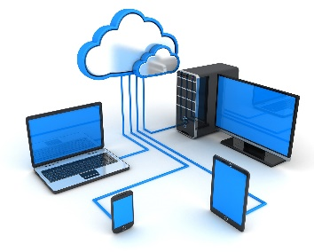
Cloud

Modern technology has also changed in which businesses are now able to store and connect to their data. There is no longer a requirement to carry around portable storage facilities such as, hard drives and USB sticks. Businesses are now able to store, retrieve, and collaborate data remotely at any location. This has also helped workplaces financially by being a paperless workplace and saving on resources. There are various online cloud storage facilities that businesses can use, and these include: Dropbox, Google Drive, One Drive. Using a cloud facility increases efficiency when working in a team environment because data is stored in one centralised location and avoids the hassle of needing to keep email file revisions and have multiple versions saved on different devices.

Following on from above, the report writer now evaluates the uses of some of the modern technologies in the workplace by using a table and stating the advantages and disadvantages:

Mobile Technology | Advantages | Disadvantages
Mobile Devices: Smart Phones, Laptops, iPad/Tablets | Portable, making it convenient to enable remote working.  Businesses can downsize and reduce business costs.  Remote working increases productivity levels.  Being able to download a bus or plane ticket, suppose to using paper. | Working remotely can affect home life balance with colleagues always being connected and not being able to switch off.  Signal & Internet connections, resulting the operation to stop working.  Less secure: causing huge security risks to sensitive or critical business data.
WIFI | Remote working - being able to connect at home or at an available Wi-Fi hotspot. These being: Cafes, Cinemas, and many more.  No cables needed or needing to be hardwired to a desk.  Always being connected to the workforce and being able to monitor businesses performances. | Less secure resulting a breach of the GDPR rules and regulations.  Reliability – sometimes WIFI spots can lose connection.  Power consumption – Uses more power which can result the device running out of battery and being disconnected.
Cloud | Flexible, accessible, and mobile allowing businesses to retrieve data and collaborate from any location at any time.  Environmentally friendly as it means data can be stored electronically without needing lots of paperwork.  Cost effective with almost limitless storage space.  Easier to back up and get data recovered. | Security Threat due to sharing data via a third-party cloud company to which hackers can attack.  Reduced accessibility if there is a lack of signal or internet connectivity (WIFI)  Possible technical or maintenance issues

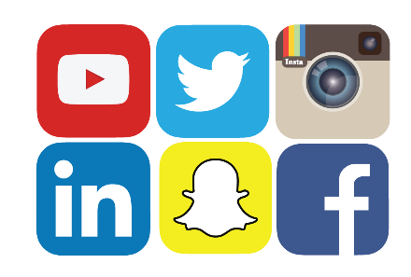

The report writer would also like to mention some of the social media platforms and applications used in today’s modern workplace. These include Facebook, Instagram, Twitter, Snapchat, and Linked In.
These are typically used to:
- Promote the business as a marketing tool by raising awareness of the business’ existence.
- To connect to their customers and suppliers
- Attract a wider audience.
- Recruiting Staff
The report writer would like to add below on how modern technology has helped with the COVID-19 pandemic. Mobile technology has enabled businesses to work remotely and offer business as usual. This has prevented a significant impact to businesses and prevented most from closing. The report writer found:
“Working from home ensures business continuity as well as facilitates social distancing. In such a scenario, technologies that enable secure access to data, enterprise applications, virtual meetings, cloud conferencing, and virtual/mixed/augmented reality are the forefront leaders to ensure deliverables are not impacted. Remote working is a blessing that comes due to technology and is of one the greatest solution that helps us in social distancing”. (Manjunath 2020)

Office Setting
Currently in the report writer’s workplace all staff are using laptops and smart phones, this gives the employees the ability to work remotely. By having access to the mobile devices it gives employees the freedom and flexibility to work anywhere. They have access to a BT Cloud phone application enabling them to receive their customer calls when being logged in. This prevents the employees having to use a landline hardwired to a modem. By using this designated app for their work calls, this prevents them receiving business calls whilst not working and disturb their homelife.
They also use a communication app called: What’s app Messenger that is downloaded on all employees’ smart phones to enable them to communicate effectively.
Employees have Microsoft Teams downloaded on both their devices to enable daily conference video calls with their managers so they can be briefed on daily tasks. This application enables management to undertake 1-2-1 performance reviews with staff meaning face-to-face interviews can still take place without the need of leaving the house.
Microsoft teams is used as a collaboration tool. Staff upload work materials such as sales scripts, objection handling guides, a lenders guide, and annual leave requests sheets. This hugely helps the business by enabling workers to access these resources easily and remotely.
In addition to this, emails go straight to employee’s smart phones by having the Microsoft Outlook email app on all their devices. Due to the workforce mainly working remotely, employees are now able to claim the work from home tax relief from HM Revenue & Customs to assist with monthly WIFI costs.
The report writer now discusses the uses of social media platforms, how it is used in his workplace and its effectiveness. The workplace uses Facebook as their main social media platform to promote their products and services on a weekly basis. This improves growth and the number of leads the company receives.
Whilst the above is proving to be working well, this could be further developed by targeting certain geographical areas to attract more of audience that in turn would improve growth.
Using the chat function on Facebook so that customers can contact the company via a web chat as opposed to a telephone chat enabling service users to make contact via WIFI would attract more of an audience.
The report writer would like to recommend for his company to use Instagram, to work alongside Facebook. Essentially this could be used to promote the way in which we inform the public audience on initiatives such as, ‘Customers happy new car day’ and including photographs of customers collecting their new car. This would attract more visitors that could lead to more interest and in turn, more sales.

Demonstrate the appropriate use of social media for creation of own personal brand (and its applications in the workplace), through the creation of own professional online presence on LinkedIn, supported by evidence.

The report writer now discusses how he as a professional individual can utilise social media to enhance networking and career prospects. Social media platforms such as Facebook and LinkedIn can be used to initiate business contacts with like-minded individuals to increase a company, or a person’s networking capabilities.
The report writer currently has profiles on Facebook, Instagram, Twitter, and LinkedIn which are being used for social and professional use. LinkedIn is used to build his professional profile. It gives him the ability to connect to a wider business audience to promote his skill set, job experiences, and identity which will increase his connections and start to build a bigger network of business and professional people. This could then lead to career advancement as recruiters will be able to reach out and match his skillset to opportunities in larger firms in which will enhance his career prospects. In addition to this the report writer could also use LinkedIn to cast a larger net of prospective clients which could over time result in more business enquiries. The algorithm uses specific targeting to connect to businesses. This could potentially lead the report writer to gain more suppliers and dealerships to offer finance to their customers. Opportunities can also arise just by wishing connections a Happy Anniversary in their role or sending a Happy Birthday message on LinkedIn. Whereas small business owners could use Facebook as it has a recruitment tool enabling them to create campaigns to reach out to new prospects.
The report writer has found a graph from 2019 on how effective LinkedIn is with generating new prospects (Leads).

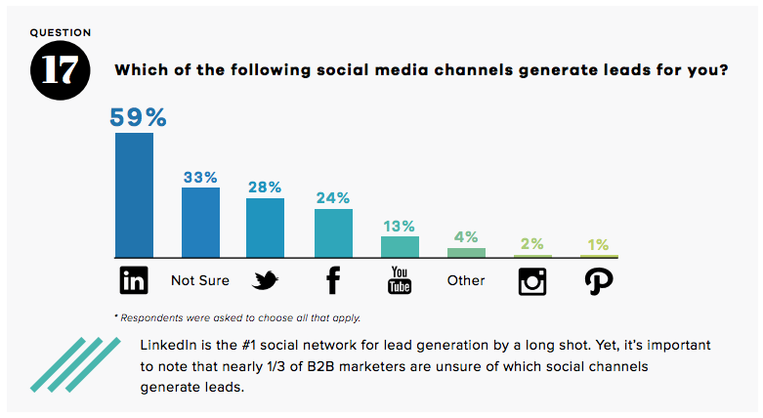
(Gould 2019)

Social Media Platform | Relevance | Social or  Professional | Advantages | Disadvantages
Facebook | A popular real-time social networking website enabling users connect to people all over the world. | Social &  Professional | Users can create their own profile to build their online brand.  Users can upload photos videos and create live feeds and statuses. This enables friends and new people to comment, like and react to.  Build professional bonds with competitors.  Users can create business pages and create groups or campaigns to find top candidates for new positions.  Users can live chat to people using the messenger facility.  Businesses to reach out and be able to offer new career opportunities. | Fake profiles, Scams, and hacking.  It can ruin the user’s professional life by being searched by a recruiter.  Data Privacy Risks
Instagram | A photo and video sharing platform | Social & Professional | Its free to use and sign up.  The ability to build community by requesting to follow people, in turn they follow back.  The ability to tag, comment and like people’s photos which could lead to more views.  “Some popular hashtags to consider for your job search are:  - #remotework  - #remotejobs  - #jobs  - #jobsearch  - #jobsearchtips” (Jay 2020) | Restricted space for additional content. For example: A detailed bio or summary on the company.  Only being mobile friendly.
Twitter | “Twitter is an online news and social networking site where people communicate in short messages called tweets”.  (Gil 2020) | Social &  Professional | Discovering people around the world and reach a wider audience.  Build a following of people who are interested in his attributes.  Able to connect to local communities, follow trends and competitors.  In bold the brand drawing more of an audience | Tweet at the right time otherwise useful and valuable tweets could be missed.  Negative comments by having people or customers complain about the user.  Restrictions on how many characters the user can type in.  Spam – users need to mindful of suspicious links.
LinkedIn | LinkedIn is the professional networking platform | Professional | Discuss and join in with opinions and groups that include like-minded people.  Gain new professional relationships.  Seek for new job opportunities.  Upload resume, skillsets, work experiences and achievements allowing fellow managers and previous managers to endorse. | Reputation can be easily affected by not updating the profile on a regular basis.  Cost  Time consuming  Privacy Breaches

After researching all the above social media platforms and looking at these in more detail, although the report writer has Facebook (See Appendix 1), Instagram, and Twitter (See Appendix 2. He has found that the majority of these are currently being used for social use only, therefore has decided to use LinkedIn as his primary professional platform to showcase his personal branding, career prospects and networking. The report writer has demonstrated this by inserting screenshots of his current LinkedIn profile including all his endorsements.

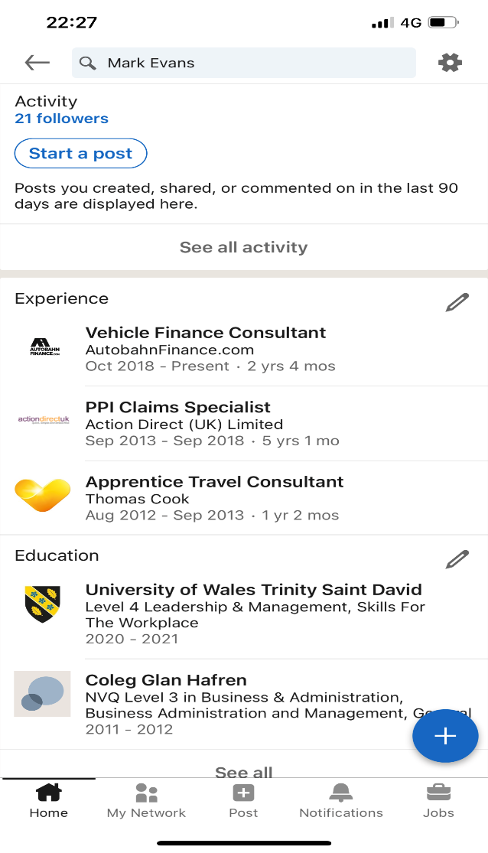
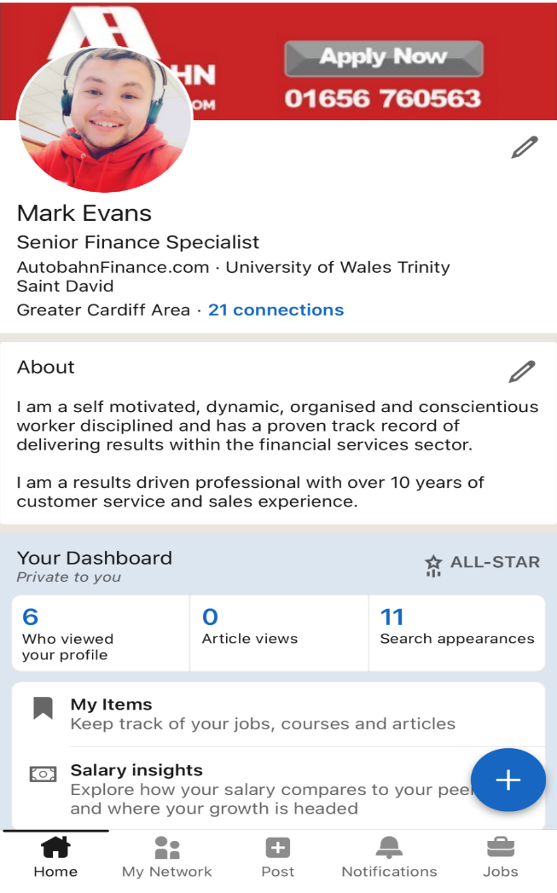
The Report Writers LinkedIn Profile

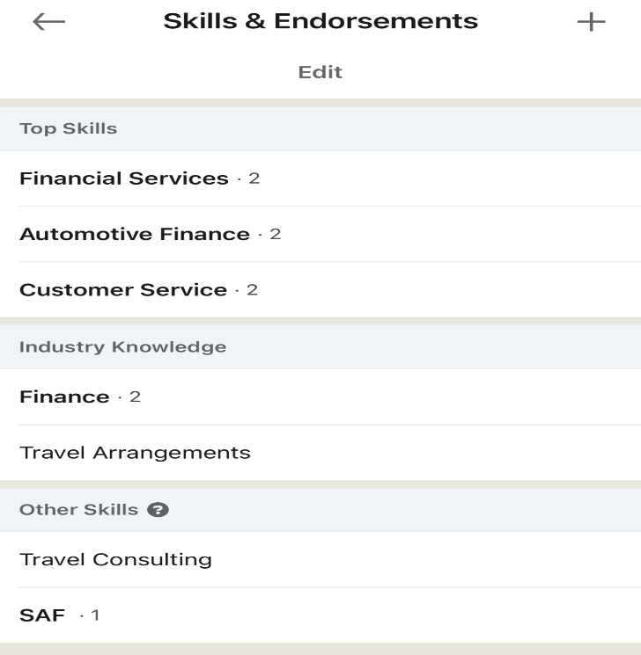

Explanation of the Report Writers LinkedIn Profile

Profile Photo
The report writer has used this photo being dressed in his work uniform, to promote his brand and to demonstrate his worth ethic and passion for who he is as a professional individual and for the company that he works for.
Summary
The report writer uses his summary to sell himself, demonstrate his unique selling points, his values and how he performs best including his overall experience specific to his industry sector.
Education/Work Experiences
The report writer has chosen to include his education and work history to demonstrate his academic qualifications along with his skillset. This will help to promote his brand to achieve an all-star ranking. He has also added his work history to showcase his skills and abilities in the motor and finance industry.
Endorsements
The report writer has also included his endorsements given by senior managers to demonstrate his ability within the role.

Explore the impact of personal branding on own

employability
What is Personal Branding?
“Personal branding is the practice of marketing people and their careers as brands. It is an ongoing process of developing and maintaining a reputation and impression of an individual, group, or organization. Whereas some self-help practices focus on self-improvement, personal branding defines success as a form of self-packaging. Your personal brand is how you promote yourself. It is the unique combination of skills, experience, and personality that you want your followers to see. It is the telling of your story, and the impression people gain from your online reputation”. (Henderson 2019)
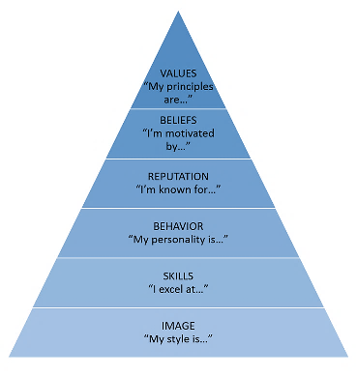
(Me.Inc. 2012)
Firstly, the report writer needs to think about his first impression and how he has only 4 minutes to do so. (Module handout - Digital Skills and personal branding 2020)
For example: If he were to walk into a room and act shy, reserved, and inadequate this could lead to a bad first impression. However, if he walks knowing how to hold himself, his values, achievements, accomplishments and having confidence ultimately this results a positive and good first impression.
When the report writer presents himself in person, online or in business he needs to have the mindset that he is sellable and employable and ask himself why someone should purchase or employ him over the next product or person. He should consider his unique selling points and image.
For example: The report writer can build and gain trust of the customer and use this to his advantage to be able to close a sale faster than his colleagues.
Behaviours and attitude also play a key role when presenting the personal brand because having a bad behaviour or attitude can have a huge impact on the reputation of the brand.
For example: If the report writer were to lie or be controversial regarding topics relating to religion, race, or gender this could lead to opportunities and promotions to fail. Another could be where he may make negative comments about previous managers or colleagues. Ultimately this could lead to people thinking he has no respect.
It is important for the report writer to be mindful of what he posts on his social media platforms as the report writer found an article stating: “In recent research, 7 in 10 employers (70%) use social networking sites to research job candidates during the hiring process. Nearly half of employers (48%) check up on current employees on social media, and a third of employers (34%) have reprimanded or fired an employee based on content found online”. (Heathfield 2020)
Therefore, he needs to be careful of what he puts on his social media platforms.
For example: If he were to post videos of himself being drunk, this could interpret inappropriate behaviour to potential new employers.

Discuss personal and professional security and

safety online.

The report writer needs to be mindful and have awareness of his personal and professional security when using the internet for work or personal use. It is also important that he is fully aware of the Data handling laws below:
- The UK data protection regime is set out in the DPA 2018, along with the GDPR (which also forms part of UK law). It takes a flexible, risk-based approach which puts the onus on you to think about and justify how and why you use data.
- The ICO (2018) regulates data protection in the UK. They offer advice and guidance, promote good practice, carry out audits and advisory visits, consider complaints, monitor compliance, and take enforcement action where appropriate. (ICO 2018)
The report writer needs to have awareness of the above ICO rules and regulations and understand that customers could and have the right to request and access their personal data. In most cases, the customer should not be charged.
The report writer needs to have awareness and have a concept to know how to handle data and how it can be shared and handed over. For example: When he is being asked to hand over or share data, he needs to be making sure he is reading the small prints before consenting to it to comply with the above laws.
The report writer also needs to be aware of his cyber security and the risks that he possibly could face in which could be detriment to him or the business.
These could include:
- Viruses attacking his files and data. By downloading a security software this could prevent the attacks from happening.
The report writer needs to be aware that he is setting his safety perimeters and switching on his privacy settings when using social media platforms. This will restrict other people being able to tag or upload posts without his permission. He also needs to ensure that he is using legitimate sources and sites when making online payments by looking out for the padlock symbol on the search bar to ensure it is a secure website. The report writer can also add an extra layer of security to some of his accounts by applying a two-factor authentication to some of his apps used on devices. This would mean only he could access his accounts on a device or via the internet to prevent multiple people being able to gain access and put his data at risk.
The report writer took part in some security courses using the Barclays Digital Wings to enhance his knowledge on personal and professional security (See appendix 3).

References

Gil, P (2020). What is Twitter & How Does It Work? Available at: https://www.lifewire.com/what-exactly-is-twitter-2483331 (Accessed 20th January 2021)

Gould, R (2019. LinkedIn vs. Facebook: Which is best for Business? Available at: https://blog.hubspot.com/marketing/linkedin-vs-facebook (Accessed 22nd January 2021)

Henderson, G. (2019). What is personal branding? Available at: https://www.digitalmarketing.org/blog/what-is-personal-branding (Accessed 23rd January 2021)

Heathfield, S M. (2020). Using Social Media for Recruiting Screening, and Background Checks Available at: https://www.thebalancecareers.com/social-media-recruiting-1919153 Accessed (23rd January 2021)

ICO (2018) Introduction to Data Protection [online] available at:
https://ico.org.uk/for-organisations/guide-to-data-protection/introduction-to-data-protection/some-basic-concepts/ (Accessed 25th January 2021)

Manjunath, B S. (2020). Covid-19: 8 ways in which technology helps pandemic management. Available at: https://cio.economictimes.indiatimes.com/news/next-gen-technologies/covid-19-8-ways-in-which-technology-helps-pandemic-management/75139759 (Accessed 12th January 2021)

Me.inc. (2012). Branding and Positioning Career Advice Available at: https://incsights.files.wordpress.com/2012/10/personal-brand-pyramid.png (Accessed 24th January 2021)

Digital Skills and Personal Branding (BMSK4007)
Digital Skills and personal branding 2020 (Accessed 23rd January 2021)

Middleton, F. (2017). Would you be happier if you worked remotely? Available at: https://www.telegrgh.co.uk/technology/connecting-britain/remote-working-benefits/ (Accessed 10th January 2021)

Southall, M. (2016). How the internet has changed the way we work for the better. Available at: https://www.walesonline.co.uk/business/business-opinions/how-internet-changed-way-work-11871042x (Accessed 12th January 2021)

Scott, T. (2020). Cybersecurity Trends in 2020: BYOD and Mobile. Available at: https://technologyadvice.com/blog/information-technology/cybersecurity-trends-2020-byod-mobile/ (Accessed 12th January 2021)

Jay, R. (2020). Using Instagram for your job search: Tips and Tricks. Available at: https://www.flexijobs.com/blog/post/using-instagram-for-job-searching (Accessed 20th January 2021)

Appendix 1
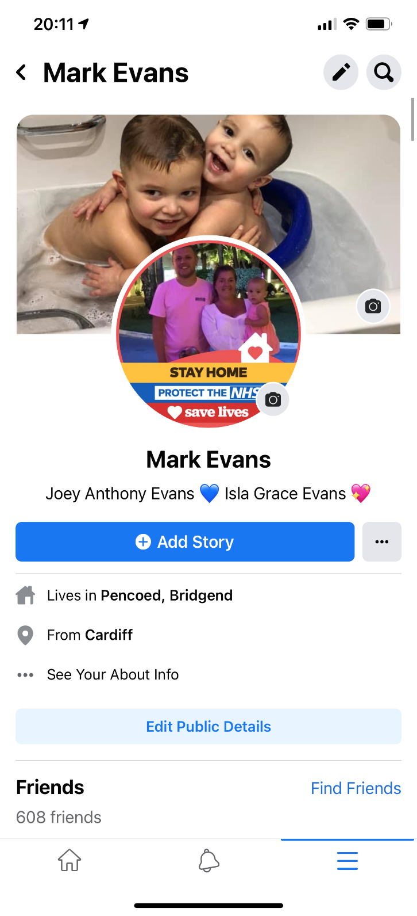
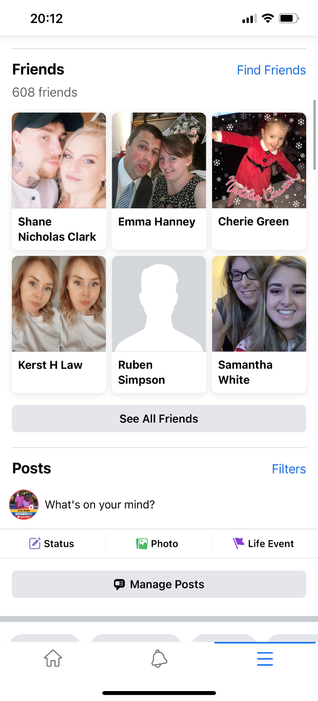

Appendix 2

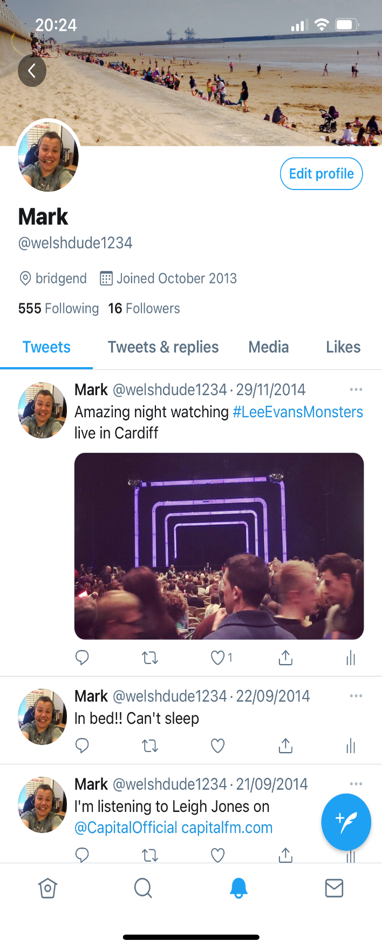
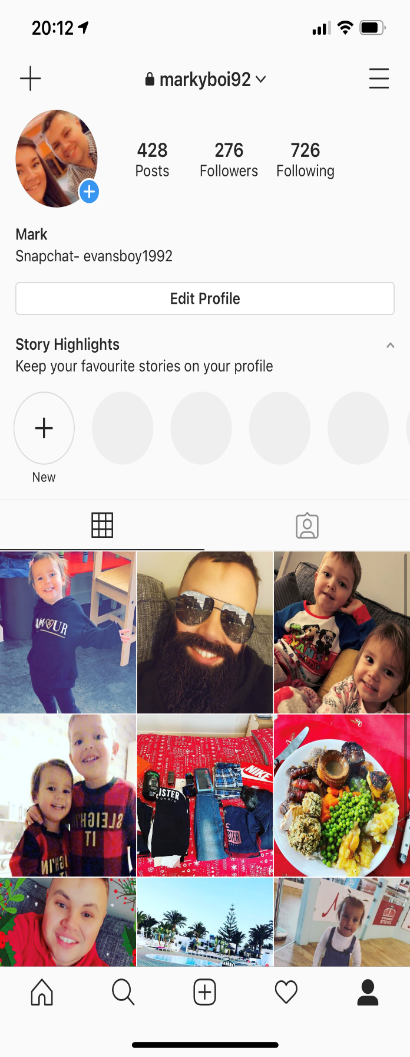

Appendix 3



