Name: Biniyam Memberu
Student Number: 2405357

WORKSHEET 5 – TESTING (Hunting for Treasure)

For this worksheet, the program is implemented in several ways to demonstrate various features.
Create your own test

Test: You win

Screenshot(s) of output:
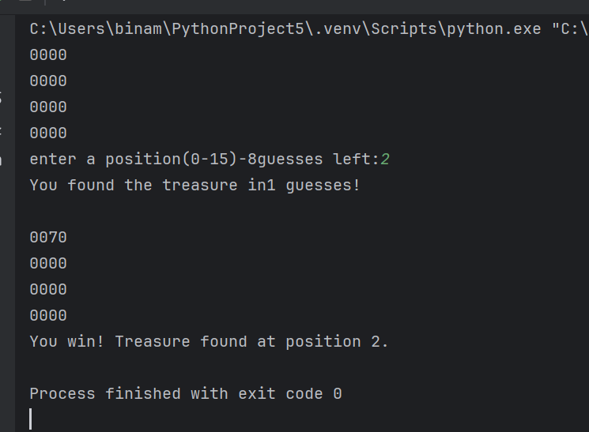
Yes, the program works as expected logically and syntactically. When guessing the correct treasure position, the program immediately displayed the message “You found the treasure in guesses!” and ended the game. The program combines features such as random treasure, a guess counter, input validation, a 4x4 grid display, out-of-range checks, and functions to improve structure.

Test: You lose

Screenshot(s) of output:
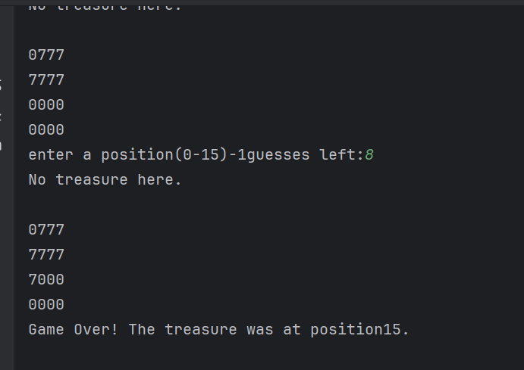
Yes, the program works as expected logically and syntactically. When all 8 guesses were used without finding the position, the program immediately displayed the message “Game over! The treasure was at position x!” and ended the game. This shows that the guessing limit feature is working correctly.

Test: Enter e

Screenshot(s) of output:
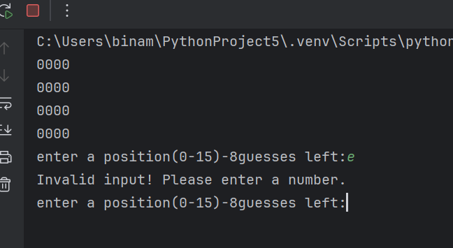
Yes, the program works as expected logically and syntactically. The program enters e did not crash. Instead, it displayed the message “invalid input! Please enter a number”. This shows that input validation and error handling work correctly.

Test: Enter 17

Screenshot(s) of output:
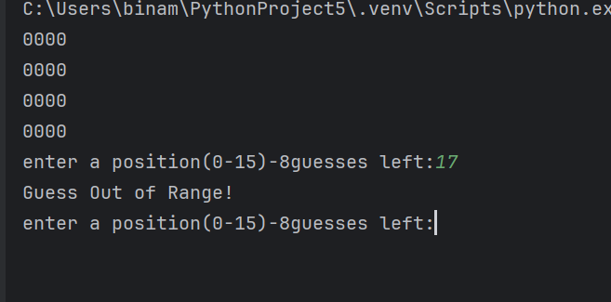
Yes, the program works as expected logically and syntactically. When the program encounters 17, it detects that the number is outside the valid range of 0 to 15. The program did not crash, and it did not count the invalid input as a guess. This shows the out-of-range validation is working correctly.

Test: Enter -1

Screenshot(s) of output:
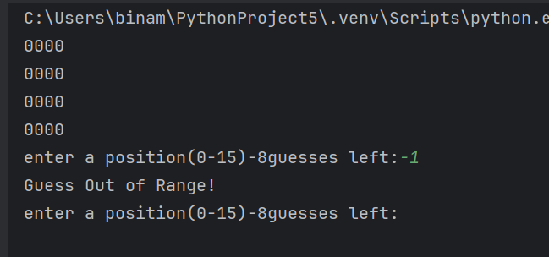
Yes, the program works as expected logically and syntactically. The program recognised that the number was outside the valid range. It displayed the message “Guess out of Range” and asked to enter a position again. The program did not crash and did not count the invalid input as a guess. This shows that the out-of-range validation is working correctly.

Test: Enter 5.7

Screenshot(s) of output:
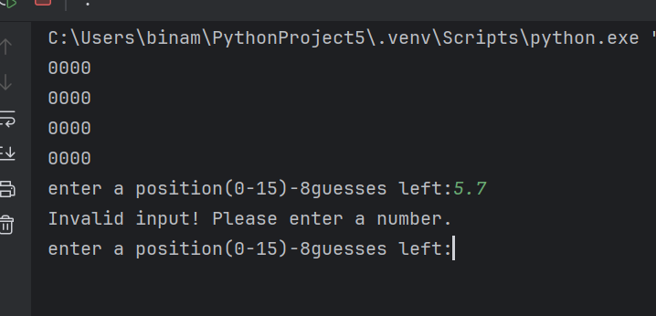
Yes, the program works as expected logically and syntactically. When entering 5.7, the program recognised it as not a valid integer. It displays the message “invalid input! Please enter a number”. The program did not crash and did not count the invalid input as a guess. This shows that the input validation for non-integer is working correctly.

Test: Enter twice the same number

Screenshot(s) of output:
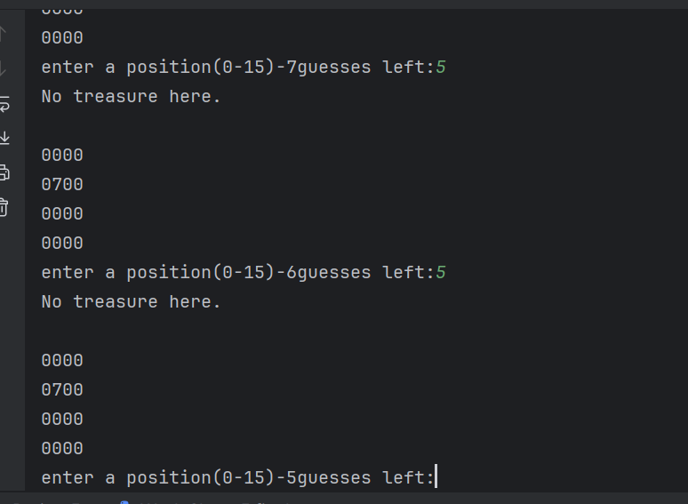
No, the program works. When you enter the same number twice, the program accepts both guesses. The first time, it marked a position with 7 and displayed no treasure and the second time, it again displayed no treasure. The map stayed the same because the position was already marked, the program did not crash, and it handled guesses correctly but logically. It needs to have improvement when you choose the position twice, like validation, to stop entering twice.

Test: Play all 16 positions

Screenshot(s) of output:
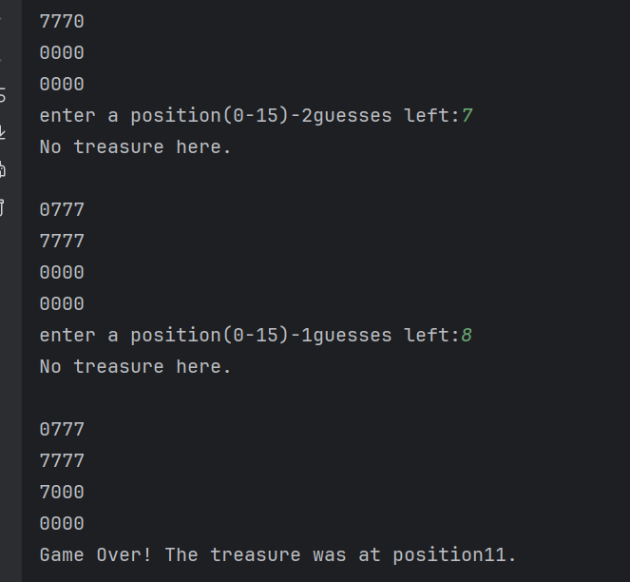
Yes, the program works as expected logically and syntactically. When trying to guess all 16 positions, the program stopped after 8 guesses because maxGuess=8. This is correct behaviour. The program ended the game and displayed “Game over! The treasure was at position x”. This shows that the guess limit feature is working properly and prevents the user from continuing once the maximum is reached.

Test: Leaves Blank

Screenshot(s) of output:
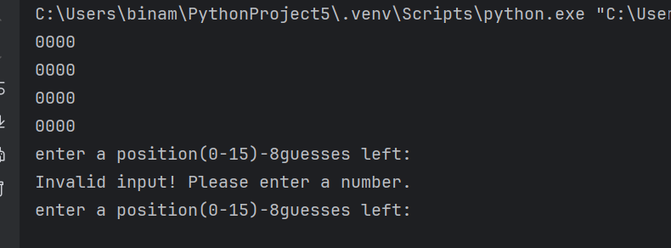
Yes, the program works as expected logically and syntactically. When you enter a blank and press Enter, the program recognises that this was not a valid input. It displayed the message “invalid input! Please enter a number”. This shows that the input validations are working correctly for empty entries.

Final code:

import random
gameMap=[0]* 16
treasurePos=random.randint(0,15)
maxGuesses=8
for i in range(0,16,4):
row=gameMap[i:i+4]
print("".join(str(x) for x in row))
found=False
guesses=0
while not found and guesses <maxGuesses:
while True:
try:
guess=int(input(f"enter a position(0-15)-{maxGuesses-guesses}guesses left:"))
if 0 <= guess <=15:
break
else:
print("Guess Out of Range!")
except ValueError:
print("Invalid input! Please enter a number.")
guesses+=1
if guess==treasurePos:
print(f"You found the treasure in{guesses} guesses!")
gameMap[guess]=7
found=True
else:
print("No treasure here.")
gameMap[guess]=7
print()
for i in range(0,16,4):
row=gameMap[i:i+4]
print("".join(str(x) for x in row))
if not found:
print(f"Game Over! The treasure was at position{treasurePos}.")
else:
print(f"You win! Treasure found at position {treasurePos}.")

