ACCA6026

Data Warehousing & Data Mining

Student Name: Ionut-Cristian Ispas
Student ID: 2325522
Table of Contents
Task 1: Strategic Data Warehousing Solution for NHS England 3
1.1 OLTP Systems vs Data Warehouse 3
1.2 Data Warehouse Architecture and ETL Process 3
1.3 Data Marts for Management Decision-Making 5
1.4 OLTP vs Data Warehouse Dimensional Modelling 6
Task 2: NHS England Data Warehouse Design and Implementation. 8
2.1 Source System Identification 8
2.2 Star Schema Design 8
2.3 Data Marts and schema 10
2.4 ETL Plan 10
2.6 Data Quality and Management. 11
3. Conclusion 12
4. Reference 13

List of Figures
Figure 1: Proposed Data Warehouse Architecture for NHS England 5
Figure 2: Star Schema for NHS Patient Activity Data Warehouse 7
Figure 3: Proposed Star Schema for the NHS England Enterprise Data Warehouse 9

Task 1: Strategic Data Warehousing Solution for NHS England

1.1 OLTP Systems vs Data Warehouse
To facilitate the day-to-day provision of healthcare services, NHS England is using several Online Transaction Processing (OLTP) systems [1]. These systems entail Electronic Patient Records (EPR), Patient Administration Systems (PAS), workforce management systems, financial management systems and clinical information systems. They primarily serve to efficiently manage routine dealings such as patient registration, appointment, diagnosis, admission and discharge, staff details and financial activities. Innovations in OLTP systems have ensured they are compatible with high processing power, data accuracy and multiple users simultaneously, which is often a fundamental part of frontline healthcare work/operation.
An OLTP system is not a system that can assist in strategic decision-making, yet they are effective in terms of how they operate [2]. The information will be stored in various databases, which are all functioning. Therefore, the combination of data across several systems is required to have an analysis of information across hospitals, departments or regions, and this is both time-consuming and might result in inconsistency.
A data warehouse overcomes these limitations by combining data from more than one operational system into one central database that is specifically set to be used in reporting and business intelligence [3]. A data warehouse, unlike the OLTP systems that constantly update their record of operations, houses the cleansed, standardised and historical data that could help in trend analysis and monitor performance within an organisation. The patient activity, workforce use, financial performance and treatment outcome can be examined over numerous years, without impacting the existing functioning systems, by decision-makers.
With NHS England, the data warehouse would provide the top management with a consistent view of the healthcare performance of its different regions, and thus, detect nurse capacity constraints, national performance objectives, improve resource allocation and aid evidence-based planning. Therefore, the OLTP systems remain crucial in daily health care delivery, but the data warehouse is the analytical foundation that must be used to enable strategic management and make long-term decisions.

Table 1: Comparison of OLTP Systems and Data Warehouses
Feature | OLTP System | Data Warehouse
Primary Purpose | Supports day-to-day healthcare operations | Supports strategic analysis and decision-making
Data Type | Current operational data | Historical and integrated data
Database Design | Highly normalised (3NF) | Dimensional model (Star Schema)
Data Updates | Continuous inserts, updates and deletes | Periodic batch loading through ETL
Query Type | Simple transactional queries | Complex analytical queries
Users | Clinicians, nurses, administrative staff | Executives, managers and analysts
Performance Focus | Fast transaction processing | Fast reporting and business intelligence
NHS Examples | EPR, PAS, Workforce and Finance Systems | NHS Enterprise Data Warehouse

1.2 Data Warehouse Architecture and ETL Process
NHS England needs an enterprise data warehouse that can link data created by various working systems in hospitals, community services and specialist healthcare providers to enhance the performance of national healthcare. The suggested architecture will not replace the current ones; it will rather be used side by side with the current ones; it will fetch operation data, handle it, create a uniform structure and store it in a central house of analytics.
The architecture starts with several running source systems which produce healthcare data every day [4]. They include Electronic Patient Records (EPR), Patient Administration Systems (PAS), and clinical information systems, workforce management platforms, financial management systems and quality monitoring databases. Individual systems have a specialised operational role and have various structures, formats, and codifications of information.
To overcome this challenge, an Extract, Transform and Load (ETL) process is used to transfer data between the operational systems and the enterprise data warehouse. During extraction, the information undergoes collection along with periodic intervals; typically, when there are minimal operating activities within the source systems to minimise the interference with the clinical services. In the process of transformation, multiple records are eliminated, inconsistent coding standards are standardised, missing values are dealt with wherever necessary, and data types like dates, diagnosis codes and organisational identifiers are mapped into common formats.
Once stored in the warehouse, the integrated data is organised into specialised data marts that cater to different sectors of the functional division of the business, such as the executive management, the finance and clinical operations data marts. Evidence-based, timely decisions can be supported with the help of these data marts, dashboards, reports, and business intelligence applications.
One of the greatest advantages of this architecture is that ETL activities are not dependent on the operational systems [5]. Healthcare professionals can continue working with the applications they have at hand, and senior managers can manage the performance and planning process based on the information presented by a quality and integrated tool. This will offer operational efficiency and a huge increase in reporting capabilities of an organisation.
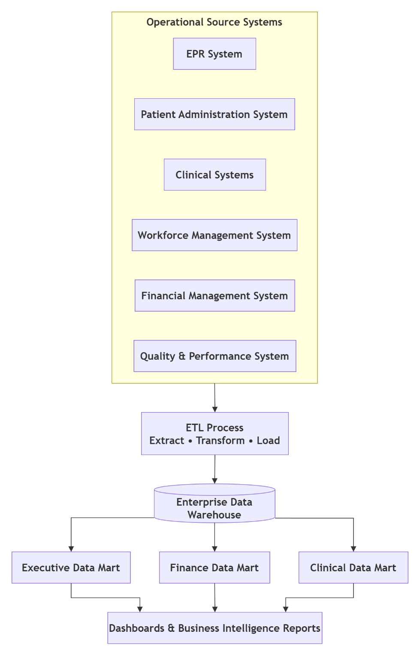
Figure 1: Proposed Data Warehouse Architecture for NHS England

1.3 Data Marts for Management Decision-Making
The enterprise data warehouse archives incorporated organisational data; the top managers at NHS England require different types of data, depending on their position. One possible solution to this is data marts, which provide subject-oriented subsets of data for decision-making in an organisation, department-wise, and maintain consistency throughout the organisation.
The Chief Executive Officer should have a strategic vision of healthcare performance within the country. The patient admissions, emergency department activity, referral-to-treatment waiting times, hospital bed occupancy, elective care backlog and regional service demand are key performance indicators that would be offered by an executive data mart.
The Finance Director needs to obtain more direct financial data, to be aware of spending habits and the proper utilisation of state funds. The data related to finance would include costs of treatments, departmental budgets, national tariffs paid, spending by a healthcare provider and cost per patient-episode. With such analytic reports at hand, the required budget can be prepared, which can forecast the financial situation and identify those spheres of cost management that are required and can lead to financial sustainability in the long run.
The Medical Director is also oriented mostly towards the quality of healthcare and clinical performance. Patient outcomes, mortality rates, readmission rates, diagnostic activity, theatre use, patient safety incidents and infection rates would be stored in a special clinical data mart. Clinical governance, quality improvement interventions and compliance with the national medical policies are some of the benefits of such analytical understandings.
The enterprise data warehouse will contain all the data, though different reports will be available to the different departments [6]. This will ensure that the departments are working with a valid and verified source of information, reduce the incidence of conflicting reports, and increase transparency in an organisation. Data marts can also improve data reporting and make decisions simpler and more informed across NHS England in real-time by providing information that is tailored to each of the managerial functions.

1.4 OLTP vs Data Warehouse Dimensional Modelling
The operational databases and data warehouses have different purposes and hence different database structures. Quickly commonplace are highly normalised designs of databases that are normally in Third Normal Form (3NF). Under this method, data is split up into a series of related tables to reduce redundancy and ensure the integrity of the data. Using patient information, admissions, treatments and staff information, and hospital information as an example, you can see that these tables have different patient data and are related, using primary and foreign keys. This structure eases updated processes and correct documentation of transacting transactions in the day-to-day healthcare business.
Data warehouses, on the other hand, are constructed to respond to analytical operations, and therefore they are founded on a dimensional modelling model, with most of them being founded on a star schema. A star schema comprises a central table (called a fact table) which stores measurable business events and a series of dimension tables which give descriptive information about the events. In comparison with heavily normalised OLTP databases, dimensional models have fewer table joins, thereby enabling complex analytical queries to be much faster and simpler to comprehend.
Such key performance indicators as cost of treatment, length of stay, waiting time and number of readmissions would be included in the main Fact Patient Activity table in the case of NHS England. The given dimension tables would describe the context of every healthcare activity, like Patient, Hospital, Date, Doctor and Treatment dimension. The provided structure will enable the analysts to not only compare the cost of treatment in various hospitals but also monitor the waiting time per area, measure the clinical outcomes throughout the time and estimate the healthcare performance in numerous aspects.
The star scheme will consequently provide a simplified, yet efficient reporting and business intelligence scheme, as well as allow NHS England to stay with regularised OLTP systems to carry out regular operational processes.
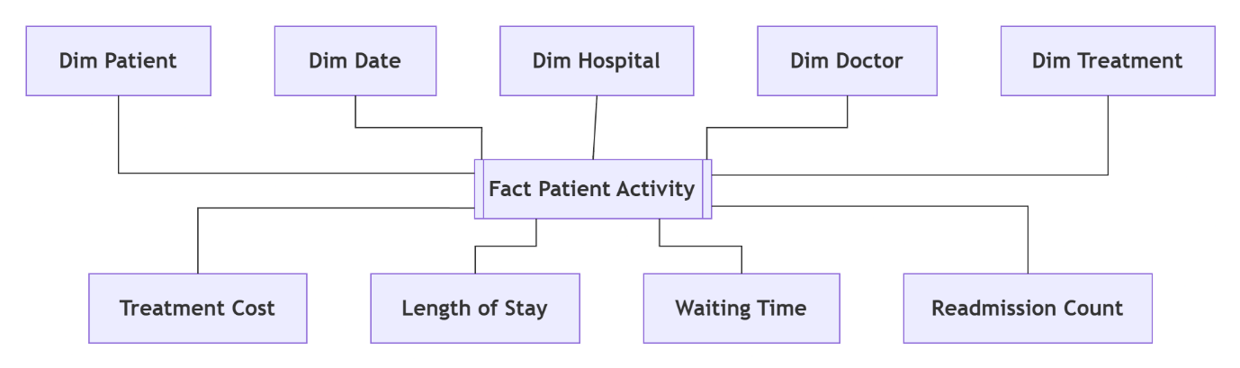
Figure 2: Star Schema for NHS Patient Activity Data Warehouse

Task 2: NHS England Data Warehouse Design and Implementation.

2.1 Source System Identification
The suggested NHS England data warehouse will bring on board data from the various internal working systems, as well as select outside reference information, with the aim of obtaining a holistic picture of healthcare performance. The internal data sources, Electronic Patient Record (EPR) system, include the patient demographics and diagnoses, procedures and clinical histories, and the Patient Administration System (PAS) includes patient admissions, discharges, referrals and appointment booking [7]. The laboratory results, diagnostic imaging and treatment information and workforce management systems provide clinical and staff information, respectively. Financial management systems provide expenditures, budgets, the cost of treatment and national tariffs. Quality management systems offer patient safety events, mortality rates and patient satisfaction information. Outside reference information may be incorporated as well through organisations such as NHS Digital and the Office of National Data to assist in the benchmarking process, population health and strategic planning in England.

2.2 Star Schema Design
NHS England needs to adopt a dimensional data model that is such that it provides support for strategic reporting and business intelligence, using a star scheme. The specialised modelling method has a specific application in analysis processing as it eases complicated queries and provides quick access to information on healthcare performance. The proposed design has a single fact table with several dimension tables detailing each healthcare action in a variety of ways.
The major Fact Patient Activity table logs quantifiable healthcare happenings throughout the patient's attention of the patient. Each record is considered an individual episode or treatment of a patient and records numerical scores that can be summed up, and a report can be made. The most used indicators will be the cost of treatment, length of stay, waiting time, the number of bed days, number of readmissions and number of patient episodes. By using these measures, NHS England can monitor the work efficiency, financial performance and clinical outcomes of individual hospitals and regions [8].
There are several dimension tables, which give descriptive details that can be analysed in detail. The table of Dim Patient has demographic data (patient ID, age group, gender and postcode area) that can be used to analyse the healthcare demand of various generations of the population. The Dim Hospital table is used to make comparisons between the healthcare providers as it uses the hospital identifier, NHS Trust, region and type of hospital. Dim Date table holds a calendar attribute as day, month, quarter and financial year as it is used in the trend analysis and seasonal reporting.
The diagnoses (ICD-10), the description of treatments, the codes of procedures and service groupings are included in the Dim Treatment table, where the data on clinical data is stored. The Dim Doctor table includes consultant identifier, medical speciality, and clinical department, and these can be compared among the specialities to check the performance. The Dim Ward table includes ward identifiers, ward type and bed capacity to aid with a hospital capacity analysis.
The surrogate keys between each dimension and the Fact Patient Activity table form a star, which makes reporting easy. The descriptive attribute in the dimensions, combined with measures in the fact table, allows users to easily analyse the performance of healthcare. The management could be used to compare costs of treatment at each hospital, waiting times at each speciality, occupancy of beds in different regions or the patient outcomes at different times, as examples.
The star schema dramatically simplifies the structure of queries and enhances reporting behaviour as compared to the highly normalised operational database [9]. As business intelligence, Microsoft Power BI can also be efficiently utilised to access aggregated data and not to perform numerous table joins to give timely evidence-based dashboards and management reports to NHS England.
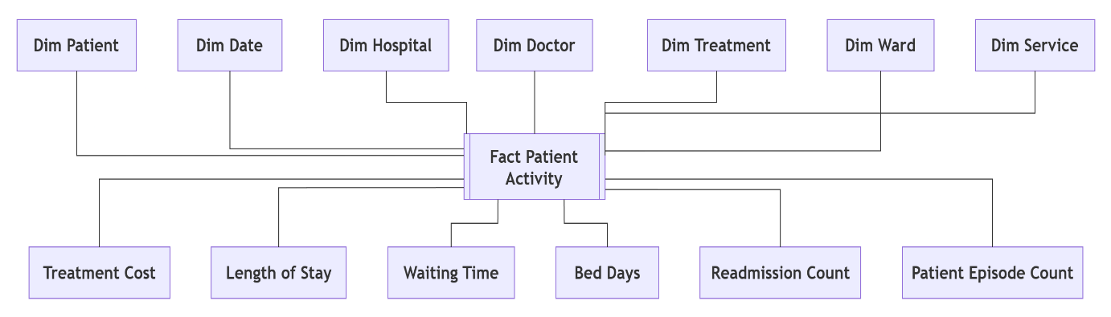
Figure 3: Proposed Star Schema for the NHS England Enterprise Data Warehouse

2.3 Data Marts and schema
Once in the enterprise data warehouse, data should be stored in subject-oriented data marts to be utilised to support departmental reporting requirements. The information in a finance data mart should include a treatment spending piece, departmental budgets, national tariff payments, cost per patient episode and financial performance measures. This will enable the finance managers to monitor their expenditure, identify the cost trends and evaluate the budget performance rates of NHS Trusts.
Clinical data mart should include information about clinical diagnoses of patients, help them to get treatment, mortality rate, readmission rates, infection rates, diagnostic activity and clinical outcomes. Such datasets help to improve the quality of care, clinical governance, and adherence to standards in healthcare that are used nationwide.
The information that will be captured and stored in the operations data-mart on the bed occupancy, the waiting time in the referral-to-treatment, the theatre utilisation, the emergency admission, the ambulance response and workforce position should focus on the efficiency of the hospital. The operational managers can use these reports to label areas of constraints of their capacity, resource allocation optimisation, patient flow and improvement of the patient flow [10].

2.4 ETL Plan
The suggested ETL process loads the operational data in the source systems of NHS England periodically and into the enterprise data warehouse. Data is collected in EPR, PAS, workforce system, finance and quality management systems during the extraction process without interfering with the live clinical processes. The transformations step discards unnecessary files, patient indicator checking, consistency of diagnosis and date-order consistency, closure of gaps in values where required and, where appropriate, invokes business rules to generate indicators such as treatment costs and waiting times. Thereafter, the generated aggregated performance indicators will be created, and the cleansed data will be loaded into the warehouse.
Source System | Key Transformations | Destination
EPR | Remove duplicates, validate patient identifiers | Dim Patient
PAS | Standardise admission and discharge dates | Fact Patient Activity
Clinical Systems | Standardise ICD-10 and procedure codes | Dim Treatment
Workforce System | Validate staff identifiers and departments | Dim Doctor
Finance System | Validate costs and tariff values | Fact Patient Activity
Quality Systems | Standardise performance indicators | Operations and Clinical Data Marts

2.6 Data Quality and Management.
The success of the NHS England data warehouse operation heavily depends on efficient data quality and governance practices. All the information should be checked to be accurate, complete and consistent before it is loaded into the warehouse. This implies that all health professionals ought to adopt standard coding systems to enable them to have credible reporting. Role-based access control, encryption, audit logging, and UK GDPR and NHS information governance policy compliance must ensure the protection of patient confidentiality. Good governance implies the availability of sound information to support evidence-based, sound, safe and sound decisions.

3. Conclusion
The front-provided enterprise data warehouse will have capabilities to provide a robust solution to NHS England for combining the data of the different existing systems into one system that can be relied upon to make strategic decisions. The warehouse enables overall performance of the healthcare in the regions and services of the healthcare by consolidating information in Electronic Patient Records, Patient Administration Systems, workforce management, financial systems and clinical applications.
A dimensional star schema will enhance reports and business and clinical intelligence as it allows executives, financial and clinical management to have a specific insight into financial reports and statistical analysis. A process-based ETL can't fail to provide high-quality data despite the day-to-day activities of the healthcare facility by ensuring data cleansing, standardisation and validation before being loaded in the warehouse. Furthermore, the good governance of data and maintenance of both the NHS information governance policies and UK GDPR protect sensitive patient information and offer reliability of data. Overall, the proposed data warehousing will streamline processes, enable evidence-driven decision-making, optimise resource allocation, and result in better patient outcomes and sustainability across NHS England.

4. Reference
[1] M. I. Alamsyah and F. Kosadi, “Training and mentoring for online-based transaction recording (online transaction processing systems-OLTP),” Pasundan International of Community Services Journal (PICS-J), vol. 5, no. 1, pp. 1–10, 2023. https://journal.unpas.ac.id/index.php/pics/article/download/6744/3415
[2] D. Joiner, M. Clement, S. T. Chan, K. Pereira, A. Wong, Y. Khmelevsky, J. Mahony and M. Ferri, “DW vs OLTP performance optimization in the cloud on PostgreSQL (A case study),” in Proc. IEEE International Conference on Recent Advances in Systems Science and Engineering (RASSE), Nov. 2022, pp. 1–8. https://www.okanagancollege.ca/sites/default/files/2025-01/2022rassedwvsoltpperformancef.pdf
[3] A. L. Antunes, E. Cardoso and J. Barateiro, “Incorporation of ontologies in data warehouse/business intelligence systems: A systematic literature review,” International Journal of Information Management Data Insights, vol. 2, no. 2, p. 100131, 2022. https://www.sciencedirect.com/science/article/pii/S266709682200074X
[4] G. Ji, J. Woo, G. Lee, C. Msigwa, D. Bernard and J. Yun, “AIoT-based smart healthcare in everyday lives: Data collection and standardization from smartphones and smartwatches,” IEEE Internet of Things Journal, vol. 11, no. 16, pp. 27597–27619, 2024. https://www.researchgate.net/profile/Denis-Bernard-3/publication/380564725_AIoT-Based_Smart_Healthcare_in_Everyday_Lives_Data_Collection_and_Standardization_from_Smartphones_and_Smartwatches/links/66e38ee264f7bf7b19aa164e/AIoT-Based-Smart-Healthcare-in-Everyday-Lives-Data-Collection-and-Standardization-From-Smartphones-and-Smartwatches.pdf
[5] S. K. Singu, “ETL process automation: Tools and techniques,” ESP Journal of Engineering & Technology Advancements, vol. 2, no. 1, pp. 74–85, 2022. https://www.researchgate.net/profile/Santosh-Kumar-Singu/publication/386874870_ETL_Process_Automation_Tools_and_Techniques/links/675a3011951ca355613eac3b/ETL-Process-Automation-Tools-and-Techniques.pdf
[6] A. Nambiar and D. Mundra, “An overview of data warehouse and data lake in modern enterprise data management,” Big Data and Cognitive Computing, vol. 6, no. 4, p. 132, 2022. https://www.mdpi.com/2504-2289/6/4/132
[7] T. Smith-Mitchell, “The role of hospital information systems (HIS), electronic patient or medical records (EPR/EMR), electronic health records (EHR), and telehealth in enhancing healthcare services,” Scientia: Technology, Science and Society, vol. 2, no. 8, pp. 28–36, 2025. https://scientia-tss.com/index.php/journal/article/download/110/107
[8] M. S. Akter, N. Sultana, M. A. R. Khan and M. Mohiuddin, “Business intelligence-driven healthcare: Integrating big data and machine learning for strategic cost reduction and quality care delivery,” American Journal of Interdisciplinary Studies, vol. 4, no. 2, pp. 1–28, 2023. https://ajisresearch.com/index.php/ajis/article/download/20/21
[9] P. Vyas, “Demystifying dimensional modeling for modern data warehousing,” Journal of Computer Science and Technology Studies, vol. 7, no. 2, pp. 174–180, 2025. https://al-kindipublishers.org/index.php/jcsts/article/download/9184/7867
[10] H. Zamani, F. Parvaresh and M. N. Isfahani, “Optimizing patient flow logistics: Strategic challenges, tactical solutions, and future directions,” BMC Health Services Research, vol. 25, no. 1, pp. 1–27, 2025. https://link.springer.com/content/pdf/10.1186/s12913-025-13516-9.pdf

