
Assignment Title: Marketing Environment Analysis of Fast Fashion Industry for Pioneer: Zara and Follower: Primark

Module: Marketing Management (LCMB7024)
lecturer: dr. tola odugbsesan

Student Name: Hinaben Rajshibhai Sundavadra
Student ID: 2521861

Table of Contents
1.0 Introduction 2
2.0 Task 1: Macro-Environmental Analysis 2
2.1 Industry and Organisational Context 2
2.1.1 Industry overview 2
2.1.2 Organisational overview for Zara as pioneer 2
2.1.3 Organisational overview of Primark as follower 3
2.2 Analysis of Macro-Environmental Actor 1: Environmental awareness 4
2.2.1 Impact on Zara 4
2.2.2 Impact on Primark 5
2.3 Analysis of Macro-Environmental Actor 2: Socio-cultural Shift 5
2.3.1 Impact on Zara 5
2.3.2 Impact on Primark 6
2.4 Summary of Comparative Analysis 7
3.0 Task 2: Strategic Response Evaluation 8
3.1 Evaluation of the Zara’s Strategic Responses 8
3.1.1 Analysis of the responses made by Zara to macro-environmental factors 8
3.1.2 Porter’s Generic Strategies to evaluate competitive approach by Zara 8
3.1.3 Ansoff’s Growth Matrix to evaluate growth strategies by Zara 9
3.1.4 Critical assessment of the strategies implied in sustaining growth and competitive advantage 9
3.2 Evaluation of the Primark’s Strategic Responses 9
3.2.1 Analysis of the responses made by Primark to macro-environmental factors 9
3.2.2 Porter’s Generic Strategies to evaluate competitive approach by Primark 10
3.2.3 Ansoff’s Growth Matrix to evaluate growth strategies by Primark 10
3.2.4 Critical assessment of the strategies implied in sustaining growth and competitive advantage 10
3.3 Comparative Evaluation and Synthesis 11
4.0 Conclusion 11
References 12

1.0 Introduction
Evaluating the macro-economic condition of a business is essential to identify key market considerations to maintain competitive advantages and sustainable growth. Key macro-environmental factors that affect business performance are economic growth, political stability of the market, environmental awareness, sociocultural change, technological development and legal standards (Gini and Agala, 2023). This report analyses the macro-environment of the fast fashion industry and discusses the strategic initiatives implemented by Zara as a pioneer organisation and Primark as a follower to deal with the macro-environmental changes. In order to provide critical analysis, this report has chosen main two macro-environmental factors that have affected the fast fashion industry including environmental awareness and socio-cultural shift in consumer behaviour. Along with that, this report also provides comparative analysis on how the identified macro-environmental factors have affected competitive positioning.

2.0 Task 1: Macro-Environmental Analysis

2.1 Industry and Organisational Context

2.1.1 Industry overview
The fast fashion industry is one of the rapidly growing industries targeting the young generation population. According to Encarnación and Roldán (2023), the fast fashion industry is mainly characterised by the availability of low-cost and high volume clothing and apparel collection. Due to maintaining its high-volume availability of the products, this industry depends on rapid production with extremely short product lifecycles of around two to three weeks (Centobelli et al., 2022). The fast fashion industry in the UK has reached a revenue of around 85.85 billion US dollars as of 2024, an increase of over 14.4 billion as compared to 2023 (Statista, 2026). However, due to the short product life cycle this industry has been criticised a lot for generating waste. As stated by Zhang et al., (2021), after the growth of this industry the UK people are buying more clothes than ever with an average person buying almost 26.7kg of clothes, causing an increasing rate of disposal of fast fashion items causing environmental pollution. Thus, to achieve sustainable growth the industry needs to focus on its sustainability practices.

2.1.2 Organisational overview for Zara as pioneer
Zara as a successful fashion market player has introduced fast fashion as a pioneer company to achieve competitiveness. In order to promote fast fashion, the company has offered rapid trendy clothing lines by redesigning its supply chain. Zara has reduced the product life cycle by 2 to 3 weeks, as compared to the general fashion items having 6 to 9 months (Jonwal, 2025). With effective business strategy, Zara has achieved a net profit of €6.22bn in 2025 with an increasing rate of 6% (Vimal, 2026). Other than that, Figueras (2025) has highlighted that as of the first quarter of 2025 the sales of Zara have grown by 5.1%. Thus, from the success story of Zara it can be evaluated that the company has managed its performance in the global market with effective strategic planning confirming its position as pioneer of this industry.

2.1.3 Organisational overview of Primark as follower
As compared to Zara, Primark is comparatively new in the fast fashion sector and acts as a follower. Primark mainly operates through physical retail stores to reduce the cost of global transport and delivery systems (Primark, 2026). Thus, the company heavily depends on its pertaining system across 400 stores around 14 countries and around 1,000 factories for managing production (Smith, 2025) [Refer to figure 1]. As of 2024, the company has achieved revenue of €9.5bn (Statista, 2025). According to Ivanov et al., (2017), Primark mainly focused on managing outsourced manufacturing and rapid production to reduce the operational costs, which allow the company to offer products at a cheap price to every customer. Thus, effective business strategies implied by Primark has established the brand as a successful follower of Zara in the fast fashion industry.
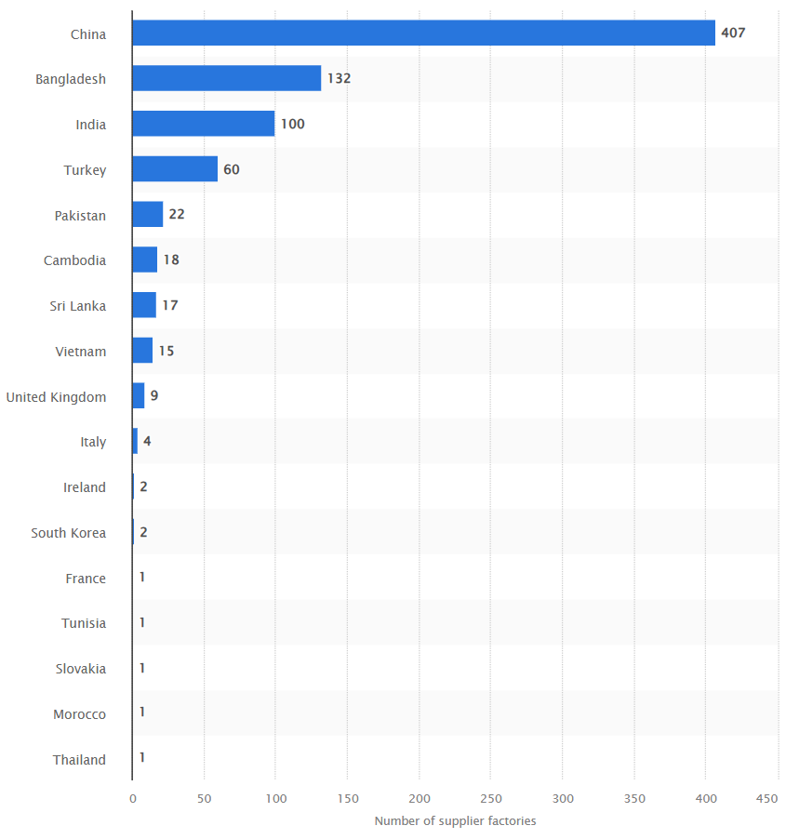
Figure 1: Number of supplier factories for Primark
(Source: Smith, 2025)

2.2 Analysis of Macro-Environmental Actor 1: Environmental awareness

2.2.1 Impact on Zara
Rising environmental awareness is a significant macro-environmental factor affecting the fast station industry. With the increasing number of fashion products consumption and high production level the amount of waste generated along with raw material wastage has increased a lot with approximately 26.5% global fabric waste (Akter et al., 2022). As a pioneer of the fast fashion industry with a strong global presence, Zara is in intense pressure of showcasing environmental responsibility. The company has taken initiative in the form of sustainability actions by launching a programme named ‘Join Life’ that focuses on using less water, sustainable packaging, sustainable raw material usage and eco-effective production procedure (Zara, 2026). However, Vassalo et al., (2024) have stated that managing sustainability for the fast fashion companies is competitively not attainable due to the consumption-driven nature of this industry. Focussing on reducing production waste, sustainable packaging and green supply chain could reduce the production speed and product turnover affecting the overall organisational growth. Considering this factor, it can be identified that by following sustainable strategies Zara could enhance its competitiveness and brand reputation. However, the company needs to be aware about certain threats including increasing environmental scrutiny, increased operational cost and making balance between sustainability and fast production cycle.

2.2.2 Impact on Primark
Similarly, as a part of the fast fashion industry, Primark also faces different sustainability concerns affecting its overall business practices. According to Biyada and Urbonavičius (2025), the growing pressure of environmental awareness often requires using recycled materials, extending garment life and sustainable cotton souring, which increase the operational cost. This increase in the operation cost affects the cost-leadership approach taken by Primark. Other than that, due to its overdependence on physical stores for selling, the main sustainability issue faced by Primark is huge greenhouse gas emissions caused due to transportation. As per the report published by Hendriksz (2017), 57% of its greenhouse gas emission was caused during transportation of goods. Thus, as compared to Zara, Primark faces more structural threats including high operational costs, huge dependency on transportation, risk of losing price competitiveness and managing a high amount of production. However, by sourcing sustainable cotton, using recyclable materials and by managing ethical practices the company could achieve higher market competitiveness.

2.3 Analysis of Macro-Environmental Actor 2: Socio-cultural Shift

2.3.1 Impact on Zara
Socio-cultural shift in the post-COVID scenario has also affected the growth of the fast fashion industry. The main socio-cultural shifts affecting the selected industry are growth of e-commerce or online shopping, rising level of digital connectivity and concerns of ethical consumption (Gupta et al., 2023). According to Jangid (2022), as a pioneer of the fast fashion industry, Zara has successfully redesigned its marketing and sustainability strategies. The application of data-driven decision-making process, continuous customer survey and responsive supply chain enabled the brand to capture current fashion trends and changes in consumer perception leading to higher profitability (Holloway, 2024). However, the socio-cultural shifts regarding ethical consumption have created a negative impact on brand perception among the customers. For instance, as per the report published by (Petro, 2022) consumers are likely to pay even more to buy sustainable products and also increase demand for slow-fashion. However, as a fast fashion company Zara faces issues in managing its sustainability issues affecting overall brand recognition in the global market. In order to achieve long-term growth Zara could focus on using responsible supply chain and data-driven technologies to serve as an opportunity for achieving long-term growth.

2.3.2 Impact on Primark
Compared to Zara, the socio-economic shift has affected Primark more negatively. Primark majorly depends on physical stores retailing, which limits its capability in engaging with costumes. In the post-pandemic era, there is a sudden increase in the number of customers using online shopping. For instance, as per the report published by International Trade Administration (2023) the overall e-commerce sales in the UK has increased by 30% in 2025 as compared to 2024. Moreover, as of 2020, more than 87% of the UK population have confirmed the use of online channels for shopping (Statista, 2020) [Refer to figure 2]. Thus, by only involving physical store selling Primark has faced issues in establishing digital customer connectivity. Moreover, in terms of sustainability concerns among the customers, the company lacks transparent communication with the customers. For example, Primark does not transparently state the sources of their products or about the Code of Conduct maintained for the employees (Hendriksz, 2017). Thus, limited sustainability communications, weak digital engagement and limited supply chain transparency are the major threats affecting Primark. However, by maintaining affordability, online business channels and transparency in communication the company could overcome the threats for achieving long-term growth.
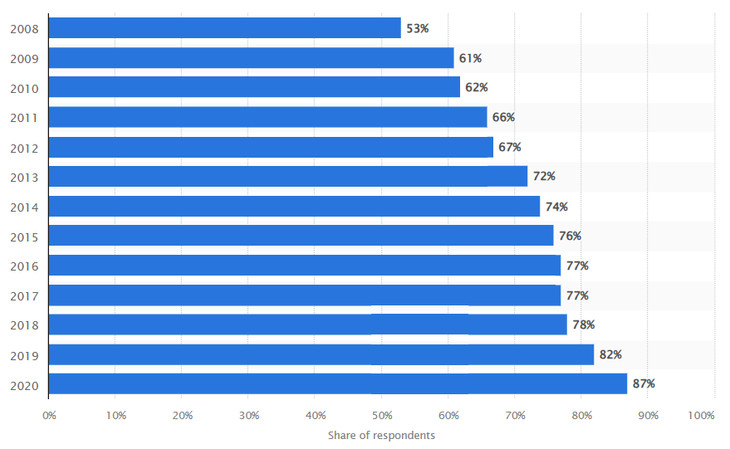
Figure 2: Growth of online purchasing intention
(Source: Statista, 2020)

2.4 Summary of Comparative Analysis
The comparative analysis between Zara and Primark regarding the impact of environmental awareness and socio-cultural changes highlights different strategic positioning of the companies. For instance, Zara experienced increased pressures in managing sustainability innovation and redesigning its fast fashion approach to adapt with the dynamic macro-environmental trends. On the other hand, Primark mainly faces structure issues in managing sustainability as it could raise operational costs and reduce the price-based competitive advantages gained by the company. The analysis further highlights that both the companies need to respond to evolving consumer demands in terms of ethical consumption and sustainability. Along with that, in-terms of socio-cultural shifts, Zara has achieved a comparative advantage over Primark. In response to changes in consumer attitude Zara has implemented strategies like digital engagement, data-driven decision-making and sustainability practices. In contrast, Primark faces more threats due to dependency on retail store selling and limited digital connections with the company.

3.0 Task 2: Strategic Response Evaluation

3.1 Evaluation of the Zara’s Strategic Responses

3.1.1 Analysis of the responses made by Zara to macro-environmental factors
In order to manage the influence of environmental awareness and socio-cultural shifts Zara has successfully combined innovation with sustainability. With the launch of ‘Join Life’ initiatives, Zara has successfully reduced the water consumption by 25% as compared to 2020 and has also started to use Natural Fiber Welding (NFW) for production, as an alternative to synthetic or animal leather (Zara, 2026).

3.1.2 Porter’s Generic Strategies to evaluate competitive approach by Zara
As per Porter's generic strategies, Zara has adopted a differentiation focus to maintain its competitiveness. The focus towards differentiation allows Zara to focus on providing trend-driven fashionable clothes with product innovation and close brand positioning. According to Sajith et al., (2025), in majority cases other fast fashion brands focus on achieving success through price competitiveness, where Zara has maintained competitiveness by implementing a vertical integrated supply chain that can respond to high design responsiveness, sustainable sourcing and a fast product turnover. This approach enables Zara to produce ever-changing collections that suit the changing customer preferences due to the inclusion of different social media channels setting global trends. Along with that Zara provides moderate prices for the products to be affordable to the mass consumers (Jangid, 2022). Thus, the differentiation strategy helps the brand to maintain brand loyalty among the customers by managing product perception value.
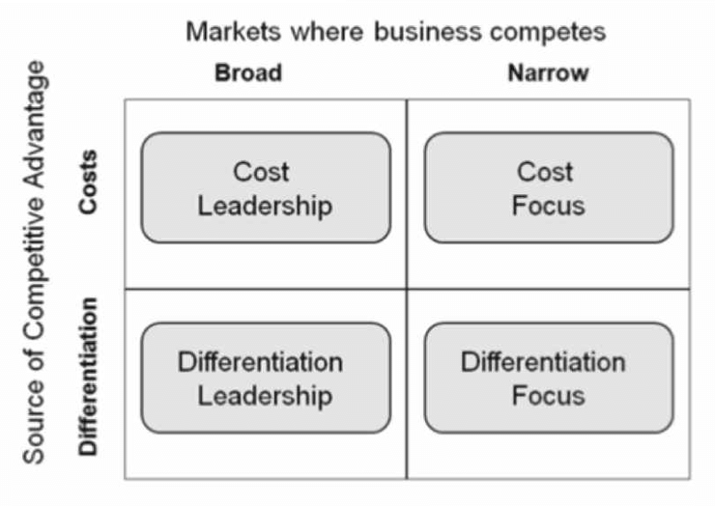
Figure 3: Porter’s generic strategies
(Source: Subrahmanyam and Arif, 2019)

3.1.3 Ansoff’s Growth Matrix to evaluate growth strategies by Zara
The growth strategy of Zara mainly aligns with the two components of Ansoff’s growth matrix including market penetration and product development. Zara releases its products for only two-three weeks and updates the fashion style as per the trends, which have been effective in market penetration (Xie and Yang, 2023). In order to maintain the wardrobe trendy and stylish, the company keeps track of global trends and also collects real-time consumer feedback, which is a good product development strategy (Casciani et al., 2022). Other than that, Zara has invested in maintaining smooth online operations that have been effective in developing digital connections with customers providing omnichannel experience. Moreover, in terms of product development, the company has started to use eco-friendly raw materials in response to growing environmental awareness (Parker-Strak et al., 2025). These initiatives have helped Zara to successfully adapt to the macro-environmental changes affecting the fast fashion sector in the UK.
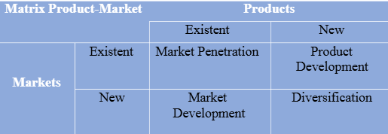
Figure 4: Ansoff’s strategy
(Source: Ferreira and Marques, 2024)

3.1.4 Critical assessment of the strategies implied in sustaining growth and competitive advantage
From the analysis, it can be highlighted that Zara could continue achieving competitiveness from the market by following strategic differentiation and growth strategies. However, to achieve sustainable growth and competitiveness, it is necessary to balance short production cycles and sustainability strategies.

3.2 Evaluation of the Primark’s Strategic Responses

3.2.1 Analysis of the responses made by Primark to macro-environmental factors
As compared to Zara, Primark has made steady progress in response to environmental and socio-cultural shifts. The company has mainly introduced initiatives like Primark Cares ensuring sustainable cotton sourcing, enhanced garment durability and limiting greenhouse gas emission (Primark, 2023). However, there are still gaps in online business management like unavailability of direct online shopping facilities by the company negatively affecting its performance.

3.2.2 Porter’s Generic Strategies to evaluate competitive approach by Primark
As of Porter’s Generic Strategies, Primark has mainly followed cost leadership strategy to maintain its competitiveness. The company is aimed at offering fashionable clothes at extremely low costs by performing large-scale outsourced manufacturing, low marketing budgets and basic inventory management (Wang, 2023). The company mainly focuses on managing a very low operational cost to reduce the product price as compared to other competitors. However, the company still faces issues in managing low operational costs due to the incorporation of sustainability demands as raised by the customers (Hendriksz, 2017). Despite the sustainability challenges, the cost-leadership method has become effective in providing competitiveness to Primark.

3.2.3 Ansoff’s Growth Matrix to evaluate growth strategies by Primark
Market penetration and market development are the key growth strategies implied by Primark as per the Ansoff’s growth matrix. The company performs market penetration by offering products at a much lower price than its competitors, which is effective in appealing customers to buy in high volume even in the existing market (Wang, 2023). On the other hand, for market development aspects the company focussed on aggressive increase in the number of retail outlets in Europe, North America and other foreign markets. Although the company was entirely based on a store-centered model, Primark has recently introduced their online services named ‘Click & Collect’ (Ologunebi, 2023). This method is a combination of online and in-store purchasing experience, where customers can purchase a product online, but they have to collect the product by themselves from nearby stores in the UK. Thus, these strategies facilitate expansion of the customer base of Primark through managing affordability as the core value proposition of the company.

3.2.4 Critical assessment of the strategies implied in sustaining growth and competitive advantage
The analysis reveals that although the low-cost production and physical retail strategy have guided Primark to receive competitiveness in the market, the constant sustainability pressure and absence of digital retailing could hamper its performance in the market. Therefore, Primark needs to reinforce sustainability strategies and digitalisation along with managing operational efficiency and affordability to attain sustainable growth and competitiveness.

3.3 Comparative Evaluation and Synthesis
Comparative analysis between the strategic intervention done by Zara and Primark reveals that there are strategic differences between the companies regarding their response towards environmental and social-cultural shifts. The analysis reveals that the strategic focus of Zara lies in differentiation and innovation. Through focusing on these pillars the company has implemented vertical supply chains for managing huge production within a short time and ‘Join Life’ programme for managing sustainability (Jangid, 2022). On the contrary, Primark has mainly focussed on managing cost leadership for competitiveness by depending on massive outsourcing and lower operational costs (Hendriksz, 2017). However, environmental awareness has created more concerns for Primark as compared to Zara as following sustainability requirements increase the overall production costs for Primark. Therefore, Zara is more adaptable in implementing strategies as per the requirements of dynamic macro-environment, but Primark is more dependent on operational efficiency to remain competitive and this company is more vulnerable towards macro-environmental changes.

4.0 Conclusion
In conclusion, among the different macro-environmental forces environmental awareness and socio-cultural changes are the main two factors affecting the fast fashion industry. This study reveals that there are differences in making strategic decisions between Zara as pioneer and Primark as follower. Zara primarily focuses on managing differentiation, innovation and sustainability for competitiveness, whereas Primark focuses on cost leadership and operational efficacy for managing competitiveness.

References
Akter, M.Md.K., Haq, U.N., Islam, Md.M. and Uddin, M.A. (2022) ‘Textile-apparel manufacturing and material waste management in the circular economy: A conceptual model to achieve sustainable development goal (SDG) 12 for Bangladesh’. Cleaner Environmental Systems 4, pp. 1–12. Available at: https://www.sciencedirect.com/science/article/pii/S2666789422000010 (Accessed: 12 March 2026).
Biyada, S. and Urbonavičius, J. (2025) ‘Circularity in textile waste: Challenges and pathways to sustainability’. Cleaner Engineering and Technology 24, pp. 1–11. Available at: https://www.sciencedirect.com/science/article/pii/S266679082500028X (Accessed: 15 March 2026).
Casciani, D., Chkanikova, O. and Pal, R. (2022) ‘Exploring the nature of digital transformation in the fashion industry: opportunities for supply chains, business models, and sustainability-oriented innovations’. Sustainability: Science, Practice and Policy 18(1), pp. 773–795. Available at: https://www.tandfonline.com/doi/full/10.1080/15487733.2022.2125640 (Accessed: 5 March 2026).
Centobelli, P., Abbate, S., Nadeem, S.P. and Reyes, J.A.G. (2022) ‘Slowing the Fast Fashion industry: an all-round Perspective’. Current Opinion in Green and Sustainable Chemistry 38(100684), pp. 1–9. Available at: https://www.sciencedirect.com/science/article/pii/S2452223622000967 (Accessed: 14 March 2026).
Encarnación, M. and Roldán, A. (2023) ‘Fast Fashion’. Routledge eBooks , pp. 266–285. Available at: https://www.researchgate.net/publication/374713908_Fast_Fashion (Accessed: 9 March 2026).
Ferreira, A. and Marques, M.B. (2024) The Importance of the Ansoff Matrix for the Study of the Information Services Market. Available at: https://www.researchgate.net/publication/382141729_The_Importance_of_the_Ansoff_Matrix_for_the_Study_of_the_Information_Services_Market (Accessed: 13 March 2026).
Figueras, A. (2025) Zara Owner Narrowly Misses Sales Forecasts, but Growth Picks Up After Slowdown. Available at: https://www.wsj.com/business/retail/sales-at-zara-owner-inditex-miss-views-but-growth-ticks-up-e06e97e1 (Accessed: 8 March 2026).
Gini, K.B. and Agala, H.O. (2023) ‘The Impact of Macro-Environmental Factors on Business Performance’. International journal of research and innovation in social science 7(11), pp. 1837–1843. Available at: https://doi.org/10.47772/IJRISS.2023.7011145 (Accessed: 12 March 2026).
Gupta, S., Kushwaha, Pooja.S., Badhera, U., Chatterjee, P. and Gonzalez, E.D.R.S. (2023) ‘Identification of benefits, challenges, and Pathways in e-commerce industries: an Integrated two-phase decision-making Model’. Sustainable Operations and Computers 4(4), pp. 200–218. Available at: https://doi.org/10.1016/j.susoc.2023.08.005 (Accessed: 14 March 2026).
Hendriksz, V. (2017) Case study on Primark sustainability, ethics, supply chain.. Available at: https://fashionunited.in/case/primark-sustainability (Accessed: 9 March 2026).
Holloway, S. (2024) ‘Consumer Perceptions of Supply Chain Responsiveness and Its Impact on Brand Loyalty in the Apparel Industry’., pp. 1–12. Available at: https://www.researchgate.net/publication/381584765_Consumer_Perceptions_of_Supply_Chain_Responsiveness_and_Its_Impact_on_Brand_Loyalty_in_the_Apparel_Industry (Accessed: 14 March 2026).
International trade Administration (2023) United Kingdom - eCommerce. Available at: https://www.trade.gov/country-commercial-guides/united-kingdom-ecommerce (Accessed: 14 March 2026).
Ivanov, D., Tsipoulanidis, A. and Schönberger, J. (2017) ‘Operations and Supply Chain Strategy’. Springer Texts in Business and Economics , pp. 69–96. Available at: https://doi.org/10.1007/978-3-319-24217-0_4?urlappend=%3Futm_source%3Dresearchgate.net%26utm_medium%3Darticle (Accessed: 11 March 2026).
Jangid, M. (2022) Zara’s Case Study -the Strategy of the Fast Fashion Pioneer the Strategy of the Fast Fashion Pioneer. Available at: https://www.researchgate.net/publication/362568585_ZARA (Accessed: 9 March 2026).
Jonwal, S. (2025) Zara Case Study 2025: The Fast Fashion Giant’s Winning Strategy. Available at: https://www.youngurbanproject.com/zara-case-study/ (Accessed: 14 March 2026).
Ologunebi, J.O. (2023) ‘An analysis of customer retention strategies in e-commerce fashion business in the UK: A case study of Primark’. Research Gate , pp. 1–11. Available at: https://www.researchgate.net/publication/375489575_An_analysis_of_customer_retention_strategies_in_e-commerce_fashion_business_in_the_UK_A_case_study_of_Primark (Accessed: 13 March 2026).
Parker-Strak, R., Boardman, R. and Studd, R. (2025) ‘The Evolving Nature of Fashion Product Development and the Importance of Product in Fashion Marketing’. Fashion Marketing , pp. 13–45. Available at: https://www.researchgate.net/publication/393411127_The_Evolving_Nature_of_Fashion_Product_Development_and_the_Importance_of_Product_in_Fashion_Marketing (Accessed: 14 March 2026).
Petro, G. (2022) Consumers Demand Sustainable Products and Shopping Formats. Available at: https://www.forbes.com/sites/gregpetro/2022/03/11/consumers-demand-sustainable-products-and-shopping-formats/ (Accessed: 12 March 2026).
Primark (2023) Our Primark Cares Commitments. Available at: https://corporate.primark.com/en-ie/a/our-approach/our-primark-cares-commitments (Accessed: 14 March 2026).
Primark (2026) About Us. Available at: https://corporate.primark.com/en-gb/a/about-us/who-we-are (Accessed: 11 March 2026).
Sajith, B., Kumar, P.M., Shetty, S., Kumar, J. and John, T. (2025) Study on Zara’s Supply Chain Efficiency and Its Impact on Global Competitiveness., pp. 1–8. Available at: https://ijirt.org/publishedpaper/IJIRT186065_PAPER.pdf (Accessed: 14 March 2026).
Smith, P. (2025) Primark: number of suppliers 2020 by country. Available at: https://www.statista.com/statistics/1102388/number-of-suppliers-of-primark-by-region/ (Accessed: 15 March 2026).
Statista (2020) Online purchasing penetration in Great Britain 2008-2020| Statista. Available at: https://www.statista.com/statistics/275968/online-purchasing-penetration-in-great-britain/?srsltid=AfmBOop_ok0MWpk090oxe-G0ovW0i3NfPB_0-86cURguyIpx1UghH5Cx (Accessed: 15 March 2026).
Statista (2025) Primark revenue 2007-2025| Statista. Available at: https://www.statista.com/statistics/383785/primark-revenue-worldwide/?srsltid=AfmBOopQ40F8FyB2h6AdEXavAyJxrvhJXHx8CVLsfgZw8nafQVp6GFB7 (Accessed: 13 March 2026).
Statista (2026) Topic: Apparel market in the UK. Available at: https://www.statista.com/topics/3348/apparel-market-in-the-uk/#topicOverview (Accessed: 11 March 2026).
Subrahmanyam, S. and Arif, S.A.F. (2019) (PDF) Carrefour’s Competitive Strategy- Cost Leadership and Differentiation: A Case Study. Available at: https://www.researchgate.net/publication/333118406_Carrefour (Accessed: 14 March 2026).
Vassalo, A.L., Marques, C.G., Simões, J.T., Fernandes, M.M. and Domingos, S. (2024) ‘Sustainability in the Fashion Industry in Relation to Consumption in a Digital Age’. Sustainability 16(13), pp. 1–11. Available at: https://www.mdpi.com/2071-1050/16/13/5303 (Accessed: 8 March 2026).
Vimal, S. (2026) Zara owner Inditex reports profit growth in FY25. Available at: https://www.retail-insight-network.com/news/inditex-reports-profit-growth-fy25/ (Accessed: 13 March 2026).
Wang, Z. (2023) ‘The Reasons of Primark Brand Loyalty in The Post-Epidemic Era Based on Marketing Mix Theory’. Highlights in Business, Economics and Management 23, pp. 590–596. Available at: https://doi.org/10.54097/p8f3e715 (Accessed: 14 March 2026).
Xie, Y. and Yang, Q. (2023) ‘Comparative Analysis of Marketing Strategies of Fast Fashion Brands ZARA and H&M’. BCP Business & Management 39(1), pp. 318–324. Available at: https://www.researchgate.net/publication/369424749_Comparative_Analysis_of_Marketing_Strategies_of_Fast_Fashion_Brands_ZARA_and_HM (Accessed: 15 March 2026).
Zara (2026) Production processes. Available at: https://www.zara.com/in/en/sustainability-products-mkt1455.html (Accessed: 13 March 2026).
Zara (2026) MIRUM®. Available at: https://www.zara.com/in/en/join-life-sih-mkt8261.html (Accessed: 15 March 2026).
Zhang, B., Zhang, Y. and Zhou, P. (2021) ‘Consumer Attitude Towards Sustainability of Fast Fashion Products in the UK’. Sustainability 13(4), pp. 1–23. Available at: https://www.mdpi.com/2071-1050/13/4/1646 (Accessed: 12 March 2026).

