Network Operating Systems and Services
ACCA 5023
Kyle Aldridge (2404215)
UWTSD - HND Computing (Cyber security and Networking)
Table of Contents
Task 1 2
I. Justification for the type of hypervisor 2
II. IP addressing 2
III. Routing 1
IV. Network services 2
Task 2 1
Task 3 10
Table of Figures 1
References 1

Task 1

Justification for the type of hypervisor
For this assignment, a type 2 hypervisor will be used due to its suitability for the network topology and ease of setup. This is due to type 1 hypervisors requiring dedicated bare-metal deployment and enterprise-grade infrastructure, which are costly for users/businesses, even when cloud-hosted[1]. Type 2 hypervisors incur inefficiencies due to base operating system (OS) overheads and can be more insecure than Type 1 hypervisors, but their hardware compatibility, convenience, and cost-effectiveness make Type 2 hypervisors more suitable for this objective[2][1]. Furthermore, due to the requirement for multiple servers, domain environments, and client computers in two different areas, it would be costly and complex to run a type 1 hypervisor compared to a type 2 hypervisor, especially in a small-scale branch with only two sites for a multinational company such as NOSS2026[1], [2].

IP addressing
Both IPv4 and IPv6 are fundamental to how the internet functions. This is due to it allowing the internet to scale easily regardless of network size[3]. This is due to it being a common standard that provides a standardised addressing framework, which supports unique identification and location within a network[3], [4]. Unlike MAC addresses, which identify a Network Interface Card (NIC) at Layer 2, IP addresses operate at Layer 3 to define logical location, enabling data to be routed between different networks rather than only within a local segment[5]. This logical addressing structure allows devices to communicate beyond their immediate physical network, forming the foundation of global Internet connectivity[5], [6].
IPv4 was the original protocol standardised for Internet communication and provides approximately 4.3 billion unique addresses[4]. While this initially appeared sufficient, the rapid growth of Internet-connected devices led to address exhaustion, prompting the development of IPv6[4]. IPv6 significantly expands the available address space to approximately 340 undecillion addresses, enabling long-term scalability and supporting emerging technologies such as the Internet of Things (IoT)[4]. Beyond increased capacity, IPv6 also improves routing efficiency and hierarchical addressing, facilitating more scalable and sustainable network design[4].
Both IPv4 and IPv6 enable routers to forward packets based on the network prefix portion of the address, which is defined through subnetting[6]. Subnetting allows organisations to divide a larger network into smaller logical segments, improving address utilisation, performance, and security[7]. By segmenting departments or services into distinct subnets, broadcast domains are reduced, enabling access control through controlled routing policies[6], [7]. Consequently, IP addressing not only enables communication but also supports structured network design and traffic management within enterprise environments[8].
Within a local network, switches operate at Layer 2 by forwarding frames based on MAC addresses, maintaining a MAC address table to efficiently direct traffic[9]. When a destination device resides outside the local subnet, the frame is forwarded to the default gateway (router)[5], [6], [9]. The router removes the Layer 2 header, examines the destination IP address, and consults its routing table to determine the appropriate outgoing interface[10]. It then encapsulates the packet within a new Layer 2 frame before forwarding it toward the next hop[10]. This process continues across networks until the packet reaches its destination. Through this layered interaction between switching and routing, IP addressing enables scalable communication across interconnected networks[3], [8], [10].
If a switch doesn't have a full MAC address table, it will broadcast the packet to all unknown interfaces, and if the required NIC responds, it will unicast the rest of the packets to that outgoing interface, and if it doesn't match any, then it will send it to the router[5].

Routing
There are two types of routing protocols static, where the router will route relevant traffic through predetermined interfaces; and dynamic, where each router will though a protocol to broadcast its networks (predetermined to be shared) to other routers and each router will then store the information from other routers in its routing table and it automatically updates frequently[11].
In a small network, static routing may be utilised as it is easier to keep track of the necessary IPv4 and IPv6 (if used) as the network isn’t large or too complex[6]. However, a growing or large network may integrate dynamic routing protocols due to it simplifying the network configuration, as performing static routing on multiple routers is time-consuming and error-prone; if one of the entries is entered in wrong, then the routing information that it was supposed to be will be wrong, which will cause problems in the future[6]. Also, if a router needs to be replaced or a network’s IP addressing changes, the change will only need to be made on the router, not the entire network, since it will be automatically announced to all routers with dynamic routing enabled[6].
The routing type for this assignment's topology will be static routing, as it is a simple network with few devices and is more suitable for this initial implementation phase. Furthermore, there is only 1 domain across 2 locations, making static routing easier to implement than dynamic routing.

Network services
The network will incorporate multiple network services, including DHCP, Active Directory Domain Services (AD DS), a Certificate Authority (CA), and VPNs. DHCP will automatically assign IP addresses to devices, allowing the network to dynamically expand as devices join[12]. Doing this will reduce the likelihood of misconfiguration errors caused by manual IP address assignment, which, on a larger scale, is expensive due to its time-consuming, tedious nature and therefore more error-prone[13]. It also adds a singular, centralised control over IP addressing schemes and reduces reliance on manual administrative intervention[13].
AD DS enforces a centralised service for managing users, their systems, and resources across computer systems[14]. It acts as a central database for anything from authentication to authorisation and policy enforcement across the networked devices[14]. Without AD DS, each system would require independent account management, increasing administrative overhead and security inconsistencies[15]. This reduces the risk of inconsistent access control across geographically separated locations[14], [15].
The CA will allow computers to connect to servers securely by verifying their identities and distinguishing genuine users from those trying to exploit the network[16]. As the CA enables identity verification that helps make encryption trustworthy, it also enables clients to trust the domain controller and secure communication between two different locations within the same domain[17]. This is because the server can prove it is who it says it is and therefore reduces the risk from self-signed certificates[16], [17]. This is useful for other services, such as VPNs and AD DS, which can enforce that a CA be present before granting access [17].
The VPN allows the company’s services, such as file servers, domain login, internal websites and management tools, to be hidden and not directly exposed to the public internet, allowing the VPN to aid the security of the company’s internal network, along with supporting remote workforce requirements and secure inter-site connectivity[18]. However, a VPN with just encryption isn’t sufficient to secure a network, so to aid the security of the VPN, a CA can be deployed and integrated so that client devices can trust by verification that the VPN is true, along with the VPN can verify the clients identity which ensures that the encrypted tunnel can be established safely and in a secure manner[16], [17], [18].
Collectively, these services create a secure, scalable and centrally managed enterprise infrastructure, where identity, addressing and secure connectivity operate in an integrated manner.

Task 2
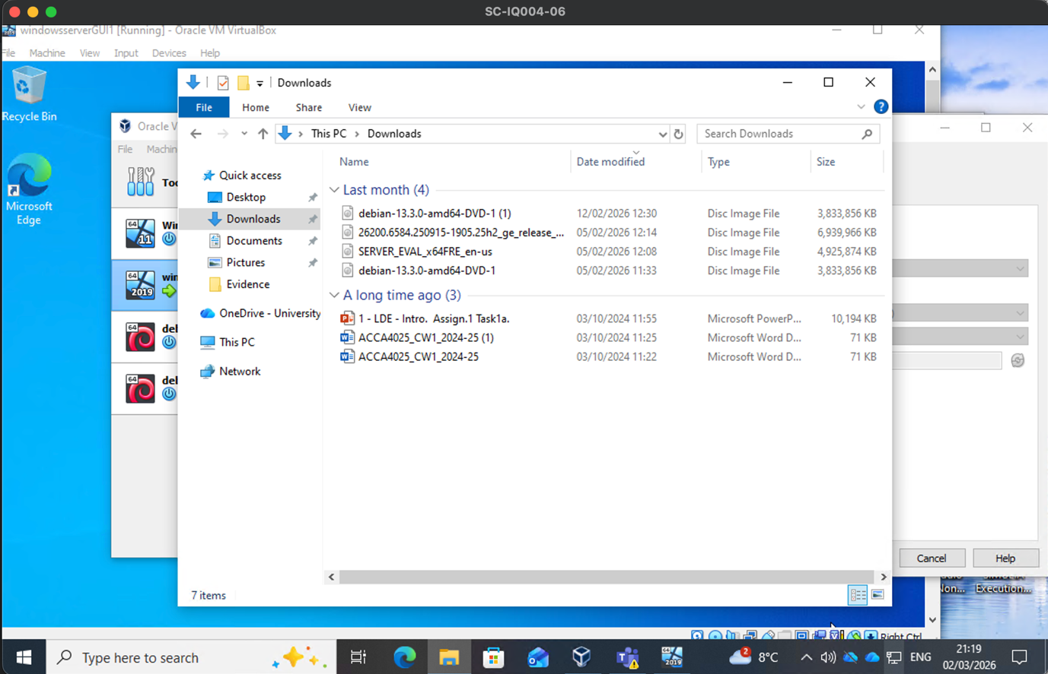
Figure 1 - iso files used for each OS and date started/downloaded
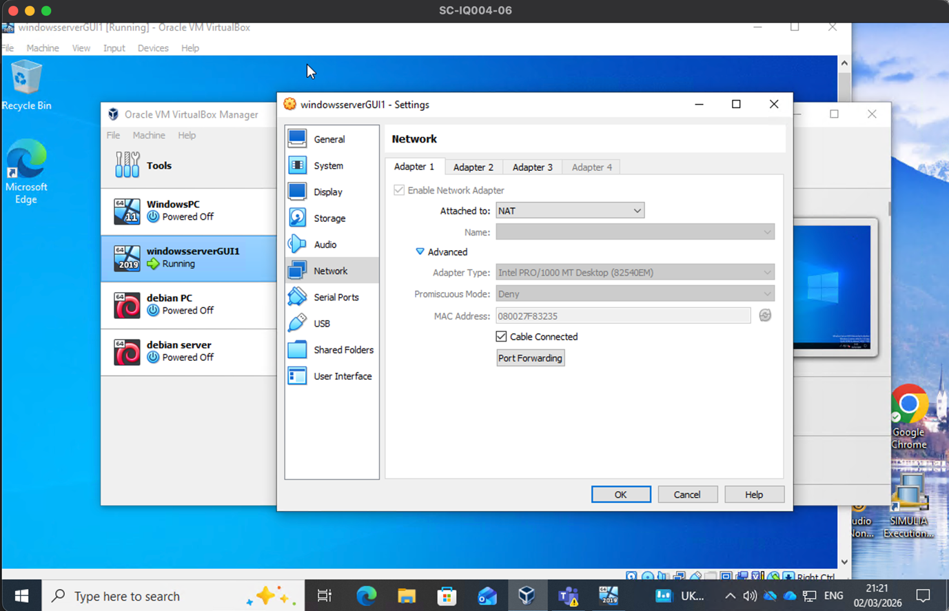
Figure 2 - VM NAT adapter used for S-DC internet adapter
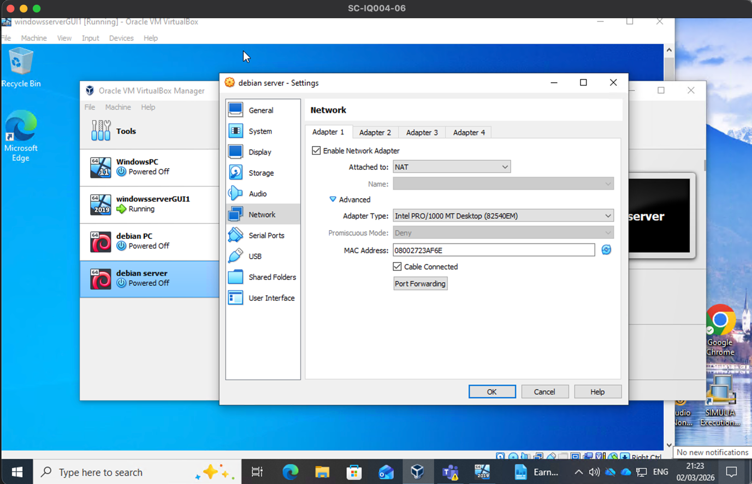
Figure 3 - VM NAT adapter used for L-DC internet adapter
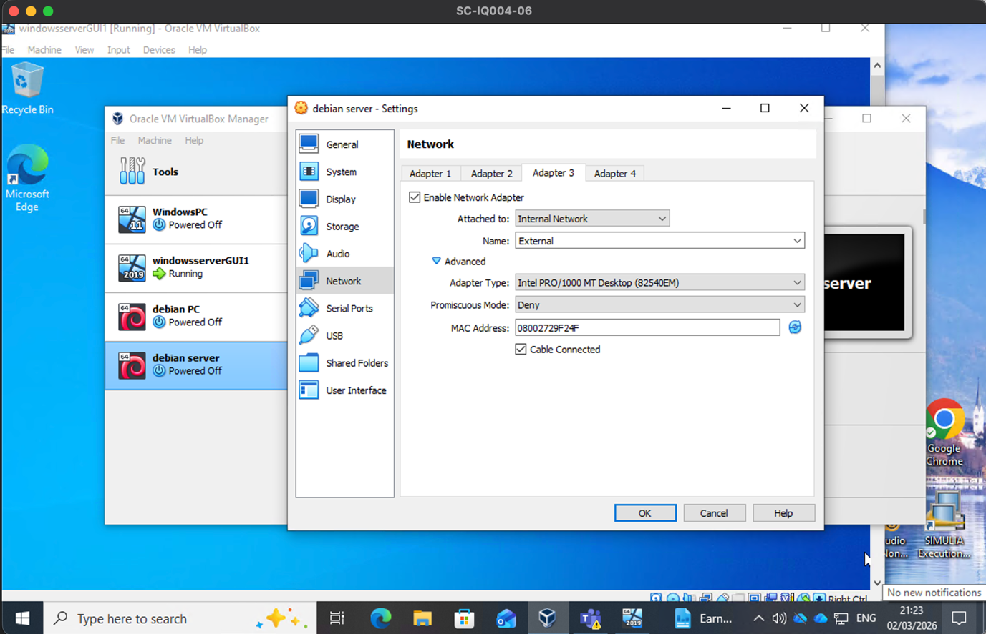
Figure 4 - VM Internal adapter type used for S-DC to L-DC network link
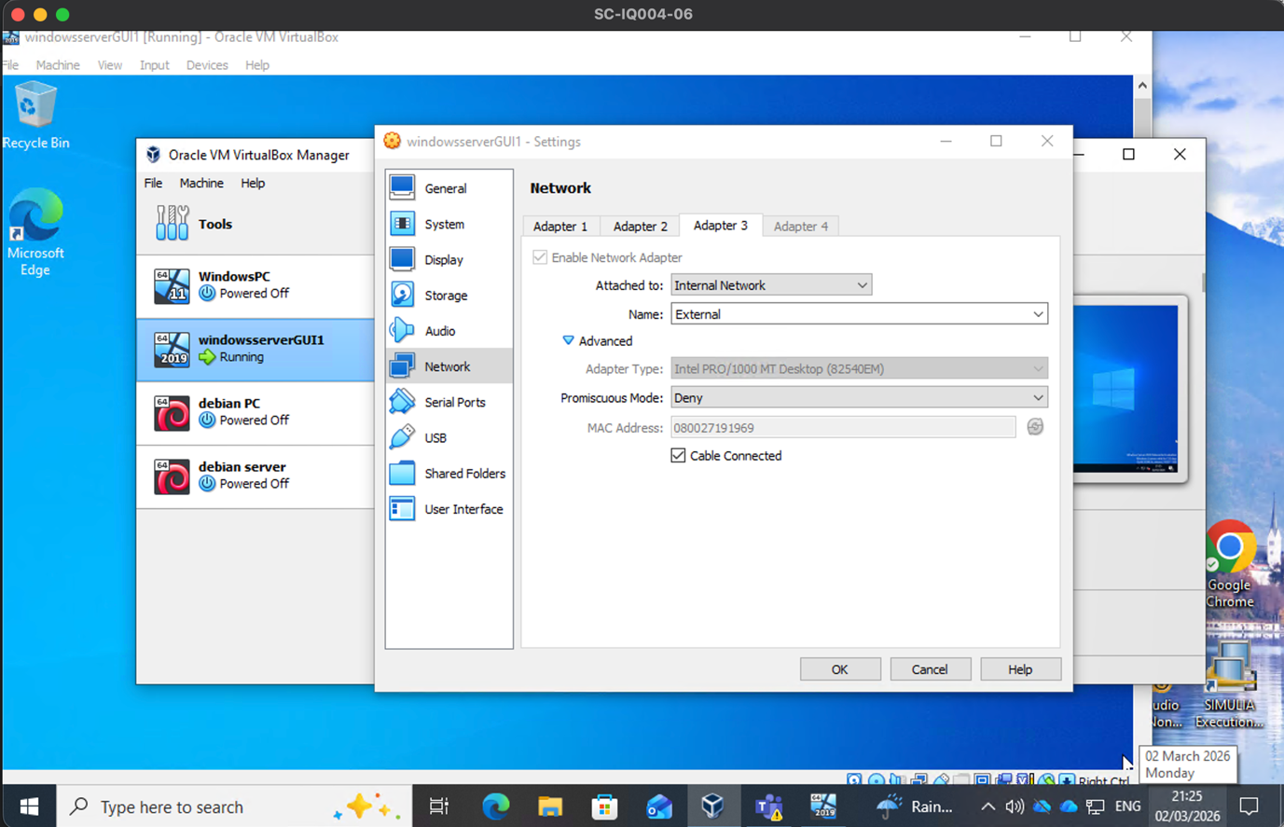
Figure 5 - VM Internal adapter type used for S-DC to L-DC network link
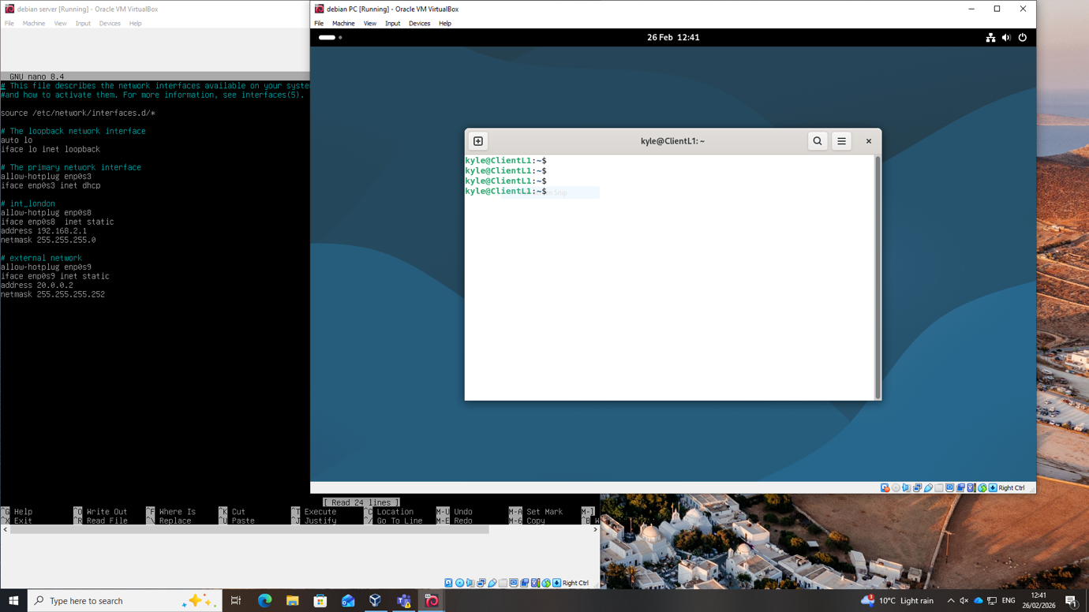
Figure 6 - Showing ClientL1’s hostname
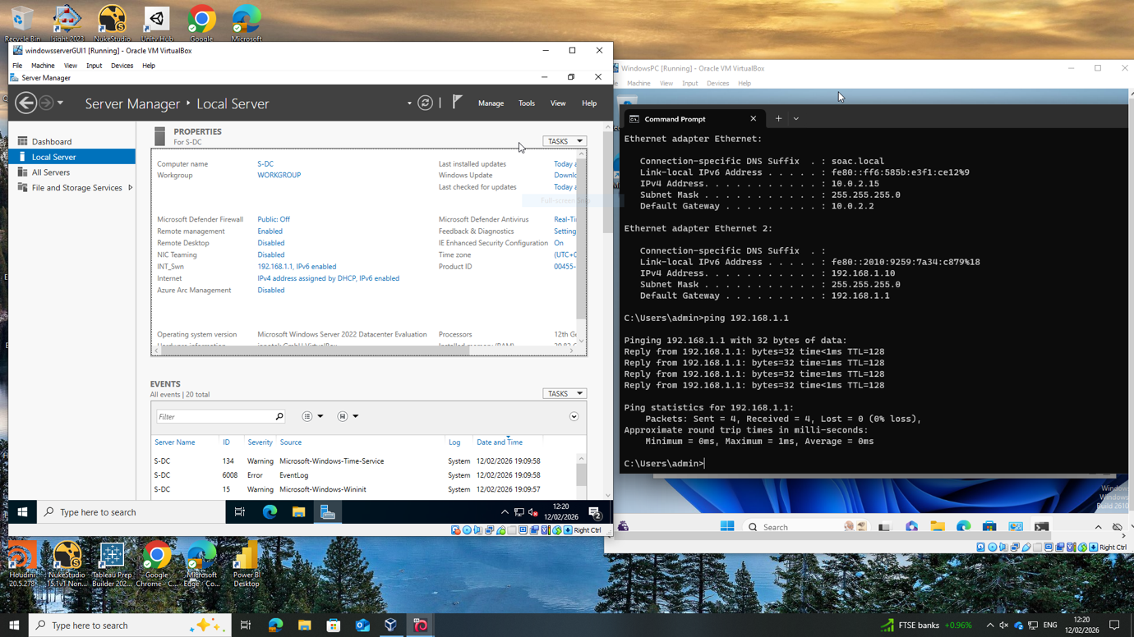
Figure 7 - S-DC showing hostname of S-DC server

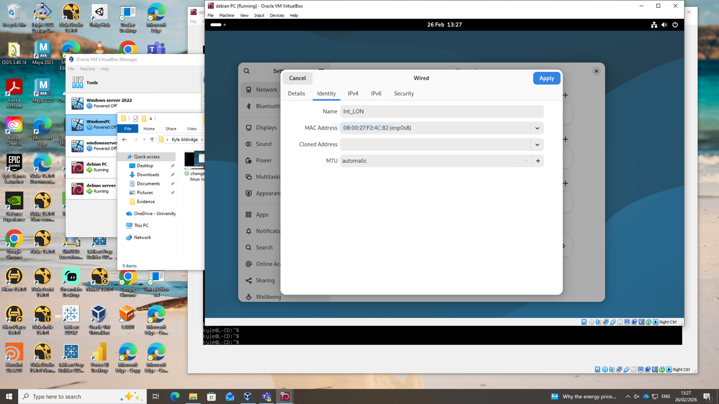
Figure 8 - Showing ClientL1 network adapter name for int_LON
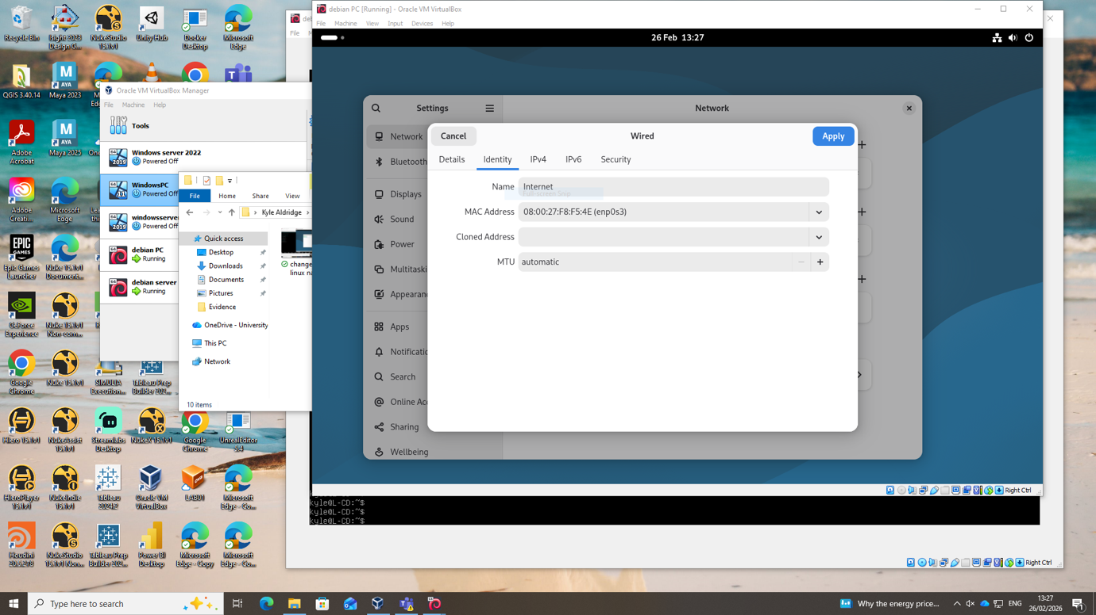
Figure 9 - Showing ClientL1 network adapter name for the internet
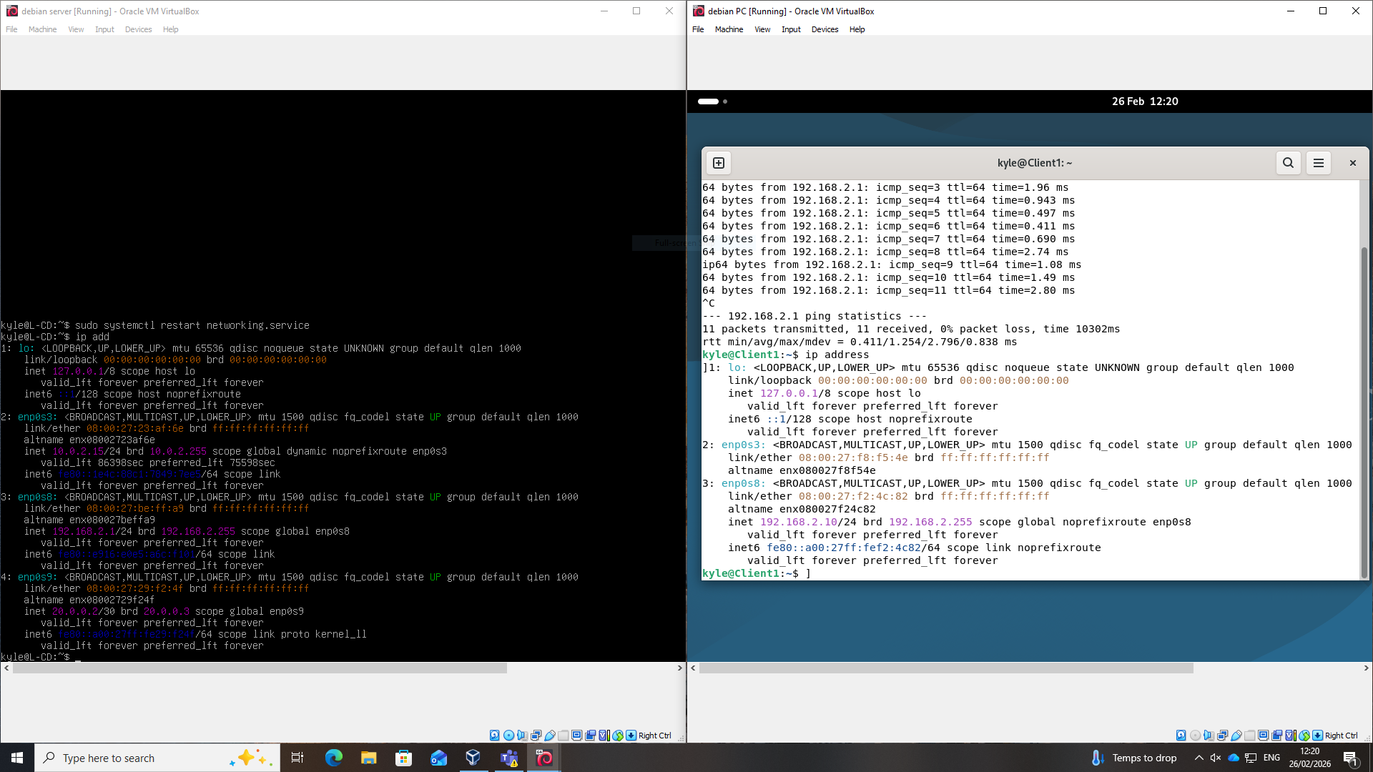
Figure 10 - showing L-DC and ClientL1 IP address configurations
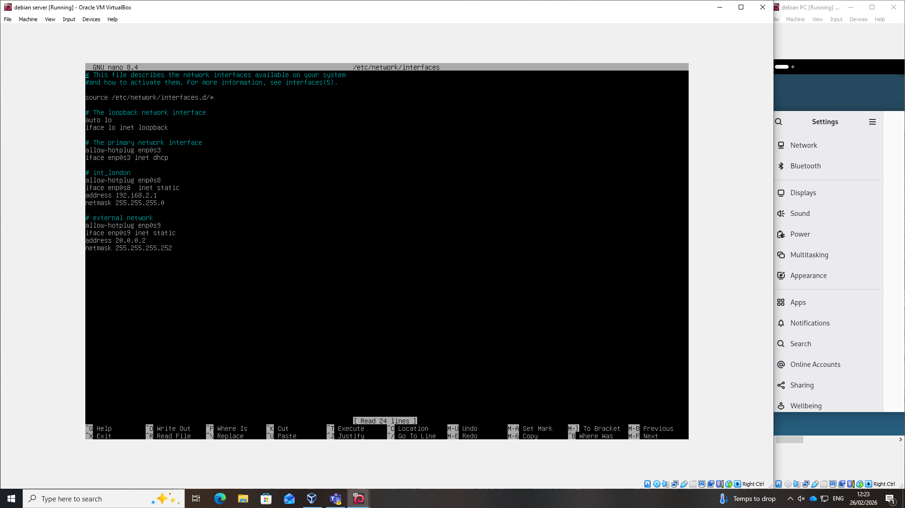
Figure 11 - L-CD Network interface names and IP addresses
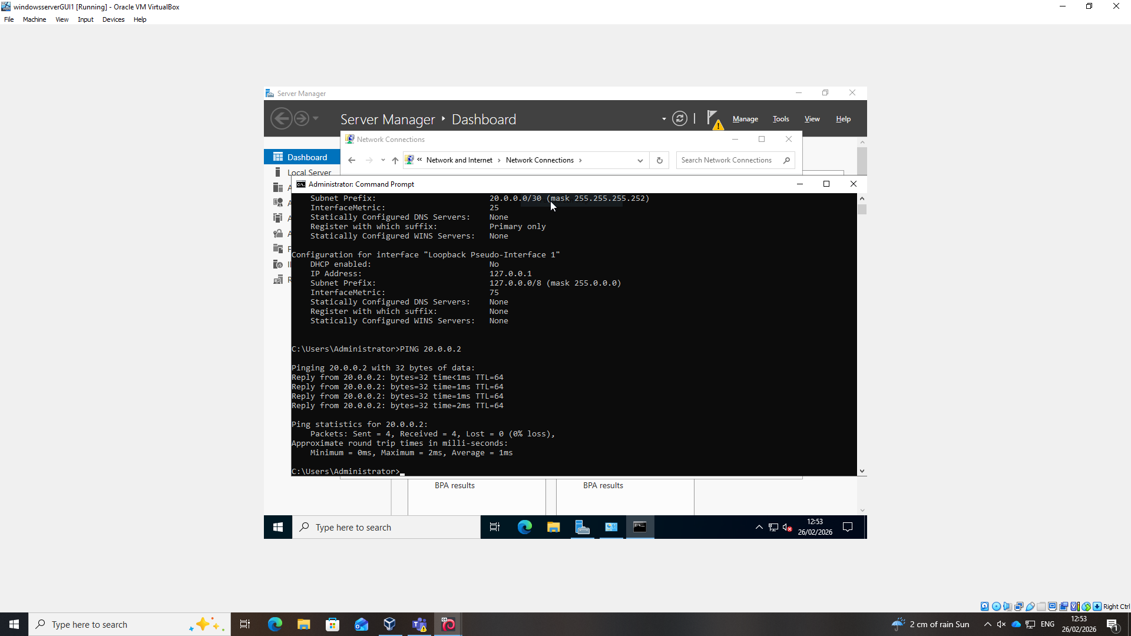
Figure 12 - S-DC Server showing successful pings to ClientS1
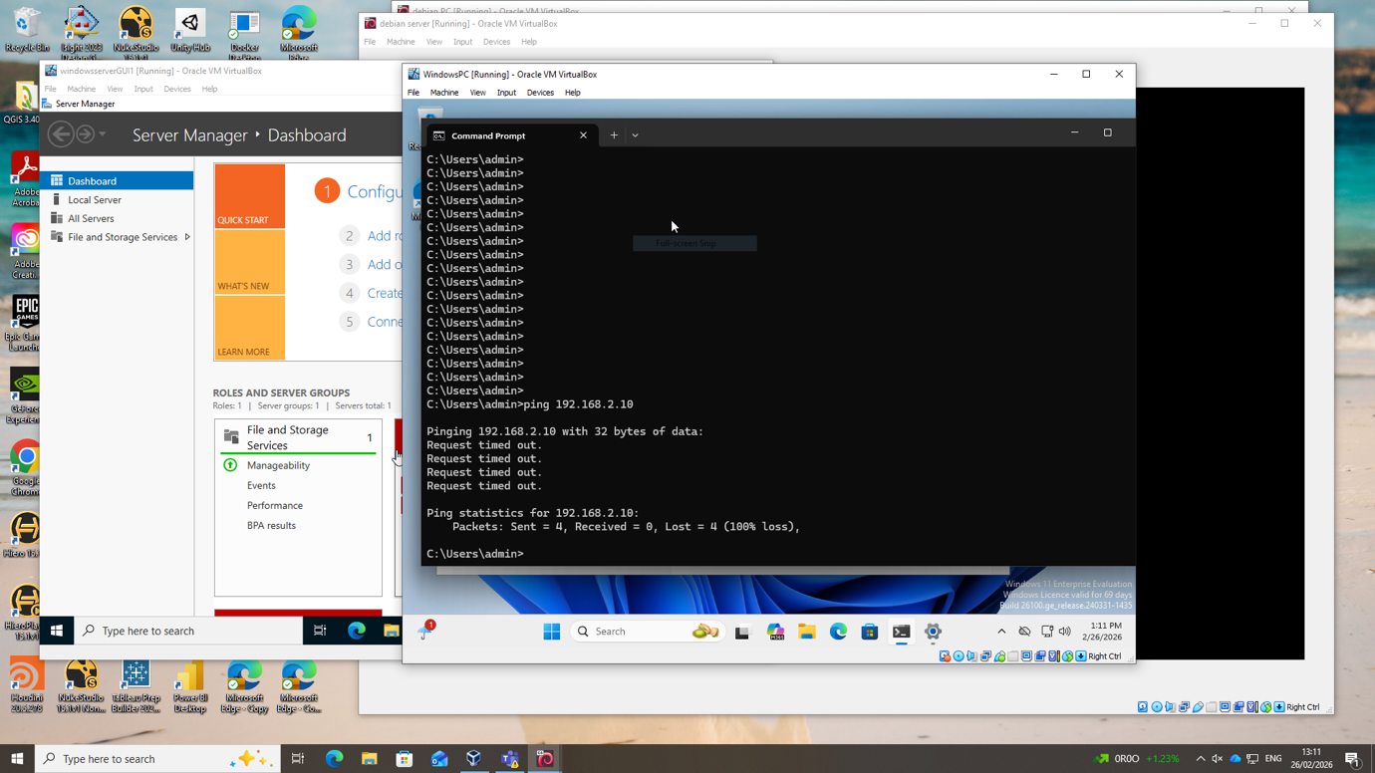
Figure 13- ClientS1 showing unsuccessful pings to ClientL1
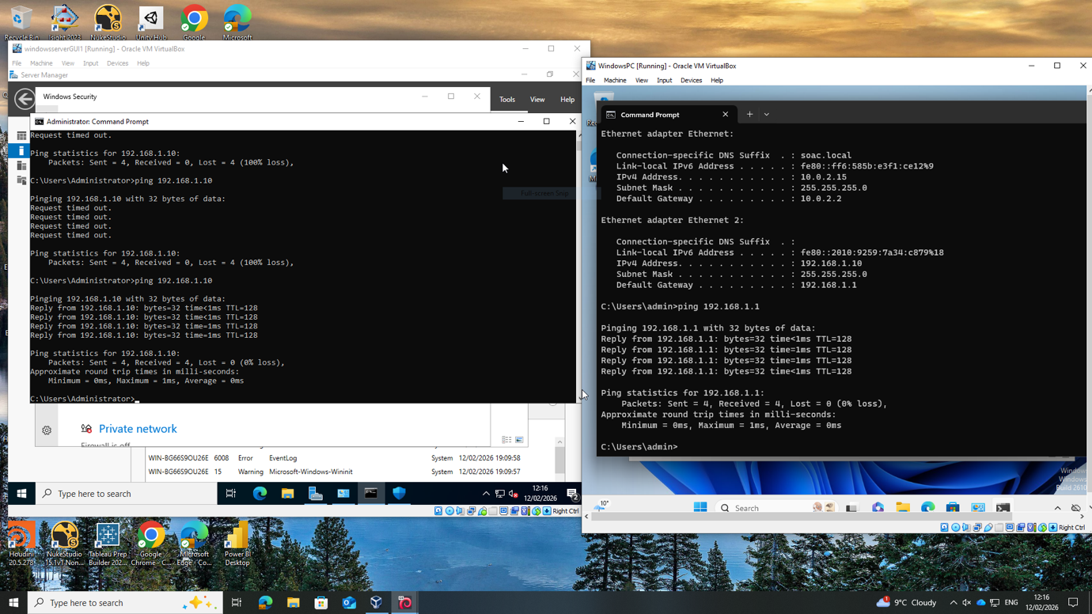
Figure 14- S-DC Server showing successful pings to ClientS1
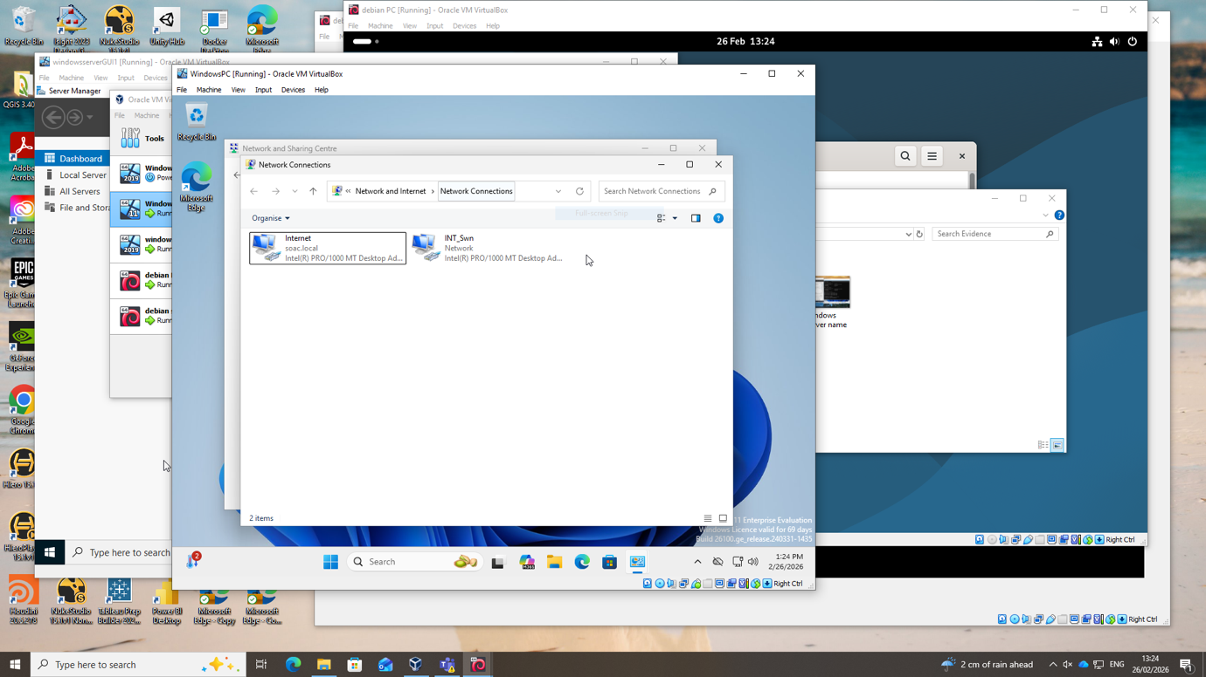
Figure 15 - Showing ClientS1 network adapter names
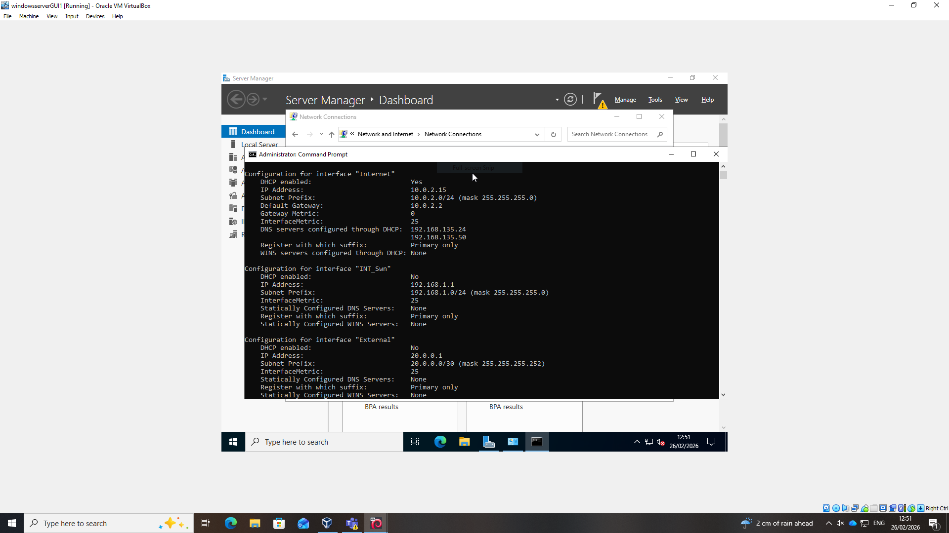
Figure 16 - showing S-DC server network adapter IP addresses and interface names

Task 3

During the configuration and setup of the servers and client OSs on the virtual machines, a few issues arose. However, there was one main issue with the Debian server: Sudo commands were not installed during the initial setup. This required editing configuration files to point parts of the bash script to a distribution for downloading and executing the sudo service installation. The issue was identified when trying to execute administrative commands, and errors occurred due to sudo not being installed. This was the only major issue that was encountered. The issue was diagnosed by analysing errors when executing sudo commands, which revealed that the sudo package had not been installed during the minimal Debian setup, which also taught me a lot about troubleshooting and the Linux base system and its configuration files. The initial setup also required careful consideration of the virtual machine configuration to avoid issues due to insufficient space or resources, such as RAM and disk space allocation. The IP addresses were also configured in line with the organisation's requirements. In future deployments, verifying package installation during initial configuration would prevent unnecessary troubleshooting delays.
Lastly, some troubleshooting tools/commands were also utilised, such as ipconfig /all and ping to view the network adapters and to see if the right devices could communicate with the correct devices. Along with disabling firewall settings and checking subnet masks.
Overall, Task 2 was completed successfully, meeting all requirements, including pinging the appropriate servers within each network. It also helped in understanding how to initially configure the start of an enterprise network setup and how to manage my time most effectively. This, in turn, improved my confidence in applying the theoretical knowledge to practical outcomes. This process, therefore, strengthened my understanding of how to initialise the deployment of an enterprise network, which will then be built upon further.

Table of Figures

Figure 1 - iso files used for each OS and date started/downloaded 1
Figure 2 - VM NAT adapter used for S-DC internet adapter 1
Figure 3 - VM NAT adapter used for L-DC internet adapter 2
Figure 4 - VM Internal adapter type used for S-DC to L-DC network link 2
Figure 5 - VM Internal adapter type used for S-DC to L-DC network link 3
Figure 6 - Showing ClientL1’s hostname 3
Figure 7 - S-DC showing hostname of S-DC server 4
Figure 8 - Showing ClientL1 network adapter name for int_LON 5
Figure 9 - Showing ClientL1 network adapter name for the internet 5
Figure 10 - showing L-DC and ClientL1 IP address configurations 6
Figure 11 - L-CD Network interface names and IP addresses 6
Figure 12 - S-DC Server showing successful pings to ClientS1 7
Figure 13- ClientS1 showing unsuccessful pings to ClientL1 7
Figure 14- S-DC Server showing successful pings to ClientS1 8
Figure 15 - Showing ClientS1 network adapter names 8
Figure 16 - showing S-DC server network adapter IP addresses and interface names 9

References

[1] “What Are Hypervisors? | IBM.” Accessed: Mar. 03, 2026. [Online]. Available: https://www.ibm.com/think/topics/hypervisors
[2] A. Gupta, Z. Aalam, V. Kumar, and S. Gour, “A review paper on hypervisor and virtual machine security You may also like A modelling & Simulation via CloudSim for Live Migration in Virtual Machines A review paper on hypervisor and virtual machine security,” J. Phys. Conf. Ser., p. 12027, 1950, doi: 10.1088/1742-6596/1950/1/012027.
[3] A. C. Bento, G. Alexandre Vieira, O. J. Santos Monteiro, and L. Henrique Furquim Sanches, “IPV4 X IPV6, Results of a Study about Use of Internet Addresses,” in 2018 International Conference on Recent Innovations in Electrical, Electronics & Communication Engineering (ICRIEECE), IEEE, Jul. 2018, pp. 409–413. doi: 10.1109/ICRIEECE44171.2018.9008928.
[4] O. Babatunde and O. Al-Debagy, “A Comparative Review Of Internet Protocol Version 4 (IPv4) and Internet Protocol Version 6 (IPv6),” International Journal of Computer Trends and Technology, vol. 13, no. 1, 2014, Accessed: Mar. 02, 2026. [Online]. Available: http://www.ijcttjournal.org
[5] M. A. Yusuf, M. Prodip, and K. Biswas, “MAC ADDRESS ROUTING POLICY OVER THE IP NETWORK,” International Journal of Engineering Applied Sciences and Technology, vol. 3, p. 11, 2019, Accessed: Mar. 03, 2026. [Online]. Available: http://www.ijeast.com
[6] S. S. Panwar, S. Mao, J. Ryoo, and Y. Li, “Static and dynamic routing,” in TCP/IP Essentials, Cambridge University Press, 2012, pp. 77–99. doi: 10.1017/cbo9781139167246.007.
[7] “Configure IP Addresses and Unique Subnets for New Users - Cisco.” Accessed: Mar. 03, 2026. [Online]. Available: https://www.cisco.com/c/en/us/support/docs/ip/routing-information-protocol-rip/13788-3.html
[8] I. El-Shekeil, A. Pal, and K. Kant, “IP Address Consolidation and Reconfiguration in Enterprise Networks,” in 2016 25th International Conference on Computer Communication and Networks (ICCCN), IEEE, Aug. 2016, pp. 1–9. doi: 10.1109/ICCCN.2016.7568534.
[9] “Overview of Layer 2 Switched Networks and Communication - Cisco Community.” Accessed: Mar. 03, 2026. [Online]. Available: https://community.cisco.com/t5/networking-knowledge-base/overview-of-layer-2-switched-networks-and-communication/ta-p/3128423
[10] “Communication at Network Layer (Layer 3) - Cisco Community.” Accessed: Mar. 03, 2026. [Online]. Available: https://community.cisco.com/t5/networking-knowledge-base/communication-at-network-layer-layer-3/ta-p/3128129
[11] M. Masood, M. Abuhelala, and I. Glesk, “A comprehensive study of Routing Protocols Performance with Topological Changes in the Networks”.
[12] “DHCP - Cisco IoT Operations Dashboard - Cisco DevNet.” Accessed: Mar. 02, 2026. [Online]. Available: https://developer.cisco.com/docs/iotod/dhcp/#dhcp
[13] “RFC 2131 - Dynamic Host Configuration Protocol.” Accessed: Mar. 02, 2026. [Online]. Available: https://datatracker.ietf.org/doc/html/rfc2131
[14] “Active Directory Domain Services overview | Microsoft Learn.” Accessed: Mar. 03, 2026. [Online]. Available: https://learn.microsoft.com/en-us/windows-server/identity/ad-ds/get-started/virtual-dc/active-directory-domain-services-overview
[15] Al Gillen, Randy Perry, Frederick W. Broussard, and Seana Dowling, “Optimizing Infrastructure : The Relationship Between IT Labor Costs and Best Practices forIdentity and Access Management with Active Directory,” IDC, Nov. 2006, Accessed: Mar. 03, 2026. [Online]. Available: https://www.google.com/url?sa=t&source=web&rct=j&opi=89978449&url=https://download.microsoft.com/download/9/f/3/9f337be9-cc5a-46d6-bcbd-27e77acdb0ed/IDC_ADIO_whitepaper.pdf&ved=2ahUKEwiokMzwyYOTAxVBUkEAHQLGHHsQFnoECBoQAQ&usg=AOvVaw2mUok3HXC4PsIUpk-68Wxh
[16] “What is the Certification Authority Role Service in Windows Server? | Microsoft Learn.” Accessed: Mar. 03, 2026. [Online]. Available: https://learn.microsoft.com/en-us/windows-server/identity/ad-cs/certification-authority-role
[17] “What is Active Directory Certificate Services in Windows Server? | Microsoft Learn.” Accessed: Mar. 03, 2026. [Online]. Available: https://learn.microsoft.com/en-us/windows-server/identity/ad-cs/active-directory-certificate-services-overview
[18] “Virtual Private Networks (VPNs) | National Cyber Security Centre - NCSC.GOV.UK.” Accessed: Mar. 03, 2026. [Online]. Available: https://www.ncsc.gov.uk/collection/device-security-guidance/infrastructure/virtual-private-networks

