January 12, 2022
ADRIAN PETRU STATE 2030021
BSc cloud computin level 4 TERM2
UWTSD,LONDON
Software Development ACCB4017
Software Development Assessment 1

Table of Contents

PART A 1
A1. 2
A2. 4
PART B 5
Exercise 1 5
Exercise 2 7
Exercise 3 9
Exercise 4 11

PART A

A1.

A list is a data type that defines a collection of data objects in a specific order, with each element occupying a specific place. The order indicated could be alphabetical, numeric, or based on the order in which the elements are added.
The difference between a list and a variable is the elements which each accepts. A variable accepts only a single element whereas a list takes a collection of data items. This therefore means that a variable holds only one object or data type at a time whereas a list holds a sequence of objects all at once at a particular time.
Accessing a List using LINQ
{var students = new List<Student>(){
new Student(){ID = 1, Name = "John"},
new Student(){ID = 2, Name = "Peter"},
new Student(){ID = 3, Name = "Faith"},
new Student(){ID = 4, Name = "Janet"},
new Student(){ID = 5, Name = "Shawn"},
};
//Accessing student list for student called Faith
var result = FROM s in students
WHERE s.Name == "Faith"
SELECT s;
foreach(var student in result)
printf(Student.ID+","+Student.Name);
}

Inbuilt List Functions
1. Add(T): It adds an object to the end of the list.
2. Insert(int32,T): Inserts an element to the list at the specified index
3. RemoveAt(T): Removes the element at the specified index of the list.
4.FindIndex(T): Searches for an element that matches the conditions defined by the specified.
5GetType(): Gets the data type of the current instance

How to use the functions
class ListFunctions{
//Creating a list
List<int> numbers = new numbers<int>()
//adding elements
numbers.Add(1);
numbers.Add(2);
numbers.Add(3);
//inserting element in the list
numbers.Isert(int5,3);
//Removing elements
numbers.RemoveAt(2);
//finding an element
numbers.FindIndex(1);
//Finding data type of element
numbers.GetType(1);
};

A2.
User defined functions are functions that are given an identifier to performs a specific task. Whenever the function is invoked from any part of the program, it executes the program code defined within the body of that function.

#Example of a user defined function
def sqr(no):
try:
square = int(no)*int(no)
print(f"the square of {no} is {square}")
except ValueError:
print("Both values you provide have to be integers")

PART B

Exercise 1
Pseudocode
- Input values from the user and store them in car_make, car_model, car_mileage and car_doors respectively.
- Validate their data types to make sure they are realistic.
- Print out each variable, describing the car.
#variables can hold any data type, here are a few expressed as properties of a car
#strings
make = "Ford"
model = "Ranger"
mileage = "600 M"
doors = 4

#A program that takes car make, model, mileage and door number from user input
and prints them if they are of the correct types

def car_details():
car_make = input("Make: ")
car_model = input("Model: ")
car_mileage = input("Mileage: ")
try:
car_doors = int(input("Enter number of car doors \n"))
except ValueError:
raise Exception("door number must be a number")
print(
f"the car make is {car_make} \n",
f"the car model is {car_model} \n"
f"the car mileage is: {car_mileage} \n"
f"the car has {car_doors} doors \n"
)

if __name__ == "__main__":
car_details()

Screenshots
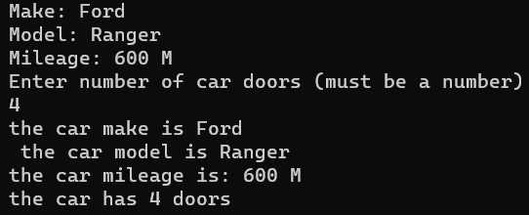
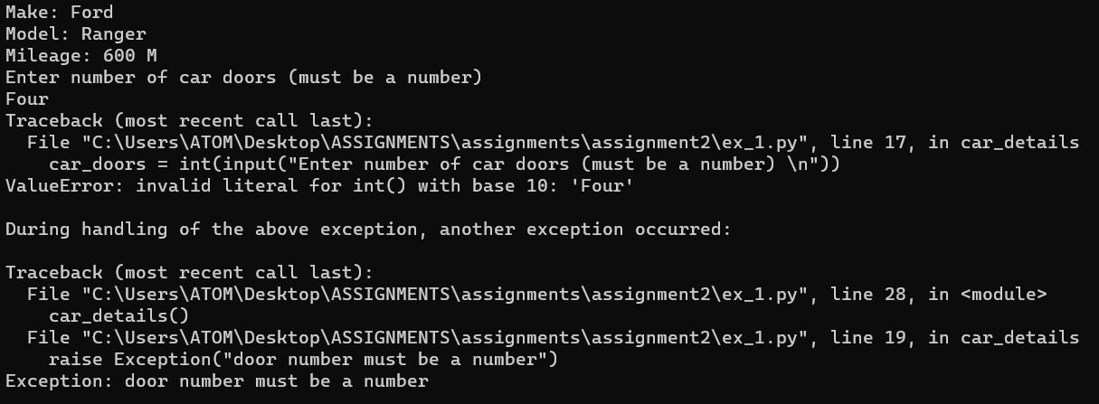

Exercise 2

Pseudocode
- Define a function that return area of a circle.
- Define another function to:
- Take user input for radius values, compare the values to catch the logical fallacy of inner radius being larger than outer radius and raise an error.
- Calculate the area of shaded parts using function in step 1.
- Print out the values of the areas of shaded parts.

#define a function that calculates area, given a radius
import math

#area of a cirlcle
def area(r):
return math.pi*float(r)*float(r)
def shaded():
r1 = int(input("enter inner radius: "))
r2 = int(input("enter middle radius: "))
r3 = int(input("enter outer radius: "))

#make sure radii ascend in size from inside
if r1>r2 or r2>r3:
raise Exception("inner radius can't be bigger than outer radius")
# red(inner) area is area with r1
red_area = area(r1)
#black area = middle area - red(inner) area
black_area = area(r2) - red_area
# blue area = outer area - middle area
blue_area = area(r3) - (black_area + red_area)
#print results
print(
f"red area: {red_area} sq. units \n",
f"black area: {black_area} sq. units \n",
f"blue area: {blue_area} sq. units \n",
)

if __name__ == "__main__":
shaded()

Screenshots
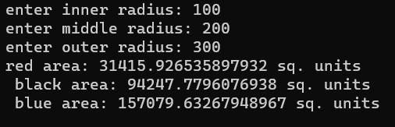
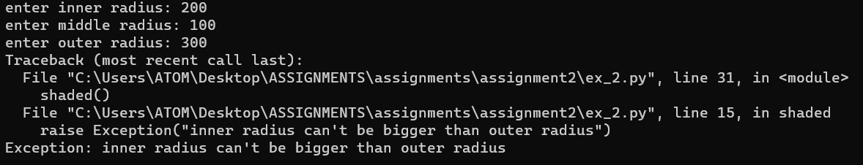
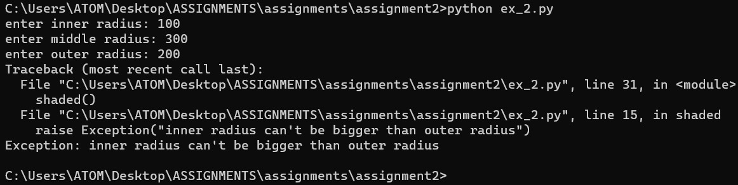

Exercise 3

Pseudocode
- Define a function with variables pointing to required lists
- Inside the function in step 1, define another function to collect each employee's data.
- Create a loop that takes a new set of employee data until instructed otherwise by user input.
- Print out the employee data in a table.
def get_details():
names = []
age = []
gender = []
salary = []

def collect():
#Store name
names.append(input("Enter employee Name: "))
#store age
try:
age.append(int(input("Enter Employee Age: ")))
except ValueError:
raise Exception("Age has to be a number.")
#store uppercase value for gender, make sure it is one of the letters f, F, m or M
gndr = input("Enter employee Gender: ")
if gndr not in "mMfF":
raise Exception(" gender has to be m or F")
else:
gender.append(gndr.upper())
try:
salary.append(int(input("Enter Employee Salary: ")))
except ValueError:
raise Exception("Salary has to be a number.")
#collect employee data in a loop unil user says no
while True:
collect()
again = input("Add employee? (y/n)")
if again=="n" or again=="N":
break
elif again == "y" or again == "Y":
continue
else:
raise Exception("You entered wrong value, y/n was required")
print("Name Age Gender Salary")
for i in range(len(names)):
print(f"{names[i]} {age[i]} {gender[i]} {salary[i]}")

Exercise 4

Pseudocode
Define a function control the game, it does the following:
- Initializes an empty list for storing random numbers.
- Initializes a variable for storing points won(in case of a win)
- Fills the initialized list with random numbers
- Removes non-repeating values from the list
- Counts the remaining values and checks if they are the jackpot value 5.
- Awards points according to value and count.
import random

#initialize number list
ints = []

def gameplay():
pts = 0
#fill ints random integers
for i in range(3):
ints.append(random.randint(0,9))
print(ints[0], ints[1], ints[2])
#create copy of ints, iterate over copy and remove
# corresponding non-repeating values from ints
rands_copy = list(ints)
for i in rands_copy:
if rands_copy.count(i)==1:
ints.remove(i)
#now ints either contains repeating values only or is empty.
# check length of ints and if it contains number 5.
if len(ints) == 3 and ints[0]==5:
pts += 2000
elif len(ints) == 2 and ints[0]==5:
pts += 200
elif len(ints) == 3 and ints[0]!=5:
pts += 20
elif len(ints) == 2 and ints[0]!=5:
pts += 10
return pts

def spin_game():
total_pts = 0
#continue spinning in a loop if user input is y, else, break.
while True:
proceed = input("Spin? (y/n)")
if proceed in "Yy":
res = gameplay()
#if spinning wins no point, print a message out
if res == 0:
print("You lose, your points are 0")
# if spinning wins points print out the aggregate of all won points
else:
total_pts += res
print(f"You won your points are {total_pts}")
continue
else:
break

if __name__ == "__main__":
spin_game()

Screenshots


