BA (Hons) Leadership and Management Skills in the Workplace

Project Management

LCLM5003

Part C project management plan

Contents
Part A – Project Poster 2
Part B -Reflection 3
Summary of feedback 3
Stage 1: Description 3
Stage 2: Feelings 3
Stage 3: Evaluation 3
Stage 4: Analysis 4
Stage 5: Conclusion 4
Stage 6: Action Plan 4
Part C – Project Management Plan 5
Introduction 5
2. Project Aims & Objectives 5
3. Scope 5
4. Project Management Approach 6
5. Work Breakdown Structure (WBS) 7
6.Project Schedule (Gantt Chart) 7
7.Risk Analysis 8
8.Stakeholder Management 9
9.Resource Allocation 10
10. Conclusion 10
11. References 10

Part A – Project Poster

The academic poster developed for this project is presented below
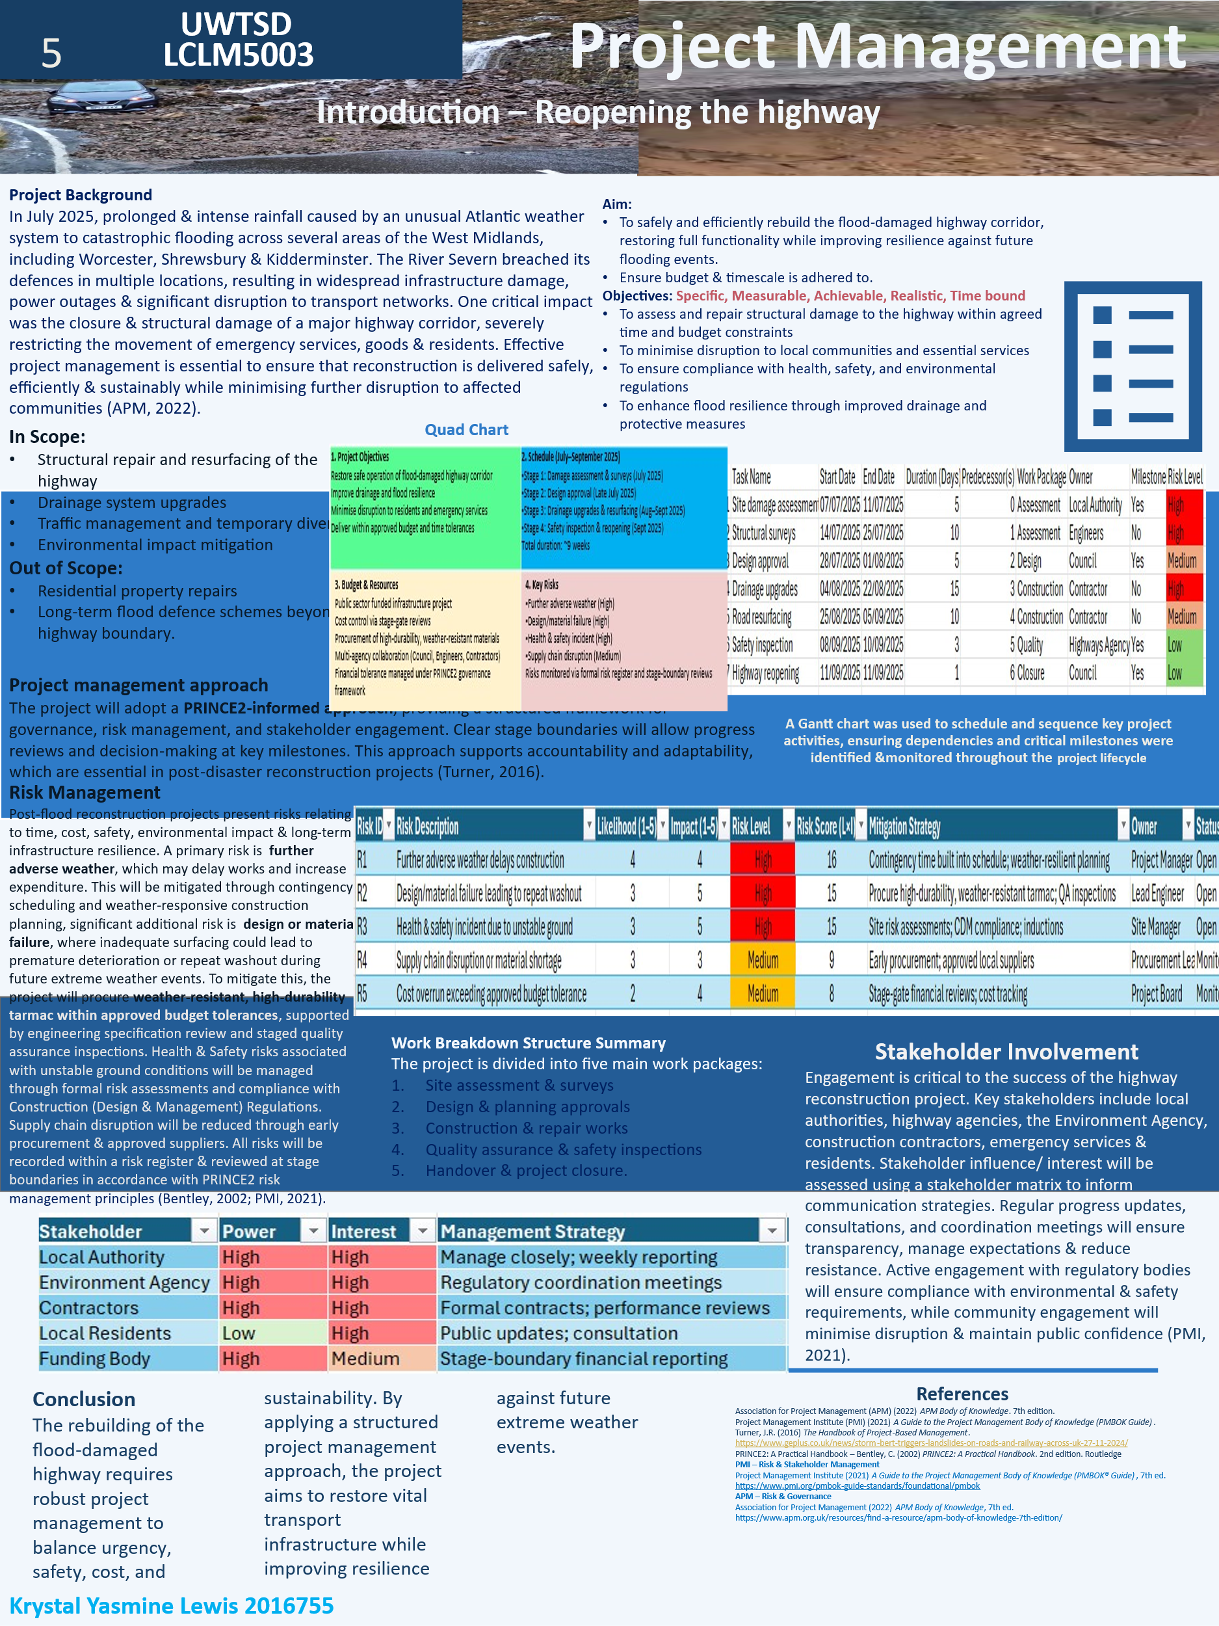

Part B -Reflection

Summary of feedback
For this critical evaluation of my performance, I will be using the Gibbs reflective cycle to reflect on what I could have done differently for a better outcome during my presentation. It is said that the theoretical model was developed in 1988 by Professor Graham Gibbs and provides a structured framework for experimental learning through a structured 6 stage process (Gibbs, 1988; Simply Psychology, 2023).

Stage 1: Description
I was tasked with creating an academic poster for the project management portfolio. It required outlining the steps that need to be considered before the highway could be reopened after damage caused by intense rainfall in July 2025, which was triggered by an Atlantic weather system that caused catastrophic flooding. The River Severn breached its banks, washing the road away. The damage caused significant disruption to the infrastructure in the West Midlands, with neighbouring towns such as Worcester, Shrewsbury & Kidderminster being negatively affected. Movement of goods, commuting and emergency service efforts were hampered due to the main arterial roads being blocked by debris left behind from the flooding. An extensive clean-up operation had to occur before the reconstruction could even begin. Feedback from the tutor & my peers was delivered verbally.

Stage 2: Feelings
Initially, I felt confident that my poster covered all required aspects of the brief. However, during the presentation I became aware that the volume of written content & lack of images made it difficult to explain each section of the poster concisely. This resulted in summarizing key points rather than reading directly from the poster to stay within the time limit & not losing the attention of the audience, thus causing my anxiety to spike whilst presenting. I could gauge the confusion coming from my peers whilst they tried to engage with the content.

Stage 3: Evaluation
A key strength identified was that I addressed the core project management components. I included risk management analysis, stakeholder involvement, smart objectives & the scope (in & out) necessary for planning the reconstruction. This confirmed that my understanding of the subject was present. However, the major area for improvement was conciseness of information & lack of visuals. Posters are intended to communicate key facts quickly & effectively to the intended audience, & I believe my first submission resembled a condensed essay with tables rather than a visually appealing summary of the plan.

Stage 4: Analysis
The feedback I received focused primarily on the presentation of the poster. I was told repeatedly that although the content covered all required areas of the brief, there were far too many words, which caused information overload. The level of detail provided demonstrated understanding, but the density of text, reduced clarity & impact for the majority. Peers also suggested incorporating diagrams of the damaged highway with charts that explain the proposed timeline of the project, rather than tables. It was also suggested I use bullet points, rather than long paragraphs. I was forced to recognise that I had prioritised detailed information to ensure completeness, but this approach limited readability & audience engagement once presented. Reflective practice encourages individuals to examine experiences critically to improve future performances (Gibbs, 1988).

Stage 5: Conclusion
I found it difficult to get my point across whilst explaining each subheading in a meaningful way. This resulted in me feeling nervous, which resulted in me tripping over my words, so I skipped a lot of unnecessary details & began summarizing the content instead of reading my work verbatim. Overall, the feedback received highlighted the importance of adapting communication style to suit both the audience and the format of presentation (Duarte, 2008). While my poster demonstrated subject knowledge, improving clarity and presenting information more concisely and visually will enhance the professionalism and effectiveness of the final submission.

Stage 6: Action Plan
In response to this feedback, I will make several improvements before submitting the final project plan. I must:
- Reduce the amount of written text and convert paragraphs into concise bullet points
- Use visual tools, such as a stakeholder matrix and risk register, to communicate information more effectively
- Review the layout of the poster to improve spacing and ensure key points are easily identifiable

Part C – Project Management Plan

Introduction
This project management plan outlines the structured approach to rebuilding a flood-damaged highway in the West Midlands following severe weather conditions in July 2025. Prolonged and intense rainfall caused widespread flooding, resulting in significant infrastructure damage, transport disruption, and restricted access for emergency services and local communities.
Effective project management is essential to ensure that reconstruction is delivered safely, efficiently, and within defined constraints, while also improving resilience against future extreme weather events. This plan applies recognised project management principles to support successful project delivery and minimise further disruption to affected areas (APM, 2022).

2. Project Aims & Objectives

The overall aim of the project is to safely and efficiently rebuild the flood-damaged highway corridor, restoring full functionality while enhancing resilience to future flooding events.
To achieve this, the following objectives have been identified. These objectives are aligned with the SMART framework (Specific, Measurable, Achievable, Realistic and Time-bound):
- To assess and repair structural damage within agreed time and budget constraints
- To minimise disruption to local communities and essential services
- To ensure compliance with health, safety, and environmental regulations
- To enhance long-term flood resilience through improved drainage and protective measures
These objectives provide a clear direction for project delivery and support effective monitoring and control throughout the project lifecycle.

3. Scope

Defining the project scope is essential to establish clear boundaries and prevent scope creep. The scope outlines the key activities included in the project, as well as those that fall outside its remit.

In Scope
- Structural repair and resurfacing of the highway
- Drainage system upgrades to improve flood resilience
- Traffic management and temporary diversion planning
- Environmental impact mitigation and compliance measures
Out of Scope
- Residential property repairs
- Long-term flood defence schemes beyond the highway boundary
- Non-essential infrastructure upgrades unrelated to flood damage
Clearly defining these boundaries ensures that resources are effectively allocated and that the project remains focused on its core objectives.

4. Project Management Approach

The project will adopt a PRINCE2-informed approach to provide a structured and controlled framework for delivery. PRINCE2 (Projects IN Controlled Environments) supports clear governance, defined roles and responsibilities, and stage-based management, which is particularly important in post-disaster infrastructure projects where accountability and adaptability are critical. This approach enables the project to be managed in clearly defined stages, with regular progress reviews and decision-making points to ensure alignment with project objectives. Risk management, stakeholder engagement, and quality control are embedded throughout the lifecycle, allowing for proactive identification and mitigation of potential issues. The use of PRINCE2 principles also ensures that the project remains focused on business justification, delivering value while maintaining control over time, cost, and quality constraints (Turner, 2016). A quad chart is used as a visual project management tool to summarise key aspects of a project on a single page, including objectives, timeline, risks, and resources. It provides a high-level overview that supports decision-making and stakeholder communication. In this project, the quad chart consolidates essential information, including the project objectives, schedule, budget considerations, and key risks associated with highway reconstruction. This enables stakeholders to quickly understand the scope and priorities of the project without requiring detailed documentation. The use of a quad chart enhances clarity and supports effective communication, particularly in time-sensitive projects such as post-disaster recovery, where concise and accessible information is critical. Furthermore, the application of a structured methodology such as PRINCE2 is particularly beneficial in public infrastructure projects, where accountability, governance, and transparency are critical. The use of clearly defined roles, including the project board and project manager, ensures that decision-making is controlled and aligned with project objectives. Additionally, stage-based planning allows progress to be reviewed at key points, enabling corrective action to be taken where necessary. This structured approach supports effective management of time, cost, and quality, ensuring that the project remains viable and delivers value throughout its lifecycle.

The quad chart below, provides a summary of the project, outlining objectives, schedule, resources, and key risks to support effective planning and stakeholder communication.

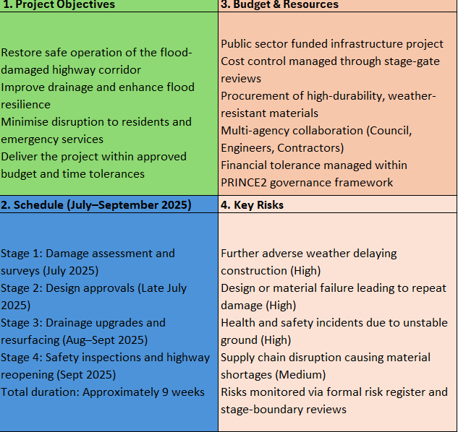

5. Work Breakdown Structure (WBS)

A Work Breakdown Structure (WBS) has been developed to organise the project into manageable components, enabling effective planning, coordination, and control. The WBS divides the project into five key work packages, each representing a distinct phase of the project lifecycle.
The first phase involves site assessment and surveys, where damage is evaluated and critical data is gathered to inform the design process. This stage ensures that decisions are based on accurate and up-to-date information.
This is followed by the design and planning approvals phase, where proposed works are reviewed and authorised to ensure compliance with regulatory, safety, and environmental requirements. The third phase focuses on construction and repair works, including drainage upgrades and road resurfacing. This represents the core delivery stage of the project and requires effective coordination of resources, materials, and contractors.
Following construction, quality assurance and safety inspections are conducted to verify that all work meets required standards and that the highway is safe for public use. This stage is essential in reducing the risk of future infrastructure failure.
The final phase involves handover and project closure, where the completed highway is formally reopened and all project documentation is finalised.
Overall, the WBS provides a structured framework for managing the project, ensuring that tasks are clearly defined, responsibilities are allocated, and progress can be effectively monitored throughout the project lifecycle.
The use of a Work Breakdown Structure also supports improved project control by clearly defining tasks and responsibilities. By breaking the project into smaller, manageable components, it becomes easier to allocate resources, estimate costs, and monitor progress. This structured approach reduces the risk of overlooked activities and enhances accountability, as each work package can be assigned to specific teams or individuals. Ensuring that the project is delivered efficiently and in line with planned objectives. This aligns with wider industry shifts towards structured and digitally supported project frameworks, which emphasise task clarity, coordination, and workforce efficiency in modern construction environments (De Soto et al., 2019).

6.Project Schedule (Gantt Chart)

A Gantt chart has been used to plan and sequence the key activities required for the successful delivery of the highway reconstruction project. The schedule outlines the logical progression of tasks, their duration, and dependencies, ensuring that work is completed in a structured and efficient manner.
As shown in Figure X, the project begins with site damage assessment and structural surveys, forming the foundation for subsequent design approval. Once approved, construction activities, including drainage upgrades and road resurfacing, are undertaken. These are followed by safety inspections and the final reopening of the highway.
The project is scheduled to be completed over an approximate nine-week period, from July to September 2025. Task dependencies have been clearly defined, ensuring that each phase is completed before the next begins, reducing the risk of delays and reworks.
The inclusion of milestones, such as design approval and final reopening, allows for progress monitoring at key stages of the project lifecycle. Additionally, risk levels associated with each task have been identified, enabling proactive management of high-risk activities, particularly during the early construction phases.
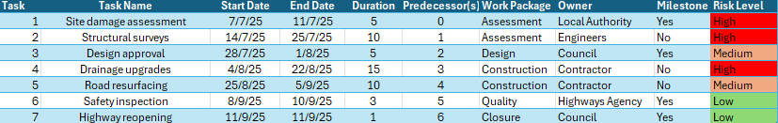
Overall, the use of a Gantt chart supports effective time management, resource allocation, and coordination, ensuring that the project remains on schedule and aligned with its objectives.

The Gantt chart illustrates the sequencing, duration & dependencies of project activities, supporting effective scheduling & progress monitoring.

In addition, the Gantt chart provides a visual representation of task sequencing, allowing project managers to identify critical paths and potential bottlenecks. This supports proactive decision-making, as delays in one activity can be assessed for their impact on subsequent tasks. The ability to monitor progress against planned timelines also enhances control and coordination, ensuring that resources are utilised effectively and that the project remains within its scheduled timeframe.

7.Risk Analysis
A risk analysis has been conducted to identify and assess potential threats to the successful delivery of the project. Effective risk management is essential within construction projects due to their complexity, uncertainty, and exposure to external factors such as weather and resource availability (Akintoye and MacLeod, 1997). One of the primary risks identified is further adverse weather, which may delay construction activities and increase costs. This risk is mitigated through contingency planning and the use of weather-resistant construction methods. Design or material failure is another significant risk, particularly if inadequate materials are used in resurfacing. To address this, the project will procure high-durability, weather-resistant tarmac and implement strict quality assurance inspections.
Health and safety risks associated with unstable ground conditions are also considered. These will be managed through formal risk assessments, compliance with Construction (Design and Management) regulations, and ongoing site monitoring. Additionally, supply chain disruptions and budget overruns have been identified as medium-level risks. These will be mitigated through early procurement strategies, approved supplier lists, and continuous financial tracking at key project stages. All identified risks are recorded within a risk register and reviewed regularly to ensure appropriate mitigation strategies are in place throughout the project lifecycle (PMI, 2021).
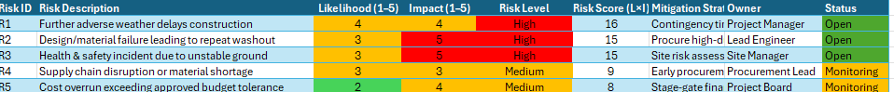
The risk register identifies and evaluates key project risks based on likelihood and impact, supporting the implementation of appropriate mitigation strategies.
High-risk activities are subject to increased monitoring and control measures to minimise disruption to the project timeline. Regular risk reviews will be conducted throughout the project lifecycle to identify any emerging risks and ensure that mitigation strategies remain effective. Contingency plans are also in place to respond to unforeseen events, reducing the overall impact on project delivery and supporting continuity in operations.

8.Stakeholder Management
Stakeholder engagement is critical to the success of the highway reconstruction project. Effective management of stakeholders in construction projects requires a systems-based approach, recognising the dynamic relationships between stakeholders, risks, and project outcomes (Ghamarimajd et al., 2024).
A stakeholder matrix has been used to assess levels of power and interest, enabling appropriate management strategies to be applied. High power and high interest stakeholders, such as local authorities and contractors, will be managed closely through regular reporting and coordination meetings.
Stakeholders with lower power but high interest, such as residents, will be kept informed through public updates and consultations to maintain transparency and minimise disruption.
Effective communication strategies, including progress updates, stakeholder meetings, and regulatory engagement, will ensure alignment, manage expectations, and support compliance with environmental and safety requirements (PMI, 2021).
As shown below, stakeholders have been assessed based on their level of power and interest, enabling appropriate management strategies to be applied to ensure effective engagement throughout the project lifecycle.
Effective stakeholder engagement is essential to maintaining trust and ensuring the smooth delivery of the project. Failure to manage stakeholder expectations can lead to delays, conflicts, and reputational damage. By adopting a structured approach to communication and engagement, the project team can ensure that stakeholders remain informed, involved, and supportive throughout the project lifecycle. This ultimately contributes to improved collaboration and a higher likelihood of project success.

9.Resource Allocation
The successful delivery of the project requires the effective allocation of resources, including labour, materials, and financial investment. Skilled engineers, construction workers, and project managers will be required across each phase of the project.
Materials such as high-durability tarmac and drainage components will be sourced to ensure long-term resilience against future flooding. Financial resources will be monitored through staged budget reviews to ensure the project remains within approved cost tolerances. Efficient resource allocation is essential to maintaining progress, controlling costs, and ensuring that project objectives are achieved within the defined timeframe.

10. Conclusion
The reconstruction of the flood-damaged highway requires a structured and well-managed approach to balance urgency, safety, cost, and sustainability. By applying established project management principles and methodologies, the project aims to restore critical transport infrastructure while enhancing resilience against future extreme weather events. Through effective planning, risk management, stakeholder engagement, and resource allocation, the project is positioned to deliver successful outcomes that meet both immediate needs and long-term infrastructure requirements.

11. References
Akintoye, A.S. and MacLeod, M.J., 1997. Risk analysis and management in construction. International journal of project management, 15(1), pp.31-38.
Association for Project Management (APM) (2022) APM Body of Knowledge. 7th ed. Available at: https://www.apm.org.uk/resources/find-a-resource/apm-body-of-knowledge-7th-edition/
Bentley, C. (2002) PRINCE2: A Practical Handbook. 2nd ed. London: Routledge.
De Soto, B.G., Agustí-Juan, I., Joss, S. and Hunhevicz, J., 2019. Implications of Construction 4.0 to the workforce and organizational structures. International journal of construction management, 5, pp.1-13.
Duarte, N. (2008) Slide:ology: The Art and Science of Creating Great Presentations. Sebastopol: O’Reilly Media.
Ghamarimajd, Z., Ghanbaripour, A., Jahan Tumpa, R., Watanabe, T., Mbachu, J. and Skitmore, M. (2024) ‘Application of systems thinking and system dynamics in managing risks and stakeholders in construction projects: A systematic literature review’, Systems Research and Behavioral Science. Available at: https://doi.org/10.1002/sres.3032
Gibbs, G. (1988) Learning by Doing: A Guide to Teaching and Learning Methods. Oxford: Oxford Polytechnic.
Project Management Institute (PMI) (2021) A Guide to the Project Management Body of Knowledge (PMBOK® Guide). 7th ed. Available at: https://www.pmi.org/pmbok-guide-standards/foundational/pmbok
Simply Psychology (2023) Gibbs’ Reflective Cycle. Available at: https://www.simplypsychology.org/gibbs-reflective-cycle.htm
Turner, J.R. (2016) The Handbook of Project-Based Management.
GE+ (2024) Storm Bert triggers landslides on roads and railway across UK. Available at: https://www.geplus.co.uk/news/storm-bert-triggers-landslides-on-roads-and-railway-across-uk-27-11-2024/

