

Mental Health Within The Police Force:
A Critical Analysis of the Effect of Mental Health Within Dyfed Powys Police

By Scott David Rees (1800195)

Dissertation submitted as part of the requirements for the award BSc Policing 2021

Covid 19 Statement
In light of the continuing impact of the global pandemic, it is important to include a statement at the start of my dissertation which outlines the effect that COVID-19 has had on the research that I have undertaken towards my undergraduate degree.
The University of Wales Trinity Saint David recognises that the COVID-19 pandemic, and the consequent closures of our campus on the 18th of March 2020 and national and international lockdowns, has directly or indirectly impacted the work of many of our undergraduate researchers. Although the campus had periods of re-opening in 2020-2021, some research will have been disrupted and some personal circumstances difficult to manage. Teaching was arranged via suitable meeting software and documents shared electronically. All research data collection was designed to utilise digital data collection.
The inclusion of this statement is to facilitate the reader’s awareness, both now and in the future, that the pandemic may have had an effect on the scope, direction and presentation of the research.
The academic standards and quality threshold for the award remains unchanged. I wish to reassure readers that this statement is not evidencing a lack of the original research or quality.

DECLARATION

This work has not previously been accepted in substance for any degree and is not being concurrently submitted in candidature for any degree.

Signed: S D Rees

Date: 07.05.2021

STATEMENT 1

This dissertation is being submitted in partial fulfilment of the requirements for the degree of BSc.

Signed: S D Rees

Date: 07.05.2021

STATEMENT 2

This dissertation is the result of my own independent work/investigation, except where otherwise stated.

Other sources are acknowledged by footnotes giving explicit references. A bibliography is appended.

Signed: S D Rees

Date: 07.05.2021

STATEMENT 3

I hereby give consent for my dissertation, if accepted, to be available for photocopying and for interlibrary loan, and for the title and summary to be made available to outside organisations.

Signed: S D Rees

Date: 07.05.2021

STATEMENT 4

I hereby give consent for my dissertation, if accepted, to be available on the university’s IT system to those who have consent to use the system.

Signed: S D Rees

Date: 07.05.2021

Acknowledgements
I would like to thank my family for their continued support and consistent faith in relation to my academic abilities in pursuit of my degree in BSc Policing. Their continuous inspiration facilitated my journey through university and enabled me to complete this degree in order to pursue my desired vocation.
Furthermore, I would like to thank all teaching staff at UWTSD for supporting me through unprecedented times. Specific gratitude must go to the efforts made by my tutors, Bronwen Williams and Caroline Jawad, in providing online learning material and feedback, thus enabling the continuation of my dissertation during a global pandemic.

Abstract
The aim of this dissertation was to critically analyse the effect of mental health on Dyfed Powys Police. Particular attention was paid to how many police workers are affected by mental health, how it affects their role within the community, availability of support, the financial implications and consideration of to what extent the police workload is based around mental health.
Clarification on the meaning of mental health has been established and how it impacts society today, taking considerations of any incentives or strategies implemented by the Welsh Government.
The researcher conducted a review on the relevant literature associated with the dissertation in order to establish how much work had been done in relation to mental health in the police force in South wales, specifically Dyfed Powys Police. The results from the literature review were then considered and utilised to establish any gaps in the research. This information facilitated the questionnaire’s design.
The primary research was conducted via the implementation of questionnaires, designed on Microsoft Forms. An online equivalent was required as a result of the global pandemic. These were distributed via The Chief of Staff and Monitoring of Dyfed Powys Police and resulted in 19 respondents.

Contents
Chapter 1.0 Introduction 13
1.0 Introduction 13
1.1 Context 13
1.2 Rationale 14
1.3 Aims and Objectives 15
1.4 Research 16
Chapter 2.0 Literature Review 18
2.0 Introduction 18
2.1 Mental Health 19
2.2Theoretical Models of Mental Health 20
2.2.1 Medical or Biological 20
2.2.2 Psychological 20
2.2.3 Systemic, Social and Environmental 20
2.3 Mind Cymru’s Blue Light Programme 22
2.4 Her Majesty’s Inspectorate of Constabulary and Fire & Rescue Services (HMICFRS) report on Policing and Mental Health, Picking up the Pieces. 23
2.5 Report from the Police and Crime Commissioner for Dyfed-Powys To the Dyfed-Powys Police and Crime Panel Mental Health and Policing July 2019 24
2.6 BBC Report: South Wales Police: Mental Health Calls Squeeze Force 25
2.7 Conclusion 26
Chapter 3 - Research and Methodology 28
3.0 Introduction 28
3.1 Research 28
3.2 Research Onion 29
3.3.1 Philosophy 29
3.2.2 Research Approach 30
3.2.3 Research Methods and strategies 30
3.2.4 Time Horizons 31
3.2.5 Technique and procedure 31
3.2.6 Sample 32
3.2.6 Data Collection and Data Analysis 32
3.3 Primary Research 32
3.4 Validity and Reliability 33
3.5 Limitations 33
3.6 Conclusion 34
Chapter 4.0 Analysis of Results 35
4.0 Introduction 35
4.1 Data Analysis 35
4.2 Primary Research Results 36
4.2.1 Demographics 37
4.2.1.1 Gender 37
4.2.1.2 Age 38
4.2.1.3 Length of Service 39
4.2.2 Mental health 40
4.2.2.1 Current state of mental health 40
4.2.2.2 The effect that the job role has on mental health with further information. 41
4.2.2.3 Level of mental health as a proportion of workload 43
4.2.2.4 Aspects of role versus levels of well-being 44
4.2.2.5 Impact dealing with mental health incidents has on fighting crime 45
4.2.3 Support 46
4.2.3.1 Awareness of available support 46
4.2.3.2 Acknowledgement of Relevant Support 48
4.2.4 Recruitment 48
4.2.4.1 Effect of Mental Health on Recruitment in Dyfed Powys Police 49
4.2.5 Qualifications and Training 49
4.2.5.1 Crime v Mental Health 49
4.2.5.2 Qualified to Deal with Mental Health 50
4.3 Conclusion 51
Chapter 5.0 Conclusions and Recommendations 52
5.0 Introduction 52
5.1 The Research Study Question and Hypothesis 52
5.2 Main Findings 52
5.3 Limitations on the Research 55
5.5 Future Recommendations 56
5.6 Conclusions 57
5.7 Reflection 58
5.8 Summary 58
Bibliography 60
Appendices 64
Appendix one – Questionnaire 64
Appendix Two – Data 67

Table of Figures
Figure 1.1 The Research Onion p16
Figure 2.1 Mental Health Theories p21
Figure 4.1 Introduction and Description of Questionnaire p35
Figure 4.2 Respondents’ Gender p36
Figure 4.3 Respondents’ Age p37
Figure 4.4 Respondents’ Length of Service p38
Figure 4.5 Figure 4.5 Crosstabulation Q3*Q16 p38
Figure 4.6 Respondents’ Current State of Mental Health p39
Figure 4.7 Respondents’ Effect on Mental Health in Relation to Job Role p40
Figure 4.8 Respondents’ Further Information on Job Role Affecting Mental p41
Health
Figure 4.9 Mental Health as a Proportion of Workload p42
Figure 4.10 Crosstabulation Q3*Q7 p42
Figure 4.11 Respondents’ Well-being in Relation to Responsibilities p43
Figure 4.12 Respondents’ opinion on impact mental health has on fighting p44
Crime
Figure 4.13 Respondents’ Awareness of Support p45
Figure 4.14 Respondents’ Awareness of Support Services p46
Figure 4.15 Respondents’ Acknowledgement of Relevant Support p47
Figure 4.16 Respondents’ Opinions on Effect on Recruitment p48
Figure 4.17 Relevance of Police Work to Mental Health p48
Figure 4.18 Respondents’ Views on Qualifications and Training p49

Chapter 1.0 Introduction

1.0 Introduction

The aim of this dissertation is to investigate and analyse the impact mental health has within the police force in South Wales, specifically, Dyfed Powys Police. It will focus predominantly on the impact it has on police officers, including the way they are affected on an individual basis alongside the impact it has on the force they are serving and its resources. These resources will encompass time, human and financial. Mental health is an ongoing issue that is prevalent in today’s society (Act For Libraries, 2021). Initially, the study will focus on the way mental health of the public affects policing in South Wales before focusing on the impact this type of work has on police workers and the force in which they are serving. This will include the impact it has on the delivery of their role within the local community, their own personal mental health and the cost implications on the police force itself.

Context

According to MentalHealth.gov,
“Mental health includes our emotional, psychological, and social well-being. It affects how we think, feel, and act. It also helps determine how we handle stress, relate to others, and make choices” (MentalHealth.gov, 2020).
Positive mental health enables individuals to “adapt to change and to cope with challenges” (HealthyPeople.gov, 2020), essential attributes of police workers. However, “a quarter of us will experience mental health problems or illness” (NHS Wales, 2021), thus highlighting the fragility of the human race and the requirement for recognition and support in tackling the issue.
The Welsh Government recognised this need in its document ‘Together for Mental Health: A Strategy for Mental Health and Wellbeing in Wales’ in order to provide a plan “for improving the lives of people using mental health services, their carers and families” ( NHS Wales, 2021). This recognition has provided a scaffolding for further improvement but still requires further development and investment.
During this dissertation, theoretical literature will be consulted and analysed in order to consolidate and strengthen the investigation.

1.2 Rationale

Due to the increased awareness and decline in the stigma associated with mental health it has become apparent that the police forces in South Wales have recognised that mental health has impacted profoundly on its staff, community and force. Many organisations have become involved in providing training and support. However, this is often perceived as lacking in consistency and quality. As a result, the well-being of staff is consistently compromised as is the force in which they are serving (Her Majesty’s Inspectorate of Constabulary and Fire and Rescue Services (HMICFRS (2018)).
Despite the prevalence of this issue in society today, it is apparent that there is a real absence of academic literature available on this area of research. This serves to highlight that not enough is being done to eradicate the issues surrounding mental health. Much of the research that has taken place involves organisations directly linked to the police or charities that support people with mental health issues. A study by Mind Cymru recognised that “Blue light workers do an extremely challenging job day in, day out, frequently encountering difficult and traumatic situations” (Moseley, S. South Wales Police, 2017). South Wales police (SWP), having previously committed to the ‘Time to Change Wales Pledge’, failed to secure their place with the ‘Blue Light Programme’ as the “Welsh Government had not allocated the Libor funding to this programme” (Bluelight Pledge Action Group). However, this was later overturned via the work of Sarah Moseley, Director of Mind Cymru, Peter Keen and SWP which resulted in Mind receiving over 1.5m to support workers in the public services. This recognition ensured that police workers were identified as being in need of support and are some of the 20,000 blue light workers receiving support as a result of this.

Aims and Objectives

The aim of this study is to analyse the impact mental health has within the police force in South Wales. In order to achieve this outcome, the following objectives will be obtained:
- To research and critically analyse existing academic literature on the impact mental health has on police workers in South Wales, including any documentation produced by professional organisations.
- To actively engage in primary research via the submission of online questionnaires to Dyfed Powys Police.
- To assess any relevant data related to statistics involving mental health in Dyfed Powys Police.
- To collate information from primary research obtained along with secondary research synthesised and summarised from extant literature in an attempt to establish the affect mental health has on Dyfed Powys Police.

1.4 Research

Research has been defined as “the systematic investigation into and study of materials and sources in order to establish facts and reach new conclusions.” (The Free Dictionary, 2020). This generalisation refers to a plethora of methods and techniques that can be implemented in a quest to find information related to a set of specific questions.
In order to research effectively it is necessary to create a research strategy that will meet all of the necessary requirements. Therefore, it is essential to implement a research model that will enhance the effectiveness of doing this. One such model is the onion model presented by Saunders, Lewis and Thornhill in their book entitled ‘Research Methods for Business Students’.
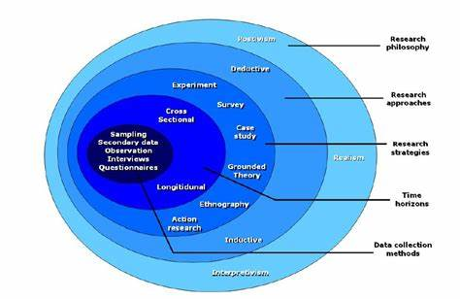

Figure 1.1 The Research Onion (Research Onion - Explanation of the Concept (ukessays.com))
Its aim is to enable students to research in a manner in which each layer complements the other in creating a holistic research methodology. In doing this, students have a source of reference to ensure that all elements come together at the end of the research to create a final design. The model incorporates six distinct layers which include: philosophy, approach, strategy, choice of methods, time horizons and data collection and analysis.

Chapter 2.0 Literature Review

2.0 Introduction

The purpose of this chapter is to establish and review relevant academic literature and scholarly sources that focus on ‘The Effect of Mental Health on Police Forces in Wales’, with specific focus on how many police workers are affected by mental health, how it affects their role within the community, what support is available, costing, and finally, how much of the police workload is based around mental health. This will be done through reviewing various types of literature, including academic journals, professional organisation websites, and other relevant sources related to the aims and objectives as outlined in chapter one of the dissertation.
It very quickly became apparent, whilst conducting research into different sources of information that there is a real paucity in relation to available academic literature with regards to the effect of mental health on police forces in Wales. Despite being an often talked about topic there seems to be very little evidence of thorough, critical research. A lack of statistical and factual evidence is also evident with minimal quantitative data available. Much of the information obtained for this chapter has been the result of report examination and evaluation. These obvious gaps in information will serve to guide my own research, data collection and investigation and provide a starting point for my dissertation.
The following literature review comprises sources obtained from the internet and include police reports, government documents and media reports.

2.1 Mental Health

Mental health is fast becoming what is commonly perceived as the next pandemic in Wales (Abrams, 2021). The stigma surrounding mental health has meant that individuals within our communities have been reluctant to seek and access support through professional channels and this therefore, has resulted in its exacerbation. Police forces in Wales have identified the toll that the effect of mental health is having, not only on the force, but also on the communities they serve, “dealing with around 200 mental health incidents every week” ( Sinclair, 2019). With many organisations reporting an increased demand on public services in supporting individuals ( Local Government Association, 2021), many question how effective this support is and how much does it impact our local police forces? According to Mental Health.gov, “Mental health includes our emotional, psychological, and social well-being” (MentalHealth.gov, 2020) and therefore encompasses a range of issues prevalent within our communities. Mental health illness can be the result of a number of factors, with a large proportion of the Welsh population currently suffering from it and going without the necessary treatment, on a daily basis.
There are many theories linked to mental health with practitioners of different professions adopting the one most relevant to their field of study. These are located and outlined below:

2.2Theoretical Models of Mental Health

2.2.1 Medical or Biological

This model has been adopted by psychiatrists rather than psychologists and refers to the genetic make-up of an individual. It treats mental illness as though there is a physical cause. Advocates of this model believe that symptoms are “outward signs of the inner, physical disorder” (McLeod, 2018). This approach is conducive to the physical structure and function of the brain.

2.2.2 Psychological

This theory is related to the cognitive and emotional aspect of mental health and includes attachment theory. In brief, attachment issues and disorders result in an individual expressing insecure qualities ( Raypole, 2019) as they do not have any relevant positive experiences to draw upon. This aspect is also affected by external factors and experiences. This model is closely linked to environmental. An individual experiencing attachment disorder will essentially be unable to form natural, trusting relationships and therefore miss out on the nurturing aspect of life.

2.2.3 Systemic, Social and Environmental

This model refers to influencing factors such as family relationships, poverty, parenting, experience of loss and bereavement amongst other relationship patterns (Lindberg, 2021). Poor mental health is believed to derive from poor early life experiences. A person living in poverty is less likely to have had positive experiences and this can manifest itself later on in life when an individual is unable to function appropriately in certain situations or environments.
Although these models can be intertwined and one often influences another, they are also understood from an individual perspective as outlined in the figure below by the Open University.
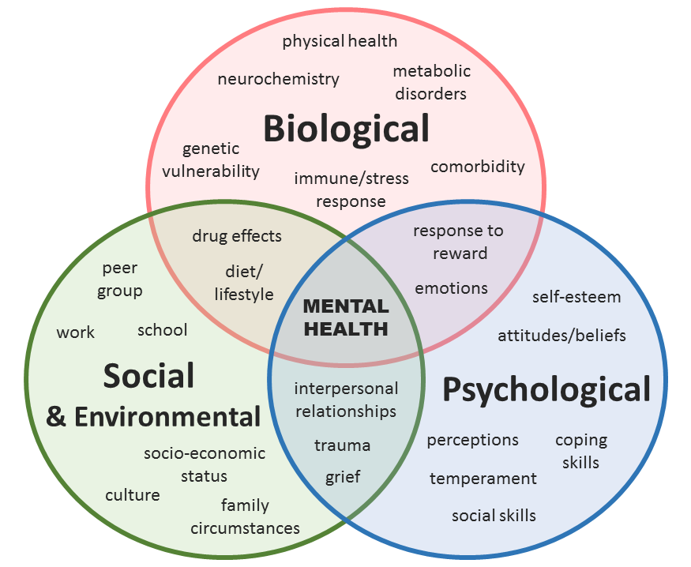
Figure 2.1 Mental Health Theories (The Open University)

Much of today’s media focuses on the impact mental health is having on our communities and subsequently our public services, in particular, our police forces, with individuals and organisations questioning how much of the police officer’s role is spent dealing with mental health related activity rather than criminal activity and more serious offences. Although at times, these can be intertwined, one would argue the extent to which the need for police to intervene in mental health incidences, would contribute to an increase in crime in our communities. With the police service providing twenty-four-hour response, it is then inevitable that at times, with the absence of the availability of other services, that they will be called upon to assist in incidences involving vulnerable people. However, this must place extreme pressures upon an already stretched public service and its employees.
Similarly, it is important to recognise the impact of being a police officer and how this can result in the compromise of their own mental health. Dealing with situations of high intensity on a daily basis will undoubtedly impact an individual’s mental health in a negative manner and thus it is important to establish what support is available for them to access and how they access it. Subsequently, this could impact recruitment within the police forces as many would believe the salary does not sufficiently correspond with the demands of the role.

2.3 Mind Cymru’s Blue Light Programme

Mind Cymru’s launch of The Blue Light Programme was a crucial milestone in establishing the support for mental health required by emergency workers. Research shows “that nearly 9 in 10 emergency workers have experienced stress, low mood or poor mental health while at work, and 1 in 4 has contemplated suicide” (Mind Cymru, 2017). This statement undoubtedly highlights the impact mental health has on our police service. The Blue Light Programme enables the support of over 20,000 workers in Wales which would have gone unsupported without the work of Mind Cymru.

2.4 Her Majesty’s Inspectorate of Constabulary and Fire & Rescue Services (HMICFRS) report on Policing and Mental Health, Picking up the Pieces.

This report recognises the burden placed upon police officers and staff in which too much emphasis and reliance is placed upon police forces in Wales to respond to crises that exceed their professional expertise and instead are conducive to healthcare settings. This results in failure of the public and a depreciation in public confidence along with the failure of a crucial service. The report also highlights the impact overreliance on the police has had, with many police officers having to deal with incidents of high impact and ones in which they are not necessarily qualified for, and thus contributing to a compromise in their own mental health.
The report recognises the role that police forces have to play and that collaborative practice between services is a necessity. However, it has noted that funding has created a gap in the community, one of which is filled by police response. It has highlighted a number of roles that the police service has had to fulfil due to a prevalent shortfall. These have included “transporting someone to hospital because an ambulance isn’t available, waiting with someone in hospital until a mental health place is found or checking on someone where there is concern for their safety” (Police and Crime Commissioner, 2019). Furthermore, the report identifies the fact that there is no clear picture as to how much demand is placed on police forces in Wales as calls are not accurately flagged or tagged as ‘mental health’ and this therefore means that the demand is more likely much higher than the statistics produced. In order to rectify this, there needs to be clarity on what constitutes a mental health response in order to eradicate the general lack of understanding of mental health demand.

2.5 Report from the Police and Crime Commissioner for Dyfed-Powys To the Dyfed-Powys Police and Crime Panel Mental Health and Policing July 2019
This document outlines the progress made in relation to the 2017-2021 Police and Crime Plan in which the Commissioner committed to a number of issues surrounding mental health in the Dyfed Powys area. The plan itself demonstrates the impact mental health is having on our police force due to the sheer requirement of establishing progression within this area. It clearly promotes the engagement of the police along with opportunities to improve understanding of the demands associated with mental health highlighting the fact that mental health has become incorporated into their role. However, despite this recognition the Commissioner has also identified the need for people suffering from mental health to be dealt with appropriately in a health care setting rather than being detained in custody.
In addition to this, the report highlights the vastness of the Commissioner’s engagement with the public and various societies within the area. This accompanied with the provision of grants for mental health charities compounds the extent to which Dyfed Powys Police is committed to mental health and thus further evidences the fact that much of the work carried out by police forces in Wales is based around mental health activity. However, one can also gather from this that the Commissioner has recognised the impact mental health has on his serving police force and therefore has initiated grants to promote the provision of mental health charities and thus lessen the burden on the police through a reduction in detainees. This then enables police officers to focus predominantly on criminal activity within their force area.

2.6 BBC Report: South Wales Police: Mental Health Calls Squeeze Force

A report by Jenny Rees highlights the monetary issues related to South Wales Police and Mental Health. The requirement for improved mental health care is explored as a solution to the cost of mental health on police in South Wales. The report recognises that the need to respond to calls associated with mental health resulted in a failure in other areas such as dealing with sexual violence and cyber-crime, thus proving the impact it has on the force and the community in which it serves. With the acknowledgement that due to the twenty-four-hour service provided by the police it has fallen to them to “gap fill” a service that they are not properly qualified for or the best organisation to do so, the impact of mental health on the police service continues to be perceived as problematic.
This report also notes that the budget does not meet the needs of the force area. Despite being the highest paid force in Wales, securing £271m in 2018/19, South Wales Police is at a risk of being unable to continue to guarantee the services already provided due to increased costs and increased demands. As a result of these constant pressures, the Home Office pledged additional funding, to enable the continuation of critical services, including “additional money for recruitment and neighbourhood policing, counter-terrorism, and fighting serious and organised crime” (Rees, J. 2019). This report recognises the effect mental health has on policing in Wales. However, it fails to deliver detailed, conclusive information or convincing statistical evidence. This fact weakens its reliability and resourcefulness.

2.7 Conclusion

Having carried out a literature review on the effects of mental health in policing in Wales, it has been revealed that it is evident that there is a real paucity in available literature on this topic. There were no available academic journals in relation to Dyfed Powys and the majority of information was located via police and government documents. One can then argue that there is a risk of bias to the information, although these documents are perceived as being reliable and factually correct and a source of reference to the public.
The lack of literature highlights the fact that the impact of mental health within the police force, its employees and its community is often overlooked and of less significance than expected. However, on the other hand, it has been clearly identified as an increasing issue. This is evident with the construction of Mind Cymru’s launch of The Blue Light Programme following its intervention in England in 2015. However, there seems to be a lack of published statistical data along with a lack of research. Scientific studies have shown that mental health illness is prevalent amongst our communities and it is then inevitable that it becomes a problem for our public services. This issue has been clearly identified amongst a number of organisations but there still remains an enormous shortfall in the amount of available evidence on this subject.
It has been established that mental health affects employees of the police service (HMICFRS) and there is unprecedented demand placed upon them to meet the needs of individuals who would benefit from more relevant, niche care (Dyfed Powys Police and Crime Commissioner, 2017). It does not state however what these demands are and this will assist in the design of the primary research.
The study in which I am going to engage in therefore strives to address this issue through the exploration of to what extent does mental health affect our local police forces in South Wales. The research will involve engaging in primary and secondary research via appropriate research methods and methodology. In doing this, reliable, quantitative and qualitative data can be collected and critically analysed accordingly. A number of key questions will be posed to ensure maximum engagement with the topic and therefore enable the maximum amount of relevant information to be collected and scrutinised. This will serve as an aid in establishing how mental health affects police forces and their communities in Wales. Investigation into the cost of mental health is also necessary. These smaller strands all contribute holistically to the big question and subsequently all play a significant role in establishing the extent to which mental health impacts our police services in South Wales.

Chapter 3 - Research and Methodology

3.0 Introduction

The purpose of this chapter is to establish and promote understanding of the varying methods that can be utilised to conduct the research necessary to answer the questions previously posed within the research proposal. This will result in the use of the most appropriate avenue and the implementation of the most relevant methods which will be done in order to meet the objective of this dissertation, thus being, ‘An Analysis of the Effect of Mental Health Within the Police Force in South Wales’. Following selection of the intended methods, justification will ensue in order to analyse the reasoning behind these selections. All selections that are made will be based on those that are most likely to provide the most reliable and relevant information.

3.1 Research

Research has been defined as,
“the systematic study of people, institutions, or social phenomena using measurement techniques such as surveys, interviews, focus groups, ethnography, or comprehensive analysis of texts” (Sternheimer, 2019).
It has also been recognised to include “the analysis of data collected by government agencies or other sources” (Sternheimer, 2019). This definition focuses on the realisation that data will be factual, based on real life experiences and data and will not be subjective in nature. Similarly, systematic refers to a process that involves an ordered and organised system conducive to reliable and relevant information.

3.2 Research Onion

The Research Onion model was developed by Saunders et al in 2007. This model outlines the stages that all researchers must navigate in order to develop an effective methodology for their intended research. The model comprises six different layers, all of which should be accessed from the outside in, until the core is reached. Through using the Research Onion model, researchers are able to access varying stages in a methodical manner and thus implement a systematic approach, from which detailed data can be obtained. The Research Onion model will be implemented during this dissertation in order to facilitate the establishment of key research strategies and methodologies to obtain the necessary information required to achieve the objectives outlined in the research proposal.

3.3.1 Philosophy

Research philosophy refers to “the development of knowledge and the nature of that knowledge” (Lewis et al p.105). The selected research philosophy is impacted by the researcher’s perception of the world around him. Consequently, these perceptions will influence the chosen research strategy and methods. It is perceived that, “the main influence is likely to be your particular view of the relationship between knowledge and the process by which it is developed” (Lewis et al p. 105).
The research undertaken in this dissertation will encompass an interpretivist approach in which data will be attained via the distribution of questionnaires and the analysis of governmental and professional sources. This will enable the collation of quantitative data. This stance reflects that of the natural scientist. Data analysis from this source will result in “the production of credible data” (Lewis et al p.113) and will facilitate the development of knowledge that is built upon existing hypotheses. The questionnaires will comprise open questions in addition to closed questions in order to highlight the diversity amongst humans and their social interactions whilst enabling a qualitative approach in which individual viewpoints can be assessed and reported. An element of interpretivism will also be achieved via the distribution of questionnaires as a number of open questions will be posed from which varying answers and interpretations can be received, thus promoting the view that humans “act out their part in accordance with this interpretation” (Lewis et al p.113).

3.2.2 Research Approach

The research approach constitutes the approach the researcher will take in his research. The elements involved here are deductive and inductive (ScienceDirect, 2021). The deductive approach primarily relates to the building of knowledge based on the evidence attained from the literature review. This knowledge is then tested in varying contexts to establish its reliability.
To contrast, the inductive approach focuses on the observations achieved by the researcher in a quest to establish his own theory on a given topic (Neuman, 2003).
Due to the lack of available information present in the literature review the research approach for this dissertation will be inductive. This will enable the collation of quantitative and qualitative data that can then be analysed and evaluated accordingly. This analysis would in turn assist in the formulation of a new theory on the given topic. This approach permits diversity and deviates away from the rigid structure brought about by a deductive approach.

3.2.3 Research Methods and strategies

Different methods can be utilised to attempt to answer the research question posed. This can be achieved via the attainment of quantitative or qualitative data via a variety of strategies. Quantitative data consists of numerical information that can be measured whilst qualitative data comprises data that cannot be expressed numerically and instead involves descriptive information (McLeod, 2019)
The research strategies that this dissertation will implement are questionnaires, interviews, analysis of historical data and government records. This will provide both quantitative and qualitative data from which a new theory can be formulated.
This type of research therefore will constitute a mixed method approach that recognises the use of quantitative and qualitative data. This aspect underpins the fourth layer of the Research Onion.

3.2.4 Time Horizons

Time constraints placed upon the researcher are recognised as cross-sectional and longitudinal. The former relates to research that is conducted and formed from observations over a long period of time that can vary from days, months, quarters or even years. The latter involves research that occurs over a single point of time and it is this timescale that the research for this dissertation will adopt. The reason for this is due to the time limitations associated with this research.

3.2.5 Technique and procedure

This dissertation will utilise questionnaires in order to collect both qualitative and quantitative data which will consequently be used to analyse the effect of mental health in Dyfed Powys Police.

3.2.6 Sample

A sample will be provided as a representation of the population due to the impracticalities associated with researching an entire professional organisation. The questionnaires will target all members of Dyfed Powys Police, irrespective of age, gender or occupation.

3.2.6 Data Collection and Data Analysis

Data collection and data analysis is considered to be the central focus of any research, hence its positioning at the core of the model. Data collection for this research will be the result of the implementation of questionnaires, and varying forms of secondary data, including official records made available on the internet. Questionnaires will be conducted online due to the current situation with Covid-19. These will be distributed and conducted amongst Dyfed Powys Police which will enable a representation of the police community in rural South Wales. This will ensure the research objectives are met via reliable primary data which can then be compared and evaluated alongside the secondary data attained from the literature review.

3.3 Primary Research

As previously noted, the questionnaires will be conducted online, and this will be done via the use of Microsoft Forms. This will enable a swift turnaround and also ensure that users are protected by anonymity. Due to the nature of the research, this will maximise the potential number of police employees who will participate in completion of the questionnaire.
Due to the current restrictions placed upon travel within Wales as a result of the pandemic, it is necessary to conduct as much research as possible via the use of the internet and thus relevant platforms.

3.4 Validity and Reliability

The research design outlined above will enable the true answer to be revealed. However, it is important to recognise the potential threats to the dissertation’s validity. This research is being conducted during a global pandemic. The current situation has had great impact on the public services and therefore mental health has been heightened during this time. The research design however will result in a response that is current and up to date, reflecting this moment in time.
The questionnaire will comprise various types of questions. These will include closed, open and multiple-choice questions. This will promote answers that are both qualitative and quantitative. Consideration has been given to the strength of the questionnaire. This will highlight any issues that could result in invalidity due to a questionnaire that leaves the participant frustrated and therefore detached from answering to the best of their ability. Weaknesses will be identified and rectified to ensure final answers are reliable and of significant worth. The promise of anonymity will also strengthen the validity of the answers provided.

3.5 Limitations

Time limitations have been placed on this dissertation. The primary research consists of a questionnaire. Data analysis of this will take a considerate amount of time. In order to meet the objectives by the deadline, a systematic and organised approach will be required alongside strict adherence to a Gantt Chart undertaken.
Coronavirus has also placed limitations upon this dissertation due to the effect it has had on the local police forces and their communities. However, there are now alternative ways to conduct research and distribute questionnaires via the internet as a result of the need to develop a means of communication that was not face-to-face.

3.6 Conclusion

In conclusion, this chapter has looked closely at research theory and has unpicked the Research Onion model, providing insight into the pathway this independent research project will take. Having analysed the various approaches, the most appropriate research methods have been outlined above. This methodology will enable the researcher to reveal the true answer to the research title posed:
‘A Critical Analysis of the Effect of Mental Health Within Dyfed Powys Police’

Chapter 4.0 Analysis of Results

4.0 Introduction

The objective of this chapter is to closely analyse the results acquired from the primary research, conducted. The Microsoft Forms questionnaire only resulted in 18 responses, a disappointing sample due to the lack of data presented, related to mental health within Dyfed Powys Police. Having spoken to Carys Morgans, the Chief of Staff and Monitoring Officer for Dyfed Powys Police, over a period of time, regarding the lack of responses, it can be concluded that many questionnaires related to mental health had been distributed amongst the force prior to my request. Due to the questionnaire being voluntary, responses could not be forced.
However, the results that have been obtained from the questionnaire will be analysed effectively and amalgamated with secondary data and research to achieve the aims and objectives as outlined in the introduction in order to promote improved understanding and intelligence.
All results from the questionnaire will be presented as a pie chart or bar chart for ease of interpretation, with the provision of percentages to complement. Crosstabulation will also be used as a means to make specific comparisons.

4.1 Data Analysis

Data analysis is “the process of collecting, modelling, and analysing data to extract insights that support decision making” (Calzon, 2021). The researcher has utilised built in analytics in Microsoft Forms to create charts and visualise data. Then the researcher has enhanced this by exporting results to Microsoft Excel. This has enabled ease of accessibility and facilitated the collation of information for comparing and contrasting purposes.

4.2 Primary Research Results

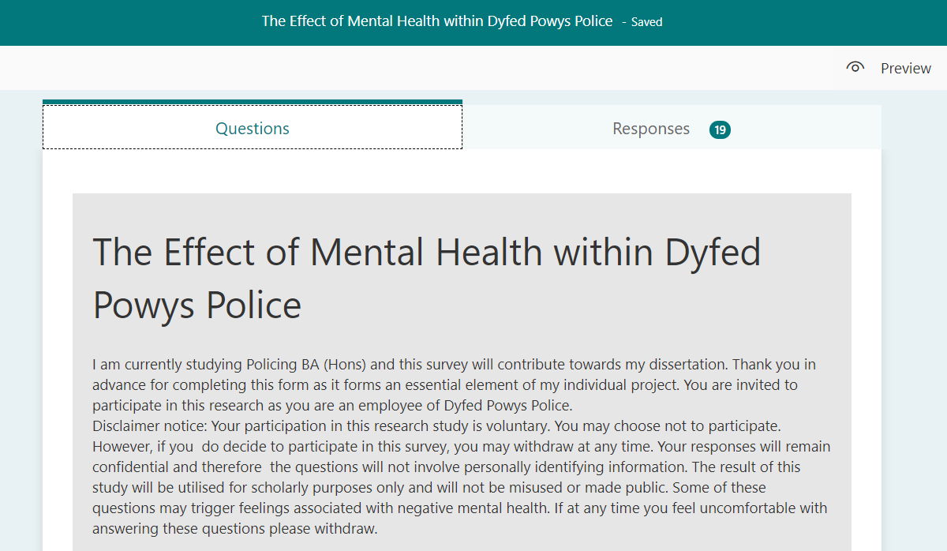
The questionnaire was administered online via Microsoft Forms. Having contacted the Chief of Staff and Monitoring at Dyfed Powys Police and subsequently the Chief Constable, it was agreed that the questionnaire would be shared via a link to employees of Dyfed Powys Police. This took some time to organise due to the nature of the roles of the employees and existing circumstances; Covid 19. In a quest to collate as many responses as possible, a description and disclaimer were provided at the start of the questionnaire. This ensured that the employees were aware of expectations and the right to refuse to participate. This also provided information on anonymity as some employees may have felt uncomfortable answering some of the questions related to their workplace. This description is evidenced below in Figure 4.1.
Figure 4.1 Introduction and description of questionnaire (Author’s own)

4.2.1 Demographics

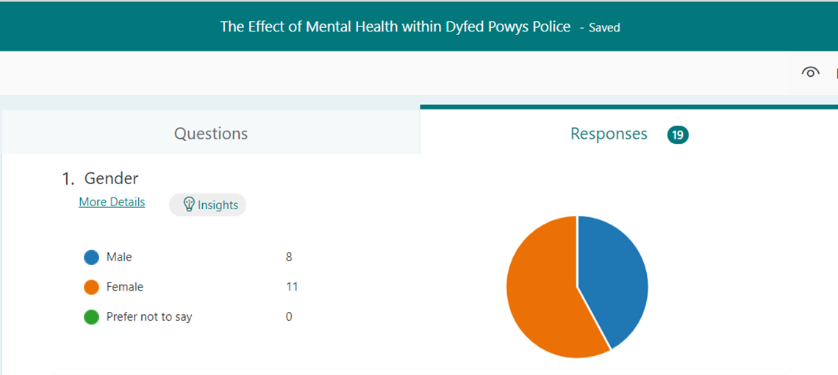
4.2.1.1 Gender

Figure 4.2 Respondents’ gender (Author’s own)

Respondents were asked their gender to ascertain whether there is a correlation between mental health and gender and to determine which gender is affected more by issues concerning mental health.
The responses obtained show that 43% were male and 57% were female. This results in an uneven sample with the majority of results coming from females.

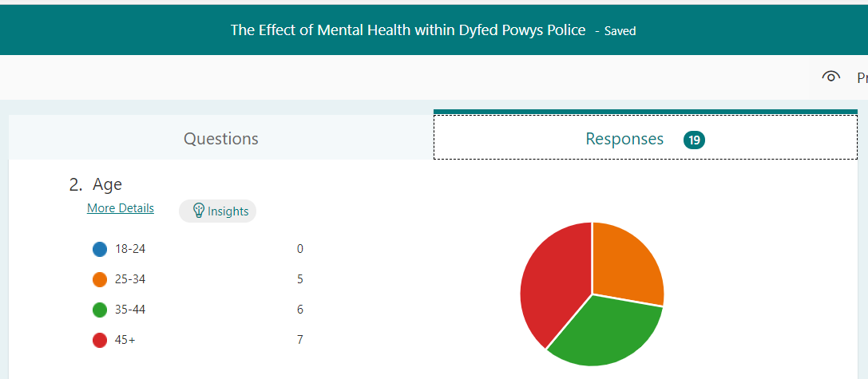
4.2.1.2 Age

Figure 4.3 Respondents’ age (Author’s own)

Respondents were asked their age to ascertain which age groups’ mental health were affected the most. The assumption being that those aged 35 – 64 are more likely to suffer from mental health issues, in accordance with data produced by the Mental Health Foundation in their report entitled Mental Health in Wales: Fundamental Facts 2016 (Mental Health Foundation, 2016).
The number of people who participated in this survey aged 18-24 were 0. This leaves a gap in the data for this age group and can be perceived as an unwillingness to participate as a result of being new to the role. The figure obtained for the age group 25 -34 is 5, with 35-44 having 6 respondents and those aged 45+ having 7. Figure 4.2.1.2 shows that the people who participated in the survey were aged 25 and over.

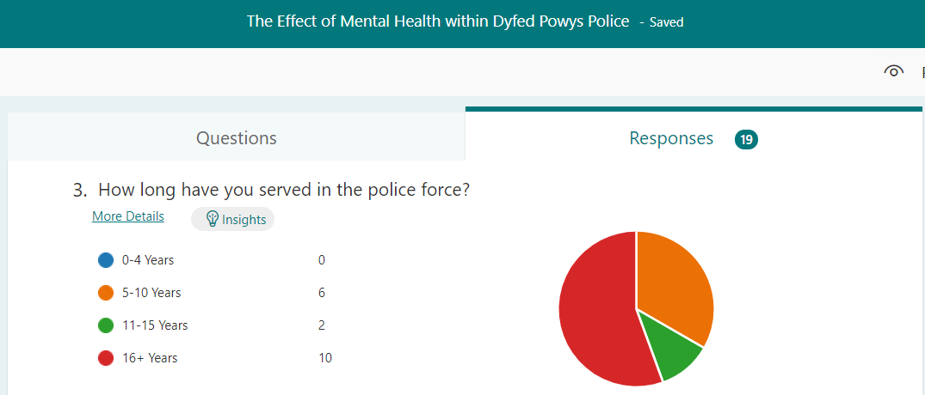
4.2.1.3 Length of Service

Figure 4.4 Respondents’ length of service (Author’s own)
This question was asked to establish whether there is a correlation between mental health and the time employed as a police officer at Dyfed Powys Police. Figure 4.4 shows that the majority of respondents have served in the police force for over sixteen years, with no respondents having served under 4 years.
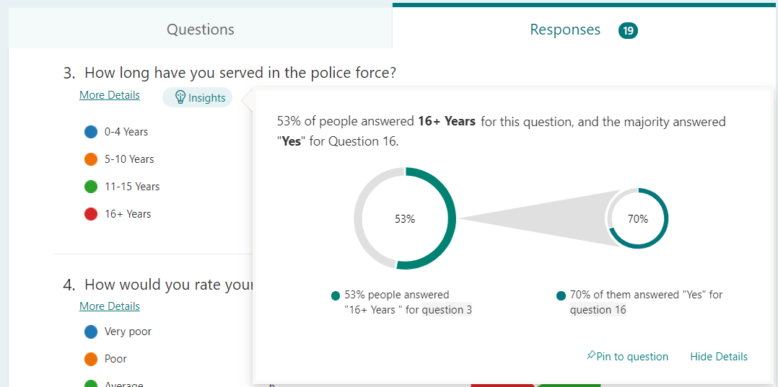
How long have you served in the police force? Would you like to receive enhanced training to deal with mental health cases? Crosstabulation
Figure 4.5 Crosstabulation Q3*Q16 (Author’s own)
The figures obtained from the crosstabulation of questions 3 and 16 show that 70% of police officers who had served for the police force for more than 16 years desired enhanced training in order to deal with cases involving mental health. This shows that despite the level of experience police officers have and their length of service, they still feel that they are not properly qualified to deal with issues related to mental health. This proves that mental health affects the functionality of the police force and the officers that serve in it. They clearly feel that they do not have the adequate skills required to deliver the necessary service to the best of their ability due to their limited knowledge in mental health.

4.2.2 Mental health

4.2.2.1 Current state of mental health
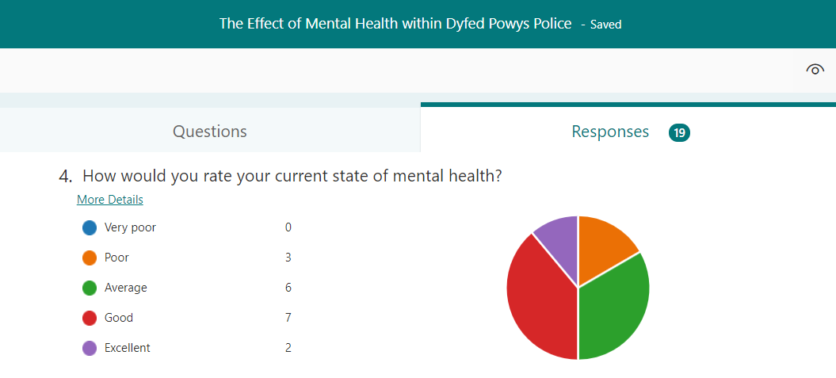

Figure 4.6 Respondents’ current state of mental health (Author’s own)
Figure 4.6 establishes that the mental health of police officers was mainly average or above. This contradicts the research done by Mind Cymru in which it states, “that nearly 9 in 10 emergency workers have experienced stress, low mood or poor mental health while at work, and 1 in 4 has contemplated suicide” (Mind Cymru, 2017). However, it should also be recognised that 3 of the 19 people surveyed, agreed that their current state of mental health was poor, which equates to 16% of the respondents.

4.2.2.2 The effect that the job role has on mental health with further information.
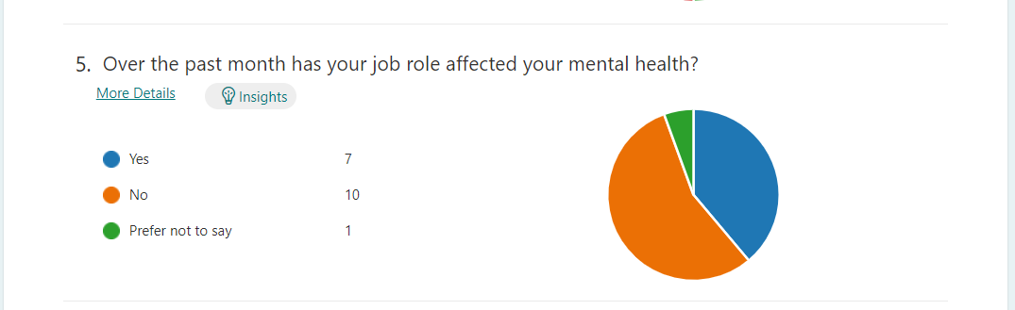

Figure 4.7 Respondents’ effect on mental health in relation to job role (Author’s own)

The purpose of this question was to establish the impact that the job role had on police officers’ mental health. Figure 4.7 shows that despite ten out of the 19 people who responded, specifying that the job role had not affected mental health, 37% of respondents felt that the job role had affected their mental health.

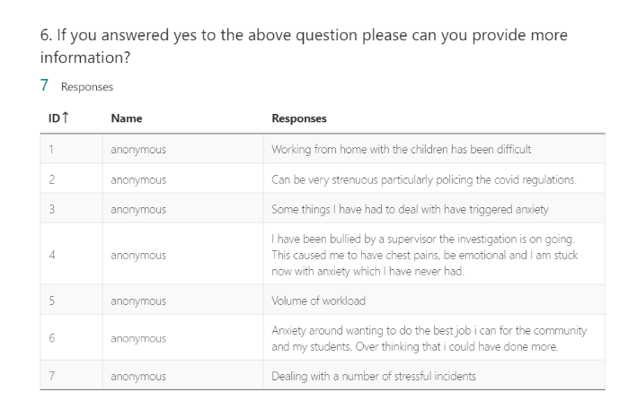

Figure 4.8 Respondents’ further information on job role affecting mental health (Author’s own)
The purpose of this request was to establish the causes that affected the mental health of individuals within the force. The results obtained, evidence a huge disparity in how the job role has affected mental health. These vary from personal circumstances, such as having to work from home whilst balancing childcare to treatment of individuals by their superiors. Of the seven responses, the nature of the role and the dealing of stressful incidents is the most prevalent issue. Due to this being a crucial element of the job, it can be suggested that many individuals will suffer from poor mental health as a result of their daily experiences. Having only 19 responses, this is significant as it enables the researcher to make her own predictions based on factual evidence. This sample is representative of the entire organisation of Dyfed Powys Police.

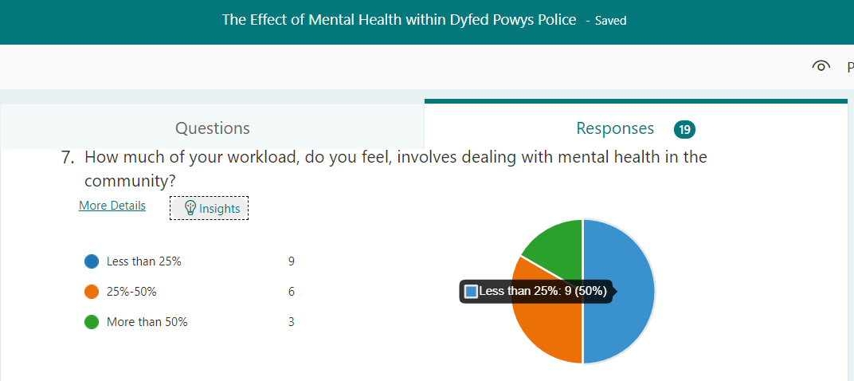
4.2.2.3 Level of mental health as a proportion of workload

Figure 4.9 Mental health as a proportion of workload (Author’s own)
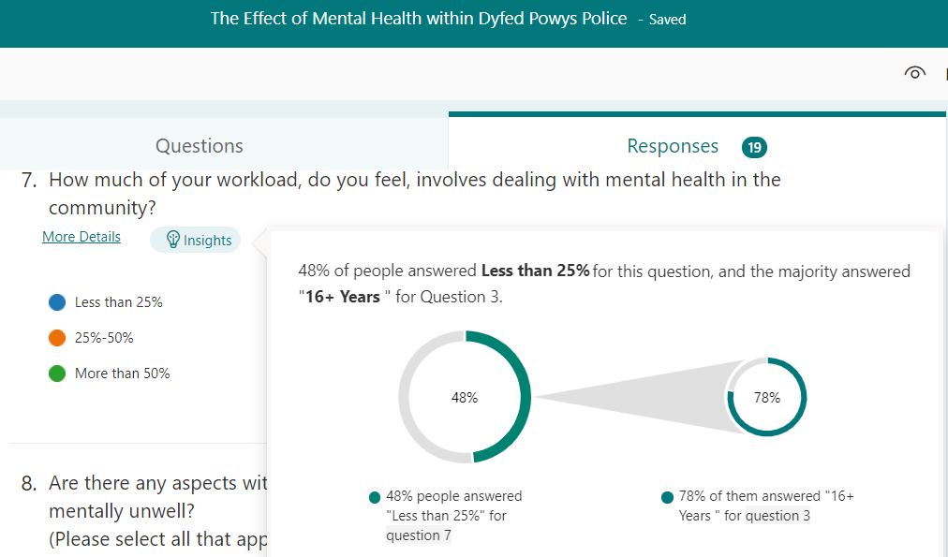

Figure 4.10 Crosstabulation Q3*Q7 (Author’s own)

Respondents were asked this question in a quest to ascertain how much of their workload was dictated by mental health in the community. The results obtained show that half of the respondents felt that less than 25% of their workload involved mental health in the community. However, the crosstabulation above shows that the majority of these had served in the force for over 16 years. An assumption can be made that this could be the result of development, progression and promotion, therefore resulting in less time being spent on the streets of the community and not having to deal directly with incidents concerning mental health. It must also be noted that the remaining 50% believed that 25% or above of their workload, was linked directly to dealing with mental health. Three of the nineteen respondents felt that this number was above 50%.

4.2.2.4 Aspects of role versus levels of well-being
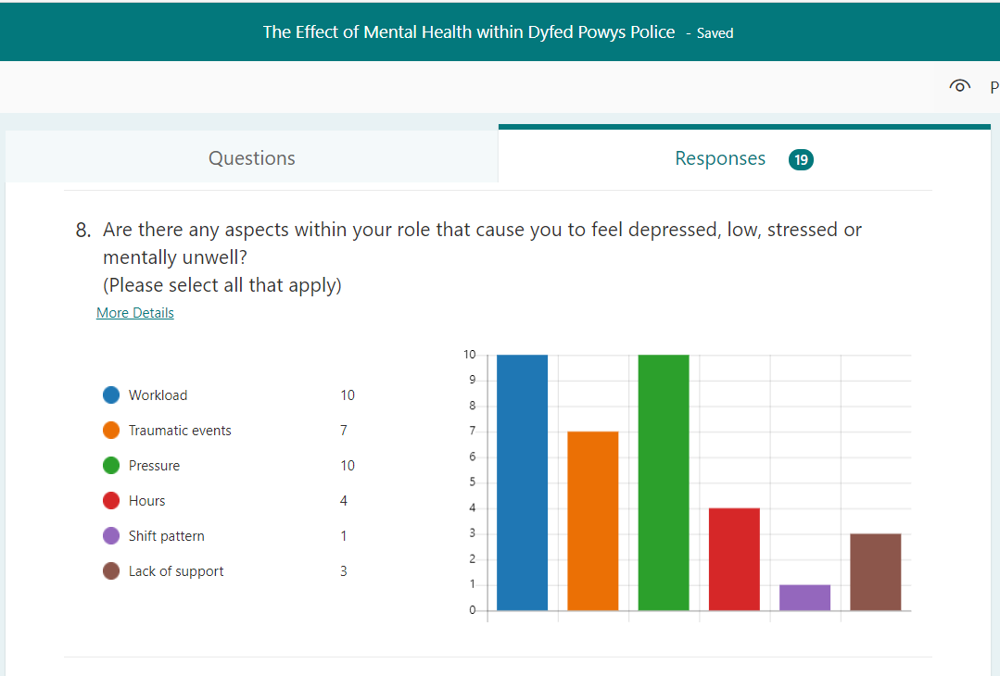

Figure 4.11 Respondents’ well-being in relation to responsibilities (Author’s own)

This question was posed to ascertain if there were any patterns related to the effect of specific aspects of the role on well-being. It can be concluded from the results obtained that workload and pressure were prevalent issues amongst the respondents, with traumatic events also contributing significantly to feelings of depression and poor mental health. General aspects such as shift pattern, lack of support and working hours only brought about a minimum return from the respondents, proving to be less than half.

4.2.2.5 Impact dealing with mental health incidents has on fighting crime
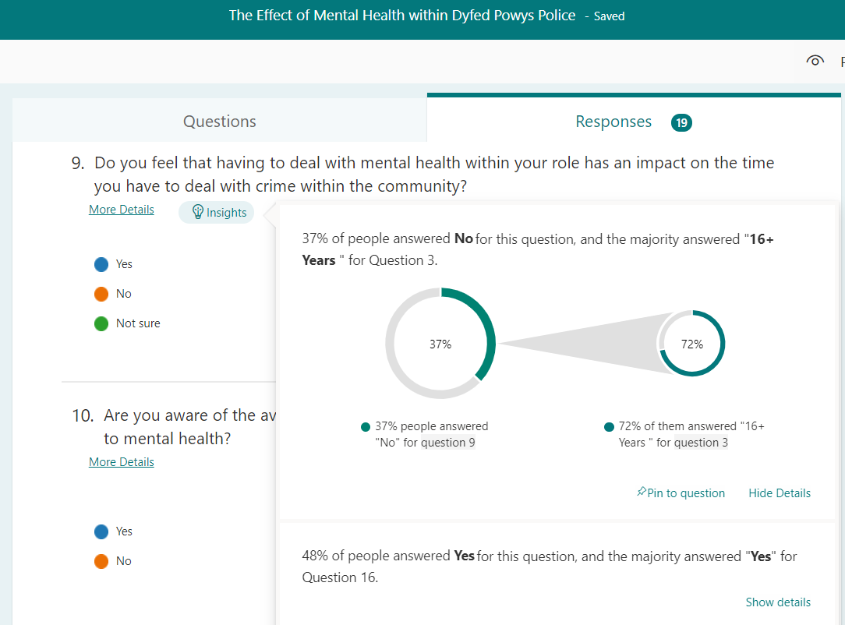

Figure 4.12 Respondents’ opinion on impact mental health has on fighting crime (Author’s own)

This question consolidates the impact that officers feel that mental health has on the time and resources they have for dealing with criminal activity in the community. 48% of the respondents felt that their time was impacted upon through having to deal with incidents related to mental health, with 72% of these feeling that there was a requirement for enhanced training in this field.

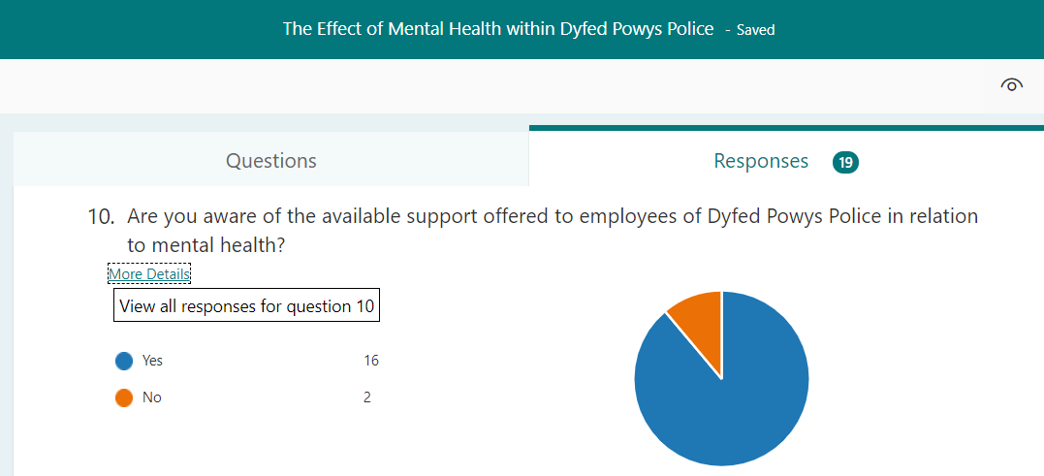
4.2.3 Support

4.2.3.1 Awareness of available support

Figure 4.13 Respondents’ awareness of support (Author’s own)

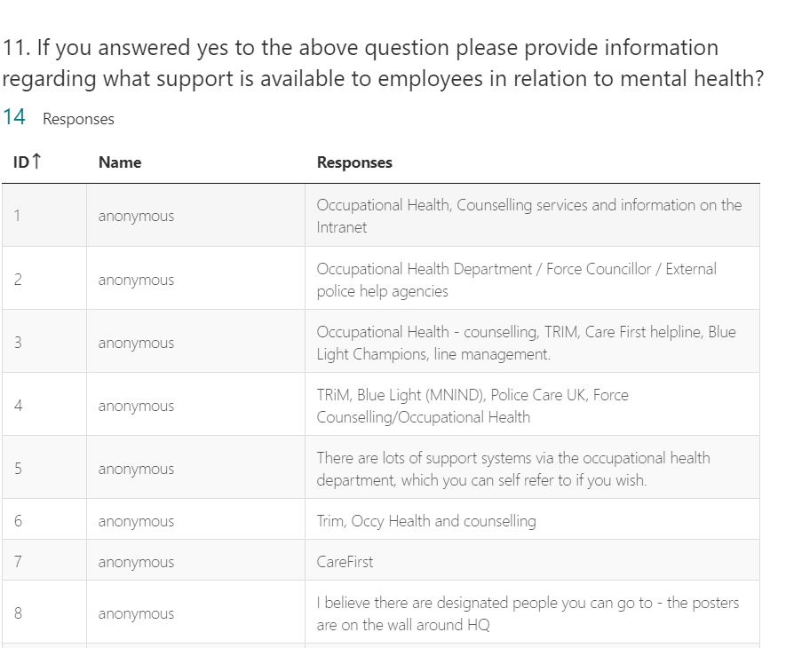
This question was posed to establish how aware employees of Dyfed Powys Police are in relation to support with mental health. An overwhelming majority ascertained their awareness, with 89% of the respondents agreeing that they were aware of available support. This question was expanded on in the next, where respondents were asked for further information related to the available support. The results are outlined below in figure 4.14.

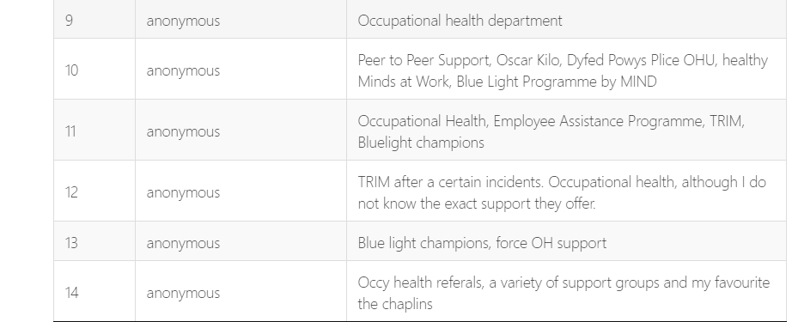

Figure 4.14 Respondents’ awareness of support services

The above question enabled the researcher to establish the extent of the services available to workers of Dyfed Powys Police along with their awareness. It is apparent that there is a diverse range of support services available, highlighting not only the requirement for these but also the awareness and acceptance of decision and policy makers that mental health issues are prevalent throughout the force. In acknowledging this, public services can be proud of their contribution to providing healthier working environments for their employees and thus promoting this awareness to others.

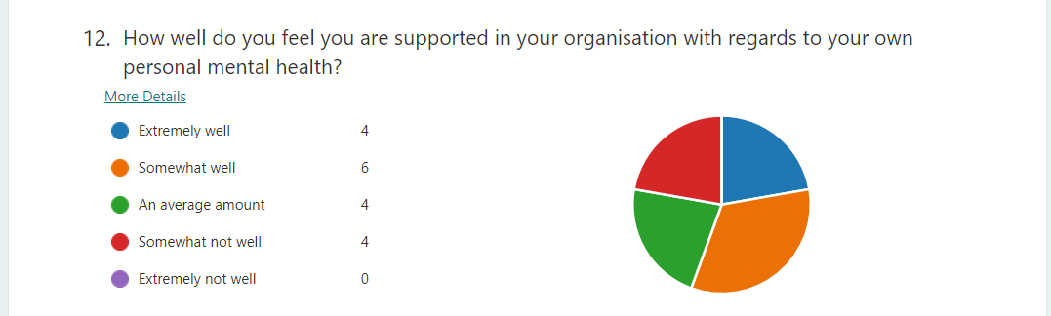
4.2.3.2 Acknowledgement of Relevant Support

Figure 4.15 Respondents’ acknowledgement of relevant support (Author’s own)

This question sought to establish how supported individual employees felt in relation to their own mental health, within their organisation. The results obtained were inconclusive as a result of, three categories having equal numbers of respondents whilst being on opposite ends of the spectrum. Some respondents noted that they felt their own mental health was looked after ‘extremely well’, whilst others disagreed, denoting a ‘somewhat not well’ response. The important consideration here is that certain individuals feel supported whilst others do not.

4.2.4 Recruitment

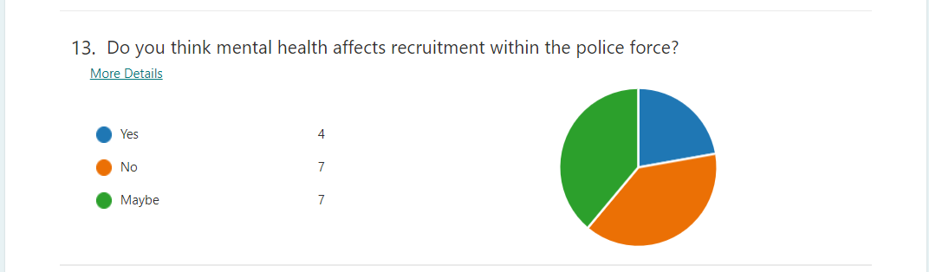
4.2.4.1 Effect of Mental Health on Recruitment in Dyfed Powys Police

Figure 4.16 Respondents’ opinions on effect on recruitment (Author’s own)

This question served to ascertain the opinions of workers of Dyfed Powys Police in relation to the effect mental health has on recruitment within the force. The results were again inconclusive as 7 out of the 18 active respondents did not answer ‘yes’ or ‘no’.

4.2.5 Qualifications and Training

4.2.5.1 Crime v Mental Health
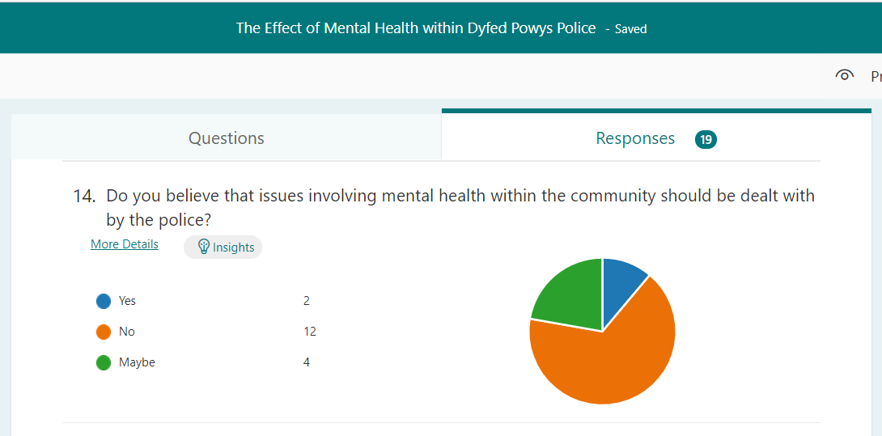

Figure 4.17 Relevance of police work to mental health (Author’s own)

Many police workers believe that dealing with incidents of mental health within the community is not the role of the police and lies with the practitioners qualified to provide the best possible support. The fact that the police have to respond to these incidents “is letting down people with mental health problems, as well as placing an intolerable burden on police officers and staff” (Her Majesty’s Inspectorate of Constabulary and Fire and Rescue Services, 2018). This question was asked to establish the opinions of those on the front line and dealing with such incidents on a daily basis. The results obtained show a distinct correlation between the Policing and Mental Health report (HMICFRS, 2018) and the results of the questionnaire, with only two of the respondents agreeing that incidents concerning mental health should be dealt with by the police.

4.2.5.2 Qualified to Deal with Mental Health
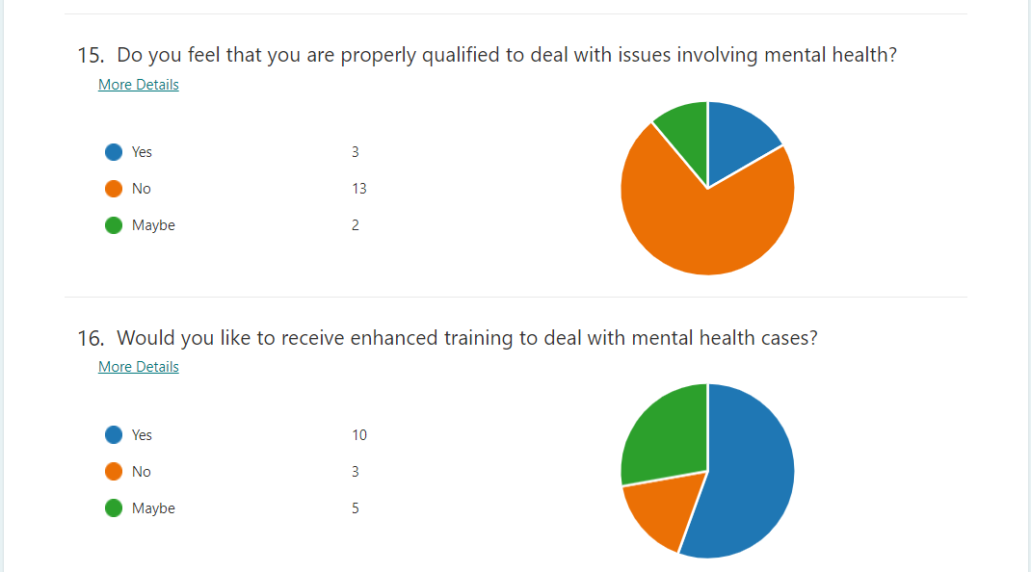

Figure 4.18 Respondents’ Views on Qualifications and Training

These two questions were asked to ascertain the confidence levels of police workers in dealing with incidents concerning mental health. There is a clear view that the majority of police workers do not feel properly qualified to deal with mental health incidents with the vast majority of these believing that enhanced training is a necessity. The acknowledgement that training is a requirement highlights the notion that employees of Dyfed Powys Police believe that mental health affects their force and the work that they do. It also acknowledges the fact that mental health will continue to put a strain on their resources in the future.

4.3 Conclusion

The purpose of this chapter was to analyse the qualitative and quantitative data produced as a result of the primary research conducted by the author. These results will be considered in the following chapter, in which the findings will be summarised and recommendations established with further research opportunities ascertained and highlighted.

Chapter 5.0 Conclusions and Recommendations

5.0 Introduction

The final objective of this research project is to collate the information that has been collected as a result of primary and secondary research in order to establish the effect mental health has on certain aspects of Dyfed Powys Police. This chapter aims to provide relevant recommendations and up to date information. Furthermore, its purpose is to highlight areas of improvement in order to aid research on this topic in the future. This will be done via careful analysis and the identification of gaps in the research.

5.1 The Research Study Question and Hypothesis

The aim of this dissertation was to establish the extent to which mental health affects Dyfed Powys Police. The purpose of the research project was to consider the hypothesis and create an argument, using the research collated to based on the stated hypothesis.
Hypothesis
Dyfed Powys Police is greatly affected by mental health with employees feeling underqualified for the duties imposed upon them.

5.2 Main Findings

The research conducted for this dissertation is in agreement with the hypothesis that Dyfed Powys Police is greatly affected by mental health, with employees feeling underqualified for the duties imposed upon them. There is sufficient evidence that has been collated in the process of the research that stipulates that despite growing awareness around mental health, many professionals within the police force feel ill-equipped to deal with incidences related to mental health.
The main findings correlate with the literature discussed in chapter 2 in which many organisations have discussed their concerns with regards to crises in mental health being left to the police to deal with (HMICFRS), who feel underqualified and unable to provide the best possible care. The data also reflects a slight correlation between the secondary research provided by Mind and the primary research collected as a result of the online questionnaires. Mind recognises “that nearly 9 in 10 emergency workers have experienced stress, low mood or poor mental health while at work, and 1 in 4 has contemplated suicide” (Mind Cymru, 2017). The data produced as a result of the questionnaire establishes that 7 out of the 19 respondents felt that their mental health had been impacted on as a result of their role and duties within Dyfed Powys Police.
The dissertation recognises the requirement for further training and qualifications in order to deal with incidences of mental health in correlation with the qualitative data produced as a result of the information collated for Chapter 2(Police and Crime Commissioner, 2019). An overwhelming majority felt that they would benefit from enhanced training in mental health, proving the issues Dyfed Powys Police are facing. This supports the hypothesis that employees feel underqualified to deal with the duties imposed upon them.
Awareness of the available support for employees of Dyfed Powys Police in relation to mental health is consistent throughout, with many individuals being able to list a plethora of organisations accessible to them as and when required with prior knowledge of the systems that are in place to support them. This consolidates the notion that Mind Cymru has stated that 20,000 police officers have been supported with their mental health by their charity.
Several barriers to mental health have been identified, in which some respondents didn’t give a definitive answer. This highlights the stigma associated with mental health and the reluctance for individuals to associate themselves with it and the relevant services, contributing further to the fact that Dyfed Powys Police is greatly affected by this issue.
The impact of mental health in society today has been identified in both primary and secondary sources of this dissertation, in the form of data collated from questionnaires and formal government reports and documents. It is evident that despite being underqualified in dealing with issues of mental health, Dyfed Powys Police are expected to respond to crises on a daily basis due to a shortage of services that are better equipped to meet the needs of these individuals. It has also been recognised that traumatic experiences also lead to feelings of depression and low mood (Mind Cymru, 2017). This notion is consolidated further in this dissertation with seven out of the nineteen respondents naming traumatic events as a trigger to poor mental health on a personal level.
The implications uncovered by this dissertation are that despite heightened awareness of the services available to combat poor mental health there still remains, a large number of employees who are currently suffering from their own state of mental health. The effectiveness of these services is then questionable as well as the notion that the stigma associated with mental health possibly prevents certain individuals from accessing the services available to them. Further training and qualifications could implement a more robust understanding of mental health, resulting in a raised awareness of the fact that everyone can be affected by it and that it does not discriminate.

5.3 Limitations on the Research

Following the analysis of results, it is apparent that there have been a number of limitations. The sample used involved employees of Dyfed Powys Police and therefore is conducive of that geographical area alone. The geographical area covered by Dyfed Powys Police is mainly rural or coastal, therefore these results cannot be used as a representative of policing and mental health in South Wales in its entirety. This is due to the fact that South Wales is also home to a number of cities and larger towns in which crime levels are much higher. However, the data can be used to predict trends as one can assume that police officers working in areas of high crime are more likely to have to deal with issues concerning mental health and therefore are more likely to have their own mental health impacted upon.
Furthermore, although length of service of the employees was established via the primary research in the form of a questionnaire, it would have been beneficial to ascertain specific job roles of the respondents in order to create crosstabulation of this with other questions including, whether or not the job role has affected their mental health. This would enable the establishment of trends related to specific job roles within Dyfed Powys Police.
In addition to that Covid-19 has impacted the outcome of this dissertation due to the limitations placed upon travel and face to face meetings. The level of strain that the pandemic has placed upon the police force has also meant that resources have been limited and despite efforts to request interviews via TEAMS, it was not possible to arrange this. Being able to conduct interviews would have created the possibility of leading to different areas other than those presented in the questionnaire as despite containing qualitative and quantitative questioning, once the answers had been given, no other questions could be created as a result of their responses. However, the information received from the questionnaire was suffice and enabled critical analysis and evaluation of the results to aid the dissertation.

5.5 Future Recommendations

This research can be improved upon in a number of ways. One such way is opening the sample up to other police forces in Wales in order to be able to make a comparison of different geographical areas. A greater sample could also be obtained to make the results more reliable. The questionnaire was distributed amongst employees with a statement that stipulated that its completion was voluntary. Due to time constraints, many might have discarded the form, therefore a summary of how long the form would take to complete might prompt individuals to participate, as the average time it took to complete the form was only three minutes and seven seconds.
Similarly, an assumption was made that all employees were aware of what constituted poor mental health. Poor awareness might have deterred certain individuals from completing the form. Therefore, links to specific websites that resulted in the provision of the necessary information could be made available. Without this, respondents would have had to do their own research and therefore completion of the questionnaire would have been more time consuming, resulting in less likelihood of its completion.

5.6 Conclusions

This dissertation has achieved all of its objectives as outlined above, with particular emphasis placed upon the hypothesis, ‘Dyfed Powys Police is greatly affected by mental health, with employees feeling underqualified for the duties imposed upon them.’ In searching for the true answer, the researcher was also able to uncover to what extent mental health affected Dyfed Powys Police. The research has provided deeper understanding of certain elements related to mental health whilst at the same time highlighting areas requiring further intervention and development. The status of mental health has been highlighted significantly over recent years, but the research uncovered from both primary and secondary data reveals that there is still much work to be done in this area. The dissertation exemplifies why employees of Dyfed Powys Police feel that their mental health is compromised in relation to their job role as well as the extent of this compromise.
In conclusion, it is evident from the research obtained and presented in this dissertation, that mental health is a prevalent issue in society today. Dyfed Powys Police employees are clearly affected by it, both on a personal level as well as having to respond to incidences associated with it. The lack of comprehensive training has created a working environment in which employees feel underqualified and therefore unable to deliver the best possible service. This creates a cycle in which these feelings of inadequacy promote low self esteem and thus contribute to poor mental health, having a detrimental effect on their well-being.

5.7 Reflection

The researcher has thoroughly enjoyed participating in this research study, having an interest in both policing and mental health. This interest is the result of the researcher’s desired vocation as well as awareness of current societal issues. It also links in directly with researcher’s programme of study; Bsc Policing.
The researcher has benefitted from the software used, (Microsoft Forms) and has also gained greater understanding of research methodology and mental health. The use of an online questionnaire meant that no travelling was required for its distribution.
The researcher has also enjoyed communicating with the Chief of Staffing and Monitoring, Carys Morgans from Dyfed Powys Police as it promoted collaboration and positive relationships, all essential attributes of a police officer.
The researcher has identified gaps in the primary research and has ascertained the benefits of filling these gaps to collate more specific information that can then be cross referenced to achieve more detailed information and aid the researcher.

5.8 Summary

The dissertation, as presented in this document, clearly depicts the effect mental health has on Dyfed Powys Police and its employees. It highlights the requirement to be empathetic and sympathetic of the needs of police workers, due to the unprecedented demand placed upon them with regards to mental health. Furthermore, despite an already raised awareness on factors associated with mental health, there still remains much that can be done to promote this awareness even further. The researcher has also established the fact that better training is required to aid understanding and confidence when dealing with incidences related to mental health. The researcher has highlighted the requirement for further investigation in order to establish a plan to combat the growing issue of mental health.

Bibliography

Abrams, A. (2021) Is a Mental Health Crisis the Next Pandemic [online]. Available at: https://www.psychologytoday.com/us/blog/nurturing-self-compassion/202103/is-mental-health-crisis-the-next-pandemic (Accessed 4th January 2021).
Act For Libraries (2021) The Impact of Mental Illness on Society [online]. Available at: http://www.actforlibraries.org/the-impact-of-mental-illness-on-society/ (Accessed 3rd January 2021).
Burton, M. Pavord, E. and Williams, B. (2014) An Introduction to Child and Adolescent Mental Health [online] Available at: https://uk.sagepub.com/sites/default/files/upm-binaries/61583_Burton_An_Introduction_to_Child_and_Adolescent_Mental_Health.pdf#:~:text=The%20different%20theoretical%20models%20used%20to%20understand%20and,classified%20according%20to%20ICD%2010%20and%20DSM%205. Accessed: 30th January 2021.
Carmen, T (2020) Reliability and Validity [online]. Available at: https://www.researchprospect.com/reliability-and-validity/ Accessed on: 14th February, 2021)
Calzon, B (2021) Data Analysis Methods and Techniques [online] . Available at: https://www.researchprospect.com/reliability-and-validity/ . (Accessed on: 28th February 2021).
Dudovskiy, J. (2020) Research Philosophy [online] . Available at: https://research-methodology.net/research-philosophy/ . Accessed on 23rd February 2021).
Dyfed Powys Police and Crime Commissioner (2019) Mental Health and Policing [online]. Available at:https://democracy.carmarthenshire.gov.wales/documents/s32937/Report.pdf (Accessed: 29th January 2021).
Healthline (2021) How Attachment Issues Impact Your Relationships [online]. Available at: https://www.healthline.com/health/attachment-disorder-in-adults. (Accessed on: 14th February 2021).
HealthyPeople.gov. (2020) Mental health and Mental Disorders [online]. Available at: https://www.healthypeople.gov/2020/topics-objectives/topic/mental-health-and-mental-disorders (Accessed: 17th February 2021).
Her Majesty’s Inspectorate of Constabulary and Fire & Rescue Services (2018) ‘Policing and Mental Health Picking up the Pieces’ [online] Available at: https://commissioner.south-wales.police.uk/media/1141/hmic-report-mental-health-nov18.pdf (Accessed:29th January 2021).
Leeming, D. (2018) The use of theory in qualitative research [online] Available at: https://pure.hud.ac.uk/ws/portalfiles/portal/14659077/About_research_JHL_DL_with_refs_.pdf (Accessed: 24th February 2021).
Local Government Association (2021) Children and Young People’s Mental Health [online]. Available at: https://www.local.gov.uk/about/campaigns/bright-futures/bright-futures-camhs/child-and-adolescent-mental-health-and (Accessed: 5th March 2021).
Mcleod, S. (2018) The Medical Model [online]. Available at: https://www.simplypsychology.org/medical-model.html (Accessed: 14th February 2021).
McLeod, S. (2019) What’s the difference between qualitative and quantitative research? [online] Available at: https://www.simplypsychology.org/qualitative-quantitative.html (Accessed: 3rd February 2021).
Mental Health Foundation (2016) Mental Health in Wales: Fundamental Facts 2016 [online]. Available at: https://www.mentalhealth.org.uk/sites/default/files/FF16%20Wales.pdf (Accessed: 5th May 2021).
MentalHealth.gov (2020) What is Mental Health? [online] Available at: https://www.mentalhealth.gov/basics/what-is-mental-health (Accessed: 29th January 2021).
Mentalhealthwales (2020) ‘Policing should not be used as a substitute for mental health services’[online]. Available at: https://www.mentalhealthwales.net/2019/10/policing-should-not-be-used-as-a-substitute-for-mental-health-services-dai-lloyd-am/ (Accessed:30th January 2021).
Mind Cymru (2017) Mind Cymru Launches Blue Light Programme in Wales. [online]. Available at: https://www.mind.org.uk/news-campaigns/news/mind-cymru-launches-blue-light-programme-in-wales/ Accessed: 30th January 2021.
Neuman, W.L. (2003) “Social Research Methods: Qualitative and Quantitative Approaches” Allyn and Bacon.
NHS Wales (2021) Mental Health [online]. Available at: http://www.wales.nhs.uk/healthtopics/conditions/mentalhealth. Accessed on 13th February 2021.
Rees, J. (2019) South Wales Police: Mental Health Calls Squeeze Force [online]. Available at: https://www.bbc.co.uk/news/uk-wales-46738600. Accessed: 28th January 2021.
Transform Psychology (2021) Models of Mental Health [online]. Available at: https://www.tranceformpsychology.com/psychology/models-of-mental-health.html.
(Accessed on: 3rd February 2021).
Saunders, M., Lewis, P. & Thornhill, A., 2009. Research Methods for Business Students. 5th ed. Harlow: Pearson Education Limited .
Saunders, M., Lewis, P. & Thornhill, A., 2009. Research Methods for Business Students. 5th ed. Harlow: Prentice Hall.
ScienceDirect. (2021) Deductive Approach. [online]. Available at: https://www.sciencedirect.com/topics/mathematics/deductive-approach (Accessed 14th February, 2021).
Sinclair, T. (2019) Police now the ‘24/7 default service’ for mental health [online]. Available at: http://pembrokeshire-herald.com/54459/police-now-the-24-7-default-service-for-mental-health/ (Accessed 3rd May 2021).
Social Care Institute for Excellence, 2012. The Importance of Theory and Methodology in Research [online]. Available at: https://www.scie.org.uk/publications/researchmindedness/makingsenseofresearch/theoryandmethodology/ (Accessed: 5th March 2021).
Sternheimer, K. (2019) What is Sociological Research [online] . Available at: https://www.everydaysociologyblog.com/2019/06/what-is-sociological-research.html (Accessed: 24th February 2021).
The Open University (2021) Mental Health Model [online image]. Available at: https://www.open.edu/openlearn/ocw/pluginfile.php/1223815/mod_oucontent/oucontent/62622/da4ddc15/ac0d8e1b/s826_ol_fig7_bpse_model_for_mental_health.png (Accessed on: 2nd May 2021).

Appendices

Appendix one – Questionnaire

The Effect of Mental Health within Dyfed Powys Police
I am currently studying Policing BSc and this survey will contribute towards my dissertation. Thank you in advance for completing this form as it forms an essential element of my individual project. You are invited to participate in this research as you are an employee of Dyfed Powys Police.
Disclaimer notice: Your participation in this research study is voluntary. You may choose not to participate. However, if you do decide to participate in this survey, you may withdraw at any time. Your responses will remain confidential and therefore the questions will not involve personally identifying information. The result of this study will be utilised for scholarly purposes only and will not be misused or made public. Some of these questions may trigger feelings associated with negative mental health. If at any time you feel uncomfortable with answering these questions please withdraw.
1.Gender
Male
Female
Prefer not to say
2.Age
18-24
25-34
35-44
45+
3.How long have you served in the police force?
0-4 Years
5-10 Years
11-15 Years
16+ Years
4.How would you rate your current state of mental health?
Very poor
Poor
Average
Good
Excellent
5.Over the past month has your job role affected your mental health?
Yes
No
Prefer not to say
6.If you answered yes to the above question please can you provide more information?
Enter your answer
7.How much of your workload, do you feel, involves dealing with mental health in the community?
Less than 25%
25%-50%
More than 50%
8.Are there any aspects within your role that cause you to feel depressed, low, stressed or mentally unwell?
(Please select all that apply)
Workload
Traumatic events
Pressure
Hours
Shift pattern
Lack of support
9.Do you feel that having to deal with mental health within your role has an impact on the time you have to deal with crime within the community?
Yes
No
Not sure
10.Are you aware of the available support offered to employees of Dyfed Powys Police in relation to mental health?
Yes
No
11.If you answered yes to the above question please provide information regarding what support is available to employees in relation to mental health?
Enter your answer
12.How well do you feel you are supported in your organisation with regards to your own personal mental health?
Extremely well
Somewhat well
An average amount
Somewhat not well
Extremely not well
13.Do you think mental health affects recruitment within the police force?
Yes
No
Maybe
14.Do you believe that issues involving mental health within the community should be dealt with by the police?
Yes
No
Maybe
15.Do you feel that you are properly qualified to deal with issues involving mental health?
Yes
No
Maybe
16.Would you like to receive enhanced training to deal with mental health cases?
Yes
No
Maybe

Appendix Two – Data


