Title: Business Data and Analysis
Assignment Name: Report- Part 1 and 2
Student Name: Daniel Ramsey
Course Name and Number: Generating Business Data and Analysis BMSP4004
Lecturer: Dr Roisin Mullins
Date: 17TH January 2018

Contents
Introduction 3
Venue Location 4
Future Generation Wales Act 5
Delegates Needs 7
Purpose of a Database 7
Functions of a Database 8
Role of a Business Analyst 9
Database Lifecycle: Planning and Analysis 9
Planning 10
Part 2 13
Introduction 13
Database Tools 13
Benefits of Database Tools 13
Current Trends 14
References 15

Introduction

The Carmarthen Business School, based on College Road, Carmarthen, intends to run a “rethinking business” conference on a yearly basis. As a rethinking business leader, the author of this report has been assigned the role of determining the most suitable venue for this conference to take place, while taking into consideration several different factors, the most important of which is for the conference to be in a sustainable environment and as low cost as possible. Sustainability has become a very important part of the way businesses are run and will be a staple part of any future business ventures. The idea that business leaders being the servants of society, and who only have the stock and shareholders as their primary interest is being challenged. Sustainability concepts are now being applied in the era where high volatility in business is characterized, and strategic risk assessments have now taken prominence in business environments (Wells, 2013). With this in mind, the final venue chosen should be in line with all the sustainability element directives available, while taking into consideration the needs of the delegates and the modules being delivered.

Venue Location
While exploring the possible venue locations, several factors must be taken into consideration. Factors such as ease of access, the needs of the delegates, fees, impact on environment and The Future Generations Wales Act, which will be discussed in further detail at a later point.
The location of venues searched to run the conference were located on the Wales coastal path. Flanked by beautiful countryside, and often faced with blue flag beaches, this is an ideal place to hold a sustainability conference.
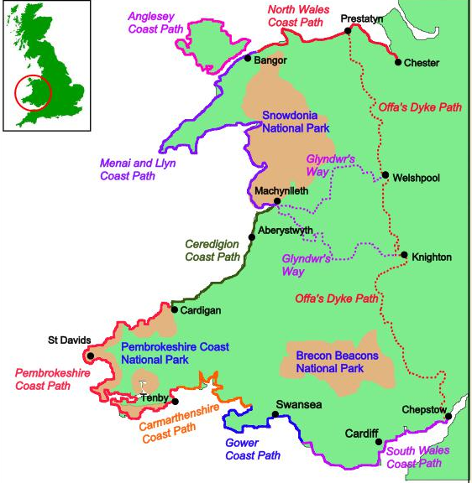

Eight counties were explored along the coastal path, with two towns provisionally chosen within those counties. In those towns, three potential venues were chosen. After careful consideration, the venue chosen to host the rethinking business conference is The Red Café based in Mumbles, Swansea. The “exemplar youth and community project promoting sustainable living” (Sustainable Swansea, n.d.) The Red Café project, whose primary aim is to provide support and activities for young people, was established by the Linden Church Trust. The project organises a variety of events and activities for various age groups, and promotes holistic learning, volunteering, fair trade across the community and sustainable living. The café serves Fairtrade food and has furniture and fittings that is made from reclaimed wood and materials that have been recycled (Sustainable Swansea, n.d.).
The Linden Church Trust group, who are the founders are the founders of The Red Café, is very community orientated. They have many projects aimed at sustainability in the community and building a better Swansea which promotes two main goals of the Future Generation Wales act; “a more equal Wales” and “A Wales of cohesive communities”.

Future Generation Wales Act
The Future Generation (Wales) Act is aimed at the improvement of the economic, environmental, cultural and social well-being of the Wales. The public bodies listed in the Act will be taught to think more about the future, maintain a good working relationship with communities and people, while taking a joined-up approach to preventing problems. This Act is put in place to create a national community that is both inviting and welcoming, for now and the foreseeable. To ensure this goal is achieved, seven well-being goals are put in place:
- A globally responsive Wales.
- A prosperous Wales.
- A resilient Wales.
- A healthier Wales.
- A more equal Wales.
- A Wales of cohesive communities.
- A Wales of vibrant and thriving Welsh Language.
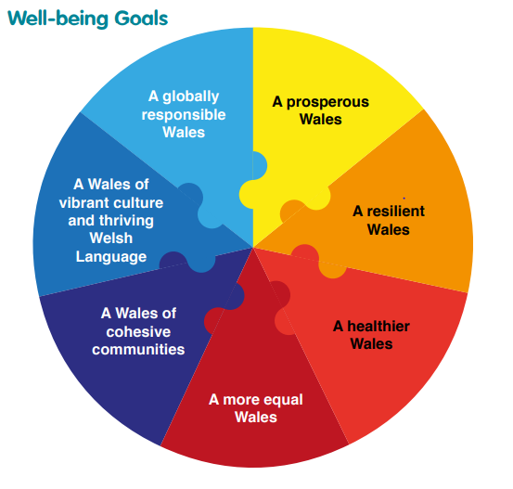

This Act includes several public bodies, ranging from Welsh Ministers through to The Higher Education Funding Council for Wales, and its main aim is sustainable development. The two goals in the Act related to the chosen venue, as stated previously, are:
- A more equal Wales – “A society that enables people to fulfil their potential no matter what their background or circumstances (including their socio economic background and circumstances)”.
- A Wales of cohesive communities – “Attractive, viable, safe and well-connected communities” (Sustainble Devolopment Branch, 2015).

The Linden Church Centre and its groups are very community focused, describing itself as a community project that works to bring the local community and people together across the City of Swansea- from the people with minor or major health issues to newly arrived citizens seeking a safe sanctuary. Their belief that Everyone Matters” is a key component to the success of the Future Generation (Wales) Act, and therefore justifies the rationale in its choosing as the principle venue for our Rethinking Business Conference.

Delegates Needs
For the conference, the number of delegates attending will be 55. For this conference to be a success, all 55 delegates needs and wants must be fulfilled to the greatest satisfaction.
The cost of the conference room will be £100 to hire for the day, making it a cheap option per delegate, with them only having to pay £1.81. There is no extra cost for the Wi-Fi facilities as the café has on site Wi-fi. As the venue chosen is a canteen. Lunch will be provided by the on site canteen as an extra cost to the delegate. All food provided is in line with fair trade and sustainability standards, with all the products used and bought on site giving producers in the poor country of origin a stable and fair wage or price for their products. (Linden, n.d.) The impact on the environment is also of great importance. As the conference will be situated in the café, no outdoor facilities will be used, therefore no waste will be generated and no wildlife or outside plant life will be harmed. Before the conference commences, appropriate liability insurance will be in place, should any accidents or damage occurs to property or delegate while the conference is in session.
The Red Café is situated in Mumbles, Swansea close to the sea front. At present, there are no direct car parking facilities that are owned by The Red Café, however, situated on Mumbles Road, there are two car parks which are close by. One is a pay and display car park with opening times from 9 am to 7 pm, and the other, Southend car park is a short walk away. Car parks such as this often have a small cost of £5 for all day parking.

Purpose of a Database
While collating data, an effective solution was needed to store and sort data gathered. For this conference, an Access database was used. (Cyclex, n.d.). The main purpose of a database is to replicate or model a system based on the real world (Ritchie, 2002) and also optimise data management. Not only is it used to update, delete and insert data, an effective database also gives a systematic representation to the system in use and allows the data to be extracted and/or modified by other users or programs (Booksmart, 2014). The corporate data fields are organised into a structure which generates and stores information and forms sets of relationships without the added unnecessary data redundancy (Singh, 2011). Singh (2011) also states the effective need for a consistent database. That and redundancy being the criteria of the most logical and important.
A poorly designed database may result in information and data being repeated and the database may be unable to represent the desired information, therefore, careful examination must take place of the data of an entity and the relationships that exist between them (Singh, 2011).

Functions of a Database
In the early formation, database management systems (DBMS) were expensive and large could only function on large computers. Although advances in technology have enabled DMSs to be operated on smaller machines, they are still highly complex systems and software that require careful management (Ward & Dafoulas, 2006). To run efficiently, a DBMS must be able to:
- Define data definition and language, allowing the users to create a database definition.
- Manipulate data language with the capability to insert, delete, update and query fields in the database.
- Concurrency control which allows the database to have shared access, transactions to be executed in tandem while maintaining database safety.
- Buffer Management whose main function is to transfer data between its main and secondary memory storage.
- Processing queries and database optimisation.
- DBMS recovery must be able to take place in the event of failure of database failure.
- The DBMS should have adequate security control, preventing unauthorised access.
- A facility must be included for Data Integrity. The DBMS must be able to facilitate the integrity enforcing constraints for when a change is made to the database, ensuring the data in the database remains consistent (Ward & Dafoulas, 2006)

Role of a Business Analyst
With business rapidly changing, the role of the business analyst is to ensure that the focus of any emerging projects are strongly focused on business. The business analyst is now emerging as the central figure in initiating major change directives in the business world (Lindbergh, Vanderhost, Hass, & Ziemski, 2007). Business analysts also have the leadership qualities as they are the ones that influence major change in their chosen organisation or business. Such qualities as:
- Being able to persuade and influence individuals to set aside individual differences and work towards a common goal for the good of the organisation.
- The ability to drive others to exceed expectations.
- To be able to merge the goals of the organisation with the vision of its employees to enable higher productivity.
- A keen motivator who strives to get the best out of others.

Although the primary role of a business analyst varies from company to company, the common directive is for the analyst to be the main agent in the changing of the business, solving problems at hand, the improving of processes to move the business forward and increase company value (Blais, 2011).

Database Lifecycle: Planning and Analysis
To design a database, a vast knowledge of database modelling and design is of or great importance. Although several database modelling approaches are available, the ER model, with its simplicity and reliability, is the most used DBMS today (Teorey, 1999). In database design, whichever methodology is applied, system developers will usually apply the same methods when designing a database. In the early stages, it will have been determined that the business will need a system to assist in the process of the business. Once this has been decided, a definitive goal needs to be outlined for the system and business requirements need to be ascertained. Once business requirements have been ascertained, those requirements will then be converted from business to system requirements where the building of the database and its accompanying applications can begin to be assembled. After Building is completed, the testing and implementation of the database is carried out (Langer, 2007).

Planning
For planning, the author of the report gathered information using Google on all the different venues located on the coastal path that could be a potential venue for the rethinking business conference. The building of the database could then begin.

An entity was then created containing three attributes, county, town and venue.

Once the entities were established, data was then entered,
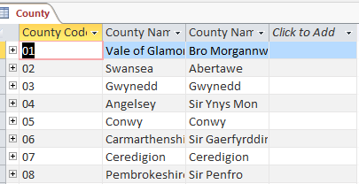

where relationships could be formed.
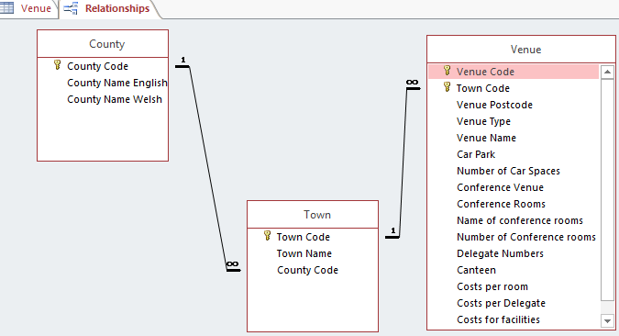
Primary keys for each entity is then decided, allowing for data in each field to do linked, extracted and makes it a requirement.
Forms were then created as a different interface on how the data is stored.


If a specific piece of information is required, the database user has to be able to extract it as efficiently and quickly as possible, a query would then entered. In this instance, queries were created for the number of car parking spaces available at each location and the cost of each venue. All in descending order.

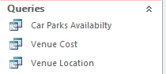
The database is now created and ready to be used. It can now be accessed by any authorised user.

Part 2

Introduction
For a successful and efficient database to be built, fundamental tools are needed. These are sometimes known as database tools. This brief report will explore the variety of database tools used in the modern era, the benefits database tools, current trends that support database use and finally, how data is collated and used in the every-day tasks we undertake.

Database Tools
There are many database design tools available with a variety of features. The design tools, which are specific to the business vendor, a software that aides the development process of the database called case tools. Drawing tools have several different functions, they are used in the conceptual modelling of data, physical database design and logical database design.
The database design tools should aid modelling and application of the database in an efficient manner. Effective design tools should:
- Aid in the capture of the vision or needs of the user.
- Have the capability to organise and model the flow of data.
- Entities and their relationships should be modelled.
- Have the capabilities to generate Data Definition Language (DDL) which creates a database object (Sumathi & Esakkirajan, 2007).

Benefits of Database Tools
Using database tool has endless benefits. If information is needed to be stored in an accurate and structured format, a database tool would be used. Its ability to anticipate numerous people accessing the database, and its record locking and conflict resolution, is a key feature in its ability and the robust way it handles your data. If the need to add more tables is apparent, database tools will anticipate that need and add more tables to a data set that originated as a flat or non-relational table. Database tool are also useful if complex queries need to be run aiding the value fact decision making process (Mullins, 2017).

Current Trends
To collate and store data, many current applications or forms are used. To build the database related to part 1 of this report, Microsoft access was used to store the data and Google was used to source the relevant information. Since the boom of the information highway or what is better known as the internet, there have been many programmes designed that have the ability to store and manage data and an individual’s data safely and in a secure manner.
Facebook, snapchat, Instagram and whatsapp are all current forms of social media which collect and store data. This data is then used to predict current trends and extend the lifespan of these companies.

References
Blais, S. (2011). Business Analysis: Best Practices for Success (Illustrated ed.). John Wiley & Sons.
Booksmart. (2014). purpose of database management system. Booksmart.
Cyclex. (n.d.). Red Cafe, Mumbles. Retrieved January 16, 2018, from Cyclex: https://mumbles.cylex-uk.co.uk/company/red-cafe-15679478.html
Langer, A. M. (2007). Analysis and Design of Information Systems (3, illustrated ed.). Springer Science & Business.
Lindbergh, L., Vanderhost, R., Hass, K., & Ziemski, K. (2007). From Analyst to Leader: Elevating the Role of the Business Analys. Berrett-Koehler Publishers,.
Linden. (n.d.). About Red Cafe. Retrieved January 16, 2018, from Red Cafe: http://www.redcafe.org.uk/
Ritchie, C. (2002). Relational Database Principles (Second ed.). London: Cengage Learning EMEA.
Singh, S. (2011). Database Systems: Concepts, Design and Applications. India: Pearson Education India, .
Sustainable Swansea. (n.d.). Sustainable Swansea. Retrieved January 16, 2018, from Sustainable Swansea: http://www.sustainableswansea.net/red-cafe.html
Sustainble Devolopment Branch. (2015). Well-being of Future Generations (Wales) Act 2015. Retrieved from Welsh Government: https://futuregenerations.wales/wp-content/uploads/2017/01/150623-guide-to-the-fg-act-en.pdf
Teorey, T. J. (1999). Database Modeling & Design (Revised ed.). Morgan Kaufmann.
Ward, P., & Dafoulas, G. (2006). Database Management Systems (Illustrated ed.). Cengage Learning EMEA,.
Wells, G. (2013). Sustainable Business: Theory and Practice of Business Under Sustainability Principles. South Australia: Edward Elgar Publishing.

