Strategic Growth Options and Proposed Strategy:
Choose and focus on one framework – Explain the framework and the proposed strategy in details.
Porter’s generic strategy:
What is Porter’s Generic Strategy model?
Explain each of the strategies.
Which strategy do you think is most appropriate for Vodafone? Justify your answer.
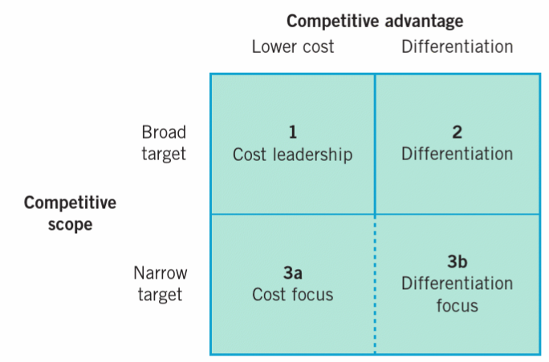

Ansoff Matrix
What is Ansoff Matrix Strategy model?
Explain each of the strategies.
Which strategy do you think is most appropriate for Vodafone? Justify your answer.
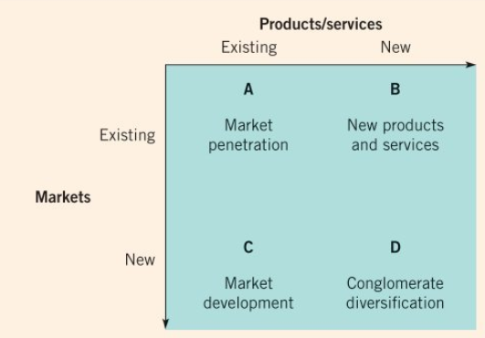

The clock strategy
What is the clock Strategy model?
Explain each of the strategies.
Which strategy do you think is most appropriate for Vodafone? Justify your answer.



