Digital Technology and its place within my own personal learning experience.
BMSP4003
Matthew Edward Kilgariff
University of Wales Trinity Saint David
Dr Alex Bell

Table of Contents

Introduction. 3
Digital Technologies and their impact on learning. 3
My Personal Learning Environment 5
My Digital Literacy. 6
References: 8

Introduction.
The industrial age brought great change and had a huge impact on the world and the workplace but we are now in the midst of a new age, the digital age. Technology is shaping the way we communicate, shop, organise our lives, play and learn. Students have to embrace the digital world to be relevant and competitive. In this report, I will be looking at Digital Technology and its place within my own personal learning experience.
BMSP4003

Digital Technologies and their impact on learning.
Comparing the present day with even a hundred years ago there has been some incredible changes in technology that has further embedded itself into our transport services, hospitals, homes and workplaces. Over the last ten years it has become apparent that technology is here to stay and every sector of life has to adapt to it. However, the class room environment has surprisingly remained largely unchanged with students still sitting in rows and learning from a single teacher. In 2010 Heidi Hayes Jacobs, the internationally recognised education leader wrote, ‘what year are you preparing your students for 1973?’ suggesting that the classroom has not kept up with the demands of a new generation of learners and technological advances. Although the education system has recently attempted to modernise itself with the use of interactive white boards and iPads etc there is still a reliance on traditional teaching methods Jacobs, H. (2010).
The Global Information Technology Report 2001–2002 predicted that as new technologies became cheaper they would become more readily available globally (Kirkman, G., Cornelius, P., Sachs, J., & Schwab, K. (2002). In the past devices such as laptops and mobile phones were for the few because they were expensive and difficult to use without training, now developing nations, technophobes and toddlers can get connected for the first time with affordable and easy to understand devices. In 1995 0.4 % of the world’s population was connected to the internet but in 2017 this had risen to 54.4 % (Global Internet Report (2017). This has opened up opportunities to learners with billions of resources online available at learners’ fingertips. The rise in social media and other platforms has occurred concurrently which has enabled the users to generate their own content and to respond to information interactively (Tuominen, K. (2007).
Technology changes upon its usage, accessibility and who is using it so it is no surprise that it keeps constantly evolving to meet these new demands. O’Reilly refers to this as ‘shakeouts’ which is when a new upcoming technology suddenly gains centre stage. If there are many changes at once, this could also be referred to as a ‘technological revolution’ (O’Reilly, T. (2009). In the early 2000s the web changed from static websites written by individual authors to websites with user generated content. This shift is also referred to as change from Web 1.0 to Web 2.0, examples of this include Wikipedia overtaking websites like Britannica. Wikipedia has a more user generated content so it allows for a diverse range of information and can be updated regularly to ensure it is up to date, all this with little added cost to Wikipedia. The internet has transformed and now can be shaped by its students (McLoughlin, C., & Lee, M. (2010). Digital learning no longer has to be traditional sense of teacher to learner. Technology can be used as a creative tool in which the learner is involved in the discussion and gets the chance not only to absorb information but also to question and alter it themselves (Kirkman, G., Cornelius, et al (2002). It is a shift from a teacher based learning environment to a new more fluid experience where the student is in control of their understanding and learning style.
Social media is becoming more and more prominent in all aspects of life and most schools and universities are adapting it, such as sharing open days and manifestos online or providing information on safe use from as young as four years old. It can also be used by students to share work eg students from New York School of Art using Flickr produced an online exhibition and the class collaborated with annotating and writing descriptions of the photos (McLoughlin, C., & Lee, M. (2010). McLoughlin writes about how personalisation of tasks ensures that students remain motivated and actively engaged in the learning process. However, in this new age where anyone can post information on the internet and make it look credible, it is also important to be vigilant as leaners and check that the facts are correct. The new generation referred to as the ‘Google generation’ have had to develop this skill with all the ‘fake news’ and clever marketing ploys prevalent in the media. Studies have found that learners are relying less on direct observation and experiences and more on accessing information through search engines. The danger with this is that people are not actively seeking their own information but are ‘copying and pasting’ other peoples’ perspectives.

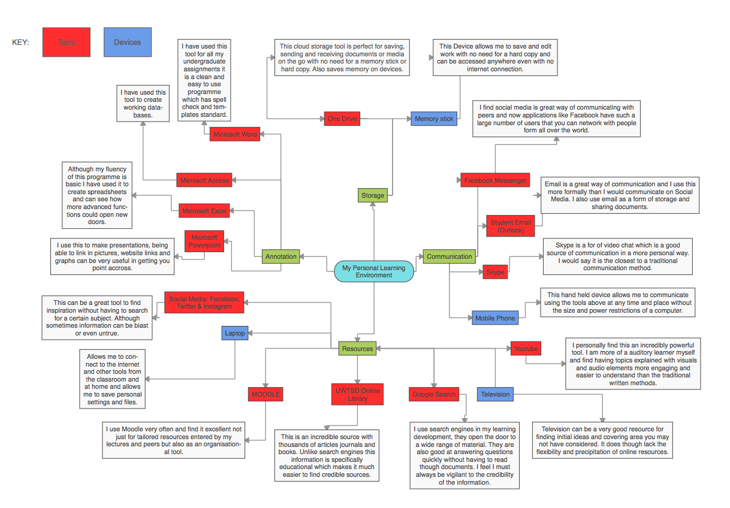

.

My Personal Learning Environment
This is my personal learning environment diagram for my undergraduate degree. It displays the tool and devices that I have used to aid my learning. Starting with the communication section of the diagram, I use a Facebook messenger group to organise term time, inform or be informed on changes to lectures, discuss assignments and network with peers. One drawback I have found with the Facebook messenger tool is that it also is connected deeply with non-educational communication from both companies and friends outside the learning environment. I find this can be a distraction and also make it hard to locate the important information. My student email however is more specific to university work and would be my first way of connecting to lectures. I have used Skype once or twice with classmates. I find it a more personal way of connecting but both parties need to be online at the same time, whereas with email and messenger you can connect with each other at any time. Messenger and email are better forms of communication globally across different time zones.
I readily use Google searches to quickly find information on a wide range of topics although it is important to check sources for credibility. The search engine is geared towards sponsored adverts and company marketing and this can be misleading. When searching for academic books and articles the universities the online library is the best resource because unlike search engines it is centered around academic material.
Youtube plays a part in my learning experience. I suffer with dyslexia so find reading and writing a challenge. Youtube shifts the skill set from reading to listening and watching which is more suited to my learning style. I can use Youtube to summarise hard to understand concepts before going on and reading more detailed articles about them. I find I absorb more information from a video than a long piece of text.
I use cloud storage devices like OneDrive or WeTransfer infrequently but I know they can be useful to save up memory on devices like laptops. The memory on the Macintosh I use for work is now low so I transferred a few gigabytes but found it took a long time to upload and to download large pieces of data. I often use a memory stick instead which I find is a safeguard to save and copy work to more than one device. This may seem old fashioned but I prefer to have important files on something physical rather than just ‘up in the clouds’.
At the start of my degree I was using Apple IOS annotation devices like pages, numbers and keynote but have since downloaded the Microsoft 365 package free from the university website. I found that Microsoft Word, Excel and Powerpoint produced more professional outcomes. Also, it is an industry standard to produce work in a Word format so I was converting pages documents to a Word format but it would alter the layout and make it look untidy. I now write work in Word and then copy and paste it into Apple Pages because of its ‘speech’ function which reads the work back to you. I find this useful because of dyslexia.
My personal favorite learning resource is Moodle which is more than just an information centre. Moodle has great organisational properties similar to a traditional paper planner informing you of times and contents of each lecture. Although I personally use this as a revision tool many of my peers who cannot attend classroom lectures use it to keep on track. However in my opinion this is no substitute for the personal touch of the lecturer, peer group discussion and the opportunity to question the content in person.

My Digital Literacy.

“Digital literacy is the ability to find, evaluate, utilize, share, and create content using information technologies and the Internet.” Cornell University. (2018).

Digital literacy includes skills such as research finding, evaluating and crediting digital sources. The constantly changing nature of the digital world makes it is difficult to keep up to date with the latest technologies and even more difficult to claim any kind of digital fluency (Johnson, L., Probst, H., & Wolfe, K. (2017). I found that judging your own digital literacy is challenging because there is no real bench mark to compare yourself with. I have been fortunate to grown up in a technological age and have used technology from an early age which has enabled me to adapt to new devices and programs. This advantage is particularly apparent when watching older members of my family trying to use new technologies. My mother has been challenged with tasks such as accessing a smart television whereas my 13-year-old cousin is more digitally fluent than myself. He has used some coding programs and has over fifty mobile applications on his iPhone undergoing tasks, ranging from personalised keyboards to music production. When talking to him about the technologies he uses I feel there is almost the same gap in understanding as between myself and mother. He has grown up in a more sophisticated Web 2.0 learning environment.
During technology discussion in class with undergraduate classmates it became apparent that my usage and fluidity were below average. This is because I am can be wary of technology and this has probably held me back as a digital learner. However, there is the danger that technologies are replacing individual experience of researching an answer as we are able to google a solution in seconds. Through the vast number of pages online, learners are now ‘skimming’ instead of reading properly and the average time spent on a E-journal is only between four and eight minutes (Naughton, J. (2008).
As a society, there are concerns about what exposure to technology is doing to our concentration or social behaviors and what effects it has on the developing brain. Studies have found that use of technologies such as animations can be detrimental to learners because they were not then performing cognitive processes on their own (Schnotz, W., & Rasch, T. (2005). There has been media interest in the amount of screen time children experience instead of actively playing and talking to peers. Heick, T. (2014) speaks of how the internet is now being replaced by pure connectivity and it is becoming increasingly difficult to know if you are connecting or not. The difference between the physical and digital worlds is becoming more blurred which can be detrimental to the health of society.
However, I do feel that the new digital age reacts well to learners who do not suit traditional teaching practices eg auditory learners preferring audiobooks and podcasts or visual learners using videos and diagrams. This changes the dynamic of the classroom and removes the restrictions of time, distance and resources. This wide range of resources and information makes it possible for the learner to tailor their own learning experience by choosing and taking part in whatever sources work for them. Technology is becoming so embedded in our society, anyone not embracing it, will fall behind competitors who are more digitally literate. However, I am aware that using new technologies unnecessarily can lead to a loss of skills such as face to face social interaction and so a balance between the digital and physical worlds is needed to provide the optimal learning environment.

References:

Cornell University. (2018). Digital Literacy Resource. Retrieved, from https://digitalliteracy.cornell.edu/

Duffy, P., and Bruns, A. (2006) The Use of Blogs, Wikis and RSS in Education: A Conversation of Possibilities. In Proceedings Online Learning and Teaching Conference 2006, Brisbane. Pages 31-38.

Fisher, M. (2013). Digital learning strategies. United States of America: ASCD. Pages, 1-2 4-6.

Global Internet Report (2017). Paths to Our Digital Future. Internet Society. Retrieved from https://www.internetsociety.org/globalinternetreport/?gclid=Cj0KCQjw4_zVBRDVARIsAFNI9eANvVT9IpqbhhIu7dnTGZ3Clar8Nu7kvQSxSr-r-FRYtfkzzmGsA4IaApmLEALw_wcB

Hartley, J. (2012) The Uses of Digital Literacy. New York, Routledge.

Heick, T. (2014). The Definition of Digital Literacy. Teach Thought. Retrieved from https://www.teachthought.com/literacy/the-definition-of-digital-literacy/

Jacobs, H. (2010). Curriculum 2, Essential Education for a Changing World. Virginia, ASCD.

Johnson, L., Probst, H., & Wolfe, K. (2017). Digital Literacy: Concepts, Methodologies. USA, IGI Global.

Kirkman, G., Cornelius, P., Sachs, J., & Schwab, K. (2002). The Global Information Technology Report 2001–2002. Readiness for the Networked World. New York: Oxford University Press. Pages 48-53

McLoughlin, C., & Lee, M. (2010). Personalised and self-regulated learning in the Web 2.0 era: International exemplars of innovative pedagogy using social software. Australasian Journal of Educational Technology, 26(1).

Naughton, J. (2008). John Naughton: Thanks, Gutenberg - but we're too pressed for time to read. the Guardian. Retrieved from https://www.theguardian.com/media/2008/jan/27/internet.pressandpublishing

O’Reilly, T. (2009). What is Web 2.0. Chicago: O’Reilly Media. Pages 3-6

Schnotz, W., & Rasch, T. (2005). Enabling, facilitating, and inhibiting effects of animations in multimedia learning: Why reduction of cognitive load can have negative results on learning. Educational Technology Research and Development, 53(3), 47-58.

Tuominen, K. (2007). Information literacy 2.0. Signum.

