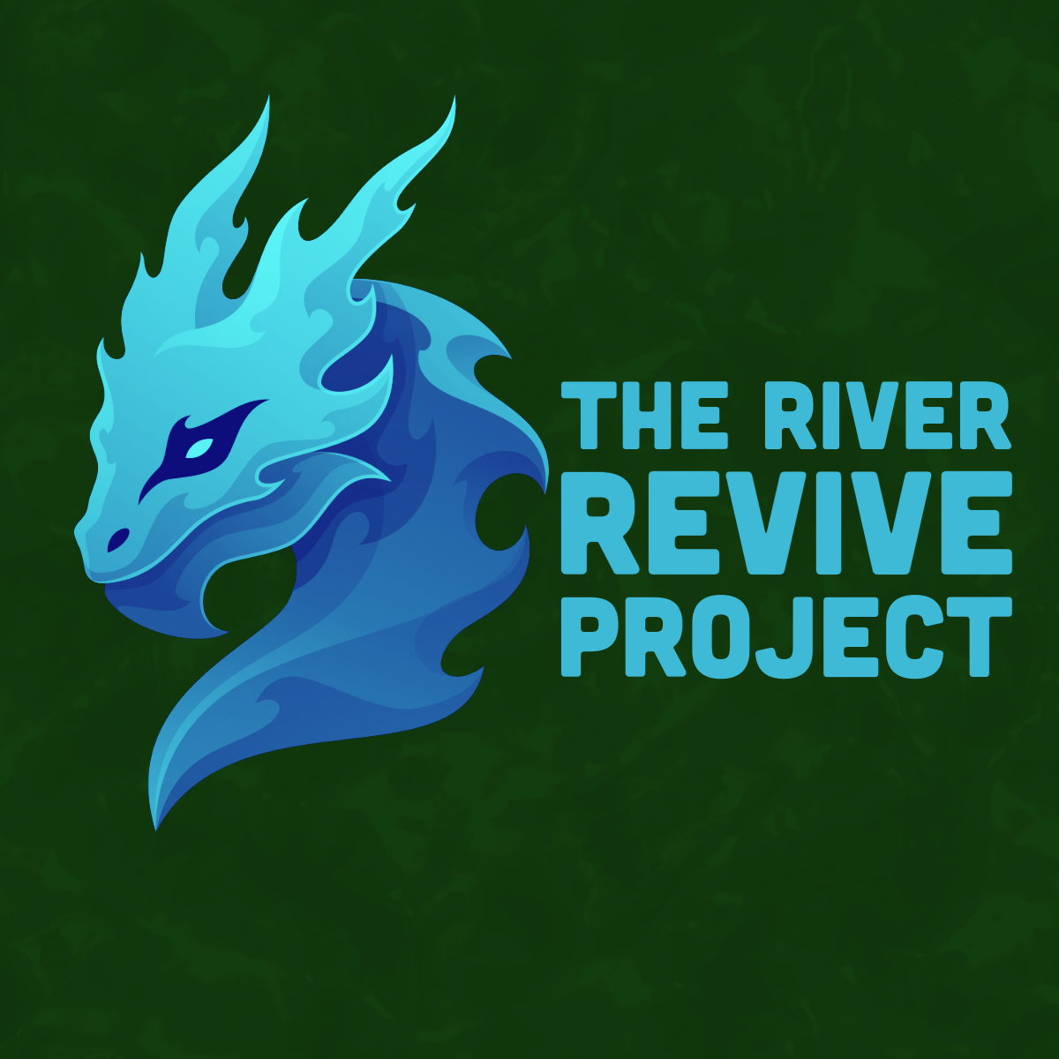
John Muir Award! Lauren, Mia, Hedd.

“Pollution of rivers by slurry is a major problem for rivers in Wales, in particular the iconic rivers Towy and Teifi in West Wales, home to once thriving but now rapidly declining salmon and sea trout populations.”

“River Towy was polluted by sewage 716 times in 2023 - lasting 4,186 hours or 166 days.”

“The River Towy is a 75-mile river that originates in the Cambrian Mountains and flows into Carmarthen Bay.”

- The river Towy is one of many bodies of water that is polluted in Wales, we want to focus on how to clean the river up and implement a structure to avoid further pollution, to then repeat the process in other polluted areas!
- We plan to work with ‘Surfers against sewage' who are a great charity who work towards cleaning up water and bringing the issue of pollution to the attention of the public.
- If we wanted to go ahead with our plans we would need to speak to correspondents in the city council in Llandeilo, Llandovery, Abergwili since the river goes through those three cities.
- Our plan is to get rid of the rubbish in the river and cut the sewage off at the source, since the sewage mainly comes from: wastewater treatment works, sewage pumping stations, foul sewers and stormwater. We would like to challenge this by raising the issues with the local council and get bigger restrictions on the allowance of sewage and pollution in our rivers and seas.
- For the pollution in the river we plan to have days where we pick the rubbish and with the permission from we also want to add ‘The great bubble barrier’ which is a cleverly designed contraption that can catch rubbish as it floats down the river but does not affect the natural wildlife that live in the river.
- For documenting our journey we plan to wear ‘gopro’ style cameras to capture the river picking process. We also want to interview some local charity workers, volunteers and experts about the pollution issue in wales. Itd also be great to interview some environmental council workers. We plan to make a short documentary about our project and our process.

We have also created an instagram page ‘@river_revive_project’ where we plan to share our journey and progress to hopefully spread awareness and gain volunteers and donations for future projects.

