Assignment 2
Reflective Essay

Module Name: Project Management

Module code: LCBB5005

Student: Marius Scorcea (1921886)
Lecturer: Prof. Dr. Faizu Edu

Contents
Module Name: Project Management 1
Introduction 3
Google Headquarter London – Project Plan 5
PMBOK and the 10 Knowledge area in Project Management 6
CONCLUSION 12
REFERENCES 12

Introduction
This assignment is a Reflective Essay and the topic that I will reflect upon is Google Headquarters Project, after previously, in the first assignment I had to critically evaluate the Google Headquarters Project in London, UK.
To make sure that the Reflection serve its purpose it needs to be approached in an academic way, following certain steps according to a Reflective cycle.
For this essay I chose to use Kolb’s reflective Cycle as it is a complex cycle in which ,,all the bases are touched’’ and the learning experience is effective.
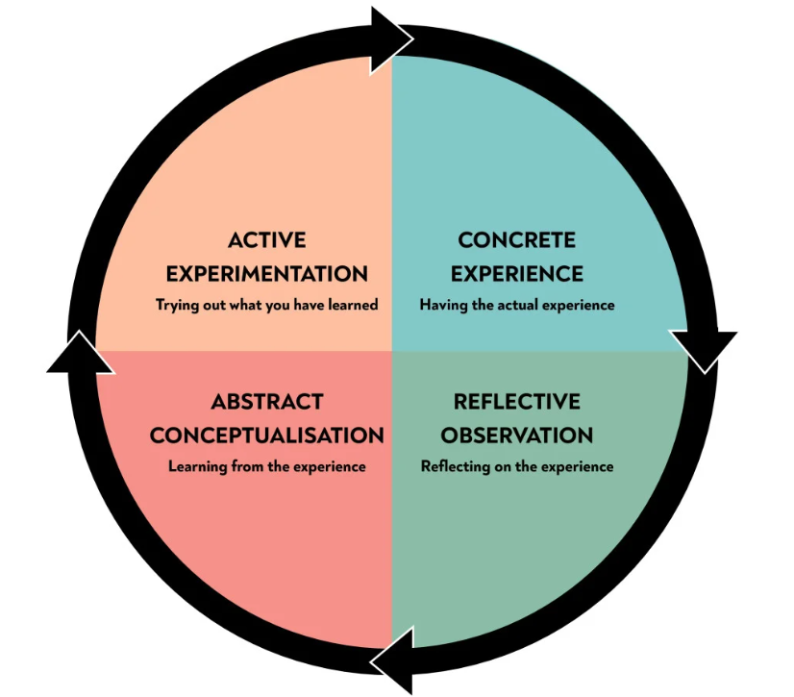
https://www.simplypsychology.org/learning-kolb.html

Google Headquarters London project is a complex project where all 10 knowledge areas of PMBOK were identified, and they led to the success of the project.
Planning, scheduling, tracking, delivering – all these steps were followed effectively by the project managers.
As a coursework it is a good opportunity for us, the students, to identify essential skills which may contribute to our success as future managers.
Reflection will help us evaluate how successful the project was, which lessons can be learnt from the whole process and how we can enlighten others regarding the approach they should have towards projects like Google Headquarter London. (Landau, 2023)

Google Headquarter London – Project Plan
As previously said, the topic of this reflection essay is Google Headquarter London, UK.
This adventure started at the beginning or 2018 and it is a huge project that involves over 7000 people, and it is built on 650,000 ft. The whole complex is supposed to be entirely delivered at the beginning of 2024.
An ambitious project which gathers under its umbrella the bests of the best: Thomas Heatherwick Studios and Danish architect Biarke Ingels.
Looking at this project from a future project manager perspective I could identify all the essential steps that are taken to start a project and here I have to mention the PMBOK 10 knowledge areas.
The Project Management Institute (PMI) published the PMBOK (Project Management Body of Knowledge), which is a collection of best practices, standard project management terminologies, and procedural concepts. The PMBOK, which is currently in its sixth edition, has developed throughout time and has become known as an accurate guide for project managers globally. The PMBOK defines 49 procedures that are separated into 10 knowledge areas and 5 process groups within a matrix structure. (Lewis, 2018)
This was completely new for me, first time I came across PMBOK concept, and it helped me understand and see Google Headquarters project through a project manager eye.
I discovered that according to the PMI’s PMBOK Guide, a project management life cycle is made up of five stages:
1. Start
2. Plan
3. Execute
4. Monitor
5. Close
These stages work together to turn a project concept into a working product. (Kissflow. 2023)
All these stages are interdependent, you can’t go to the next one without completing the previous one.

PMBOK and the 10 Knowledge area in Project Management

As the first assignment was based on a study case – Google Headquarters UK – I must mention that I the access to information was not facile. There are not detailed facts about the projects, I had to gather data from various websites but I hope I manage to introduce the essence of the project, its importance and its main benefits that are brought to British business environment.
I cannot approach this project in a reflective manner without making references to the 10 Knowledge areas which are included in PMBOK.
- Project Integration Management
This is the part of the project that presenting the main stakeholders and gathers facts and procedures that will be utilize in the development of the project.
Google Hq London hired Biarke Ingels and Thomas Heatherwick to design the London campus and after two years they could present their planning application to Camden Council to build an enormous rooftop garden, a swimming pool and a running track. (Dezeen, 2017)
This Project Integration Management is split in 7 other processes:
  - Project charter development
  - Bringing forward project management plan
  - Project work management
  - Project knowledge management
  - Project work monitor and control
  - Integrated change control activities
  - Project closure
I understood that every detail in this area is determining in fact the outcome of the project.
- Second area is Project Scope Management.
Now is the moment to develop the plan for the project setting up the tasks and the order to be fulfilled. The cost is estimated and also the progress of the plan is assessed.
For Google HQ London, the cost of the project was estimated at 1 billion pounds.
According to UK Google representant Ronan Harris the purpose of the Google development is to refresh the work environment, and it is a statement of their belief in the future of the office as an ideal place of work. (McCulloh, 2022)
- Project Time Management
Before this project I always looked at time management as an important feature of management. And I linked this mainly to organizing and prioritizing tasks.
After this class, I can say that I will become a wiser manager as I understood that time management itself can be considered as a project through which the job is analysed and as a result a timeline for delivering the project is set up. It goes further than this at it is done across a 6 steps project:
- Define Activities – establish what tasks need to be perform in order to complete the project,
- Split the activities – the order of the task’s performance is established, so are the deliverable.
- Resources estimation – the deliverable are produced based on the resources that are required and this is the moment when they are analysed
- Appreciate duration – the timeline frame for the project completion will be set up after each task duration is approximated.
- Schedule development – based on all the above a project schedule will be created.
- Schedule control – as all the projects implies risks and changes on the way a strategy is needed to address eventual issues.
Google HQ London project managers made sure that all these steps were fulfilled and also that every stakeholder involved in the process contributed with accurate data so that the estimation is correct. (Dickerson, 2021)
- Project Cost Management
This step is related to the budget of a project allocated at the beginning. But more than this it involves tracking expense4s and looking for solutions to minimize costs and maximize the resources.
As previously was said, Google HQ London benefited of a generous budget of one billion pounds which is not a surprise considering the location and the reputation of the companies that were hired to complete the project.
- Project quality Management
Project quality management is the process of understanding and breaking down a project’s approach to achieving the quality levels required for the project’s overall success. It’s a process that project managers use to measure and evaluate the quality of the general quality of the work being produced and the procedures included in a project to make sure the quality standards are being met. Before the project begins, teams typically establish quality guidelines. These guidelines are used to set deliverable milestones and measure the quality of the work. If project managers aren’t meeting their quality goals, they may use project quality management to modify specific project components to make sure they meet quality standards. (Indeed Editorial Team, 2022)
Analysing Google HQ London project, I can say that the quality standards are very high. Designed by the Heatherwick Studio and Bjarke Ingels Group, no efforts were spared in delivering a project that is truly amazing.
From the Building Information Modelling (BIM) technologies to the air displacement ventilation and the electrical network, the timber-steel panels, all were proof that the quality of the project was not neglected.
I think that for a project Manager, especially if you are involved in delivering a masterpiece like this one, staying close and observing if the quality standards are followed and achieved, this will become his business card, it is conferring credibility and appreciation on the labour market.
- Project resources management
To optimise utilisation and maximise the value of the project's components, resources such as people, machinery, technology, and facilities must be planned, scheduled, and managed as effectively as feasible.
A resource is anything or all that can be planned or allocated to complete a job or project. Depending on the industry, resources can vary. Most of the time, reusable resources are involved in resource planning and scheduling. This can include your workforce’s unique skill set, as well as other human resources, or it could be a non-human resource such as computers, equipment, space, cars, and so on.
By planning and managing your resources, you can ensure that all of them are being used effectively, on time, and within your budget. This can help boost your team’s productivity, reduce stress, and reduce overtime. (Ganttic, 2019)
From the information provided about this project, I could see that Google HQ London was creating around 7000 work places. On top of this all the equipment’s, computers, furniture used which are considered resources as well.
It is a big job that needs supervising considering that resources managements are closely related to the budget provided, budget that needs to be respected.
- Project Communication Management
Communication is an important aspect in any area, moreover, considering a project of Google HQ London dimensions.
There is communication with stakeholders and between stakeholders that needs to be ensured, the information needs to be provided in time and has to be opened.
That is why a project manager needs to make use of all the communication channels he has at his disposal, making sure that he can address any conflicts among the team members or between stakeholders.
- Project Risk Management
This was entirely a new concept for me in terms of management. I always knew that there is a risk management which implies a contingency plan, but the quantitative risks analysis related to the project and using project life cycle to monitor the risks brought a different perception towards the skills that a manager should possess.
In our study case, Google faced a lot of risks. The idea of the project was materialised in 2016, it was literally put in practice starting with 2018 and if we consider COVID-19 and Brexit, the pressure was as huge as the project.
- Project procurement management
“Project Procurement Management includes the processes necessary to purchase or acquire products, services, or results needed from outside the project team.” (PMBOK Guide, 6e).
The process of deciding how to obtain resources to carry out a project and putting those decisions into action is known as project procurement management. Put otherwise, it is up to you to choose whether to purchase those materials, equipment, or services from outside suppliers through a contract, lease, or purchase. Keeping positive working connections with suppliers is another way to guarantee supply chain continuity.
Google HQ London supply chain was ensured especially by BIM Technologies which worked closely with design team and the Main Contractor to make sure they are facilitating and meeting Google HQ requirements.
10. Project stakeholder Management
Stakeholders are the people who have a stake in the outcome of the project. Stakeholders typically include project sponsors, project executives, consumer stakeholders, users, and project team members. Stakeholders are people who will be affected by the project at every stage of its development, and their opinions will have a direct effect on the outcome. Effective management of stakeholders and regular communication are key to working together on the project.
In Google London Hq we have the main stakeholder – Google which invested 1 billion pounds.
Then we have the Camden Council which had to give the project’s ,,good to go’’ and they were pleased to do so as Google is bringing a ,,fresh air’ into the area business environment. Considering the gorgeous architecture, the shops and coffee shops that are part of the Gallery, the workplaces for almost 7000 people, Google Hq is a project that will add value to Camden area.
Other stakeholders are all the companies involved in the delivery of the project, the construction company, the architects, the landscapers from Gillespie etc.

CONCLUSION
Going through all these Project Management knowledge Areas, Google HQ London is a complex project that can serve as a valuable lesson for future projects. The amount of resources that it used, the value of the investment, the challenging economical and political climate, see Brexit and Covid-19 – all comes with lessons to be taught.
For me, personally, this project came with a lot of new information, terms, procedures.
And being aware of my skills, I realized that I need to improve, especially when analysing and critical evaluating a project and the steps that needs to be followed to complete and deliver a successful project.
Starting with the first phase of the project, initiation and planning and ending with the stakeholder management, every step needs attention to the smallest details.
Being a project manager is like you gather all the management roles and put them into the same hat and the only way to wear this hat is to invest in yourself, in studies, classes as Project Management is becoming a real science.

REFERENCES

‌Anon, (2021). What is Project Procurement Management? | Xebrio., Available at: https://xebrio.com/project-management-guide/faq/what-is-project-procurement-management/, (Accessed: 22 December 2023).
BIM.Technologies. (n.d.). KGX1 - New Google London HQ, Available at: https://bimtechnologies.co.uk/projects/kgx1-new-google-london-hq, (Accessed: 19 December 2023).
Dezeen. (2017). Google finally reveals its plans for London HQ by BIG and Heatherwick. [online] Available at: https://www.dezeen.com/2017/06/01/google-finally-reveals-plans-london-hq-big-heatherwick-architecture-news/, (Accessed: 19 December 2023).
Henderson, L. (2023), 10 Key Project Management Knowledge Areas (PMBOK), Available at: https://niftypm.com/blog/project-management-knowledge-areas-pmbok/, (Accessed: 19 December 2023).
Dickerson, S. (2021). Project Time Management: Strategies, Tips & Tools, Available at: https://www.projectmanager.com/blog/project-time-management-strategies, (Accessed: 21 December 2023)
Ganttic (2019), What Is Resource Management And Why Should You Care? – Ganttic, Available at: https://www.ganttic.com/blog/what-is-resource-management, (Accessed: 22 December 2023).
Indeed Editorial Team (2022), What is Project Quality Management? (tools and benefits), Available at: https://uk.indeed.com/career-advice/career-development/project-quality-management, (Accessed: 22 December 2023).
King’s Cross, (n.d.) Google - King’s Cross. Available at: https://www.kingscross.co.uk/google, (Accessed: 21 December 2023).
Kissflow (2023). 5 Phases of Project Management Process | Kissflow Project. Available at: https://kissflow.com/project/five-phases-of-project-management/#:~:text=According%20to%20the%20PMBOK%20Guide, (Accessed: 21 December 2023).
Landau, P. (2023) The 10 Project Management Knowledge Areas (PMBOK), ProjectManager, Available at: https://www.projectmanager.com/blog/10-project-management-knowledge-areas, (Accessed: 23 December 2023)
Lewis, S. (2018). What is Project Management Body of Knowledge (PMBOK)? - Definition from WhatIs.com., Available at: https://www.techtarget.com/whatis/definition/Project-Management-Body-of-Knowledge-PMBOK, (Accessed: 21 December 2023).
McLeod, S. (2023), Kolb’s Learning Styles and Experiential Learning Cycle, Available at:
https://www.simplypsychology.org/learning-kolb.html, (Accessed: 23 December 2023)
McCulloch, A. (2022). Google adds London offices and aims for 10k headcount, Available at: https://www.personneltoday.com/hr/google-adds-london-offices-and-aims-for-10k-headcount/#:~:text=Google%20has%20purchased%20a%20further, (Accessed 21 December 2023)
Partridge, J. (2020). Google commits to vast London office despite rise of remote working. The Guardian, Available at: https://www.theguardian.com/technology/2020/jul/28/google-commits-to-vast-london-office-despite-rise-of-remote-working, (Accessed: 21 December 2023).
Wrike (2019). What is a Stakeholder in Project Management?, Available at: https://www.wrike.com/project-management-guide/faq/what-is-a-stakeholder-in-project-management/, (Accessed: 19 December 2023).

