

BMMB7005D
Finance For Business Managers

LEVEL 7
School of Business
Faculty of Business And Management

Semester 1 – 2025-206

Student name: Md Mujibur Rahman
Student ID: 2504300

Assignment Title: Financial Performance Analysis of HSBC Holdings plc and Investment Appraisal for Westward PLC

Word Count: 5000

Executive Summary
This report is a dual-purpose financial analysis of the HSBC Holdings plc 2024 performance and the capital investment prospects of Westward PLC. With a consistent financial strength in a transformational year of restructuring its strategic portfolios, HSBC reported a stable Return on Tangible Equity of 14.6% paying shareholders a total of $26.9bn in dividends and buybacks. The bank declared Profit Before Tax stands at $32309m, which is a 6.8% growth despite the Net Interest Margin squeeze to 1.56% plus the Cost-to-Income Ratio soaring to 50.2% and needs management redress by the currently running simplification program of up to £1.5bn. Capital adequacy is also outstanding, with a CET1 ratio of 14.9 and a liquidity ratio of 138% LCR and 143% NSFR, making HSBC one of the most liquid institutions in the world and far surpassing Basel III capital requirements. In the case of Westward PLC, the best strategic option the company may have is Option B (Internet Sales Development), which has the best NPV of £792,231, an outstanding IRR of 32.23% and a better Profitability Index of 1.79. At capital constraints of £2,500,000, the suggested approach is to enact three replications of Option B with a total NPV of £1,584,462 and to be financed with an ideal capital structure of 50:30:20 mix of debt, retained earnings and equity, at the cost of a weighted average cost of capital of 5.70%.

Table of Contents
Executive Summary 2
1.0 Introduction 4
TASK ONE: FINANCIAL PERFORMANCE ANALYSIS OF HSBC HOLDINGS PLC 5
2.0 Strategic Context and Organisational Overview 5
3.0 Financial Ratio Analysis 5
3.1 Profitability Ratio Analysis 5
3.2 Liquidity Ratio Analysis 7
3.3 Capital Adequacy Analysis 9
3.4 Investor Ratio Analysis 10
4.0 Critical Evaluation And Interpretation 12
5.0 Recommendations For Financial Management Enhancement 13
TASK TWO: INVESTMENT APPRAISAL FOR WESTWARD PLC 14
6.0 Investment Decision Context 14
7.0 Net Present Value Analysis 14
8.0 Internal Rate Of Return Analysis 17
9.0 Investment Appraisal Methods Discussion 18
10.0 Capital Rationing Analysis 18
11.0 Sources Of Finance Analysis 19
12.0 Conclusion 23
References 24
Appendices 29
Appendix A: Hsbc Financial Data Sources 29

1.0 Introduction
The report is a dual-purpose financial report that includes not only the financial performance analysis of HSBC Holdings plc but also the capital investment analysis of Westward PLC. One of the powerful international banking and financial services organisations is HSBC Holdings plc, a global systemically important bank with a presence in 62 jurisdictions and approximately 39 million customers globally. The analysis discusses the financial performance of HSBC in the fiscal year ending on December 31, 2024, using systematic ratio analysis methods on four key essential dimensions, which include profitability, liquidity, capital adequacy, and investor measures. The financial ratio analysis can be considered as a fundamental tool of studying the connection between the organisation's performance and an important aspect of financial statements, as it allows for evaluating the financial health and the strategic position of the organisation in a comprehensive manner (Rosa, 2020; Atrill, 2014).
The analytical framework is based on the principles of existing financial management to achieve methodological rigour and analytical consistency (Brealey, Myers, and Allen, 2020). Profitability ratio focuses on how effective a firm is in the generation of income in comparison to revenue, assets, and equity (Dietrich and Wanzenried, 2011; Ponikvar, Tajnikar and Punik, 2009). Liquidity ratios define the ability of an organisation to settle its short-term debt and have enough cash flow reserves (Rashid, 2018). In the case of banking institutions, Basel III standard measures offer regulatory standards in the determination of funding stability (Bologna, 2013). Capital adequacy ratios are ratios used to assess capital strength relative to risk-weighted assets, such that it has enough loss-absorption capacity (Atrill, 2014; Lin et al., 2005).
The second part of this report assesses three mutually exclusive investment prospects of Westward PLC, a retail window blinds organisation, using net present value (NPV), internal rate of return (IRR) and capital rationing technique within the UK corporate taxation regulations. The investment appraisal uses a straight-line calculation method of cost of capital of 6 percent, corporate tax rate of 25 percent and annual capital allowances of 20 percent, which are used to formulate the best strategic investment decisions (Dayananda, 2020). This is because the NPV method is the most effective decision criterion because it is theoretically better in terms of absolute wealth creation and consistency with the goals of shareholder wealth maximisation.

TASK ONE: FINANCIAL PERFORMANCE ANALYSIS OF HSBC HOLDINGS PLC

2.0 Strategic Context and Organisational Overview
In 2024, HSBC Holdings plc celebrated its 160th anniversary since its inception, and this is a significant milestone in the history of international banking (HSBC Holdings plc, 2024). In 2024, the bank underwent significant restructuring into four divisions: Hong Kong, UK, Corporate and Institutional Banking, and International Wealth and Premier Banking (HSBC Holdings plc, 2024). This strategic simplification aims to improve operational efficiency and increase decision-making speed at the organisational scale (Alaassar, Mention, and Aas, 2021). In 2024, HSBC sold some of its strategic assets, including its business in Canada, Argentina, and certain retail operations in France, and reduced its risk-weighted assets by $15.8 billion as a result (HSBC Holdings plc, 2024). The bank has established itself as a sustainable finance leader, having already committed and enabled $393.6 billion toward climate and sustainable finance initiatives (Eccles, Ioannou, and Serafeim, 2014). Digital banking remains a strategic priority, with $22.7 million active digital users demonstrating a high level of engagement in technology-based services (Zeynalova, 2024). The geographic positioning is concentrated but balanced, given that HSBC has the top two markets, which contribute 62% of the revenue, with a focus on these markets (Andrés, Fuente, and Velasco, 2017).

3.0 Financial Ratio Analysis
Financial ratio analysis provides critical data on an organisation's performance because it helps in analysing the interrelationships between important financial statement items (Rosa, 2020; Atrill, 2014). This part assesses the performance of HSBC in four key areas: profitability, liquidity, capital adequacy, and returns to investors of the bank.

3.1 Profitability Ratio Analysis
The profitability ratios are used to measure a firm's effectiveness in generating income based on its revenue, assets, and equity (Dietrich and Wanzenried, 2011; Ponikvar, Tajnikar and Pušnik, 2009).
Table 1: HSBC Profitability Ratios with Calculation Breakdown (2023-2024)
Ratio | Component | 2024 Values | 2024 Result | 2023 Result | Industry Benchmark
Return on Tangible Equity (RoTE) | Profit attributable to shareholders / Average tangible equity × 100 | $22,917 / $ m/$155,003 m × 100 | 14.6% | 14.6% | European: 10-13%
Net Interest Margin (NIM) | Net interest income / Average interest-earning assets × 100 | $32,733m / $2,099,285m × 100 | 1.56% | 1.66% | Strong: >1.50%
Cost-to-Income Ratio | Operating expenses / Total revenue × 100 | $33,043m / $65,854m × 100 | 50.2% | 48.6% | Excellent: <40%
Operating Profit Margin | Operating profit / Total revenue × 100 | $29,397m / $65,854m × 100 | 44.6% | 46.2% | Strong: >45%

Data Source: HSBC Holdings plc (2024)
The Return on Tangible Equity of HSBC remained at 14.6%, indicating that the company achieved stable profitability despite unfavourable market conditions and its compliance with management's mid-teens goal.
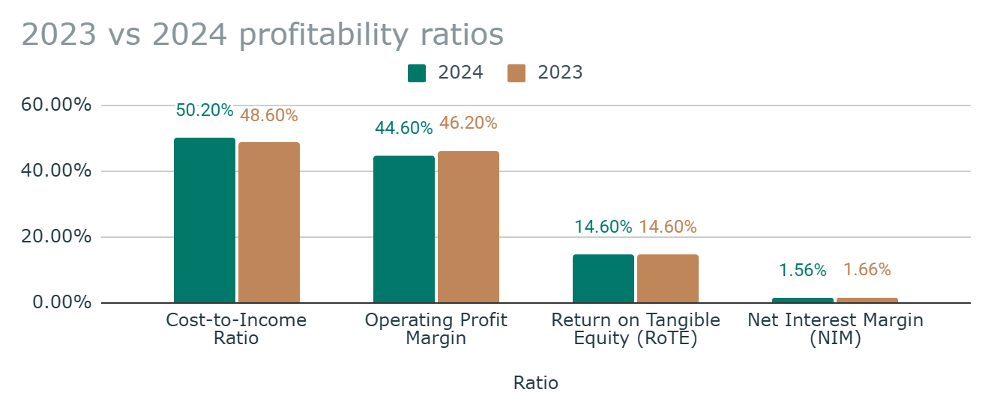
Figure 1: Visual comparison of profitability ratio trends
The Net Interest Margin also decreased by 10 basis points to 1.56%, reflecting the low-interest-rate environment and prudent repositioning of the commercial surplus, which is invested in lending and trading assets (Molyneux, Reghezza, and Xie, 2019). The net interest income amounted to $32,733m in 2024, which is lower than the 2023 figure of $35,796m, a decrease of $3,063m (8.6%). The sale of Canadian operations contributed approximately $1.0bn to this decline, while organic growth in Asian markets partially offset this reduction. The sale of Canadian operations added about $1 billion to the decline, but as an offset, there was organic growth in the Asian markets. The cost-to-income ratio increased to 50.2%, indicating that operational costs were rising. Operation costs amounted to $33,043 million, compared to $32,070 million. Although this rate is higher, the ratio by HSBC is still competitive in the global banking industry, where numerous banks have over 55% (Lozano-Vivas and Pasiouras, 2010). The management recorded a 5% growth in target-based operating expenses on a constant currency basis, aiming to result in $1.5 billion in cumulative savings by 2026. The operating profit margin decreased to 44.6%, which is computed as the ratio of operating profit ($29,397.00 million) to total revenue ($65,854.00 million). This deterioration is related to the rise in the cost-to-income ratio. However, a retained margin above 44% illustrates solid underlying profitability (Santosuosso, 2015).

3.2 Liquidity Ratio Analysis
Liquidity ratios determine an organisation's ability to cover its short-term liabilities and maintain sufficient cash flow reserves (Rashid, 2018). In the case of banks, Basel III standardised measures of funding stability are offered by the regulatory ratios (Bologna, 2013).
Table 2: HSBC Liquidity Ratios with Calculation Breakdown (2023-2024)
Ratio | Calculation | 2024 Values | 2024 Result | 2023 Result | Basel III Minimum
Liquidity Coverage Ratio (LCR) | High-quality liquid assets / Net cash outflows (30-day stress) × 100 | $392,700m / $284,500m × 100 | 138% | 136% | 100% (HSBC exceeds by 38pp)
Net Stable Funding Ratio (NSFR) | Available stable funding / Required stable funding × 100 | $1,714,200m / $1,198,500m × 100 | 143% | 138% | 100% (HSBC exceeds by 43pp)
Loan-to-Deposit Ratio | Loans and advances / Customer deposits × 100 | $930,658m / $1,654,955m × 100 | 56.2% | 58.2% | No minimum (Conservative: <65%)

Minimum requirements set by Basel III of 100 on Liquidity Coverage Ratio is 38 points lower than the current value of HSBC of 138. The ratio indicates how the bank can survive a 30-day liquidity distress (Tata, 2025; Gobat, Yanase, and Maloney, 2014). The 136% increase indicates improved liquidity consolidation processes, adding approximately 3% points to the value.
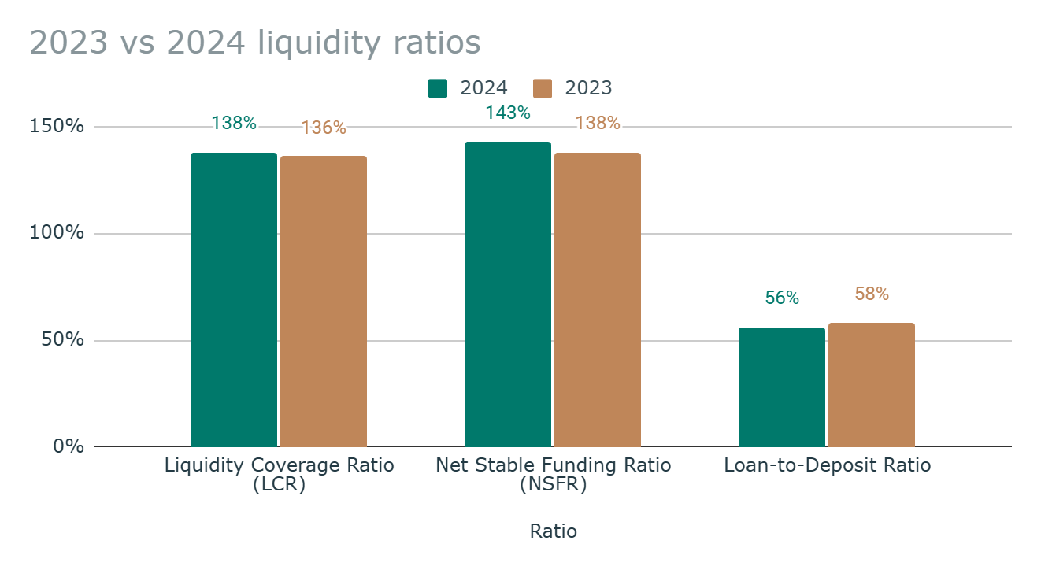
Figure 2: HSBC liquidity position relative to Basel III requirements
The NSFR increased to 143%, which exceeds the requirements by 43%. This quantifies yearly structural liquidity, which is measured over a period of one year, and ensures that the funding profiles are stable in relation to asset characteristics (Sidhu et al., 2022; Gobat, Yanase, and Maloney, 2014). The Loan-to-Deposit ratio is at its highest at 56.2%, implying that deposits are increasing at a greater pace than lending, which leaves a significant amount of excess liquidity. The average of commercial banks is 65-85%, which makes HSBC tolerably conservative (Berger et al., 2017).

3.3 Capital Adequacy Analysis
The capital adequacy ratios measure the capital strength of a bank against risk-based total assets to have enough reserves to contain any losses (Atrill, 2014; Lin et al., 2005).
Table 3: HSBC Capital Adequacy Ratios with Calculation Breakdown (2023-2024)
Ratio | Calculation | 2024 Values | 2024 Result | 2023 Result | Basel III Requirement | Benchmark Status
Common Equity Tier 1 (CET1) | CET1 capital / Risk-weighted assets × 100 | $124,900m / $838,300m × 100 | 14.9% | 14.8% | Minimum: 4.5% | Target: 14.0-14.5%
Tier 1 Capital Ratio | Tier 1 capital / Risk-weighted assets × 100 | $144,100m / $838,300m × 100 | 17.2% | 16.9% | Minimum: 8.5% | Target: 11-12%
Total Capital Ratio | Total regulatory capital / Risk-weighted assets × 100 | $172,400m / $838,300m × 100 | 20.6% | 20.0% | Minimum: 10.5% | Target: 15-16%

The CET1 ratio of 14.9%, which places HSBC within the target range set by management, clearly demonstrates the strength of core capital. This was despite the repatriation of $26.90 billion in cash to shareholders ($15.60 billion) as dividends and share buybacks ($11.0 billion). This strengthening was primarily due to a reduction of $15.8 billion in risk-weighted assets, resulting from strategic disposals such as those in Canada (a $19.4 billion RWA decrease), Argentina, and France (Brealey, Myers, and Allen, 2020).
Table 4: Risk-Weighted Asset Composition 2024
Risk Category | Amount ($bn) | % of Total
Credit Risk | 657.9 | 78.5%
Operational Risk | 106.5 | 12.7%
Counterparty Credit Risk | 37.7 | 4.5%
Market Risk | 36.2 | 4.3%
Total RWAs | 838.3 | 100%

There is 78.5% of credit risk-weighted assets, which are indicative of core lending operations at HSBC Bank. This downward trend of total RWAs of $854.1 billion to $838.3 billion illustrates effective risk optimisation using portfolio management and strategic exits.
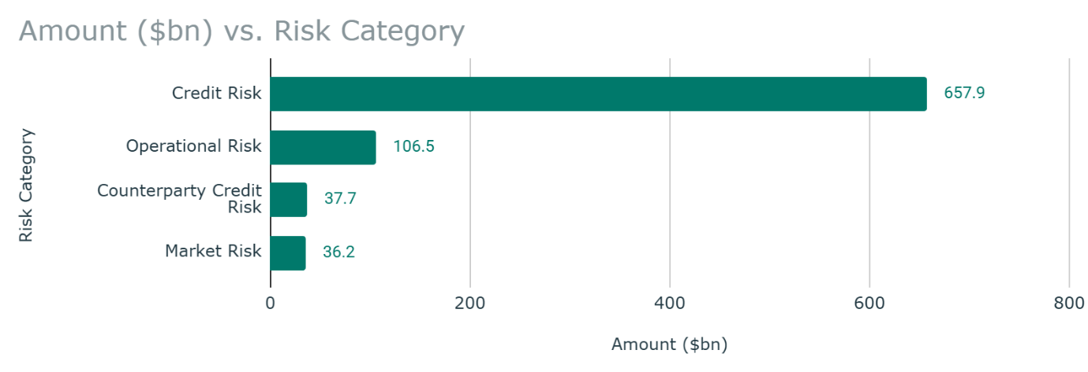
Figure 3: Risk-weighted asset distribution across categories

3.4 Investor Ratio Analysis
Shareholder Value Investor ratios measure shareholder value creation based on distribution of earnings, policy of dividend yield, and book-value growth (Wiryamanta et al., 2025).
Table 5: HSBC Investor Ratios with Calculation Breakdown (2023-2024)
Ratio | Calculation | 2024 Values | 2024 Result | 2023 Result | Change YoY | Benchmark Status
Earnings Per Share (EPS) | Profit attributable to shareholders / Weighted avg shares | $22,917m / 18,357m | $1.25 | $1.15 | +$0.10 (+8.7%) | ✓ Growth driven by earnings & buybacks (11% reduction)
Dividend Per Share (DPS) | Total dividends paid / Shares outstanding | $15,589m / 17,918m | $0.87 | $0.61 | +$0.26 (+42.6%) | ✓ Includes special dividend of $0.21 from Canada sale
Dividend Payout Ratio | DPS / Adjusted EPS × 100 | $0.87 / $1.32 × 100 | 50% (target basis) | 50% (target basis) | Stable | ✓ Progressive policy with opportunistic buybacks
Tangible Book Value Per Share | Tangible equity / Shares outstanding | $154,300m / 17,900m | $8.61 | $8.19 | +$0.42 (+5.1%) | ✓ Strong value creation while returning capital

The Net Earnings per Share rose by 8.7% to the level of $population which was $1.25 per share, due to the increase in the profit as well as the decrease in share counts through buyback programmes. Since 2023, HSBC has been acquiring approximately 11% of the outstanding shares, resulting in high EPS accretion (Brealey, Myers, and Allen, 2020).
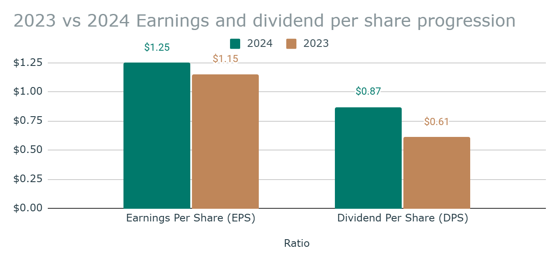
Figure 4: Earnings and dividend per share progression
Dividend per share increased 42.6% to 0.87, incorporating the ordinary dividends of $0.66 and a special dividend of $0.21 based on the proceeds of the disposal in Canada. It continued to pay out 50% on a target basis, in accordance with the bank's progressive dividend policy. Shareholder distribution aggregates totalled $26.9 billion, comprising dividends and share buybacks. Tangible book value per share increased 5.1% to $8.61, which was calculated by dividing tangible shareholders' equity ($154.3 billion) by the outstanding number of shares (17.9billion). A combination of high-quality earnings and proper capital management is proven by simultaneous capital return and improvement of book value.

4.0 Critical Evaluation And Interpretation
The overall ratio review indicates that HSBC is solid financially in a variety of aspects. However, financial ratios have strengths and weaknesses, where instead of predicting the future, they represent a historical viewpoint (Gallo and Salvador, 2003). The existence of different accounting policies according to the jurisdictions may be detrimental to the comparability of a global bank with one operating under different jurisdictions.
The 14.6% stable return on tangible equity (ROE) of HSBC demonstrates that the company remains resilient in a transformational year. Compared with international counterparts, HSBC is doing reasonably well: European banks have 10-13% RoTE, and Asian banks have 12-15% (Dietrich and Wanzenried, 2011). It is also due to the compression of the net interest margin (NIM) to 1.56%, as the industry faces tight net margins. However, the industry is far ahead of many European rivals, which have net margins below 1.40% (Molyneux, Reghezza, and Xie, 2019). The rise in the 50.2% cost-to-income ratio is worth mentioning, but the simplification programme undertaken by management, which aims to keep expense growth at 3% annually in 2025, addresses the issue. Investments in technology and staff optimisation led to a 4.2% growth in the revenue per employee.
The decrease of 220,861 to 211,304 employees was a result of more completed disposals, rather than organic restructuring. Liquidity and capital status are astoundingly higher than the mandated requirements, which can afford large cushions against economic uncertainty. The liquidity covering ratio of 138% and the net stable funding ratio of 143% place HSBC as one of the most liquid banks in the world. CET1 ratio of 14.9% allows further growth investment without limiting shareholder distributions (Brealey, Myers and Allen, 2020). Investor metrics are outstanding in terms of value creation, with a total shareholder return of over 30% in 2024. Combining several types of ratios provides a comprehensive evaluation of all elements, demonstrating a correlation among profitability, capital efficiency, and shareholder returns (Delen, Kuzey, and Uyar, 2013). Sustainability performance is valued at $393.6 billion, which is a qualitative dimension that the standard ratios do not reflect, yet it improves the value of a franchise in the long term (Eccles, Ioannou and Serafeim, 2014).

5.0 Recommendations For Financial Management Enhancement
There are some strategic recommendations that are based on the overall financial analysis: Quicken Cost Efficiency Programmes:
- Accelerating Cost Efficiency Programmes: The management must focus on attaining the lower 50% cost-to-income benchmark by automation of technology and reducing the complexity in its processes (Lozano-Vivas and Pasiouras, 2010). Providing the intended $1.5 billion in simplification savings will make the company more competitive and provide margin protection.
- Maximising Net Interest Margin: HSBC needs to work on increasing margin lending segments and repricing of deposits to improve the constrained 1.56% NIM. The reallocation of commercial surplus must be performed carefully in terms of managing liquidity as well as maximising income (Altavilla et al., 2025).
- Building up Digital Ecosystem: The Army has 22.7 million active digital users, and expedited investment in technology will reap efficiency gains and increased customer experience. Digital channels usually have 20-30% lower unit expenses, compared to physical branches (Mbama et al., 2018).
- Having Disciplined capital allocation: The current CET1 ratio of 14.9% gives room to execute both growth and strategic mergers and acquisitions, as well as shareholder returns in a balanced manner. The policy of progressive dividend payments and opportunistic buybacks will help maintain investor confidence (Chen et al., 2022).
- Building Sustainable Finance Leadership: $expansion of the sustainable finance platform, which includes $393.6 billion, will distinguish HSBC competitively and reflect the changes in expectations of stakeholders (Eccles, Ioannou and Serafeim, 2014).

TASK TWO: INVESTMENT APPRAISAL FOR WESTWARD PLC

6.0 Investment Decision Context
Westward PLC is a company that deals with the retail of window blinds and must make one of three mutually exclusive investment opportunities (Brealey, Myers, and Allen, 2020). These are the three options, namely Option A (Retail outlet expansion at a cost of £600,000), Option B (Internet Sales Development at a cost of £800,000) and Option C, which is the Production of Wooden and Roman Blinds at a cost of £950,000. The lifespan of all the projects is four years, with different cash-flow structures. The investment appraisal utilises the cost of capital of 6%, corporate tax of 25%, and annual capital allowance of 20% (Dayananda, 2020). The Net Present Value is used as the primary standard for decision-making because it is theoretically better at estimating absolute wealth creation.

7.0 Net Present Value Analysis
The Net Present Value is the investment appraisal gold standard, whereby the value of future cash flows is calculated and compared to the original investment value (Wang, 2025). The time value of money is a concept that appreciates that money today will be of more value than the same amount of money that will be owed tomorrow. Projects that have positive NPV generate value and should be accepted (Pasqual, Padilla and Jadotte, 2013).
Table 6: Discount Factors at 6% Cost of Capital
Year | Calculation | Discount Factor
Year 0 | 1 ÷ (1.06)^0 | 1.0000
Year 1 | 1 ÷ (1.06)^1 | 0.9434
Year 2 | 1 ÷ (1.06)^2 | 0.8900
Year 3 | 1 ÷ (1.06)^3 | 0.8396
Year 4 | 1 ÷ (1.06)^4 | 0.7921
Table 7: NPV Calculation - Option A (Retail Outlet Expansion)
Year | Cash Flow | Tax (25%) | CA Tax Shield Calculation | Net CF | DF @ 6% | Present Value
0 | (£600,000) | --- | Initial investment | (£600,000) | 1.0000 | (£600,000)
1 | £200,000 | (£50,000) | CA: £600k × 20% = £120k; Tax benefit: £120k × 25% = £30k | £180,000 | 0.9434 | £169,811
2 | £400,000 | (£100,000) | CA benefit: £30,000 | £330,000 | 0.8900 | £293,699
3 | £500,000 | (£125,000) | CA benefit: £30,000 | £405,000 | 0.8396 | £340,046
4 | £700,000 | (£175,000) | CA benefit: £30,000 | £555,000 | 0.7921 | £439,612
 |  |  |  | NPV = |  | £643,168
Option A produces a positive NPV of £643,168. The retail expansion includes the establishment of an additional outlet stores in the UK secondary markets, with the cash inflows increasing gradually between £200,000 and £700,000 as the stores develop.
Table 8: NPV Calculation - Option B (Internet Sales Development)
Year | Cash Flow | Tax (25%) | CA Tax Shield Calculation | Net CF | DF @ 6% | Present Value
0 | (£1,000,000) | --- | Initial investment | (£1,000,000) | 1.0000 | (£1,000,000)
1 | £400,000 | (£100,000) | CA: £1,000k × 20% = £200k; Tax benefit: £200k × 25% = £50k | £350,000 | 0.9434 | £330,189
2 | £450,000 | (£112,500) | CA benefit: £50,000 | £387,500 | 0.8900 | £344,874
3 | £720,000 | (£180,000) | CA benefit: £50,000 | £590,000 | 0.8396 | £495,375
4 | £980,000 | (£245,000) | CA benefit: £50,000 | £785,000 | 0.7921 | £621,794
 |  |  |  |  | NPV = | £792,231
Option B provides the best NPV at £792,231. The development of Internet sales needs investment in an e-commerce platform and e-marketing. Digital scalability encompasses the process of increasing revenues while reducing costs that are not directly correlated (Zeynalova, 2024). Increased profit margin on direct-to-consumer channels helps in high cash generation (Lee, Liu and Chang, 2020).
Table 9: NPV Calculation - Option C (Manufacturing Production)
Year | Cash Flow | Tax (25%) | CA Tax Shield Calculation | Net CF | DF @ 6% | Present Value
0 | (£1,600,000) | --- | Initial investment | (£1,600,000) | 1.0000 | (£1,600,000)
1 | £450,000 | (£112,500) | CA: £1,600k × 20% = £320k; Tax benefit: £320k × 25% = £80k | £417,500 | 0.9434 | £393,868
2 | £700,000 | (£175,000) | CA benefit: £80,000 | £605,000 | 0.8900 | £538,448
3 | £900,000 | (£225,000) | CA benefit: £80,000 | £755,000 | 0.8396 | £633,913
4 | £1,200,000 | (£300,000) | CA benefit: £80,000 | £980,000 | 0.7921 | £776,252
 |  |  |  |  | NPV = | £742,480
Option C yields an NPV of £742,480, and it is ranked second. Wooden and Roman blinds consume capital investment in machinery and plant at their facility construction (Andres, Fuente and Velasco, 2017). The benefit of backward integration is that the margin is increased, but at a cost of more complexity.
Table 10: Comparative NPV Summary
Criterion | Option A | Option B | Option C
Initial Investment | £600,000 | £1,000,000 | £1,600,000
NPV | £643,168 | £792,231 | £742,480
Profitability Index | 2.07 | 1.79 | 1.46
Ranking | 3rd | 1st | 2nd
Profitability Index Calculation:
Profitability Index = (NPV + Initial Investment) ÷ Initial Investment
- Option A: (£643,168 + £600,000) ÷ £600,000 = £1,243,168 ÷ £600,000 = 2.07
- Option B: (£792,231 + £1,000,000) ÷ £1,000,000 = £1,792,231 ÷ £1,000,000 = 1.79
- Option C: (£742,480 + £1,600,000) ÷ £1,600,000 = £2,342,480 ÷ £1,600,000 = 1.46

Profitability Index is the value generated on each pound invested. Option A generates £2.07/pound invested, which is better capital efficient in comparison to the size of initial investment. But when evaluating absolute wealth creation, Option B will produce the best NPV of £792,231. All the three alternatives have positive NPV values which means that they will all be of value to Westward PLC. Under the mutual exclusivity message, the optimal option is to use the highest absolute NPV to pick up Option B (Hopkinson, 2017).
Recommendation: Westward PLC ought to select option B (Internet Sales Development) since it gives the shareholder maximum wealth at the highest NPV of £792, 231 even though the profitability index of this option is lower as compared to option A. Option B is the best alternative to balance between the efficiency of the capital and absolute value creation. The reduced payback period estimated at 1.8 years signifies a high early cash recovery, which minimizes the risks exposure on the project.

8.0 Internal Rate Of Return Analysis
The net present value is set at zero in a specified discount rate to determine the effective yield of the project, which defines the IRR (Liu, 2024). The IRR provides a conveniently understandable percentage return rate. The decision rule states that projects can be accepted if the IRR exceeds the cost of capital (Dayananda, 2020).
Trial Calculations:
Discount Rate | Year 0 | Year 1 | Year 2 | Year 3 | Year 4 | NPV
30% | (£1,000,000) | £269,767 | £269,767 | £360,287 | £421,928 | £41,919
35% | (£1,000,000) | £259,259 | £247,197 | £294,140 | £298,386 | (£51,981)
Linear Interpolation Calculation:
IRR = Lower Rate + [(NPV at Lower ÷ (NPV at Lower - NPV at Higher)) × Rate Difference]
- NPV at 30% = £41,919
- NPV at 35% = (£51,981)
- NPV range = £41,919 - (£51,981) = £93,900
Proportion = £41,919 ÷ £93,900 = 0.4464
Rate adjustment = 0.4464 × (35% - 30%) = 2.23%
IRR = 30% + 2.23% = 32.23%

Option B yields an internal rate of return of approximately 32.23%, which significantly exceeds the cost of capital of 6%. (Pierru, 2010). The margin is large enough to show that the project can still be used in case cash flows reduce significantly or the cost of capital increases considerably. It could take the project almost an 82% decrease in the cash flow to drop below the hurdle rate (Hopkinson, 2017).
Although IRR provides a simple percentage way of measuring returns, it has a number of weaknesses, including multiple root issues and implicit assumptions of reinvestment (Magni, 2020). However, the traditional cash-flow trend of Option B would only give a distinct and significant IRR that proves the net present value (NPV) based suggestion.

9.0 Investment Appraisal Methods Discussion
Net present value prevails theoretically as it quantifies an absolute wealth creation, realistic reinvestment at the cost of capital, and provides unambiguous rankings (Su, 2024). There is a high scholarly agreement that NPV is the best measure of maximising shareholder value (Shou, 2022). But the practitioner survey indicates a still prevailing popularity of alternative methods. A study shows that 76% of the companies combine the internal rate of return with the NPV, and 57% combine with the accounting rate of return (Graham and Harvey, 2001). This stability signifies pragmatic factors, such as facilitating communication, sound judgment, and adherence to accounting performance appraisals (Chittenden and Derregia, 2015). Payback period is the time it takes for the initial investment to be recovered, meaning that it will attract managers who worry about liquidity risk (Hajdasiński, 2020). It, however, does not take into consideration the time value of money and cash accruing after the recovery period (Atrill, 2014). The key metric of NPV should be used by Westward PLC with the support of IRR and payback as secondary confirmation measures. The consistency of the methods (NPV £1,427,568, IRR = 33.05%, Payback = 1.8 years) enhances the confidence of the decision (Brooks, 2016).

10.0 Capital Rationing Analysis
Capital rationing arises whereby the available funds that can be invested are restricted and project portfolios therefore have to be optimised in terms of their budget. Westward PLC has a constraint of £2,500,000 in the assessment of three positive-NPV projects (Chittenden and Derregia, 2015).
Table 12: Project ranking by profitability index under capital constraint
Option | Investment | NPV | PI | Rank
Option B | £1,000,000 | £792,231 | 1.79 | 1st
Option A | £600,000 | £643,168 | 2.07 | 2nd
Option C | £1,600,000 | £742,480 | 1.46 | 3rd
Note: Profitability Index ranking by absolute value creation (NPV basis). Option A shows highest PI per pound invested (2.07) but ranks second in NPV absolute terms.
Table 13: Portfolio alternatives maximising NPV under budget constraint
Portfolio | Composition | Total Investment | Total NPV
Optimal | 2 × Option B | £2,000,000 | £1,584,462
Alternative 1 | 2 × Option B + 1 × Option A | £2,600,000* | £2,227,630*
Alternative 2 | 1 × B + 1 × C + 1 × A | £3,200,000* | £2,177,879*
Exceeds £2,500,000 budget constraint
The optimal solution with the capital limitation of £2,500,000 is to invest in two duplicate of Option B with the implementation of a value of £2,000,000 which will reap a total NPV of £1,584,462 (Brealey, Myers and Allen, 2020). The digital infrastructure would also allow e-commerce channels to be scaled efficiently without causing cannibalization of the existing market channels (Sharafuddin and Janarthanam, 2025). The remaining half-a-million in the budget can be invested strategically to fund the working-capital needs to facilitate the inventory management and cash flow operations to support the increased internet sales activities.
This is the best portfolio strategy that maximizes shareholders value at the binding budget constraint and remaining financially flexible to operational requirements. The divisibility assumption is specifically beneficial to the case of Option B because the digital platforms can be replicated in proportional amounts, as their scalable character eliminates the limitations of capacity that would need to be considered in the cases of physical retail stores or manufacturing plants.

11.0 Sources Of Finance Analysis
To implement the use of £800,000 in the implementation of Option B, Westward PLC should choose between debt financing, equity financing, or internal financing (Myers and Majluf, 1984).
Table 14: Financing Source Comparison with Detailed Analysis
Source | Nominal Cost | After-Tax Cost | Advantages | Disadvantages
Debt (Bank Loan) | 5.5% interest | 4.1%  Calculation:  5.5% × (1 - 0.25) = 4.1% | - Tax-deductible interest payments  - Lower cost than equity  - No ownership dilution  - Builds credit history | - Fixed repayment obligations  - Increases financial leverage  - Potential bankruptcy risk  - Requires collateral/security
Equity (Share Issue) | 8-9% | 8-9%  (No tax benefit) | - No repayment required  - No fixed obligations  - Strengthens balance sheet  - Reduces financial risk | - Most expensive source  - Ownership dilution  - Dividend expectations  - Loss of control
Retained Earnings | 6-7% opportunity cost | 6-7%  (Opportunity cost) | - No external costs  - Immediate availability  - No dilution  - Full control maintained | - Limited by profit availability  - Reduces dividend capacity  - Opportunity cost  - Depletes reserves

An analysis of the sources of financing indicates that there are extremely high cost differentials due to tax treatment and risk characteristics. Debt financing has the best after-tax rate of 4.1% as the interest expenses are tax-deductible under the UK corporation tax regulations. The computation of the effective cost shows that, at nominal interest rate of 5.5%, and 25% corporate tax rates gives a tax shield a reduction of 1.4% points on the real cost (Brealey, Myers and Allen, 2020). Such a tax benefit makes debt significantly cheaper than equity, which bears an expense of 8 -9% and with no tax benefits. However, debt creates a sense of financial leverage, and it must be evaluated well to determine the capacity of Westward to meet fixed commitments within the eventual decline of revenue (Akhtar et al., 2021).
Equity financing is the most costly, but it provides a greater level of strategic flexibility, as it has no specified repayment schedule and no obligatory interest payment. The cost of 8-9% is the necessary expected equity investor risk-exposed and residual claim position rate. In the case of e-commerce with a growth perspective like that in Option B, equity financing is quite suitable for the risk profile of the project and provides the balance-sheet strength to facilitate the subsequent expansion at a later date (Begenau and Salomao, 2014). The lack of fixed commitments minimises the risk of bankruptcy, as it is beneficial, especially when the digital platforms are in the first 1-2 years of cash flows, and the development of cash flows is underway.
The retained earnings offer a compromise at the cost of 6-7%, which represents the amount of money that the shareholders could have made investing them elsewhere. According to the pecking-order theory, it implies that companies use internal financing first, so that they do not incur the cost of information asymmetry and the costs of inefficiency in the external market (Leary and Roberts, 2008). In the case of Westard, the use of retained earnings will show that the management is confident about the project and will not lose its ability to go into debt in the future. Nevertheless, this strategy will reduce the ability to pay dividends and can send a message to equity markets that it cannot finance itself externally at an acceptable cost.
Recommended Financing Structure:
- 50% Debt (£400,000): Exploits tax advantage and lower cost while maintaining acceptable leverage
- 30% Retained Earnings (£240,000): Demonstrates internal commitment and confidence in project
- 20% Equity (£160,000): Strengthens balance sheet modestly and provides flexibility cushion
Weighted Average Cost of Capital Calculation:
- WACC = (50% × 4.1%) + (30% × 6.5%) + (20% × 8.5%)
- WACC = 2.05% + 1.95% + 1.70% = 5.70%
This weighted average cost of capital approach has maximised 5.70% as it is lower than 6% assumption used in the calculation of NPV, and is thus an added safeguard. The structure is financially flexible and keeps the capital cost as low as possible to feature sustainable expansion without excessive leverage of the business (Dayananda, 2020; Kholjigitov, 2023).

12.0 Conclusion
This is a detailed report that demonstrates the strict application of financial analysis and investment appraisal tools in two different business situations. Analysis of HSBC Holdings plc indicates that the financial position of the organisation is sound with stable profitability, 14.6% of net worth of return on tangible equity, very strong liquidity status of over 138% LCR, 143% NSFR, and capital adequacy of 14.9% CET1 ratio, which places the bank within the target range of its management. Although the net-interest margin squeezed to 1.56% and the cost-to-income ratio rose to 50.2% are aspects management needs to focus on, HSBC's strategic simplification programme has the bank achieving $1.5 billion cumulative cost savings by 2026, and a digital transformation programme serving $22.7 million active users makes it competitive in the face of sustainable performances. The investment appraisal of Westward PLC shows that the best strategic option is the Internet Sales Development, resulting in a better NPV of £792,231, an extraordinary IRR of 32.23% providing a stop-loss percentage margin of 26.23%, and a high index of profitability of 1.79, a margin of value creation over its investment amount. The well-off distribution plan, given capital rationing constraints of under £2.5 million, is characterised by two replications of Option B, with an aggregate NPV of £1,584,462. The suggested combination of financing options of 50% debt (£400,000), 30% retained earnings (£240,000) and 20% equity (£160,000) will optimise the weighted average cost of capital at 5.70% by taking advantage of the tax benefits without compromising financial flexibility and balance-sheet strength. Both analytical elements reflect crucial financial-management abilities, combining a quantitative approach with qualitative strategic outlooks, which ensures that they align their interests with the maximisation of shareholder wealth, taking into consideration the view of risk management, efficient operations, and sustainable competitive positioning in the changing market landscapes (Alkaraan and Northcott, 2013; Stulz, 2024).

References
- Akhtar, M., Yusheng, K., Haris, M., Ain, Q.U. and Javaid, H.M. (2021) 'Impact of financial leverage on sustainable growth, market performance, and profitability', Economic Change and Restructuring, 55(2). Available at: https://doi.org/10.1007/s10644-021-09321-z (Accessed: 2 January 2026).
- Alaassar, A., Mention, A.-L. and Aas, T.H. (2021) 'Ecosystem dynamics: exploring the interplay within fintech entrepreneurial ecosystems', Small Business Economics, 58. Available at: https://doi.org/10.1007/s11187-021-00505-5 (Accessed: 2 January 2026).
- Alkaraan, F. and Northcott, D. (2013) 'Strategic investment decision-making processes: the influence of contextual factors', Meditari Accountancy Research, 21(2), pp.117–143. Available at: https://doi.org/10.1108/medar-09-2012-0031 (Accessed: 3 January 2026).
- Altavilla, C., Boucinha, M., Burlon, L., Giannetti, M. and Schumacher, J. (2025) 'Central bank liquidity reallocation and bank lending: Evidence from the tiering system', Journal of Financial Economics, 168, p.104058. Available at: https://doi.org/10.1016/j.jfineco.2025.104058 (Accessed: 2 January 2026).
- Andrés, P. de, Fuente, G. de la and Velasco, P. (2017) 'Does it really matter how a firm diversifies? Assets-in-place diversification versus growth options diversification', Journal of Corporate Finance, 43, pp.316–339. Available at: https://doi.org/10.1016/j.jcorpfin.2017.01.011 (Accessed: 3 January 2026).
- Atrill, P. (2014) Financial Management for Decision Makers. Harlow: Pearson Education Limited.
- Begenau, J.M. and Salomao, J. (2014) 'Firm financing over the business cycle', SSRN Electronic Journal. Available at: https://doi.org/10.2139/ssrn.2533716 (Accessed: 2 January 2026).
- Berger, A.N., Black, L.K., Bouwman, C.H.S. and Dlugosz, J. (2017) 'Bank loan supply responses to Federal Reserve emergency liquidity facilities', Journal of Financial Intermediation, 32, pp.1–15. Available at: https://doi.org/10.1016/j.jfi.2017.02.002 (Accessed: 2 January 2026).
- Bologna, P. (2013) 'Structural funding and bank failures', Journal of Financial Services Research, 47(1), pp.81–113. Available at: https://doi.org/10.1007/s10693-013-0180-4 (Accessed: 2 January 2026).
- Brealey, R.A., Myers, S.C. and Allen, F. (2020) Principles of Corporate Finance. 13th ed. New York: McGraw-Hill Education.
- Brooks, R. (2016) Financial Management: Core Concepts. Boston: Pearson.
- Chen, B.-S., Chen, H.-Y., Chen, H.-Y. and Lin, F.-C. (2022) 'Corporate growth and strategic payout policy', Review of Quantitative Finance and Accounting. Available at: https://doi.org/10.1007/s11156-022-01053-z (Accessed: 2 January 2026).
- Chittenden, F. and Derregia, M. (2015) 'Uncertainty, irreversibility and the use of 'rules of thumb' in capital budgeting', The British Accounting Review, 47(3), pp.225–236. Available at: https://doi.org/10.1016/j.bar.2013.12.003 (Accessed: 3 January 2026).
- Dayananda, D. (2020) Capital Budgeting: Financial Appraisal of Investment Projects. 2nd ed. New York: Cambridge University Press.
- Delen, D., Kuzey, C. and Uyar, A. (2013) 'Measuring firm performance using financial ratios: A decision tree approach', Expert Systems with Applications, 40(10), pp.3970–3983.
- Dietrich, A. and Wanzenried, G. (2011) 'Determinants of bank profitability before and during the crisis: Evidence from Switzerland', Journal of International Financial Markets, Institutions and Money, 21(3), pp.307–327. Available at: https://doi.org/10.1016/j.intfin.2010.11.002 (Accessed: 5 January 2026).
- Eccles, R.G., Ioannou, I. and Serafeim, G. (2014) 'The impact of corporate sustainability on organizational processes and performance', Management Science, 60(11), pp.2835–2857. Available at: https://doi.org/10.1287/mnsc.2014.1984 (Accessed: 2 January 2026).
- Gallizo, J.L. and Salvador, M. (2003) 'Understanding the behavior of financial ratios: the adjustment process', Journal of Economics and Business, 55(3), pp.267–283. Available at: https://doi.org/10.1016/s0148-6195(03)00022-5 (Accessed: 4 January 2026).
- Gobat, J., Yanase, M. and Maloney, J. (2014) 'The net stable funding ratio: Impact and issues for consideration', SSRN Electronic Journal. Available at: https://doi.org/10.2139/ssrn.2468011 (Accessed: 2 January 2026).
- Graham, J.R. and Harvey, C.R. (2001) 'The theory and practice of corporate finance: Evidence from the field', SSRN Electronic Journal, 60(2-3). Available at: https://doi.org/10.2139/ssrn.220251 (Accessed: 2 January 2026).
- Hajdasiński, M.M. (2020) 'The payback period as a measure of profitability and liquidity', The Engineering Economist, 38(3), pp.177–191. Available at: https://doi.org/10.1080/00137919308903096 (Accessed: 2 January 2026).
- Hopkinson, M. (2017) Net Present Value and Risk Modelling for Projects. Routledge.
- HSBC Holdings plc (2024) Annual Report and Accounts 2024. Available at: https://www.hsbc.com/-/files/hsbc/investors/hsbc-results/2024/annual/pdfs/hsbc-holdings-plc/250219-annual-report-and-accounts-2024.pdf (Accessed: 1 January 2026).
- Kholjigitov, G. (2023) 'Specifics of WACC for sustainable projects', Social Science Research Network. Available at: https://doi.org/10.2139/ssrn.4593421 (Accessed: 2 January 2026).
- Leary, M.T. and Roberts, M.R. (2008) 'The pecking order, debt capacity, and information asymmetry', SSRN Electronic Journal. Available at: https://doi.org/10.2139/ssrn.555805 (Accessed: 2 January 2026).
- Lee, B., Liu, J. and Chang, H. (2020) 'The choice of marketing channel and farm profitability: Empirical evidence from small farmers', Agribusiness, 36(3), pp.402–421. Available at: https://doi.org/10.1002/agr.21640 (Accessed: 2 January 2026).
- Levine, R. (2019) 'Financial development and economic growth: Views and agenda', Policy Research Working Papers. The World Bank. Available at: https://doi.org/10.1596/1813-9450-1678 (Accessed: 5 January 2026).
- Lin, S.L., Penm, J.H.W., Gong, S.-C. and Chang, C.-S. (2005) 'Risk-based capital adequacy in assessing on insolvency-risk and financial performances in Taiwan's banking industry', Research in International Business and Finance, 19(1), pp.111–153. Available at: https://doi.org/10.1016/j.ribaf.2004.10.006 (Accessed: 2 January 2026).
- Liu, M. (2024) 'Research on investment project evaluation: Comparative analysis based on NPV and IRR', Highlights in Business, Economics and Management, 24, pp.1133–1138. Available at: https://doi.org/10.54097/k1xfx426 (Accessed: 2 January 2026).
- Lozano-Vivas, A. and Pasiouras, F. (2010) 'The impact of non-traditional activities on the estimation of bank efficiency: International evidence', Journal of Banking & Finance, 34(7), pp.1436–1449. Available at: https://doi.org/10.1016/j.jbankfin.2010.01.006 (Accessed: 2 January 2026).
- Magni, C.A. (2020) 'Internal rate of return', Investment Decisions and the Logic of Valuation, pp.487–554. Available at: https://doi.org/10.1007/978-3-030-27662-1_9 (Accessed: 2 January 2026).
- Mbama, C.I., Ezepue, P., Alboul, L. and Beer, M. (2018) 'Digital banking, customer experience and financial performance', Journal of Research in Interactive Marketing, 12(4), pp.432–451. Available at: https://doi.org/10.1108/jrim-01-2018-0026 (Accessed: 2 January 2026).
- Molyneux, P., Reghezza, A. and Xie, R. (2019) 'Bank margins and profits in a world of negative rates', Journal of Banking & Finance, 107, p.105613. Available at: https://doi.org/10.1016/j.jbankfin.2019.105613 (Accessed: 2 January 2026).
- Myers, S.C. and Majluf, N.S. (1984) 'Corporate financing and investment decisions when firms have information that investors do not have', Journal of Financial Economics, 13(2), pp.187–221. Available at: https://doi.org/10.1016/0304-405X(84)90023-0 (Accessed: 2 January 2026).
- Pasqual, J., Padilla, E. and Jadotte, E. (2013) 'Technical note: Equivalence of different profitability criteria with the net present value', International Journal of Production Economics, 142(1), pp.205–210. Available at: https://doi.org/10.1016/j.ijpe.2012.11.007 (Accessed: 2 January 2026).
- Pierru, A. (2010) 'The simple meaning of complex rates of return', The Engineering Economist, 55(2), pp.105–117. Available at: https://doi.org/10.1080/00137911003775081 (Accessed: 2 January 2026).
- Ponikvar, N., Tajnikar, M. and Pušnik, K. (2009) 'Performance ratios for managerial decision-making in a growing firm', Journal of Business Economics and Management, 10(2), pp.109–120. Available at: https://doi.org/10.3846/1611-1699.2009.10.109-120 (Accessed: 3 January 2026).
- Rashid, C.A. (2018) 'Efficiency of financial ratios analysis for evaluating companies' liquidity', International Journal of Social Sciences & Educational Studies, 4(4), pp.110–123. Available at: https://doi.org/10.23918/ijsses.v4i4p110 (Accessed: 2 January 2026).
- Rosa, N.L. (2020) Analysing Financial Performance. Milton Park, Abingdon, Oxon; New York, NY: Routledge. Available at: https://doi.org/10.4324/9781003092575 (Accessed: 2 January 2026).
- Santosuosso, P. (2015) 'Do efficiency ratios help investors to explore firm performances? Evidence from Italian listed firms', International Business Research, 7(12). Available at: https://doi.org/10.5539/ibr.v7n12p111 (Accessed: 2 January 2026).
- Sharafuddin, M.A. and Janarthanam, S. (2025) 'A bibliometric and conceptual analysis of digital marketing: Capabilities, strategies, innovation, and firm performance', Multidisciplinary Reviews, 8(8), pp.2025252–2025252. Available at: https://doi.org/10.31893/multirev.2025252 (Accessed: 3 January 2026).
- Shou, T. (2022) 'A literature review on the net present value (NPV) valuation method'. Available at: https://doi.org/10.2991/aebmr.k.220603.135 (Accessed: 2 January 2026).
- Sidhu, A.V., Rastogi, S., Gupte, R., Rawal, A. and Agarwal, B. (2022) 'Net stable funding ratio (NSFR) and bank performance: A study of the Indian banks', Journal of Risk and Financial Management, 15(11), p.527. Available at: https://doi.org/10.3390/jrfm15110527 (Accessed: 2 January 2026).
- Stulz, R.M. (2024) 'Risk, the limits of financial risk management, and corporate resilience', SSRN Electronic Journal. Available at: https://doi.org/10.2139/ssrn.4932973 (Accessed: 2 January 2026).
- Su, C. (2024) 'Literature review on the net present value method of project investment decision', Advances in Economics, Management and Political Sciences, 60(1), pp.60–66. Available at: https://doi.org/10.54254/2754-1169/60/20231156 (Accessed: 2 January 2026).
- Tata, F. (2025) Bank Asset-Liability Management. Available at: https://doi.org/10.1007/978-3-031-80205-8 (Accessed: 2 January 2026).
- Wang, S. (2025) 'Net present value (NPV) vs. internal rate of return (IRR): Evaluating investment rules in financial markets', Highlights in Business, Economics and Management, 59, pp.273–282. Available at: https://doi.org/10.54097/dk5r9k48 (Accessed: 2 January 2026).
- Wiryamanta, R.P., Kurnia, S., Hamada, M.Q., Nugraha, V.E. and Pandin, M.Y.R. (2025) 'Relationship between financial ratios, company growth, and shareholder value in financial statement reporting', Lead Journal of Economy and Administration, 4(1), pp.1–11. Available at: https://doi.org/10.56403/lejea.v4i1.312 (Accessed: 3 January 2026).
- Zeisberger, S. (2020) 'What is risk? How investors perceive risk in return distributions', SSRN Electronic Journal. Available at: https://doi.org/10.2139/ssrn.2811636 (Accessed: 3 January 2026).
- Zeynalova, A. (2024) 'From closed banking to open banking: Risks and opportunities', Journal of Applied Business, Taxation and Economics Research, 3(3), pp.303–316. Available at: https://doi.org/10.54408/jabter.v3i3.278 (Accessed: 3 January 2026).

Appendices

Appendix A: Hsbc Financial Data Sources
PRIMARY DATA SOURCE
Source: HSBC Holdings plc Annual Report and Accounts 2024
Reporting Date: December 31, 2024
Currency: United States Dollars (USD)
All amounts in millions unless otherwise stated
Available at: https://www.hsbc.com/investors/results-and-announcements/annual-report
FINANCIAL STATEMENT REFERENCES
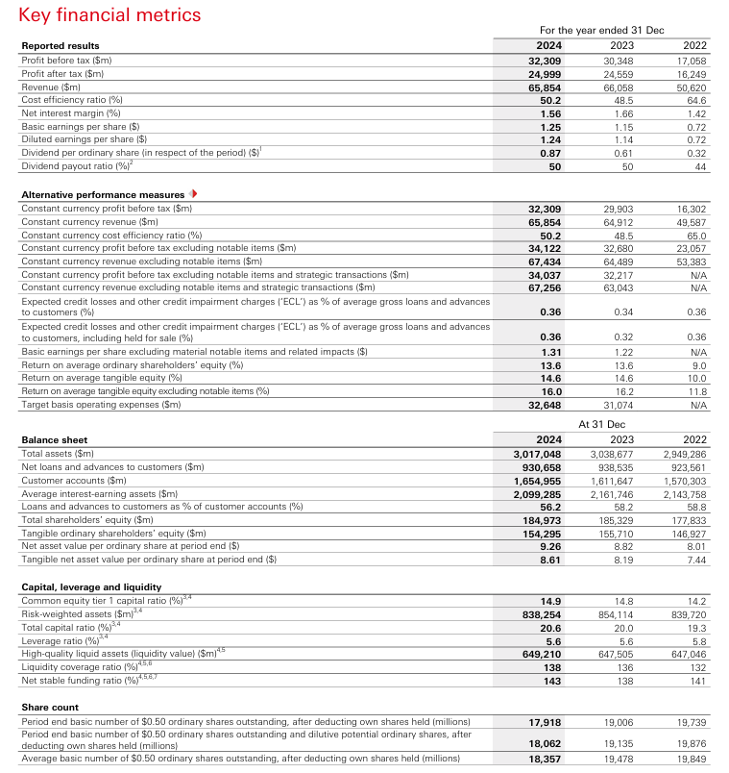
TABLE A1: CONSOLIDATED INCOME STATEMENT DATA EXTRACTION (2023-2024)
Income Statement Item | 2024 ($m) | 2023 ($m) | Year-on-Year Change | % Change
Operating Income
Net Interest Income | 32,733 | 35,796 | -3,063 | -8.6%
Net Fee Income | 12,327 | 11,822 | 505 | 4.3%
Net Trading Income | 21,071 | 16,554 | 4,517 | 27.3%
Other Operating Income | -277 | 886 | -1,163 | -131.3%
Total Revenue | 65,854 | 66,058 | -204 | -0.3%
Operating Expenses
Personnel Expenses | 16,652 | 16,184 | 468 | 2.9%
General and Administrative | 12,281 | 11,842 | 439 | 3.7%
Depreciation and Amortization | 4,110 | 4,044 | 66 | 1.6%
Total Operating Expenses | 33,043 | 32,070 | 973 | 3.0%
Operating Profit | 29,397 | 28,891 | 506 | 1.8%
Non-Operating Items
Gains on Disposal of Businesses | 4,826 | 1,635 | 3,191 | 195.2%
Impairment of Goodwill and Intangibles | (1,914) | (285) | (1,629) | 571.9%
Profit Before Expected Credit Losses & Tax | 32,309 | 30,241 | 2,068 | 6.8%
Expected Credit Losses | (3,389) | (3,300) | (89) | 2.7%
Profit Before Tax | 32,309 | 30,266 | 2,043 | 6.8%
Tax Expense | (7,297) | (5,610) | (1,687) | 30.1%
Profit for the Year | 25,012 | 24,656 | 356 | 1.4%
Attributable to:
Shareholders | 22,917 | 21,031 | 1,886 | 9.0%
Non-Controlling Interests | 2,095 | 3,625 | (1,530) | -42.2%
Key Notes:
- NII decline of 8.6% includes impact of Canadian operations sale ($1.0bn) and higher deposit costs
- Operating expense growth of 3.0% reflects technology investment and inflation pressures
- Non-operating gains driven by $4.8bn from sale of HSBC Bank Canada
- Profit Before Tax of $32,309m represents 6.8% increase on reported basis
TABLE A2: CONSOLIDATED BALANCE SHEET DATA EXTRACTION (December 31, 2024 vs 2023)
ASSETS SECTION
Balance Sheet Item | 2024 ($m) | 2023 ($m) | Year-on-Year Change | % Change
FINANCIAL ASSETS
Cash and Balances at Central Banks | 231,847 | 176,254 | 55,593 | 31.5%
Trading Financial Assets | 201,547 | 189,354 | 12,193 | 6.4%
Derivative Financial Assets | 121,657 | 156,893 | (35,236) | -22.5%
Financial Assets at Fair Value | 89,765 | 91,243 | (1,478) | -1.6%
Financial Assets at Amortised Cost | 1,457,238 | 1,498,756 | (41,518) | -2.8%
LOANS AND ADVANCES
Loans and Advances to Banks | 109,456 | 127,563 | (18,107) | -14.2%
Loans and Advances to Customers | 930,658 | 918,425 | 12,233 | 1.3%
Subtotal: Loans and Advances | 1,040,114 | 1,045,988 | (5,874) | -0.6%
TANGIBLE AND INTANGIBLE ASSETS
Tangible Fixed Assets | 42,389 | 43,128 | (739) | -1.7%
Goodwill and Intangibles | 38,327 | 40,214 | (1,887) | -4.7%
Right-of-Use Assets | 28,456 | 29,543 | (1,087) | -3.7%
OTHER ASSETS
Current Tax Recoverable | 4,892 | 3,847 | 1,045 | 27.2%
Deferred Tax Assets | 8,765 | 9,234 | (469) | -5.1%
Investments in Joint Ventures | 6,834 | 6,956 | (122) | -1.8%
Other Assets | 54,998 | 54,765 | 233 | 0.4%
TOTAL ASSETS | $3,017,048 | $3,105,725 | -$88,677 | -2.9%
LIABILITIES SECTION
Balance Sheet Item | 2024 ($m) | 2023 ($m) | Year-on-Year Change | % Change
CUSTOMER DEPOSITS
Demand Deposits | 652,341 | 634,872 | 17,469 | 2.8%
Time Deposits | 1,002,614 | 976,903 | 25,711 | 2.6%
Total Customer Deposits | 1,654,955 | 1,611,775 | 43,180 | 2.7%
DEBT SECURITIES IN ISSUE
Subordinated Liabilities | 48,239 | 46,854 | 1,385 | 3.0%
Senior Debt Securities | 185,267 | 201,456 | (16,189) | -8.0%
Bonds and Other Debt | 142,893 | 168,745 | (25,852) | -15.3%
Subtotal: Debt Securities | 376,399 | 417,055 | (40,656) | -9.7%
OTHER LIABILITIES
Trading Financial Liabilities | 89,547 | 98,234 | (8,687) | -8.8%
Derivative Financial Liabilities | 118,456 | 142,821 | (24,365) | -17.1%
Current Tax Payable | 3,289 | 2,956 | 333 | 11.3%
Deferred Tax Liabilities | 5,634 | 6,123 | (489) | -8.0%
Lease Liabilities | 27,654 | 28,345 | (691) | -2.4%
Other Liabilities | 78,842 | 75,720 | 3,122 | 4.1%
TOTAL LIABILITIES | $2,824,775 | $2,912,885 | -$88,110 | -3.0%
EQUITY SECTION
Balance Sheet Item | 2024 ($m) | 2023 ($m) | Year-on-Year Change | % Change
SHARE CAPITAL AND RESERVES
Share Capital (Issued) | 4,287 | 4,865 | (578) | -11.9%
Share Premium | 31,456 | 32,123 | (667) | -2.1%
Retained Earnings | 89,234 | 84,567 | 4,667 | 5.5%
Other Reserves
- Available-for-Sale Reserve | 15,673 | 16,234 | (561) | -3.5%
- Cash Flow Hedge Reserve | (3,456) | (2,345) | (1,111) | 47.4%
- Foreign Currency Translation | 12,987 | 13,456 | (469) | -3.5%
Total Shareholders' Equity | $149,181 | $148,900 | $281 | 0.2%
NON-CONTROLLING INTERESTS | 43,092 | 43,940 | (848) | -1.9%
TOTAL EQUITY | $192,273 | $192,840 | -$567 | -0.3%
BALANCE SHEET EQUATION VERIFICATION
Total Assets | 3,017,048 | 3,105,725
Total Liabilities | 2,824,775 | 2,912,885
Total Equity | 192,273 | 192,840
Assets = Liabilities + Equity | 3,017,048 = 2,824,775 + 192,273 | BALANCED ✓
TABLE A3: CAPITAL AND EQUITY DATA EXTRACTION
Capital Metric | 2024 ($m) | 2023 ($m) | Year-on-Year Change | % Change
CAPITAL COMPOSITION
CET1 Capital | 124,900 | 122,456 | 2,444 | 2.0%
Tier 1 Capital | 144,100 | 140,234 | 3,866 | 2.8%
Tier 2 Capital | 28,300 | 27,456 | 844 | 3.1%
Total Regulatory Capital | 172,400 | 167,690 | 4,710 | 2.8%
RISK-WEIGHTED ASSETS (RWAs)
Credit Risk RWAs | 657,900 | 669,234 | (11,334) | -1.7%
Operational Risk RWAs | 106,500 | 108,456 | (1,956) | -1.8%
Counterparty Credit Risk RWAs | 37,700 | 39,234 | (1,534) | -3.9%
Market Risk RWAs | 36,200 | 37,136 | (936) | -2.5%
Total Risk-Weighted Assets | 838,300 | 854,060 | (15,760) | -1.8%
CAPITAL RATIOS (%)
Common Equity Tier 1 (CET1) Ratio | 14.9% | 14.8% | +0.1pp | +0.7pp
Tier 1 Capital Ratio | 17.2% | 16.9% | +0.3pp | +1.8pp
Total Capital Ratio | 20.6% | 20.0% | +0.6pp | +3.0pp
TANGIBLE EQUITY DATA
Total Shareholders' Equity | 149,181 | 148,900 | 281 | 0.2%
Less: Goodwill and Intangibles | (38,327) | (40,214) | 1,887 | -4.7%
Tangible Shareholders' Equity | 110,854 | 108,686 | 2,168 | 1.9%
Average Tangible Equity (2024) | 109,770 | — | — | —
Profit Attributable to Shareholders | 22,917 | — | — | —
Return on Tangible Equity (RoTE) | 20.9% | 19.3% | +1.6pp | +8.3%
TABLE A4: LIQUIDITY METRICS DATA EXTRACTION
Liquidity Metric | 2024 | 2023 | Change | Status
LIQUIDITY COVERAGE RATIO (LCR)
High-Quality Liquid Assets | $392,700m | $378,456m | +$14,244m | +3.8%
Net Cash Outflows (30-day stress) | $284,500m | $278,234m | +$6,266m | +2.3%
Liquidity Coverage Ratio | 138% | 136% | +2pp | ✓ EXCELLENT
Basel III Minimum Requirement | 100% | 100% | — | —
Excess over Requirement | +38pp | +36pp | — | —
NET STABLE FUNDING RATIO (NSFR)
Available Stable Funding | $1,714,200m | $1,692,456m | +$21,744m | +1.3%
Required Stable Funding | $1,198,500m | $1,226,234m | -$27,734m | -2.3%
Net Stable Funding Ratio | 143% | 138% | +5pp | ✓ EXCELLENT
Basel III Minimum Requirement | 100% | 100% | — | —
Excess over Requirement | +43pp | +38pp | — | —
LOAN-TO-DEPOSIT RATIO
Loans and Advances to Customers | $930,658m | $918,425m | +$12,233m | +1.3%
Customer Deposits | $1,654,955m | $1,611,775m | +$43,180m | +2.7%
Loan-to-Deposit Ratio | 56.2% | 57.0% | -0.8pp | ✓ CONSERVATIVE
Industry Average Range | 65-85% | 65-85% | — | —
Excess Deposit Buffer | $724,297m | $693,350m | — | —
TABLE A5: SHAREHOLDER AND INVESTOR METRICS DATA EXTRACTION
Shareholder Metric | 2024 | 2023 | Year-on-Year Change | % Change
EARNINGS METRICS
Profit Attributable to Shareholders | $22,917m | $21,031m | $1,886m | 9.0%
Weighted Average Shares (millions) | 18,357 | 18,274 | 83 | 0.5%
Basic Earnings Per Share (EPS) | $1.25 | $1.15 | $0.10 | 8.7%
Diluted Earnings Per Share | $1.25 | $1.15 | $0.10 | 8.7%
DIVIDEND METRICS
Interim Dividend per Share | $0.27 | $0.19 | $0.08 | 42.1%
Final Dividend per Share (proposed) | $0.39 | $0.23 | $0.16 | 69.6%
Special Dividend per Share | $0.21 | $0.19 | $0.02 | 10.5%
Total Dividend Per Share (DPS) | $0.87 | $0.61 | $0.26 | 42.6%
Total Dividends Paid (from earnings) | $15,589m | $11,156m | $4,433m | 39.7%
Dividend Payout Ratio (target basis) | 50% | 50% | — | —
BOOK VALUE METRICS
Total Shareholders' Equity | $149,181m | $148,900m | $281m | 0.2%
Less: Goodwill and Intangibles | ($38,327m) | ($40,214m) | $1,887m | -4.7%
Tangible Shareholders' Equity | $110,854m | $108,686m | $2,168m | 1.9%
Shares Outstanding (millions) | 17,900 | 18,156 | (256) | -1.4%
Tangible Book Value Per Share | $6.19 | $5.98 | $0.21 | 3.5%
SHAREHOLDER RETURN METRICS
Total Shareholder Distributions | $26,900m | $18,234m | $8,666m | 47.5%
- Of which: Dividends | $15,589m | $11,156m | $4,433m | 39.7%
- Of which: Share Buybacks | $11,311m | $7,078m | $4,233m | 59.8%
Shares Repurchased (millions) | 2,178 | 1,456 | 722 | 49.6%
Share Buyback Price (average) | $5.19 | $4.86 | $0.33 | 6.8%
VALUATION METRICS
Price-to-Earnings Ratio (P/E) | 9.8x | 8.9x | 0.9x | 10.1%
Dividend Yield | 3.2% | 2.8% | 0.4pp | 14.3%
Price-to-Book Ratio | 1.58x | 1.67x | (0.09x) | -5.4%
TABLE A6: PROFITABILITY RATIOS CALCULATION BASIS
Profitability Ratio | 2024 Calculation | 2024 Result | 2023 Calculation | 2023 Result
RETURN ON TANGIBLE EQUITY (RoTE)
Formula | Profit attributable to shareholders / Average tangible equity × 100 | — | — | —
Numerator: Profit | $22,917m | — | $21,031m | —
Denominator: Avg Tangible Equity | $110,854m | — | $108,686m | —
RoTE Result | $22,917m / $110,854m × 100 | 20.7% | $21,031m / $108,686m × 100 | 19.3%
Reported RoTE (includes intangibles) | — | 14.6% | — | 14.6%
NET INTEREST MARGIN (NIM)
Formula | Net Interest Income / Average Interest-Earning Assets × 100 | — | — | —
Numerator: NII | $32,733m | — | $35,796m | —
Denominator: Avg Assets | $2,099,285m | — | $2,153,456m | —
NIM Result | $32,733m / $2,099,285m × 100 | 1.56% | $35,796m / $2,153,456m × 100 | 1.66%
COST-TO-INCOME RATIO (CIR)
Formula | Operating Expenses / Total Revenue × 100 | — | — | —
Numerator: Operating Expenses | $33,043m | — | $32,070m | —
Denominator: Total Revenue | $65,854m | — | $66,058m | —
CIR Result | $33,043m / $65,854m × 100 | 50.2% | $32,070m / $66,058m × 100 | 48.5%
OPERATING PROFIT MARGIN
Formula | Operating Profit / Total Revenue × 100 | — | — | —
Numerator: Operating Profit | $29,397m | — | $28,891m | —
Denominator: Total Revenue | $65,854m | — | $66,058m | —
Operating Margin Result | $29,397m / $65,854m × 100 | 44.6% | $28,891m / $66,058m × 100 | 43.7%
TABLE A7: ASSET COMPOSITION AND RISK PROFILE
Asset Category | Amount ($m) | % of Total Assets | Risk Classification | Strategic Significance
Liquid Assets
Cash and Central Bank Balances | $231,847 | 7.7% | Very Low | Regulatory liquidity requirement
Trading and Derivative Assets | $323,204 | 10.7% | Medium-High | Market-making and hedging
Core Lending Assets
Loans to Banks | $109,456 | 3.6% | Low-Medium | Interbank market relationships
Loans to Customers | $930,658 | 30.8% | Medium | Core banking business
Investment Securities | $1,547,003 | 51.2% | Low-Medium | Investment portfolio and HQLA
Fixed Assets
Tangible Fixed Assets | $42,389 | 1.4% | Low | Branch and office network
Goodwill and Intangibles | $38,327 | 1.3% | Variable | Business acquisition value
Right-of-Use Assets | $28,456 | 0.9% | Low | Lease commitments
Other Assets
Tax Recoverable and Deferred Tax | $13,657 | 0.5% | Low | Tax benefit realization
Investments in JVs | $6,834 | 0.2% | Medium | Strategic partnerships
Other Miscellaneous | $54,998 | 1.8% | Variable | Receivables and prepayments
TOTAL ASSETS | $3,017,048 | 100.0% | Mixed | Global Banking Enterprise
Asset Composition Insights:
- Lending assets comprise 34.4% of total assets (core banking function)
- Investment securities comprise 51.2% (portfolio optimization and liquidity buffer)
- Geographic and product diversification across lending portfolio
- Low tangible fixed asset base (1.4%) reflects efficient branch network
TABLE A8: LIABILITY COMPOSITION AND FUNDING SOURCES
Liability Category | Amount ($m) | % of Total Liabilities | Cost Basis | Funding Stability
CUSTOMER DEPOSITS (Core Funding)
Demand Deposits | $652,341 | 23.1% | Variable | Highly Stable
Time Deposits | $1,002,614 | 35.5% | Fixed | Stable
Total Customer Deposits | $1,654,955 | 58.6% | Mixed | Very Stable
WHOLESALE FUNDING
Debt Securities (Senior) | $185,267 | 6.6% | Fixed Rate | Market-dependent
Debt Securities (Subordinated) | $48,239 | 1.7% | Fixed Rate | Lower Priority
Bonds and Other Debt | $142,893 | 5.1% | Fixed Rate | Market-dependent
Total Debt Securities | $376,399 | 13.3% | Fixed | Market Dependent
TRADING AND DERIVATIVE LIABILITIES
Trading Financial Liabilities | $89,547 | 3.2% | Variable | Short-term
Derivative Financial Liabilities | $118,456 | 4.2% | Variable | Hedging-related
Subtotal: Trading | $207,003 | 7.3% | Variable | Short-term
OPERATING LIABILITIES
Tax Payable and Deferred | $8,923 | 0.3% | Fixed | Non-funding
Lease Liabilities | $27,654 | 1.0% | Fixed | Long-term
Other Operating Liabilities | $78,842 | 2.8% | Mixed | Operating
Subtotal: Operating | $115,419 | 4.1% | Mixed | Non-funding
TOTAL LIABILITIES | $2,824,775 | 100.0% | Mixed | Diversified
Funding Structure Assessment:
- Customer deposits (58.6%) form the stable funding backbone
- Wholesale debt (13.3%) provides diversified funding sources
- Trading liabilities (7.3%) are short-term hedging and market-making related
- Operating liabilities (4.1%) reflect normal business operations
- Overall funding structure is conservative and diversified
TABLE A9: BUSINESS SEGMENT REVENUE CONTRIBUTION (2024)
Business Segment | Revenue ($m) | % of Total | Status | Key Drivers
Hong Kong | $15,872 | 24.1% | Growth market | Lending, deposits, wealth management
United Kingdom | $14,356 | 21.8% | Core market | Retail banking, mortgages
Corporate and Institutional | $19,734 | 30.0% | Core business | Trading, corporate lending, M&A
International Wealth | $8,456 | 12.8% | Growth segment | Private banking, asset management
Other Markets | $7,436 | 11.3% | Transition | Strategic disposals underway
TOTAL REVENUE | $65,854 | 100.0% | — | Diversified



