Programme: BA Business Management
Module: Entrepreneurship
Module code: LCBB5001

Assignment Title: Component 2: Practical: Presentation & Report

Student name: Loredana Zsofi
Student id: 2111130
Lecturer’s name: Nishi Ramsurrun.
Table of Contents

Task A: Pitch: In class 3
Task B: Evaluation Report 10
Evaluation of the business idea and the motivational factors leading to the choice 10
Five entrepreneurship skills, traits, and behavior and their importance to the business 11
An evidence based self-assessment to become an entrepreneur 12
➢ An extensive market research including PEST analysis of the UK 12
References 13

Task A: Pitch: In class
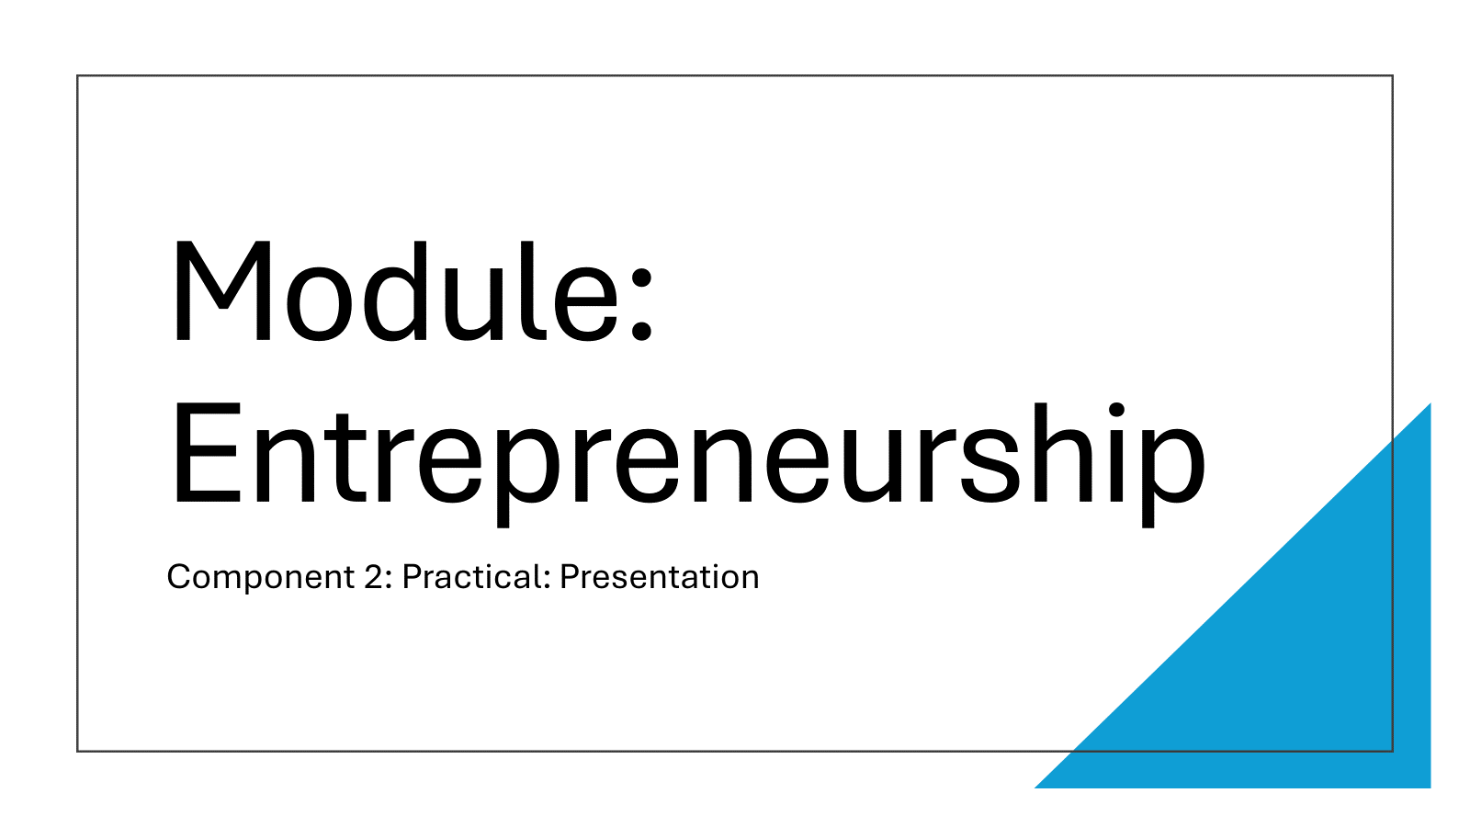
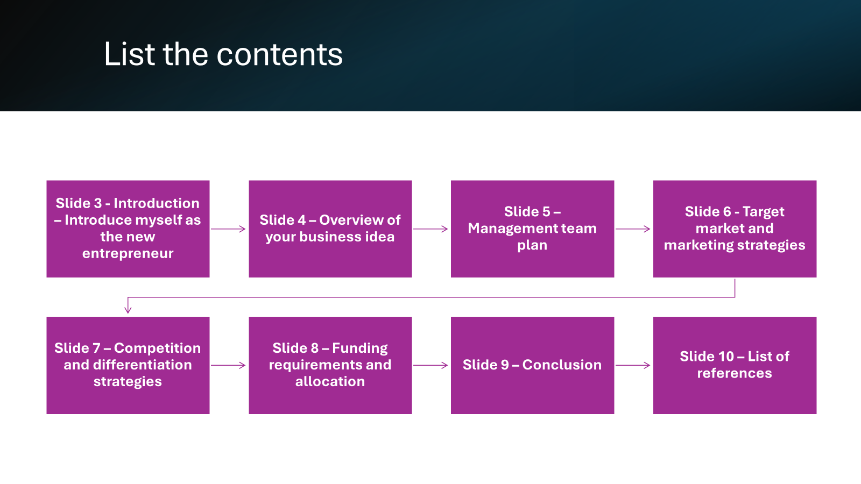
Slide 3 - Introduction – Introduce myself as the new entrepreneur

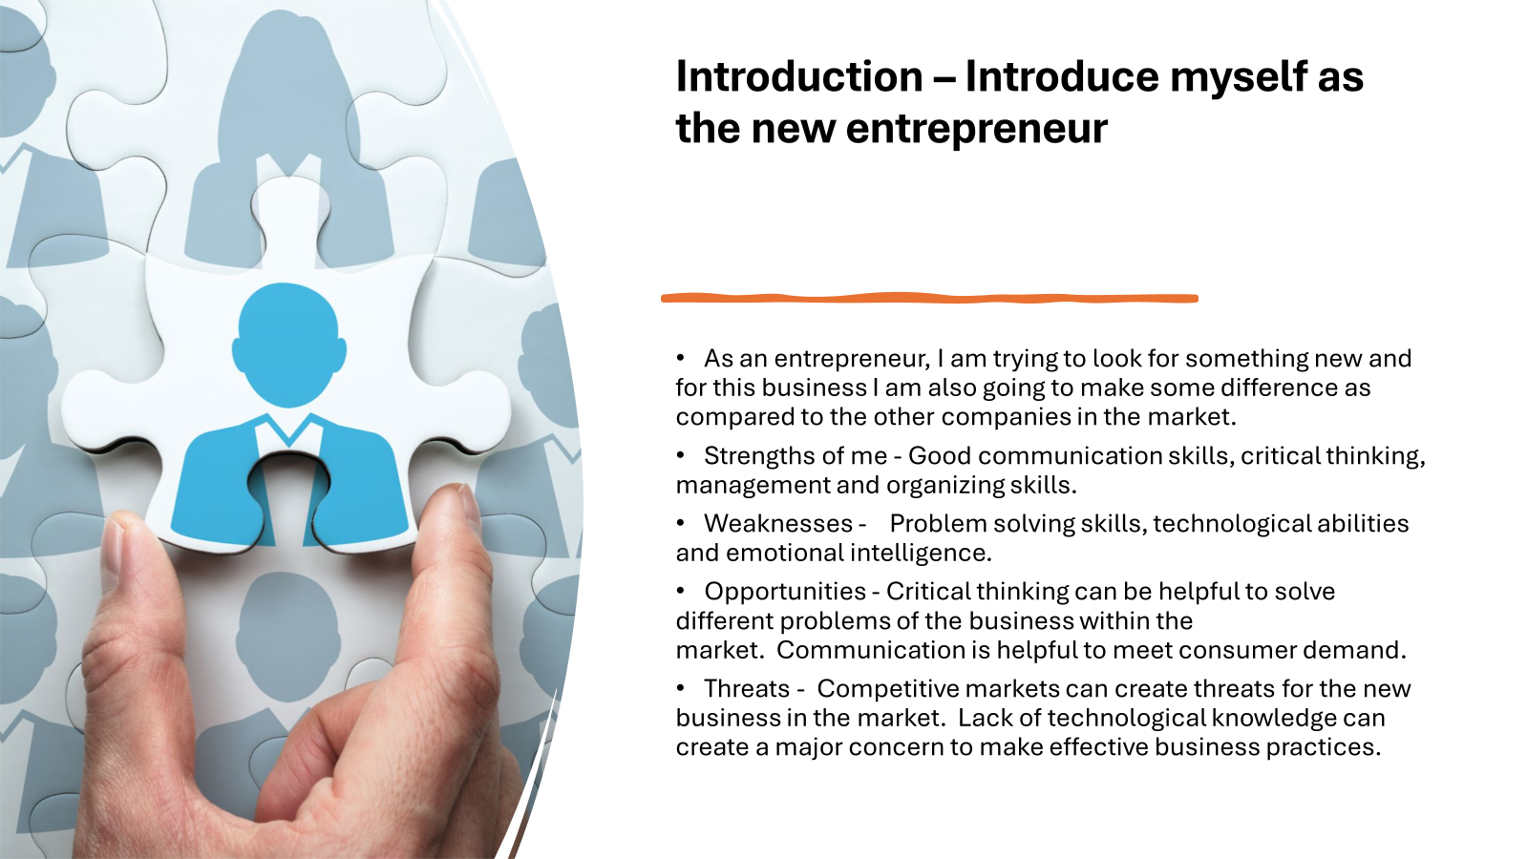
Entrepreneurship refers to the readiness as well as the ability for organizing as well as developing the business that can make the development of business profit (Hisrich, Peters and Shepherd, 2017) As an entrepreneur, I am looking to create some differences. Here, my critical thinking skills are helpful for me to create a proper business idea within the market. But, I also have some weaknesses that can create major threats for me that need to be managed properly by me.
Slide 4 – Overview of your business idea
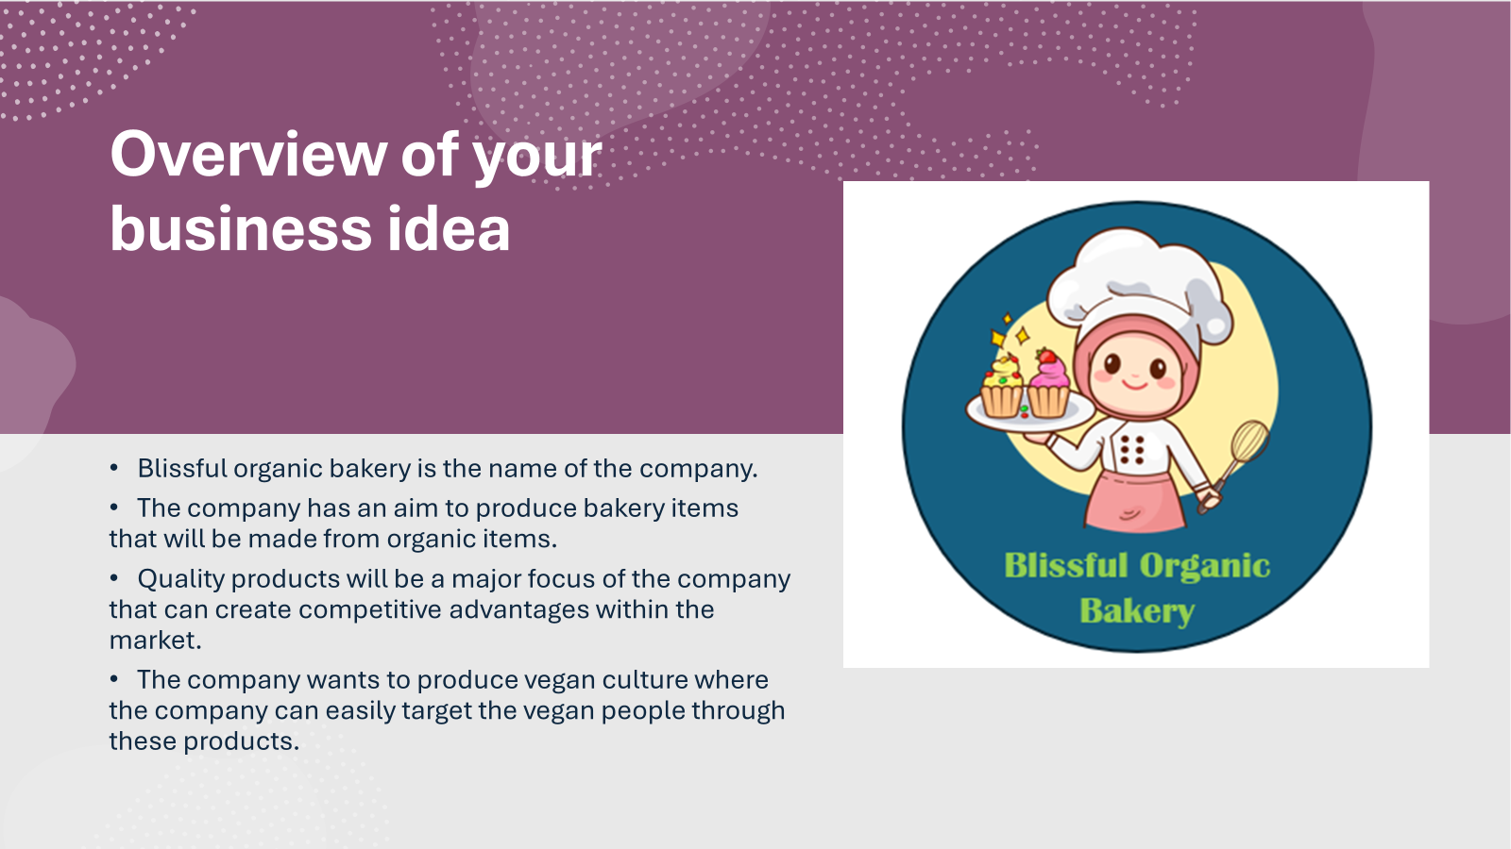
A new business called Blissful Organic Bakery intends to launch a location in the center of London, UK. The ticket firm intends to include a fresh, fashionable composition in their offering. This will be helpful for the development of the competitive advantages for the organization within the market. The business has made the decision to launch vegan baked goods onto the marketplace. The product's manufacturing procedure will ensure that the flavor is maintained without sacrificing any of it.
Slide 5 – Management team plan
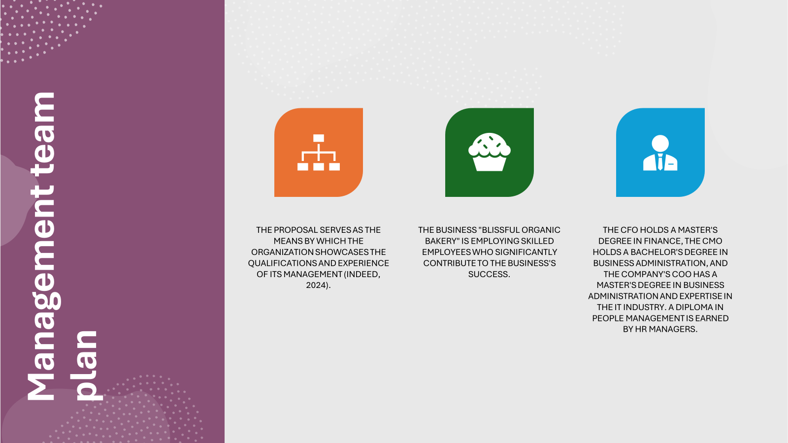
There is a focus on the development of the skilled team that can make the overall performance development of the organization. Through this it can be said that there is the importance of people management that will be helpful for the overall performance development of the organization within the market.
Slide 6 - Target market and marketing strategies
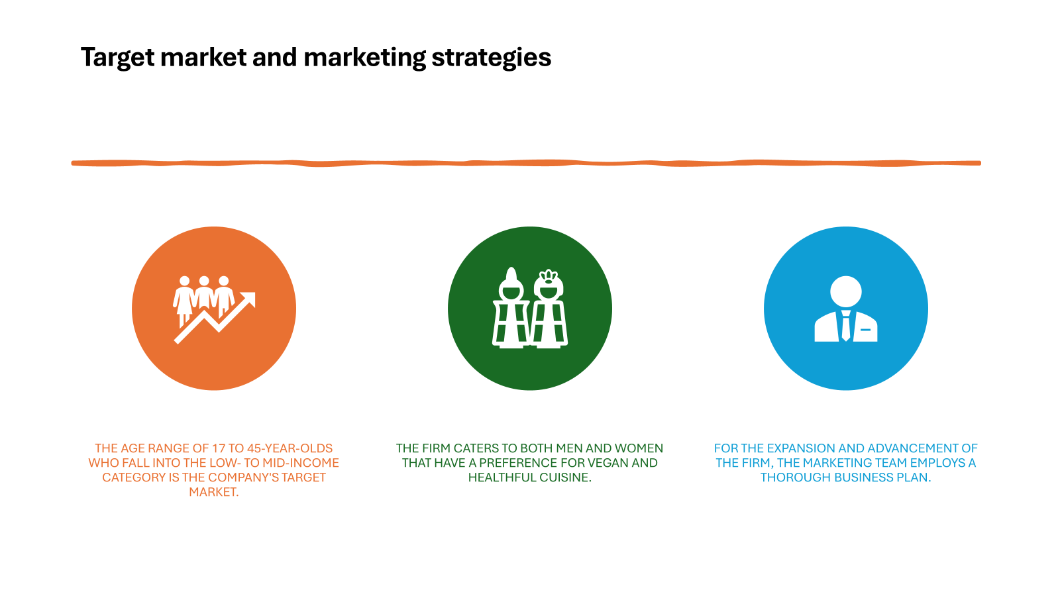
STP strategy will be focused on through the development of the strategies for the target market. Both men and women will fall under the target market. However, there is the consideration of targeting the people with a healthy lifestyle that can create proper values for the company.
Slide 7 – Competition and differentiation strategies
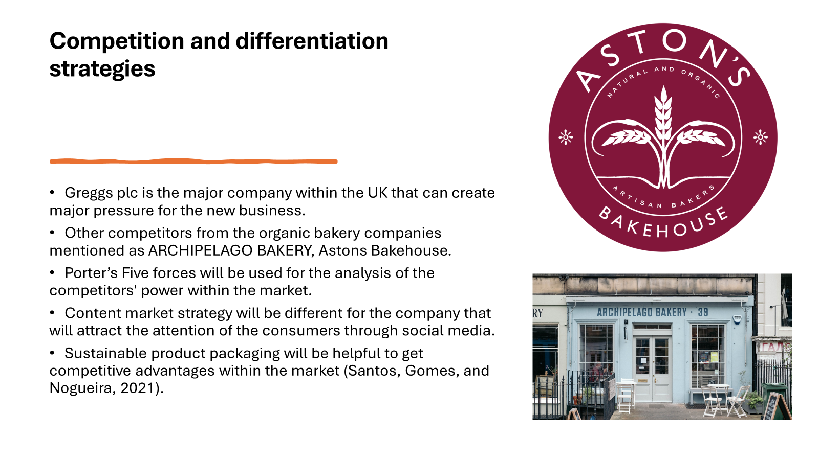
Different strategies will be a major focus for the company. Through This the company has an aim to make innovation through content marketing within the social media platforms. There is also the consideration of sustainable packaging that is an important area for making competitive advantages for the organization (Santos, Gomes, and Nogueira, 2021).
Slide 8 – Funding requirements and allocation
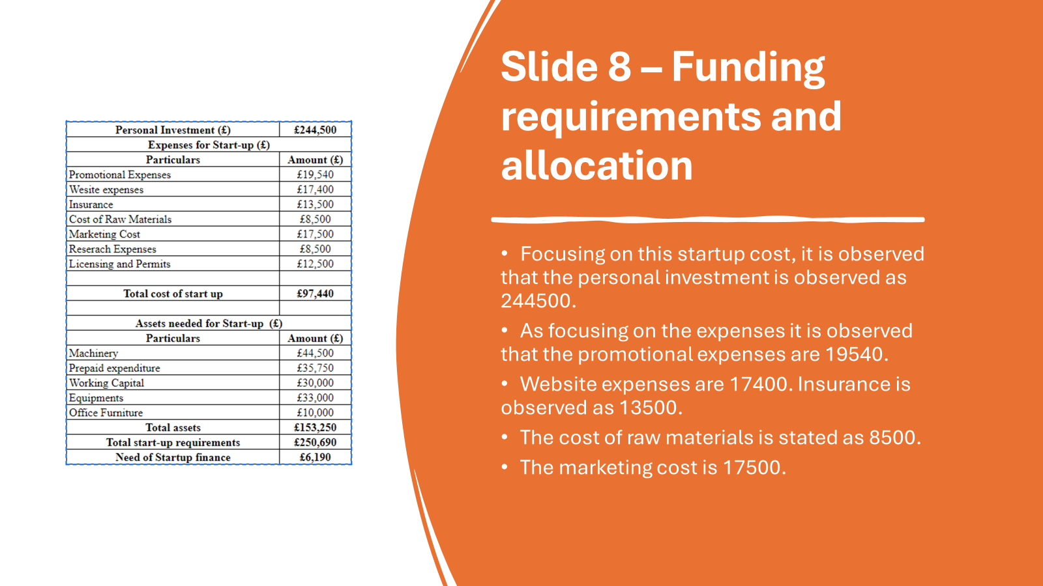
The research expenses are observed as 8500 pounds. The licensing and permits are observed as 12500 pounds. Therefore the overall start-up cost is observed as 97440 pounds. Focusing on the asset, the machinery is 44500 pounds. The prepaid expenditure is stated as 35750 pounds. The working capital is 30000 pounds. The equipment is stated as 33000. The office furniture is observed as 10000 pounds. Therefore the overall asset is 153250 pounds. The startup requirement is observed as 250690 pounds. Therefore, the need for startup finance is 6190 pounds.
Slide 9 – Conclusion
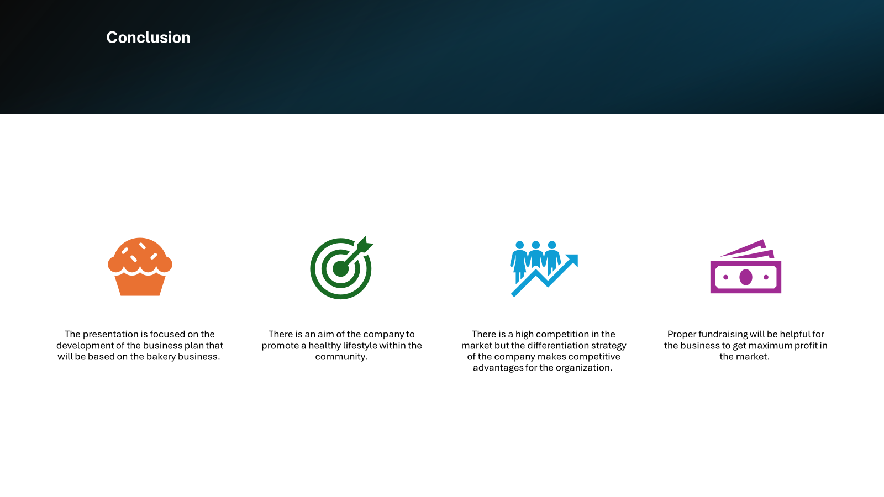
Bakery business is a major focus for the company. I think that I can create a major value through organic products, and this will also be helpful to create a better community. Though there are different types of issues within the market, proper development of the competitive strategy is helpful for creating value for the organization.
Slide 10 – List of references
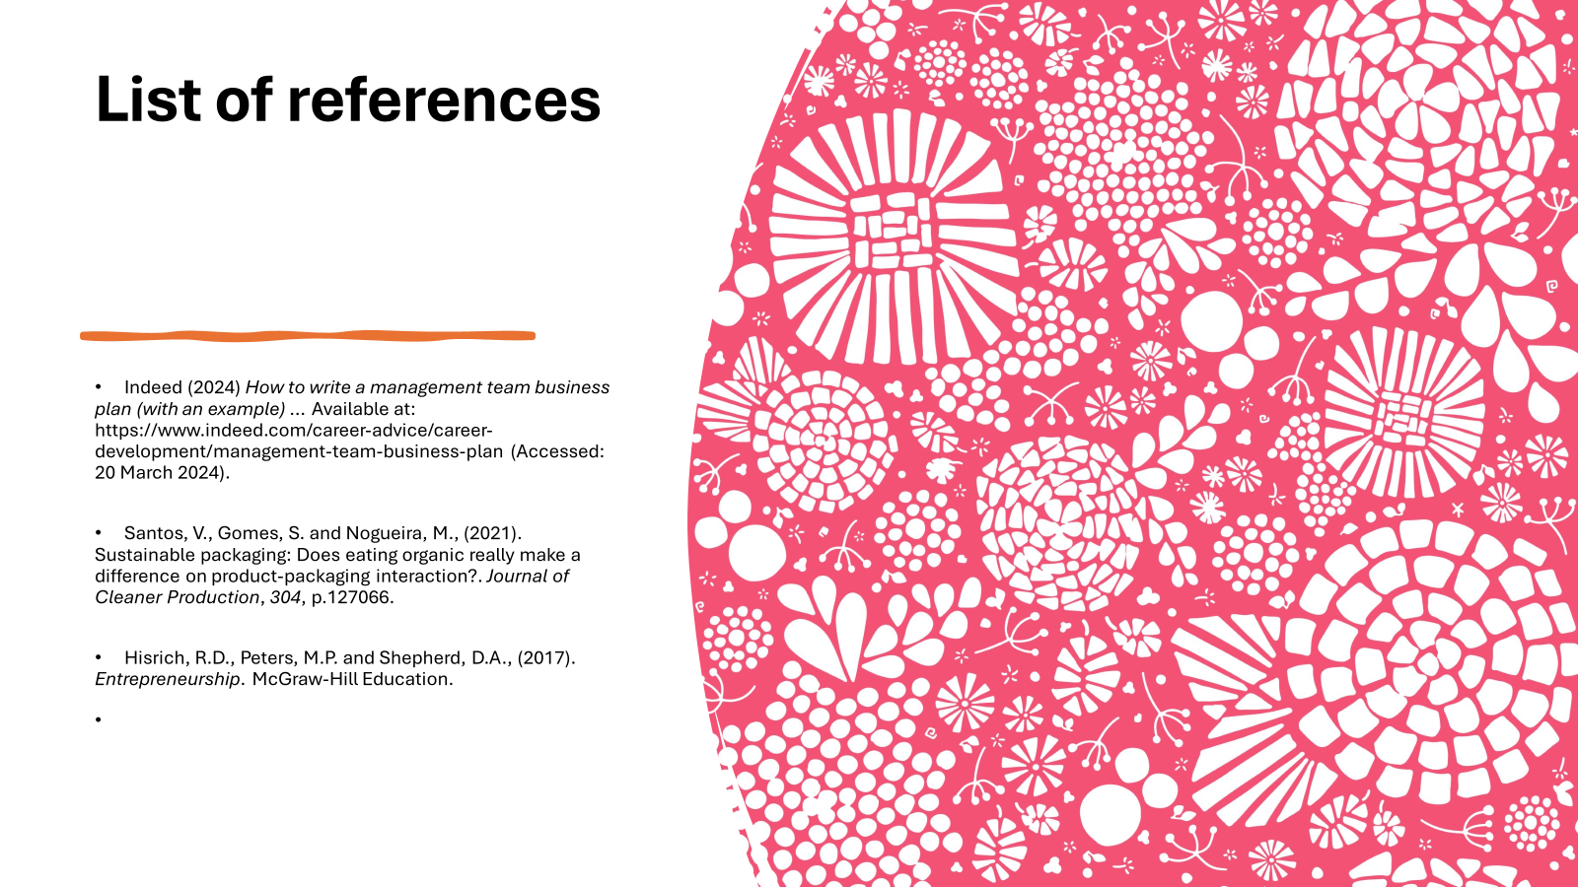

Task B: Evaluation Report

Evaluation of the business idea and the motivational factors leading to the choice
Blissful Organic Bakery will be the business idea that is proposed, and it is expected that the business will make profit through the market areas. Year after year, making organic cakes has grown in popularity, following a recent trend. Since this product won't have any negative health consequences on consumers, entrepreneurs are encouraged to pursue this line of work (Bucketofbread, 2024). Business owners want to buy safe and environmentally friendly bakery goods in order to produce organic veggie cakes. When customers purchase bread goods these days, stores do not adequately display their riches. As an entrepreneur, I have experienced firsthand the urgent health advantages of items made organically. In an attempt to appeal to a wide range of people who dislike food derived from animals, I have thought of creating a dessert with organic veggies. Generally, egg is used for manufacturing the cake, but I think organic items can be healthy items for the people and this will also be suited for all.
Considering this area, it can be said that there are different types of the motivational factors for the development of this business idea that can be -
Organic products can make healthy bakery items - Given its popularity with consumers, adding veggies to cake may be the newest fad in bakeries. Organic vegetable-made cake is the ideal option for clients who are attempting to live a healthier diet by including new flavors into their cake (Fooddive, 2024). I am aware that a large number of consumers prefer veggie cake as their healthier bakery option. Asda is a UK-based sustainable firm that provides its clients with a variety of veggie cake alternatives. There is nothing healthy about the cake by nature. On the other hand, adding veggies can make it somewhat healthier. They are probably going to be viewed by customers as a superior option. This was the catalyst for me to launch a cake company with an organic vegetable foundation.
Consumer interest in organic products - I have observed global consumer trends in recent years, including a rise in the desire for natural and health-conscious products, which has increased demand for organic bakery items. Because customers are becoming more conscious of the negative effects of pesticides, they are choosing to use organic ingredients to drive market growth. Additionally, consumers are drawn to organic ingredients; gluten-free organic bakery products will satisfy their dietary requirements. As a result, the increased development of organic bakery products in the online retail platform has inspired me to open a cake bakery using organic vegetables.

Five entrepreneurship skills, traits, and behavior and their importance to the business
Skills
Communication skills - In order to offer business guided growth in the first place, the proprietor of Blissful Organic Bakery will carry out the duties of a baker in addition to selling organic vegetable cake in the market. In other words, it will essentially be a bakery. As a result, the owners of the business must interact with clients, suppliers, and employees from both an employer and an employee standpoint. They must be able to speak easily with one another in order to Clearly to express the notion. In order to receive client feedback, Blissful Organic Bakery must also have effective communication skills. Additionally, good communication may guarantee that each member of the team knows exactly what their responsibilities are in the kitchen (Wageman et al. 2008).
Organization skills - Through the development of the organization skills there is the consideration of the different types of management development of the organization. This skill is needed for managing the work of the different areas of the workplace of the organization. This is the area that is also a major area for resourcing different types of materials of the organization. Through this there is the consideration of the effective manufacturing of the products within the organization. Through this there is the consideration of the development of the administrative area that can make the development of the overall management process of the organization (Chan et al. 2018).
Traits
Creative Thinker - For bakery enterprises to showcase their employees' creative qualities, they must possess artistry. To observe a lot of passion and excitement for their product among customers, the corporation has to come up with some creative ideas. Being creative may help a bakery firm expand its mind and draw in investors with an innovative business concept. In order to increase economic success, a cake and bakery should be inquisitive, creative, and appreciative of different viewpoints.
Realistic person - As entrepreneurs, bakers frequently possess practical qualities. They take pleasure in working outside. For them, gaining practical experience through projects is essential. A realistic person finds it easy to connect with the material world. Rather than confronting their issue head-on, they attempt to find a solution.
The idea to bake cakes using organic veggies came to Blissful Organic Bakery when they saw the industry's practical trend toward health consciousness. During the epidemic, people's decisions about what foods to buy are impacted by health concerns. The corporation wants to give the bakery a better choice so that it can please its consumers. Their staff’s realistic qualities provide a more natural element to the cake-baking process.
Behavior
Openness towards criticism - One critical behavior in the baking industry is handling criticism. A bakery company occasionally has to accept helpful criticism in order to make the required adjustments. They should concentrate on behaving in a way that accepts failure organically before moving on to progress (Goryńska-Goldmann et al. 2020). Various types of openness work together to aid in the creation of new products. The resistance to criticism shapes less radical innovation.
Employees at Blissful Organic Bakery should demonstrate by their actions that they are receptive to constructive criticism in order to foster the growth of their innovative company concepts.

An evidence based self-assessment to become an entrepreneur.
Skill audit:

Skill, I have | Example
Good communication skills | I can speak 2 languages rather than English and it drives a strong understanding of one another.
Critical thinking skill | I read different types of books, and it helps to boost my higher thinking abilities.
Strong management skill | I usually manage my task my making schedule to complete it within deadline
Organization skill | I used to arrange all tasks well and I received appreciation from seniors.
Skil I Would like to improve | Example
Problem solving skill | While any kind of problems are going on, I could find out the root cause of the problem in university.
Emotional intelligences skill | I lost my patiences while the conflict was going in surrounding.
Technological skills | I was not able to create excel preparations and formula calculation in my assignment in study.

Swot analysis:

Strengths | Weaknesses
- I have a strong ability to communication with all clients.  - Having abilities to think in a critical way.  - I can manage multiple number of tasks quickly and well manner.  - I can make a schedule and complete tasks in an organized way. | - I am poor at solving various problems.  - I Could manage emotional areas of the myself and others.  - I am poor at handling technological tools.
Opportunities | Threats
- Communication will help to build understanding with my clients  - Critical thinking helps to drive higher innovation in the business. | - Higher competitive rivalry in the market.  - Lack of technological ability creates complexity to managing various tasks.

➢ An extensive market research including PEST analysis of the UK 400
political factor: Government regulation is the most essential area to improve the business of the bakery industry. The UK government has created a clear set of quality as well as storage which ensures the security of the business. Brexit created a higher trafficking price, and it can lead to increase the cost of the operations. The bakery industry was also negatively impacted by Brexit and consumers faced a 9% rise in the product (Smail, 2023). In these circumstances, new start businesses can face higher operations costs and trouble in importing and exporting. In the post-Brexit time, wheat product transportation has been disrupted between Britain and Ireland (Irish Times, 2023).
Economical factor: In the Global recession condition of the UK, the Bakery business can face price hike-related issues of all necessary items like flour, butter, chocolates, sugar, etc. However, the global bakery market revenue value has reached US$16.27 billion in 2024 it is also expected that this business will grow 3.82% within 2028 (Statista, 2023). Covid-19 has created a positive drive for this industry. During the time of the pandemic, the demand for pastries and bakery has increased and this industry has created the next normal tactic to drive growth of the business. A new start-up brand would not be impacted by any kind of disaster because it can be run at home (Databridgemarketresearch, 2023).
Social factor: Customer preferences in the present market are continuously changing and it created a significant impact on the bakery business operation process. As this business follows customers' needs, and preferences in the right way, it can create possibilities to attract millions of customers by changing the marketing plan and approach plan. The higher preferences for organic products and preferences for health benefits can create obstacles but if this bakery company carefully manages it, it will drive strong revenues for the business. Additionally, it creates job opportunities, supports the local economy and fosters a higher sense of community to drive higher success in the business.
Technological factor: The digital transformation has created a positive impact on the bakery industry, and it helps to optimize the supply chain process within the UK market. By adopting technical support this brand can analyze the demand forecasting, as well as create possible estimation of the reduction of the waste and create sustainable goals (Bakeryinfo, 2023). Additionally, this industry can take digital marketing support to enhance market reach and e-commerce medium can create opportunities to supply products all over the country.

References

Bakeryinfo, (2023). The digital revolution in baking: a recipe for sustainability. British Baker. Available at: https://bakeryinfo.co.uk/promotional-features/the-digital-revolution-in-baking-a-recipe-for-sustainability/682915.article (Accessed 21 Mar. 2024).
Bucketofbread, C. at (2024) Health benefits of Organic Baking, Bucket of Bread (And More!). Available at: https://bucketofbread.com/organic-baking-health-benefits/ (Accessed: 20 March 2024).
Chan, S.W., Ahmad, M.F., Zaman, I. and Ko, W.S., (2018). Employers’ perception on important employability skills in the manufacturing industry. International Journal of Engineering & Technology, 7(2.29), pp.170-175.
Databridgemarketresearch, (2020). Impact of COVID-19 Bakery Products Analysis by Data Bridge Market Research. Available at: https://www.databridgemarketresearch.com/covid-19-resources/covid-19-impact-on-bakery-products-in-the-food-and-beverage-industry(Accessed 21 Mar. 2024).
Fooddive (2024) Adding vegetables won’t make cake healthy, but will provide new flavors, Food Dive. Available at: https://www.fooddive.com/news/adding-vegetables-wont-make-cake-healthy-but-will-provide-new-flavors/504533/ (Accessed: 20 March 2024).
Goryńska-Goldmann, E., Gazdecki, M., Rejman, K., Kobus-Cisowska, J., Łaba, S. and Łaba, R., (2020). How to prevent bread losses in the baking and confectionery industry?—measurement, causes, management and prevention. Agriculture, 11(1), p.19.
Irish Times. (2023). Brexit: Irish bakeries turn from Britain and look to EU and NI. Available at: https://www.irishtimes.com/business/agribusiness-and-food/brexit-irish-bakeries-turn-from-britain-and-look-to-eu-and-ni-1.4605986 (Accessed 21 Mar. 2024).
Smail, J. (2021). What does Brexit mean for bakery? British Baker. Available at: https://bakeryinfo.co.uk/ingredients-reports/what-does-brexit-mean-for-bakery/653277.article (Accessed 21 Mar. 2024).
Statista. (2023). Bread & Cereal Products - UK | Statista Market Forecast. [online] Available at: https://www.statista.com/outlook/cmo/food/bread-cereal-products/united-kingdom(Accessed 21 Mar. 2024).
Wageman, R., Nunes, D.A., Burruss, J.A. and Hackman, J.R., (2008). Senior leadership teams: What it takes to make them great. Harvard Business Review Press.

