Business Plan
Managing Enterprise in 21st Century (BMSW4006)

Market Express
A Super-shop for All

Student Names | Student Number | Written Section(s)
Ana Sofia Moreno | 2133751 | Executive Summary  Introduction  Section1 to 1.6  Section 3 to 4.0
Ivone Mota | 2132598 | Section 4.1 to 4.6
Faisal Mahmood | 2130774 | Section 5 to 5.5.6
Mihaia Danilov | 2133590 | Section 6 to 6.4
Vikhramkumar Patel | 2133821 | Section 2

Executive summary
Soft talents include the likes of interpersonal, communicative, and networking proficiency. an authentic comprehension of the benefits and drawbacks of self-employment analytic and practical business skills (financial, human resource, and market research) industry-specific expertise (legislation, taxes, financial sources, etc.) Self-aware business owners have a better chance of accurately assessing team members' strengths and weaknesses, which is essential for building a cohesive team with complementary skill sets. Those that go on to create successful businesses are the ones who learn to harness their own personal strength. Being in touch with one's own identity is crucial in developing a credible brand. Major conclusions drawn from data analysis conducted for this study include the following: it helps in the creation of job opportunities for graduated youths; it helps in the development of self-employment and independence; it helps in rural development; and it helps in the development of individual psychomotor skills for entrepreneurship. The success of a business depends on the people who run it. These skills are useful because they allow professionals to better understand the internal and external factors that impact an organization's success, as well as the steps necessary to reach its goals.

Contents
Executive summary 2
Introduction 3
Section 1- Business Description 4
1.1 Objectives of Market Express 4
1.2 Mission of Market Express 5
1.3 Vision of Market Express 5
1.4 Ownership 5
1.5 Legal Compliances 5
1.6 Summary of the Startup 6
Section 2- Market Audit 7
2.1 Internal Analysis of Market Express 12
2.1.1 SWOT Analysis 12
2.1.2 Competitor Analysis 13
2.2 External Analysis of Market Express 15
2.2.1 PESTEL Analysis 15
Section 3-Product and Services 16
3.1 Sales literature 18
4. Management Team 19
4.1 Importance of Management Team: 20
4.2 Mission and Vision: 20
4.3 Risk management: 21
4.4 PESTLE Analysis: 21
4.5 Management Team Structure: 22
4.6 Meetings of the Management Team: 26
5. Target Market 29
5.1 Market Analysis: 29
5.2 Market Segmentation: 29
5.3 Target Market Strategy: 30
5.4 Market Growth: 31
5.5 Marketing plan: 31
5.5.1 Market positioning statement: 32
5.5.2 Pricing strategy: 32
5.5.3 Distribution Strategy: 33
5.5.4 Promotional Strategy: 34
5.5.5 Marketing Promotion Budget: 35
5.5.6 Recommendation: 35
6. Financial Plan 38
6.1 Project description: 38
6.2 Project funding requirement: 38
6.3 Resource Mobilization of Market Express 45
6.4 Overall projection: 46
References 49

Introduction
As the owner and only decision-maker for their company, those who choose to work independently are considered self-employed. People who work for themselves do not get PAYE tax withholdings and do not have the same legal protections and responsibilities as employees. The capacity to take calculated risks is a crucial quality in a business owner. Though he is taking a risk, he should proceed with caution. He has to be able to deal with setbacks and look for opportunities despite the circumstances. Therefore, entrepreneurs are the primary driver of the gig economy. This is a business plan conducted as a group work of the module and we choose a super0shop named Market Express.

Section 1- Business Description
Supermarkets are enormous stores that provide a wide variety of food and household items. Medication, apparel, and other fast-turnover consumer products are also often included in the selection (FMCG). Opening a supermarket from scratch is an exceptionally lucrative business idea. No matter the economy or the current situation, there will always be a need for the most fundamental commodities and services. Every person need some kind of grocery store service or associated product on a regular basis. Customers that want such ease on a regular basis will find it at the supermarket. This proves that opening your own grocery store is a smart move since the supermarket industry is always expanding and diversifying. There is presently more than US$3 trillion worth of business in the worldwide supermarket sector. The market is expected to reach over $15 trillion (USD) by 2030. There's no denying that the potential for profit in this field is enormous.
Considering all of these statistics and market condition, we are opening a super shop named Market Express. The location of this business will be in Westminster, London. As a supershop, this business will be starting its operation with all kinds of products available in the market.
Opening Time | 6:00 AM Monday-Thursday  7:00 AM Friday-Saturday
Closing Time | 10:00 PM Monday-Thursday  12:00 PM Friday-Saturday
Additionally, our employees care deeply about the satisfaction of our clients and will go out of their way to make each visit unique and customized.

1.1 Objectives of Market Express
Market Express’s business goals are designed to satisfy client needs
- To offer a high-end, laid-back super shop experience.
- To fill a void in the local community by offering a grocery super shop store.
- In order to meet the needs of the target audience, we will open a several super shop stores later, all of which will serve all kinds of products

1.2 Mission of Market Express
Offering low prices on premium goods along with attentive service

1.3 Vision of Market Express
Market Express’s long-term goal is to be the number 1 supershop in the UK. The company's long-term goal is to dominate the market for supershop chain.

1.4 Ownership
All five partners in market Express share equally in its ownership and management. A twenty percent stake in the company is split equally among all the partners. The following is a breakdown of the business that the owners oversee:
Owners | Managing position
A | General manager
B | Assistant manager
C | Executive Chef
D | Floor Manager
E | Floor Manager

1.5 Legal Compliances
Every one of Market Express's five owners has an equal stake in the business. Given that it was purchased by five people working together, we can classify this company as a partnership. Based on the law, this company is considered to be a general partnership.
It is easy and inexpensive to form a partnership in the United Kingdom. Given that Market Express will initially function as a partnership, it is imperative that the company familiarize itself with all applicable laws and rules governing such partnerships. The legal framework for partnerships in the United Kingdom (1890). Partnership formation involves a few distinct phases, including 1) establishing the partnership, 2) choosing a name for the partnership, and 3) registering the partnership. The potential effects of these actions on Market Express are mentioned below:
Setting Up
The owners must agree on a name for the company in accordance with the requirements of UK partnership Business legislation (1890). As an added step, the firm must be registered with HRMC and the partners must choose who will be the partners. The proprietors of Ciao Bella have completed all of the actions required at this stage, including choosing the name "Ciao Bella" for their business and choosing business partners.
Naming our partnership
To correctly complete these requirements, Ciao Bella just needs to avoid using any names that could be construed as insulting and add the word "Limited" to the end of the name. The business's owners must also submit their full names.
Register the partnership
The proprietors of a UK partnership must now register with HRMC for self-assessment in accordance with the UK partnership Business statute (1890). After a company is formed, each owner must make their own tax payments.

1.6 Summary of the Startup
In light of all of these facts and the current state of the market, we have decided to launch a megastore that will be known as Market Express. This company will have its headquarters in Westminster, which is located in London. This company, which bills itself as a supershop, will launch its operations with all the different sorts of products that are now on the market.

Section 2- Market Audit
In the course of doing market research for Market Express, the researcher polled the competitors' market, which was made up of a total of 5 individuals, in order to ascertain the responses received from patrons of a variety of supershop located in Westminster and nearby places. The following is an analysis of the responses received from the clients:
Q1: What is your view on the different restaurants & bakery businesses goods price? Higher, lower, or about the same?
The responses is:
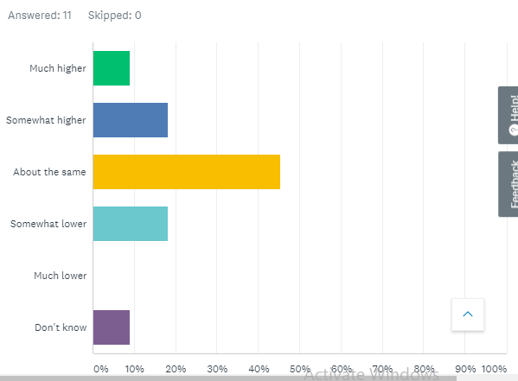
According to the feedback from five customers, we can deduce that 45.45% believe the prices to be comparable to those of other supermarkets, while 18.18% believe they are lower. As a result, it is reasonable to draw the conclusion that Market Express needs to arrive at some sound conclusions on the method that it will take to pricing its products. Market Express has an opportunity to establish itself as the dominant player in the supershop category since it will be able to keep its prices competitive even while its rivals raise their prices.
Q2: How likely are you to refer any of our competitors to a friend or coworker?
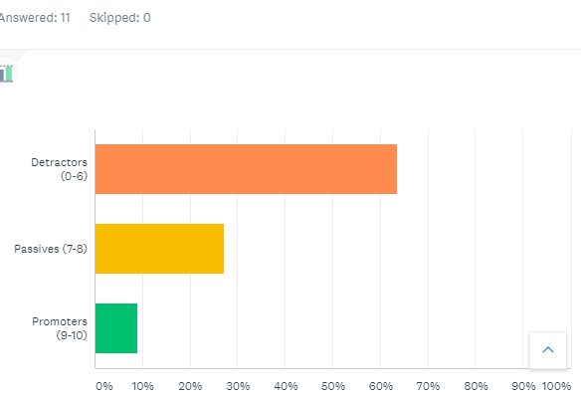
From the responses of the 5 customers polled, it is clear that the vast majority do not recommend the establishments mentioned above to their friends, family, and coworkers. Therefore, Market Express should work to enhance both the quality and affordability of its offerings. Moreover, 27.27 percent of diners will give the eateries a positive review without actively doing so. So, here's a chance for Market Express since the number of people recommending the restaurant will skyrocket if they make some changes to the quality of their products and prices.
Q3- In general, how would you rate a supershop that you have been to?

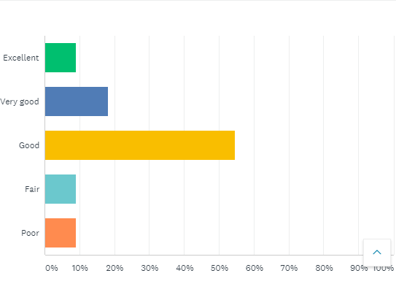
The results of this poll tell us that 54.55 percent of respondents prefer to go elsewhere for their product purchase, as well as for their other basic needs. The feedback from clients is typical. The fact that the majority of shoppers are dissatisfied with existing options bodes well for the success of this enterprise. In order to fill a void in the market, Market Express can improve the quality of its products and receive higher customer ratings.
Q4- How effectively do other upershop staff conduct themselves?
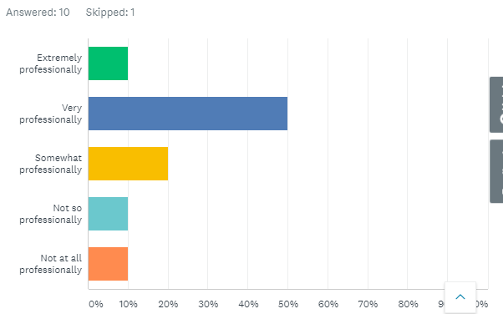
It's clear from looking into this subject that some supershop staff members are more cordial and service-oriented towards customers, which should help with the final decision. Since the vast majority of clients spoke highly of the staff's professionalism, this is the case. As our survey shows, customers have a favorable impression of the company's level of professionalism because of the employees' direct interaction with them. This is especially true in the early stages of the company's development, when both employees and owners are working hard to foster positive relationships with customers in order to anticipate and meet their needs. So, if Market Express is serious about opening this restaurant, it must hire competent and hospitable staff members if it is to compete with the best establishments in the country.
Q5- What is your first impression of the supershop goods you just purchased?
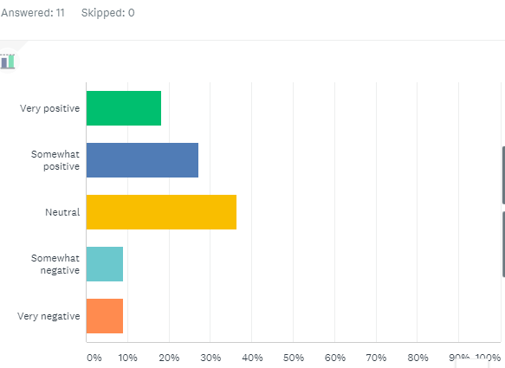
After using the product, the vast majority of consumers had a lukewarm response at best. As there are customers that have a positive reaction, Market Express has room to grow in the future. In order to win over customers, Market Express must deliver not only high-quality goods but also excellent service. All of these things can increase the likelihood of a favorable response from clients.
Market Express is going to be a brand-new supershop venture. While initial client feedback may be mixed, Market Express will eventually win over skeptics with its superior products and service, as well as by avoiding the flaws that make its competitors attractive to customers.

2.1 Internal Analysis of Market Express

2.1.1 SWOT Analysis
The SWOT analysis of Market Express is presently being addressed in order to better understand its strengths, weaknesses, opportunities, and threats.
Strength  1. In different of products, customer demands more variety.  2. Market Express has advanced automation in sales and inventory management system  3. Professional and educated employee.  4. Enough equipment ability to fulfil demand. | Weakness  - The investment range is very high  - Risk of financial is very high.  - Huge market competition.
Opportunity  - Locating near the residential area will boost up the sales.  - People from different area will be informed in match time.  - Easily getting new customer for selling all types of products.  - Easy way to expand product range. | Threats  - More than 5 competitors are located nearby  - Downturn economic situation of the country.  - Less possibilities of sales during no match time.

2.1.2 Competitor Analysis
Tesco, ASDA, Sainsbury, Morrison etc. are the major competitor in the supershop market of the UK. Details about these competitors are listed below:
Tesco
As one of the Big Four supermarket chains in the United Kingdom, Tesco faces stiff competition from Sainsbury's, ASDA, and Morrison's. Waitrose is a second major retailer that is second only to the Big Four in terms of size. During this time period, German discount supermarket chains Aldi and Lidl have emerged as formidable rivals in the British grocery industry.
Convenience stores, which compete with Tesco, are on the rise as shoppers opt to make fewer but more frequent excursions to the grocery store. There are a lot of different players in the convenience store industry. Tesco has a 27% share of the U.K. grocery market as of the end of 2020, followed by Sainsbury's (15.7%) and ASDA (14.1%). Aldi and Lidl have been eating into the huge incumbent's market share for the past five years.
ASDA
ASDA, which had been a wholly owned subsidiary of Walmart since its takeover in 1999, was acquired by Zuber, Mohsin Issa, and TDR Capital on October 2, 2020. Of the company's 635 stores, 584 are supermarkets. Supermarkets of a bigger format are also run by ASDA, and in addition to goods, they stock a wide variety of other products like apparel and home decor. As part of its aim to compete with the other "Big Four" supermarkets in the United Kingdom, ASDA places a premium on offering the lowest pricing. The corporation is also updating the design of its stores and its online sales platform to cater to modern consumers. ASDA is also trying to increase the healthfulness of its private-label offerings.
Sainsbury
With 1,418 stores, Sainsbury's ranks as the UK's number two supermarket chain. It's safe to say that supermarkets and convenience stores each account for about half of these establishments. Sainsbury's is widely recognized as the best supermarket in terms of quality, as evidenced by consumer ratings and brand strength studies. This allows it to charge a premium for groceries, however cutting prices has been a key part of the company's competitive strategy as of late. Sainsbury's is trying out new store designs, adding more general item selections, and advertising its in-store banking services to attract and retain more customers. Plans to increase the number of stores include a focus on the convenience concept.
Morrisons
The company Morrisons runs 492 supermarkets and 50 drugstores. The corporation is also heavily involved in food production, contributing to the industry to the point that it is the second-largest producer in the United Kingdom. Morrisons employs farmers to supply it with chicken, beef, and produce, and also has 18 food processing plants and 8 distribution hubs. Morrisons is striving to reduce everyday pricing by boosting efficiency through its vertically integrated structure. One component of the strategic price review is the development of a less extreme method of promotional pricing. Morrisons is opening fewer, smaller stores due to its stringent capital investment budget.

2.2 External Analysis of Market Express

2.2.1 PESTEL Analysis
Political Factors
The success of the grocery as well as supermarket business depends on a peaceful world. Tesco, Walmart, Carrefour, Kroger, Sobeys, Lidl, Aldi, and Costco are just a few of the major retailers that collaborate with domestic and international suppliers. The retailers will feel the effects of any issues with their global suppliers. There are a number of ways in which political tensions could affect the food retail sector. For instance, the costs and duration of importing goods to the UK from the EU have been affected by the introduction of new regulations in the wake of Brexit. An estimated eighty percent of the United Kingdom's food imports originate in the European Union (Walker and Mugudubi, 2021).
Protests against multinational corporations are commonplace in many countries. For instance, in several French cities, residents have protested against Amazon, claiming that the company is responsible for urbanizing previously rural areas (Aljazeera, 2021). Protests of a similar nature have occurred against other international retail giants in a variety of countries.
Economic Factors
Financial conditions have an immediate effect on the supermarket and food supply industry. Those who are employed and have some financial flexibility will likely spend more money on food than those who are less well off. Similarly, supermarkets provide specialized services for various demographics. Products with higher price tags are aimed at those with more disposable income than those with more limited means.
Supermarkets have to charge more for their goods because of rising property rent, local authority fees, and tax rates. Though many economies had a rough 2020, the outlook for the years after is promising for the grocery business.
Social Factors
Many stores in the United Kingdom, the United States, and elsewhere stock items designed to meet the needs of customers of various cultural backgrounds. The market for ethnic foods around the world is projected to expand rapidly over the next five years. And as the market for vegetarian and vegan options continues to grow, businesses should not miss out on the opportunities this trend presents. The favorable age distribution in Africa, the Middle East, and Asia bodes well for the grocery retail industry in those regions (Wunsch, 2020). This is partly due to the fact that more and more people are escaping poverty. However, as more and more people learn about the risks associated with sugary products, retailers will see fewer orders for a wide variety of products.
Technological Factors
As a result of technological advancements, grocery stores now function very differently from their predecessors. Most stores now use digital loyalty cards, and stock levels are tracked by computer. Moreover, they promote their products on numerous social networking sites.
Unfortunately, a shortage of qualified IT workers at brick-and-mortar stores is a significant obstacle for retailers. Cybersecurity flaws and data loss can provide their own unique sets of difficulties.
Environmental Factors
Retail operations have an effect on the natural world. For instance, food packaging is directly responsible for various environmental problems such as pollution, and overloaded landfills. Likewise, technologies and gadgets used for frozen products consume a lot of energy and create greenhouse emissions. Therefore, it is imperative that stores always work to lessen the harm they cause to the planet.
The PESTEL analysis of the food and supermarket industry is incomplete without an examination of the legal environment. Countries have varied rules and regulations which influence on the shops differently. For instance, merchants must pay at least the minimum wages in the UK. Likewise, the Equality Act 2010 safeguards people from job discrimination in the country.
Examining the strengths, weaknesses, opportunities, and threats facing the United States

Section 3-Product and Services
Meat & fish
- 500g pack of chicken breast
- pack of cod
- pack of salmon
Dairy
- 5 liters of semi-skimmed milk
- 6 eggs
- 1kg of Greek yogurt
- 1 500g block of cheese
Vegetables and fruit
- 1 large bag of apples
- 2 bunches of bananas
- 1 bag of mandarins
- 1 punnet of grapes / strawberries / blueberries / mango
- 1 punnet of cherry tomatoes
- 1 cucumber
- A bag of 3 peppers
- 2 onions
Freezer
- 1 or 2 packs of frozen vegetable
- 2 pizzas
- Frozen fruit for oatmeal or smoothies
Bread & bread spreads
- Peanut butter
- 1 loaf of whole-grain bread
- A bag of 8 buns
- Croissants
- 2 packs of oatmeal
- 1 jar of jam
- 1 pack of rice cakes
Dry Goods
- Pasta
- 2 cans of chopped tomatoes
- 1 can of coconut milk
- 1 carton fo almond milk
- 1 box of tea
- 1 pack of coffee
Care Products
- 1 pack of toilet paper
- 1 pack of kitchen roll
- 1 tube of toothpaste
- 1 can of deodorant
- 1 bottle of laundry detergent
- 1 bottle of fabric softener
- 1 bottle of washing up liquid

3.1 Sales literature
Competitors, commuters, bankers, parents for coffee mornings, harried professionals on the way to work, harried students on the way to class, first dates, study partners, readers, and WIFI obsessives are just some of the cliente we're aiming for. We expect to have at least 1000 customers each day during our slow time(coffee, 2020). We won't be focusing on our competitors so much as keeping our prices low and launching a loyalty card program for all of our new café customers in the hopes of keeping the millennials as customers. Market Express plans to attract customers by providing them with various products that change with the seasons, such as pumpkin spice lattes in the fall. In addition, the vast majority of shoppers want to save money whenever possible. Products from Market Express are of the highest quality and are priced affordably. With our ticket service and online purchase system, customers who are at the workplace or on the train will know exactly when their items will arrive. We surveyed over fifty people and produced a questionnaire to better understand the market, since marketing is a crucial part of our development plan. Then we had a social media data collection, so we created a Facebook page and got some more numbers to help us figure out what our clients wanted. Besides putting up a "opening soon" banner outside the storefront and promoting themselves on Facebook, Twitter, and Instagram, Market Express will also put up a pavement sign close to the train station to let people know they're open for business. We won't be focusing on our competitors so much as keeping prices low and launching a loyalty card program for all of our new customers in the café sector in the hopes of keeping the millennials as customers. Market Express plans to attract customers by providing them with beverages that change with the seasons. For example, in the fall, we may provide beverages with pumpkin spice tastes. The name, logo, and social media handles of our business will be printed on the takeout coffee cups our customers take with them. With the rise in mobile device use, we plan to promote our ads on social media, where we want to attract a large audience by offering deep discounts in the form of electronic coupons, buy-one-get-one deals, lunch specials, and more. For example, in the mornings, Market Express will be handing out free samples of expresso. Market Express plans to provide complimentary Wi-Fi and charging stations for customers' electronic devices. One research found that businesses who offered free Wi-Fi saw a 40 percent increase in consumer time spent and a 50 percent increase in revenue. We anticipate a high volume of consumers thanks to our big service staff, which will enable us to accommodate walk-ins without limiting service quality. Since we provide our services based on seasonal foods, we take great pride in offering our patrons a menu that is subject to change on a regular basis but always delicious. A sample menu and café price list for Market Express is included in the appendix at the end of this business plan.

4. Management Team
A management team can be thought of as a collection of senior employees that a business owner has employed to handle work responsibilities within the company. These people make up the top layers of management inside a company, and each has a particular field of business management expertise. The management group is in charge of ensuring that the business firm's entire workforce is committed to accomplishing shared organizational goals and objectives. A management team is necessary to ensure that everything proceeds in line with the predetermined organizational plan established by the management for the company to perform at its highest level. Similar to this, effective team management is essential since these individuals help the employees to feel more motivated and productive.

4.1 Importance of Management Team:
For the business model of the company to expand and develop sustainably, a management team is necessary. A management team's main goal is to help business owners or sponsors identify, assess, and take the appropriate business actions as outlined in the company's strategic business plan. Moreover, the management team also offers a venue for the organization to debate and address a variety of business challenges to ensure efficient business operation. Additionally, Effective team management is crucial for fostering team-building inside the organization, which enhances job performance and boosts work efficiency. Effective team management also gives every employee in a business the chance to acquire new knowledge and abilities, which eventually leads to an improvement in job performance. Similarly, an effective team management also strives to eliminate unwarranted conflicts between employees and within various functional and managerial teams to boost job satisfaction and lower employee turnover.

4.2 Mission and Vision:
A vision statement may be thought of as a public statement that incorporates the expected future position of the company. Thus, it is a business document that outlines the organization's present and future goals as well as what the owners and management team hope to accomplish in the long term. On the other hand, A mission statement provides a succinct description of an organization's purpose. As a result, it clarifies the organization's purpose and its overall aim, which is backed by the vision and utilized by management to convey purpose and direction to staff members, clients, and other important stakeholders of the business. Market Express is not an exception. The management team of Market Express will inform the general public about the company's future goals through the vision statement. The management team of Market Express, on the other hand, will use the mission statement to enlighten, clarify, and alert the personnel about the previously decided organizational goals and objectives. The management will know that everyone is acting in accordance with expectations by doing this.

4.3 Risk management:
The systematic process of detecting, assessing, and prioritizing various business risks is known as risk management. This is followed by the efficient and well-coordinated use of resources to reduce, manage, and regulate the likelihood of the risk occurring and the severity of the losses that would result from it. Market Express' management must take an active role in identifying and analyzing any potential hazards to the business. The impact of the risks on the firm should be assessed when they have been discovered and examined. Market Express will work in the supermarket chain sector; thus, the company's main business risks are those related to customers, supplier, competitiveness, liquidity, data protection, compliance, food safety and workplace safety. To prepare for such risks and hazards, the management team must be prepared. When handling a potential crisis, the team should have a strategy in place.

4.4 PESTLE Analysis:
A PESTLE analysis is a strategic business approach that relies on the systematic investigation of several important external business environment elements that might have a substantial influence on the firm's revenue, profitability, and other critical operational features (Del Mar Fuentes-Fuentes, 2016). Since the Market Express will be based in the UK, several political factors like BREXIT are expected to have a detrimental impact on the company's business performance and supply chain system. Economic factors like sluggish economic growth of UK, depreciation of the British pound sterling against US dollar in recent years will have negative impact on the revenue and profitability of the business of Market Express. Different social factors like increased preference of people in online shopping in recent years especially during the recent pandemic period will have favorable impact on the sales revenue and profitability of the business. The recent development in technology such as self-service checkout point will favorably influence the performance of Market Express in the coming years. Market Express will have to concentrate on minimizing its greenhouse emissions in the atmosphere while operating its convenience store in Westminster due to rising pressure on businesses to address environmental concerns and implement operational practices that what would contribute to the betterment of the society.

4.5 Management Team Structure:
An organization's management hierarchy is organized according to a management structure. A hierarchy is present in practically all organizations. The organization's hierarchy establishes the lines of power, channels of communication, and obligations. It also dictates how information is shared between the various levels of management and how power, authority, responsibilities and duties are given, regulated, and integrated among different members employed in the business. Thus, how information is transferred across layers of the organization as well as how duties and responsibilities are distributed and managed are governed by its management structure which enable the business firm to maintain efficiency and focus(Fuentes-Fuentes, 2016).
The management team structure of Market Express is shown below:

Figure 1 Source: (Fuentes-Fuentes, 2016)

- Board of Directors:
The board of directors of the proposed business venture will be comprised of 7 directors. The five owners of the business will act as the sponsor director of the Market Express. The General manager of the business will act as the executive director of the business. The other member of the board will act as a sponsor director who will represent the angel investors for the purpose of safeguarding the angel investor’s investment in the proposed business venture. The directors will not receive any remuneration from the business for presiding over the board.
- General Manager:
The highest-ranking executive in a business is the General manager who is tasked with making significant business decisions as well as overseeing a company's overall operations and resources. As the highest-ranking employee at Master Express, the general manager is in charge of overseeing all staff members, overseeing the preparation of the company's budgets for optimal resource allocation, and managing the company's organizational structure and long-term organizational strategy to ensure Master Express's continued success in the fiercely competitive UK supermarket chain sector. The remuneration of the general manager of Master Express will be £60000 per year. The duties and responsibilities of general manager of Master Express are described below:
- Developing business policies:
Effective and efficient business policies regulate a business.
These organizational rules will assist the general manager in establishing a common ground for the whole team because the individuals working in the business are diverse and their individual perceptions vary as well.
At Master Express, the general manager will be in charge of developing and overseeing the execution of strategic business policies that are acceptable to everyone.
- Effective team building:
Top talent is attracted to firms by general manager who are effective. As the general manager of Master Express, he will be in charge of developing and managing the senior leadership team, who in turn recruit and manage top and middle management within their divisions, but they are not in charge of hiring or firing every individual employee.
- Communicating with different stakeholders:
As the public face of the firm, the general manager of Master Express will be responsible for representing the company in front of the general public, the press, legislators, workforce, customers, suppliers, or any other stakeholders who are directly or indirectly interested in business operations.
- Effective decision making:
The general manager of Master Express will make the majority of the choices, while some will be made by the other managers as well. The general manager will decide on marketing tactics, budget changes, recruiting and firing decisions, and personnel rotation. He will seek the advice of other managers in certain circumstances.
A person must meet a number of requirements in order to be eligible to serve as a general manager at Master Express. The candidate should have three to five years of general manager experience in the same or a relatively related business. A person must also possess exceptional enthusiasm, great leadership abilities, excellent communication skills, and a distinct vision of the supermarket industry. The general manager should have a problem-solving perspective because she will be in charge of the majority of the work that is done. Professional degrees in a field connected to business will be advantageous.

- Finance Manager:
As a top ranking official of a business firm, the financial manager is in charge of allocating financial resources for effective management of asset structure in order to achieve the optimum combination of financing options and formulate an acceptable dividend policy in light of the company's goals. As the financial manager of Master Express, the duties of a financial manager will be:
- generating different periodic managerial and financial reports
- forecasting periodic cash flow of the business through the preparation of periodical cash flow statement
- Preparing master budget for forecasting revenue, and different types of cost.
- Disseminating relevant financial information to interested parties within Master Express to facilitate the financial decision-making process.
- Assessing the capital investing decisions
- Management of financial loss risk through budgeting
As the finance manager of Master Express, he/she will receive £36000 per year as remuneration. He/she should have 2 to 3year experience as a finance manager in any supermarket business firm or any firm operating in the related industry.

- Procurement Manager:
As the Procurement Manager of Master Express, he/she will be responsible for overseeing the firm's overall supply chain process. Thus, the project manager will be in charge of selecting and assessing suppliers, ensuring that merchandise procurement proceeds smoothly, manage cost-effective negotiations with suppliers without compromising the quality of procured merchandise, as well as developing and implementing an effective and efficient inventory management system to shorten lead times in the supply chain system. The monthly remuneration of procurement manager will be £36000 per year.

- Distribution manager:
As Master Express's distribution manager, the employed person's main responsibility will be the delivery of goods from the warehouse to the convenience store of the company as well as delivering the sold goods from online orders to clients along with identifying for logistical issues in the distribution process and developing plans to resolve the issues. The monthly remuneration of distribution manager will be £36000 per year(Bărbuţă-Mişu, 2018)..
- Human Resource Manager:
as the human resource manager of Master Express, the hired candidate is responsible for developing human resource strategy in line with long term strategy of the proposed convenience store, identifying potential candidates for the middle and lower level management of the convenience store, developing proper compensation structure for the employees, arranging different types of training programs for improving employee skills and experience as well as to ensure that human resource strategy and the compensation structure complies with different rules and regulation outlined in the prevalent labor and employment laws of UK. The monthly remuneration of human resource manager will be £36000 per year
- Store manager:
As the Store Manager of the proposer convenience store, the recruited individual will be responsible for overseeing the daily operations of their store to making sure that the business operation of the proposed superstore runs smoothly and effectively in Westminster. thus, the store manager will be responsible to develop business strategies to manage the checkout section of the superstore as well as to provide quick customer service and resolve consumer complaints as soon as possible to ensure superior customer satisfaction to the target market. The monthly remuneration of human resource manager will be £36000 per year
Each of these functional managers will be supported by two line managers.

4.6 Meetings of the Management Team:
In a financial year, the management will hold two different types of meetings. Weekly and monthly meetings will be on the agenda.
- Weekly meetings
The last day of the week will be the time for this kind of discussion. The purpose of the meeting will be to provide an update on the different operational aspects of the business. During the meeting, the plans for the upcoming week will be reviewed, and any recent developments will also be covered.
- Monthly Meeting:
At the conclusion of each month, a meeting will be conducted. All of the information gathered over the month will be combined by the management team. Besides, the board of directors will convene at the end of each month to evaluate the strategy and performance of the proposed venture.

5. Target Market

5.1 Market Analysis:
The Master Express is a potential superstore brand featuring a physical and mortar and an automotive shop in Westminster, London, United Kingdom. It will be set up like a convenience shop and sell a variety of grocery goods under both private label and name-brand labels. In terms of revenue, the UK supermarket industry's market size is expected to reach £188.1 billion in 2021. Between 2017 and 2021, the market size of the UK's supermarkets sector increased by an average of 7.6% per year. While the global supermarket sector grew more slowly, the UK's supermarket market grew more quickly. The wholesale and retail trade sector for supermarkets in the UK is ranked first in all of Europe. The market size of the UK supermarket sector is anticipated to rise by an average of 11.3% each year between 2022 and 2027, providing a solid business opportunity for the company's shareholders to open a convenient superstore in Westminster.

5.2 Market Segmentation:
A convenience shop will be beneficial to a variety of individuals in Westminster, the area that houses the UK's Houses of Parliament, as well as several historical attractions including Buckingham Palace, Westminster Abbey, 10 Downing Street, Bigben, Trafalgar Square, and other open parks along with globally renowned football clubs such as Chelsea FC, Arsenal FC. As a result, Master Express will be able to offer its service to a wide range of people ranging from local residents, government and private office workers, students as well as both domestic and foreign tourists visiting different historical monuments such as Buckingham palace, Bigben, 10 Downing Street(Bărbuţă-Mişu, 2018).
The following table shows the market segmentation of the proposed convenience store, Master Express:
Segmentation Criteria |  | Target Customer Segment
Geographic | Region | London, UK
Geographic | Concentration | Urban
Demographic | Age | People of all age
Demographic | Gender | Both Male and Female
Demographic | Income | Middle and low-income people
Demographic | Occupation | Employees, professionals, tourists
Demographic | Social class | Working class, lower middle class, middle class
Psychographic | Lifestyle | Traditionalists, mainstreamer individuals, reserved, cost conscious
Behavioral | Benefit sought | Cost advantage, value seeking
Behavioral | Attitude | Positive, easy going

5.3 Target Market Strategy:
Based on the market segmentation table, target customer segment for Master Express will be both male and female living in the urban area of Westminster. Master Express will first employ a mass marketing targeting strategy in which it will target the whole market while ignoring disparities between market segments. However, the focus of the target market strategy will eventually shift towards the cost-conscious individuals living and visiting the Westminster who are sensitive to price changes of merchandise and prefer value proposition.

5.4 Market Growth:
Over the next five years, the UK grocery market is forecast to increase by 11.3%, with discounters predicted to have the quickest rate of growth as the cost-of-living challenge takes over as the industry's main obstacle. Additionally, it was estimated that the market's overall worth will increase from £188.1 billion in 2021 to £241.3 billion by 2027. Discount superstores like Aldi, Lidl is expected to expand at the quickest rate over the next five years, by 23.9% to £7.1 billion within 2027. More households trying to save money during the time of economic downturn arising from the BREXIT, pandemic and onging Russo-Ukranian war will be the driving force behind this.

5.5 Marketing plan:
The major goal of this marketing strategy is to evaluate Market Express's various marketing tactics in order to determine whether it would be commercially viable in the very competitive UK supermarket chain market. The retail industry experienced a decline as a result of customers' reduced spending as a consequence of the statewide lockdown following the Covid-19 pandemic in the early 2020 breakout. The pandemic's emergence, however, led to a rise in the number of customers who prefer to purchase online to save time and prevent viral transmission. The most important aim for the proposed business venture Is to delivery of Quality products or merchandise at a competitive price as well as to offer superior customer service to the target consumers. To provide superior customer value as well as to expand market share in the London, the firm will continuous investment in technology, infrastructure, supply chain system, employee training and diversified portfolio in the coming years(Bărbuţă-Mişu, 2018)..

5.5.1 Market positioning statement:
To become a successful brand in the UK supermarket industry, Market Express will focus on different marketing positing strategy to occupy a distinct, appealing position in relation to rivals’ market offerings in the target market.
The management of Market Express will be able to provide branded items of greater quality with improved functionality under the functional positioning approach. Through this positioning approach, Market Express, for instance, will be able to market its higher cost unique items. Since the superstore will be able to charge a higher price due to the merchandise's superior functionality and quality, products offered through this positioning approach will typically be more expensive compared to the convenience store's basic variety of merchandises. Market Express will be able to sell its essential or standard goods via the use of price positioning strategy as this strategy will enable the proposed business firm to draw in price-sensitive client segments that are more concerned with the price of the goods compared to rival supermarket corporations. Market Express may also use the multi-segment positioning strategy to simultaneously target several segments with various items.

5.5.2 Pricing strategy:
One crucial element of the marketing mix is the pricing strategy, which is used to determine the appropriate price for a good or service. Such a strategy is crucial for the business's performance since it enables you to set pricing that will optimize performance and profitability while taking into account the market. Based on the strategic market decision of the firm to expand its business operation aggressively in the London supermarket industry, the firm will the market penetration pricing strategy. Market Express will sell its products at a low starting price as part of the market penetration pricing strategy in an effort to attract clients and increase sales revenue and market share. A cheap initial price guarantees market acceptability and creates client habits, which is the justification for selecting this technique. Market Express will be able to attract clients' attention with competitive pricing and offer the greatest deal, then wow and excite them to keep them loyal to the brand and encourage them to make repeated purchases.
To support the market penetration strategy, Market Express will employ two pricing strategies: value-based pricing and cost-plus pricing. Market Express will use the cost-plus pricing technique to set cheaper prices for its branded and non-standardized merchandise without sacrificing the quality of the goods. Such pricing strategy is essential to grow sustainably in the highly competitive UK supermarket industry as both industry incumbents such as Asda, Tesco, Sainsbury as well as discount supermarket chain such as Aldi and Lidl primarily rely on this pricing strategy to expand their market share. Market Express must achieve economies of scale in its business operations in order to benefit from this pricing strategy. It will have to continuously collaborates with its suppliers to build an effective and efficient supply chain, which will help to lower the cost of acquiring the goods and enable the management of Market Express to offer high-quality products at lower prices.
With value-based pricing, Market express will be able to charge higher price for the unique and standardized merchandise of the convenience store due to their higher product quality and functionality. This pricing strategy will be used by Market Express to sell higher quality exclusive branded and private labelled merchandises of the firm.

5.5.3 Distribution Strategy:
The goal of the distribution strategy is to make sure that customers can find the products they desire with ease. To guarantee that customers can readily and swiftly obtain the items, the business firm often makes large investments in its distribution system.
Market express will follow the direct distribution strategy in which the convenience store will sell its goods directly to customers through its website and retail store in the Westminster. As a result, Market Express will employ both physical and online distribution channels as its primary direct distribution methods. The Westminster retail supermarket will serve as the foundation for the offline distribution channel's operations. There, a variety of goods will be exhibited on shelves, and customers may choose what they want to buy and pay for it in the store's checkout counter. On the other hand, the supermarket's website will serve as the operational hub for the online distribution channel. Following receipt of the customer's online orders, the business will deliver the products to the customer's preferred location for a predetermined fee.

5.5.4 Promotional Strategy:
Another component of the marketing mix that is frequently utilized by commercial enterprises to promote, advertise, and sell their market offerings to the customers is referred to as promotional strategy. Market Express will use advertising, sales promotion and public promotion.
Before selecting appropriate channel for advertising the product to the target market, a survey has been conducted on a sample of people in the Westminster to assess whether traditional printing media such as television, radio or the social media advertising such as Facebook, YouTube, Twitter, Instagram. The result of the survey is show below:

Based on the survey result, it can be opined that most of the respondents view social media marketing as one of the effective advertisings channels for promoting a firm’s product. Thus, the management of Market Enterprise will hire the professional social media marketing agency, Spin Brands to develop and implement an aggressive social media marketing strategy for the convenience superstore.
Sales promotion techniques helps the business firms to achieve rapid growth in sales in a short period of time. Market Express will different sales promotional tactics to expand its market share in the UK supermarket industry. At the beginning of the convenience store, the management of Market Express will launch a referral program in which People will receive one time 10% discount during their shopping in the convenience store if they refer or recommend the brand to five people in the social media. Besides, A variety of sales promotion strategies will occasionally be used by Market Express. The company will launch a "buy one, get one" (BOGO) promotion in which the convenience store will give away an additional item for free when customers buy the same grocery item or a grocery item with a higher value. Given that 76% of customers indicate they prefer BOGO to all other discount offers and that 95% have used BOGO offers once minimum once, this is a crucial sales promotion strategy in the UK supermarket sector. Similarly, the convenience store will launch flash sale campaign in which the business will offer different merchandises at deeply discounted prices for short period of time at different occasions such as 25% flat discount on all merchandise at the Christmas day or at Black Friday etc. Similarly, the superstore will offer discounts, coupons voucher, free shipping on online purchases etc. Within the first quarter after opening, Market Express will roll out a loyalty program that will enable the convenience store to identifying and targeting its loyal clientele. Every time a customer uses their loyalty card to make a purchase, they get points. these points can be redeemed for exclusive deals and discounts.

5.5.5 Marketing Promotion Budget:
The marketing promotion budget of Market Express for 2022 is shown below:
Particulars | Expected Cost
Hiring of Spin Brands | £20000
Funds for advertisement in print media | £10000
Funds for sales promotion tactics | £42500
Development cost of Loyalty program | £15000
Funds for sponsoring different charitable and public programs | £20000
Total budget for Marketing promotion of Market Express | £107500

5.5.6 Recommendation:
The management of Market Express should focus on extensive marketing promotional tactics to penetrate aggressively the grocery food industry of London to ensure the sustainable development of the proposed business venture. Industry incumbents of UK supermarket industry hugely relies on the marketing promotional techniques not only to retain its existing customers by improving consumer loyalty but also to attract new customers by offering different promotional offers. The management of Market Express should focus on promoting its brand in the social media platforms through the development and implementation of an effective social media marketing strategy as social media marketing is very cost effective and helps to reach a large number of audiences compared to the traditional print media marketing. Similarly, Market Express should make sizeable investment in the promotional activities as people in UK prefers these promotional offers while making purchase in the supermarkets.

6. Financial Plan

6.1 Project description:
The financial manager will be in charge of overseeing the launching of the proposed business venture starting on January 1st 2022 and all fiscal aspects, including the development of a financial plan with financial projections. In order to assist the management in making financial choices, the financial manager will be tasked with preparing financial statements, firm activity reports and identifying cost-cutting opportunities.

6.2 Project funding requirement:
Table 01: Funding sources of the proposed venture
Source | Amount
Long term Bank Loan | £800,000
Equity Investment from shareholders | £800,000
Contribution from Angel investors | £250,000
Total funds raised | £1,850,000

To finance the proposed business venture, the 5 shareholders of Market Express will each make an initial equity investment of £150000, thus a total of £800,000 will be injected as the capital investment by the shareholders. This equity investment will be only redeemed when the firm will make an initial public offering in the London stock exchange. However, this initial equity investment will not be enough to support the initial investment of overall asset structure of the business. Thus, the shareholders of Market Express will resort to long term bank loans and angel investment. Bank loans are regarded as a major means of raising capital for Market Express, not due to a lack of equity investment but rather to take advantage of applicable deductions. The loan's interest payment is an eligible deduction that lowers the business's chargeable income and, as a result, lowers its tax burden. the shareholders will arrange a long-term loan of £800,000 from a commercial bank at 9% interest rate for a period of 9 years. Similarly, the shareholders will also raise £250,000 from angel investors to meet financing requirements. Additionally, the shareholders will arrange £150000 more in angel investment in the second year of business operation.
Table 02: Budgeted Total Capital Investment for the Opening of Market Express
Particulars | Amount
Store
Store – Leasing | £900,000
Store preparation - Renovation | £144,000
Equipment and machinery:
Cost of equipment and machinery | £450,000
Installation (25% of the Book value) | £112,500
Engineering consulting fee (10% of Book value) | £45,000
Preliminary expenses (2.5% of Book value) | £11,250
Cost of Delivery vans | £85,000
Total Capital investment | £1,747,750

The store of Market Express will be financed through a financial lease agreement. Thus, A financial lease arrangement will be used to finance Market Express's shop, under which Market Express will pay the lessor entity a predetermined annual lease payment in exchange for ownership of the leased asset at the conclusion of the lease period. The lease will be for a period of ten years. Although Market Express won't be the owner of the shop for the duration of the lease, the proposed business venture will be in charge of all store maintenance expense. The investment in equipment of machinery includes the procurement of fixtures, displaying selves, racks, QR code scanner, BAR code scanner, checkout counters, computers, security cameras, trash cans, forklifts, hanger stands, refrigeration equipment, glass cases etc. Two vans will be purchased for £85,000. One of the vans will be used to procure materials from suppliers and deliver to the warehouse of the store. The other van will be used to deliver the merchandise of online orders of the customers.
Table 03: Project Annual Compensation of Employees in 2023
Particulars | Amount | Amount
General manager (5,000 x 12) | £60,000
Finance manager (3000 x 12) | £36,000
Procurement manager (3000 x 12) | £36,000
Distribution manager (3000 x 12) | £36,000
Human resource manager (3000 x 12) | £36,000
Store manager (3000 x 12) | £36,000
Line manager-10 employee (2300 x 12*10) | £276,000
Staffs-8 employee (1800 x 12*8) | £172,800
Drivers (1550 x12 *2) | £37,200
Security Personnel (1600*12*4) | £76,800
Total Salary Expenses |  | £802,800

Table 04: Total Operational Cost of Market Express in 2023
Total Cost of Market Express in 2023
Cost of Merchandise
Procurement cost of Grocery Merchandise | £840,000
Procurement cost of Non-grocery Merchandise | £315,200
Procurement cost of apparels | £116,800
Total cost of merchandise |  | £1,272,000
General and administrative expense
Salary expense | £802,800
Packaging materials | £30,000
Maintenance cost of equipment and vans (3% of total book value of equipment and delivery van) | £16,050
Promotional Expenses | £107,500
Warehousing expenses | £0
Rates | £2,200
Stationery expenses | £1,500
Waste management expenses | £2,500
Legal fees | £4,000
Utility expenses | £5,500
Fuel expenses | £19,000
Insurance expenses | £9,000
Miscellaneous expenses | £2,500
Bank charges | £2,500
Total General and Administrative Expense |  | £1,005,050
Finance Cost
Interest expense (9% of bank loan) |  | £68,000
The total cost of operation |  | £2,345,050

The total cost of Market Express is comprised of cost of merchandise, total administrative and general expenses and financial cost. Total cost of merchandise of Market Express in 2023 is £1,272,000 of which £840000 will be spent on the procurement of grocery merchandises, £315200 will be spent on the procurement of non-grocery merchandises and £116800 will be spent on the procurement of apparel merchandises. The total general and administrative expense of the business is projected to be £1005050 in 2023. Salary expense (£802800) is projected to be largest cost driver of the general and administrative expenses of Market Express in 2023. The interest expense is projected to £68000 for 2023. As a result, total operational cost of Market Express will be £2345050 in 2023.
Table 05: Projected Income statement of Market Express
 | 2023 | 2024 | 2025 | 2026
Sales revenue | £2,044,000 | £2,759,400 | £3,725,190 | £5,029,007
Cost of sales | £1,272,000 | £1,717,200 | £2,318,220 | £3,129,597
Gross Profit | £772,000 | £1,042,200 | £1,406,970 | £1,899,410
General and Administrative expenses | £1,005,050 | £1,035,202 | £1,066,258 | £1,098,245
Finance cost | £68,000 | £68,000 | £68,000 | £68,000
Net profit/loss before tax | -£301,050 | -£61,002 | £272,712 | £733,164
Tax paid |  |  | £81,814 | £219,949
Net profit/loss after tax | -£301,050 | -£61,002 | £190,899 | £513,215

It is assumed that the sales revenue of the proposed business venture will be £2,044,000 in 2023. This projected revenue of the Market Express is based on the fact that the supercenter is located in one of the busiest areas of UK as well as the favorable growth rate of the UK supermarket industry. It is assumed that the revenue will grow at the rate of 35% from 2024 to 2026. The 35% revenue growth rate is based on the assumption that the aggressive market promotional activities will help the business firm to attract a large number of consumers, thus boosting the demand and revenue of the firm in the coming years. The cost of sales is assumed to be 62% of total sales revenue. The cost of sales is expected to increase linearly with the increase in sales revenue. The general and administrative expenses of Market Express in 2023 is £1005050 which is expected to increase at 5% up to 2026. Since the proposed business venture is a startup, it is expected that the firm will enjoy tax exemption from the UK for the first two years of business operation. However, an annual 30% tax rate will be imposed on the profit of the firm from 2025.
Table 06: Projected Balance sheet of Market Express
 | 2023 | 2024 | 2025 | 2026
Non-current asset
Right of use asset – Store | £1,044,000 | £984,000 | £985,000 | £981,000
Delivery vans | £85,000 | £112,000 | £147,780 | £193,548
Property, Plant and Equipment | £450,000 | £295,000 | £397,500 | £344,500
Total Book value of Non-current Assets | £1,579,000 | £1,391,000 | £1,530,280 | £1,519,048
Depreciation | £157,900 | £130,600 | £141,828 | £137,127
Net Book Value | £1,421,100 | £1,260,400 | £1,388,452 | £1,381,921
Current Assets
Inventories | £224,559 | £235,787 | £247,576 | £259,955
Trade Receivables | £241,861 | £253,954 | £266,652 | £279,984
Cash and bank balances | £53,859 | £222,858 | £17,220 | £323,981
Total Assets | £1,941,379 | £1,972,999 | £1,919,900 | £2,245,842
Liability and Shareholder’s equity
Current liabilities
Trade payables | £201,675 | £211,759 | £22,234 | £23,346
Bank Overdraft | £100,000 | £96,000 | £45,000 | £4,170
Other account payables | £90,754 | £95,291 | £10,005 | £10,501
Certificate of deposit (CD) |  | £101,418 | £101,418
Long term liabilities
Bank loan | £800,000 | £732,000 | £732,000 | £364,000
Lease liability | £1,044,000 | £984,000 | £985,000 | £981,000
Convertible bond | £250,000 | £400,000 | £400,000 | £400,000
Shareholder’s Equity
Capital account | £800,000 | £800,000 | £800,000 | £800,000
Income surplus | -£301,050 | -£362,052 | -£89,339 | £643,825
Total Liability and Shareholder’s Equity | £1,941,379 | £1,972,999 | £1,919,900 | £2,245,842

The total asset of the business is £1941379 in 2023, £1972999 in 2024, £1919900 in 2025 and £2245842 in 2026. The total asset of the business is comprised of non-current asset and current asset. The depreciation method chosen for depreciating all the non-current asset is straight-line depreciation method. An 10% annual straight line depreciation rate has been used for depreciating these non-current assets over their estimated economic lifetime. Total stock of the business in 2023 is £224559 which is assumed to be 11% of total sales revenue of the firm in 2023. The volume of inventory as percentage of inventory is expected to reduce at 2% annually up to 2026. Such reduction is based on the assumption that Market Express will become more efficient in inventory management which will help to reduce lead inventory time over the years. the investment of the angel investor is characterized as convertible bond, thus classifying as a long-term liability for the business. However, these bonds are expected to be converted into common stock of the business when the shares of the firm will be publicly sold to the general public through the London Stock Exchange. When these bonds will be converted into common equity of the business during the initial public offering of the business, the long-term liability of the business will be reduced and common equity of the business will be increased. If the business operation of Market Express turns out as projected in the financial statements of the business, then the shareholders and angel investors will be able to liquidate their investment during the initial public offering process of the firm. The firm is expected to sell its shares publicly in 2028.
Table 07: Projected Capital Expenditure of Market Express
Capital Expenditure | 2023 | 2024 | 2025 | 2026
Lease of Store | £900,000 | £900,000 | £900,000 | £900,000
Improvement of Store building | £144,000 | £84,000 | £85,000 | £81,000
Motor vehicle | £85,000 | £27,000 | £35,780 | £45,768
Equipment and machinery | £450,000 | £295,000 | £397,500 | £344,500
Less: Accumulated depreciation | £157,900 | £130,600 | £141,828 | £137,127
Net Plant, Property and Equipment | £1,421,100 | £1,175,400 | £1,276,452 | £1,234,141

6.3 Resource Mobilization of Market Express
All actions made by an individual or group with the goal of securing new or more resources are referred to as mobilizing resources. It is also used to describe different strategies utilized by companies to maximize the use of their current resources. For a project to be completed efficiently and for any organization, resource mobilization is essential. Finding the different sources of resource mobilization was essential for the effective completion of our project. We have financial, human, and material resources. For the time being, a conversation will centre on investment and capital resources.
- Financial Resources:
Financial resources are consisting of all money accumulated to pay for Market Express's operations. The initial justification for some of the resources being obtained through bank loans is stated. In order to raise money as angel investment in the first two years of business operation, the shareholders will also communicate with investors and other significant people interested in the venture. The five owners will each contribute equity at the start of the proposed business enterprise.

- Capital resources:
In this instance, capital resources include the store, its equipment, and its delivery vehicles. The planned business would lease the space where it will sell the goods it has purchased. The money obtained at the beginning of the business venture will be used to buy the machinery and equipment. The major reason for leasing a building rather than buying one is to benefit from the capital allowance. A capital allowance, which really is a permitted deduction, will make sure that the company may reduce its tax bill and have enough cash on hand to keep running. Once more, as a deductible expenditure for operating the restaurant, the capital allowance will be given on all other depreciable assets such delivery vehicles and equipment. It follows that loan costs will qualify as deductible expenses for tax purposes.

6.4 Overall projection:
- The shareholders of Market Express will able to purchase the store form the lessor company at the end of the financial lease term at a predetermined price. The arrangement of such financial lease will help Market Express to strengthen its financial stability at the first years of the business operation and benefit from the capital allowance. Thus, the management of proposed business venture to lower the tax obligations
- The shareholders as well as the angel investors of the proposed business venture will not withdraw any profit from the business as dividend for their investment in the first four years of the business operation. They will be able to liquidate their investment during the initial public offering process of the firm.

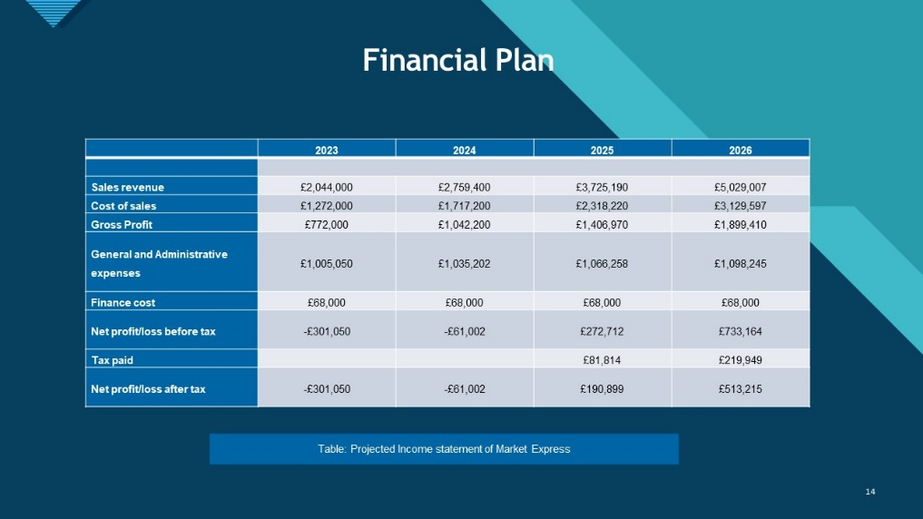

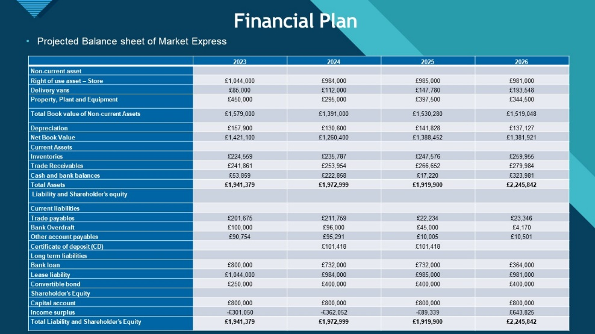

References
F. R.-A.et al., 2003. Consumption of bakery products, sweetened soft drinks, p. 421.
FabriqueBakery, 2019. FabriqueBakery. [Online] Available at: http://fabrique.co.uk/#oss [Accessed 2 12 2022].
ForkDeli,2020. ForkDeli. [Online] Available at: http://www.forkdeli.co.uk/#about [Accessed 2 12 2022].
Holmes, J., 2018. Bakery Business Startup: How to Start, Run & Grow a Trendy Bakery Business. 1st ed. s.l.: Valencia Publishing Press.
The UK, G. o., 1890. Set up a business partnership. [Online] Available at ttps://www.gov.uk/set-up-business-partnership [Accessed .11.12.2022].
Expresso and coffee guide (2020). [online] available at: https://espressocoffeeguide.com/gourmet-coffee/coffees-of-the-americas/brazil-coffee/ [accessed 05.12.2022]
Gov.uk/trademarks (2020). [online] available at: https://www.gov.uk/how-to-register-a-trade-mark/apply [accessed 05.12.2022]
Oxford University press, (2020). [online] available at: https://www.oxfordreference.com/view/10.1093/oi/authority.2011 [accessed 11.12.2022]
Study.com (2020). [online] available at: https://study.com/academy/lesson/what-is-competition-in-marketing-definition-types-quiz.html# [accessed 11.12.2022]
Shoes for crews Blog (2020). [online] available at: https://www.google.co.uk/amp/s/blog.sfceurope.com/simple-coffee-shop-marketing-ideas%3fhs_amp=true [accessed 12.12.2022]
Bărbuţă-Mişu, N. (2018). Analysis of factors influencing managerial decision to use trade credit in the construction sector. Economic research-Ekonomska istraživanja, 31(1), 1903-1922.
Hut, P. M. (2008, September 7). PMH. Retrieved from PMHunt Web site: http://www.pmhut.com
Khurana, I. K., Martin, X., & Pereira, R. (2006). Financial development and the cash flow sensitivity of cash. Journal of Financial and Quantitative Analysis, 787-807.
Li-Hua, R., & Lu, L. (2013). Technology strategy and sustainability of a business. Journal of Technology Management in China.
Miller, G. F., & Spoolman, S. (2011). Living in the environment: principles, connections and solutions (17th ed.). Belmont, CA, U.S.A: Brooks-Cole.
Seltzer, J. B. (2014, October 20). Health Communication Capacity Collaborative. Retrieved April 22, 2018, from Health Communication Capacity Collaborative Web site: http://www.healthcommcapacity.org/resource-mobilization-important
Benoliel, P. (2017). Managing senior management team boundaries and school improvement: An investigation of the school leader role. International Journal of Leadership in education, 20(1), pp.57-86.
Faulkner, B. (2019), April. Leading your sub-team managers. In BSAVA Congress Proceedings 2019 (pp. 290-291). BSAVA Library.

