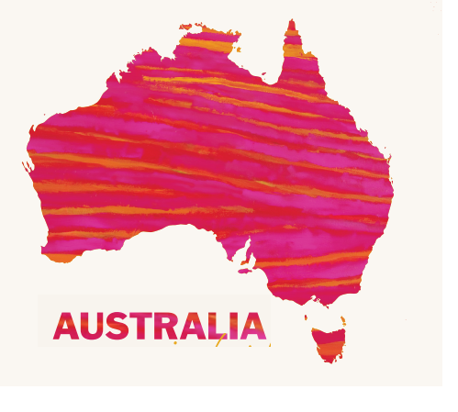

GLOBAL TOURISM AND DESTINATION MANAGEMENT

Student Name: Biswajit mukherjee

Student ID: 1815040

Module code: M6X01932

Lecturer: Dale Clarke


Introduction……………………………………………………………………………pg3

History……………………………………………………………………………….pg4

Australia heritage and culture……………………………………………………pg4

Australia tourism business……………………………………………………….pg5

Promoting tourism…………………………………………………………………pg8

Australian government role in tourism…………………………………………pg8

Major tourism attractions…………………………………………………………pg10

Future tourism growth and development in Australia………………………pg11

Experiment products analysis strategy ………………………………………pg13

conclusion…………………………………………………………………………..pg14

references …………………………………………………………………………….pg15


This report highlighted the insight on Australia as a destination for tourism. The geographical, topography, and history are highlighted while examining the future growth and challenges the industry is facing with respect to infrastructure development. The report examined the regional structure and tourism investment the government
Tourism is a diverse factor in the Australian economy that is combined with the economic prosperity of the nation. Tourism in Australia is inclusive of accommodation, attractions, tour operators, support organizations. This report highlights outlook on Australia as a destination.
Australia is an island country that is diverse in its population, culture. Its total population is 23.5 million as of December 2014 (Tourism Investment, 2018). The famous crowded regions are New South Wales and Victoria including capitals, Sydney and Melbourne. The population is concentrated in coastal regions and small concentrations around Perth. The center is sparsely populated. The geographic area is approx. 7682300 sq. km making the largest country in the world and number of position is six.(Austrade, 2019). The area lies between Pacific oceans from north to south with coastline 367755 km long. Canberra is Australia's city capital and has a population of approx. 390000 people. It is situated between Melbourne and Sydney (Austrade, 2019). Australia is ranked among World Heritage properties and has 19 properties listed (Austrade, 2019). It is famous for the Sydney Harbor Bridge as a landmark building.
The Australian climate is warm in northern states with cool winters in the southern states with no subzero temperatures. The areas experience snowfall in winter month's particularly New South Wales and Victorian resorts and the island state Tasmania. Four topographic regions of Australia - a sandy coastal plain, eastern highlands, central plains, and western plateau (Austrade, 2019).



Australia is first inhabitants the Aboriginals migrated to Australia between 50000 to 60000 years (Austrade, 2019) Captain James Cook is accredited with sighting the city. The European settlement of Australia was in the year 1788 under the command of Captain Philip. The transportation of convicts was abolished in the year 1852 (Austrade, 2019). Australia follows the Westminster system of government and law inherited by the British during the colonized period. Each state has its government.

Australia heritage and culture

Australia heritage includes values, events, and experiences. The government is extensively working for protecting the valuable asset and living landscape. Australia has secured a seat in UNESCO World heritage and has secured a seat in 2017-21 (Australian government, 2020). The Australian sites listed on world heritage are total 19 including the sites Sydney Opera House, fossil sites Riversleigh and Naracoorte, and the Greater barrier reef that is vital as social and cultural fabric (Destination NSW, 2019). It has more natural sites than other countries. Australia has rich diversity and culture that has developed considerable strength with manufacturing and services with economic integration. Australia s immigration policy welcomes people from across the world with no discrimination on racial, cultural grounds. The national referendum is used which removed discrimination against Indigenous population.

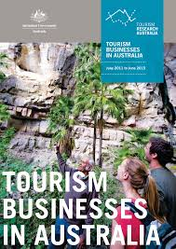

As of 2018, there around 350000 tourism businesses operating in Australia. New South Wales, Victoria, and Queensland account for 35%, 28%, and 19% of the business (Austrade, 2019). The remaining business is based in Tasmania, northern territory, and Australian Capital Territory.
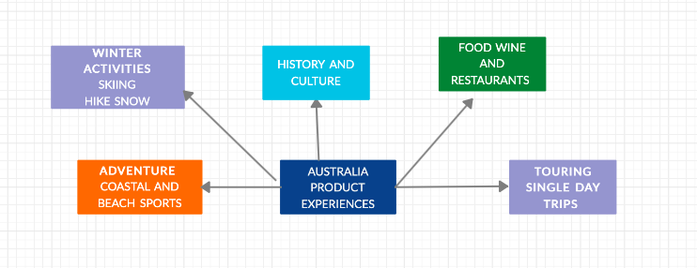
Tourism labor development by government -Tourism employment plans as a part of Tourism 2020 for labor and skill pressures. Job support and quality will support the tourism and hospitality sector with future growth. Australia accommodation outlook has been sharply increasing with the accommodation sector has occupancy with 12000 rooms capacity increase.
Figure 1- Australia cluster group

Exploring the country
The cruise industry plays an important role in showcasing coastal attractions. It delivers economic benefits to coastal cities and communities. Cruising is one of the growing sectors and cruise infrastructure has to keep up with modern vessels. Sydney us Australia‘s busiest cruise port but has infrastructural constraints due to accommodating vessels being too large. The companies functioning in Sydney are pre-requisite to scheduling broader itinerary for mega cruise liners. Australia is well placed into an upward trajectory and authentic travel experience for travel opportunities. Visitors are confined to day trips. The area requires partnership for labor skills collaboration at industry levels and government. The scope of tourism hot spots in the area is large.
Tourist demographics
The share of international visitors has grown with over 19% in the past 10 years and domestic overnight and day visitors have been equal in shares (Deloitte, 2019).
Industry Composition | Percentage in composition
Travel agency and tour Operator | 40%
Transport services | 15%
Accommodation | 25%
Motor vehicle hiring | 7%
Table -1 – Industry composition
Allied industry involved
Clubs and casinos
Museums and arts
Entertainment space
Others
Table 2- Industry composition (allied)
Regional hotspots
International leisure is majorly concentrated in Sydney, Melbourne, and Queensland with the regional visitation of 2 million international sectors to Great Barrier Reef. New South Wales and Victoria have regional visit as compared to the largest cities involved New emerging destinations are also challenging traditional destinations (Department of foreign affairs, 2016)
Driver | Purpose
Package Traveler | These visitors account for major portion and are usually covering the regional hotspots
Business group and family travelers | The length of their stay is generally longer
Employment | Their stay is limited but occupancy percentage in regional discovery and travel
Table 3- Australia visitor’s composition.

- Sustainable tourism model
Travel and tourism are positive enablers for job creation and economic activity. The sector has to grow in a sustainable model with local communities and no negative impact on the natural environment. The environmental challenge due to an increase in number for visitors has grown large (Austrade, 2019).
- Tourism product development
The demand can be leveraged through increasing the length of the trip. The target distribution to increase the non-leisure visitors and extend their stay. The need for international marketing for reducing and revising price structure will impact the tourist in the length of the trip

Promoting tourism

- Promoting indigenous tourism
Market assessment for domestic and international consumers for contemporary dimensions to Aborigines. Marketing of existing products for domestic and international markets.
- Aviation policy support
Negotiating aviation toes and arrangements with key markets for long haul markets will ensure more tourism inbound visits.
- Promotion of travel tourism pathway
This will ensure that the workforce in tourism can cater to demand for an increase in the knowledge domain of the customers. The career raining for the industry should be developed for youth jobs and programs by the government. Establishing pre-employment programs for local business.

Australian government role in tourism

Australian chamber – tourism is a part of an advocacy network for tourism sector promotion and labor supply, visa, and infrastructure. The development of Tourism 2020 for resilience and competitiveness in the industry (Tourism Australia, 2016). The investment-related to investment, infrastructure is addressed through this government strategy. The tourism Australia market projects through partnership agreements on regional annual plans. Tourism Australia provides funding for developmental activities. Federal government support on tourism business Entrepreneurship Programs, business development program.
- Government investment
The government has developed initiatives for industry growth and an increase in visitor's experience. The government has developed market campaigns, tourism experience, and reducing red tape for industry burden. The Australian government encourages the tourism industry and implementing reforms. The tourism project facilitation services are admitted to supporting regulatory approval through the state. The regional tourism is chosen as eight initial regions for growth and development
Government measures through video highlights
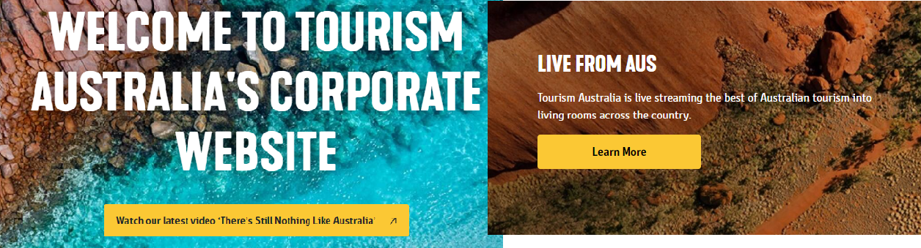
Figure – Government tourism web page
Policy reform
Austrade is central towards government progress for policy and reform in tourism The Austrade focus on industry growth and drive through tourism minister for indigenous tourism, works with infrastructural support and development and pursue reform in Australian exports in overseas market through Foreign Ministry (Austrade, 2019). The marketing campaign at the local and state level is also the priority of Austrade

Major tourism attraction

The tourism sector in Australia is significant in size and has offered experience across destinations, new attractions, and key activities.
Activity | Penetration
Food and Wine | 42%
Aquatic experience | 22%
Nature and wildlife | 19%
Cultural heritage and wellness | 10%
Table – Activity parameter
Australia boasts global wineries with New South Wales for a significant presence in the country. Australian coastal market involves freshwater fishing. The coastal experience involves Kangaroo Island and Western Australia to escape with water sports as prime activities (Deliotte, 2019). The major investment in the market is by private players Intercontinental Hayman, Crystal Brook Collection (Australian government, 2019). The wildlife provides experience through National Park. The government agencies take precautions for wildlife with the public interest. The extent of presence in wildlife is standardized with prominent development. The rise of wellness in contemporary Australia has been fueled by holistic therapies and the western system it accounts for growth in the inbound and outbound tourism. Cruise shipping is one of the fastest-growing sectors in the Australia tourism industry. Its annual contribution is $790 million (Destination NSW, 2019). The high-value traveler will be driven to coastal, food, and wine for selecting the selecting holiday destination.
- Key tourism assets
Wildlife -The region has diverse wildlife and seasonal wildlife experiences with input in product development. The diverse landscape with cultural heritage has rich culture asset in the backdrop
- Tourism Product development
The domestic market visitors are key components of cultural experience. The indigenous culture development will incur the overnight domestic tourism market. The product gaps are indigenous interaction and savannah guides
- Marketing/ branding activity
Tourism Australia has created a global campaign for positioning Australia as a destination favored and memorable. It has partnered to create highlights on the aquatic and coastal regions with food and wine, natural wildlife experience, and highlighting the key hotspots for the region for tourists. The message emphasis the cultural aspect of Australia. The campaign "there is nothing like Australia" has built a strong connection for stimulating the experience through its message (Tourism Australia, 2016). The video depiction has been used as the umbrella campaign.
Australia market category
The leisure market is in maturity and investment approach is stranded. The main traveling countries are China, UK, and the USA are the economic powerhouse and Germany, Hong Kong Malaysia is a moderate-high traveler (Tourism investments, 2018). The aviation development has given rise to India, Indonesia with destination travel to Australia
State and territory tourism partnerships
The state and tourism initiate drive marketing campaigns for trade events and offshore activities. This will help in strengthening Australia in future tourism prospects. The tourism demand program will help in identifying countries with development ratio and reducing the barrier to travel with aviation development

Future tourism growth and development in Australia

- Competitive air travel services
Australia as a travel country has regulated air travel with negotiated air services with 94 countries, government s international liberalization will positively impact Australia‘s growth with regional tourism provisions
- Government initiatives in encouraging regional tourism
The government has developed a range of programs for regional tourism in New South Wales for Queensland‘s Regional development program (Tourism Australia, 2018). The Australian government is involved in destination marketing and use marketing for major events.

- Tourism based infrastructure
The significant improvement can be developed in tourism infrastructure in Australia. The cruise ship terminals require infrastructural support in Sydney and Brisbane to cope with the demand (Department of foreign affairs, 2016). Infrastructure in national parks requires more promotion, monetary support for display boards, and improvement. Park agencies require an operator for running its business and the government has enlisted the destinations on portal.
- Capacity restrictions and limitations in regional areas
Improvement in airport efficiencies and regional implications as well for direct incentive in a regional area and quality workforce programs
The future outlook for investments
The economic outlook is positive for Australia with a weaker global condition resulting in inbound tourism. A considerable increase in property can be observed with the hotel market in the locations of Canberra, Adelaide, Gold coast, and Sydney (Deliotte, 2018). Australia has unadulterated shoreline and rainforest, beaches with national park presence that adds to its destination landscape. Art tourism is growing in Australia with incurs in overall growth in the last 5 years (Austrade 2019). The tourism infrastructure development program is developed by the government for the public-private partnership for conventional and cruise terminal development.

Experience product strategy analysis

Experience is critical in driving emotional response in the multi-faceted relationship for destination setting (Cooper, 2012). The market providers are infusers and provide satisfaction and create service experience with experiences in the landscape program experience.
Australian coastal wilderness is a unique experience as a national landscape with a rich diversity of flora and fauna (Destination NSW, 2019). The product offers natural experience with cultural experience for experience seekers. The national landscape program by tourism Australia provides adventure and variety in a single day trip. The program essentially covers tourism organization and indigenous community for area agencies and a forum for connecting with local population.
- Product positioning and benefits
The program carets and indulges the natural asset inexperience drive for the natural and cultural environment. The experience development strategy is based on value-based tourism for a wilderness experience with regional growth of 15% on annual revenues (Destination NSW, 2019).
- Market segment
The long overall travelers and experience seekers are midi and tech-savvy. The ideographic composition is under the age group 40 with the global market for travel mindset and motivation with domestic tourism constituting a major part in this structure and experience though the National Landscape program. The program is considering the emerging market with backpackers for the online tour package

- Linking brand with experience
The coastal parks and Biosphere arks are a part of the UNESCO world network (Australian government, 2020). This develops a conservation tourism program for international visitors and builds on existing food and wine initiatives. They provide recreational experience for visitors with exercise or pursuits.

- Analysis with benefits
The strategic priorities caret environment and culture contribution to the natural and cultural asset with an appreciation for private sectors and is successful in growth and measure for infrastructural opportunities for the state for e and tourism in the annual growth on annual percentage for product offerings and distinctness of Australia as a destination brand.
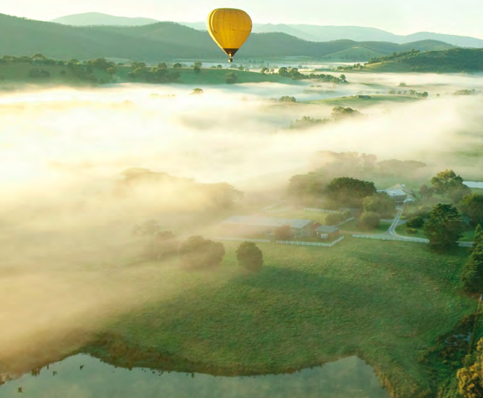
and tourism in the annual growth on annual percentage for product offerings and distinctness of Australia as a destination brand.



Prioritizing negotiation for aviation for visitors will help in supply and boost tourism. The inbound market and airport restructuring is essential. No regular delivery for business development support for the signature indigenous expense and operated tourism guidance for direct benefit are challenges for tourism.
Climate change impact- The climate change will have a variable impact on biodiversity with threats on plants and animal, Australia has established itself as nature-based tourism with endowed with natural assets for a tourist attraction that will endanger its natural habitat for destination tourism.
The Australian tourism industry offers wide tourism options due to diversity in Australia heritage and natural assets. The developmental comic program will benefit tourism and sustainability in economic growth. Facilitating experience for travel with natural and cultural programs require government support and investment for building business capacity.


Austrade. (2019). State of industry. Retrieved from file:///C:/Users/t.anya03/Downloads/TRA_State_of_the_Industry_2019% 20(1).pdf
Australian government. (2019). About Australia heritage. Retrieved from https://www.environment.gov.au/heritage/about
Australian government. (2020). National landscape. Retrieved from https://www.environment.gov.au/topics/national-parks/national-landscapes-0
Cooper, C., Hall, M. (2012). Contemporary Tourism: An international approach. Good fellows
Deloitte. (2020). Understanding visitor’s regional dispersal. Retrieved from https://www2.deloitte.com/content/dam/Deloitte/au/Documents/Economics/deloitte-au-economics-regional-dispersal-october-2019-151119.pdf
Department of foreign affairs. (2016) Australia in brief. Retrieved from https://www.dfat.gov.au/sites/default/files/australia-in-brief.pdf
Destination NSW. (2019).Culture and heritage tourism. Retrieved from https://www.destinationnsw.com.au/wp-content/uploads/2019/07/cultural-and-heritage-tourism-to-nsw-snapshot-ye-de-2018.pdf
Tourism Australia. (2016). Corporate plan 2017-2021. Retrieved from https://www.tourism.australia.com/content/dam/assets/document/1/6/x/6/a/2002546.pdf
Tourism Australia. 2018. Annual reports. Retrieved from https://www.tourism.australia.com/content/dam/assets/document/1/7/9/6/b/2018099.pdf
Tourism investments. (2018). Retrieved from https://www.tourisminvestment.com.au/content/dam/assets/document/1/7/4/7/s/2011672.pdf

