

Written response – A proposal for a school community project

The Primary school aims to provide a broad balance and rich curriculum. They offer an inclusive environment where pupils are encouraged to be happy, digitally competent and creative, confident and resilient learners. They challenge their pupils to reach their full potential, equipping them with the skills necessary to continue their journey into lifelong learning. The school runs different schemes with the local community including a wellbeing service during the current coronavirus outbreak. The school is involved with FAN (Friend and Neighbours) groups in Swansea which works on bringing the community together, Local area coordination, working on supporting the elderly, families and disabled people in the area to build relationships within the community. They also work closely with charity, giving world, which helps to provide free of charge clothing, food items, toiletries and household cleaning products to the most vulnerable people in the area. All year round the school focusses on the grow project uniform recycling scheme to support the local community provide uniforms to the deprived families in the area.
SDP (2019-20) provides the following information:
The school has 163 pupils including 16 part time Nursery pupils. There are 11 teachers, 18 TA’s (teaching assistants), 3 office staff, 1 caretaker, 3 cleaners and 2 kitchen staff. The pupils are organised into 9 mixed classes, including OAU (Observational assessment unit). There are no pupils with welsh as their first language. 23.5% of the school are EAL pupils (English as an additional language). Over 70% of pupils live in deprived areas within Wales. 39.8% ALN (Additional learning needs), 32 have statements of special education need, 22 are school action and 12 school action plus. 2019 – 2020 individual school budget per pupil is £6,368 with a minimum - £2,786, maximum - £8,500. This is the 2nd highest in Swansea out of 76 other schools. The last Estyn inspection was in March 2017 and the follow up Estyn report in July 2018 (SDP, 2019).
To teach in wales has its merits for all educators. Due to the growing number of pupils in wales and the growing percentage of these pupils living in poverty it is vital that the teachers are there to support the children thrive in their schooling environment. The number of pupils eligible for free school meals across wales has risen in the Swansea area since 2015 according to (Statswales, 2020).
The number of pupils aged 5 and over with a first language other than English or Welsh has also risen since 2015 (Statwales B, 2020) meaning more support needed from teachers and the local community. Crosse (2007) suggests that it is beneficial to all involved with the teaching of EAL when writing that pupils “will bring with them many skills and experiences from their home culture and will be both anxious and excited about their new situations”. Crosse (2007) further goes on to suggest that introducing the English language at a young age is beneficial for the learner when stating “a good foundation for learning English as an additional language is embedded in quality early years practice”.
The community project proposal is ‘Volunteer Community Mentor’.
Pupils of all ages and abilities are underachieving due to a variety of social and emotional factors. RBKC (2011) suggest that “these barriers can become internalised, taking the form of low self-esteem, lack of confidence, poor concentration and difficulties in relationships or unmanageable feelings of anger, loss or sadness”. These effects can further spiral downwards affecting “health, attendance, and level of engagement in learning” (RBKC, 2011). RBKC (2011) go on to say that these pupils have deeper causes than are seen on the surface through “family circumstances, bereavement, relationships, adapting to a new culture”. Many of the above causes are seen in numbers of households across wales, more specifically the Swansea area where the project proposal is focused. The community mentoring will provide pupils in the school with the chance to access help from a variety of more knowledgeable individuals. Lev Vygotsky’s theory of MKO (more knowledgeable other) “refers to someone who has a better understanding or a higher ability level than the learner, with respect to a particular task, process, or concept” (McLeod, 2018). These MKO’s will provide the learners with their education in school and their life outside school if needed. The mentors for the selected pupils will be used similarly to life coaches, guiding the pupils through all forms of their lives where the support is needed most. RBKC (2011) supports this further when stating it can offer pupils short term support to “sort out and make sense of what is happening to them, to reflect on how their actions can be causing problems and to work out ways to making life better”.
Promoting the Welsh language is now a focus of the educational system in Wales in which every school across the area conduct compulsory welsh lessons and use incidental phrases in their day to day school days. The Welsh Government has set up a Welsh action plan which aims to achieve their vision by 2021 in all schools in Wales. The vision is “to enable all learners to develop their Welsh language skills and to use the language confidently in everyday life” (Welsh Government, 2017, p.14). This affected the choice of focus for the project as the mentoring system will help both children with EAL and pupils who have a lack of welsh knowledge. The system will allow pupils not only to speak welsh but understand the welsh culture and the background of the language's roots. Donaldson (2015, p.24) supports this when stating “the future of Welsh and Welsh culture is wholly dependent on transmitting the language to our young people” and later stating that the goals of Donaldson's recommended curriculum are “for a Wales that is prosperous, resilient, healthier, and more equal, with cohesive communities, a vibrant culture and a thriving Welsh language” (Donaldson, 2015, p.27).
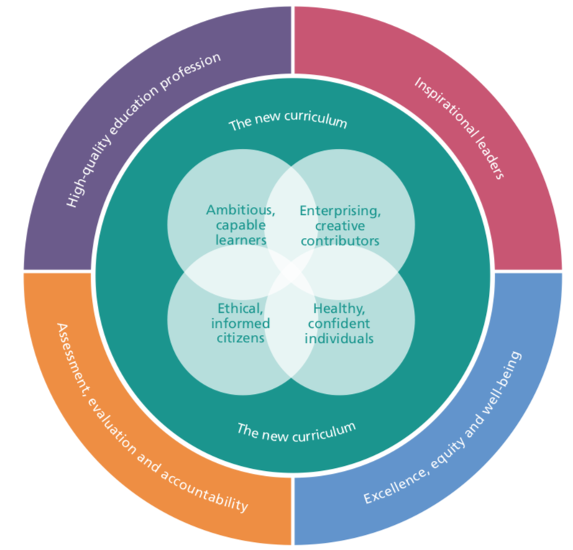
Figure 1 - (Welsh Government B, 2017, p.19)
The above Figure 1 was taken from the national mission of Wales new curriculum. The whole system that has been proposed has its pros and cons. However, it has affected the decision of the project for the community and school chosen in this document. The above aims are not for the mentors implement but to support the teachers. The teachers will “be effectively supported by other colleagues within the education workforce” and “benefit from opportunities to improve the quality of their pedagogy, while aspiring to be a better teacher” (Welsh Government B, 2017, p.25).
The chosen school's vision is “Your right to be the best you can be” (prospectus, 2019-20). The school has the aim to provide its pupils with a “broad, balanced and rich curriculum” in which they offer an “inclusive environment where pupils are encouraged to be happy, digitally competent, creative, confident, and resilient learners” (Prospectus, 2019-20). The school has the hopes for the pupils to become functioning members of modern society and through the school's educational system equip “the skills necessary to continue on their journey of lifelong learning” (Prospectus, 2019-20).
The school’s mission statement is a key factor when the project was decided, “learning and working together as a community, we challenge and support each other, to achieve our goals” (Prospectus, 2019-20). Through this statement we can project that the school will be backing the mentoring system which will bring the members of the community closer and support the school's staff and pupils. On the other hand the school may have barriers in supporting the system in the forms of correct training for the mentoring volunteers, which contradicts the aims of the Welsh government action plan’s aim of improving “the quality of pedagogy, while aspiring to be a better teacher” (Welsh Government, 2017, p.25).
The school underwent a consultation with parents of the pupils in order to best agree on what they deem important for the pupil's overall growth. The ‘Home - school agreement’ works in the favour of teachers and parents to support each other through the child's education. The Prospectus (2019-20, p.7) states that the parent/guardian will need to “support their child in homework and other opportunities for home learning”, “get to know the child’s life at school”, “attend any school meetings, assemblies, events” along with a number of other responsibilities. What if the parent/guardian works late? What if they are EAL person? What if they cannot support their child's education needs? These questions have a very simple answer of mentoring support. The one-to-one mentor can support the parent and the pupil through education and offer advice and guidance on how to have a positive effect on their child's learning. Welsh Government support the importance of support children in all parts of life as they state
“caring school communities support the social and emotional development of children as well as their educational attainment. In such school cultures, additional support, learner support and pastoral care are evident throughout the school and are part of an inclusive approach to meeting children’s needs”
(Welsh Government, 2016, p.32)
The mentoring system will provide pupils with this support along with the support of the parents. The Welsh Government goes on to discuss the importance of supporting all forms of pupils as they state,
“Promoting positive relationships and behaviour is key to not just helping children develop the four capacities, but to enabling the most vulnerable children to benefit from as full an educational experience as possible.”
(Welsh Government, 2016, p.32)
This relates to the schools Prospectus (2019-20, p17/18), more specifically the LAC (Looked after children). This addresses the pupils coming and going to the school through the headteacher ALNco staff. These members of staff have been trained how to detect any problems with the children. They also work closely with parents in order to support the children, with regular meeting and one-to-one sessions with the pupils in the school. The ALNco staff can provide pastoral care for the pupils in need. This was a key factor in the project proposal as the mentoring staff can be a non-bias link to the pupil in order to support the ALNco staff, possible continuing the pastoral care at home and giving a well-rounded professional view to the ALNco staff of the pupil's home life. The link between school, mentor and parent to aid in the pupils education is discussed when Whalley (2007, p.51/52) states that "the recognition that the parents’ specialised knowledge of their own child can stimulate our thinking is part of our professional development”, suggesting that this link benefits all parties involved. It goes on to say, “parents are still viewed by many practitioners as ‘helpers’ rather than as ‘equal and active partners” (Whalley, 2007, p.52).
MBF (2010) have found that participants of “peer programmes and school staff feel that the programmes benefit both the young people and the pupils that they mentor”. They have conducted studies that demonstrate “the impact of peer mentoring in helping to reduce bullying, promoting self-confidence and self-esteem (MBF, 2010, p.4). The MBF (2010, p.16) have conducted case studies which have seen positive results to pupils and mentors, seen in the following:
“80% of the mentees improved their attendance compared to only 40% of those who were not mentored”
“60% of the peer mentors improved their attendance compared to only 30% of those who were not mentoring other young people”
“60% of the mentees improved their behaviour compared to 20% of those who were not being mentored”
“50% of the peer mentors improved their behaviour compared to 30% of those who were not acting as peer mentors.”
These results had a considerable impact on the choice of project due to the abundance of positive impacts on all involved, however these results reflect the impact of peer mentors. Though this approach can be implemented in the project proposal, the aim is for external mentors to support the pupils, such as, comprehensive pupils, local community and potential future teachers.
Main Body 2
The aim for this project is to support all the necessary pupils through education. Allow every pupil in the school to have an equal opportunity as other and to provide equity in the support given. Equity is key to the success of this project. The level support given to the pupils in the system will depend on their needs. This system shares aims with Donaldson (2015) in which the system “prepares pupils at the school for the opportunities, responsibilities and experiences of later life”.
Aims of the project:
- To connect with parents/guardians and support them through their child's education.
- To engage with the community, encouraging involvement with the school.
- To further develop the children in need of support.
Outcomes of the project:
- Parents/guardians being an encouraging influence on their child's learning with regular engagement with school and homework.
- To have a wider community circle where all are welcome to support the pupils.
- Pupils who are ready to independently face the challenges of everyday life
The system will use a variety of sources to provide mentors for pupils. The link between the primary and the comprehensive school will be utilised to give older pupils the opportunity to work with primary children. These volunteers will be selected by the comprehensive school and filtered to select the most appropriate mentors for each specific child to support. The barrier that is faced here is comprehensive pupils may not have the experience or knowledge to support the pupils educationally. However, they may possess the social and communication skills to support the pastorally. Leigh (2019) conducted a peer mentoring programme to support the children in the school pastorally where it was found that “in terms of promoting emotional intelligence, resilience and self-awareness, it seems that the weekly visits to lower school tutor groups initially helped those mentees”. However, it was found that “the impact faded over time, largely due to issues with attendance” Leigh (2019). Considering this the suggestion of allocated time each week will be arranged for the mentor to support the mentee in the school along with an allocated period in the comprehensive timetable for the mentor not to discourage their development.
The school is currently working with the community in the form of supporting the elderly, disabled people and families within the local area. This can be utilised within the project to support all parties. The links to the elderly care home can be used to provide mentors for the children and the elderly. Stanford (2016) have conducted research showing that “aging adults play critical roles in the lives of young people, especially the most vulnerable in society”. Younger children engaging with the elderly benefits their language development through “talking to new adults, reading stories and singing nursery rhymes, provides opportunities for young children to improve listening skills and expand their vocabularies with new words” (Kids Play, 2016).
During the recent PTE (Professional teaching experience) placement observations of pupils and systems in the school were observed. Pupils who needed support contributed in family learning, dyslexia learning, comprehensive learning, and counselling and Darbyshire positive play. This supported the decision to focus on mentoring. The aim for this project is to support the pupils through these schemes externally. To be the supporting external party outside the school environment. The mentors will be trained for specific roles and will be assigned to the children those roles will support. The importance of quality training and teaching for the mentors is vital as the school somewhat lacks in this area as Estyn (2018) report states “there is still too much variability in the quality of teaching in a minority of classes in key stage 2”. However, the system will need to work closely with the schools' social care ethos as the report also states that the school “promotes pupils’ health and wellbeing effectively and provides a caring and supportive environment” (Estyn, 2017, p.7).
A team will need to be created to steer the Community Mentor Project. The assigned staff will consist of the following staff roles:
School team -
Head Teacher/Deputy Head – They will coordinate with all parties to oversee the project, ensuring the pupils are benefitting.
ALNco Staff – These two staff members will work together in order to collect data of the pupils within the school through their daily and weekly sessions.
OAU Teacher – This teacher will work within the school assessing pupils at the foundation level.
STF Teacher – This teacher will work within the school assessing pupils at the key stage 2 level.
The above team will meet once a week to discuss the progress of the pupils participating in the project. The advantage of this team is that all members have gone through extensive training in a variety of social care areas. The team has the experience and prior knowledge of pupils to give the project a running start.
External team -
Comprehensive Deputy Head Teacher – They will oversee the volunteer pupil mentors.
Care Home Team – Volunteer members of the care home and staff will work together.
PTA (Parent Teacher Association) – will be the key link between the school and external parties.
Main Body 3
To measure the impact of the project a variety of tools can be used. Quantitative data can be collected in order to evaluate progression through tests. Qualitative data through pupil’s self-evaluation can be used to get a rough estimate on how they feel they are progressing, if they are. Observational techniques may be used in order to get an overview of their performance. One to one informal interview with the pupils can be used to get a well-rounded idea of their thought and feelings of the project.
Collecting data through self-evaluation and interviews are time consuming as the “time required for data collection, analysis and interpretation are lengthy” (McLeod, 2019). Another disadvantage is that this kind of measuring tool is very subjective, one assessor can have a completely different criteria than the other. McLeod states that “because of the subjective nature of qualitative data and its origin in single contexts, it is difficult to apply conventional standards of reliability and validity”. A way around this would be for all analysts to complete the same training, set a criterion beforehand and discuss the results of the analysis openly with another confidential or in hour party.
The mentors will play a key part in measuring the impact the project is having at home. The mentor will observe the family at home, the attitude of the pupil when doing work and the engagement and interest the family show in the child’s work. It is important that the mentor persists in focussing on the overall well-being and development of the pupil. There is a possibility of video or voice recording the session the mentor has with the pupil in order to bring to the school and discuss further with the teachers and steering team.
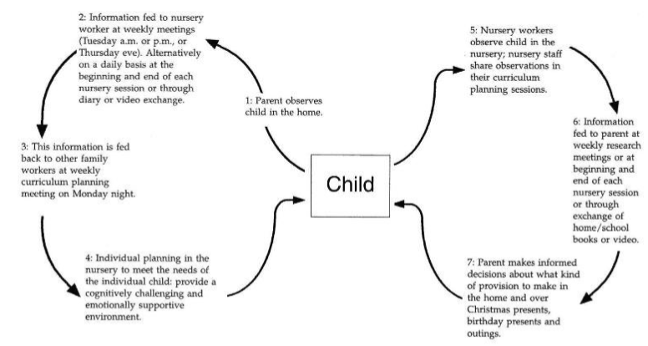
Figure 2 (Whalley, 2007)
Figure 2, sections one to four is a diagram of a parent led observation who feeds back to the teachers. This is a sound example of how the communication of a parent works to benefit the child's continuing development. This is an approach that the project would like to use, especially as Whalley (2007) states that the parents participated in a session “to use the camcorder and how to make effective video vignettes of their children playing and learning at a deep level”. Through this style of observation, the parents/guardians will get a deeper understanding of the needs of their children and develop the knowledge of how to educate their child at home. This theory works in reverse as seen in the diagram above in sections five to seven. This happens during conversations at pick-ups and drops off at school, through homework books and diaries and any weekly scheduled meetings that are planned. Whalley (2007) supports this approach through the statement that “Parents use the information that staff share with them to make informed decisions about how to extend the provision that is available at home to support their children’s learning”.
A case study was completed by Estyn (2017. B). This consisted of pupils from a nursery attending a care home on a weekly basis to work with the residents in the hopes of developing both parties. It was a success and they began regular visits there. Estyn (2017. B) stated that the visit to the residential care home developed “the children’s social and emotional skills well and give them confidence”. The residents engaged in continuous conversations with the children which further helped to “develop the children's speaking and listening skills” Estyn (2017. B). This is the same approach this project wishes to take in order to develop the child's learning. Through this approach the pupils will discover many attributes that will help them as they grow and become “healthy, confident individuals” who will “have the skills and knowledge to manage everyday life as independently as they can” (Donaldson, 2015, p.29).

4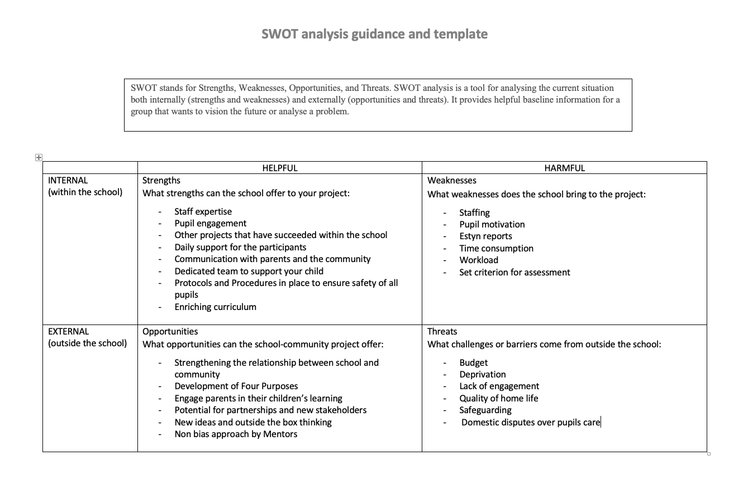
Figure 3 - SWOT Analysis

The Community Mentor Project has many benefits for both the school and external parties involved. What the school prides itself on is the time and care they put into their pupils. Thus, the participants of the project will have continued support daily in school, Estyn (2017) has found that extra care has been taken to attendance in order to boost pupils contribution to lesson when stating that the
“pastoral officer has established strong relationships with the families of pupils with a history of low attendance. This work has led to notable improvements in attendance and has encouraged more parents to take part in school activities”.
Estyn (2017, p.8)
An enriching and inclusive curriculum has been set to ensure all pupils can achieve the best they can. This is a strength to the project as it provides the parents with the highest quality of teaching materials and guidance in supporting their child's development and learning. This links to Donaldson (2015, p.14) report where its stated that the curriculum should be “easily understood by all, encompassing an entitlement to high quality education for every child and young person”.
An opposing argument can be made that there are weaknesses such as the workload and time consuming. The workload is the main concern for the school as they are currently working tirelessly to implement the new curriculum. This extra workload may become a barrier for the staff to produce high quality work. Whalley’s (2007) study found similar problems as at various stages of the project staff needed to raise “concerns over the increase in their workload as a result of the new way of working”. Staff members prioritised the new work than continuing to teach high quality lessons. The project effected staff due to “family commitments, pressures relating to other aspects of their work or personal inclination” (Whalley, 2007, p.29). To overcome this barrier the staff could create a rota with alternates responsibilities each week, allowing all staff involved time to produce quality work. This suggestion is supported as Whalley (2007)’s report stated “Staff were allocated some additional time” which benefitted all aspects of their work.
This project brings forward opportunities to external factors as seen in figure 3. With the opportunity for parents to engage more with their children's learning comes a new branch of support through the child's educational journey. Athey (2007) supports the importance of parental involvement when stating “parents and professionals can help children separately or they can work together to the great benefit of the children”. During the study that was conducted it was found that;
“Parents can give practical help in classrooms (as many already do), but perhaps the greatest benefit to teachers in working with parents is the spur towards making their own pedagogy more conscious and explicit”.
Athey (2007, p.209)
However, a threat to this positive is the home life of the pupils. Currently 6,086 schooling families in the Swansea area are eligible for free school meals. This is an indication to the number of families living in poverty locally. Home life complications can accompany poverty. This can have a huge effect on the pupil's education and well-being. WalesOnline (2020) state that “Police figures show that there were 41,532 domestic abuse-related offences recorded across the country in 2018/19”. Although this is a news site which may have alternative motives than providing facts, this statistic can be used to indicate how many households across wales suffer with the severe poor homelife.

Conclusion
In summery the project has been designed with considerations to how culture and religious beliefs effect learning. The project replicates the needs of the school according to their recent Estyn reports and the needs of the surrounding community. The proposed outcomes of this project strive in bringing the community together through supporting the local school and its pupils in need.
The project strives to work within the parameters of the curriculum and with social justice at the forefront of it design. The term social justice can be defined as “the fair and equitable distribution of power, resources, and obligations in society to all people regardless of race or ethnicity, age, gender, ability status, sexual orientation, and religious or spiritual background” (Ayala, 2011, p.2795). What the project takes away from the term social justice is that every child MUST have equal opportunities but NEED to be treated with equity.
In addition, social justice and wellbeing are linked as Ayala (2011) states “social justice issues and access to resources are also inexorably tied to collective well-being (e.g., relation- ships and political welfare) of families, communities, and society.

Word Count (Not including titles and reference list) - 4,230
Word Count SWOT Analysis – 150
Total Word Count – 4,380

Appendix - 1

Reference list –

Ayala, E. 2011. Social Justice Theory. [Online]. [10 May 2020]. Available from: https://www.researchgate.net/publication/310769309_Social_Justice_Theory
Crosse, K (2007). Introducing English as an additional language to young children. [Online]. London: SAGE Publications. [11 May 2020]. Available from: https://www-dawsonera-com.ezproxy.uwtsd.ac.uk/readonline/9781849203470
Donaldson, G. 2015. Successful Futures Independent Review of Curriculum and Assessment Arrangements in Wales. [Online]. [07 May 2020]. Available from: Donaldson Report-Successful Futures...-NASUWTwww.nasuwt.org.uk›asset
Estyn. 2017. Developing children’s social and emotional skills through community links. [Online]. [14 May 2020]. Available from: https://www.estyn.gov.wales/effective-practice/developing-childrens-social-and-emotional-skills-through-community-links
Gouk, A. 2020. More than 35,000 reports of domestic violence in Wales never got to court last year. [Online]. [14 May 2020]. Available from: https://www.walesonline.co.uk/news/wales-news/domestic-violence-crime-women-wales-17540509
instry, M. 2015. English as an Additional Language in the Early Years. [Online]. [08 May 2020]. Available from: https://www-dawsonera-com.ezproxy.uwtsd.ac.uk/abstract/9780203559147
Kids play. 2016. Benefits of Nursery children visiting residential care homes. [Online]. [13 May 2020]. Available from: https://www.kidsplaychildcare.co.uk/nurseries/2019/05/29/benefits-care-homes/
Leigh, J. 2019. How can a peer mentoring programme be developed to meet pastoral care priotirities?. [Online]. [13 May 2020].Available from: https://impact.chartered.college/article/how-can-peer-mentoring-programme-developed-help-meet-pastoral-care-priorities/
Mbf. 2010. Peer Mentoring in Schools. [Online]. [13 May 2020]. Available from: https://www.google.com/url?sa=t&rct=j&q=&esrc=s&source=web&cd=1&cad=rja&uact=8&ved=2ahUKEwj6_u230LXpAhVzQUEAHe4BByEQFjAAegQIBRAB&url=https%3A%2F%2Fwww.bl.uk%2Fbritishlibrary%2F~%2Fmedia%2Fbl%2Fglobal%2Fsocial-welfare%2Fpdfs%2Fnon-secure%2Fp%2Fe%2Fe%2Fpeer-mentoring-in-schools-a-review-of-the-evidence-base-of-the-benefits-of-peer-mentoring-in-schools-including-findings-from-the-mbf-outcomes-measu.pdf&usg=AOvVaw31VpJV85ZiQU030Omzfs_9
McLeod, S. 2018. Lev Vygotsky. [Online]. [07 May 2020]. Available from: https://www.simplypsychology.org/vygotsky.html
Mcleod, S. 2019. What’s the difference between qualitative and quantitative research?. [Online]. [13 May 2020]. Available from: https://www.simplypsychology.org/qualitative-quantitative.html
RBKC. 2011. Practice guide to learning mentoring. [Online]. [07 May 2020]. Available from: https://www.rbkc.gov.uk/pdf/Practice%20Guide%20for%20Learning%20Mentors%20and%20Line%20Managers%20%28PDF%29.pdf
Stanford. 2016. Older people offer resources that children need, Stanford report says. [Online]. [13 May 2020]. Available from: https://news.stanford.edu/2016/09/08/older-people-offer-resource-children-need-stanford-report-says/
The governing body of morriston primary school. 2019. Morriston Primary School. School Prospectus 2019-2020. [Online]. [08 May 2020].Available from: https://www.morristonprimaryschool.co.uk/prospectus/
Welsh government (A). 2019. Pupils aged 5-15 eligible for free school meals by local authority, region and year. [Online]. [01 May 2020]. Available from: https://statswales.gov.wales/Catalogue/Education-and-Skills/Schools-and-Teachers/Schools-Census/Pupil-Level-Annual-School-Census/Provision-of-Meals-and-Milk/pupilsaged5to15eligibleforfreeschoolmeals-by-localauthorityregion-year
Welsh government (B). 2019. Pupils aged 5 and over with a first language other than English or Welsh by local authority, region and year. [Online].[01 May 2020]. Available from: https://statswales.gov.wales/Catalogue/Education-and-Skills/Schools-and-Teachers/Schools-Census/Pupil-Level-Annual-School-Census/Ethnicity-National-Identity-and-Language/pupilsaged5andoverfirstlanguageotherthanenglishwelsh-by-localauthorityregion-year
Welsh government. 2016. Theme 4: Helping families to actively support their child’s learning. [Online]. [10 May 2020]. Available from: https://gov.wales/sites/default/files/publications/2018-12/theme-4-helping-families-to-actively-support-their-child-s-learning-resources-1-5.pdf
Welsh government. 2017. Education in Wales: Our national mission Action plan 2017–21. [Online]. [08 May 2020]. Available from: https://gov.wales/sites/default/files/publications/2018-03/education-in-wales-our-national-mission.pdf
Welsh government. 2017. Welsh in education Action plan 2017–21. [Online]. [07 May 2020]. Available from: https://gov.wales/sites/default/files/publications/2018-02/welsh-in-education-action-plan-2017–21.pdf
Whalley, M. 2007. Involving parents in their children learning. [Online]. [10 May 2020]. Available from: https://www-dawsonera-com.ezproxy.uwtsd.ac.uk/readonline/9781446204634

