Engine Strip and Rebuilding practical work.
Brian Conway. 1903844
Session 1.
Date: Thursday 3rd Oct.
Instructor: John Kinsella.
Engine: V-star 650.
Notes for the V-star 650 engine.
The valve clearances are adjusted via the valve lifter bucket shims
Chain Driven Cams
Aims for Session 1.
- Take care to note, document, photo and label all work carried out for future reference.
- Strip Top End of Engine Starting from the head.
- Locate cam chain tensioner.
- Remove cams.
- Understand the complete head assembly.
- Remove Piston.
H.S.E
- Adhere to all HSE Signage within the workshop.
- Take note of the location of the first aid kit.
- Ensure the workspace is clean and tidy before beginning any work.
- Apply all P.P.E for a given task.
- Remove all jewelry.
P.P.E
- Capped shoes.
- Tie up any loose ends or long hair
- Shop coat.
- Safety glasses.
- Rubber gloves.
- Barrier cream.

Tools Needed.
- Socket set.
- Spanner set.
- Magnetic tipped Screw drivers set.
- Parallel punch set.
- Small pry bar.
- Soft mallet.
- Circlip pliers.
Work Process.
Primary Work.
While labeling up the parts, ensure the front and rear cylinder components are all kept neat and organized. Do not mix up the parts from each cylinder. The positioning of all components is vital.
Begin by removing the Cylinder head covers. Undo the cylinder head cover bolts using a suitable socket. After the bolts are removed gently tap the cylinder head cover with a soft mallet to loosen them from there gasket. As this is a full Engine strip it is not necessary to find top dead center this time.
Relieve the tension in both the cam chains by removing the cam chain tensioners.
Do not turn over the crankshaft while the tensioners are removed as this could damage the valves.
Remove the camshaft bearing caps by Undoing the bearing cap bolts. Note each camshaft position before removal and label them appropriately.
Remove Cylinder head bolts. Using a soft mallet gently tap the Cylinder heads loose from there gaskets and mountings. Carefully lift them away and label them front and rear.
Use a soft mallet to gently tap Cylinders loose from gaskets. Gently remove cylinders to expose pistons and conrods.
Use circlip plyers to remove the circlip from the side of each piston.
Use a parallel Punch of suitable size to gently remove the gudgeon pins to free the Pistons.
Remove the cylinder head gaskets.
Secondary work.
Piston Ring Removal.
Note the 3 different piston rings and their purpose and orientation before removal. Remove the piston rings carefully and inspect. The top two rings on each piston are for compression and the bottom ring is the oil ring.

Machine Shop Practical work.
Brian Conway
Session 1
Date: 15/11/19
Instructors: Dave Cooper /
Part or component: Bike Stand Modification Shaft
Drawing By: Brian Conway
Purpose of component.
To modify and recycle a broken bicycle workshop stand to work specifically with folding electric bikes in the designer's workplace. The modification will allow suitable working height to service the bikes. The modification also will allow better stability to carry out work and more clearance to rotate pedals as the previous set up had no clearance to do so. It can also be used as a point of sale to display the bikes at trade shows.
Machines to be used
Band Saw.
Manuel Lathe.
Tool List.
- Chuck key.
- Center drill.
- Carbide or high-speed steel tip cutter
- Chamfer tool.
- De-burr tool.
- File.
Material.
- Alliminium.
Aims for Session 1.
- Take care to follow all HSE and PPE guidelines.
- Complete the component as drawn to tolerance.
- Leave a tidy workspace.

H.S.E
- Adhere to all HSE Signage within the workshop.
- Take note of the location of the first aid kit.
- Ensure the workspace is clean and tidy before beginning any work.
- Apply all P.P.E for a given task.
- Remove all jewelry.
- No gloves allowed in the machine shop.

P.P.E
- Capped shoes.
- Tie up any loose ends or long hair
- Shop coat.
- Safety glasses.
- Barrier cream.

Safety while operating the lathe.
- Be aware that spinning shafts may appear stationary.
- Keep hands clear of work piece.
- Do not stand in line with Chuck while Turning.
- Note all ways to stop the machinery in case of emergency.
- Set tool height correctly.
- De-burr all sharp edges

Work Process table.
Job # | Process | Roughing / Finishing | Profile / Feature | Size | Tolerance | Tool | RPM
#1 | Facing off | Finishing | Face A | N/A | N/A | Carbide Tip | 525 RPM
#2 | Center Drilling | N/A | Face A | N/A | N/A | Center Drill | 650 RPM
#3 | Set up Between Centers | N/A | N/A | N/A | N/A | N/A | N/A
#3 | Prepare  Dia 44mm shoulder with a  Rough Cut. | Roughing Cut | Shoulder to 65mm in Z axis | Dia 44.5mm | +/- 0.2mm | Carbide Tip | 650 RPM
#4 | Prepare  Dia 36.9mm Face with a  Rough Cut. | Roughing Cut | Short Face to 60mm in Z axis | Dia 37.2mm | +/- 0.1mm | Carbide Tip | 650 RPM
#5 | Finish  Dia 44mm Shoulder | Finish Cut | Shoulder to 65mm in Z axis | Dia 44mm | +/- 0.2mm | Carbide Tip | 800 RPM
#6 | Finish  Dia 36.9mm Face | Finish Cut | Short Face to 60mm in Z axis | Dia 36.9mm | + 0.0mm  -0.5mm | Carbide Tip | 800 RPM
#8 | Chamfer | Finish | Face A | 0.5mm | +/- 0.1mm | Chamfer tool | 350 RPM
#9 | Chamfer | Finish | Shoulder Front side | 0.2mm | +/- 0.05mm | Chamfer tool | 350 RPM
#10 | Turn workpiece around | Prep to face off, Face B | Mark clearly 145mm |  |  | Height Gauge
#11 | Facing off | Finishing | Face B | 145mm from Face A (total height) | +/- 0.5mm | Carbide Tip | 525 RPM
#12 | Center Drilling | N/A | Face A | N/A | N/A | Center Drill | 650 RPM
#13 | Set up Between Centers | Use shim to protect work. | N/A | N/A | N/A | N/A | N/A
#14 | Prepare  Dia 27.9mm Face with a  Rough Cut. | Roughing Cut | Up to shoulder, 80mm in Z axis | Dia 28.3mm | +/- 0.2mm | Carbide Tip | 650 RPM
#15 | Finish Dia 27.9mm Face | Finish Cut | Short Face to 60mm in Z axis | Dia 36.9mm | + 0.0mm  -0.5mm | Carbide Tip | 950 RPM
#16 | Chamfer | Finish | Face B | 0.5mm | +/- 0.1mm | Chamfer tool | 350 RPM
#17 | Chamfer | Finish | Shoulder Back side | 0.2mm | +/- 0.05mm | Chamfer tool | 350 RPM

Work process.
As this piece will be turned between centers the first step is to cut the 50mm bar stock at 160mm using the band saw. File off the burrs and mount in the chuck of the lathe and leave about 10mm stick out. Ensure chuck is tight and the key is removed.
The above table shows the correct approach in which to tackle the job itself.
Missing from the table are, Coolant ON / OFF and FEED RATE as the machine shop does not have coolant in the Machines and the auto feed is always disengaged. However, both features would dramatically improve the surface finish.
Machine Shop Practical work.
Brian Conway
Session 2
Date: 22/11/19
Instructors: Dave Cooper / Andy Tibbot
Part or component: Brass Component for yacht
Figures By: Brian Conway
Purpose of component.
This component will be used to allow electrical wiring to pass through the wooden panel of a wall in a yacht. Brass was chosen as it is nonferrous and will last a long time.
Brian Conway
Machines to be used
Band Saw.
Manuel Lathe.
Bench grinding wheel
Tool List.
• Chuck key.
• Center drill.
• Carbide or high-speed steel tip cutter
• High speed steel formed cutter
- Parting blade
• De-burr tool.
• File.
Material.
• Brass

Aims for Session 2.
- Take care to follow all HSE and PPE guidelines.
- Complete the component as drawn to tolerance.
- Leave a tidy workspace.
- Form a profile radius cutter from high speed steel using the bench grinding wheel.
- Complete the desired component.
H.S.E
- Adhere to all HSE Signage within the workshop.
- Take note of the location of the first aid kit.
- Ensure the workspace is clean and tidy before beginning any work.
- Apply all P.P.E for a given task.
- Remove all jewelry.
- No gloves allowed in the machine shop.
P.P.E
- Capped shoes.
- Tie up any loose ends or long hair
- Shop coat.
- Safety glasses.
- Barrier cream.
Safety while operating the lathe.
- Be aware that spinning shafts may appear stationary.
- Keep hands clear of work piece.
- Do not stand in line with Chuck while Turning.
- Note all ways to stop the machinery in case of emergency.
- Set tool height correctly.
- De-burr all sharp edges

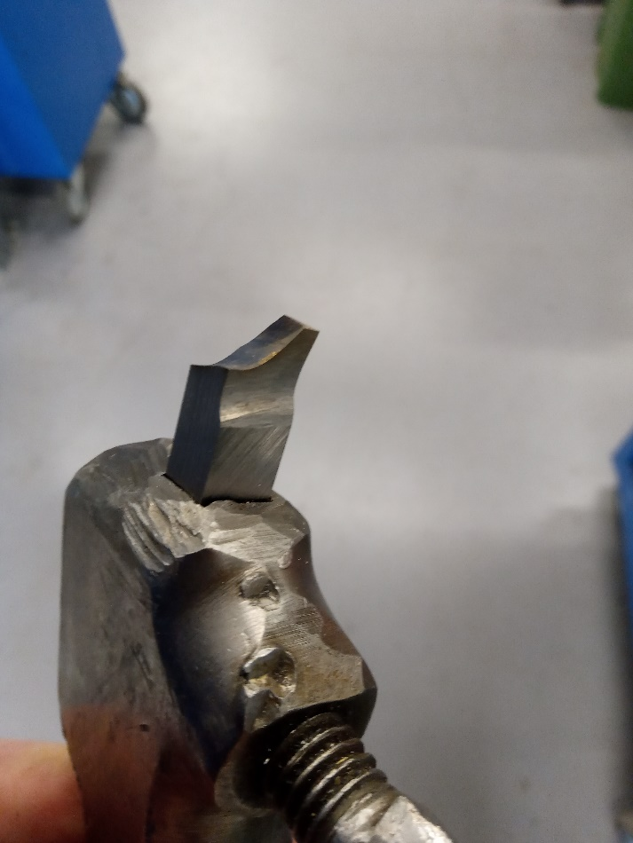
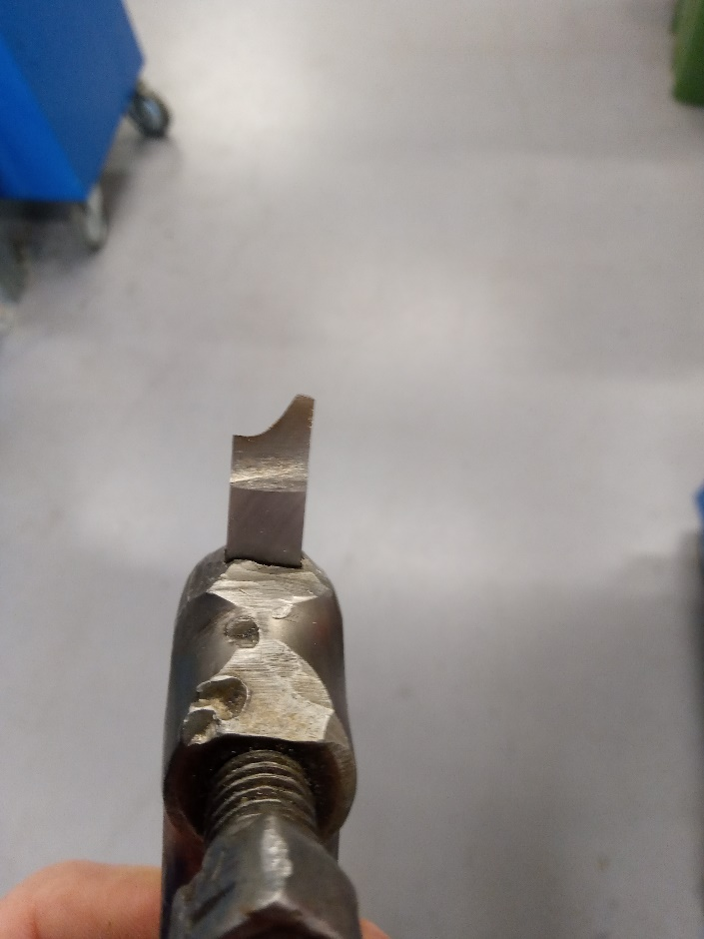
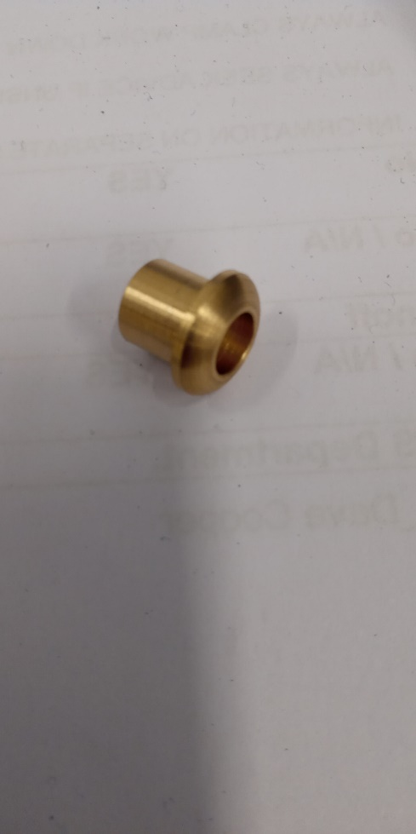
A custom tool was ground in order to produce the desired profile on the front of the component. As brass is soft a steep rake angle was chosen so swarf can be removed a good rate. The Process was much like that of session one. The brass was placed in the chuck. Faced off and the outer 12mm diameter turned down. Then the smaller 10mm diameter was turned leaving a shoulder on the component and this side deburred before turning the component around. Then the component was spot drilled using a center drill then the inner diameter 8mm drilled through. Finally using the profile cutter the mushroom profile was produced. Then de burr and part off. And as seen in the figure to the right the component turned out nice and was in tolerance.

Guest Lecture.
Bloodhound SSC Land Speed record.
27/11/2019
Time: 1pm – 2pm
Room Q101.
Guest: Dr Ben Evans.

Bens history.
Ben has been involved with the project from 2007. He was doing a PHD in Fluid dynamics or CFD. During which he got an invite to be a part of the design team for the land speed record which Richard Noble and Andy green were to embark on. His role within the project would be to take the aerodynamic lead on all the 3D modeling within the design. Although Ben is not a major fan of cars his main reason to get involved with the project was purely because it is scientifically challenging and interesting.

Essential Tasks undertaken by Ben and his team.
- What shape should the car be?
- Will it achieve 1000 MPH?
- Can it be done safely?
- The car Has got to stay on the ground!
- Minimize Drag.

The project had many financial threats over the years. And went bankrupt more than once. The project was finally Bought by a private investor which allowed the Attempt to continue its research, development and testing.

Car Spec’s.
7 tons of carbon fiber and Aluminum Alloy. Currently fitted with a Jet engine, and later to be retro fitted with a Rocket as well. The engine is a Rolls Royce EJ200 Jet Engine also found in the Eurofighter Typhoon aircraft. Conventional disc brakes on the front wheels which can be applied from around no more than 160MPH. Aero Breaks and Parachutes also fitted.
With Just a Jet running, initial testing in South Africa Placed Bloodhound as the 3rd fastest car in history. It has achieved approximately Mach 0.80 or 80% of the speed of sound and can achieve 0 – 210MPH in 12 seconds.
Previous record was set in 1997 by Trust SSC at 763MPH.

Subsonic Travel.
Regular cars and other forms of travel are done so sub-sonically, while doing so an object will project pressure waves ahead of it which can be deemed as sound waves as they travel at the speed of sound. Approximately 760MPH as this value varies with temperature. These waves effectively relay information to the air ahead of the object in motion that, something is coming and you're going to have to start moving out of the way and make a space for this object to pass through.

Supersonic Travel.
This occurs when an object travels faster than the speed at which the sound waves can propagate. Hence the waves are unable to get ahead of the object in question. As a result, the air ahead of this object has no idea this object is coming. At this point an object will produce a shockwave.

Bens Further Research.
More than 10 years of work have been invested into such areas as how shockwaves produced by supersonic travel interact with the car and the ground ahead of the car.

CFD is used to model how the car will behave aerodynamically. And how various external conditions effect the car at different speeds. It begins with a geometry specification, then create a CFD Grid over the car. Then it goes to a CFD Solver which runs on a supercomputer due to the level of detail required. This will be used to solve such equations known as Navier-Stokes Equations which solve things like pressure distribution and skin friction drag predictions. These predictions then impact the design in order to improve performance. And the cycle continues to repeat itself so to achieve the best car possible for the task.
CFD testing resulted in many features such as fin width, nose height and wheelbase being modified and changed repeatedly over the course of the project. Also overall car performance and total Lift force can be tested. The range of speed tested on bloodhound is as follows. Low speed Starts at Mach 0.3 or approximately 200MPH. A this speed the car behaves similar to a regular sports car where accelerating the flow of air underneath the car will create a drop in pressure and thus the car will suck itself onto the floor otherwise known as downforce. While accelerating through Mach 0.6 – 0.7 the downforce begins to deteriorate until a speed of roughly Mach 0.9 where all the downforce has disappeared and small amounts of lift, and peak lift is achieved at around Mach 1 before it tails off again. At Mach 1 Approximately 1 – 2 tons of lift will be achieved. As the car is around 7 tones, the lift at Mach 1 shouldn’t cause a problem.
Trans Sonic Regime’s Occur when the car transitions from subsonic to supersonic speeds.
The CFD Program was tested in the 90’s to ensure its dependability where a 1/10 scale version of the trust SSC car with rockets attached was placed on a track to make a run and compare data from CFD with a real-world experiment. There was an artificial road in place to try replicate the shockwave hitting the ground. The car accelerated from 0 to 800 MPH in just 0.8 of a second and experienced approximately 50 G of acceleration. There were several pressure sensors attached to the car at particular points of the geometry and the sole purpose was to measure a given pressure as a function of speed. After the real-world data was compared with the predicted data by CFD, a graph was plotted, and it showed that both lines plotted where very closely matched and that that level of correlation for CFD in the 90’s was astonishing.
The bloodhound SSC has over 200 of these pressure sensors.
Ben Also conducted a similar comparison Using CFD and also
One obstacle that stood in the way during the design phase was the rear suspension pivot arms. Between Mach 0.8 – 0.9 the original suspension was producing 14 tones of lift. To combat this and reproach the design they used a statistical tool called Design Experiment Optimization which lead the design team to redesign and reshape the whole back of the car. They froze the design process there after in late 2014 and set out building Bloodhound. The build took about 18 months and finished in early 2017.
The car was tested in South Africa, in a region of Northern Cape known as the Hakskeenpan where a stretch of dried up lakebed sits in the Kalahari desert. Ben Also conducted a similar comparison to that mentioned above where CFD and also the data from this initial +600MPH run were seen to be very accurate and well within a 5% tolerance band and a speed of 628MPH was achieved by the driver Andy Green.
Conclusion.
The bloodhound project is in a league of its own. Incredible how a project in the making for over 10 years has had so many ups and downs. Yet lives on solely because of the passion by all who are invested in it not only financially but with their dedication, persistence, attention to detail and hard work. A true engineering marvel that is inspiring to say the least.

