
Skills for the Workplace
Module Assignment Submission
Student Name: | Craig Bennett
Student Number: | 119380
Module No: | BMSK 4006
Module Title: | Managing enterprise in the 21st century

Statement of Confirmation of Authenticity
By the act of making this submission, the student declares that this is the work of the student named above. The work has not, in whole or in part, been knowingly presented elsewhere for assessment, or where assessment has been built on a previous assessment, this has been identified. Where materials have been used from other sources it has been properly acknowledged. If this statement is untrue, the student acknowledges that an assessment offence has been committed.
Attention is drawn to the plagiarism and unfair practice policies of both the University and of ILM.
Permission for ILM to use this script
ILM uses learners’ submissions – on an anonymous basis – for assessment standardisation. By submitting, both the centre and the learner agree that ILM may use this script on condition that identifying information is removed. However, if you are unwilling to allow ILM use this script, please refuse by ticking the box: □

Table of contents

Front sheet……………………………………………………………………………………………………………….………………….1

Table of contents………………………………………………………………………………………………………………………….2

Executive summary………………………………………………………………………………………………………………………4

Business Overview……………………………………………………………………………………………………………………….5

Markets and competition…………………………………………………………………………………………………………….6

Target Markets…………………………………………………………………………………………………………………………….6

Competition…………………………………………………………………………………………………………………………………6

Sales and marketing……………………………………………………………………………………………………………………..7

Product and positioning………………………………………………………………………………………………………………..7

Marketing and sales………………………………………………………………………………………………………………………7

Management…………………………………………………………………………………………………………………………………8

Key personnel……………………………………………………………………………………………………………………………….8

Advisors and support services……………………………………………………………………………………………………….8

Operations…………………………………………………………………………………………………………………………………….9

Premises and equipment……………………………………………………………………………………………………………….9

Employees…………………………………………………………………………………………………………………………………….9

Suppliers……………………………………………………………………………………………………………………………………….9

Financial forecast…………………………………………………………………………………………………………………………10

Sales…………………………………………………………………………………………………………………………………………….10

Cashflow………………………………………………………………………………………………………………………………………10

Profitability…………………………………………………………………………………………………………………………………..10

Financing………………………………………………………………………………………………………………………………………14

Appendix 1 …………………………………………………………………………………………………………………………………..15

References……………………………………………………………………………………………………………………………………16

Executive Summary

This business I want to set up is a training hotel, offering accommodation, food and drink services including function, conferencing, meeting and banqueting facilities. The target markets would be business customers for conferencing and meetings, leisure travellers, staycations, Sports enthusiasts, Sightseeing tourists, tourists of all descriptions, Dylan Thomas enthusiasts.

I will market the business with companies and businesses in the United kingdom for meeting and conference facilities. I will market online via a website, social media, Instagram, Twitter. I will target sports enthusiasts by marketing stays to clubs and societies for example golf societies, surfing clubs, birdwatching clubs.

The key people within the business would be myself Craig, my wife Lisa(administrator) and a head chef, as well as two duty managers. All other staff would be training associates on an apprenticeship program to develop their skills within the hospitality and tourism sector gaining professional qualifications whilst working and getting paid to learn. There are currently 14 letting rooms and 5 rooms used for stock storage. I would update these stock rooms into letting rooms making 19 letting rooms in total.

I have worked all sectors of the business as base rates (net rate) then added 64% gross profit and 20% tax so I have worked out my costings and sales rates.

Net sales per annum £1,357,200

Gross sales (64%gp and 20% tax included) £2,661,732

Annual training allowance £143,520

I would need financing which I have sources at £300,000pa

The hotel is sold with all equipment, fixtures and fittings.

Business Overview

My background has always been in hospitality, I trained as a chef when I left school and went straight into the industry. My business overview deals with buying a hotel and setting it up as a training hotel, targeting post school leavers to get into the hospitality industry age 16-24, offering them an apprenticeship program for 3 years to cover a wide range of hospitality services, whilst they are getting paid and receiving on the job training.

The hotel I would like to buy is a hotel recently brought on the market, Browns hotel in Laugharne. This is a historic hotel and would be ideal for my venture. It has ties with Dylan Thomas who was a regular in the hotel. It is situated in Carmarthenshire which has direct access to all the transport links.

It is a working hotel with restaurant and conference facilities as well as a public bar. My target market would be anyone who wants to have a leisure or business break in West Wales.
Markets and Competition

Target Markets

Families- We would offer families a package which would include theme park entry tickets to attractions like Folly Farm, Oakwood or Annas zoo experience to attract the families. We offer on site accommodation in large family rooms as well as comfy double rooms, and we also offer scrumptious food in our award winning restaurant “Dylans” restaurant.

Business – The hotel offers the business traveller a host of conference and banqueting options from a cozy 10 seat boardroom to full function service for 100 people. This can include banqueting facilities. The hotel offers free in house wi-fi, business centre with 6 computers, scanning facilities, fax, printing services.

Staycation – This group is for people who want to “get away” from the hussle and bussle of modern life. The hotel is set in tranquil Carmarthenshire in the heart of West Wales where there are multitudes of activities you can do, or just sit back and relax.

Sports – West Wales boasts a host blue flag beaches suitable for surfing and all forms of watersports, forestry’s, country parks, mountain ranges, bike trails, archery and a plethora of sporting activities. The hotel could organise rugby tickets for any of the major international fixtures or tickets to see the local team Llanelli Scarlets.

Competition

In Laurgharne there are no hotels currently open other than Browns and that is for sale. The main competitors are Corrans resort and spa in Laugharne but that business has folded and gone into receivership from the Covid crisis, The only other notable hotel in the locality is the Royal Ivy Bush Hotel in Carmarthen where on comparison the charges they make to the guest are 20% higher rates that Browns. This includes overnight stays, food, drink, conference and banqueting so I think as well as training young staff into the industry Browns is actually very competitive.

Sales and Marketing

Product Positioning

In Laurgharne there are no hotels currently open other than Browns and that is for sale. The main competitors are Corrans resort and spa in Laugharne but that business has folded and gone into receivership from the Covid crisis, The only other notable hotel in the locality is the Royal Ivy Bush Hotel in Carmarthen where on comparison the charges they make to the guest are 20% higher rates than that of Browns. This includes overnight stays, food, drink, conference and banqueting so I think as well as training young staff into the industry Browns is actually very competitive. Other hotels but on a smaller scale with only up to 10 rooms are :-

The boat house B&B

Hill farm B&B

Premier inn

Big barn camping

Picton House B&B

So in light of this and the current Covid situation unfortunately making a lot of local businesses being put into receivership Browns is ideally situated to take advantage of the current market trends and take full advantage of the market resurgence.

Marketing and sales

Working closely with Cambrian Training Company who deliver work based learning apprenticeships they have an active marketing base to all the companies in Wales where they advertise placements and job vacancies, marketing for small companies and businesses across Wales. I would also actively market online to companies and businesses in The United kingdom advertising the fact that we are a small to medium hotel right in the heart of stunning West Wales, detailing the facilities of the hotel. I would use social media to market the hotel to everyone as a target market.

Management

Key Personnel

Craig Bennett – Owner/managing director I would be in charge of the day to day running of the hotel and have the final say over purchasing goods and stock.

Lisa Bennett – Administrator Having had over 15 years experience in administration from insurance services, MFI and Carmarthen County Council Lisa has the extensive experience to provide the administration services to the hotel.

Assistant manager x2 – to assist in the day to day running of the hotel

Head chef – to run the kitchen and be responsible for the day to day operations of the catering facilities.

Associate staff x 65 – They would be key staff in each section of the hotel where they learn on the job as well as gaining a professional qualification. Main areas in the hotel would be :-

Kitchen

Bar

Restaurant and banqueting

Room service

Reception

Cleaning

Advisors and support services

Accountancy - Charles & Co Accountants (Llanelli), responsible for tax, VAT, Payroll, corporation business tax, self-assessments and end of year accounts.

Operations Premises and Equipment

Browns Hotel is a running, working hotel with all the fixtures and fittings needed for day to day operations. The hotel is for sale with all the equipment, fixtures and fittings needed to run the hotel.

Employees

Apart from the management team which would consist of Managing director, Administrator, head chef, assistant managers.

The associate staff (65) would consist of associates who would sign up to a 3 year apprenticeship to work and learn “on the job” in every area of the hotel and get a professional qualification in professional cookery, hotel services level 2 qualifications whilst in work. Staff would work 3.5 days a week for 28.5 hours over a rolling rota on minimum national wage.

Suppliers

3663 – Food and drink services

Bookers – food and drink services

Trade team- drinks service

Excel – food and drinks suppliers

Nisbets – catering equipment and suppliers

Diversy Lever- Cleaning equipment and materials

Johnstone and Johnstone – Cleaning equipment and materials

XTS laundry supplies – all laundry supplies, towels, bedding, cushions, shower gels, soaps, etc.

All suppliers offer 3 months interest free credit.

Financial Forecast

Assumptions

It is assumed that in the first example the hotel will be at full 100% occupancy and 30 walk-in guests for lunch and for dinner and a bar trade. This will be a rolling monthly forecast not a yearly one.

Sales

Rooms

19 double rooms for let at £140 per room per night.

£70 base rate £ 9310

£45 64% gross profit £ 5985

£25 20% tax £ 3325

Making each room saleable for £140 per night.

19 rooms x £140 x30 (days per month) £ 18,620

FOOD

Set 3 course menu for £30 per person

Lunch 30 people (walk in guests)

Dinner 30 people (walk in)

Dinner 38 residents, making 98 meals

Menu cost £15 £ 44,100

64% gross profit £10 £ 29,400

Tax at 20% £5 £ 14,700

Total sales £88,200

Conference and functions

Let out the function room for £110 per day, assuming a minimum of 3 functions per week

Base rate £70 x 3 x 30 £ 6,300

64% gross profit £38 £3,420

20 % tax £2 £ 180

Total sales £9,900

Bar

Assuming each guest buys 4 drinks

Food/bar 30 lunch guests, 38 dinner, 30 walk in food

Just bar 30 walk in lunchtime, 30 walk in dinner, 20 conference and banqueting making daily total guests requiring bar 178

Cost of each drink £2.50 x 178 x 4(drinks) x 30(days) £53,400

Gross profit @64% £1.60 £34,176

Tax @ 20% £0.82 £17,515

Total drink cost £4.92 Total sales £105,091

Training allowance (payment from Welsh Government)

65 learners(associates) getting a training allowance of £230 per month £14,950

Tax @20% £2990

Net allowance £11,960

Net sales £ 113,110 x 12(months) £1,357,200

Gross sales £221,811 £2,661,732

Plus annual training allowance after tax deduction £143,520

Cashflow

As with any hotel payment is made upon departure. If the hotel runs at 100% occupancy the profit would be net sales minus overheads minus staff wages minus stock purchases (this would be a weekly and monthly outgoing which is factored into the gross cost of sales).

Profitability

Per annum +£1,500,720

Staff wages National minimum wage £8.72ph x 28.5(hours) x 65(staff) x(52 weeks) - £839,997

Gas, electric, water business rates -£160,003

Total net profit in 1 years trading £500,720
Financing

I have sourced financing with funding circle for £800,000. This would then include cost of premises and 3 months trading costs including cost of stock purchases, overheads like gas, electric and water, business rates. I also researched my sourcing for stock suppliers that would include 3 months interest free credit.

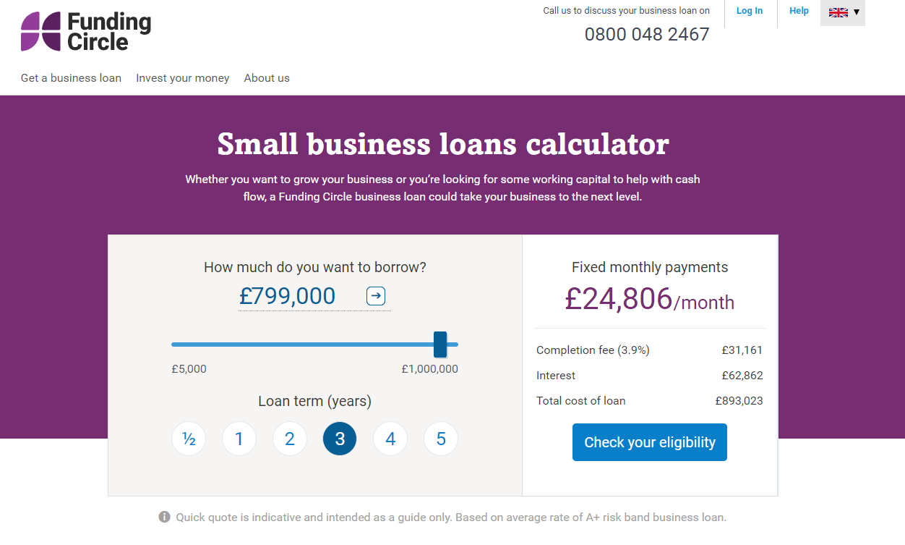

(Business Loan Calculator For Small Businesses | Funding Circle, 2020)

Appendix 1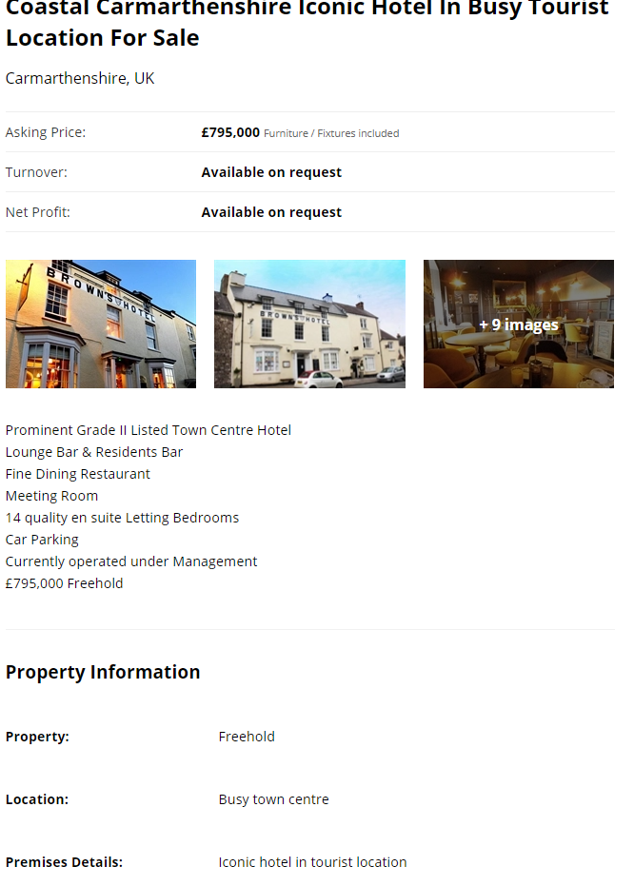

(Check out this commercial property on Rightmove!, 2020)

References

Fundingcircle.com. 2020. Business Loan Calculator For Small Businesses | Funding Circle. [online] Available at: <https://www.fundingcircle.com/uk/small-business-loans-calculator/> [Accessed 11 July 2020].
Rightmove.co.uk. 2020. Check Out This Commercial Property On Rightmove!. [online] Available at: <https://www.rightmove.co.uk/commercial-property-for-sale/property-94477394.html> [Accessed 11 July 2020].

