

Menu Engineering
(Practical Task)

Module code: BMIH4002
Lecturer NAME: Ka Po Chong
STUDENT NAME: oXANA GHERTOG
STUDENT ID: 2243161
WORLD COUNT: 390 words
10.11.2023


The Leopold Hotel located in Sheffield is a partner of The Trinity Hotel Group in UK. This 4-star hotel is situated in the heart of Sheffield and is housed in a historic building that previously served as a Boys Grammar School. This hotel is well known in the area and is conveniently located for those traveling from London to Scotland or for those looking for a base to explore the local attractions such as the Crucible Theatre, Sheffield Arena, and the Peak District National Park.
The Leopold Hotel's restaurant concept marries the grandeur of its historic roots with a contemporary dining experience. The establishment offers a buffet breakfast, and a bar & lounge that serves lunch and dinner, crafted to cater to both guests and walk-in diners.
The day starts with a buffet breakfast in a casual yet elegant setting. The spread includes a range of hot and cold items, from traditional English breakfast components to continental selections. Guests can expect local farm-fresh eggs, artisan bread, and regional specialties like Sheffield honey and Derbyshire oatcakes, reflecting the locale's palate.
For lunch and dinner, the bar & lounge transitions into a more sophisticated ambiance. The service style varies: lunch is a relaxed affair with an à la carte menu featuring gourmet sandwiches, salads, and seasonal soups, perfect for business lunches or leisurely dining. Dinner elevates the experience with the option of a plated service or a tasting menu, offering a culinary journey through Sheffield's gastronomic landscape.
The restaurant prides itself on its flexible service style. Breakfast is self-service, encouraging guests to start their day at their own pace. Lunch and dinner provide a plated service, focusing on presentation and personal attention, while the tasting menu for dinner offers a chef's selection that showcases the kitchen's creativity and the seasonal best.
The restaurant caters to hotel guests and locals who appreciate fine dining with a casual yet sophisticated twist. It is aimed at food enthusiasts, couples seeking a romantic setting, business professionals looking for a quality meal in a comfortable environment, and tourists attracted to the historical significance of Sheffield.
To enhance the dining experience, the restaurant could include interactive elements such as a live cooking station during breakfast, where guests can have their omelets made to order, or a 'Gin Cart' during dinner, featuring local gins for a bespoke cocktail experience.
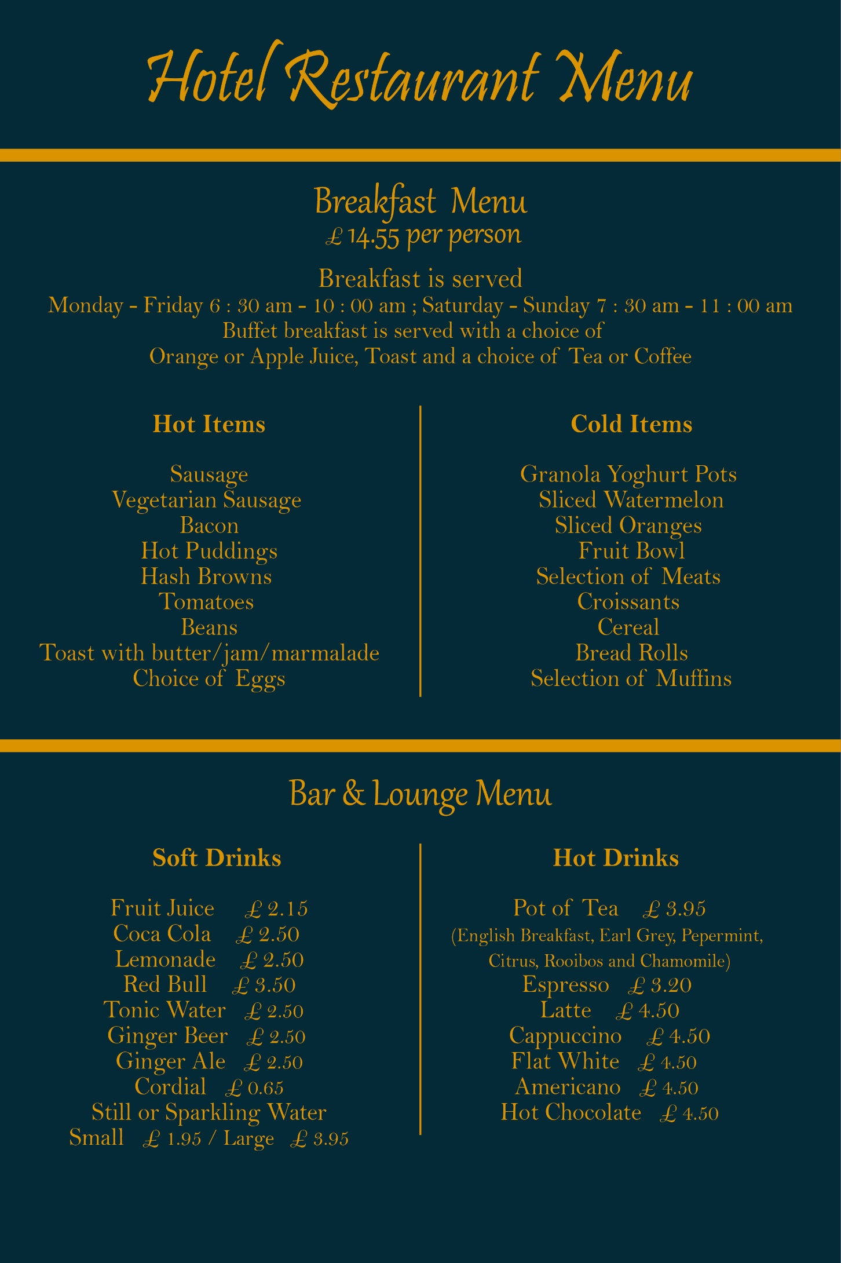
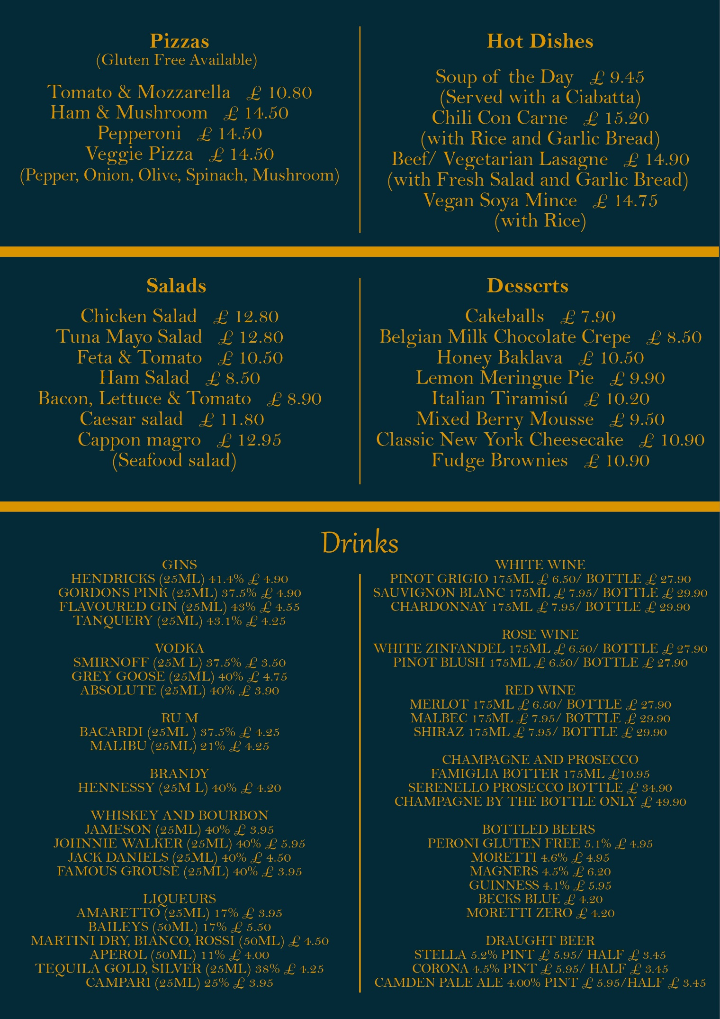

References
Bourdain, A., 2000. Kitchen Confidential: Adventures in the Culinary Underbelly. 1 ed. s.l.:Bloomsbury Publishing.
Boussard, S., 2021. Food and Beverage Management in the Luxury Hotel Industry. 1 ed. New York: Business Expert Press.
Brown, D. R., 2007. The restaurant manager's handbook : how to set up, operate, and manage a financially successful food service operation. Ocala, Florida: Atlantic Publishing Group Inc.
Cousins, J. &. W. S., 2020. Food and Beverage Service. 10 ed. London: Hodder Education Group.
Groups, T. H., 2023. Trinity Hotel Groups. [Online]
Available at: https://trinityhotelgroups.com/our-partner-hotels
[Accessed 4 11 2023].
Hotel, T. L., 2023. The Leopold Hotel Sheffield. [Online]
Available at: https://www.leopoldhotel.co.uk/en/dining
[Accessed 5 11 2023].
Johnston, R., 2012. Service operations management : improving service delivery. 4th ed ed. Harlow, England: Pearson.
Kinni, T., n.d. Be Our Guest: Perfecting the Art of Customer Service. 10 Anniversary ed. 2011: Disney Editions.
Meyer, D., 2007. Setting the Table: Lessons and Inspirations from One of the World's Leading Entrepreneurs. 1 ed. s.l.:Marshall Cavendish.
Oswell, P., 2016. 48 hours in... Sheffield - Best of both worlds - (53.9 degsN 1.5 degsW). London, Haymarket Business Publications Ltd.

