Databases and Application Development
Student: Max Morton Lewis
Lecturer: Paul John
Module Code: ACCA5026
Contents
Introduction 2
1.0. Entity relationship Diagram (ERD) 3
2.0. Data Dictionary 4
3.0. Code for file 1 4
3.0.1. Table structure 4
3.0.2. Create the referential integrity constraints 6
3.0.3. Check constraints 6
3.0.4. Populate tables 6
3.0.5. Validate constraints 9
3.0.6. Transactions, rollback and commit operations 9
4.0. Section 2 of Task 1 10

Introduction
I will be making a database for an international company called “Adventure Works Cycle”. I will be responsible for making sure that database has strict validation to make sure user do not input inaccurate data, I will be responsible for the design and layout of the database.

Installation and setup of database
Once you have the sql scripts its important that you execute them in this order. First you execute UpdateProducts_PRO then secondly AdventureWorksCycle_Working.

1.0. Entity relationship Diagram (ERD)
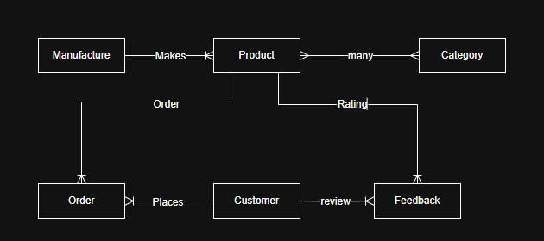
Figure 1 Before making the database
This is the ERD I made at the start of the project as an outline for what would later be the database
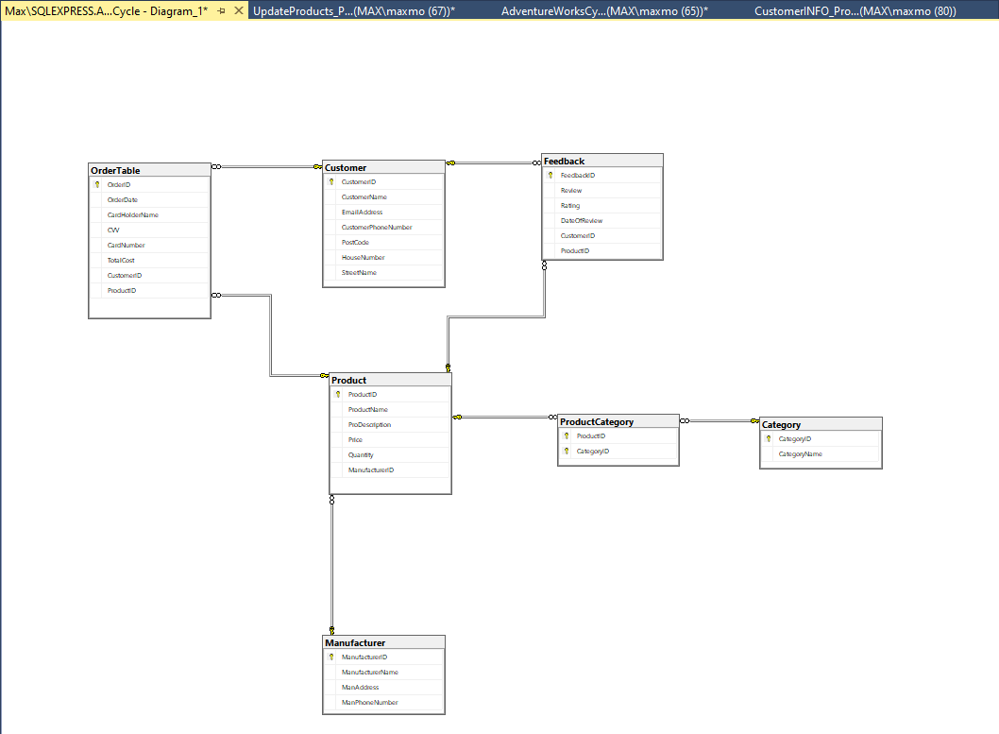
Figure 2 ERD in sql server
In Figure 2 we can see the ERD in sql server which show the relation ships and attributes

3.0. Code for file 1

3.0.1. Table structure
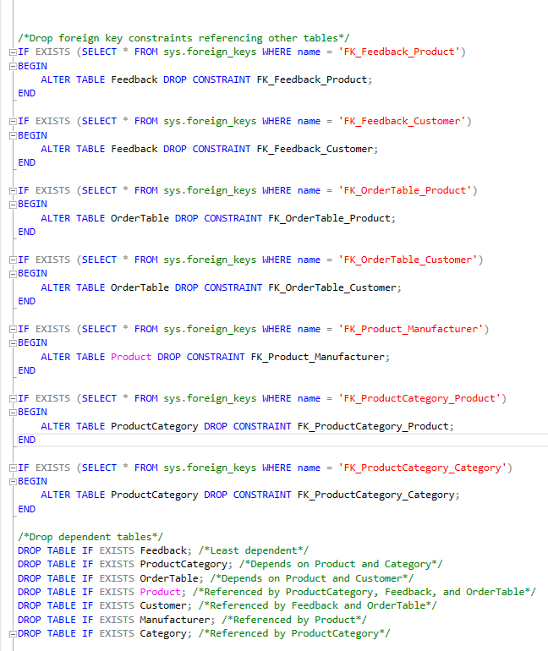
Figure 3 Dropping the foreign keys and the tables in order
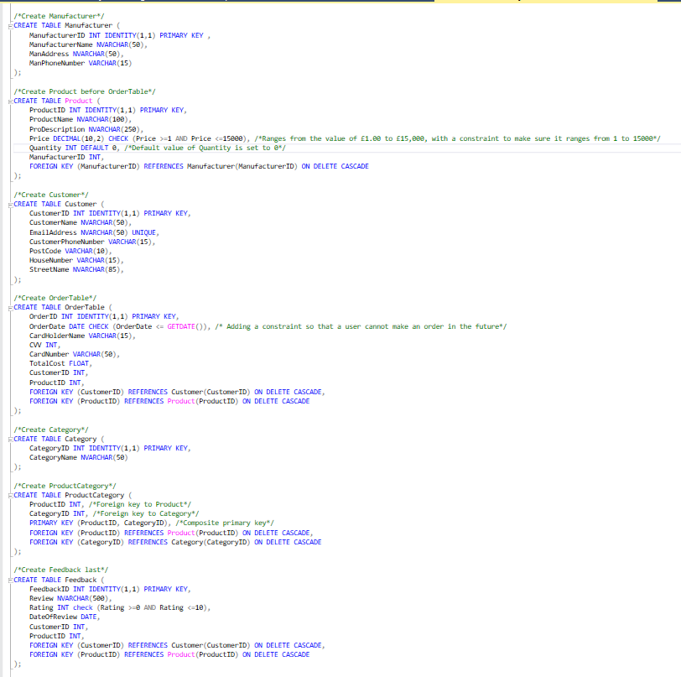
Figure 4 Creating the tables

3.0.2. Create the referential integrity constraints
Figure 5 we use ON DELETE CASCADE so that if a row is deleted from the parent table it will also be deleted from the child
Figure 6 we use ON DELETE CASCADE so that if a row is deleted from the parent table it will also be deleted from the child
Figure 7 we use ON DELETE CASCADE so that if a row is deleted from the parent table it will also be deleted from the child
Figure 8 we use ON DELETE CASCADE so that if a row is deleted from the parent table it will also be deleted from the child

3.0.3. Check constraints
Figure 9 This will check to see if order date is equal than or less to get date
Figure 10 This will check to see if the price is less than or equal to 1 and greater than or equal to 15,000
Figure 11 This will check to see if the rating is less than or equal to zero and greater than or equal to 10
Figure 12 Date check for the feedback review date

3.0.4. Populate tables
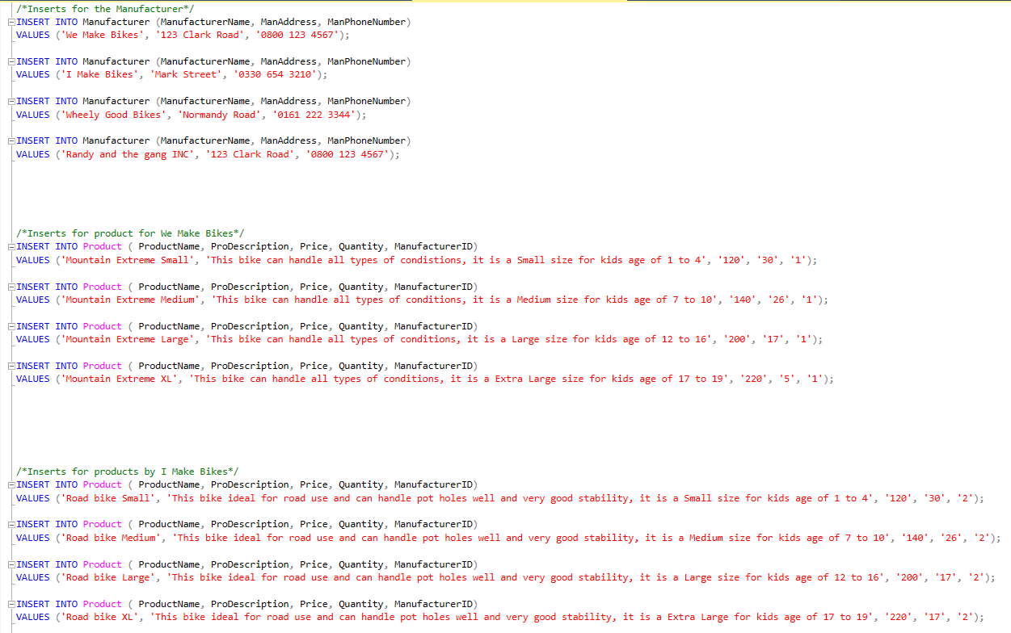
Figure 13 Insert for manufacturer and Product
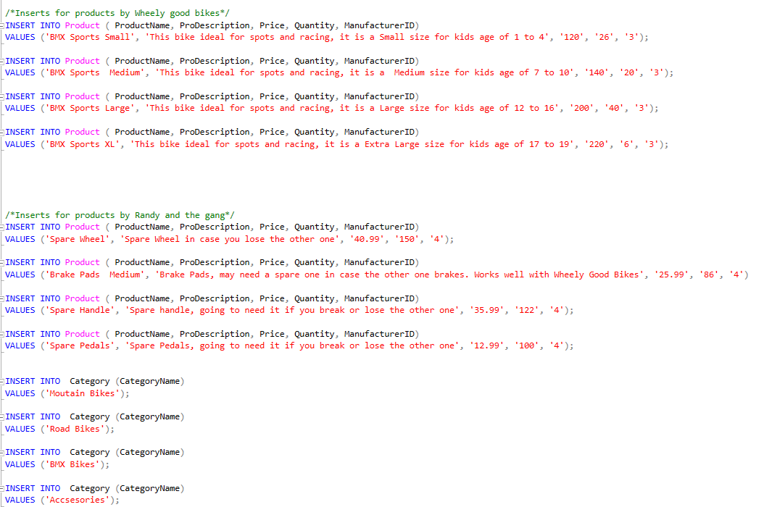
Figure 14 Insert from products and Category
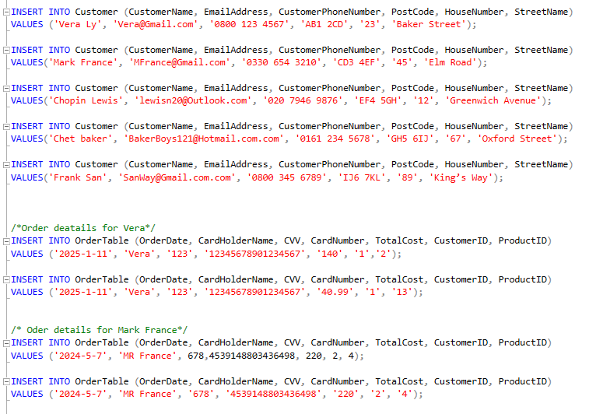
Figure 15 Insert for customers and their orders
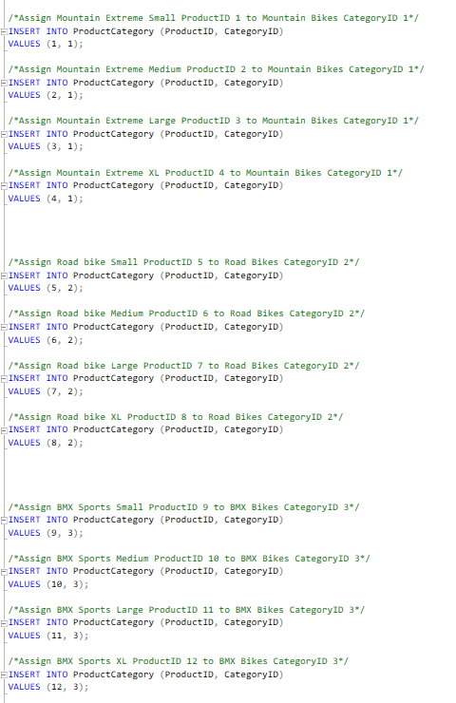
Figure 16 Inserting the products to their category
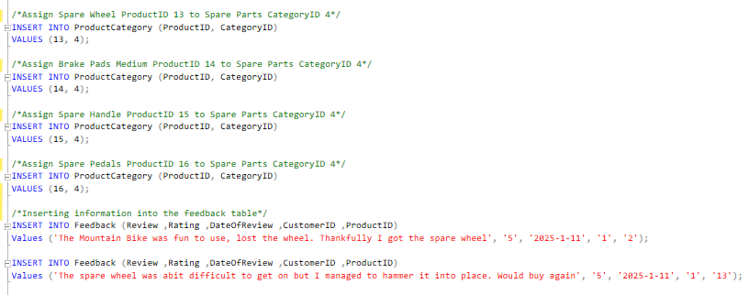
Figure 17 inserting the product into category and inserting data for feedback

3.0.5. Validate constraints
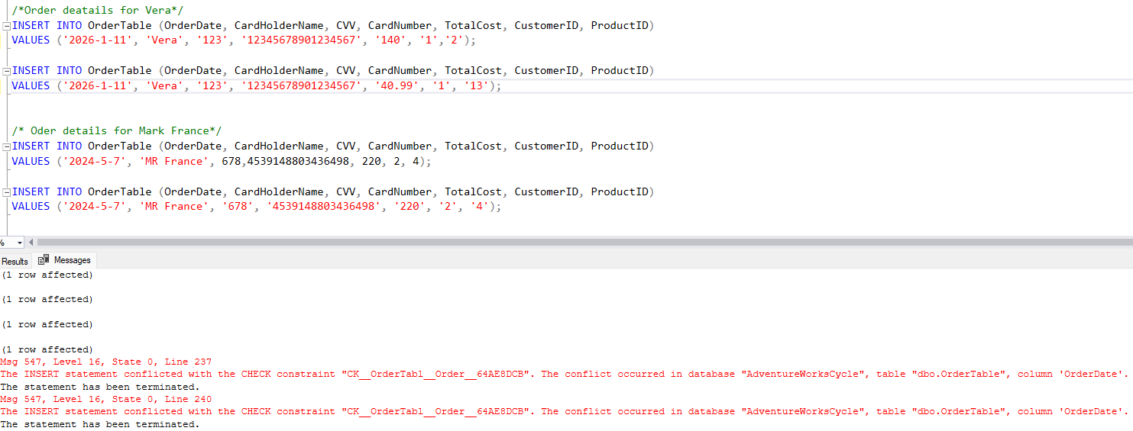
Figure 18 Validating the year on feedback for Vera
In figure 18 we are testing the date constraint for vera order. We change the date to 2026 a year in the future and see if it returns an error which it does.
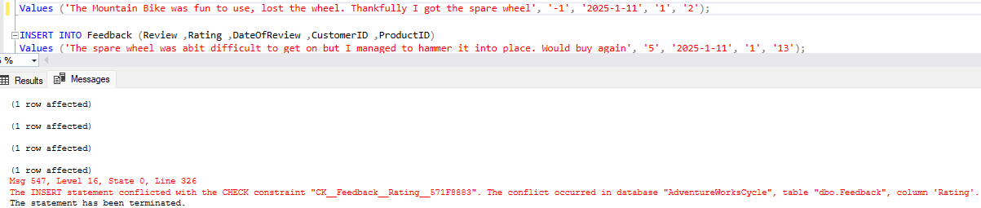
Figure 19 Validating the rating feedback
In figure 19 we are testing the rating constraint for vera’s feedback. We change the rating to something outside of 0 and 10 and see if it returns an error, which it does.

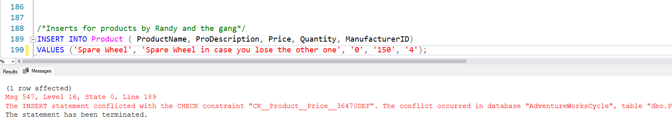
Figure 20 Testing the price check
In figure 20 we are testing the price check. We set the price to something outside the valid range of data, this should return an error, which it does.

3.0.6. Transactions, rollback and commit operations
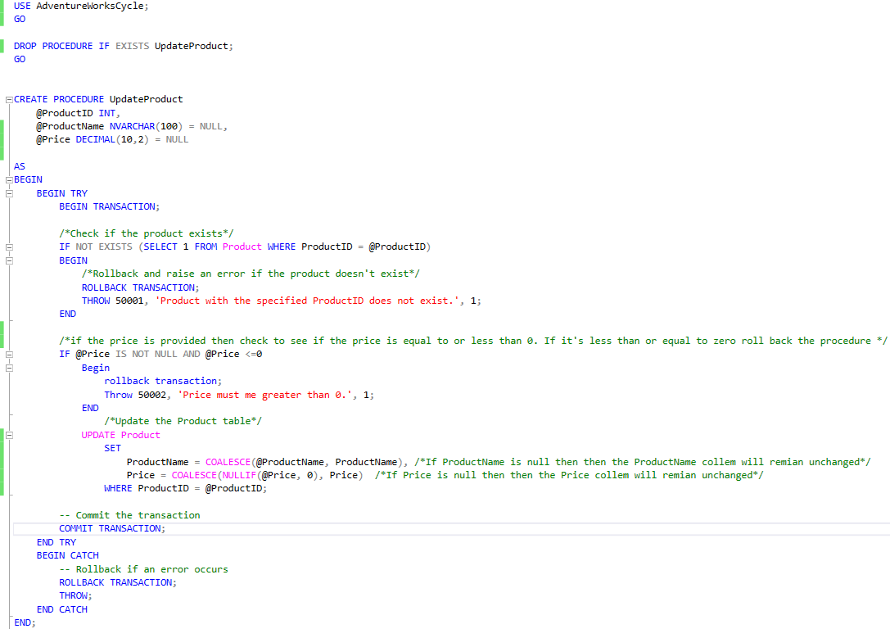
Figure 21 Code for the stored procedure
In figure 21 you can see my stored procedure. There are many steps to this store’s procedure so let’s go through them. We name the procedure, define the inputs for this procedure and then begin it.
We test to see if the product ID entered exists in the product table, if not then we roll back the changes and display an error message 5001. For price we do something similar. If the price provided is less than or equal to 0, we rollback the changes then display error message 5002.
Then we update the product table if the insert has passed validation. If the price that is entered is 0 then we fall back on the current price that is in the price column, if the price is not null then we use COALESCE to get the first non-null value which if valid is then used to update the price column. Once the valid price is entered, we then commit to this action to save the update. Then at the end we have a catch just for any unexpected errors (system level, database and query errors) with a rollback for these unexpected errors. Throw is then used to display the error to the user so it can be logged by the user or recognised and isn’t silently ignored. We then end the catch and the procedure

4.0. Section 2 of Task 1
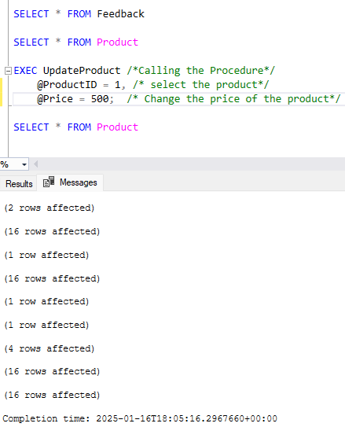
Figure 21 Changed the price of the product that would be accepted
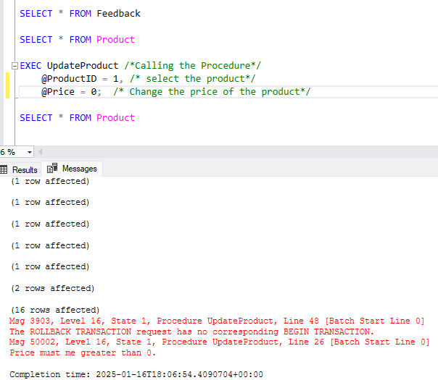
Figure 22 Change the price lower than the seta mound causing an error
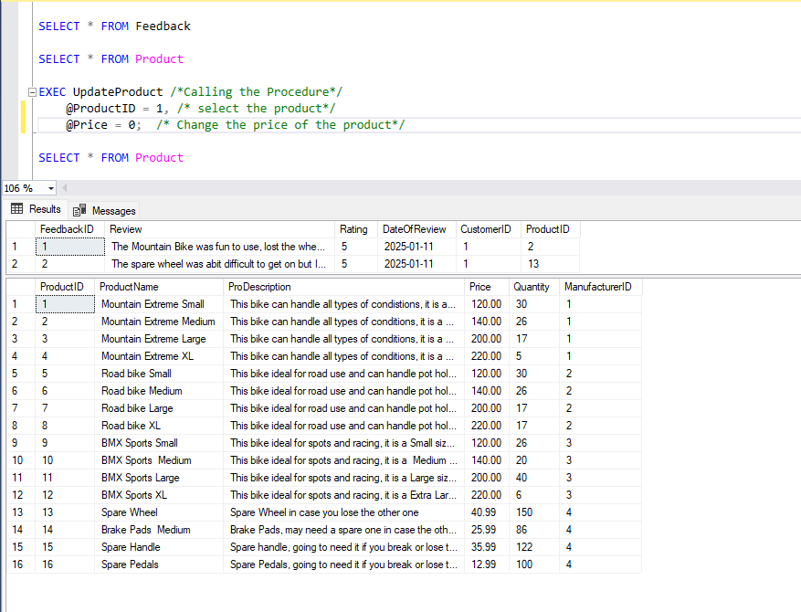
Figure 23 The tables do not get updated with the incorrect data
The reasoning behind this scenario is because the price of products can change, and if they are being manually changed this can lead to human error. By having this procedure in place, the chance a user being able to input an incorrect number is very low. This stored procedure has transaction, rollback, commit and update. We can use transactions to catch any errors early if data is invalid and only update the table if the validations are met. This is where rollback is used to revert any changes made to the database making sure that no invalid data is displayed and that an error message is passed to display to the user what went wrong. If the validation criteria are met then we can use commit to the updated data to the table. This will save the change only if the data is valid.

References
(Bro, 2022)
(W3schools, SQL INNER JOIN, N/A)
(W3schools, SQL LEFT JOIN Keyword, N/A)
(W3schools, SQL RIGHT JOIN Keyword, N/A)
(W3schools, SQL FULL OUTER JOIN Keyword, N/A)
(W3schools, SQL GROUP BY Statement, N/A)
(W3school, N/A)
(W3schools, SQL Constraints, N/A)
(W3schools, SQL CHECK Constraint, N/A)
(d, N/A)
(Taryn, N/A)
(Dalvi, N/A)
(CodeLikeBeaker, N/A)
(W3schools, SQL Server COALESCE() Function, N/A)
(W3schools, SQL Server NULLIF() Function, N/A)

Bibliography
Bro, C. (2022, October 30). MySQL: JOINS are easy (INNER, LEFT, RIGHT). N/A, N/A, N/A.
W3school. (N/A, N/A N/A). SQL INSERT INTO Statement. Retrieved from W3schools: https://www.w3schools.com/sql/sql_insert.asp
W3schools. (N/A, N/A N/A). SQL FULL OUTER JOIN Keyword. Retrieved from W3schools: https://www.w3schools.com/sql/sql_join_full.asp
W3schools. (N/A, N/A N/A). SQL GROUP BY Statement. Retrieved from W3schools: https://www.w3schools.com/sql/sql_groupby.asp
W3schools. (N/A, N/A N/A). SQL INNER JOIN. Retrieved from W3schools: https://www.w3schools.com/sql/sql_join_inner.asp
W3schools. (N/A, N/A N/A). SQL LEFT JOIN Keyword. Retrieved from W3schools: https://www.w3schools.com/sql/sql_join_left.asp
W3schools. (N/A, N/A N/A). SQL RIGHT JOIN Keyword. Retrieved from W3schools: https://www.w3schools.com/sql/sql_join_right.asp

