

Strategic Management for Business
Individual Report

Student Name: Ioan Stefan Madaras
Student Number:2332801
Lecturer Name: Dr Faizu Edu
Module code: LCLM-6001

1. Executive summary
Vodafone UK is undergoing a massive transformation after announcing it was to be merged with Three UK to form VodafoneThree by 2025. The merger has resulted in the UK's biggest mobile network operator and an investment of £11bn in network infrastructure over the next decade with an aim to create £700m a year in cost savings. The report employs the PESTEL analysis and Porter's Five Forces to assess the current strategic position of Vodafone – highlighting a shift in competition, which is driven by industry consolidation, as well as the political, economic and technological environment. The suggested growth strategies for the report are market development and product development, such as expanding 5G Standalone coverage, increasing digital, business and IoT services, as well as differentiation and not price-oriented competition on the basis of the aforementioned matrices from the Ansoff matrix and the Porter generic model. The SFA framework supports this strategy to be suitable, feasible and acceptable. The report also pinpoints key stakeholders and proposes an implementation schedule containing objectives, actions and performance indicators for a timeframe of up to 3 – 5 years.

Table of Contents
1. Executive summary 2
2. Introduction to Vodafone 4
3. Evaluation of Current Market Situation 4
3.1 PESTEL Analysis 5
3.2 Porter's Five Forces Analysis 6
4. Strategic Growth options and proposed strategy 8
5. Strategy Evaluation 9
6. Stakeholder analysis 11
7. Implementation and Monitoring 12
Conclusion 13

2. Introduction to Vodafone
Vodafone Group Plc is a telecommunications company headquartered in Newbury, England, in the UK. It was established in 1991 and is listed on the London Stock Exchange (LSE). It provides mobile, fixed-line, broadband and digital communications to its customers across Europe and Africa. The company has made changes in recent years, offloading bonds between Spain and Italy, as both are considered sleeping giants of the company. Vodafone has been rationalising its business and, in the last few years, has sold its bonds in Spain and Italy, which is essentially a sleeping giant company that only does core operations. This resulted in total revenues of €37.4 billion for the company in the 2025 financial year, where the company's services revenues increased by 5.1%, reflecting improved business performance.
Vodafone's purpose is to connect people for a better future by delivering trustworthy and inventive communication solutions. It aims to be a digital services provider that is the benchmark in Europe and Africa and can contribute to an inclusive and sustainable digital society. Vodafone's values are known as the ‘Spirit of Vodafone and focus on aspects of ‘Trust ', ‘Innovation ', ‘Simplicity' and ‘Putting customers first '. These are its values, which affect its day-to-day business and activities. The three main strategic priorities – Customers, Simplicity and Growth will benefit from the strong leadership of new CEO Margherita Della Valle in their implementation. The priorities focus on enhancing Consumer experience and more on improving Operational Efficiency and support, with a focus on Business Growth for the medium to long-term.
But in May 2025, Vodafone's capabilities were enhanced in the UK when it acquired Three UK, creating the UK's largest mobile network operator, Three today through a merger. The integration will help create an even more enhanced network, contribute to investments in the business and serve sustainable growth, hopefully all coupled with making it easier for Vodafone to fulfill its mission of "connecting people and communities.

3. Evaluation of Current Market Situation
In this section, there is an assessment of the Vodafone UK business environment based on two strategic frameworks (PESTEL analysis and Porter's 5 forces). PESTEL examines external environmental forces and Porter's Five Forces is a competitive analysis of the industry. These frameworks outline some major opportunities and threats faced by a new company Vodafone Three in the UK telecoms industry.

3.1 PESTEL Analysis

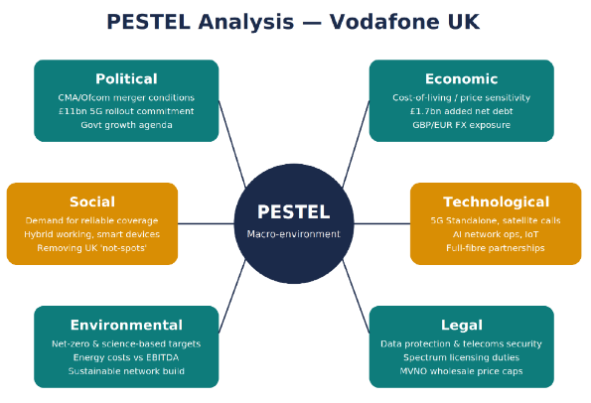
Figure 1 PESTLE Analysis of Vodafone source (Self created)
Political: The government promotes investment in telecom infrastructure for digital connectivity in the UK. Vodafone and Three's proposed merger received approval from the Competition and Markets Authority (CMA) last December, but with the stipulation that both parties entered into legally binding commitments. This included an investment commitment of £11 billion in the network to be spread over the next 10 years and three years of wholesale price protection for the smaller Mobile Virtual Network Operators (MVNOs) (Birru, Sudarmiatin and Hermawan, 2022). Until the company becomes compliant, there is a duty to ensure regulatory compliance, which falls with CMA and Ofcom, with the company reporting back to CMA and Ofcom annually.
Economic: Churn with mobile providers is on the rise as customers in the UK focus more on price due to the rising cost of living. The financial effect from the introduction of the euro also affected the Vodafone Group's results due to fluctuations in the exchange rate from the British pound. Following the merger, the consolidated net debt of the Vodafone Group got a boost of £1.7 billion (€2.0 billion) (Freeman and Velamuri, 2023). The two listed parent companies also invested £800m in VodafoneThree. It's also a company that requires a significant amount of capital expenditure with the figure of £1.3bn spent in the first year by VodafoneThree.
Social: They demand swift and reliable internet connections when working remotely, online entertainment and smart devices. Combining the users on the two networks will provide access to the other network's coverage, which will help to speed up the mobile 4G signals by up to 40% in some parts of the UK and contribute to eliminating the "Mobile Coverage Gaps", including indoors and in rural areas (Curtis and Harpley, 2024).
Technological: The telecommunications industry is changing and new technologies are entering, such as 5G Standalone, satellite-to-mobile communication, the Internet of Things (IoT) and the new approach to artificial intelligence (AI) usage. In January 2025, Vodafone was the first to develop a common mobile gadget into a satellite video conferencing phone (Ferreira and de Sá, 2024). The company has also increased its full-fibre broadband coverage by working with CityFibre and Openreach, covering over 19 million premises in the UK.
Environmental: Vodafone continues to make progress to become more sustainable, with efforts to achieve Science-Based Emission Targets, as well as operational movements towards Net Zero, among the steps taken. With the high rise in energy prices, moreover, the operating cost of networks also shoots up in a significant manner (Ferreira, Morgado and Lins, 2024).
Legal: It is necessary for Vodafone to comply with UK data protection security regulations, spectrum licensing requirements and the legal conditions of the merger, which influence how and where new network infrastructure can be developed (Freeman, Menghwar and Grushka-Cockayne, 2025).

3.2 Porter's Five Forces Analysis
Porter's Five Forces | Analysis
Competitive Rivalry (High) | - Competition in the UK telecommunications market is very strong.  - The number of major operators reduced from four to three after the merger.  - VodafoneThree, BT/EE and Virgin Media O2 compete through 5G services, pricing and bundled broadband and mobile packages (Hashemkhani Zolfani et al., 2022).  - Companies continue to invest in better network quality and customer services.
Threat of New Entrants (Low) | - Entering the market requires expensive spectrum licences.  - Large investment is needed to build network infrastructure.  - New companies must meet strict government regulations.  - However, MVNOs can enter the market by leasing network capacity from existing operators.
Bargaining Power of Buyers (High) | - Customers can easily switch to another provider.  - Online price comparison websites increase customer choice.  - Many SIM-only and business plans are available (Himamsha and Nallabothula, 2026).  - Providers must offer competitive prices and better services to retain customers.
Bargaining Power of Suppliers (Moderate to High) | - Only a few companies supply network equipment and tower infrastructure.  - Suppliers have greater control over prices and delivery times.  - Vodafone depends on these suppliers to maintain and expand its network (Pangarkar and Prabhudesai, 2024).
Threat of Substitutes (Increasing) | - Wi-Fi calling provides an alternative to traditional mobile networks.  - Messaging apps reduce the use of SMS and voice calls.  - Satellite communication services are becoming more common (Pradhan and Subhashree, 2024).  - SD-WAN solutions provide alternative communication options for businesses.

As per the porter’s five forces and PESTLE Analysis the competitive position of Vodafone is enhanced through the Three mergers. It provides them scale, spectrum and cash flow profile to invest in 5G infrastructure. On the other hand the organisation have advantage but there are problems such as regulators are consistently monitoring commitments, customers preferences are changing and competitors like BT/EE and Virgin Media O2 will continue investment (Raju and Madhuri, 2024). Therefore rather than competing based on price this environment provides a strategy that converts network scale into a genuinely differentiated customer proposition.

4. Strategic Growth options and proposed strategy

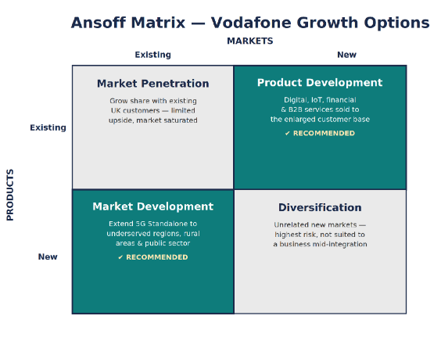
Figure 2 Ansoff matrix source (self created)
The Ansoff matrix is a useful framework for Vodafone to consider in its relation to existing and new products. Whilst market penetration is one avenue there is limited upside, as it is a fairly saturated market and naturally being pushed through via the businesses combined customer base with the merged brands. The greatest level of risk is diversification in to areas unrelated and the business is less suited to a business in a period of incorporation of a significant merger (Sanchita, 2022). Market development and product development are the two most appealing options for Vodafone.
With Market Development, VodafoneThree will deploy its extensive 5G Standalone network to tackle areas and customer segments that have not been well connected before, such as rural areas and small businesses and public sector bodies for instance (Simões, 2024). Product development includes enhancing Vodafone's digital, financial services, IoT and enterprise security portfolio, which will be offered to its now much larger customer base, which grew by 4.0% in FY25 via services revenue and 13.8% via digital services revenue.
Proposed strategy: Vodafone should consider two main strategies such as a market development strategy, which involves expanding its superior 5G Standalone coverage to little-served areas in the UK and a product development strategy, by scaling digital and IoT services and business connectivity, including smart cities and autonomous vehicle infrastructure, across the enlarged customer base generated by the merger (Zugay and Zakaria, 2023).
Support for growth path: according to Porter's generic strategies: the growth plan is most justified with a broad differentiation strategy, not cost leadership. Displacing competitors from the 5G market will take time, and this is where the most important benefit of VodafoneThree's integration of digital and IoT services with a UK market-leading broad and reliable 5G Standalone network will come into play (Zupic et al., 2025). In the medium term only BT/EE or Virgin Media O2 can compete with VodafoneThree in this regard as the former has committed to investing £11bn and can utilise its spectrum assets to give it an edge in nationwide 5G Standalone coverage.
This is broadly in line with the purpose of Vodafone's worldwide operations to connect people for a better future and with its 'Customers, Simplicity, Growth' priorities, as it serves its underserved customers (Customers), relies on a network integration focussed already on its portfolio (Simplicity) and is focussed on its higher growth digital and IoT services (Growth).

5. Strategy Evaluation
The strategy proposed is tested for its Suitability, Feasibility and Acceptability (SFA) in line with a popular strategy-testing framework developed by Johnson and Scholes.
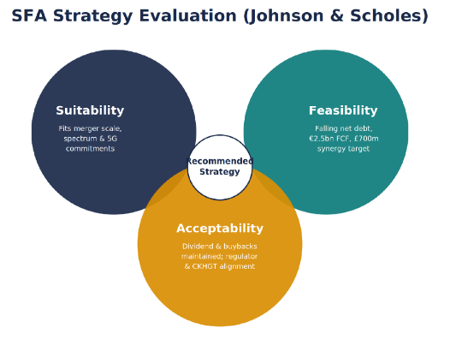
Figure 3 SFA Strategy evaluation source (self created)
Suitability: The strategy directly targets opportunities and constraints identified in the PESTEL and Five Forces analysis: it leverages VodafoneThree's growing spectrum and network scale, addressing regulatory commitments already secured regarding 5G rollout, and the digital/IoT growth areas the business has already started to pursue (Birru, Sudarmiatin and Hermawan, 2022).
Feasibility: Challenges will occur in executing the plan because Vodafone Group's financial performance has improved: net debt has been lifted by ~ €11 billion over the last two years, Adjusted free cash flow headroom improved to €2.5 billion in FY25, and the commitment of £1.3bn of capex looked at these funds for year one (Ferreira and de Sá, 2024). This should see cost and capex synergies of £700m/yr, which will go toward additional rollout, in year five. One of the important assumptions to make here is without any data being truly shared, that synergy realisation was mostly in a phased fashion as Vodafone has publicly hinted and will only become free-cash-flow accretive from around FY29.
Acceptability: The strategy is acceptable for the shareholders as the dividend (4.6125 eurocents per share in FY26) and continuous share buy backs shall be obtained, which would be inevitable due to the magnitude of investment. From customer's perspective it should yield less cost of data moving and high speeds (Ferreira, Morgado and Lins, 2024). Continued CMA/Ofcom monitoring, execution risk of the two networks and workforces as the two entities grow into a single one and governance risk as CMA/Ofcom considers minor stakeholder arrangement is not fully finalized at the time of writing are key risks.
On balance the SFA evaluation suggests that a recommended approach for proceeding is considered justifiable. Its suitability is good, as it follows a direct fit with the post-merger environment: its feasibility is reasonable and depends on remaining delivery of synergy; and its acceptability is "conditional" on transparent interactions (or communications) between stakeholders and the market, especially those with regulators and minority shareholders, throughout the multi-year investment horizon (Freeman and Velamuri, 2023).

6. Stakeholder analysis

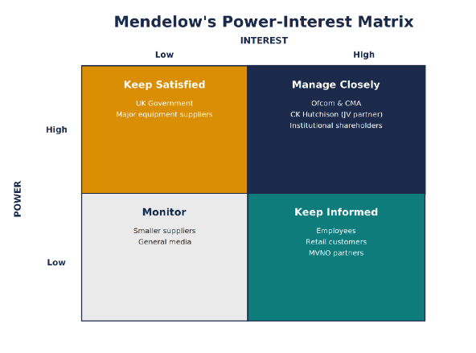
Figure 4 Stakeholder analysis source (self created)
Johnson and Scholes' Suitability, Feasibility and Acceptability (SFA) framework is used to assess the proposed strategy. The strategy is deemed appropriate as it addresses the opportunities and challenges recognized from the PESTEL and Porter Five Forces analysis. It leverages VodafoneThree's larger network and spectrum resources, prepares for its upcoming 5G rollout and prioritizes the enhancement of Digital and Internet of Things (IoT) offerings to secure growth in the years ahead (Freeman, Menghwar and Grushka-Cockayne, 2025). The strategy is also seen as viable as the financial performance of the Vodafone Group has improved, but there's a need for heavy investment. In the past two years, the company's Net Debt grew by an additional €11 billion and Adjusted Free Cash Flow amounted to €2.5 billion for FY25.
The total cost and capital expenditure savings in the first year of the plan for VodafoneThree are £1.3 billion, with a further annual saving of £700 million anticipated by year five. These savings should enhance the company's free cash flow from around FY29. The strategy is acceptable, with a dividend of 4.6125 eurocents per share in FY26 and continuous share buy-backs will add value for shareholders over the long term. Customers will also enjoy an increased level of service, higher network speed and lower prices for products (Hashemkhani Zolfani et al., 2022). Nevertheless, the company has to keep the regulatory process under control, overcome the objections from the CMA and Ofcom and carry out the successful merger process and continue with effective stakeholder management. For overall growth, the strategy is appropriate, viable and suitable for long-term, recessive growth.

7. Implementation and Monitoring
The strategy proposed is assessed based on the Suitability, Feasibility and Acceptability (SFA) framework proposed by Johnson and Scholes. Opportunities and challenges as identified in the PESTEL and Porter's Five Forces analysis have been taken into account in the strategy, which is deemed to be suitable. It operates on the bigger network and spectrum resources of the VodafoneThree network and "embarks" on commitment to the rollout of 5G, meanwhile focusing on digital and IoT services, "as agreed. The strategy is also viable since while the business requires a lot of investment, Vodafone Group's financial position has improved. Net debt rose by around €11 billion during the past two years, with the adjusted free cash flow in FY25 now at €2.5 billion (Himamsha and Nallabothula, 2026).
VodafoneThree is investing £1.3bn in capital expenditure during its first year, with the costs and capital expenditure synergies projected at £700m a year by year five. The environment from around FY29 is expected to have strength in free cash flow as a result of these savings. The strategy is viable as it will help sustain its value proposition to shareholders 1) with its long-term dividend expectation of 4.6125 eurocents per share through FY26) through continuous share buy-back activity customers would be expected to receive the added benefit of higher network speeds and lower-cost services (Pangarkar and Prabhudesai, 2024). But there are challenges still to be overcome regulatory scrutiny from the CMA and Ofcom, merging the two companies and governance expertise. The overall strategy is appropriate, with good potential to be reasonably realistic and acceptable, provided there is effective stakeholder communication and success in implementation during the investment period.

Conclusion
Three's acquisition of Vodafone UK will improve the business's overall position in the UK telecoms sector. It has increased VodafoneThree's network size, spectrum resources and ability to invest in future technologies such as 5G Standalone. From the PESTEL and Porter's Five Forces analyses, the company is still considered to have an opportunity for growth even though it will continue to deal heavily with regulatory issues and customers' bargaining power. According to the recommendation, the mix should be “Market Development”-“Product Development” with an emphasis on service differentiation in preference to price competition.
This strategy is suitable, feasible and acceptable in the context of SFA analysis, which ensures long-term business success. Having a clear stakeholder plan will also contribute to developing and sustaining positive customer, regulatory, employee and shareholder relations. Key elements to enable its success will be careful planning, continued investment and ongoing tracking of the important performance indicators (KPIs). If the strategy is executed well then VodafoneThree would have a good chance of sustainable growth, of a rise in customer satisfaction and of long-term customer and shareholder value creation.

References
Birru, A.C., Sudarmiatin, S. and Hermawan, A. (2022) ‘Competitive strategies in the lodging service sector: Five Porter analyses and case study SWOT analysis’, Journal of Business and Management Review, 3(1), pp. 1–17.
Curtis, H. and Harpley, C. (2024) Telecommunications sector risk and resilience profile: PESTLE and gap analysis.
Ferreira, A.P.P.F.S. and de Sá, M.M.B.P. (2024) ‘The importance of the Ansoff matrix for the study of the information services market’, The Canadian Journal of Information and Library Science, 47(2), pp. 78–84.
Ferreira, M.D.A.V., Morgado, C.D.R.V. and Lins, M.P.E. (2024) ‘Organizations and stakeholders’ roles and influence on implementing sustainability requirements in construction projects’, Heliyon, 10(1).
Freeman, R.E. and Velamuri, S.R. (2023) ‘A new approach to CSR: Company stakeholder responsibility’, in R. Edward Freeman’s Selected Works on Stakeholder Theory and Business Ethics. Cham: Springer International Publishing, pp. 251–264.
Freeman, R.E., Menghwar, P.S. and Grushka-Cockayne, Y. (2025) ‘A stakeholder theory perspective for project management’, International Journal of Project Management, article 102764.
Hashemkhani Zolfani, S., Bazrafshan, R., Ecer, F. and Karamaşa, Ç. (2022) ‘The suitability-feasibility-acceptability strategy integrated with Bayesian BWM-MARCOS methods to determine the optimal lithium battery plant located in South America’, Mathematics, 10(14), article 2401.
Himamsha, M.D. and Nallabothula, N. (2026) ‘Exploring the influence of market analysis on product innovation and development’, International Journal of Economic Social Science and Management Law, 7(1), pp. 136–141.
Pangarkar, N. and Prabhudesai, R. (2024) ‘Using Porter’s Five Forces analysis to drive strategy’, Global Business and Organizational Excellence, 43(5), pp. 24–34.
Pradhan, R. and Subhashree, M.S. (2024) ‘An analysis of the financial performance of pre and post-merger of Vodafone Idea’, International Journal of Enhanced Research in Management & Computer Applications, 13(5), pp. 78–86.
Raju, R. and Madhuri, G. (2024) ‘Vodafone and Idea merger: A shareholder’s dilemma’, Global Business Review, 25(1), pp. 216–231.
Sanchita, S. (2022) ‘An analysis of the Vodafone and Idea merger’, Indian Journal of Legal Research, 4(3), pp. 1–7.
Simões, J.S. (2024) Equity Research of Vodafone Group PLC. Master’s thesis. Universidade do Porto, Portugal.
Zugay, B. and Zakaria, R. (2023) Ansoff Matrix. Thousand Oaks, CA: SAGE Publications.
Zupic, I., Čater, T., Caputo, A. and Uršič, D. (2025) ‘Mapping the influence of Ansoff’s corporate strategy’, Strategic Change.

