

Name: nicola Plummer
Student number:
Course name: BSc applied computing
Module Name: data warehousing and data mining



Module code: ACCA_BIRM
Lecturer: md Abar jahin almazi bipon
Submission date; July 17th, 2026
Time: 2: oopm

ABSTRACT
NHS England manages a complex healthcare system that generates large volumes of patient, clinical, workforce, operational, and financial data. However, much of this information is held in separate operational systems, which makes it challenging to obtain a complete view of healthcare performance and support timely decision-making. This report proposes a strategic data warehousing solution to address these challenges by integrating data from multiple NHS sources into a single, trusted vault. The report evaluates the role of data warehouses in comparison with Online Transaction Processing (OLTP) systems and presents an NHS-specific architecture which incorporates Extract, Transform and Load (ETL) processes, dimensional modelling, star schemas, and departmental data marts. A realistic implementation plan is also developed, together with recommendations for maintaining data quality, governance, security, and regulatory compliance throughout the data lifecycle. The proposed design demonstrates how integrated healthcare data can support more effective monitoring of patient flow, workforce capacity, financial performance, waiting times, and clinical outcomes. By providing accurate and consistent information for operational and strategic decision-making, the proposed solution would help NHS England to improve in resource planning, boost patient care, and support the long-term sustainability of healthcare services through evidence-based decision-making.

Table of Contents
ABSTRACT 1
TASK 1 3
INTRODUCTION 3
1.1 OLTP VS DATA WAREHOUSE 3
1.2 DATA WAREHOUSE ARCHITECTURE AND ETL PROCESS 4
1.3 DATA MARTS FOR MANAGEMENT DECISION-MAKING 7
Chief Executive Data Mart 7
Finance Director Data Mart 7
Medical Director Data Mart 7
Benefits of Data Marts 8
1.4 OLTP NORMALISATION VS DATA WAREHOUSE DIMENSIONAL MODELLING 8
TASK 2 10
NHS ENGLAND DATA WAREHOUSE DESIGN AND IMPLEMENTATION PLAN 10
2.1 Source System Identification 10
2.2 STAR SCHEMA DESIGN 12
2.3 DATA MARTS AND SCHEMA 15
2.4 SIMPLIFIED ETL PLAN 16
2.5 Data Quality and Governance 18
CONCLUSION 18
REFERENCES 19

TASK 1

INTRODUCTION
NHS England manages a complex healthcare system that generates a large volume of patient, clinical, workforce, operational, and financial data. However, much of this information is stored across separate systems, which limits the organisation’s ability to achieve a cohesive perspective of performance that can support timely decision-making. This report examines how a Data Warehouse could integrate data from several NHS sources to optimise operational efficiency, patient outcomes, and a methodical and crucial planning. It discusses the differences between OLTP systems and Data Warehouses, Data Warehouse Architecture and ETL processes, Data Marts for executive decision-making, and Dimensional Modelling within NHS England’s specific operational context.

1.1 OLTP VS DATA WAREHOUSE
NHS England operates through Integrated Care Systems (ICSs), NHS Trusts, community providers, mental health services, and specialist centres. Daily healthcare activities rely on Online Transaction Processing (OLTP) systems such as Electronic Patient Records (EPRs), Patient Administration Systems (PAS), workforce platforms, and financial applications. These systems process routine transactions, including patient registrations, appointments, admissions, discharges, staff scheduling, and financial activity, while maintaining accurate operational records [1].
However, OLTP systems have constraints for strategic analysis because NHS data is often stretched across separate hospitals, Trusts, ICSs, and regional systems. This decentralisation of data makes it very challenging to evaluate RTT waiting times, bed occupancy, workforce shortages, and elective care backlogs across England. Running complex data queries on operational systems can also put extra strain on systems designed that are built for daily transactions [2], [3].
A Data Warehouse deals with these restrictions by integrating data from multiple sources into a centralised database for reporting and evaluation. It supports historical analysis, allowing NHS England to identify trends, compare regional performance, forecast demand, and examine large datasets. For example, leaders could compare waiting-list pressures between London teaching hospitals and Midlands’s district general hospitals.
In general, a Data Warehouse would provide a unified and dependable view of patient, clinical, workforce, operational, and financial information, that will support better resource distribution, performance evaluation, service planning, and coordinated decision-making across NHS England [4], [5].

1.2 DATA WAREHOUSE ARCHITECTURE AND ETL PROCESS
NHS England oversees healthcare delivery across multiple ICSs, NHS Trusts, community providers, mental health services, and specialist treatment centres. These organisations generate information through EPRs, PAS platforms, workforce systems, diagnostic applications, and financial systems. A proposed data warehouse architecture, see Fig 1, would integrate these separate sources into a structured analytical environment, helping NHS England develop a more consistent national view of healthcare activity and performance [5], [6].

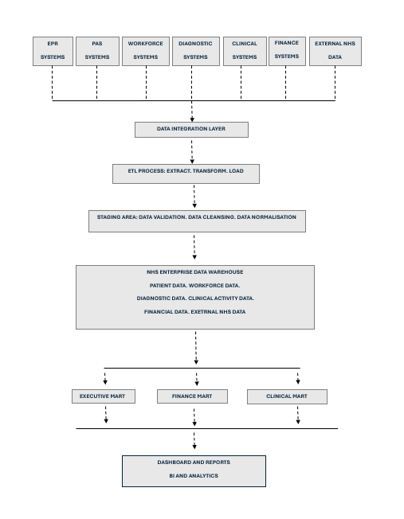

Figure 1: A proposed NHS England Data Warehouse Architecture.

The proposed architecture would combine data from London teaching hospitals, Midlands’s district general hospitals, Northwest community services, Southwest rural providers, and Northern specialist centres. This includes patient admissions, clinical activity, workforce capacity, treatment costs, bed use, waiting lists, and quality indicators. Integrating these sources would minimise decentralised reporting and provide a wider view of implementation across regions and care pathways.
The ETL process supports this integration through three stages. During Extract, data is copied from EPR, PAS, workforce, diagnostic, clinical, finance systems and external NHS data. During Transform, it is cleaned, validated, and standardised. For example, ICD-10 codes, provider identifiers, patient references, and workforce categories can be modified into steady formats. During Load, the prepared data is then transferred into the warehouse for evaluation. ETL frameworks therefore help transform different healthcare data sources into consistent structures [7].
Cloud technologies and automated data pipelines can also maximise scalability as NHS data volumes increase. This would endorse expandable clinical, operational, workforce, and financial data while keeping analytical workloads separate from frontline systems [8].
To minimise disruption, scheduled extraction and incremental loading can copy new or updated records without stopping clinicians and administrative staff from using operational systems. Research involving English prescription data also shows the value of expandable data analysis for NHS intelligence [8], [9].
Ultimately, this architecture would help NHS England to properly monitor patient flow, elective care pressures, workforce capacity, financial performance, and regional differences. A more integrated analytical environment would strengthen strategic planning and support evidence-based responses to changing healthcare demands [10].

1.3 DATA MARTS FOR MANAGEMENT DECISION-MAKING
An NHS England enterprise data warehouse would provide integrated information, but senior leaders require insights suited to their responsibilities. Data marts offer focused subsets of warehouse data while maintaining consistency with the central source [10], [11].

Chief Executive Data Mart
The Chief Executive requires a national view of healthcare performance. An executive data mart could provide indicators such as RTT waiting times, elective care backlogs, emergency pressures, bed occupancy, ambulance performance, patient outcomes, and regional differences. Dashboards could compare London teaching hospitals, Midlands’s district general hospitals, Northwest community services, Southwest rural providers, and Northern specialist centres. This would help identify underperforming areas, capacity pressures, and priorities for resource allocation and service improvement.
For example, the Chief Executive could compare elective recovery across regions, identify areas with ongoing bed pressures, and assess progress against national operational objectives.

Finance Director Data Mart
The Finance Director requires detailed information about financial performance. A finance data mart could combine treatment costs, national tariffs, expenditure, budgets, cost per patient episode, agency staffing costs, and overtime. This would support comparisons across Trusts, ICSs, regions, services, and national levels.
The Finance Director could identify overspending, compare treatment costs between providers, and assess the financial impact of agency staff use. Correlating of financial information with patient activity would also show whether resource use reflects service demand.

Medical Director Data Mart
The Medical Director requires clinical and quality information. A clinical data mart could include readmission rates, mortality indicators, patient safety incidents, infection measures, treatment outcomes, and patient satisfaction. These measures could be assessed across acute care, community services, mental health pathways, cancer treatment, cardiac services, and other specialist areas.
This would allow the Medical Director to compare outcomes between providers, identify trends across specialties, and target quality improvement where concerns arise.

Benefits of Data Marts
Although each leader requires different information, all three data marts would use the same integrated warehouse. This supports consistent executive, financial, and clinical reporting while minimising the threat of conflicting departmental information. Tailored analytical views would help NHS England’s senior leaders understand complex data and make evidence-based decisions suited to their responsibilities [9].

1.4 OLTP NORMALISATION VS DATA WAREHOUSE DIMENSIONAL MODELLING

NHS operational systems such as EPRs, PAS platforms, workforce applications, and finance systems usually use normalised relational structures. Fig 2 shows the NHS star schema for patient activity analysis. Data is separated into connected tables to minimise duplication and maintain consistency. For example, patient details, appointments, diagnoses, treatments, staff records, and provider locations can be stored in separate tables and linked using primary and foreign keys. This approach works well for regular operational transactions but can make large analytical queries across different healthcare areas more difficult.
In comparison, data warehouses commonly use dimensional models that make analytical queries and reporting easier. A star schema has a central fact table connected to surrounding dimension tables. For NHS England, this allows gaugeable healthcare activities to be assessed alongside detailed information about patients, providers, treatments, workforce groups, finance, and time.

Figure 2: NHS England Star Schema for Patient Activity Analysis.

In this model, FACT_CARE_ACTIVITY stores measurable NHS activity, including admissions, length of stay, bed days used, treatment costs, RTT waiting days, and readmission indicators. The surrounding dimensions provide descriptive context for analysis. For example, NHS England could examine average RTT waiting days by ICS region and specialty or compare treatment costs across providers and financial years. Healthcare data integration and ETL approaches support the preparation of source data for analytical structures of this kind.
The dimensional model therefore provides a clearer analytical structure than highly normalised operational databases. By combining measurable activity with patient, provider, treatment, workforce, finance, and date dimensions, NHS England could monitor performance patterns and support more informed strategic planning [1].

TASK 2

NHS ENGLAND DATA WAREHOUSE DESIGN AND IMPLEMENTATION PLAN

2.1 Source System Identification
NHS England’s data warehouse would collect information from both internal and external sources. Fig 3 shows both internal and external sources of data. Internal sources include Electronic Patient Records (EPRs), Patient Administration Systems (PAS), laboratory and radiology systems, pharmacy systems, theatre systems, bed management systems, financial applications, and the Electronic Staff Record (ESR). Together, these systems provide patient, treatment, workforce, operational, and financial information. External sources include GP records, NHS Spine services, Integrated Care System datasets, Office for National Statistics population data, UK Health Security Agency information, and national tariff and performance datasets. Bringing these sources together would allow NHS England to analyse complete care pathways and compare demand, capacity, costs, and patient outcomes across different regions. Healthcare data warehouses are valuable because they combine clinical and administrative data from different systems to support wider analysis and better decision-making [1], [6].

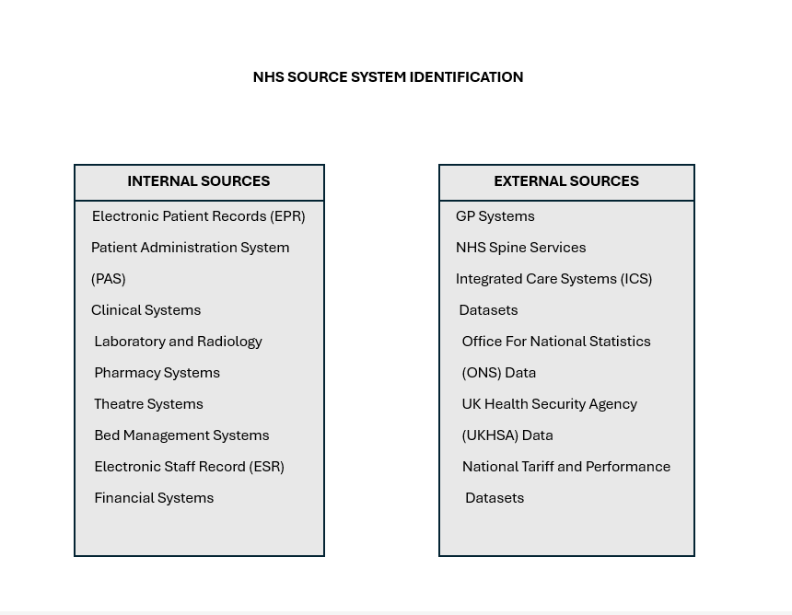

Figure 3: NHS Source System Identification

2.2 STAR SCHEMA DESIGN
A suitable data warehouse for NHS England could use a patient activity star schema as shown in Fig 4 is built around FACT_PATIENT_ACTIVITY. The grain of the fact table would represent one recorded healthcare activity, such as a patient admission, outpatient appointment, procedure, diagnostic test, or community visit. Defining a clear grain is important because every measure in the fact table must represent the same level of healthcare activity.
The fact table would include foreign keys linked to the patient, date, provider, service, treatment, staff, and finance dimension tables. It would also contain measures such as admissions, appointments, length of stay, bed days used, referral-to-treatment waiting days, treatment costs, and readmission status. These measures would help NHS England compare healthcare activity, waiting pressures, resource use, and costs across different providers and services. Dimensional models make large healthcare datasets easier to analyse and support both day-to-day reporting and long-term decision-making [9]
DIM_PATIENT would store patient master data, including a pseudonymised NHS number, age band, sex, ethnicity, postcode area, and deprivation band. Personal patient information should not be included in reporting tables unless it is essential. Using pseudonymised data helps protect patient privacy while still allowing healthcare activity to be analysed across different population groups.
DIM_STAFF would store workforce master data, including staff group, role, grade, contract type, and whether staff are directly employed or work through an agency. This would support analysis of workforce capacity, agency use, sickness levels, and staffing costs. DIM_PROVIDER would contain information about NHS Trusts, hospitals, Integrated Care Systems, regions, and provider types. Together, these master data tables provide consistent information about NHS organisations and staff [10].
Metadata would mainly be stored in DIM_SERVICE, DIM_TREATMENT, DIM_DATE, and DIM_FINANCE. DIM_SERVICE would describe service type, clinical specialty, care setting, care pathway, and commissioning type. DIM_TREATMENT would include ICD-10 diagnosis codes, OPCS procedure codes, diagnosis groups, and outcome types. DIM_DATE would contain the day, month, quarter, year, and NHS financial year, while DIM_FINANCE would include tariff codes, cost centres, budget codes, and funding streams. Standardising this metadata is important because different source systems may use different names and coding structures for the same healthcare activities [10], [11].

A second fact table, FACT_MONTHLY_PERFORMANCE, would store aggregated data. Its grain would represent one provider, one service, and one month. Measures could include total admissions, average RTT waiting days, bed occupancy rates, readmission rates, total treatment costs, and target achievement. Calculating these measures in advance would improve dashboard performance and make national comparisons more efficient.
Using separate fact tables is appropriate because individual patient activity and monthly performance represent different levels of detail. Combining them into one table could result in double-counting and inaccurate totals. The proposed design therefore keeps detailed patient activity available for investigation while providing summary information for executive reporting. It would enable NHS England to identify which ICS has the longest RTT waiting times, which services have the highest readmission rates, and whether staffing levels and spending reflect patient demand.

Figure 4: A detailed implementation design including master data, metadata, workforce, finance, and monthly aggregate data.

2.3 DATA MARTS AND SCHEMA

Three main data marts would be developed from the enterprise data warehouse. Fig 5 alludes to this. Each data mart would share common dimensions, including date, provider, service, and location, to ensure reporting remains consistent across NHS England.
The Operations Data Mart would store information on patient activity, waiting lists, admissions, discharges, bed occupancy, theatre use, appointments, and ambulance performance. Its main fact tables would be FACT_PATIENT_ACTIVITY and FACT_MONTHLY_PERFORMANCE. Operational managers could use this information to analyse RTT waiting times, bed occupancy, delayed discharges, elective care backlogs, and regional capacity. This would support both day-to-day service management and future demand planning.
The Clinical Quality Data Mart would contain information about diagnoses, treatments, readmissions, mortality indicators, infections, patient safety incidents, treatment outcomes, and patient satisfaction. It would connect activity and quality fact tables with the patient, treatment, service, provider, and date dimensions. This would allow medical leaders to compare outcomes across NHS Trusts, specialties, demographic groups, and care pathways, helping them identify differences and focus on quality improvement.
The Finance Data Mart would combine treatment activity with tariffs, budgets, expenditure, agency staffing costs, overtime, and cost per patient episode. Its schema would link financial and activity fact tables with the provider, service, staff, finance, and date dimensions. This would help finance teams identify budget differences, compare costs between providers, and assess whether spending reflects patient demand.
Because all three data marts would use the same governed enterprise warehouse, NHS England could ensure departments work from one reliable version of performance data instead of producing conflicting reports [11].

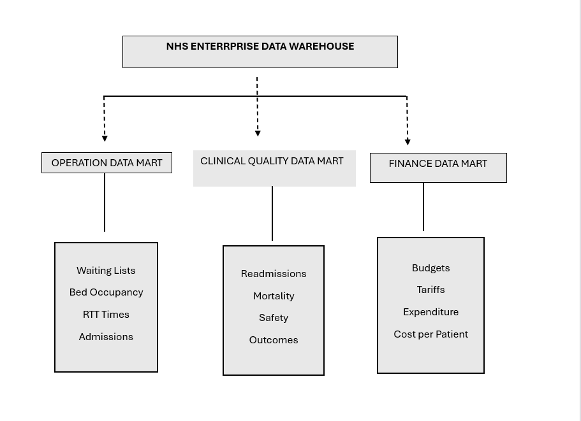
Figure 5: NHS Enterprise Data Warehouse

2.4 SIMPLIFIED ETL PLAN
Data would first be extracted from EPR, PAS, clinical, ESR workforce, finance, and external systems using scheduled or incremental transfers. This is highlighted in Fig 6. The data would then move into a staging area where null and void records, duplicate entries, missing values, and organisation issues would be identified. Patient information would be pseudonymised, dates standardised into one format, and NHS provider, ICD-10, OPCS, staff, and tariff codes matched to agreed standards. Surrogate keys would then be generated for the dimension tables. The dimension tables would be loaded before the patient activity fact tables to ensure all foreign-key relationships remain valid. Monthly measures, including bed occupancy, average RTT waiting times, readmissions, and treatment costs, would then be calculated and loaded into the aggregate fact table. Incremental loading would also reduce the impact on frontline operational systems [7], [8].

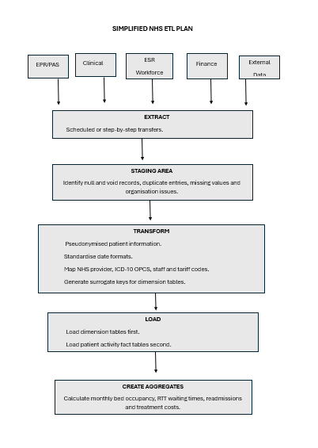

Figure 6: A simplified NHS ETL plan.

2.5 Data Quality and Governance
Data should be checked for accuracy, completeness, consistency, validity, timeliness, and duplication throughout ETL and warehouse operation. Data owners should approve definitions, coding standards, and correction procedures. Patient information must be protected through pseudonymisation, encryption, role-based access, audit logs, and retention controls. Processing must follow UK data-protection requirements and NHS information-governance policies. Organisations accessing NHS patient data must also provide security assurance through the Data Security and Protection Toolkit [13], [14].

CONCLUSION
This report has shown how a data warehouse could help NHS England address fragmented data across healthcare systems. Integrating patient, clinical, workforce, operational, and financial information would provide a more comprehensive view of national performance. ETL processes, data marts, and dimensional modelling could support analysis of patient flow, waiting times, resource use, costs, and clinical outcomes. Consequently, a data warehouse could strengthen evidence-based decision-making, improve operational efficiency, and support sustainable healthcare planning across England while contributing to NHS England’s ongoing digital transformation objectives.

REFERENCES
[1] S. Lyu et al., “The development and use of data warehousing in clinical settings: A scoping review,” Frontiers in Digital Health, vol. 7, 2025. [Accessed: Jun. 16, 2026].
[2] S. Khanra, A. Dhir, A. K. M. N. Islam, and M. Mäntymäki, “Big data analytics in healthcare: a systematic literature review,” Enterprise Information Systems, vol. 14, no. 7, pp. 878–912, Aug. 2020, https://doi.org/10.1080/17517575.2020.1812005 [Accessed: Jun. 24, 2026]
[3] K. Lipinska et al., “Selecting and Preparing Clinical Sites for the Successful Conduct of Decentralized Clinical Trial Activities–Findings From the Trials@Home <scp>RADIAL</scp> Proof‐of‐Concept Trial,” Clinical Pharmacology & Therapeutics, vol. 118, no. 5, pp. 1057–1066, Oct. 2025, https://doi.org/10.1002/cpt.70075. Accessed: Jun. 24, 2026]
[4] Rahman Akorede Shittu et al., “The role of business intelligence tools in improving healthcare patient outcomes and operations,” World Journal of Advanced Research and Reviews, vol. 24, no. 2, pp. 1039–1060, Nov. 2024, https://doi.org/10.30574/wjarr.2024.24.2.3414 [Accessed: Jun. 28, 2026].
[5] K. Shahzad, S. A. Khan, M. Latif, A. Muhammed, and A. Iqbal, “Big data analytics in healthcare: current practices, innovations, and future prospects,” Journal of Big Data, vol. 12, no. 1, Oct. 2025, https://doi./10.1186/s40537-025-01288-2. [Accessed: Jul. 01, 2026]
[6] T. Knezevic Ivanovski, S. Honap, R. Matic, S. Markovic, and L. Peyrin-Biroulet, “Building a healthcare data warehouse: considerations, opportunities, and challenges,” Frontiers in Digital Health, vol. 7, Dec. 2025, https://doi.org/10.3389/fdgth.2025.1691142. [Accessed: Jul. 01, 2026].
[7] M. T. -, “Cloud-Native ETL: Integrating Databricks and Azure Data Factory for Scalable Data Processing in Enterprise Environments,” International Journal For Multidisciplinary Research, vol. 6, no. 6, Nov. 2024, https://doi.org/10.36948/ijfmr.2024.v06i06.29886 [Accessed: Jul. 01, 2026]
[8] A. Onyebuchi et al., “Business Demand for a Cloud Enterprise Data Warehouse in Electronic Healthcare Computing,” International Journal of Cloud Applications and Computing, vol. 12, no. 1, pp. 1–22, Mar. 2022, https://doi.org./10.4018/ijcac.297098. [Accessed: Jul. 09, 2026]
[9] S. Pandya, From Transcription to Intelligence: Applying Large Language Models to Healthcare Enterprise Decision Support Systems. Geh press, 2026. [Accessed: Jul. 10, 2026].
[10] Desmond, Jacob, et al. "OMOP ETL Framework for Semi-Structured Health Data." arXiv preprint arXiv:2511.09017 (2025). [Accessed: Jul. 10, 2026].
[11] Yu, Q., Healy, S., Ravi, I. and Patel, P., 2022, March. Data ingestion pipeline and data marts to empower UK researchers, academics, and business and economic decision makers. In Future of Information and Communication Conference (pp. 158-172). Cham: Springer International Publishing. [Accessed: Jul. 11, 2026].
[12] Dheeraj Kumar Bansal, “Enterprise Data Engineering: Architecting Modern Data Warehouses for Business Success,” International Journal of Scientific Research in Computer Science, Engineering and Information Technology, vol. 11, no. 1, pp. 3266–3277, Feb. 2025, https://doi.org/10.32628/cseit251112348. [Accessed: Jul. 11, 2026].

[13] R. D. Thantilage, N.-A. Le-Khac, and M.-T. Kechadi, “Healthcare data security and privacy in Data Warehouse architectures,” Informatics in Medicine Unlocked, vol. 39, p. 101270, 2023, https://doi.org/10.1016/j.imu.2023.101270. [Accessed: Jul. 15, 2026].
[14] Kumar, Indresh, Bhavna Dhingra, and Shikha Malik. "Healthcare Data Security and Privacy in the AI Era." In Artificial Intelligence in Smart Healthcare Systems, pp. 151-160. CRC Press, 2026. [Accessed: Jul. 15, 2026].

