Perceived changes in tension and voice quality in adult, non-professional voice students after using Alexander Technique instructions and poses as directed by their voice teacher

Lourdes M. González-Caraballo
2318051
Module 3 Assignment
Word Count: 6,107

PROJECT PROPOSAL:
Title: What are the perceived changes in tension and voice quality in adult, non-professional voice students after using Alexander Technique instructions and poses as directed by their voice teacher?

Context:

The Alexander Technique (AT) addresses physical misalignments that affect voice quality (O’Sullivan et al., 2006; Hodges, Sapsford and Pengel, 2007; Wilson Arboleda and Frederick, 2008; Staes et al., 2011; Franco et al., 2014; Kennard et al., 2015; Jintae et al., 2016; Kim and Kim, 2016; Mahdavie, Rezasoltani and Simorgh, 2017) by teaching balanced body alignment and unlearning maladaptive habits (Alexander, 1932; Heirich, 2005). Originating in the 1890s, AT has been shown to improve posture, movement, tension, and voice quality (Bosanquet, 1987a; Little et al., 2008; MacPherson et al., 2013; Fung Ying et al., 2015; Lauche et al., 2016; Essex et al., 2017; Davies, 2020; Becker et al., 2021). Despite its benefits, AT-certified teachers are scarce in Puerto Rico, making the technique largely inaccessible. This study explores the impact of incorporating AT poses and instructions into singing lessons by a voice teacher experienced in AT but not formally certified.

Justification:
Puerto Rico has limited access to certified AT instructors, hindering students from benefiting from the technique. Although I am not a not a certified AT teacher, years of personal and instructional experience have revealed anecdotal improvements in student singing. The absence of studies focusing on AT poses applied by non-certified instructors in voice lessons highlights the novelty and potential value of this research. Poses are particular ways of sitting, standing or lying down as described by F.M. Alexander. Some of them include the semi-supine and monkey positions.

Intended Impact:
This study aims to make AT principles more accessible, helping students manage tension and improve voice quality. Participants may discover alternative ways to alleviate tension, potentially sparking further interest in pursuing certified AT instruction. The findings could inform teaching practices and benefit broader student populations facing similar accessibility challenges.

Outlined Intention:
The research adopts a mix of qualitative and quantitative methods to investigate adult, non-professional voice students’ perceptions of tension and vocal changes after AT-based interventions. Participants will assess tension in voice-related areas (e.g., neck, shoulders, jaw) and ease of phonation before and after lessons using a Likert scale, similar to that used by Fung Ying et al. (2015) in their study on piano students. The responses will be summarized using descriptive statistics. Non-parametric statistical analysis of differences of means will be performed to determine trends in the data.
Each session will follow a standardized warm-up incorporating AT directions, semi-supine position, and monkey posture (Heirich, 2005). After the session, participants will report perceived tension levels and provide comments on their experience. Responses will undergo thematic analysis to identify trends and insights.
The study targets 8–12 voice students who take weekly singing lessons, all of whom will be invited to participate voluntarily. Participants will receive live guidance during lessons, and preliminary results will be withheld to avoid influencing final feedback. Each student will provide feedback for 4 consecutive weeks.

Ethics and Insider Research:
Ethical considerations address potential power dynamics, where students might feel pressured to align responses with perceived teacher expectations. To mitigate this, participants will receive clear instructions to answer truthfully and be assured they can withdraw at any time without consequences. The researcher will also exclude personal assessments to minimize bias.

Personal Learning Outcomes:
- Enhance teaching practices through evidence-based insights.
- Deepen knowledge of qualitative research methods.
- Broaden the understanding of effective voice teaching strategies.
- Improve student outcomes by addressing tension and enhancing vocal ease.
- Validate previous observations and hypotheses about the application of AT in voice instruction.
This research aspires to bridge the gap in AT accessibility, contributing valuable insights to the fields of voice pedagogy and holistic teaching approaches.

INTRODUCTION
Physical misalignments in the body significantly impact vocal production, affecting both spoken and singing voices. The Alexander Technique (AT), developed in the 1890s by F. M. Alexander (Alexander, 1932), promotes balanced body alignment and tension release to address these misalignments. Initially created to resolve Alexander’s personal issues with breathing and vocal strain, AT has since been shown to enhance movement, posture, tension release, and voice quality, making it particularly relevant in the context of vocal pedagogy (Bosanquet, 1987b; Heirich, 2005; Little et al., 2008). Despite its potential benefits for singers, access to certified AT instructors is limited, particularly in Puerto Rico, where only two certified teachers practice.
This study explores the impact of incorporating AT principles and poses into singing lessons led by a non-certified instructor experienced in AT. It focuses on adult, non-professional voice students, an underserved group in vocal instruction. These students typically seek lessons for personal growth, stress relief, or enjoyment rather than career advancement, presenting unique needs such as reducing tension and building sustainable techniques. Many voice teachers work with amateur students, and integrating AT principles offers a practical, low-cost way to address common vocal challenges. Unlike previous studies that examine AT under the guidance of certified practitioners (Parent, 2007; Murphy, 2010; Fung Ying et al., 2015), this research addresses the gap in literature regarding its use by experienced but non-certified voice teachers. This offers practical implications by expanding the accessibility of AT-based techniques, enabling voice teachers without formal AT certification to enhance their teaching methods and address students' vocal challenges using these tools.
The study is grounded in mixed-methods research, incorporating both quantitative and qualitative measures. Participants will rate their perceived tension and vocal ease using a Likert scale, a method successfully used in previous music education studies (Fung Ying et al., 2015). Statistical analysis will include non-parametric methods to identify trends in the data (Field, 2013), while thematic analysis will be conducted to extract qualitative insights from participant feedback (Braun and Clarke, 2006).
By making AT principles more accessible, this research aims to provide students with tools to manage vocal tension and improve their singing. Beyond its immediate impact on participants, the study seeks to inform teaching practices and contribute to broader discussions about integrating holistic approaches like AT into vocal pedagogy, especially in regions with limited access to certified instructors.
LITERATURE REVIEW
The Alexander Technique (AT), developed by F.M. Alexander in the late 19th century, is widely studied for addressing physical misalignments affecting voice quality. It promotes balanced body alignment and unlearning maladaptive habits that interfere with vocal performance (Alexander, 1932; Heirich, 2005). Research shows its benefits in improving posture, reducing tension, and enhancing voice quality (Bosanquet, 1987b; Little et al., 2008; MacPherson et al., 2013; Lauche et al., 2016; Davies, 2020; Becker et al., 2021). However, access to certified AT instructors is limited in some regions, such as Puerto Rico. Additionally, most studies focus on classical vocal training, with little exploration of contemporary styles and their specific vocal demands (Cardoso, Lumini-Oliveira and Meneses, 2019).
Mindfulness practices align with AT principles and show promising results in reducing performance-related stress and tension. This awareness technique has been proven to reduce stress, anxiety and depression (Fjorback et al., 2011; Baer, Carmody and Hunsinger, 2012), increase cognitive abilities (Dunning et al., 2019; Mirabito and Verhaeghen, 2023) and contribute to neuroplasticity (Yu et al., 2021; Mora Álvarez et al., 2023). However, there hasn’t been a lot of research on what it means when learning music, specifically singing (Czajkowski, Greasley and Allis, 2021). The few studies that have been done on mindfulness and singing have found positive results like an improvement in breath awareness and efficiency, focus, reducing extraneous tension, enhanced aural and physical awareness, easier learning, better sound production and improved teacher/student relationships (Czajkowski and Greasley, 2016; Tan, Diaz and Miksza, 2020; Czajkowski, Greasley and Allis, 2021). However, Ornoy and Cohen (2021) found no significant link between mindfulness training and vocal proficiency, suggesting a need for further studies. While mindfulness emphasizes mental and respiratory ease, AT integrates these principles with physical coordination, which is vital for singers who use their body as an instrument (Kildow, 2017).
Postural alignment, a key component of AT, refers to the positioning of body segments in relation to each other. Proper alignment reduces unnecessary tension and supports vocal efficiency (Wilson Arboleda and Frederick, 2008). Misalignments such as forward head posture and rounded shoulders, where the shoulder blades move forward causing the chest to collapse and restrict breathing capacity, have been linked to decreased respiratory efficiency and increased vocal strain (O’Sullivan et al., 2006; Wilson Arboleda and Frederick, 2008; Staes et al., 2011; Franco et al., 2014; Kennard et al., 2015). Sway-back posture, characterized by excessive arching of the lower back leading to compromised core stability, has also been associated with similar negative effects on vocal function (O’Sullivan et al., 2006; Wilson Arboleda and Frederick, 2008; Staes et al., 2011; Franco et al., 2014; Kennard et al., 2015). You can see Appendix 1 for more detailed descriptions of these misalignments and how they might affect the voice.
The AT approach addresses these challenges by promoting awareness of the dynamic relationship between the head, neck, and spine, which Alexander described as crucial to overall physical coordination and vocal freedom (Heirich, 2005; Brennan, 2016). The technique encourages the release of unnecessary muscular tension and the adoption of balanced body positioning to facilitate easier phonation (Mayers and Babits, 1987; Cacciatore, Johnson and Cohen, 2020). The anatomical demands of singing further justify the integration of AT in vocal pedagogy. Singing involves coordinated control of the larynx, respiratory system, and postural muscles. The larynx and pelvic floor share embryonic origins and hormonal receptor similarities, emphasizing the interconnectedness of the body during phonation (Dimon, 2018). Misalignments or excessive tension in these areas can lead to vocal strain and reduced efficiency (Dimon, 2018).
Key AT poses and instructions include the semi-supine position (Figure 1), the whispered 'ah' and the ‘monkey’ (Figure 2). The semi-supine position involves lying on the back with bent knees and feet flat on the floor, promoting spinal release and body awareness while reducing back tension. This position supports head and neck alignment, easing strain on the larynx and throat muscles (Conable and Conable, 2000). It also minimizes the effort required to maintain posture, allowing singers to focus on releasing unnecessary tension while promoting mindfulness of tension patterns (Sentianin, 2018). The whispered 'ah' emphasizes tension-free phonation and breath control (Alexander, 1932), while the monkey pose facilitates dynamic balance and freedom of the ribcage, diaphragm, larynx, and jaw—essential components for singing (Heirich, 2005). Research has highlighted the importance of such postural adjustments in minimizing tension and facilitating optimal vocal function (de Veer, 2009). For further information on how the monkey may impact the vocal apparatus, refer to Appendix 2.

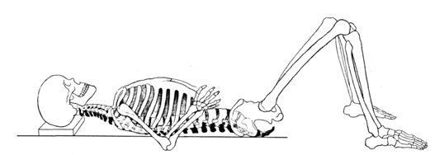
Figure 1. Semi-supine position (Heirich, 2005)
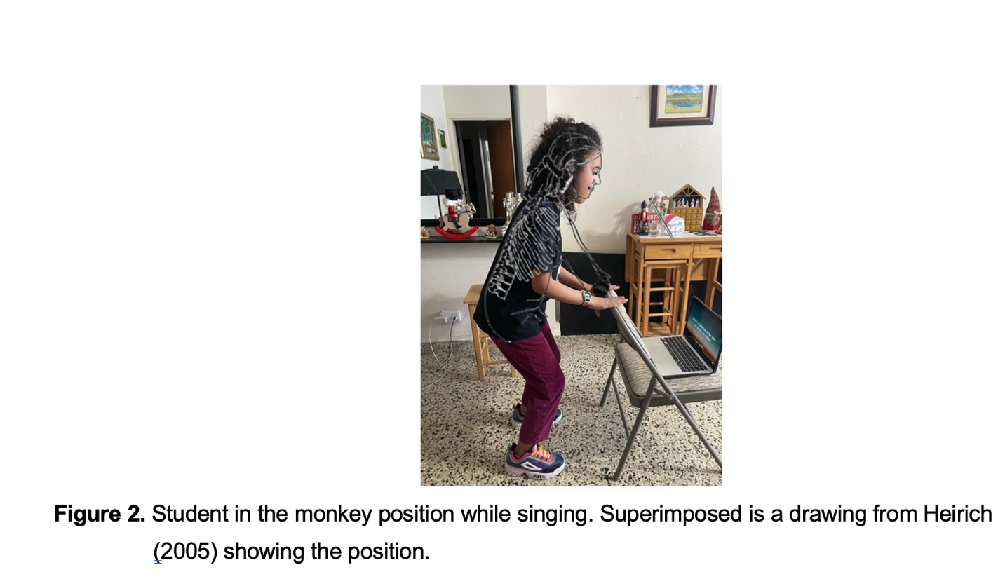
Empirical studies support AT’s application in music education. Fung Ying et al. (2015) demonstrated its effectiveness in reducing tension among piano students, highlighting its potential for broader music performance contexts. In vocal settings, AT aligns with the physiological demands of singing, such as breath control and phonation efficiency (Cardoso, Lumini-Oliveira and Meneses, 2019). However, research has largely focused on classical vocal training (Staes et al., 2011), with limited attention to contemporary vocal styles (Cardoso, Lumini-Oliveira and Meneses, 2019). Further exploration into diverse styles and their demands is needed.
The proposed study investigates the impact of AT-based interventions on perceived tension and voice quality in adult singing students. Using a mixed-methods design, participants will assess their tension levels and vocal ease using a Likert scale, inspired by prior music education research (Fung Ying et al., 2015). Descriptive and non-parametric statistical analyses will identify trends in the data (Field, 2013) while participant reflections will undergo qualitative thematic analysis (Braun and Clarke, 2006). This study aims to inform vocal pedagogy by integrating AT principles into voice instruction, emphasizing body awareness, tension release, and alignment. These findings could help voice teachers incorporate body awareness strategies into their practice, contributing to holistic vocal education.
METHODOLOGY AND METHODS

Methodological Approach
This study was grounded in a constructivist paradigm, emphasizing participants' subjective experiences and their interaction with the intervention. The constructivist paradigm, as outlined by Lincoln and Guba (1985) prioritizes subjective meaning-making and acknowledges multiple realities constructed through individual experiences. Aligned with qualitative traditions (Creswell, 2014), this approach emphasizes participants' lived experiences and contextual understandings, offering nuanced insights into vocal tension and ease.
Alternative methods, such as grounded theory (Charmaz, 2006), content analysis (Krippendorff, 2013) and Interpretative Phenomenological Analysis (Smith and Osborn, 2003) but did not select them. were considered but not chosen. Grounded theory's focus on theory generation did not align with my goal of pattern identification, while content analysis was too rigid for exploring subjective experiences. Interpretative Phenomenological Analysis, though useful, focuses on individual case studies rather than group trends. The constructivist approach provided the best framework for centering participants' voices while exploring meaningful patterns in their experiences.

Research Design and Framework
I used the Alexander Technique principles alongside a repeated measures design to monitor changes in participants' tension, breathing ease, and sound production. This approach, which emphasizes mind-body awareness and self-perception, supported the exploration of how physical adjustments influenced vocal performance, considering both physiological and psychological aspects of learning (Alexander, 1932; Gelb, 1994). I chose a repeated measures design to track changes across multiple sessions, minimizing variability between participants and improving result consistency (Creswell, 2014).

Intervention and Session Structure
Each session was structured to ensure consistency and maximize the benefits of the Alexander Technique exercises. The steps followed in each session were:
- Body Stretching: Participants engaged in gentle stretching exercises targeting key muscle groups to release tension and promote physical openness.
- Semi-Supine Position: Participants laid on their backs with knees bent and focused on spinal alignment while performing controlled breathing exercises.
  - Inhale and exhale, allow your back to relax towards the floor, your head going towards the wall, your toes to the opposite wall and your knees towards the ceiling
  - Allow air to enter and exhale in an 's' (three times)
  - Allow air to enter and exhale in a whispered 'ah' (three times).
- Seated Posture Work: Listen carefully to Alexander's directives (3 times): "I allow my neck to be free, so that my head goes forward and upward, allowing my back to lengthen and expand, my shoulders to spread and my knees to go forward and outward."
  - Allow air to enter and exhale in an 's' (three times)
  - Allow air to enter and exhale in a murmured 'a' (three times)
- Monkey Position Vocalization: The session concluded with vocal exercises in the monkey position, using the vocalization pattern 'su' with a ‘12321’ note pattern while gradually straightening to a standing posture when going down the scale.
This sequence progressed from relaxation and alignment to dynamic application. Stretching addressed everyday tension, while the semi-supine position began alignment work aided by gravity. Controlled breathing reduced habitual tension and gently engaged breath support. Seated posture work introduced alignment in an upright position, reinforcing cognitive and physical integration of Alexander's principles. Monkey position exercises lengthen the spine, integrating alignment and tension-release principles into vocalization.
Participants completed a Likert scale questionnaire after each session to rate their perceived tension, ease of breathing, and sound production. In the first session, they completed two questionnaires: one before starting and one after completing the exercises.They were also given the opportunity to make comments about how they felt during and/or after the intervention. You can find the informational hand-out given to participants detailing the steps in Appendix 2. I conducted the intervention for 15 minutes per session across four consecutive weeks. The methodological approach ensured a balanced integration of both qualitative and quantitative data, capturing a comprehensive understanding of participants' experiences while maintaining methodological rigor.

Thematic Analysis Process
To complement the quantitative data, I conducted a thematic analysis of participants' open-ended comments. These were analyzed thematically using Braun and Clarke's Braun and Clarke's (2006) six-phase framework: familiarization, initial coding, theme identification, review, definition, and report writing. Qualitative data analysis software ensured a systematic approach, facilitating the coding process and organizing data into broader thematic categories. This iterative process enhanced transparency and reliability, as described by Braun and Clarke (2013).
Participant Recruitment and Ethical Considerations
The study involved 10 adult non-professional singing students from Prof. Lourdes González's In Crescendo studio, whom I selected based on their availability and willingness to engage in the study. I employed purposeful sampling, a strategy aimed at intentionally selecting participants who met specific criteria relevant to the research objectives, ensuring a homogeneous group suitable for the intervention's goals (Patton, 2015). Ethical considerations were carefully addressed throughout the study. Participants' confidentiality was strictly maintained by storing all consent forms and data securely on a password-protected computer and Google Drive account. Participants were informed of their right to withdraw from the study at any time and were assured that they could refuse to answer any questions without consequence.

Quantitative Data Analysis and Justification
Quantitative data were analyzed using descriptive statistics, paired and independent t-tests, (Field, 2013) Kruskal-Wallis tests (Siegel and Castellan, 1988), and Spearman's rho correlations. Non-parametric tests were chosen due to the small sample size (n=10) and ordinal nature of Likert scale data, which do not assume normal distribution (Field, 2013). Non-parametric tests are particularly useful when data violate the assumptions of parametric tests, such as normality and homogeneity of variances (Siegel and Castellan, 1988). The Kruskal-Wallis test provided a method for comparing multiple groups without the need for normality, making it suitable for smaller datasets. Spearman's rho correlation measured the strength and direction of associations between ordinal variables, offering insights into the relationships between tension, breathing, and sound production scores (Field, 2013). Paired t-tests were used specifically for within-participant comparisons between pre- and post-exercise tension scores in the first session, as they allow for direct comparisons of repeated measures within the same subjects and assess whether the mean difference between paired observations is statistically significant (Field, 2013).
FINDINGS AND RESULTS
The primary goal of this study was to thoroughly evaluate the impact of Alexander Technique exercises on multiple aspects of vocal performance, specifically focusing on perceived tension, ease of breathing, and ease of sound production among adult singing students when directed by a non-AT-certified voice teacher. The participants were assessed using a Likert scale where 1 indicated less tension or easier performance and 10 indicated more tension or increased difficulty. The study aimed to explore both the immediate effects (single-session results) and long-term effects (multiple session data) of the Alexander Technique exercises. By examining whether consistent application of these principles could lead to sustained improvements in vocal performance, this study aimed to provide empirical evidence for the benefits of integrating AT and other body awareness techniques into vocal coaching practices.
Descriptive Statistics
The study included 6 female participants and 4 male participants, with females slightly outnumbering males (Figure 3). The age distribution had a mean of 45 years, ranging from 28 to 72 years, and displayed a slight skew towards younger participants (Figure 4). When analyzed by gender, the median age for females was approximately 50 years with a broader age range, while the median age for males was around 32 years with a narrower range (Figure 5). Descriptive statistics further revealed a standard deviation of 16.55 years, indicating moderate variability in age among participants. This level of variability suggests that while ages are somewhat spread out, they do not exhibit extreme differences, with most participants’ ages clustering within approximately one standard deviation (16.55 years) above or below the mean age of 45 years. However, the presence of participants at both younger and older extremes (28 and 72 years) also contributes to the observed spread. Such age diversity is essential as it allows for more generalized conclusions regarding the effects of AT on singers from various life stages.
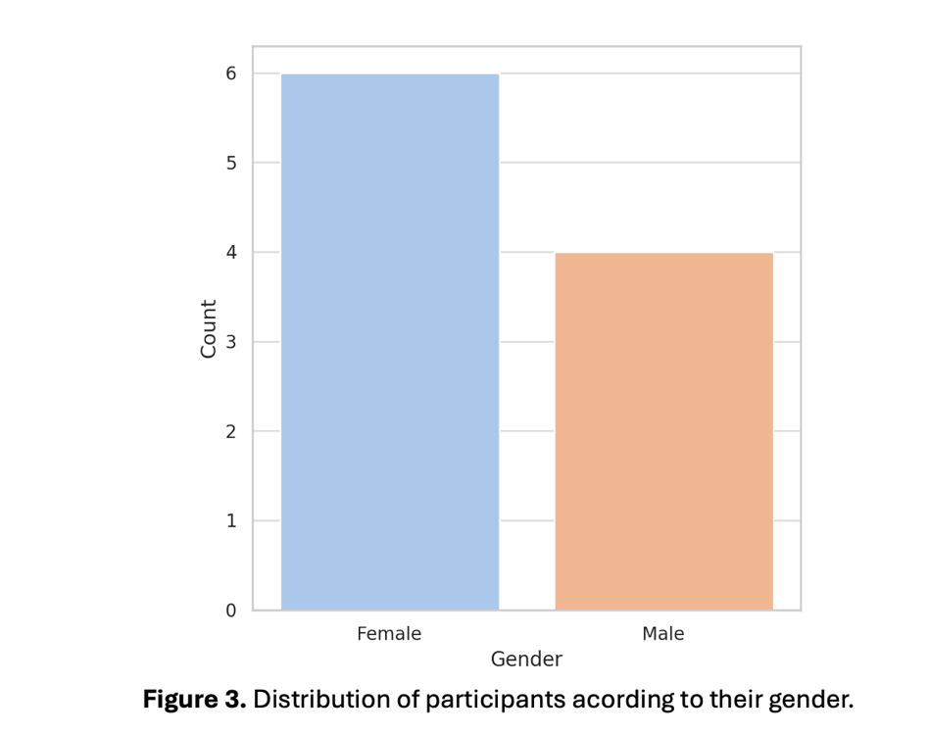
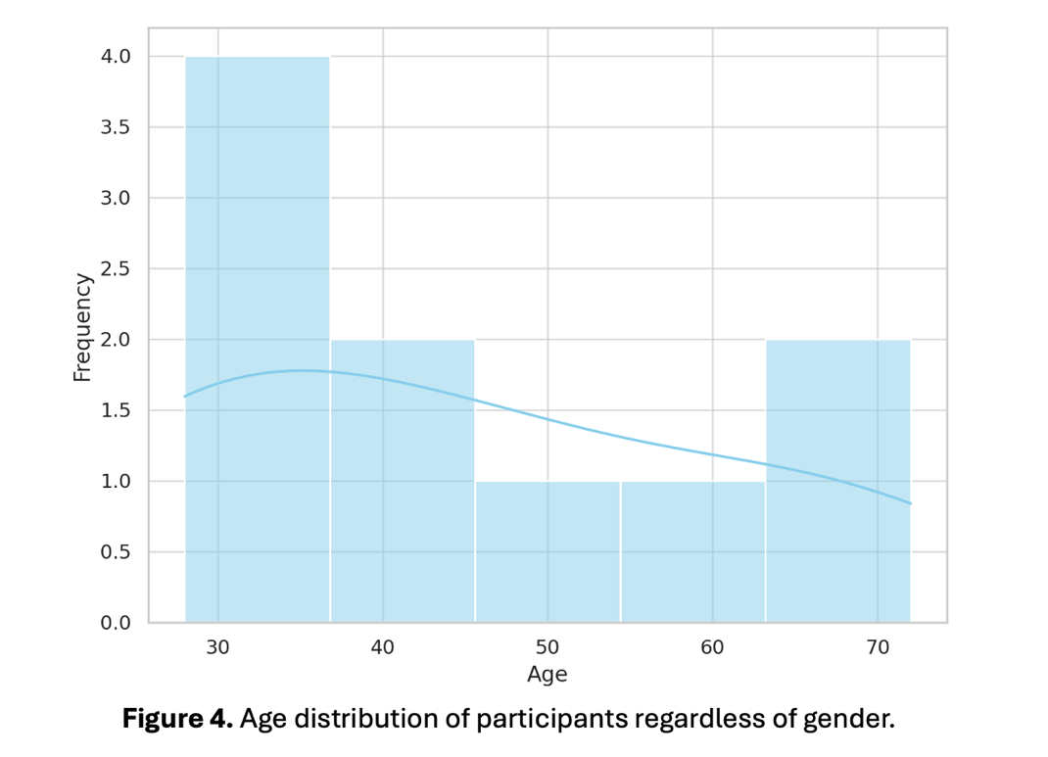
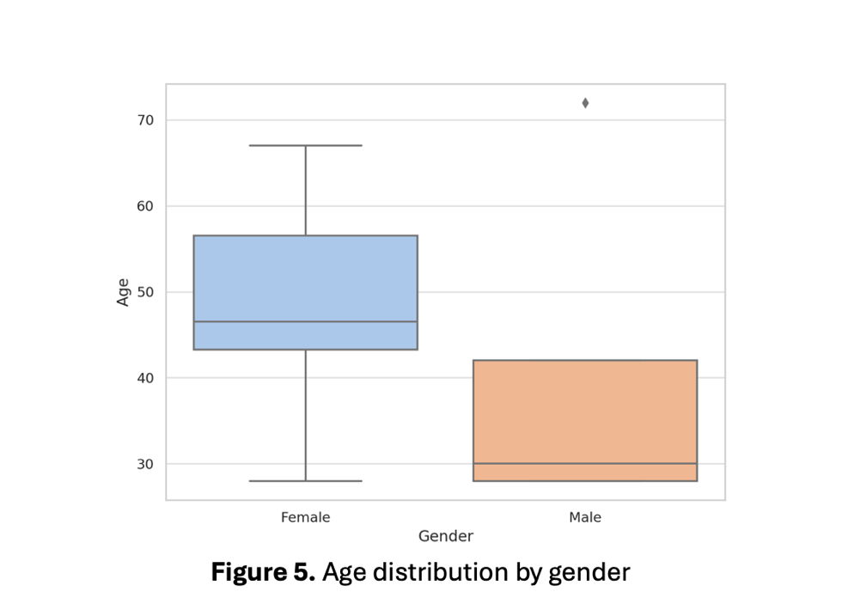

Perceived Immediate Effects (Session 1: Before vs. After Exercises)

To determine the immediate effects of Alexander Technique exercises, participants were evaluated before and after completing the exercises in their first session. A Wilcoxon Signed-Rank Test (Wilcoxon, 1945), a non-parametric test suitable for ordinal data, was used to compare scores for tension, breathing, and sound production (Table 1).

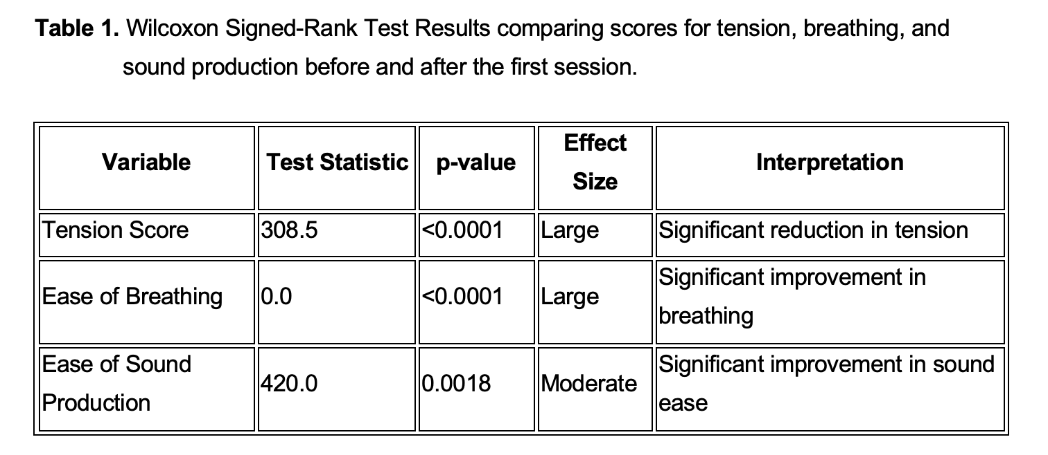

The immediate analysis showed a statistically significant reduction in perceived tension, with an average decrease across all participants following the exercises. Ease of breathing also demonstrated a large and statistically significant improvement with minimal variance among participants, indicating a consistent positive effect. Sound production improved significantly, though the effect size was moderate compared to breathing. Exploratory analysis was conducted to determine whether gender or age influenced the results. No significant differences were found between male and female participants in their responses to AT exercises (p > 0.05). Age was also not significantly correlated with changes in perceived tension, ease of breathing, or ease of producing sound (r < 0.20, p > 0.05). These findings suggest that Alexander Technique exercises provide rapid physiological benefits that may be linked to improved body awareness and tension release (Stallibrass, Sissons and Chalmers, 2002; Cacciatore, Horak and Henry, 2005). These results are similar to those found in Parent (2007) where a certified AT teacher was involved in the process.
To further contextualize these findings, individual comments from participants described sensations of relaxation and enhanced vocal control following the initial intervention. Several participants noted feeling a distinct reduction in jaw tension and improved airflow during singing. Common themes included increased body awareness, reduced physical strain, and greater control over vocalization after AT exercises. Statements such as "I felt more grounded and connected to my breath" and "My voice felt freer and less restricted" were frequently reported. This qualitative feedback reinforces the statistical data, highlighting a consistent pattern of tension reduction and physiological ease across participants.

Longitudinal Effects Across Sessions
To assess the effectiveness of the Alexander Technique over multiple sessions, the study employed the Friedman Test (Friedman, 1937) (Table 2), a non-parametric test for repeated measures analysis. Over the course of multiple sessions, tension scores continued to decline significantly (Figure 6), indicating a cumulative benefit of the Alexander Technique over time. Ease of sound production also showed statistically significant improvement across the sessions (Figure 7), suggesting that consistent application of the exercises led to progressive enhancement in vocal comfort. Participants mentioned the ‘monkey’ as being the posture that they felt mostly impacted their sound production. On the other hand, ease of breathing improvements were not sustained significantly after the initial session (Figure 8), implying a possible plateau effect where the initial benefits were not further enhanced with repeated practice alone.This might indicate that teachers and students should seek to enhance breathing by incorporating more targeted exercises (Ali and I, 2016; Desjardins and Bonilha, 2020).
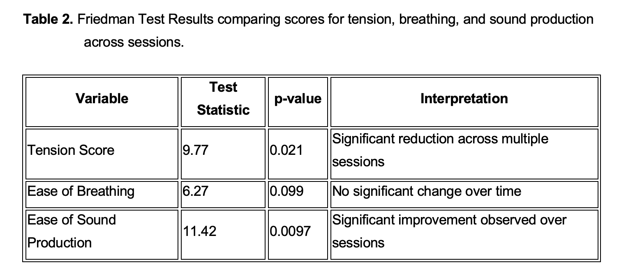
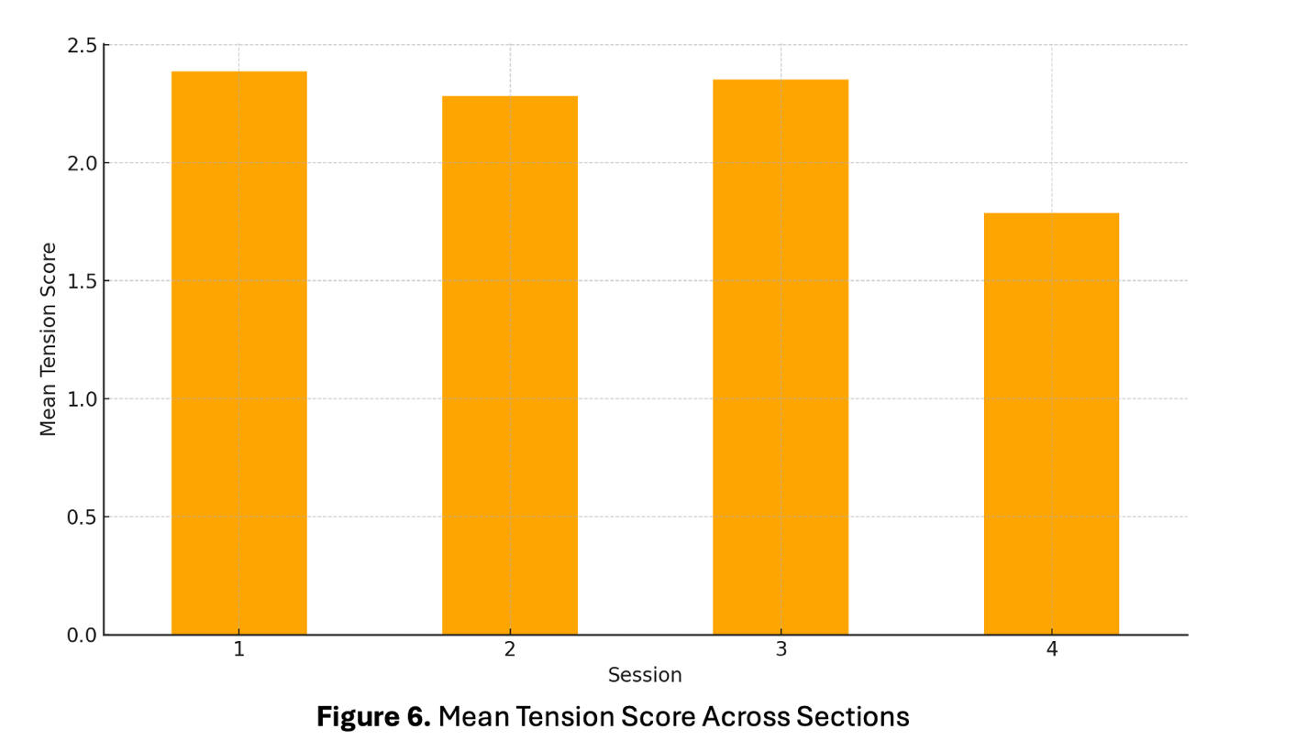

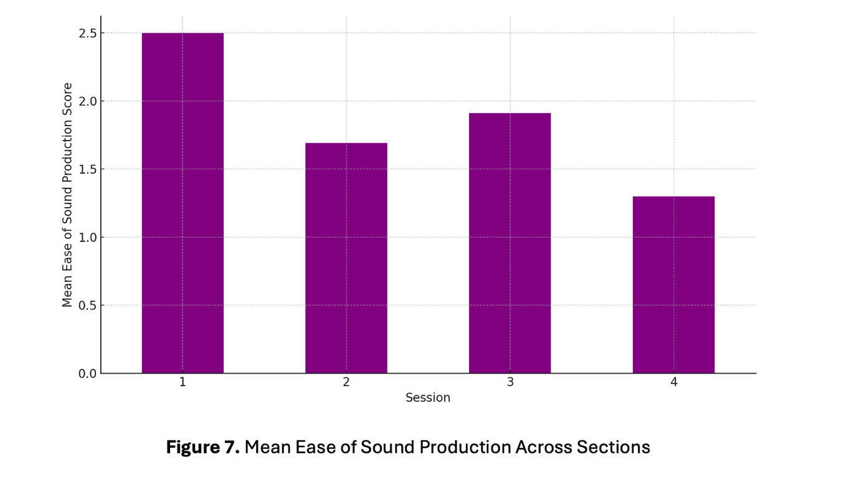

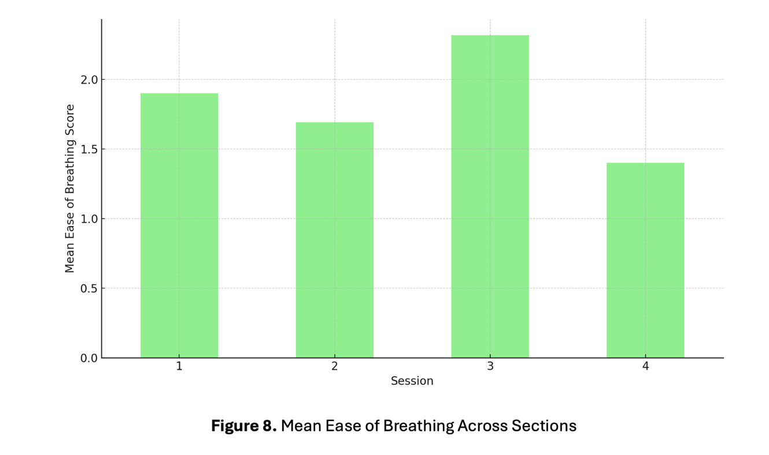

To provide a clearer visual representation of these relationships, a correlation heatmap summarized the associations between tension, breathing ease, and sound production ease (Figure 9). Positive correlations were observed between tension, ease of breathing, and ease of sound production. Breathing and sound production exhibited a stronger correlation with each other than tension did with the other variables.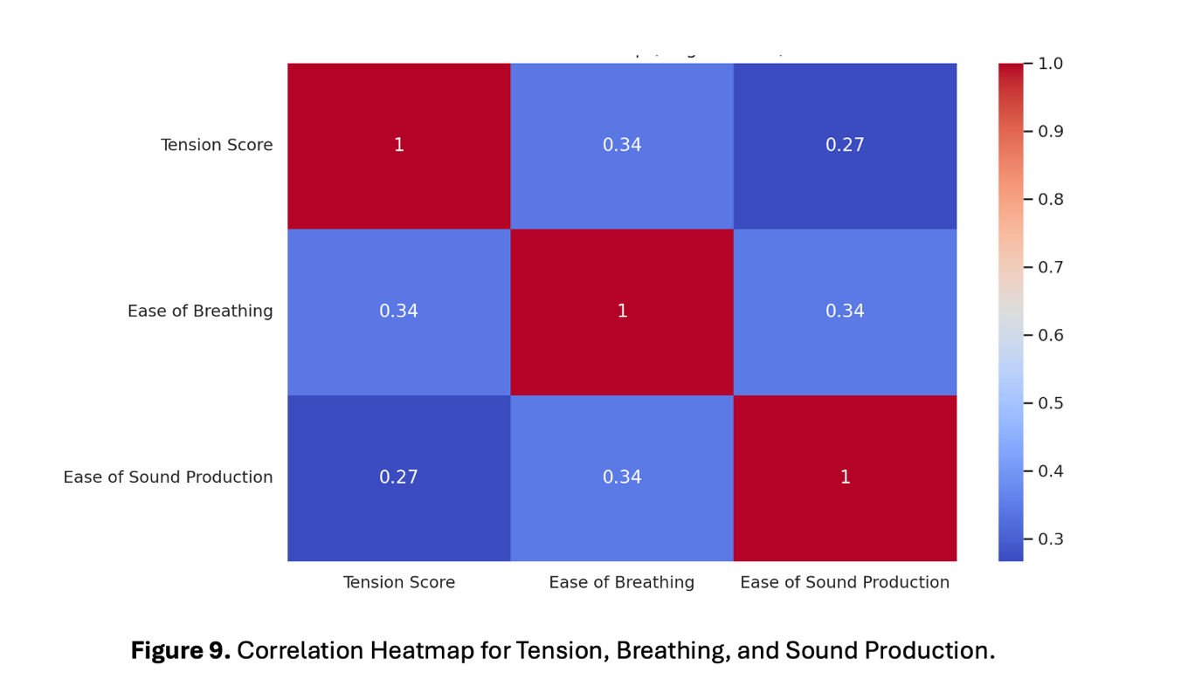
In the comments, participants reported enhanced comfort and vocal control in later sessions, with some noting a more effortless production of high notes and improved stamina during extended singing periods. This qualitative data complements the statistical findings, emphasizing progressive tension reduction and vocal ease with continued practice.

Post-hoc Pairwise Comparisons between sessions
The Wilcoxon Signed-Rank Test, a non-parametric statistical method suitable for paired data (Wilcoxon, 1945), was employed to assess differences across multiple sessions. The test was chosen due to its appropriateness for small sample sizes and non-normal data distribution. Results were considered statistically significant at p < 0.05. A significant reduction in tension was observed between Sessions 3 and 4, indicating an improvement in relaxation. For sound production, improvements were noted early (Session 1 vs. 2) and towards the later stages (Session 1 vs. 4) (Table 3).

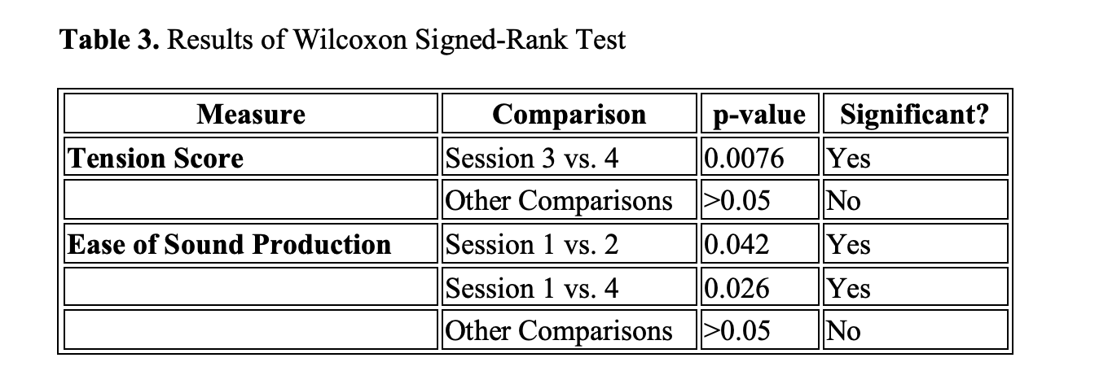
Statistical Analysis Summary Taking into account Gender and Age

Similar results were obtained when factoring in gender and age. Significant reductions in perceived tension and improvements in both ease of breathing and sound production were observed across all groups. Notably, female participants showed a larger effect size in sound production, while younger participants experienced more immediate improvements in breathing ease. Interpretation: Tension scores decreased significantly over multiple sessions for both genders. Ease of breathing improvements were more evident in the 20-40 age group, though sustained changes were limited to the older age group (41-60 years). across multiple sessions. Sound production ease improved significantly across all groups, with a larger effect observed among females.
The findings from this study suggest that the Alexander Technique (AT) can positively influence vocal performance by reducing perceived tension and improving ease of sound production and breathing. This will help contribute to the lack of studies assessing the effects of the technique (Gunjawate, Rohit and Rajashekhar, 2018). The observed gender differences, where female participants showed a greater need for sound production strategies while male participants benefited more from tension management, highlight the necessity for gender-sensitive vocal coaching methods (Hunter, Tanner and Smith, 2011). Additionally, the greater tension management needs among older participants emphasize the importance of age-specific approaches for effective vocal training. Further studies with a larger sample size and age distribution are needed to validate these results.

Results by Body Parts
Following Alexander Technique exercises, participants experienced varying degrees of tension reduction across different body parts (Figure 10). The legs exhibited the highest levels of tension with a mean score of 3.18, followed closely by the back at 2.98. In contrast, the jaw displayed the lowest tension score of 1.58, with the chest also reporting relatively low tension at 1.68. The distribution of mean tension scores across body parts is summarized in the following table:
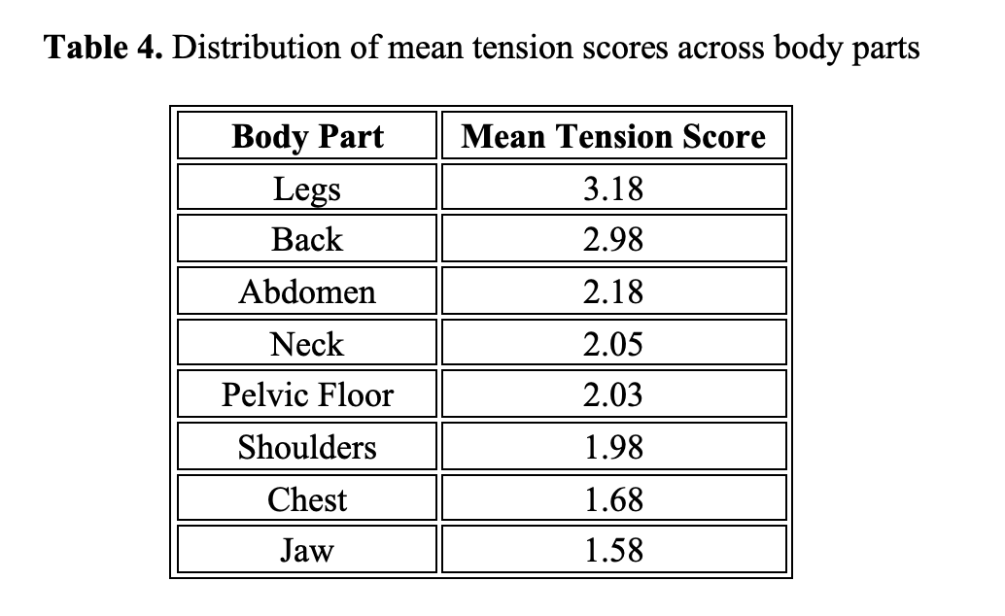
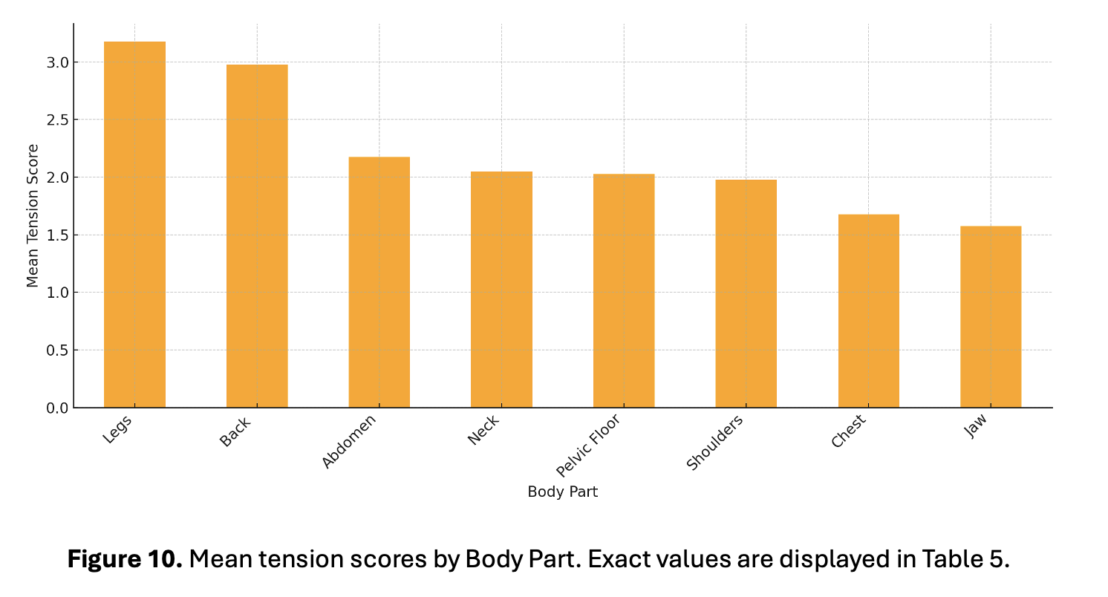
A Kruskal-Wallis test (Kruskal and Wallis, 1952) was conducted to examine the differences in tension levels among body parts. The results (H = 36.19, p-value = 6.68e-06) indicated statistically significant variation, with tension in the legs and back being notably higher compared to other areas, while the jaw and chest experienced the least residual tension. This pattern aligns with principles of body alignment and tension distribution in poses of mechanical advantage like the monkey, where lower body engagement supports upper body relaxation (Heirich, 2005).
The analysis of ease of breathing across multiple sessions (Friedman, 1937) revealed no significant changes in any of the measured body parts (Figure 11). The lowest p-values observed approached p=0.099, which did not reach statistical significance. This suggests that the Alexander Technique did not produce localized improvements in breathing ease in specific body areas but may have influenced more generalized breathing patterns or overall body awareness without significant variation across different regions.
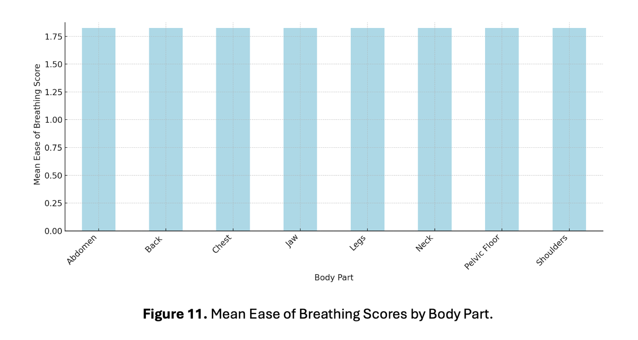
In contrast, the results for ease of sound production (Friedman, 1937) demonstrated significant improvements across all measured body parts (Figure 12), including the abdomen, back, chest, jaw, legs, neck, pelvic floor, and shoulders. All p-values were below p<0.013p, indicating consistent and statistically significant enhancement in vocal ease following Alexander Technique interventions. This widespread improvement suggests a more comprehensive effect, potentially linked to whole-body tension release and alignment adjustments facilitated by the technique.
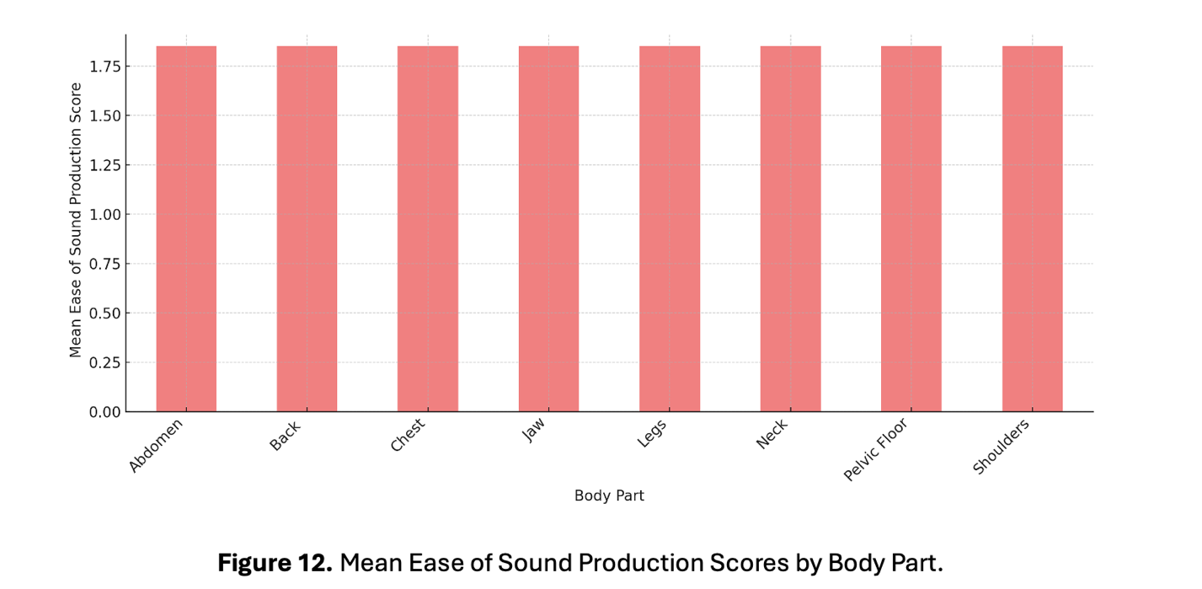
Together, these findings highlight a distinction in the effects of the Alexander Technique: while its influence on sound production appears broad and significant across multiple body parts, its impact on breathing ease may be more subtle or generalized rather than targeting specific anatomical regions. The limited and inconsistent improvements in ease of breathing imply that additional targeted interventions might be necessary to achieve more significant progress in this area (Ali and I, 2016; Desjardins and Bonilha, 2020; Walker, 2021). Future iterations of this study should incorporate targeted breathing interventions to address this limitation.

Thematic Analysis Results
The thematic analysis revealed several key patterns emerging from participants' comments, shedding light on their experiences with the Alexander Technique exercises and their impact on vocal performance. The qualitative feedback gathered provided detailed insights into both physical and psychological effects experienced by participants across multiple sessions. By examining the narrative feedback, it became evident that participants perceived multiple dimensions of improvement, both in their physical ease during vocalization and their emotional experiences associated with the practice.
A prominent theme identified was the reduction of physical tension (Table 5), as participants frequently described experiencing a sense of physical release after the exercises. Several comments reflected greater bodily awareness, particularly in areas commonly associated with vocal strain, such as the neck, shoulders, and jaw. This heightened awareness often correlated with a reported decrease in tension levels, aligning with the quantitative findings of lower post-session tension scores. Participants described how becoming more aware of bodily tension led to an increased ability to release it, with some noting sensations of lightness and reduced muscle stiffness.
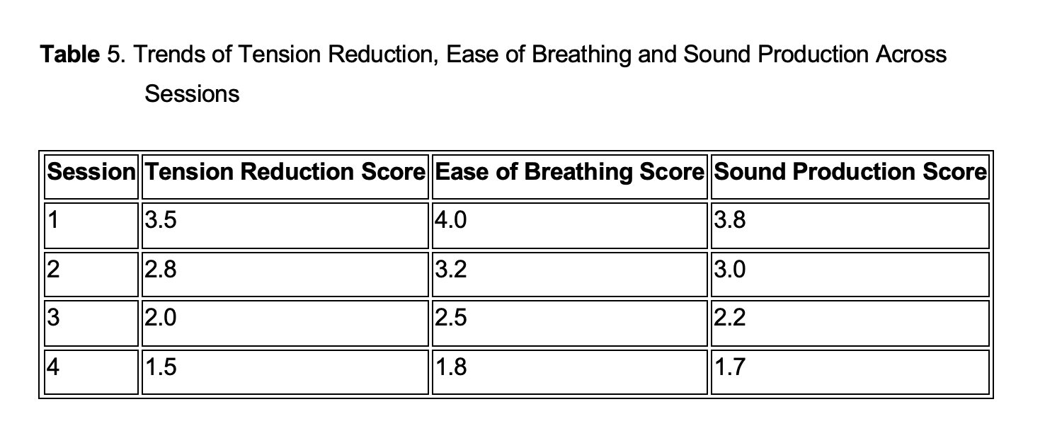
Additionally, the process of physically engaging with the Alexander Technique exercises appeared to promote greater alignment and postural awareness. Multiple participants reported that as they adjusted their posture and released tension, they felt more physically balanced and better supported during vocalization. This increased awareness of bodily alignment was often described as a contributing factor to vocal comfort and reduced strain.
Thematic analysis also highlighted participants’ reflections on improved breathing ease. Many participants reported experiencing a smoother breath flow and enhanced breath control after engaging in the Alexander Technique exercises. Comments often described a more effortless inhalation and exhalation process, which participants linked to the structured breathing exercises incorporated during the sessions. This perception corresponded with a decrease (1 = more easy) in Likert-scale scores for ease of breathing across multiple sessions. Some participants also reported better control over sustained phrases and an enhanced ability to modulate airflow for dynamic variation. Others mentioned how focusing on the mechanics of breathing during the exercises allowed them to notice and correct shallow or restricted breathing patterns. Participants also highlighted the emotional impact of easier breathing, suggesting it led to greater vocal confidence and relaxation during performance situations.
Another recurring theme centered around improved sound production and vocal projection. Participants noted greater clarity and resonance in their vocal output following the sessions. Several comments specifically described how reduced tension and enhanced breath control positively influenced sound quality, allowing for more sustained notes and clearer vocal delivery. These qualitative insights were consistent with the statistical reduction in sound production difficulty scores measured post-session. In addition to clarity and resonance, participants frequently mentioned increased vocal stability and control, with some attributing these changes directly to the tension-reduction techniques practiced during the exercises. Others described how feeling more grounded and physically balanced contributed to a stronger vocal presence and more consistent projection.
Participants frequently expressed emotional responses linked to comfort and confidence in their singing abilities. Many reported feeling more relaxed, confident, and grounded during vocalization after performing the Alexander Technique exercises. Some comments reflected increased enjoyment of the singing process, suggesting a psychological benefit beyond physical improvements. Emotional responses included descriptions of reduced anxiety and a greater sense of control during challenging vocal passages. Several participants highlighted that as physical tension decreased, their emotional tension also lessened, leading to a more positive and fulfilling singing experience. This emotional transformation was especially evident in later sessions, where participants often expressed feeling more at ease and self-assured.
Across the four sessions, themes of tension reduction, breath control, and sound quality remained consistent but became more pronounced in later sessions. Early sessions often featured descriptions of initial physical adjustments and unfamiliar sensations, while later sessions showed a more consistent association between the exercises and positive vocal outcomes. This progression mirrored the declining tension scores and improving ease ratings documented quantitatively. The data also revealed that participants who initially experienced greater tension saw more dramatic improvements across multiple sessions. Additionally, some participants noted that it took time to fully integrate the principles into their singing practice, indicating a gradual process of physical and psychological adaptation.

Limitations and Recommendations
The study's limitations include a small sample size, which may limit the generalizability of the findings. The use of self-reported Likert scales, while insightful, introduces subjective bias that could be complemented by more objective acoustic measurements (Roy et al., 2013; Pimentel, 2019; Brockmann-Bauser and de Paula Soares, 2023). Additionally, the study lacks longitudinal follow-up to determine the lasting effects of AT exercises on vocal performance over extended periods. There was also no formal validation or pilot-testing of the Likert scale questions before conducting the study. This risks misinterpretation of questions, inconsistent responses, and unclear measurement of the intended concepts, which can lead to biased results, challenges in data analysis, and reduced credibility of the findings. Future studies should address the lack of validation of the questionnaire by conducting pilot-testing to ensure the questions are clear, reliable, and accurately measure the intended variables, strengthening the study’s overall methodological rigor.
These findings have significant implications for vocal pedagogy. Implementing gender-specific adjustments in coaching, such as focusing on sound production strategies for female singers and tension management for male singers, can enhance personalized instruction (Hunter, Tanner and Smith, 2011). Moreover, age-specific strategies, including sustained tension management and breathing support, are crucial for older singers to maintain vocal health and progress (Hunter et al., 2012). Regular progress tracking through Likert scales and periodic evaluations can provide valuable feedback for both students and instructors (Roy et al., 2013; Herrell, 2014; Brockmann-Bauser and de Paula Soares, 2023).
The Alexander Technique can significantly enhance vocal pedagogy by addressing neck and shoulder tension, promoting whole-body alignment, and emphasizing the connection between posture, breath support, and phonation. Vocal coaches are encouraged to focus on reducing tension in the neck, back, and shoulders, incorporate posture work for improved sound production, and introduce breathing exercises alongside Alexander Technique principles. Personalized coaching based on individual tension patterns and consistent practice are essential for sustained benefits. Dedicated workshops by certified AT instructors can offer valuable additions to a comprehensive vocal health curriculum.
Future research should expand the participant pool to ensure balanced representation across age and gender. Incorporating objective acoustic analysis tools, such as spectrograms and airflow measurements, could strengthen the reliability of findings (Roy et al., 2013; Gunjawate, Rohit and Rajashekhar, 2018; Brockmann-Bauser and de Paula Soares, 2023). Additionally, developing gender-sensitive and age-specific coaching modules tailored to individual needs could further optimize vocal training outcomes. In order to implement the use of more objective acoustic measurements, a consensus of which parameters are important and a standardized way of measuring them is important among voice teachers and other voice professionals (Gunjawate, Rohit and Rajashekhar, 2018).

CONCLUSION AND DISCUSSION
The findings of this study support the benefits of the Alexander Technique (AT) in reducing tension, improving breathing, and enhancing sound production. Significant reductions in tension were noted, particularly in the neck, back, and shoulders, aligning with research by Klein, Bayard and Wolf (2014), who found AT effective in alleviating upper body muscle tension and performance anxiety. These reductions also mirror Woodman and Moore's (2012) findings on AT’s positive effects on postural control and tension, though they noted a need for further research.
Improvements in sound production across all body parts highlight AT's role in enhancing global body awareness. This echoes Klein, Bayard, and Wolf’s Klein, Bayard and Wolf's (2014), findings of vocal quality improvements, including increased vocal "ring" and sound pressure levels, in classical singers following AT lessons. However, ease of breathing showed only initial gains, which were not sustained over time. Similar mixed results are reflected in Dennis (1987) who found no significant respiratory improvements in wind instrumentalists after AT lessons, suggesting complementary techniques like diaphragmatic breathing may be necessary.
The variability in tension reduction, particularly minimal changes in the abdomen and pelvic floor, highlights the need for individualized approaches to vocal coaching. This aligns with Klein, Bayard and Wolf's (2014) emphasis on tailoring coaching to individual physiological patterns. Long-term benefits, such as cumulative tension reduction and sound production improvements, reinforce the importance of consistent AT practice, as supported by both Klein, Bayard and Wolf (2014) and Woodman and Moore (2012), who emphasized that ongoing AT lessons are essential for lasting results.
This study contributes to gaps in the literature by providing additional evidence of the Alexander Technique's effectiveness in reducing tension and improving sound production among adult singing students. While prior research has emphasized its benefits for professional performers, this study expands the scope by highlighting its potential for broader application in voice pedagogy, particularly in a mixed-experience adult singing population. The findings also underscore the need for further investigation into the long-term effects of AT on breathing and the importance of personalized approaches to tension management in vocal training.
In conclusion, vocal teachers coaches can draw several key recommendations from these findings: emphasize targeted tension reduction in the neck, back, and shoulders; prioritize whole-body alignment for enhanced sound production; integrate breathing exercises alongside AT practices for sustained respiratory improvements; personalize coaching based on individual tension patterns; and encourage consistent, long-term practice to maximize the benefits of the Alexander Technique in the voice studio.

Appendices:
Appendix 1: Common misalignments and their effect in the voice
- Forward Head Posture (Kyphosis / FHP)
- Definition: the structural forward positioning of the head away from the centerline of the body, where lower cervical vertebrae are bent and upper cervical vertebrae are extended, and the weight of the head supported by the neck is increased (Kim and Kim, 2016)

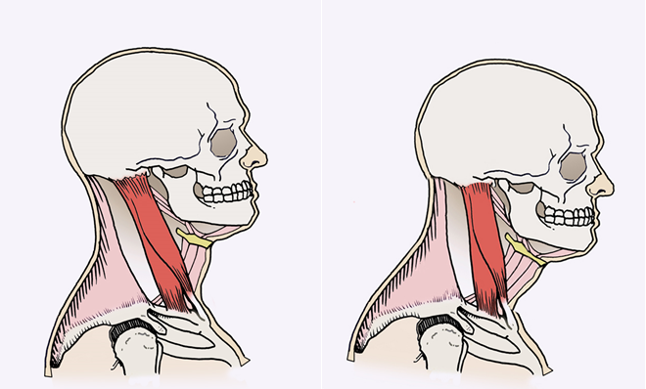
Figure 1. Aligned neck and head (left) and forward head posture (right) (Fitzgordon, 2024)
- Effects on the body
    - negative effect on respiration by inducing a weakening of the accessory muscles and a decline of thoracic mobility (Jintae et al., 2016).
    - weakens and shortens muscles in the neck that lead to laryngeal elevation, narrowing of the pharynx and changes in the shape of the vocal tract (Jintae et al., 2016; Kim and Kim, 2016).
    - weakens and shortens muscles in the neck that lead to laryngeal elevation, narrowing of the pharynx and changes in the shape of the vocal tract (Jintae et al., 2016; Kim and Kim, 2016)
- Consequences on the voice
    - decrease in muscle efficiency, changes in resonance and possible difficulties in pitch elevation (Kennard et al., 2015).
- Rounded Shoulders
- Definition: Individuals who maintain their shoulders in a rounded forward position (Wilson Arboleda and Frederick, 2008)
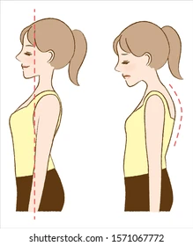

Figure 2. Rounded shoulders (Stock Image)
b. Effects on the body
    - tightness of pectoral and abdominal muscles as well as weakening of the scapular muscles (Wilson Arboleda and Frederick, 2008a).
    - shortens intercostal and pectoral muscles, hindering respiration (Wilson Arboleda and Frederick, 2008).
c. Consequences on the voice
i. decrease in respiratory function and an increase in vocal fatigue (Wilson Arboleda and Frederick, 2008a).

3. Sway back posture
- Definition: anterior translation of the pelvis and hip joints, beyond the center gravity line, a flattened curve in the lumbar region and overextended hip and knee joints (Mahdavie, Rezasoltani and Simorgh, 2017).
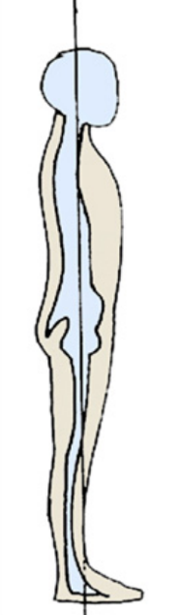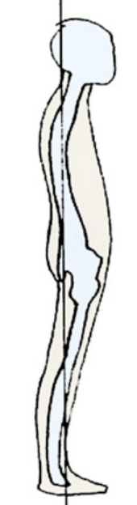
Figure 1. Balanced posture (left) and sway back posture (right) (Wilson Arboleda and Frederick, 2008)
- Effects on the body
    - decreases the activity of lumbar and pelvic floor muscles shortens intercostal and pectoral muscles (O’Sullivan et al., 2006)
    - increases the activity of some abdominal muscles (O’Sullivan et al., 2006)
    - reduces the diameter of the thorax (O’Sullivan et al., 2006)
c. Consequences on the voice
i. hinders respiration (Staes et al., 2011)
ii. decreases voice support (Staes et al., 2011)

Appendix 2. Effects of the Monkey Position on the Vocal Apparatus

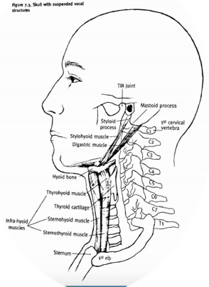
Figure 1. Relationship of the vertebrae to the vocal apparatus (Heirich, 2005).

- Respiration:
The monkey frees the rib cage from all tension so the ribs, intercostal muscles, lungs and diaphragm move in a more natural, non-restricted way, aided by the force of gravity (Figure3). Once we get used to singing in this position in which breathing is easier and is not forced, breathing in other positions will be freer and more efficient (Heirich, 2005; de Veer, 2009).

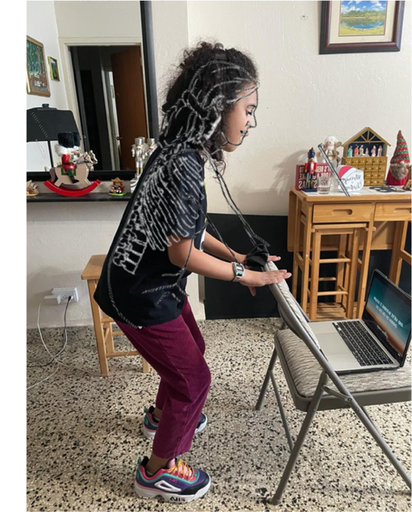
Figure 4. Student in the monkey position while singing. Superimposed is a drawing from Heirich (2005) showing the position.

- Jaw
One of the things singers should be very aware of is maintaining a relaxed jaw. If the muscles in the jaw are tense we create tension in the other structures related to sound production. Also, if we clench the jaw we can’t create the necessary space for air to flow freely. We should let the lower jaw drop in order to obtain free movement when singing and the monkey helps the jaw hang freely from the base of the skull (if we allow it and don’t pull it forward) (Heirich, 2005).

3. Larynx
The larynx, where the vocal cords reside, have a tendency to tense and go up (especially in the higher pitches), limiting the space available for the air to flow freely, producing a small and tight sound. Lowering the larynx in a forceful and excessive manner can also create tension and damage the vocal health and quality of the singer. When singing in this pose, the larynx hangs naturally (aided by gravity), which facilitates sound production (Figure 4) (Heirich, 2005).
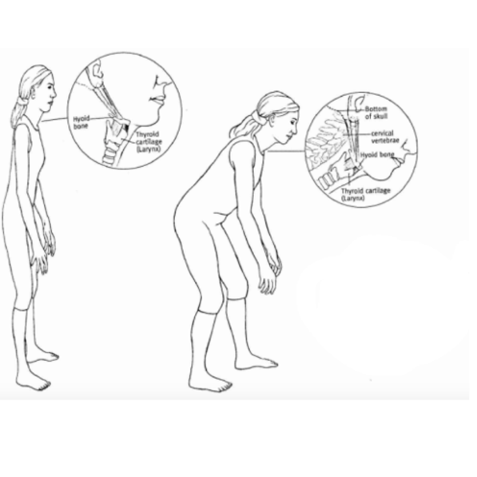
Figure 5. Larynx hanging from hyoid bone in shallow (left) and deep (right) monkey position (Heirich, 2005).

Appendix 3. Informational sheet given to participants

Purpose: To study whether there is a relationship between vocalizing tension and the use of Alexander technique exercises

Method:

- Body Stretching
- Semi-supine position
  - Inhale and exhale, allow your back to relax towards the floor and curl up, your head going towards the wall, your toes to the opposite wall and your knees towards the ceiling.
  - Allow air to enter and exhale in an 's' (three times)
  - Allow air to enter and exhale in a murmured 'a' (three times)

Figure 1. Semi-supine position (Heirich, 2005)

- Seated
  - Listen carefully to Alexander's directives (3 times): "I allow my neck to be free, so that my head goes forward and upward, allowing my back to lengthen and expand, my shoulders to spread and my knees to go forward and outward."
  - Allow air to enter and exhale in an 's' (three times)
  - Allow air to enter and exhale in a murmured 'a' (three times)
- Monkey Position
  - Vocalize in 'his' 12321
  - Straighten up little by little

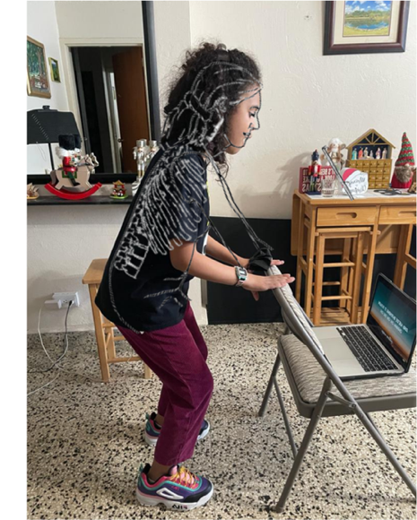

Figure 2. Student in the monkey position while singing. Superimposed is a drawing from Heirich (2005)showing the position.

- Complete questionnaire

Note: In the first session, two questionnaires will be completed: one before starting (S0) and one after the exercises (S1)

Participants: minimum of 10 adults, non-professional singing students from Prof. Lourdes González's In Cresendo study

Duration: 15 minutes of the class over 4 weeks

Commitment:
- Even if I agree to participate now, I can withdraw at any time
- I may refuse to answer any questions during the research process without any consequences of any kind.
Risks: Discomfort with postures

Confidentiality:
- In any report on the results of this investigation, my identity will remain anonymous.
- The signed consent forms and original questionnaires will be kept on my computer, and Google Drive (both protected by passwords) until I complete my master's degree in 2026.
- Participants have the right to access the information they have provided at any time
- Participants can contact any of the people involved in the research to seek clarification

Appendix 4. Participant’s Consent Form
Study on the use of Alexander Technique postures in a singing class
Consent to participate in research
I___________________________________________ voluntarily agree to participate in this research study.
- I understand that even if I agree to participate now, I can withdraw at any time.
- I understand that I may refuse to answer any questions during the research process without any consequences of any kind.
- The purpose and nature of the study have been explained to me in writing and I have had the opportunity to ask questions about the study.
- I understand that participation involves warm-up exercises with the guidance of the teacher and answering a questionnaire.
- I understand that I will not directly benefit from participating in this research.
- I understand that all information I provide for this study will be treated confidentially.
- I understand that in any report on the results of this investigation, my identity will remain anonymous.
- This will be done by changing my name and disguising any details of my interview that may reveal my identity or the identity of the people I am talking about.
- I understand that disguised excerpts from my interview may be cited in: dissertation, conference presentation, published works.
- I understand that the signed consent forms and original questionnaires will be retained on my computer, and google drive (both password protected) until I complete my master's degree in 2026.
- I understand that, under the legalization of freedom of information, I have the right to access the information I have provided at any time while it is stored as specified above.
- I understand that I am free to contact any of the individuals involved in the investigation to seek clarification of the information.
Lourdes M. González Caraballo, MT, VHP
Voice Study Centre, University of Wales

______________________________________________
Participant's Signature, Date
I understand that the participant is giving informed consent to participate in this study:

________________________________________________
Researcher's Signature, Date

Appendix 5. Permission Letter

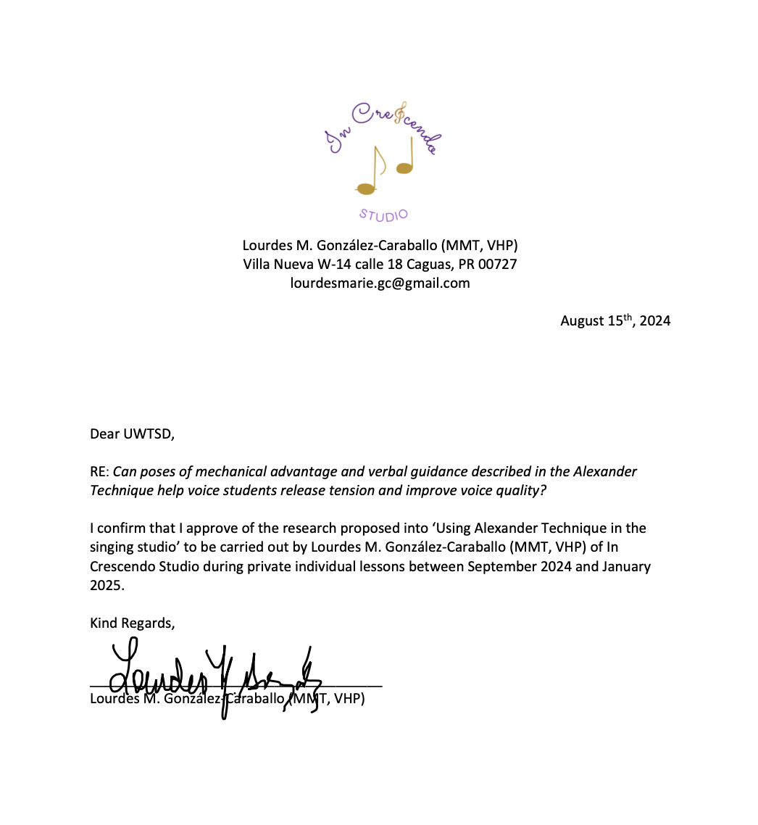

Appendix 6. Gantt Chart



Bibliography

Alexander, F.M. (1932) The Use of the Self.
Ali, L. and I, G.A. (2016) ‘The Relationship Between Voice and Breathing in the Assessment and Treatment of Voice Disorders’, Perspectives of the ASHA Special Interest Groups, 1(3), pp. 94–104. Available at: https://doi.org/10.1044/persp1.SIG3.94.
Baer, R.A., Carmody, J. and Hunsinger, M. (2012) ‘Weekly Change in Mindfulness and Perceived Stress in a Mindfulness-Based Stress Reduction Program’, Journal of Clinical Psychology, 68(7), pp. 755–765. Available at: https://doi.org/10.1002/jclp.21865.
Becker, J.J. et al. (2021) ‘Alexander technique vs. Targeted exercise for neck pain—a preliminary comparison’, Applied Sciences (Switzerland), 11(10). Available at: https://doi.org/10.3390/app11104640.
Bosanquet, R.C. (1987a) ‘The Alexander Principle and its Importance to Music Education’, British Journal of Music Education, 4(3), pp. 229–242. Available at: https://doi.org/10.1017/S0265051700006069.
Bosanquet, R.C. (1987b) ‘The Alexander Principle and its Importance to Music Education’, British Journal of Music Education, 4(3), pp. 229–242. Available at: https://doi.org/10.1017/S0265051700006069.
Braun, V. and Clarke, V. (2006) ‘Using thematic analysis in psychology’, Qualitative Research in Psychology, 3(2), pp. 77–101. Available at: https://doi.org/10.1191/1478088706qp063oa.
Braun, V. and Clarke, V. (2013) Successful qualitative research: A practical guide for beginners. Sage.
Brennan, R. (2016) Alexander Technique : An Introductory Guide to Natural Poise for Health and Well-Being. La Vergne, UNITED STATES: Pavilion Books. Available at: http://ebookcentral.proquest.com/lib/trinity/detail.action?docID=5525297.
Brockmann-Bauser, M. and de Paula Soares, M.F. (2023) ‘Do We Get What We Need from Clinical Acoustic Voice Measurements?’, Applied Sciences (Switzerland), 13(2). Available at: https://doi.org/10.3390/app13020941.
Cacciatore, T.W., Horak, F.B. and Henry, S.M. (2005) ‘Improvement in Automatic Postural Coordination Following Alexander Technique Lessons in a Person With Low Back Pain’, Physical Therapy, 85(6), pp. 565–578. Available at: https://academic.oup.com/ptj/article/85/6/565/2805039.
Cacciatore, T.W., Johnson, P.M. and Cohen, R.G. (2020) ‘Potential mechanisms of the alexander technique: Toward a comprehensive neurophysiological model’, Kinesiology Review, 9(3), pp. 199–213. Available at: https://doi.org/10.1123/KR.2020-0026.
Cardoso, R., Lumini-Oliveira, J. and Meneses, R.F. (2019) ‘Associations between Posture, Voice, and Dysphonia: A Systematic Review’, Journal of Voice. Mosby Inc., pp. 124.e1-124.e12. Available at: https://doi.org/10.1016/j.jvoice.2017.08.030.
Charmaz, K. (2006) Constructing Grounded Theory. Sage.
Conable, Barbara and Conable, Benjamin (2000) What Every Musician Needs to Know About the Body:The Application of Body Mapping to Making Music . Portland: Andover Press.
Creswell, J.W. (2014) Research Design: Qualitative, Quantitative, and Mixed Methods Approaches. Sage.
Czajkowski, A. and Greasley, A. (2016) ‘Mindfulness for Singers: The effects of a targeted mindfulness course on learning vocal techniques’, British Journal of Music Education, 33(3), p. 347. Available at: https://doi.org/10.1017/S0265051716000097.
Czajkowski, A.M.L., Greasley, A.E. and Allis, M. (2021) ‘Mindfulness for Singers: A Mixed Methods Replication Study’, Music and Science, 4. Available at: https://doi.org/10.1177/20592043211044816.
Davies, J. (2020) ‘Alexander Technique classes improve pain and performance factors in tertiary music students’, Journal of Bodywork and Movement Therapies, 24(1), pp. 1–7. Available at: https://doi.org/10.1016/j.jbmt.2019.04.006.
Dennis, R.J. (1987) Musical Performance and Respiratory Function in Wind Instrumentalists: Effects of the Alexander Technique of Muscoloskeletal Education. Columbia University.
Desjardins, M. and Bonilha, H.S. (2020) ‘The Impact of Respiratory Exercises on Voice Outcomes: A Systematic Review of the Literature’, Journal of Voice, 34(4), pp. 648.e1-648.e39. Available at: https://doi.org/10.1016/J.JVOICE.2019.01.011.
Dimon, T. (2018) Anatomy of the Voice : An Illustrated Guide for Singers, Vocal Coaches, and Speech Therapists. Berkeley, California: North Atlantic Books. Available at: https://ezproxy.uwtsd.ac.uk/login?url=https://search.ebscohost.com/login.aspx?direct=true&db=nlebk&AN=1571344&site=ehost-live.
Dunning, D.L. et al. (2019) ‘Research Review: The effects of mindfulness-based interventions on cognition and mental health in children and adolescents – a meta-analysis of randomized controlled trials’, Journal of Child Psychology and Psychiatry and Allied Disciplines. Blackwell Publishing Ltd, pp. 244–258. Available at: https://doi.org/10.1111/jcpp.12980.
Essex, H. et al. (2017) ‘An economic evaluation of Alexander Technique lessons or acupuncture sessions for patients with chronic neck pain: A randomized trial (ATLAS)’, PLoS ONE, 12(12). Available at: https://doi.org/10.1371/journal.pone.0178918.
Field, A. (2013) ‘Discovering statistics using IBM SPSS statistics’. sage London.
Fitzgordon, J. (2024) https://www.corewalking.com/the-pelvis-and-forward-head-posture-2/.
Fjorback, L.O. et al. (2011) ‘Mindfulness-based stress reduction and mindfulness-based cognitive therapy - a systematic review of randomized controlled trials’, Acta Psychiatrica Scandinavica, pp. 102–119. Available at: https://doi.org/10.1111/j.1600-0447.2011.01704.x.
Franco, D. et al. (2014) ‘Is the sagittal postural alignment different in normal and dysphonic adult speakers?’, Journal of Voice, 28(4), pp. 523.e1-523.e8. Available at: https://doi.org/10.1016/j.jvoice.2014.01.002.
Friedman, M. (1937) ‘The use of ranks to avoid the assumption of normality implicit in the analysis of variance’, Journal of the American Statistical Association, 32(200), pp. 675–701.
Fung Ying, L. et al. (2015) ‘Tension Release in Piano Playing: Teaching Alexander Technique to Undergraduate Piano Majors’, Procedia - Social and Behavioral Sciences, 174, pp. 2413–2417. Available at: https://doi.org/10.1016/J.SBSPRO.2015.01.910.
Gelb, M. (1994) Body Learning: An Introduction to the Alexander Technique. Aurum Press.
Gunjawate, D.R., Rohit, R. and Rajashekhar, B. (2018) ‘Acoustic Analysis of Voice in Singers: A Systematic Review’, Journal of Speech, Language, and Hearing Research, 61(1), pp. 40–51. Available at: https://doi.org/10.1044/2017_JSLHR-S-17-0145.
Heirich, J. (2005) Voice and the Alexander Technique.
Herrell, K.A. (2014) The Development and Validation of a Rubric to Enhance Performer Feedback for Undergraduate Vocal Solo Performance. Lindenwood University.
Hodges, P.W., Sapsford, R. and Pengel, L.H.M. (2007) ‘Postural and respiratory functions of the pelvic floor muscles’, Neurourology and Urodynamics, 26(3), pp. 362–371. Available at: https://doi.org/https://doi.org/10.1002/nau.20232.
Hunter, E.J. et al. (2012) ‘Age and speech production: A 50-year longitudinal study’, Journal of the American Geriatrics Society, pp. 1175–1177. Available at: https://doi.org/10.1111/j.1532-5415.2012.03983.x.
Hunter, E.J., Tanner, K. and Smith, M.E. (2011) ‘Gender differences affecting vocal health of women in vocally demanding careers’, Logopedics Phoniatrics Vocology, 36(3), pp. 128–136. Available at: https://doi.org/10.3109/14015439.2011.587447.
Jintae, H. et al. (2016) ‘Effects of forward head posture on forced vital capacity and respiratory muscles activity’, The Journal of Physical Therapy Science, 28, pp. 128–131.
Kennard, E.J. et al. (2015) ‘A Preliminary Comparison of Laryngeal Manipulation and Postural Treatment on Voice Quality in a Prospective Randomized Crossover Study’, Journal of Voice, 29(6), pp. 751–754. Available at: https://doi.org/10.1016/j.jvoice.2014.09.026.
Kildow, E.S. (2017) ‘Ahead of the Curve: Considerations of the Alexander Technique as a Mindfulness Modality’, ExChange: Journal of Alexander Technique International, pp. 20–26.
Kim, E.-K. and Kim, J.S. (2016) ‘Correlation between rounded shoulder posture, neck disability indices, and degree of forward head posture’, The Journal of Physical Therapy Science, 28, pp. 2929–2932.
Klein, S., Bayard, C. and Wolf, U. (2014) ‘The Alexander Technique and musicians: a systematic review of controlled trials’, BMC complementary and alternative medicine, 14, p. 414. Available at: https://doi.org/10.1186/1472-6882-14-414.
Krippendorff, K. (2013) Content Analysis: An Introduction to Its Methodology. Sage.
Kruskal, W.H. and Wallis, W.A. (1952) ‘Use of ranks in one-criterion variance analysis’, Journal of the American Statistical Association, 47(260), pp. 583–621.
Lauche, R. et al. (2016) ‘Efficacy of the Alexander Technique in treating chronic non-specific neck pain: A randomized controlled trial’, Clinical Rehabilitation, 30(3), pp. 247–258. Available at: https://doi.org/10.1177/0269215515578699.
Lincoln, Y.S. and Guba, E.G. (1985) Naturalistic Inquiry. Beverly Hills: Sage.
Little, P. et al. (2008) ‘Randomised controlled trial of Alexander technique lessons, exercise, and massage (ATEAM) for chronic and recurrent back pain’, BMJ, 337(7667), pp. 438–441. Available at: https://doi.org/10.1136/bmj.a884.
MacPherson, H. et al. (2013) ‘Alexander Technique Lessons, Acupuncture Sessions or usual care for patients with chronic neck pain (ATLAS): Study protocol for a randomised controlled trial’, Trials, 14(1). Available at: https://doi.org/10.1186/1745-6215-14-209.
Mahdavie, E., Rezasoltani, A. and Simorgh, L. (2017) ‘The Comparison of the Lumbar Multifidus Muscles Function Between Gymnastic Athletes With Sway-Back Posture and Normal Posture’, International journal of sports physical therapy, 12(4), pp. 607–615.
Mayers, H. and Babits, L. (1987) A Balanced Approach: The Alexander Technique, Source: Music Educators Journal.
Mirabito, G. and Verhaeghen, P. (2023) ‘The Effects of Mindfulness Interventions on Older Adults’ Cognition: A Meta-Analysis’, Journals of Gerontology - Series B Psychological Sciences and Social Sciences. Gerontological Society of America, pp. 394–408. Available at: https://doi.org/10.1093/geronb/gbac143.
Mora Álvarez, M.G. et al. (2023) ‘Effects of web-based mindfulness training on psychological outcomes, attention, and neuroplasticity’, Scientific Reports, 13(1). Available at: https://doi.org/10.1038/s41598-023-48706-0.
Murphy, D.R. (2010) The Alexander Technique in the Choral Classroom. University of Wisconsin-Platteville. Available at: https://minds.wisconsin.edu/bitstream/handle/1793/46181/MurphyDavidR.pdf (Accessed: 6 January 2025).
Ornoy, E. and Cohen, S. (2021) ‘The effect of mindfulness meditation on the vocal proficiencies of music education students’, Psychology of Music [Preprint]. Available at: https://doi.org/10.1177/03057356211062262.
O’Sullivan, P. et al. (2006) ‘Lumbopelvic Kinematics and Trunk Muscle Activity During Sitting on Stable and Unstable Surfaces’, J Orthop Sports Phys Ther, 36, pp. 19–25. Available at: www.jospt.org.
Parent, K.A. (2007) Applying Alexander Technique in the high school choral rehearsal. Available at: https://open.library.ubc.ca/collections/831/items/1.0055079.
Patton, M.Q. (2015) Qualitative Research and Evaluation Methods. Sage.
Pimentel, J.L. (2019) ‘Some Biases in Likert Scaling Usage and its Correction’, International Journal of Sciences: Basic and Applied Research (IJSBAR), 45(1), pp. 183–191. Available at: https://www.gssrr.org/index.php/JournalOfBasicAndApplied/article/view/9874.
Roy, N. et al. (2013) ‘Evidence-based clinical voice assessment: A systematic review’, American Journal of Speech-Language Pathology. American Speech-Language-Hearing Association, pp. 212–226. Available at: https://doi.org/10.1044/1058-0360(2012/12-0014).
Sentianin, P. (2018) Natural Singing: A Guide for Using the. University of Colorado.
Siegel, S. and Castellan, N.J. (1988) Nonparametric Statistics for the Behavioral Sciences. McGraw-Hill.
Smith, J.A. and Osborn, M. (2003) Interpretative Phenomenological Analysis. Sage.
Staes, F.F. et al. (2011) ‘Physical therapy as a means to optimize posture and voice parameters in student classical singers: A case report’, Journal of Voice, 25(3). Available at: https://doi.org/10.1016/j.jvoice.2009.10.012.
Stallibrass, C., Sissons, P. and Chalmers, C. (2002) ‘Randomized controlled trial of the Alexander Technique for idiopathic Parkinson’s disease’, Clinical Rehabilitation, 16(7), pp. 695–708.
Tan, D., Diaz, F.M. and Miksza, P. (2020) ‘Expressing emotion through vocal performance: Acoustic cues and the effects of a mindfulness induction’, Psychology of Music, 48(4), pp. 495–512. Available at: https://doi.org/10.1177/0305735618809873.
de Veer, C. (2009) ‘Peer Reviewed Article The Alexander Technique: Rehearsal Tools For Releasing the Actor’s Voice’, Voice and Speech Review, 6(1), pp. 31–37. Available at: https://doi.org/10.1080/23268263.2009.10761502.
Walker, M. (2021) ‘Breathing and Voice: Speaking Again’, in R. Nusser-Müller-Busch and K. Gampp Lehmann (eds) Facial-Oral Tract Therapy (F.O.T.T.) : For Eating, Swallowing, Nonverbal Communication and Speech. Cham: Springer International Publishing, pp. 177–206. Available at: https://doi.org/10.1007/978-3-030-51637-6_8.
Wilcoxon, F. (1945) ‘Individual Comparisons by Ranking Methods’, Biometrics Bulletin, 1(6), pp. 80–83.
Wilson Arboleda, B.M. and Frederick, A.L. (2008) ‘Considerations for Maintenance of Postural Alignment for Voice Production’, Journal of Voice, 22(1), pp. 90–99. Available at: https://doi.org/10.1016/j.jvoice.2006.08.001.
Woodman, J.P. and Moore, N.R. (2012) ‘Evidence for the effectiveness of Alexander Technique lessons in medical and health-related conditions: a systematic review’, International Journal of Clinical Practice, 66(1), pp. 98–112. Available at: https://doi.org/https://doi.org/10.1111/j.1742-1241.2011.02817.x.
Yu, J. et al. (2021) ‘Mindfulness intervention for mild cognitive impairment led to attention-related improvements and neuroplastic changes: Results from a 9-month randomized control trial’, Journal of Psychiatric Research, 135, pp. 203–211. Available at: https://doi.org/10.1016/j.jpsychires.2021.01.032.

