A critical analysis of how Amazon is adapting Artificial Intelligence (AI) for their marketing purposes

NAME | Sadia Anjum
STUDENT NUMBER | 1708775
PROGRAM | Master of Business Administration
MODULE | Marketing Management
MODULE CODE | LCMB7001_BIRM
LECTURER | Dr Olu Adegbite

Executive summary:
Artificial intelligence and technology is the hottest topic nowadays and all professions and trades are researching this field. Technology and Artificial Intelligence is the backbone for a lot of organisations, especially online based companies are dependent on AI.
Amazon is one of the first online based retail company. They have managed to achieve the first Amazon Go physical store in the world by using computer vision, sensor fusion, machine learning algorithms and other technologies. Their intelligent voice assistant “Alexa” is also a preceding work of Amazon in the field of artificial intelligence. Currently Alexa has over 10,000 of users all over the world, and it could provide more than 45,000 functional applications covering the smart home, automobile, computer, mobile devices, toys and many other industries. It enables consumers to control more than 13,000 smart home devices of 2,500 brands only with the sound, bringing users a new smart home experience (Rossman and Euchner, 2018).
This report has analysed how Amazon is adapting Artificial Intelligence (AI) for their marketing purposes. This report also discusses the challenges Amazon faces regarding AI technologies. There are also some recommendations included in this report for how Amazon can improve and excel in their services and innovations.

List of figures:
Figure 1: Machine Learning

Table of Contents
List of figures: 3
1.0 Introduction 5
2.0 Company overview: 6
3.0 Internal and External environment analysis 7
3.1 SWOT analysis 7
3.2 PESTEL analysis: 7
3.3 Porter’s 5 factors 8
4.0 Challenges: 9
4.1 Development of Artificial Intelligence and technology: 9
4.1.1 Amazon and AI and technology 9
4.1.2 Machine Learning 10
4.1.3 Amazon Alexa: 11
4.1.4 Amazon Go: 11
5.1 Recommendation: 12
6.1 Conclusion: 13
Reference list: 14
Appendix A 17
Appendix B 18
Appendix C 19
Appendix D 20
Appendix E 21
Appendix F 22

1.0 Introduction
A market is a place where the buyers who have similar needs meet the sellers who have the products or services to satisfy the buyers’ needs (Slater and Olson, 2002). It is a structure that allows buyers and sellers to exchange any type of goods, services, and information. The exchange of goods or services might be with or without money.
Market analysis is detailed research of a specific market within an industry. Market analysis focuses on the assessment of the underlying determinants of a project’s income-earning capacity at both levels: Macro-economic and Micro-economic. The market analysis is research, an investigation of a market to find out information about the customers, the competitors, the industry, the employees and other variables of the market.
Market segmentation divides the target market into smaller, approachable groups. It makes market analysis easier to perform. Market segmentation enables to collect information on market energy and power to gain competitive advantage (Thomas, 2007). To analyses market structure and process, extensive knowledge about the market is essential. Various information, such as: customer needs and wants, product benefit, etc. can be obtained when market research is done for market segmentation. Also this process can identify different products for different groups, better match customer wants and product benefits, maximize the use of available resources and focus marketing expenditures and competitive advantages (Karlsson, 2012). To make accurate investment decision a good marketing analysis can have a significant role. It can also help an organisation to decide the current trend in the market and predict the future trend and how to work towards it (Thomas, 2007).

2.0 Company overview:
Amazon was created in 1994 in Seattle, Washington by Jeff Bezos. It was founded in the garage of his rented home with his parents’ $250,000 investment. Amazon opened as a bookseller in July 1995, with largest collection of books in the world. In the first two months of business, Amazon’s sales were up to $20,000 per week, and they were selling in over 45 countries. They announced themselves to the public in October 1995 and on the 15th of May 1997, for the first time they offered their stocks to the public. 19th June 2000, they changed their logo with a curved arrow leading from A to Z, symbolising that they now sell every product from A to Z. In 2019, the number of employees amazon had was 798,000. During the third quarter of 2021, Amazon generated total net sales of 110.81 billion U.S. dollars, surpassing the 96.15 billion U.S. dollars in the same quarter of 2020. The majority of Amazon revenues were via net product sales (Coppola, 2021).

3.0 Internal and External environment analysis

3.1 SWOT analysis
For internal environment analysis SWOT is the best tool used in organisations. Some of the key points found from SWOT analysis of Amazon are as follows (Please refer to Appendix D for the complete SWOT analysis):
- Amazon is a recognised and popular brand name all over the world and it has an enormous number of customers (Top 100, 2021). It is a very consumer-focused company which introduces new innovative products and services regularly. Amazon uses modern, innovative technology and artificial intelligence for their business (Feldman, 2019).
- Amazon has a vast number of third-party sellers which in fact is a strength but also can be a weakness too. Amazon does not have any control on the quality of products sold by the third-party sellers. Amazon was fined for misusing third-party data (Leggett, 2021).
- There is a number of big companies who are competing with in Amazon in the market, such as: Netflix, Walmart, eBay, etc.

3.2 PESTEL analysis:
PESTEL is one of the popular tools used to analyse the external environment of an organisation. Some of the key points raised from PESTEL analysis of Amazon are (Please refer to Appendix A, B and C for the complete PESTEL analysis):
- Government is supporting e-commerce businesses and putting a lot of effort on cyber-security. This is helpful for Amazon and at the same time this is increasing the competition in the market as more companies are starting online retail business.
- People are concerned about the environment now. Companies are trying to become sustainable by offering eco-friendly products and services and using renewable energy.
- While expanding all over the world, Amazon abides by the rules and regulations. They are very concerned about their cyber-security and protecting data of their customers.
- With the advancement of technology, competition in innovation is increasing and also cyber-crime is increasing.

3.3 Porter’s 5 factors
The following are some of the external factors affecting Amazon, based on Porter’s Five Forces Analysis model (Please refer to Appendix E and F for the complete Porter’s 5 factors analysis):
- Amazon has got strong competitors, high availability of substitutes and low switching cost.
- Bargaining power of buyers is high and switching cost is low
- Moderate intensity of bargaining power of the suppliers
- The treat of substitution is high with low switching cost and high availability of substitutes
- Moderate threat of new entry with low switching cost but high cost of brand development.

4.0 Challenges:

4.1 Development of Artificial Intelligence and technology:
In today’s world, social daily life, organisational and economic activities, everything is dependent on Artificial intelligence (AI) technology (Lu et al., 2017). Artificial intelligence (AI) is bringing new prospects and challenges for marketing management (Cao et al., 2021; Davenport et al., 2019; Kumar, Dwivedi, & Anand, 2021; Mustak et al., 2021; Rust, 2019; Vlaˇci´c & Corbo, 2021). Recently, AI has proved to be an influential tool in Customer Relationship Management, as it allows firms to analyse extensive amount of data quickly and accurately (Libai et al., 2020). Businesses and organisations are customising AI technologies for their (Gupta et al., 2020; Rust & Huang, 2014).

4.1.1 Amazon and AI and technology
Amazon is the leader in customer experience innovation. It has rearranged its AI technology and Machine learning to make itself even better. Amazon’s current approach to AI is called a flywheel. It is a simple tool designed to store energy efficiently. Instead of turning on and off constantly, it keeps the energy at the same level and spreads it to other parts of the machine when a machine is not needed to work. As Amazon improved their Machine Learning and AI technology, it has become the key element to their expanding business (Morgan, 2018).

4.1.2 Machine Learning
Machine learning is a number of algorithms that uses collected data to make predictions, extract structures from the record data and make sense of the data. Machine learning generates statistical code (an ML model) by using the data, the efficiency of the ML model depends on the quality and quantity of the recorded data.
Amazon uses ML to grow business, improve customer experience and service quality. The main focus of ML is to solve difficult pragmatic business problems. Amazon started a website called AWS so that they can share the same IT infrastructure with other businesses. Amazon has enabled every business to get ML technologies. The development team of Amazon focus on creating powerful but easy to use ML tools and services. They test these on Amazon first and then they expose those to AWS to enable other businesses to get benefit from using them (Amazon Web Services, Inc., 2019; Morgan, 2018).

Figure:1 Machine Learning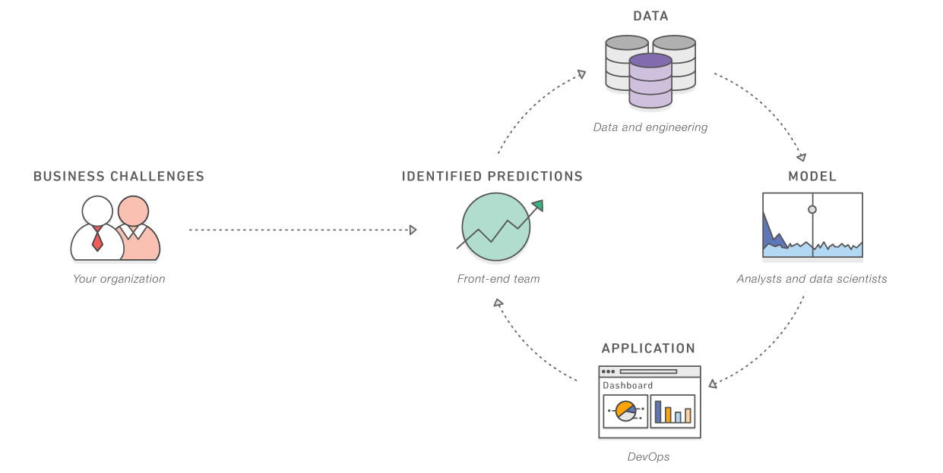

4.1.3 Amazon Alexa:
In recent years the use of voice-assistants has increased significantly with the advancement of voice technology. According to Statista, in 2019, the value of the global voice-assistant market was $11.9 billion and is estimated to increase to $35.5 billion by 2025 (Vailshery, 2021). Today, Apple’s Siri, Amazon Alexa, Google Assistant, and Samsung Bixby are some of the most popular and used voice-assistants in the world. A recent survey by Statista shows that 52% of the people prefer using a voice-assistant rather than a website to search for information as voice-assistants were more convenient for them (Statista, 2021). Another report indicated that 48% people use voice-assistants as it allows them to multitask and work hands-free.
Amazon Alexa is one of the first virtual voice-assistant that was small in size and could be use at home. When the technology started coming together, Amazon realised that Alexa can be beneficial to their other products, such as: Amazon Prime, Amazon music, personalised product recommendation, etc. (Zwakman, Pal and Arpnikanondt, 2021).

4.1.4 Amazon Go:
Amazon opened their first Amazon Go store on January the 22, 2018 which looked like any other ordinary supermarket with similar range of products on the shelves. The only visible difference was that there are no cashiers or cash desks (Gershgorn, 2018). Amazon tracks customer shopping activities and trends from their collected data using ML tool. The ML team constantly works to improve Amazon Go experience (Türegün, 2019).
The aim of Amazon Go is for the customers to spend as little time as possible to do shopping. There is no need to stand in a line at checkout in Amazon Go. On the outside, everything looks the same as any other supermarket, the shelves are filled with goods and people can just pick up whatever they want to buy. Inside the shop there are a few employees to do different things. One of them welcomes the visitors, one of them checks the goods to the receipts so that there is no mistake with the price, some of them are constantly making sure that the shelves have the right goods, some of them prepare fresh products in the kitchen. The customers just need to install the Amazon Go App and register, put their shopping in the cart and then just get out without stopping at the checkout (Reuters, 2018). Payments are made automatically through the app.

5.1 Recommendation:
- Amazon needs to protect their customer data and sellers data and privacy more attentively by using strict cybersecurity.
- They can update their security system so that they are less vulnerable to cyber-crime.
- The need to improve their data storing system and their cloud system to secure privacy.
- They should increase their investment for new technological innovations and services.
- Amazon has a massive number of third-party sellers. It can be a little more selective to ensure the quality of goods sold by these sellers.
- Amazon can attract more companies and third-party sellers by their Seller Education Channel on you Tube.
- They need to focus more on building strong review and feedback system.
- Build an advertising strategy by placing sponsored product ads in the search result.
- Open more Amazon go stores.

6.1 Conclusion:
Artificial Intelligence and technology are the future tools for ensuring success for a company. Big organisations are investing for innovating new products and services. Adapting to technology and AI is a must for survival of a company. Amazon is mainly based online; they are leader of online retail companies. They are regularly bringing out innovation in products and services. Sometimes they face some challenges but with their innovative ways and ML tools, they can overcome these challenges without much struggle.

Reference list:
- Amazon Web Services, Inc. 2021. What is Artificial Intelligence (AI)? — Amazon Web Services. [online] Available at: <https://aws.amazon.com/machine-learning/what-is-ai/> [Accessed 30 November 2021].
- Amazon Web Services, Inc. 2021. What is Artificial Intelligence (AI)? — Amazon Web Services. [online] Available at: <https://aws.amazon.com/machine-learning/what-is-ai/> [Accessed 30 November 2021].
- Cao, G., Duan, Y., Edwards, J.S. and Dwivedi, Y.K. (2021). Understanding managers’ attitudes and behavioral intentions towards using artificial intelligence for organizational decision-making. Technovation, 106, p.102312.
- Coppola, D., 2021. Amazon quarterly net revenue 2007-2021 | Statista. [online] Statista. Available at: <https://www.statista.com/statistics/273963/quarterly-revenue-of-amazoncom/> [Accessed 30 November 2021].
- Davenport, T., Guha, A., Grewal, D., & Bressgott, T. (2019). How artificial intelligence will change the future of marketing. Journal of the Academy of Marketing Science. https://doi.org/10.1007/s11747-019-00696-0.
- Feldman, D., 2019. Netflix’s Dominance In U.S. Wanes As Hulu, Amazon Gain Subscribers. Forbes, [online] Available at: <https://www.forbes.com/sites/danafeldman/2019/08/21/netflix-is-expected-to-lose-us-share-as-rivals-gain/?sh=75951a9b66d6> [Accessed 30 November 2021].
- Gershgorn, D. (2018). Amazon's AI-powered grocery store is openingto the public tomorrow. Retrieved from https://qz.com/1184978/amazon-gos-ai-powered-grocery-store-is-opening-to-the-public-in-seattle-tomorrow/
- Gupta, S., Leszkiewicz, A., Kumar, V., Bijmolt, T. and Potapov, D. (2020). Digital Analytics: Modeling for Insights and New Methods. Journal of Interactive Marketing, 51, pp.26–43.
- Kumar, P., Dwivedi, Y. K., & Anand, A. (2021). Responsible artificial intelligence (AI) for value formation and market performance in healthcare: The mediating role of patient’s cognitive engagement. Information Systems Frontiers, 1–24. https://doi.org/10.1007/s10796-021-10136-6
- Leggett, T. (2021). Amazon hit with $886m fine for alleged data law breach. BBC News. [online] 30 Jul. Available at: https://www.bbc.co.uk/news/business-58024116 [Accessed 30 Nov. 2021].
- Libai, B., Bart, Y., Gensler, S., Hofacker, C.F., Kaplan, A., Kötterheinrich, K. and Kroll, E.B. (2020). Brave New World? On AI and the Management of Customer Relationships. Journal of Interactive Marketing, 51.
- Lu, H., Li, Y., Chen, M., Kim, H. and Serikawa, S., 2017. Brain Intelligence: Go beyond Artificial Intelligence. Mobile Networks and Applications, 23(2), pp.368-375.
- Morgan, B., 2018. How Amazon Has Reorganized Around Artificial Intelligence And Machine Learning. Forbes, [online] Available at: <https://www.forbes.com/sites/blakemorgan/2018/07/16/how-amazon-has-re-organized-around-artificial-intelligence-and-machine-learning/?sh=1566844d7361> [Accessed 30 November 2021].
- Mustak, M., Salminen, J., Pl´e, L., & Wirtz, J. (2021). Artificial intelligence in marketing: Topic modeling, scientometric analysis, and research agenda. Journal of Business Research, 124, 389–404. https://doi.org/10.1016/j.jbusres.2020.10.044.
- Rankingthebrands.com. 2021. Top 100. [online] Available at: <https://www.rankingthebrands.com/PDF/Interbrand%20Best%20Global%20Brands%202021.pdf> [Accessed 30 November 2021].
- Reuters, T. (2018). Amazon's 1st high-tech grocery store opens to thepublic. Retrieved from https://www.cbc.ca/news/technology/amazon-go-grocery-store-1.4497862
- Rossman, J. and Euchner, J. (2018). Innovation the Amazon Way. Research-Technology Management, 61(1), pp.13–22.
- Rust, R.T. (2019). The future of marketing. International Journal of Research in Marketing, 37(1).
- Rust, R.T. and Huang, M.-H. (2014). The Service Revolution and the Transformation of Marketing Science. Marketing Science, 33(2), pp.206–221.
- Smithers, R., 2020. Amazon launches 'eco-friendly' shopping platform. The Guardian, [online] Available at: https://www.theguardian.com/technology/2020/oct/27/amazon-launches-eco-friendly-shopping-platform [Accessed 25 November 2021].
- Statista, “Smart Speaker Market Value Worldwide 2014–2025,” [Online]. https://www.statista.com/statistics/1022823/worldwidesmart-speaker-market-revenue/, Accessed 8 Sep 2020.
- Thomas, D., 2021. Amazon to pay out over defective third party goods. BBC News, [online] Available at: <https://www.bbc.co.uk/news/business-58163915> [Accessed 30 November 2021].
- Türegün, N., 2019. Impact of technology in financial reporting: The case of Amazon Go. Journal of Corporate Accounting & Finance, 30(3), pp.90-95.
- Vailshery, L., 2021. Smart speaker global market revenue 2014-2025 | Statista. [online] Statista. Available at: <https://www.statista.com/statistics/1022823/worldwide-smart-speaker-market-revenue/> [Accessed 30 November 2021].
- Vlaˇci´c, B., Corbo, L., Costa e Silva, S., & Dabi´c, M. (2021). The evolving role of artificial intelligence in marketing: A review and research agenda. Journal of Business Research, 128, 187–203. https://doi.org/10.1016/j.jbusres.2021.01.055.
- Zwakman, D., Pal, D. and Arpnikanondt, C., 2021. Usability Evaluation of Artificial Intelligence-Based Voice Assistants: The Case of Amazon Alexa. SN Computer Science, 2(1).

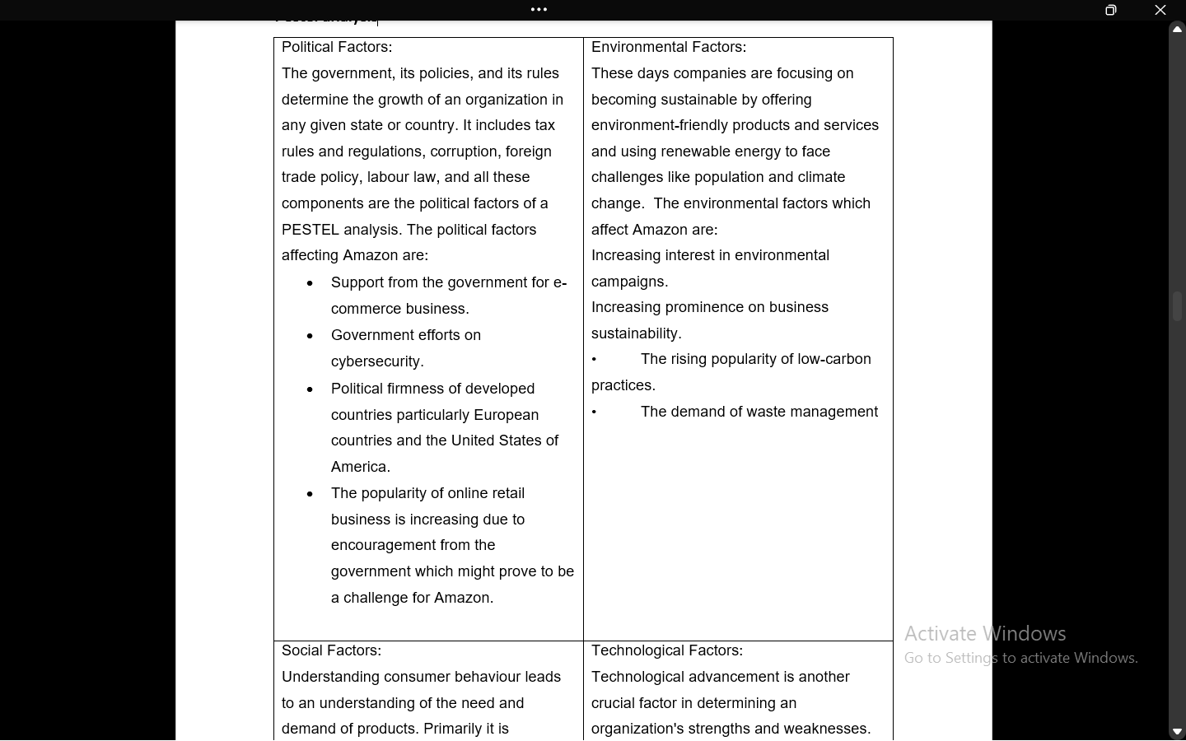

Appendix A

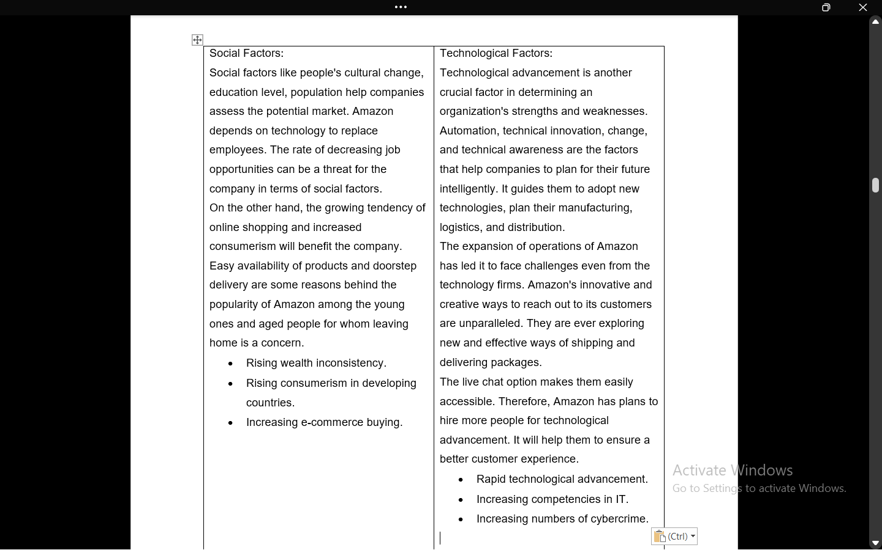

Appendix B

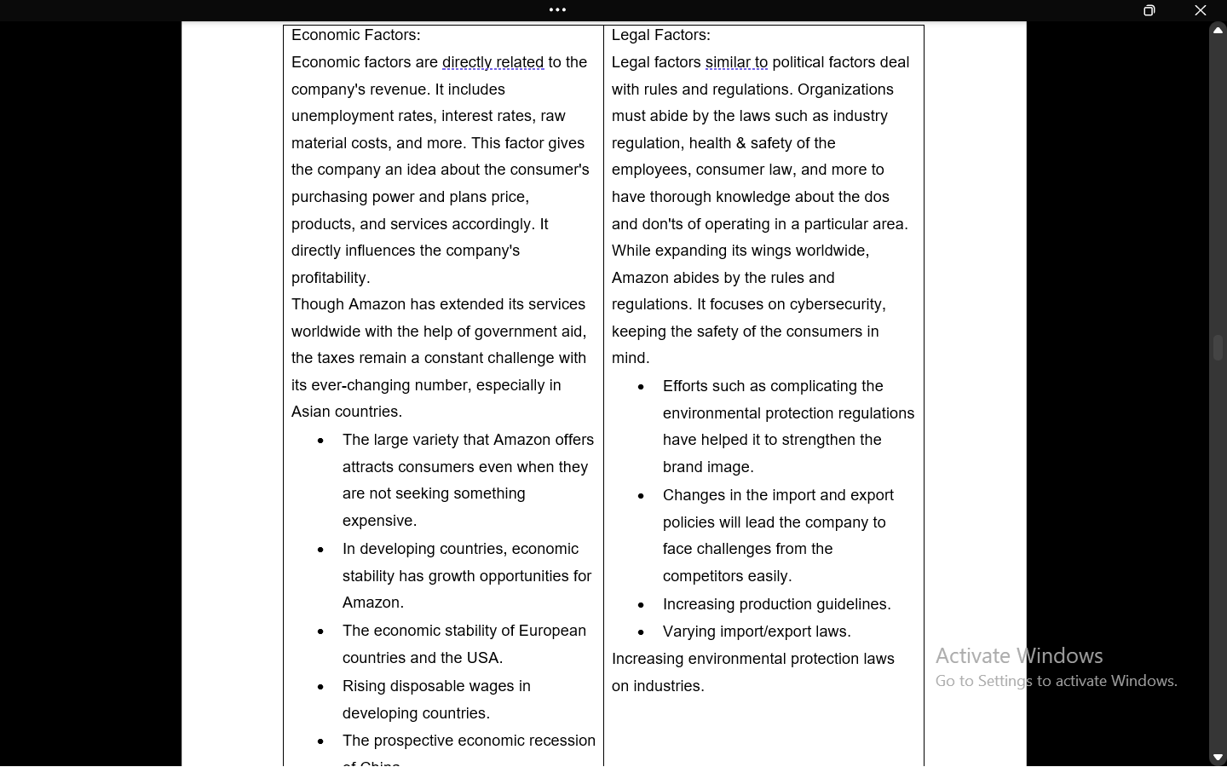

Appendix C

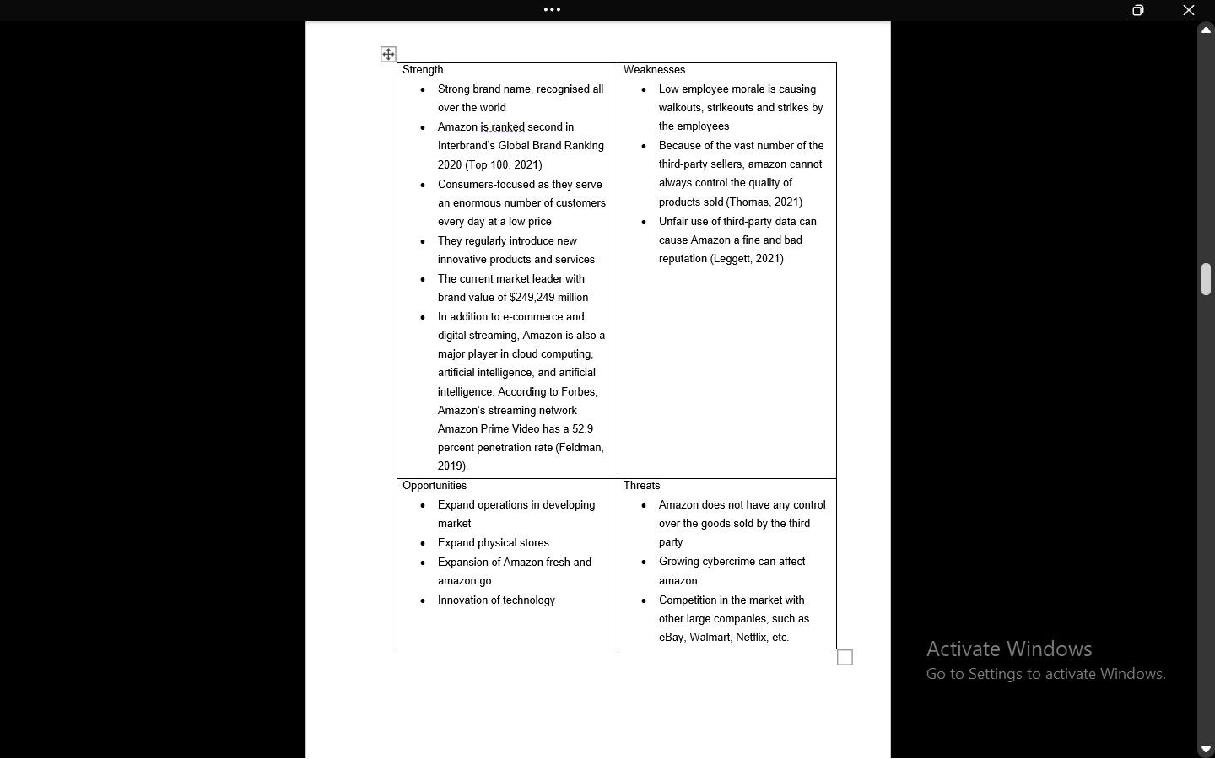

Appendix D

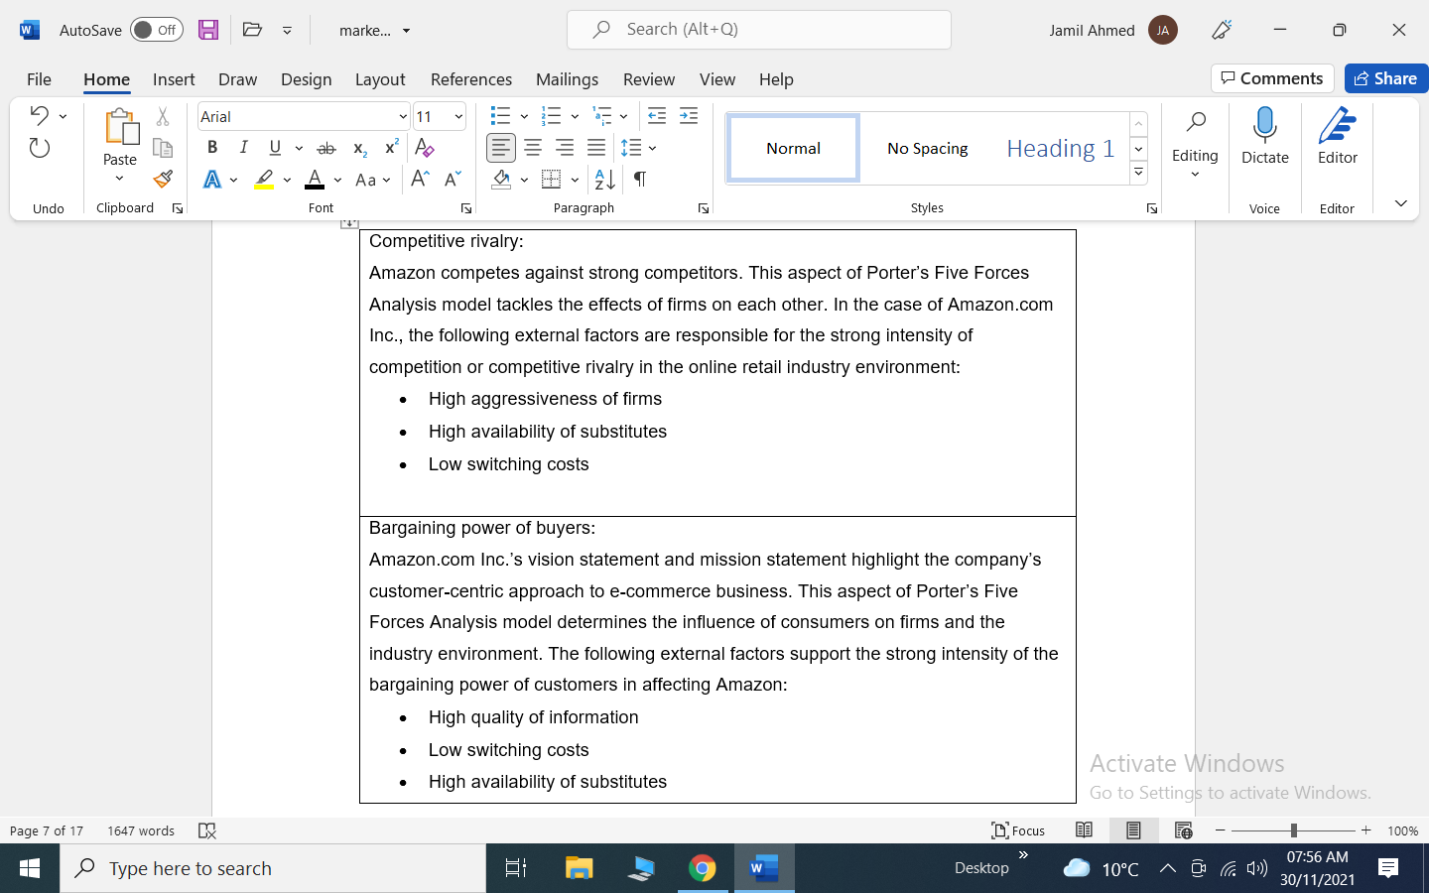

Appendix E

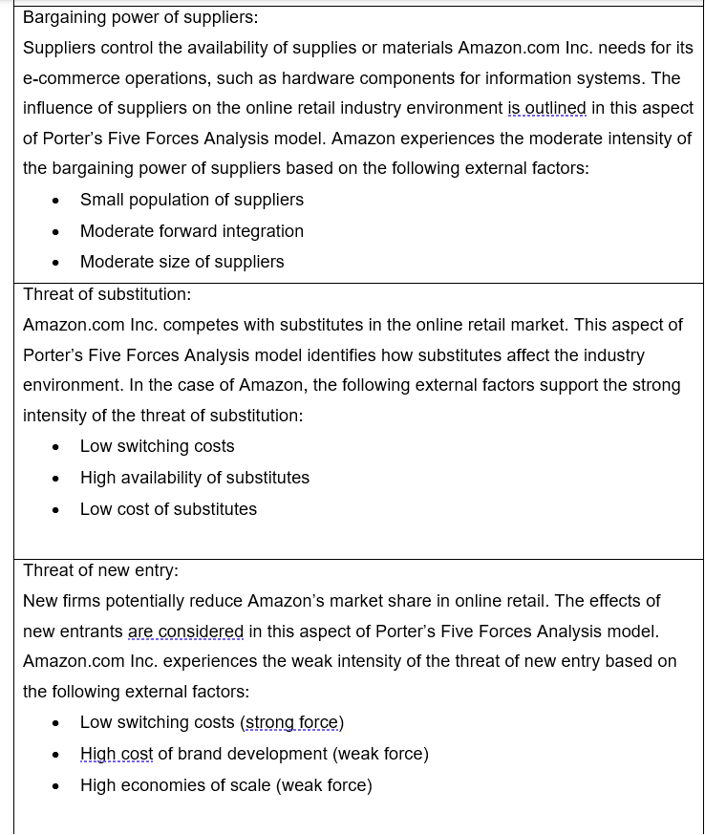

Appendix F

