UNIVERSITY OF WALES TRINITY SAINT DAVID



A New Approach to Performance Management

NAME | Cheah Jia Hui
STUDENT ID | 1903 885
LECTURER | Julie Hayward
SUBJECT | M6X00873 Contemporary Human Resource in Practice

Executive Summary
This report is written for the upper management team to address the need for the current annual performance appraisal in practised in the organisation to change to a more modern approach. Research and many influential companies have revealed that traditional performance management lacks the ability to promote employee engagement, which is essential for better and improved performance. The business environment has changed rapidly since the first application of annual performance appraisal, it does not make sense for employees to be managed the same way.

It is found that after extensive research that the conventional annual appraisal method gives feedback too infrequently. Work issues brought up in annual meetings are too late to be discussed and backwards-looking. To avoid conflicts, ratings given by managers to employees are too generic to promote improvements. Data collected from ratings can be inconsistent and subjective as it is prone to raters’ bias. The forced rankings that come with ratings increase stress and turnover rates. Overall, this conventional approach is shown to deliver little positive performance results. To combat this problem, a more modern performance management approach is suggested to increase employee engagement. Suggestions include more frequent check-ins that provide developmental coaching, using technological platforms to provide real-time feedback, practice forward-looking discussions and rate only what matters. Kubler Ross’ change curve is used as a reference to ease the change management process. It is recommended that communication and feedback are important throughout the whole process. Implement the change gradually to reduce resistance and show progress made so results and effort can be seen.
Table of Contents
1. Introduction 1

2. Main Body 2
2.1 What is Performance Appraisal? 2
2.2 Problems with Traditional Performance Appraisal 3
2.3 The Modern Approach to Performance Management 6

3. Conclusion 10
3.1 Recommendation 10

4. References 12

1. Introduction
In the 21st century where the phenomenon of machines and AI replacing number of manufacturing, transactional and repetitive jobs is no surprise (MGI, 2013), fewer people are willing to work as blue-collar workers (McGrath, 2014; Elvery, 2019; Wolf and Chiripanhura, 2019). Alternatively, many people are gravitating towards being what some authors begin to call ‘learning workers’ (Hart, 2015; Jain, 2016; Morgan, 2016a). These workers create value to organisations by creatively and innovatively apply learnings to changing circumstances (Morgan, 2016b; Brown, 2017), helping organisations steer through the business environment that is increasingly volatile, uncertain, complicated and ambiguous due to megatrends like changing demographics and new behaviours (Bennett and Lemoine, 2014; Kraaijenbrink, 2018).

With the environment changing, it makes sense for employees to be managed in a different way (Watts and Kane, 2016). Latham (2015), Bailey et al. (2015), and Bridger (2018) suggest that in order for employees to willingly go the extra mile in providing better work performance, engagement is important. Many authors have criticised the annual appraisal process as ineffective in raising employee engagement and commitment and suggest a need for change (Reviewsnap, 2015; Ryan, 2016; Ewenstein, Hancock and Komm, 2016). Big companies like GE, Adobe, Microsoft, and Netflix claim the ranking and annual feedback system in traditional performance management as incompetent in raising performance and is already practising a new method in managing performance (Wingfield, 2013; McCord, 2014; Nisen, 2015a; Meinert, 2015). This change is expected as the way employees work now is different than how it was decades ago.

According to CEB, in a year, an average manager is estimated to spend more than 200 hours on activities related to performance appraisals. With these hours of effort combined with the cost of the performance-management technology itself, an organisation with around 10,000 employees is expected to spend roughly US$35 million per year to conduct appraisals (Rock, Jones and Davis, 2014; Cunningham, 2015; Wilkie, 2015). It is a lot of time and money invested in a system that is said to deliver little results. This report, prepared for the upper management team, outlines the reasons why there is a need to change from the current traditional performance management in the organisation to a more up-to-date approach to avoid resource-wastage. Recommendations will then be given on how the transition can be successfully achieved with reference to change management techniques.

2. Main Body

2.1 What is Performance Appraisal?
Before addressing the problems with the traditional performance appraisal system, it would be best to first understand what it is and why companies are practising it. The first industrial use of a performance appraisal can be traced back to the ‘80s in Robert Owen’s New Lanark Textile Mills where levels of employee performance were indicated by coloured blocks placed on workers’ desks to show how well they performed (Grint, 1993, pp.61-77; Bayon, 2013; Cappelli and Conyon, 2017, pp.88-116). Over the years, performance appraisal gradually became an annual practice used in managing employee performance across different companies and the idea is still taught in business schools after all these years, regardless of how much has changed in the business environment.

According to Armstrong (2000, pp. 10-12) and Griffin and Ebert (2004, p. 216), performance appraisal, also known as performance review is defined as the formal evaluation and rating of employees customarily done by managers to determine how well an employee has performed. Though the term is often used synonymously with performance management, it is crucial to note that they differ. Traditionally, performance appraisal is referred to as performance management itself but now, it is commonly referred to as a part of the performance management process (Bersin, 2009; Chrisos, 2019). The most common practice in conventional performance management is to have one formal review annually (Tavis and Cappelli, 2016; Armstrong, 2018, pp.70-77). Many descriptions can be found on what generally happens in a typical performance appraisal by different authors but when examined closely, most descriptions seem to have the common elements listed as shown in figure 2.1 below.
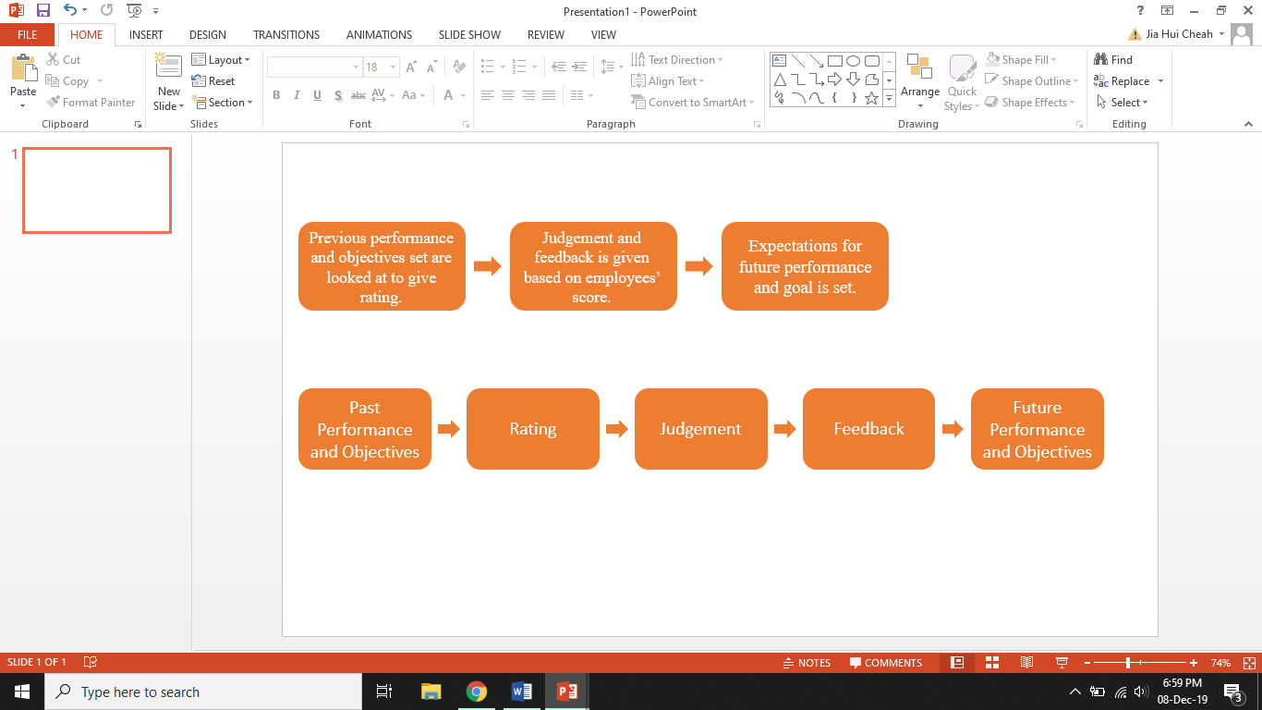
Figure 2. 1 Links in the performance appraisal chain (CIPD, 2016).

Krishnan, Ahmad and Haron (2018) define performance appraisal as a developmental platform to address individuals’ strengths and weaknesses. It intends to ensure employees’ performance is on par with business goals through assigning objectives at the beginning of the year (Juneja, n.d; Agunis, 2009; CIPD, 2019). Doing so gives employees a sense of responsibility and gives them a direction as to where they should be heading. Achievements are rewarded and downfalls are taken note of to improved on during the annual meeting so better performance can be expected in the future (Fajana, 1997; Atiomo, 2000). Organisations also use performance appraisal for various administrative purposes like validating promotion, demotion and layoff issues, and determining pay (Iqbal, 2012, pp. 41-63; CIPD, 2019). This is why organisations are still practising performance management (Hearn, 2018; Reh, 2019).

However, as time goes by many scholars are doubting the effectiveness of annual performance appraisals and recommend a need for evolution (Meinert, 2015; Ewenstein, Hancock and Komm, 2016; Kostopoulos, 2018). It makes little sense for employees to be managed the same way when the working environment is constantly changing. A small survey was done by CIPD in 2015 looking at HR and senior business leaders’ views on the effectiveness of annual appraisals. It is identified that 55% of HR leaders and 73% of senior business leaders who conducts annual appraisal in their company claim the annual process as ineffective (CIPD, 2016). In 2016, Accenture, joining Adobe, Microsoft, and Deloitte disbanded rankings and the once-a-year evaluation process as it did not drive better performance among employees (Nisen, 2015a; Cunningham, 2015). In 2019, Gartner Performance Management Benchmarking Survey showed that 81% of HR leaders are making changes to performance management (Wiles, 2019). It can be observed that change is definitely happening.

2.2 Problems with Traditional Performance Appraisal
The organisation practices a traditional approach to performance management whereby an appraisal is done annually. It measures six different performance criteria and gives an overall performance rating. All of these are rated using a five-level rating scale from 1 being ‘well below standards’ to 5 being ‘well above standards’. Some problems with this conventional approach can be identified, which are:

- Infrequent Feedback
The emphasis on a once-a-year appraisal process tends to focus all feedback to one point, discouraging frequent conversations and updates that truly promote improvements (Nisen, 2015b). It gives little time for managers to really analyse employee performance when everything that happened in the last 12 months is cramped into one meeting, leading to information gaps (Lavoie, 2016). Recent events may overshadow earlier shortcomings or achievements. Feedback given will also matter less to employees as it is not given in a timely manner, making it hard to correct performance issues or to encourage good performance (Sullivan, 2011). In the traditional performance management, goals are usually set at the beginning of the year with little consideration as to the possible obstacles that may arise due to changing circumstances. It reduces the probability for goals set to be achieved by the end of the year which affect employees’ ratings, further demotivating them in the future (Baker, 2019).

- Backwards Looking
As mentioned earlier, how employees did in the past year is usually discussed and rated during the appraisal meeting. In a survey done by TINYpulse, 12% of managers and 10% of employees questioned said work issues were discussed too late and those discussions provide little value (Wang, 2016). What happened in the past cannot be changed but the future can be fixed through sending employees for training and development. It is a waste of time as the time spent on justifying employee performance rating could have been utilised to enhance future results through determining skills and competencies to be developed (Meinert, 2015; Ewenstein, Hancock and Komm, 2016; Heathfield, 2019a).

- Ratings are Too Generic
To avoid confrontations, some managers prefer giving ‘above average’ ratings or give everyone the same ratings. Some managers even provide feedback that is vague and generic in order to not offend anyone, making it impossible for employees to learn from their mistakes and takes away the opportunity for employees to enhance their career paths (Nandish, 2015). The five-level rating scale that the organisation practices do not point out employees’ strengths and weaknesses well enough. Performance is more than just between ‘well below standards’ to ‘well above standards’ (Adler et al., 2016). Significant incidents, clear examples of positive and negative behaviours have to be addressed to employees to make the most out of the whole performance management process.
- Raters Bias
In the organisation, managers are to rate employees based on 6 skills from meeting deadlines/commitments to product/technical knowledge. While one can easily measure if employees have met the deadline set, employees’ product/technical knowledge is a subjective matter and is hard to measure as one can never have all the knowledge in the world. Managers may rate this aspect based on his/her own product/technical knowledge and compare employees with the perceived rating of themselves. This is identified as the idiosyncratic rater effect (Buckingham, 2015). Data produced when assessing someone’s skills will also be inconsistent depending on who rates it (Goodall and Buckingham, 2015a). What one person sees as a good grasp in product/technical knowledge may be different than others (London, 2001).

- Forced Ranking
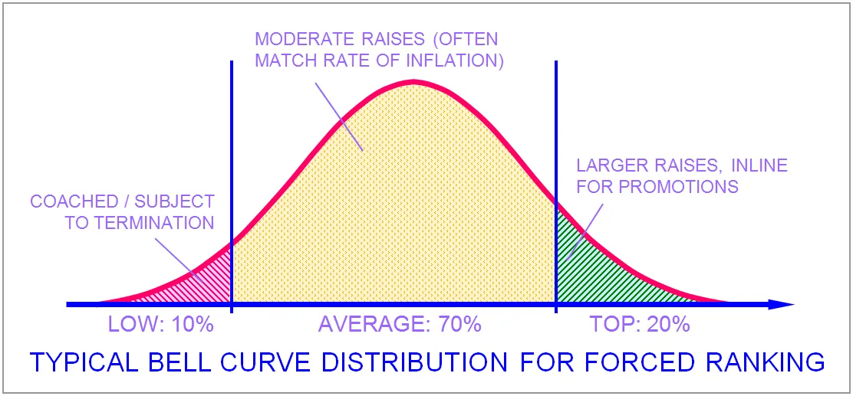
Figure 2. 2: Typical Bell Curve Distribution for Forced Ranking (Haak, 2018).

Forced ranking is the distribution of employees on a curve (see above) based on their ratings given by managers to differentiate between top and low performers (Bersin, 2014). Employees are labelled and ranked against each other, then told where they stand with promotions and bonuses on the line (Rock, Jones and Davis, 2014). In order for someone to be moved to a higher category, someone else must be moved out and this adds to increased stress and creates a toxic workplace (Colvin, 2015). It is also not a good performance measurement as employees can be forced down to the low performing category even though they are doing fairly well just to fit into the bell curve. In 2013, Microsoft killed its forced ranking after decades of use when they realise that it increases employee turnover rate (Brustein, 2013). It inadequately rewards high performers, neglects to motivate average workers, and stresses low performers (Deloitte, 2014). It is helpful if organisations are planning to restructure but shows negative effects if done annually.

2.3 The Modern Approach to Performance Management
To combat the problems associated with traditional performance appraisal and to increase employee engagement and motivation, the organisation can acquire the methods below:

- More Check-ins
With consistent check-ins be it quarterly, monthly or weekly, thoughts can be exchanged right there and then between managers and employees (Wilkie, 2015; Watts and Kane, 2016). Challenges surfaced can be informed to managers immediately rather than waiting until the annual performance appraisal meeting, making it too late to fix any problems that occurred. Also, frequent feedback provides employees with personal development coaching. It helps improve employees ability to perform and allows them to focus on their goals, while at the same time let managers communicate their expectations for employees outcomes clearer (Heathfield, 2019a). Doing this also takes away the anxiety and stress one gets from review meetings being too formal and awkward (Allan, 2018).

Instead of spending time on the administrative side of performance appraisal like filling review forms, more time can be spent on higher-value activities like ongoing informal feedback, which promotes communication that tightens workplace relationships (Wilkie, 2015). High-profile organisations like Accenture, Netflix, Adobe, GE and Microsoft are already leaning towards a much more regular coaching-type conversations (Duggan, 2017a). In kCura, monthly performance coaching is encouraged and internal data shows frequent coaching increases both employee satisfaction and engagement (Duggan, 2017b). Engagement is defined as when someone feels involved, enthusiastic, and empowered and expresses these feelings when working (Mone and London, 2018, p. 4). A research done by Engage for Success has found that with regular check-ins, it increases employee engagement and this contributes positively to organisations as shown in table 2.1 below.
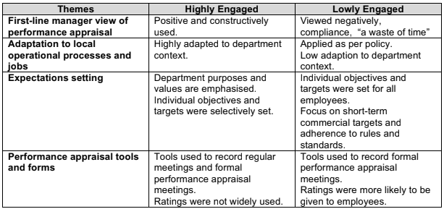
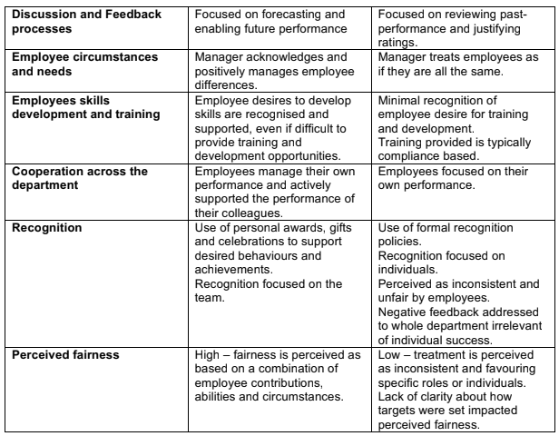
Table 2.1: Differences in the conduct of performance appraisal by line-managers in
highly and lowly engaged departments (Boot et. al, 2014).
- Make Use of Other Platforms for Feedback
When talking about giving feedback, it is commonly assumed that the parties involved will have to be at a set time and place. However, as technology advances, that will not be necessary as other platforms like email, intranet and instant text messaging can be utilised. In Marriott and GE, apps are used to give real-time performance feedback on how employees are performing (Nisen, 2015b; Emily, 2019). This encourages employee engagement since people are so used to getting an instant response in their daily lives thanks to mobile devices making communication so easily accessible (Muther, 2016; Ernst & Young, 2018). Having instant feedback also puts people in a position to correct themselves on the spot.

- Practice Forward-Looking Performance Discussions
Gartner research found that the focus on making performance appraisals forward-looking increases employee performance by 13% (Baker, 2019). It allows managers and employees to look ahead and think of solutions rather than focusing on past failings. There might be a possibility that employees are not performing well because the work assigned to them is not of their interest or within their capabilities. Two-way communication has to be practised during performance reviews so employees’ wants and needs can be paid attention to, not just concentrating on what the managers expect from employees. Employees should be able to collaborate with management on goal-setting so that skills needed to bring out their work potential can be developed (Lavoie, 2016). Motivation can be associated with having good challenging goals that employees will work hard to aim for, combining with frequent check-ins to remind and recognise employees of their purpose and contribution (CIPD, 2017). Besides, it also gives employees a clear expectation of what managers want.

- Rate What Matters
By measuring what the organisation is measuring now for example how well employees did in determination or adaptability only determines what managers think of that individual. It provides little information as to how managers can work on developing employees capabilities (Goodall and Buckingham, 2015b). Ratings are important even though it risks managers being biased. In a CEB survey did with 9,000 participants across 18 countries, it is found that without ratings, employees performance dropped by 8%. It also gives a harder time for managers to justify promotions and pay rise, resulting in employees thinking that managers are unfair (McGregor, 2016). The same happened in Gartner’s survey, performance dropped when ratings are taken away (Wiles, 2019). Therefore, some sort of ratings is needed.

Instead of asking managers to rate employees’ skills, future actions to be taken with employees is asked to team leaders in Deloitte (Goodall and Buckingham, 2015b). Here, only four statements about team members are inquired - (1) overall performance and (2) ability to work with others are rated, then (3) performance problems and (4) employee work potential are identified through firstly answering a “yes or no” question regarding their career paths (McGregor, 2015). Doing this simplifies the rating process and allows both parties to come up with and attain valuable solutions and information useful for future improvements.

3. Conclusion
The business environment has changed rapidly since the first application of annual performance appraisal. What used to work in managing performance does not work anymore because of the changing nature of work. Employees now are said to be learning workers as opposed to blue-collar workers and in order for them to contribute better performance, work engagement is important. The traditional performance appraisal has been critiqued and criticised for being ineffective in doing so.

The conventional annual appraisal approach gives feedback too infrequently. It is backwards-looking and work issues brought up are too late to be discussed. To avoid conflicts, ratings given by managers to employees are too generic to promote improvements. Data collected from ratings can be inconsistent and subjective as it is prone to raters’ bias. The forced rankings that come with ratings increase stress and turnover rates.

A more modern performance management approach is suggested to increase employee engagement. Suggestions include more frequent check-ins that provide developmental coaching. With the rise of technology, apps can be used to provide real-time feedback. Forward-looking performance discussions are encouraged and ratings should be able to give results that can be used to develop employees.

3.1 Recommendation
When the modern method to performance management is introduced to the organisation, a change is happening and Kubler Ross states that people will experience these stages before they settle down (Connelly, 2018) as shown in the figure below.
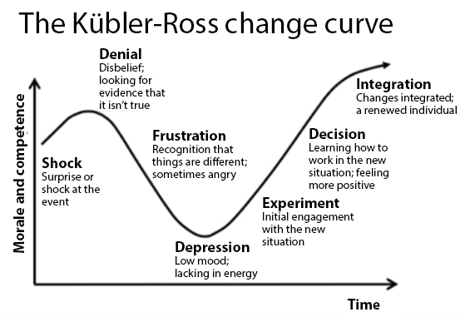
Figure 3. 1: Kubler-Ross change curve (Lee, 2017)

For the change to a new performance system to work, people have to be informed that a change is coming so they can be prepared for it to reduce the initial shock. Explain why the need to change to a new system is necessary and the benefits that come with it to decrease the denial for change to happen (Heathfield, 2019b). Take the time to ask employees what they think through a survey to include them in the change process. Answers should be given regarding the change if any questions were to arise. During the change, some people may be frustrated and even depressed. To avoid this from happening, changes should happen slowly (Aguirre, 2014). Rather than forcing managers to provide more feedback immediately, implement it gradually from annual to semi-annual to monthly basis. Once managers and employees are used to it, they can adopt the change quicker. Demonstrating progress made can also motivate the change so results can be seen. Once managers and employees sees that their effort in change has delivered positively, they will be more willing and adapt to the change (Sologar, Smith and Ewenstein, 2015).

4. References
Adler, S. et. al. (2016) Getting Rid of Performance Ratings: Genius or Folly? A Debate. Industrial and Organizational Psychology, 9(2), pp. 219-252.
Aguinis, H. (2009) Performance Management. 2nd ed. Malaysia: Pearson Education Malaysia, Pte. Ltd.
Aguirre, D. (2014) How to Lead Change Management. [Video] Available at: https://www.youtube.com/watch?v=PQ0doKfhecQ [Accessed 10 Jan. 2020].
Allan, L. (2018) What Is Wrong with Performance Appraisals?. Available at: https://www.hrheadquarters.ie/compensation-and-benefits/what-is-wrong-with-performance-appraisals/ [Accessed 3 Jan. 2020].
Armstrong, M. (2000) Performance Management: Key Strategies and Practical Guidelines. 2nd ed. London: Kogan Page, pp.10-12.
Armstrong, M (2018) Armstrong’s Handbook of Performance Management: An Evidence Guide to Developing High Performance. 6th ed. London: Kogan Page, pp.70-77.
Atiomo, A. C. (2000) Human Resource Management. Malthouse Management Science Books, Lagos.
Bailey, C. et al. (2015) The Meaning, Antecedents and Outcomes of Employee Engagement: A Narrative Synthesis. International Journal of Management Reviews, 19(1), pp.31-53.
Baker, M. (2019) 3 Ways to Improve Performance Management Conversations. Available at: https://www.gartner.com/smarterwithgartner/3-ways-to-improve-performance-management-conversations/ [Accessed 2 Jan. 2020].
Bayon, S. (2013) The Origin, Concept and Value of Performance Appraisal. International Journal of Economics, Commerce and Management. [Online] 1(2). Available at: http://ijecm.co.uk/wp-content/uploads/2014/01/1211.pdf [Accessed 10 Dec. 2019].
Bennett, N. and Lemoine, G. (2014) What VUCA Really Means for You. Available at: https://hbr.org/2014/01/what-vuca-really-means-for-you [Accessed 13 Dec. 2019].
Bersin, J. (2009) Performance Management is Management. Available at: https://joshbersin.com/2007/05/performance-managements-7-important-element/ [Accessed 10 Dec. 2019].
Bersin, J. (2014) The Myth Of The Bell Curve: Look For The Hyper-Performers. Available at: https://www.forbes.com/sites/joshbersin/2014/02/19/the-myth-of-the-bell-curve-look-for-the-hyper-performers/#267d6b1f6bca [Accessed 10 Jan. 2020].
Boot, G. et. al. (2014) Initial Findings from the Research Being Undertaken by the E4S Performance Management TAG. PhD. Cranfield University.
Bridger, E. (2018) Employee Engagement: a Practical Introduction. 2nd ed. HR Fundamentals. London: CIPD and Kogan Page.
Brown, M. (2017) ‘Learning Workers’ and The Need to Learn Continuously. Available at: https://magazine.vunela.com/learning-workers-and-the-need-to-learn-continuously-787234b2b1c2 [Accessed 12 Dec. 2019].
Brustein, J. (2013) Microsoft Kills Its Hated Stack Rankings. Available at: https://www.bloomberg.com/news/articles/2013-11-13/microsoft-kills-its-hated-stack-rankings-dot-does-anyone-do-employee-reviews-right [Accessed 10 Jan. 2020].
Buckingham, M. (2015) Most HR Data is Bad Data. Available at: https://hbr.org/2015/02/most-hr-data-is-bad-data [Accessed 10 Jan. 2020].
Cappelli, P. and Conyon, M. (2017) What Do Performance Appraisals Do?. ILR Review, 71(1), pp.88-116.
Chrisos, M. (2019) Performance Management and Performance Appraisal: Defining the Difference. Available at: https://www.techfunnel.com/hr-tech/performance-management-and-performance-appraisal-defining-the-difference/ [Accessed 9 Dec. 2019].
CIPD (2016) Could do better? Assessing what works in performance management. [Online] Available at: https://www.cipd.co.uk/Images/could-do-better_2016-assessing-what-works-in-performance-management_tcm18-16874.pdf [Accessed 27 Dec. 2019].
CIPD (2016) Rapid Evidence Assessment of the Research Literature on the Effect of Performance Appraisal on Workplace Performance. [Online] CIPD. Available at: https://www.cipd.co.uk/Images/rapid-evidence-assessment-of-the-research-literature-on-the-effect-of-performance-appraisal-on-workplace-performance_tcm18-16902.pdf [Accessed 4 Dec. 2019].
CIPD (2017) Strengths in Numbers. What's New in Performance Management. [Podcast] Available at: https://www.cipd.co.uk/podcasts/performance-management [Accessed 10 Jan. 2020].
CIPD (2019) Performance Reviews: Understand the Basics of Performance Reviews and How to Ensure the Process Adds Value to the Organisation. Available at: https://www.cipd.co.uk/knowledge/fundamentals/people/performance/appraisals-factsheet [Accessed 4 Dec. 2019].
Colvin, G. (2015) Microsoft and Dell are Ditching Employee Performance Reviews. Available at: https://www.strategy-business.com/article/00275?gko=c442b [Accessed 10 Jan. 2020].
Connelly, M. (2018) Kubler-Ross Five Stage Model. Available at: https://www.change-management-coach.com/kubler-ross.html [Accessed 10 Jan. 2020].
Cunningham, L. (2015) In Big Move, Accenture Will Get Rid of Annual Performance Reviews and Rankings. Available at: https://www.washingtonpost.com/news/on-leadership/wp/2015/07/21/in-big-move-accenture-will-get-rid-of-annual-performance-reviews-and-rankings/?arc404=true [Accessed 30 Dec. 2019].
Deloitte (2014) It’s Official: Forced Ranking Is Dead. Available at: https://deloitte.wsj.com/cio/2014/06/10/its-official-forced-ranking-is-dead/ [Accessed 10 Jan. 2020].
Duggan, K. (2017a) Six Companies That Are Redefining Performance Management. Available at: https://www.fastcompany.com/3054547/six-companies-that-are-redefining-performance-management [Accessed 3 Jan. 2020].
Duggan, K. (2017b) How Workplace Feedback Is Changing (And How Technology Can Play A Role). Available at: https://www.forbes.com/sites/forbestechcouncil/2017/04/07/how-workplace-feedback-is-changing-and-how-technology-can-play-a-role/#477268dd2dd0 [Accessed 2 Jan. 2020].
E. Watts and H. Kane (2016) 5 Alternatives to the Annual Performance Review. [video] Available at: https://www.youtube.com/watch?time_continue=272&v=NDeq3kn4T4E&feature=emb_title [Accessed 11 Dec. 2019].
Elvery, J. (2019) Changes in the Occupational Structure of the United States: 1860 to 2015. Economic Commentary (Federal Reserve Bank of Cleveland), pp.1-8.
Emily. (2019) Talk at the University of Wales Trinity Saint David, Swansea, 14 Nov.
Ewenstein, B., Hancock, B. and Komm, A. (2016) Ahead of the Curve: The Future of Performance Management. Available at: https://www.mckinsey.com/business-functions/organization/our-insights/ahead-of-the-curve-the-future-of-performance-management [Accessed 5 Dec. 2019].
Fajana, S. (1997) Human Resources Management. Labofin and Company, Lagos.
Goodall, A. and Buckingham, M. (2015b) Reinventing Performance Management. Available at: https://hbr.org/2015/04/reinventing-performance-management [Accessed 10 Jan. 2020].
Goodall, A and Buckingham, M. (2015a) How One Company Is Rethinking Peer Feedback and the Annual Review, and Trying to Design a System to Fuel Improvement. Reinventing Performance Management, [Online] pp.43-44. Available at: http://web.vdw.co.za/sara/file%20storage/Documents/2015/Reinventing%20Performance%20Management%20-%20HBR%20APR%2015.pdf [Accessed 7 Jan. 2020].
Griffin, R. and Ebert, R. J. (2004) Business Essentials. London: Prentice Hall, p. 216.
Grint, K. (1993) What Wrong with Performance Appraisals? A Critique and a Suggestion. Human Resource Management Journal, Vol. 3, No.3, pp.61-77.
Haak, T. (2018) The HR Canon. Available at: https://hrtrendinstitute.com/2018/11/12/the-hr-canon-a-sneak-preview/ [Accessed 10 Jan. 2020].
Hart, J. (2015). From “Knowledge Worker” to “Learning Worker”: What This Means For an Organisation – Learning in the Modern Workplace. Available at: https://www.c4lpt.co.uk/blog/2015/05/04/from-knowledge-worker-to-learning-worker/ [Accessed 12 Dec. 2019].
Hearn, S. (2018) Why is Performance Management Important?. Available at: https://www.clearreview.com/why-performance-management-important/ [Accessed 9 Jan. 2020].
Heathfield, S. (2019) How to Communicate to Facilitate Change in Employee Actions. Available at: https://www.thebalancecareers.com/communication-in-change-management-1917805 [Accessed 10 Jan. 2020].
Heathfield, S. (2019a) 4 Problems With Performance Appraisals: Where Do Managers Go Wrong?. Available at: https://www.thebalancecareers.com/performance-appraisal-problems-1918857 [Accessed 31 Dec. 2019].
Iqbal, M. (2012) Expanded Dimensions of The Purposes and Uses of Performance Appraisal. Asian Academy of Management Journal, Vol. 17, No. 1, pp. 41–63.
Jain, A. (2016). From “Knowledge Worker” to “Learning worker. Available at: https://medium.com/evc-ventures/from-knowledge-worker-to-learning-worker-what-you-seek-from-your-team-may-be-all-wrong-d7fd2590d4d7 [Accessed 12 Dec. 2019].
Juneja, P. (n.d.) Performance Appraisal - Meaning, Objectives and Advantages. Available at: https://www.managementstudyguide.com/performance-appraisal.htm [Accessed 9 Dec. 2019].
Kostopoulos, T. (2018) Performance Reviews Are Dead. Here's What You Should Do Instead. Available at: https://www.inc.com/thomas-koulopoulos/performance-reviews-are-dead-heres-what-you-should-do-instead.html [Accessed 7 Dec. 2019].
Kraaijenbrink, J. (2018) What Does VUCA Really Mean?. Available at: https://www.forbes.com/sites/jeroenkraaijenbrink/2018/12/19/what-does-vuca-really-mean/#4fe0b3fa17d6 [Accessed 13 Dec. 2019].
Krishnan, R., Ahmad, N. and Haron, H. (2018) The Effect of Employees’ Perceived Fairness of Performance Appraisal Systems on Employees’ Organizational Commitment. International Journal of Academic Research in Business and Social Sciences, 8(3).
Latham, A. (2015) 10 Reasons Your Employee Engagement Program Is Hurting Your Company. Available at: https://www.forbes.com/sites/annlatham/2015/11/01/10-reasons-your-employee-engagement-program-is-hurting-your-company/#7af23676235d [Accessed 13 Dec. 2019].
Lavoie, A. (2016) 3 Ways in Which Annual Performance Evaluations Fail Your Team. Available at: https://www.entrepreneur.com/article/272700 [Accessed 26 Dec. 2019].
Lee, M. (2017). 7 Stages Of Grieving The End Of A Relationship. Available at: https://www.huffingtonpost.com/entry/7-stages-of-grieving-the-end-of-a-relationship-and_us_57c3d80fe4b06384eb40b8e3 [Accessed 10 Jan. 2020].
London, M. (2001) How people evaluate others in organizations. Mahwah, N.J. Lawrence Erlbaum.
McCord, P. (2014) How Netflix Reinvented HR. Available at: https://hbr.org/2014/01/how-netflix-reinvented-hr [Accessed 5 Dec. 2019].
McGrath, R. (2014) Management’s Three Eras: A Brief History. Available at: https://hbr.org/2014/07/managements-three-eras-a-brief-history [Accessed 11 Dec. 2019].
McGregor, J. (2015) What If You Could Replace Performance Evaluations With Four Simple Question?. Available at: https://www.washingtonpost.com/news/on-leadership/wp/2015/03/17/deloitte-ditches-performance-rankings-and-instead-will-ask-four-simple-questions/ [Accessed 10 Jan. 2020].
McGregor, J. (2016) Firms Ditching Performance Reviews, But There's No Obvious Successor Yet. Available at: https://www.pressreader.com/usa/the-washington-post/20160608/281878707641582 [Accessed 10 Jan. 2020].
Meinert, D. (2015) Is It Time to Put the Performance Review on a PIP?. Available at: https://www.shrm.org/hr-today/news/hr-magazine/Pages/0415-qualitative-performance-reviews.aspx [Accessed 6 Dec. 2019].
MGI (2013) Disruptive technologies: Advances that will transform life, business, and the global economy. McKinsey Global Institute, p. 42.
Mone, E.M. and London, M. (2018) Employee engagement through effective performance management: A practical guide for managers. Routledge, p. 4.
Morgan, J. (2016a) Say Goodbye To Knowledge Workers And Welcome To Learning Workers. Available at: https://www.forbes.com/sites/jacobmorgan/2016/06/07/say-goodbye-to-knowledge-workers-and-welcome-to-learning-workers/#82e17e22f93b [Accessed 12 Dec. 2019].
Morgan, J. (2016b) The 5 Trends Shaping the Future of Work. [Video] Available at: https://www.youtube.com/watch?v=LrhmHbDLM8o&feature=youtu.be [Accessed 13 Dec. 2019].
Muther, C. (2016) Instant Gratification is Making Us Perpetually Impatient. Available at: https://www.bostonglobe.com/lifestyle/style/2013/02/01/the-growing-culture-impatience-where-instant-gratification-makes-crave-more-instant-gratification/q8tWDNGeJB2mm45fQxtTQP/story.html [Accessed 28 Dec. 2019].
Nandish, J. (2015) Top Performance Appraisal Problems. Available at: https://www.linkedin.com/pulse/most-serious-top-performance-appraisal-problems-jyothi-nandish/ [Accessed 5 Jan. 2020].
Nisen, M. (2015a) Accenture is freeing 300,000-plus employees from performance reviews. Available at: https://qz.com/461095/accenture-is-freeing-300000-plus-employees-from-performance-reviews/ [Accessed 26 Dec. 2019].
Nisen, M. (2015b) Why GE had to kill its annual performance reviews after more than three decades. Available at: https://qz.com/428813/ge-performance-review-strategy-shift/ [Accessed 5 Dec. 2019].
Reh, J. (2019) Annual Performance Reviews - Make the Most of the Required Procedure. Available at: https://www.thebalancecareers.com/the-annual-performance-review-2275322 [Accessed 26 Dec. 2019].
Reviewsnap (2015) The Truth About Performance Appraisals. [Online] Available at: https://ww2.reviewsnap.com/hubfs/whitepaper/TheTruthAboutPerformanceAppraisals.pdf [Accessed 5 Dec. 2019].
Rock, D., Jones, B. and Davis, J. (2014) Kill Your Performance Ratings, 76. [Online] Available at: https://www.strategy-business.com/article/00275?gko=c442b [Accessed 30 Dec. 2019].
Ryan, L (2016) Ten Good Reasons To Kill Performance Reviews. Available at: https://www.forbes.com/sites/lizryan/2016/02/29/ten-good-reasons-to-kill-performance-reviews/#41dfd17c5c21 [Accessed 5 Dec. 2019].
Sologar, B., Smith, W. and Ewenstein, A. (2015) Changing change management. Available at: https://www.mckinsey.com/featured-insights/leadership/changing-change-management [Accessed 10 Jan. 2020].
Sullivan, D. (2011) The Top 50 Problems With Performance Appraisals. Available at: https://www.tlnt.com/the-top-50-problems-with-performance-appraisals/ [Accessed 26 Dec. 2019].
Tavis, A. and Cappelli, P. (2016) The Future of Performance Reviews. Available at: https://hbr.org/2016/10/the-performance-management-revolution [Accessed 25 Dec. 2019].
Walster, E., Walster, G. W. and Scott, W. G. (1978) Equity: Theory and Research. Boston: Allyn and Bacon.
Wang, D. (2016) The Worst Flaws of Performance Reviews. Available at: https://www.tinypulse.com/blog/the-worst-flaws-of-performance-reviews-new-report [Accessed 5 Jan. 2020].
Wiles, J. (2019) The Real Impact on Employees of Removing Performance Ratings. Available at: https://www.gartner.com/smarterwithgartner/corporate-hr-removing-performance-ratings-is-unlikely-to-improve-performance/ [Accessed 30 Dec. 2019].
Wilkie, D. (2015) Is the Annual Performance Review Dead?. Available at: https://www.shrm.org/ResourcesAndTools/hr-topics/employee-relations/Pages/performance-reviews-are-dead.aspx [Accessed 30 Dec. 2019].
Wingfield, N. (2013) Microsoft Abolishes Employee Evaluation System. Available at: https:// bits.blog.nytimes.com/2013/11/13/microsoft-abolishes-employee-evaluation-system/ [Accessed 5 Dec. 2019].
Wolf, N. and Chiripanhura, B. (2019) Long-Term Trends in UK Employment: 1861 to 2018 - Office for National Statistics. Available at: https://www.ons.gov.uk/economy/nationalaccounts/uksectoraccounts/compendium/economicreview/april2019/longtermtrendsinukemployment1861to2018#the-evolution-of-sectoral-distribution-of-employment [Accessed 12 Dec. 2019].

