Applied Qualitative Business Research BMDB7002

6 Entries

Taishan Bu

1806485

TABLE OF CONTENTS

Entry 1 Introduction to Qualitative Methods...................................................... 3
Appendix 1: ...................................................................................................... 5
Appendix 2: ...................................................................................................... 6
Appendix 3: ...................................................................................................... 6
Appendix 4: ...................................................................................................... 8
Entry 2 Becoming Ethical Researchers........................................................... 10
Appendix 1: .................................................................................................... 13
Appendix 2: .................................................................................................... 14
Appendix 3: .................................................................................................... 15
Appendix 4: .....................................................................................................16
Entry 3 Field Research....................................................................................17
Appendix 1: ................................................................................................... 19
Appendix 2: ................................................................................................... 20
Appendix 3: ................................................................................................... 21
Appendix 4: .....................................................................................................22
Entry 4 Interviewing........................................................................................ 23
Appendix1: .................................................................................................... 25
Appendix 2: .................................................................................................... 26
Appendix 3: .................................................................................................... 27
Appendix 4: .................................................................................................... 28
Entry 5 Focus Groups..................................................................................... 31
Appendix 1: .................................................................................................... 33
Appendix 2: .................................................................................................... 33
Appendix 3: .................................................................................................... 34
Appendix 4: .................................................................................................... 36
Entry 6 Data Analysis and Coding................................................................... 38
Appendix 1: .................................................................................................... 40
Appendix 2: .................................................................................................... 41
Appendix 3: .................................................................................................... 41
Appendix 4: .................................................................................................... 44

Entry 1: Introduction to Qualitative Methods

Background of research methods

Those with a more scientific background may have a different view of research than those from the social sciences and social sciences are more complicated than natural sciences (Cook, 2020). Positivism is an important academic research paradigm. A paradigm represents a basic world view shared by a community (Cassell et al., 2018). Thomas Kuhn defined the concept of paradigms as "recognized scientific achievements in providing model problems and solutions to a group of practitioners over a period of time" (Kuhn, 1996, P. 10). Humanities is the study of the significance of human experience through the analysis and interpretation of the products of experience (whether conceptual, cultural or material artifacts) (Given, 2008). Positivist paradigm and qualitative research methods seem to contradict each other. Specifically, positivism is traditionally believed to be mainly related to quantitative methods, while qualitative research is often related to the subjectivism of researchers. However, positivist paradigm and qualitative methods can coexist harmoniously (Cassell et al., 2018). As two different methodologies, positivism and humanism also represent two different ways to explore knowledge in empirical research, the former is scientism, the latter is naturalism. Qualitative positivism (Gephart, 2004, 2013) uses natural science methods and replaces quantitative methods and data with qualitative methods and data. Positivism assumes that science can reflect reality, and through reliable and effective methods similar to quantitative methods, it can reveal the causal factors between facts and variables (Gephart, 2013, P. 291). Therefore, qualitative positivism imitates quantitative positivism, and pays limited attention to the significance of social phenomena to social actors in daily environment (Cassell et al., 2018). In the development of qualitative research methods, human and Social Sciences point out the key needs of the ways to deal with people's connections with society, culture and material environment and to endow them with meaning. This shows that people accept the role of human subjectivity, context and (in addition) human values in knowledge generation and inquiry logic (Given, 2008).

The nature of qualitative research methods

Qualitative research begins with the use of hypotheses and explanatory / theoretical frameworks that inform research questions and address the significance of individuals or groups attributed to social or human problems (Creswell, 2018). In positivist qualitative research, the input of research process is usually composed of many kinds of data, especially unstructured data. Data sources include interviews, observations, videos and documents (Patton, 2001). These different formats of data are widely used in different business and management fields (e.g. Gersick, 1989; Orlikowski, 2002; Kane et al., 2014). Interviews usually consist of open-ended or semi-structured questions about the subjects' experience, perception and knowledge. In the final publication, interviews usually take the form of direct quotes. Observation and video capture multiple levels of behavior, interaction, dialogue, practice, process and other dynamics, including individual, interpersonal, group, community, organization, inter organization and industry. These data are incorporated into the final publication as field notes. Documents include written records, official publications and reports, letters, press releases, memorabilia, works of art, photographs, films and videos (Cassell et al., 2018). Qualitative research is often regarded as ‘messing around’, being ‘vague’, not scientiﬁc and not following a structured plan (Jonker & Pennink, 2010). Positivist qualitative research has its challenges. Because of its often field-based and highly systematic research process, it may require a lot of time and input, as well as access to research sites for in-depth investigation (Cassell et al., 2018).

Appendix 1: References

Cropley, A. J. (2019, 2nd updated, revised, and enlarged edition). Qualitative research methods: A practice-oriented introduction for students of psychology and education. Riga, Latvia: Zinātne.
Catherine Cassell, Ann L. Cunliffe and Gina Grandy.(2018). The SAGE Handbook of Qualitative Business and Management Research Methods. SAGE Publications, Inc.
Gephart, R.P. (2004) ‘From the editors: qualitative research and the Academy of Management Journal’, Academy of Management Journal, 47(4), 454–62.
Gephart, R.P. (2013) ‘Doing research with words: qualitative methodologies and I/O psychology’, in R. Landis and J. Cortina (eds), Modern Research Methods for the Study of Behaviour in Organizations. New York: Taylor & Francis/Psychology Press, pp. 265–3.
Gersick, C. J. G. 1989. ‘Marking Time: Predictable Transitions in Task Groups’, Academy of Management Journal (32:2), pp. 274–309.
Jan Jonker, Bartjan Pennink.(2010).The Essence of Research Methodology: A Concise Guide for Master and PhD Students in Management Science. Springer-Verlag Berlin Heidelberg.
John W. Creswell.(2018). Qualitative Inquiry & Research Design: Choosing Among Five Approaches(Fourth Edition). SAGE Publications, Inc.
Kane, G. C., Johnson, J. & Majchrzak, A. 2014. ‘Emergent Life Cycle: The Tension Between Knowledge Change and Knowledge Retention in Open Online Coproduction Communities’, Management Science (60:12), pp. 3026–3048.
Kuhn, T. S. 1996. The Structure of Scientific Revolutions, Chicago, IL: University of Chicago Press.
Lisa M. Given.(2008). The SAGE Encyclopedia of Qualitative Research Methods. SAGE Publications, Inc.
Norman K. Denzin, Yvonna S. Lincoln. (2018). The SAGE Handbook of Qualitative Research (Fifth Edition). SAGE Publications, Inc.
Orlikowski, W. J. 2002. ‘Knowing in Practice: Enacting a Collective Capability in Distributed Organizing’, Organization Science (13:3), pp. 249–273.
Patton, M. Q. 2001. Qualitative Research and Evaluation Methods (2nd edition), Thousand Oaks, CA: Sage.
Rachel Cook.(2020). Applied Qualitative Business Research. Class PPT.

Appendix 2: Useful Links

1. Introduction to qualitative research methods.
http://miror-ejd.eu/wp-content/uploads/sites/34/2017/03/Introduction-to-qualitative-research-methods.compressed.pdf
2.What is basic research?
https://en.wikipedia.org/wiki/Basic_research
3. What is applied research?
https://en.wikipedia.org/wiki/Applied_science
4.Qualitative Research
https://www.le.ac.uk/oerresources/lill/fdmvco/module9/page_52.htm
5.Qualitative Research: definition, types, methods and examples.
https://www.questionpro.com/blog/qualitative-research-methods/
6. An Overview of Qualitative Research Methods
https://www.thoughtco.com/qualitative-research-methods-3026555

Appendix 3: Tables
Table 1.Purpose and context of basic research and applied research
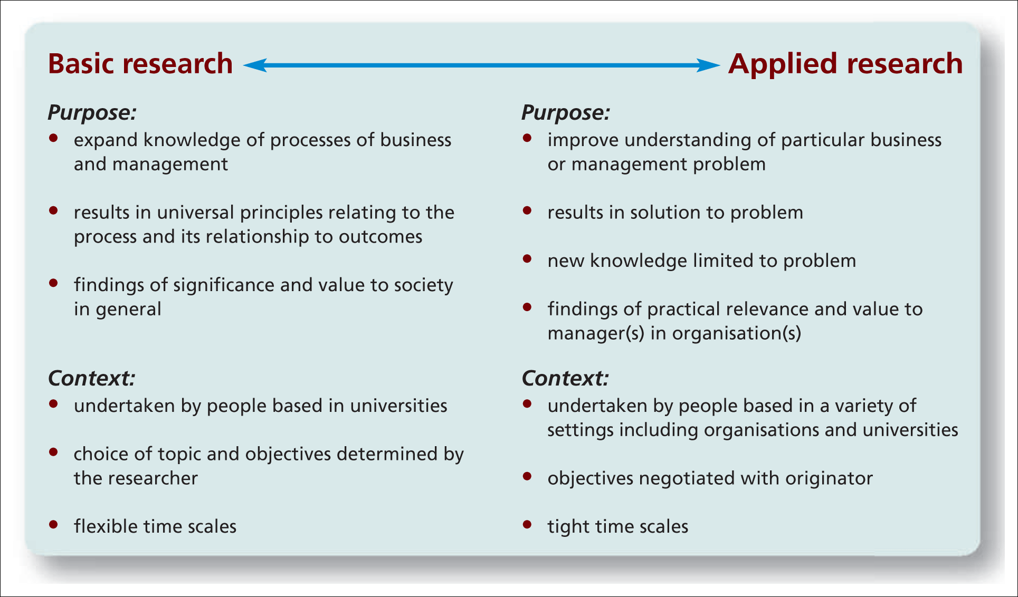
Source: (Rachel Cook, 2020 Class PPT)
Table 2. The research onion
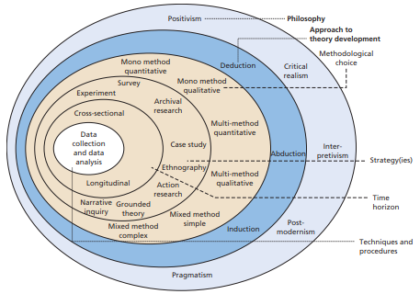
Source: (Saunders et al, 2016)
Table 3. Framework for qualitative interpretive science research
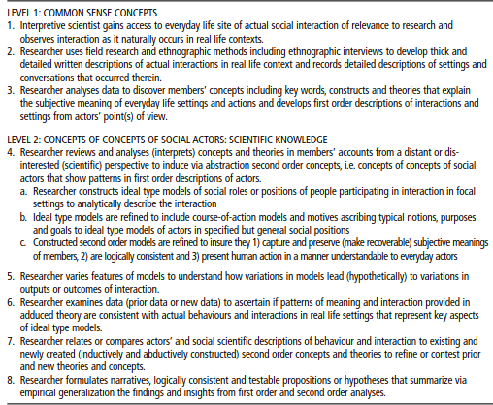
Source: (Cassell et al., 2018)
Table 4: Characteristics of idealized quantitative and qualitative approaches
Dimension | Quantitative Approach | Qualitative Approach
Design | experimental | non-experimental
Setting | laboratory | field
Data Collection | instruments (e.g., electronic or  mechanical devices, tests,  questionnaires) | collection of “narratives,” either  already existing (e.g., diaries), or  new (e.g., interviews)
Data Type | numerical (ratio, interval, ordinal) | descriptive (e.g., interview  protocols, written records, videos)
Analysis | descriptive and analytic statistics | analysis aimed at revealing meaning
Generalization | focus on testing hypotheses | focus on generating hypotheses
Source: (Cropley, A. J, 2019)

Appendix 4: Development Activities
Benefits and Drawbacks between basic research and applied research
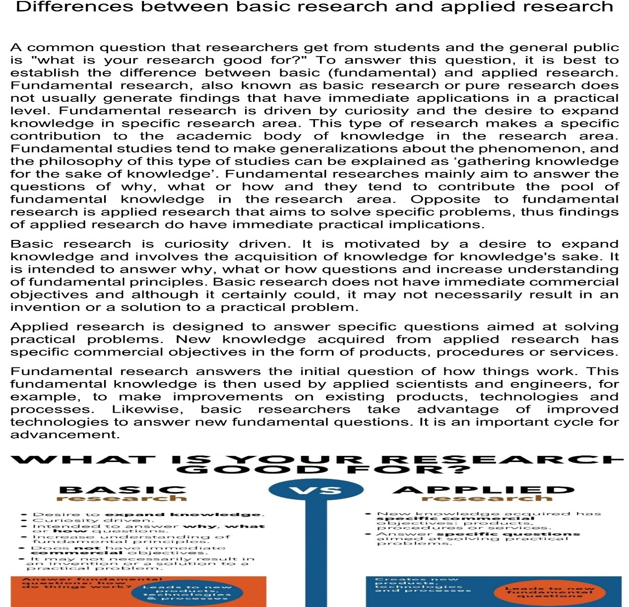
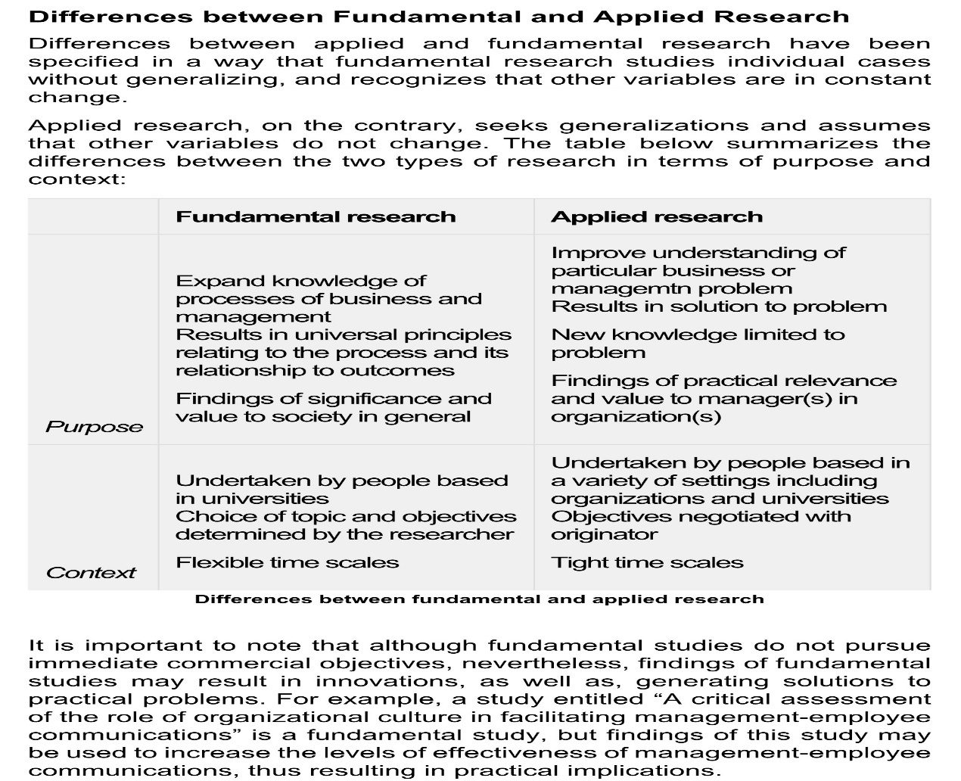
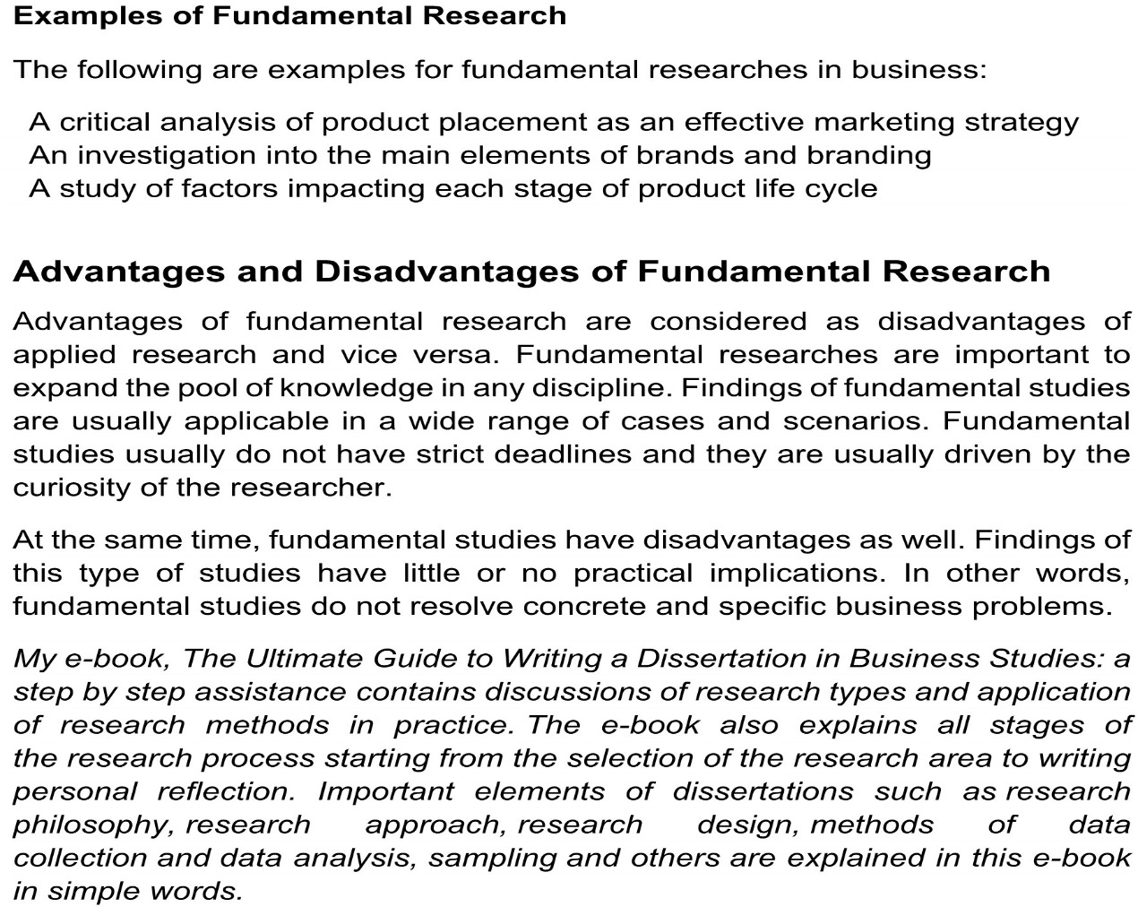
Entry 2: Becoming Ethical Researchers

Ethics and its kinds

Beauchamp & Childress (1989) classically defines ethics as the action of doing good and avoiding harm. Ethics is a part of human philosophy, which focuses on proper behavior and virtuous life (Given，2008). There are two kinds of ethics: first one is normative ethics or moral theories, the second is Metaethics(Given，2008). Normative ethics are organized frameworks around the principles of guiding decision-making or the dynamics of relations guiding human behavior. The most common ethics are justice-based ethics, duty-based or deontological ethics, consequence-based or utilitarian ethics, and virtue-based ethics. For example, caring ethics guides qualitative researchers to treat others in a natural and direct way, and supports relationships based on positive emotions and mutual concern. Metaethics is the individual's assumption of moral theory and moral decision-making, including the framework, the assumptions and justification of decision-making (Given，2008).

Ethical research principles

The basic ethical principle of qualitative research is not to destroy the natural environment of research (Drew et al.,2008). Consent, deception and privacy are unique ethical issues in qualitative research (Brinkmann & kvale, 2005; Haverkamp, 2005). Qualitative researcher should follow three ethical principles: respect for persons (autonomy), focus on welfare (beneficence), and justice (NCPHS,1978; Capron, 1989; Orb et al, 2000; Creswell and Poth, 2018). According to Capron (1989), respect for people is to recognize the rights of participants, including the right of being informed, the right of freely deciding whether to participate in research and the right of withdrawing at any time without punishment. Participants also have the right of voluntarily accepting or refusing to participate in the study as autonomous persons (Orb et al, 2000). For example, researchers have the right to study formal and informal counselor-student interactions in a secondary school environment. Informed consent must be obtained from counselors, students and parents of students who are being formally consulted. Focus on welfare is to ensure adequate protection for participants, which means the researchers must provide evidence that they are not putting participants at risk (Creswell and Poth, 2018). Justice means sharing and treating equally and fairly, i.e. avoiding exploitering and abusing of participan，recognizing the participants’ vulnerability and their contributions to the study(Orb et al, 2000).
Confidentiality is based on the principle of respecting for autonomy, and the identifiable information about individuals collected in the research process cannot be revealed without permission (BSA, 2004). Anonymity is one of the ways of confidentiality, but the anonymity of data cannot cover all the problems caused by confidentiality concerns. Confidentiality means that any information obtained from the interviewee cannot be disclosed deliberately or accidentally in a way that may identify the individual (Wiles et al., 2006 and 2008). Confidentiality and anonymity can be undermined by legal requirements, such as when researchers' data are called for legitimate purposes. If legal reporting is required, such as cases of child or elderly abuse, participants should be informed that this information will be excluded from confidentiality and anonymity. While confidentiality is required, qualitative research needs to be verifiable, i.e. documentation of all activities included in the research. Other researchers can follow this audit trail (Streubert & Carpenter, 1999). This process may cause moral dilemmas in confidentiality and anonymity. In some cases, participants may need to know that other researchers may review the process and data. Informed consent means that participants should be adequately and voluntarily informed (Mohd Arifin, 2018). All participants must provide written informed consent and sheet, and they have the right to withdraw from the study at any time even after signing the informed consent.
Becoming Ethical Researchers

Researchers should consider the possible ethical problems in the qualitative research process and plan how to solve these problems. Weis and Fine (2000) provided the possibility catalogue to solve these issues: considering ethical problems from the roles as participants' insiders / outsiders; assessing issues of being afraid of publishing; building respectful and supportive relationships, rather than using stereotypes or labels that participants do not accept; recognizing who will be the representative of our final research; and reflecting on who we are and the individuals we study, and writing these reflexive thinking into report. Hatch (2002) summarized that researchers shouldn’t put vulnerable populations and participants at risk but keep balanced power relations with participants. The principle of ‘no harm’ to participants ought to be considered by researchers, who should be aware that the potential harms might inflict study subjects (Jawad, 2020). Researchers can't ignore privacy in any research. If there are potential problems, consent should always be obtained. In addition, participants should be assured that the data will be kept strictly confidential to protect anonymity. Few studies require data to be kept in a form that identifies participants. According to experience, researchers should invade the privacy of participants as little as possible. If there is a potential privacy risk, investigators should take all precautions. Any research that substantially violates privacy can put participants at risk. These procedures also reduce the public's trust in the importance of successful knowledge acquisition, thus putting scientific behavior at risk (Drew et al.,2008). Researchers cannot use deception. If participants are involved in activities that may pose potential risks to them, their consent must be obtained. Consent may be given by a parent, guardian or other agent, i.e. the administrator of an institution, unless one notices that the interests of the consenting person are inconsistent with those of the subject. When participants cannot provide their own consent, "parental" consent is not enough (Drew & Hardman, 2007).
Appendix 1: References

Angelica Orb, Laurel Eisenhauer, Dianne Wynaden. (2000). Ethics in Qualitative Research. Journal of Nursing Scholarship.
Beauchamp, T.L, & Childress, J.F. (1989). Principles of biomedical ethics. New York, NY: Oxford University Press.
Brinkmann, S. & Kvale, S. (2005). Confronting the ethics of qualitative research. Journal of Constructivist Psychology,18(2): 157-181.
BSA. (2004). Statement of ethical practice for the British sociological association. Retrieved August 17, 2006, from http://www.britsoc.co.uk/equality/63.htm.
Caroline Jawad.(2020). Applied Qualitative Business Research. Class PPT.
Clifford J. Drew, Michael L. Hardman, John L. Hosp. (2008). Designing and conducting research in education. Sage Publications Ltd.
Dilmi Aluwihare-Samaranayake. (2012). Ethics in Qualitative Research: A View of the Participants’ and Researchers’ World from a Critical Standpoint. International Journal of Qualitative Methods.
Drew, C. J., Hardman, M. L., & Hosp, J. L. (2008). Designing and Conducting Research in Education. LA: Sage Publications.
Hatch, J. A. (2002). Doing qualitative research in education settings. Albany: State University of New York Press.
John W. Creswell, Cheryl N. Poth.(2018). Qualitative Inquiry & Research Design: Choosing Among Five Approaches(Fourth Edition). SAGE Publications, Inc.
Lisa M. Given.(2008). The SAGE Encyclopedia of Qualitative Research Methods. SAGE Publications, Inc.
National Commission for the Protection of Human Subjects of Biomedical and Behavioral Research, Department of Health, Education and Welfare (DHEW) (1978). The Belmont Report (PDF). Washington, DC: United States Government Printing Office.
Peter Allmark, Jonathan Boote, Eleni Chambers. (2009). Ethical issues in the use of in-depth interviews: literature review and discussion.
Ron Iphofen AcSS. (2012). Research Ethics in Ethnography/Anthropology. European Commission, DG Research and Innovation
Rose Wiles, Graham Crow, Sue Heath & Vikki Charles. (2006). Anonymity and Confidentiality. ESRC National Centre for Research Methods.
Siti Roshaidai Mohd Arifin. (2018). Ethical Considerations in Qualitative Study. International Journal of Care Scholars.
Streubert, H.J., & Carpenter, D.R. (Eds.). (1999). Qualitative research in nursing. Advancing the humanistic imperative (2nd ed.). Philadelphia: Lippincott.
Weis, L., & Fine, M. (2000). Speed bumps: A student-friendly guide to qualitative research. New York, NY: Teachers College Press.
Wiles, R., Charles, V., Crow, G. and Heath, S. (2006) ‘Researching researchers:
Lessons for research ethics’, Qualitative Research, pp. 283-299.
Rose Wiles, Graham Crow, Sue Heath & Vikki Charles (2008): The Management of Confidentiality and Anonymity in Social Research, International Journal of Social Research Methodology, 11:5, 417-428

Appendix 2: Useful links

How do you make sure your research is ethical?
https://www.theguardian.com/higher-education network/blog/2014/may/20/
why-research-ethics-matter
Ensuring your research is ethical: A guide for Extended Project Qualification students
https://wellcome.ac.uk/sites/default/files/wtp057673_0.pdf
Five principles for research ethics
https://www.apa.org/monitor/jan03/principles
Belmont Report
https://en.wikipedia.org/wiki/Belmont_Report
Statement of ethical practice for the British sociological association.
http://www.britsoc.co.uk/equality/63.htm

Appendix 3: Tables

Table 1 Ethical Issues in Qualitative Research
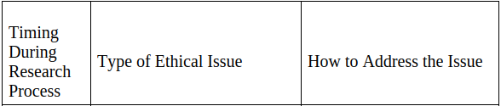
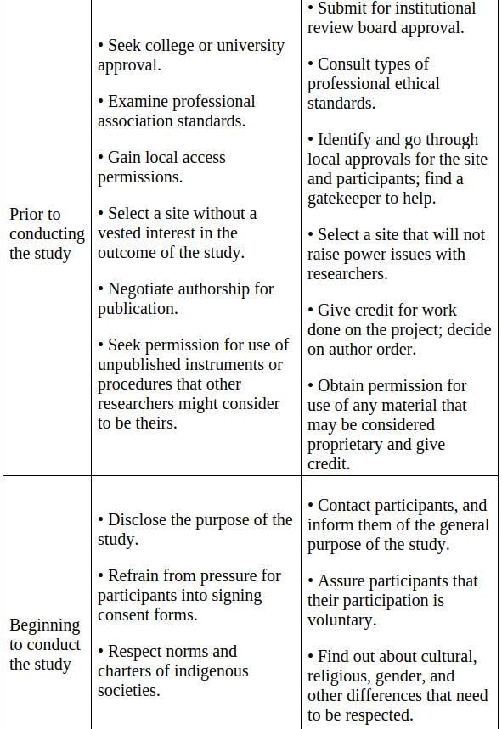
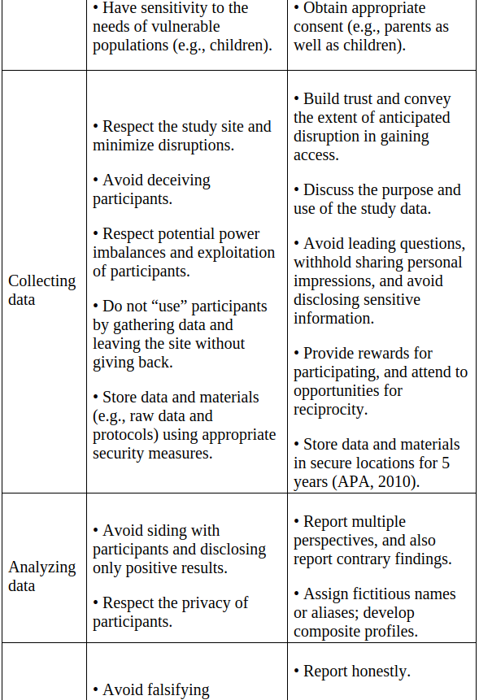
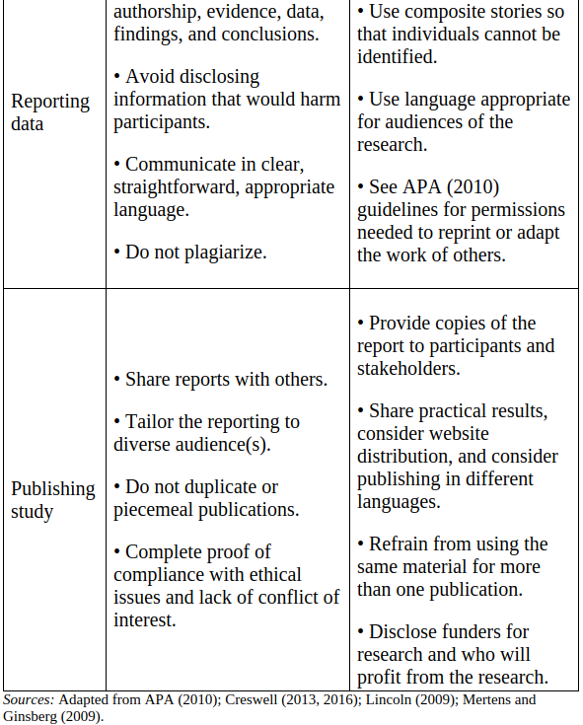
Source: Creswell and Poth (2018)

Appendix 4: Self-development activity

Talking about the ontological, epistemological positions and ethical considerations with the article Barriers and enablers to employment: black disabled peoples living with sickle cell disorder 2017-2018.
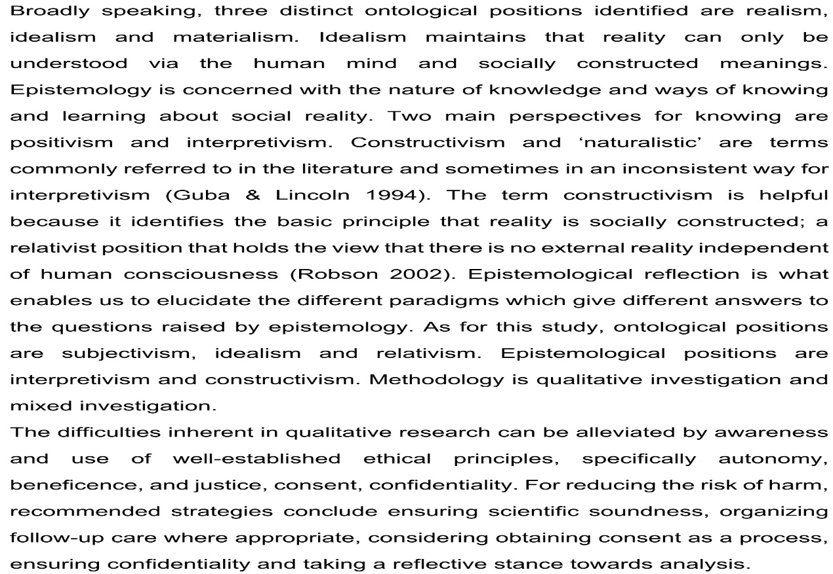
Entry 3: Field Research

Definition and Characteristics

Field research, also called fieldwork, originates from the work of Malinowski, who firstly study the inhabitants in Trobriand Islanders by living with them between 1915 and 1918. It is an investigation method which is not only used in the social sciences such as anthropology, but also used in natural and physical sciences to describe the data collecting (Given, 2008). So, fieldwork refers to the work of anthropologists who receive special training enter a community to obtain first-hand information by participating in observation and living experience (Given, 2008). The fieldwork method has the following points (Cook, 2020): 1. Emphasize holism; 2. Time requires a period of more than one year; 3. Space is limited to a small area, generally a village; 4. Skill requires participation in observation and in-depth interview; 5. Theoretical generalization requires the theory to be upgraded from specific experience to general.

Emic and etic perspective

The concept of emic in anthropology refers to the interpretation of things by the research objects themselves, while the concept of etic is the interpretation of things by anthropologists from their own perspective (Morris et al., 1999). Therefore, the emic study emphasizes the analysis and understanding of events from the perspective of culture, while the etic study emphasizes the position and interpretation from the outside of culture. According to Buckley et al. (2014), emic research and etic research will come to different conclusions when they analyze the same cultural phenomenon in different research context. Insider refers to people who belong to the same cultural group as the research object, while outsider refers to people who are outside a certain cultural group. Corresponding to the concept of emic and etic. As an insider, native anthropologists can even use information that is difficult to get from outsiders directly. Of course, native anthropologists will turn a blind eye to what they are studying.

Field notes

Field notes initially refers to the private ideas, thoughts, and queries of the researchers about their research observations and interviews (Phillippi and Lauderdale, 2018). They are the interviewer's “jottings” and no useful in the analysis, therefore they remain private (Ottenberg, 1990). Kawulich (2005) explained that field notes are records of field observations and informal discussions or ceremonies. Neuman (2011) determined the type of field annotation used for qualitative data collection. Data types include notes (short memory triggering), direct observation (writing immediately after leaving the scene), inference (reflecting social relations, emotions and meaning), analysis (method strategy and theory notes), interview notes (information about the interview site and interviewers) and personal diaries (personal feelings and emotional responses). Neuman (2011) warned researchers to ensure that reasoning is separated from other processes so that researchers can separate observation, reasoning and belief.

Procedures of conducting fieldwork study

Singleton and Straits (2005) identified the following 5 stages in field research: The first stage is problem description, that is defining the main focus of the study by describing the problems you want to know more about. The second stage is choosing a research setting, that is knowing and deciding where to start. The setting shall allow clear observation. The third stage is obtaining research access, i.e. how do you get into a group you want to study? The fourth stage is presenting yourself: you need to decide how you will show yourself to people in this field. Do you do secret research? What role do you need to play? How will you get along with others? How actively do you participate in other people's lives? If you were a researcher, would others accept you in their daily lives? The fifth stage is collecting and recording information: sometimes it is difficult to observe and record at the same time. What types of information should be used as field notes? If you can't record your observations completely in the wild, what should you do? Always take a notepad with you to make short notes. Sometimes there is no choice but to wait and record the observations after leaving the settings. You should record your observations as soon as possible to minimize recall issues. You can also rely on tape recorders, cameras and other devices. Forms of data collection in fieldwork include observations (participant to non-participant, field notes), Interviews(closed to open-ended, focus groups), documents(private to public, Journals, letters, (auto)biographies, and records), Audiovisual materials(photos, videos, website, sounds, text messages, and objects) (Cook, 2020).

Appendix 1：References

Buckley, PJ, Chapman, M, Clegg, J et al. (1 more author) (2014) A Linguistic and Philosophical Analysis of Emic and Etic and their Use in International Business Research. Management International Review, 54 (3). 307 - 324.
Deggs, D. M., & Hernadez, F. (2018). Enhancing the value of qualitative field notes through purposeful reflection. The Qualitative Report, 23(10), 2552-2560. Retrieved from https://nsuworks.nova.edu/tqr/vol23/iss10/18.
Julia Phillippi and Jana Lauderdale. (2018). A Guide to Field Notes for Qualitative Research: Context and Conversation. Qualitative Health Research, Vol. 28(3) 381–388.
John W. Creswell, Cheryl N. Poth.(2018). Qualitative Inquiry & Research Design: Choosing Among Five Approaches(Fourth Edition). SAGE Publications, Inc.
Kawulich, B. B. (2005). Participant observation as a data collection method [81 paragraphs]. Forum Qualitative Sozialforschung / Forum: Qualitative Social Research, 6(2), Art. 43, http://nbn-resolving.de/urn:nbn:de:0114-fqs0502430.
Lisa M. Given.(2008). The SAGE Encyclopedia of Qualitative Research Methods. SAGE Publications, Inc.
Morris M., Leung K., Ames D., & Lickel B. (1999). Views from inside and outside: Integrating emic and etic insights about culture and justice judgement. Academy of Management Review, 24(4), 1781796.
Norman K. Denzin, Yvonna S. Lincoln. (2018). The SAGE Handbook of Qualitative Research (Fifth Edition). SAGE Publications, Inc.
Rachel Cook.(2020). Ehhnographic research and the use of field notes. Class PPT.
Singleton Jr., R. A., & Straits, B. C. (2005). Approaches to social research (4th edition). New York, NY: Oxford University Press

Appendix 2：Useful websites and links

What is Field Research: definition, methods, examples and advantages.
https://www.questionpro.com/blog/field-research/
Field Research
https://www.researchconnections.org/childcare/datamethods/fieldresearch.jsp
Field Research: What Is It and When to Use It?
https://saylordotorg.github.io/text_principles-of-sociological-inquiry-qualitative-and-quantitative-methods/s13-01-field-research-what-is-it-and-.html
Selected Perspectives: an Open Introduction to Cultural Anthropology
https://courses.lumenlearning.com/sunyculturalanthropology/chapter/fieldwork/
Reading: Field Research
https://courses.lumenlearning.com/alamo-sociology/chapter/research-methods-field-research-and-secondary-data-analysis/
Two Views of Culture: Etic & Emic
https://courses.lumenlearning.com/culturalanthropology/chapter/two-views-of-culture-etic-emic/
Qualitative Methods in Monitoring and Evaluation: The Emic and the Etic: Their Importance to Qualitative Evaluators
https://programs.online.american.edu/msme/masters-in-measurement-and-evaluation/resources/emic-andetic?cmgfrm=https%3A%2F%2Fwww.google.
Field notes
https://en.wikipedia.org/wiki/Fieldnotes

Appendix 3: Tables

Table 1. Functions of Field Notes in Qualitative Research in the Original Study.
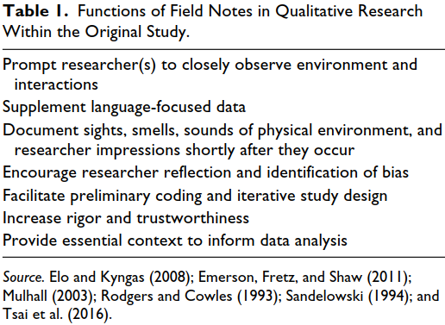
Source: (Phillippi and Lauderdale, 2018)

Table 2.Typology of Sampling Strategies
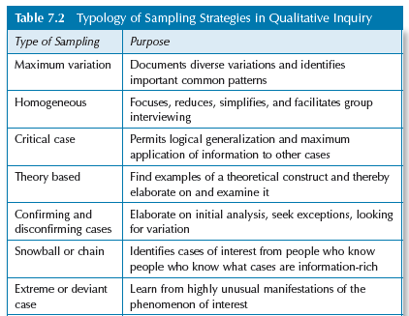
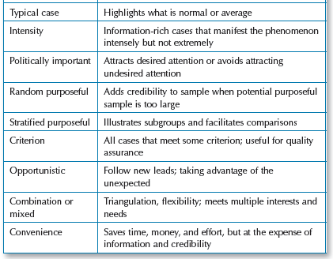
Source: (Rachel Cook, 2020)

Appendix 4：Self-development activity

Activity: How to control the quality in ethnographic and field research?
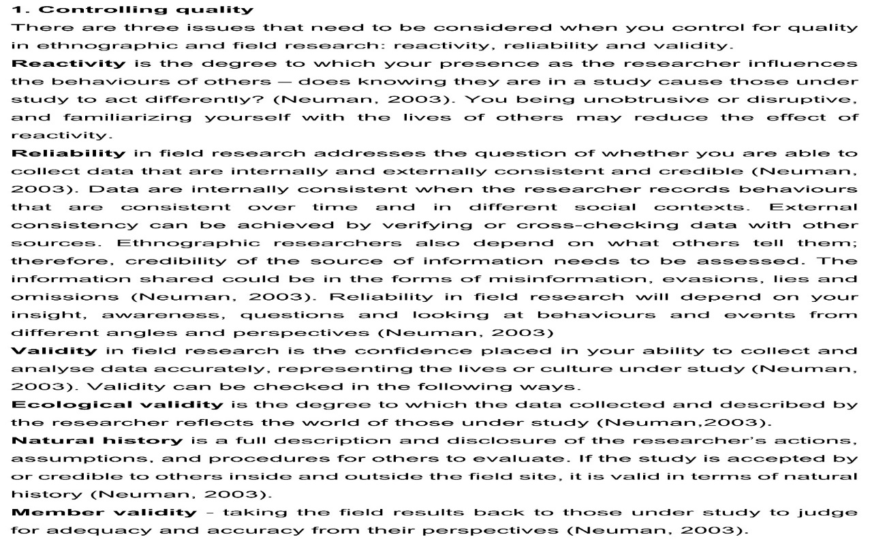

Entry 4. Interviewing

Definitions and the difference types of Interviewing

Interviewing is a kind of conversational practice, which generates knowledge through the interaction between the interviewer and the interviewee or a group of interviewees (Given，2008）. In the classic text, Maccoby E. & Maccoby N. (1954) defined interview as "face-to-face oral communication, in which one person, the interviewer, attempts to obtain information or express opinions or beliefs from another or more people" (page 449). Today, interviews take many forms by phone (Shuy, 2002) or Internet (James & Busher, 2012). Miller (1995), Sturges and Hanrahan (2004), Opdenakker (2006), Holt (2010) and Vogl (2013) tested telephone as an interview mode and determined that the results produced by telephone interview were comparable to those of face-to-face interview. However, as Novick (2008) points out, many authors "use the telephone in the report only when it is necessary to replace face-to-face interviews with the telephone, which may damage the quality" (P. 394). Hine (2010) believes that one way to define online interviews is to use the Internet as a medium for research. In addition, James and Busher (2006) call the web-based interview method as online interview. In today's world, the Internet provides many synchronous (such as Skype, IM, etc.) and asynchronous communication (e.g., e-mail, web page, etc.) technologies, which make online interview and information search a feasible choice for qualitative research. James and Busher (2009) believe that the Internet is a complex phenomenon involving dynamic social, spatial and temporal dimensions, which shape the relationship and background of research projects. In other words, online interview is a research method worthy of careful discussion.

Research interviews can be structured, in which, the standardized questions are raised and the answers are given in the form of the quantitative procedures. Most qualitative research interviews are semi-structured because the agenda is set by the researcher's interest, and there is room for more spontaneous description and narration. Some interviews take a more unstructured form, including a life history interview, sometimes with just an opening question to invite the interviewee to tell his or her life story (Given, 2008). Both Maccoby and Maccoby’s definitions apply to structured and unstructured interview forms, which is a difference, should be regarded as a continuum, and only in theory can extreme situations occur (Norman & Yvonna, 2018).

Interview procedures

The Brinkman and Kvale (2015) pointed out interview’s seven stages: thematizing the inquiry; designing the study; interviewing; transcribing the interview; analysing the data; verifying the validity, reliability and generalizability of the findings; reporting the study. Creswell and Poth (2018) put forth the following procedures to prepare and conduct the interviews (see table 3):
·Determining the questions of the research. These questions about central phenomenon in the study should be answered in a general and open-ended way by the interviewees.
·Distinguishing the types of interview to get the most useful and suitable one.
·Collecting data by using recording device, i.e. lapel microphones or headsets.
·Designing and using an interview protocol about 6 to 7 open-ended questions.
·Refining the interview questions and the procedures through pilot testing. Sampson (2004) and Yin (2014) use pilot testing to improve the plan of data collection and develop relevant questions.
·Locating a quiet, suitable place to conduct the interview.
·Obtaining consent from the interviewee, who can withdraw at any time.
·Complying with good interview procedures. Researcher should be respectful, courteous, listen more, comment less, and follow the interview protocol.
·Deciding the content to be transcribed and the software to be used.
Appendix 1: References

Brinkmann, S., & Kvale, S. (2015). Interviews: Learning the craft of qualitative research interviewing (3rd ed.). Thousand Oaks, CA: Sage.
Hine, C. (2010). Book Review: Natalita James and Hugh Busher, online interviewing. Qualitative Research, 10(4), 502–504.
Holt, Amanda (2010). Using the telephone for narrative interviewing: A research note. Qualitative Research, 10(1), 113-121.
James, N., & Busher, H. (2009). Online interviewing. London, UK: Sage.
James, N., & Busher, H. (2012). Internet interviewing. In J. F. Gubrium, J.A. Holstein, A. B. Marvasti,& K. D. McKinney (Eds.), Handbook of interview research: The complexity of the craft (pp. 177–192). Thousand Oaks, CA: Sage.
John W. Creswell, Cheryl N. Poth.(2018). Qualitative Inquiry & Research Design: Choosing Among Five Approaches (Fourth Edition). SAGE Publications, Inc.
Lisa M. Given.(2008). The SAGE Encyclopedia of Qualitative Research Methods. SAGE Publications, Inc.
Maccoby, E. & Maccoby, N. (1954). The interview: A tool of social science. In G. Lindzey (Ed.), Handbook of social psychology (pp.449–487). Cambridge, MA: Addison-Wesley
Miller, Carol (1995). In-depth interviewing by telephone: Some practical considerations. Evaluation and Research in Education, 9(1), 29-38.
Norman K. Denzin, Yvonna S. Lincoln. (2018). The SAGE Handbook of Qualitative Research (Fifth Edition). SAGE Publications, Inc.
Novick, Gina (2008). Is there a bias against telephone interviews in qualitative research? Research in Nursing and Health, 31, 391-398.
Opdenakker, Raymond (2006). Advantages and disadvantages of four interview techniques in qualitative research. Forum Qualitative Sozialforschung / Forum: Qualitative Social Research, 7(4), Art. 11 .
Sampson, H. (2004). Navigating the waves: The usefulness of a pilot inqualitative research. Qualitative Research, 4, 383–402.Shawn D. Long. (2012). Virtual Work and Human Interaction Research. Information Science Reference.
Shuy, R. W. (2002). In-person versus telephone interviewing. In J.F. Gubrium & J. A. Holstein (Eds.), Handbook of interview research: Context & method (pp. 537–555). Thousand Oaks, CA: Sage.
Sturges, Judith E. & Hanrahan, Kathleen J. (2004). Comparing telephone and face-to-face qualitative interviewing: A research note. Qualitative Research, 4(1), 107-118.
Vogl, Susanne (2013). Telephone versus face-to-face interviews: Mode effect on semistructured interviews with children. Sociological Methodology, 43(1), 133-177.
Yin, R. K. (2014). Case study research: Design and method (5th ed.). Thousand Oaks, CA: Sage.

Appendix 2: Useful links

- Definitions of Interviews
https://content.wisestep.com/what-is-an-interview/
2. Difference between structured, unstructured and semi-structured job interviews
https://www.talentlyft.com/en/blog/article/92/difference-between-structured-unstructured-and-semi-structured-job-interviews
3.The 6 Different Types Of Interviews (And The Pros And Cons of Each)
https://www.coburgbanks.co.uk/blog/assessing-applicants/6-different-types-of-interview/
4. General Guidelines for Conducting Interviews
https://managementhelp.org/businessresearch/interviews.htm
5. Qualitative Interviews: A Methodological Discussion of the Interviewer and Respondent Contexts
http://www.qualitative-research.net/index.php/fqs/article/view/2551/3998

Appendix 3: Tables

Table 1 The features and the differences of three types of interviews
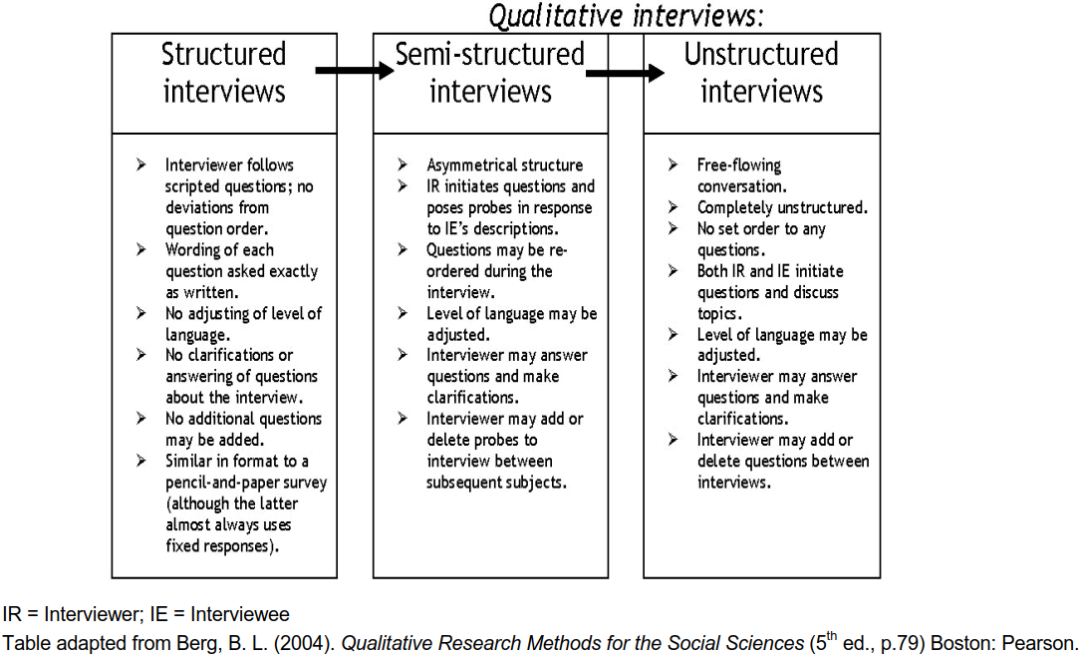
Table 2 Forms of interview
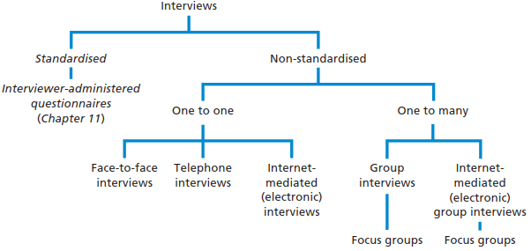
Source:(Saunders et al., 2016)
Table 3 Procedures for Preparing and Conducting Interviews
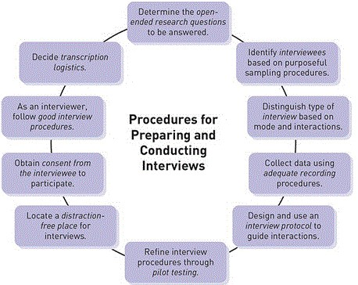
Source: (John and Cheryl, 2018)
Appendix 4: Self-development activity
You were provided with 3 KEY readings relating to interview research. You have 3 x 60 minutes in your groups to identify the key points made by each article.
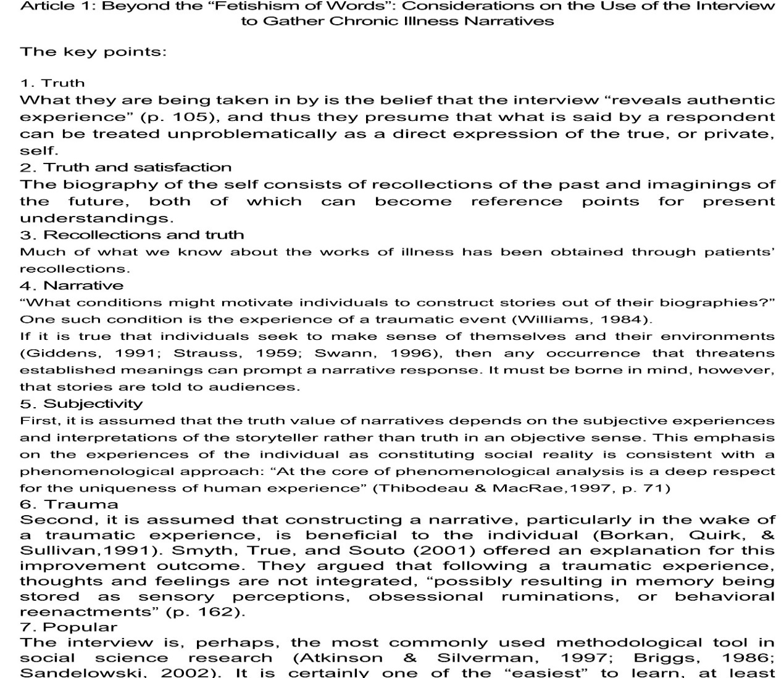
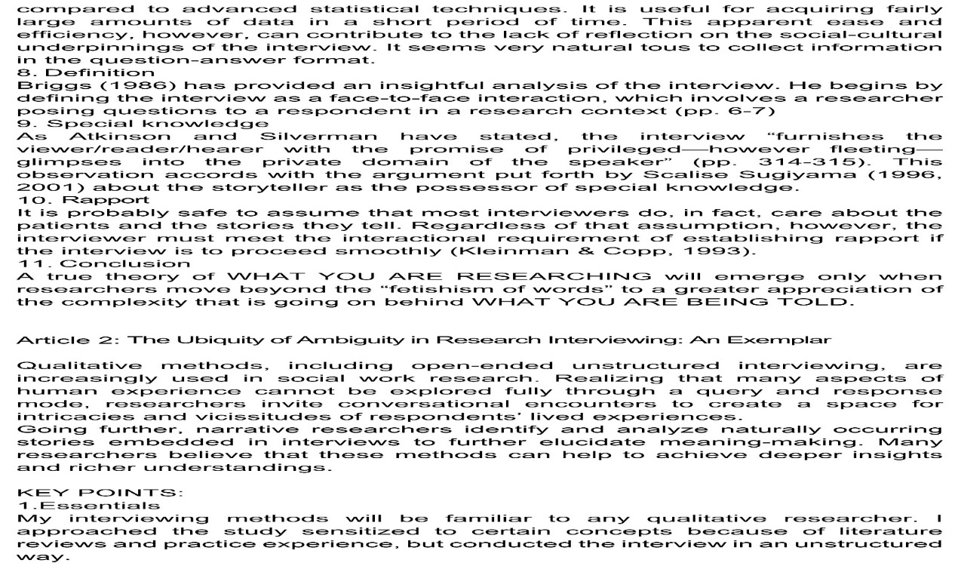
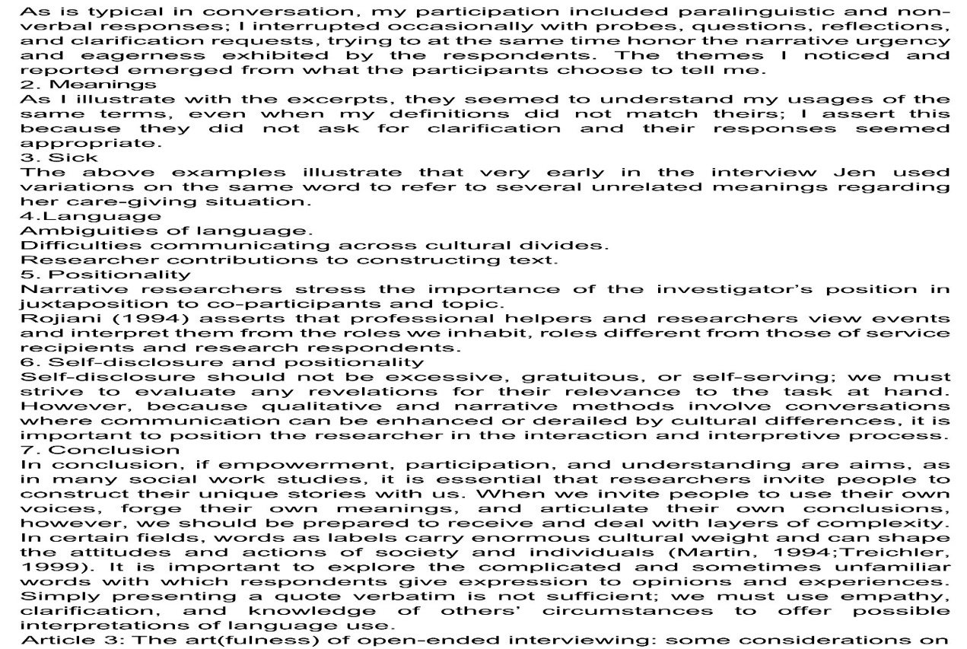
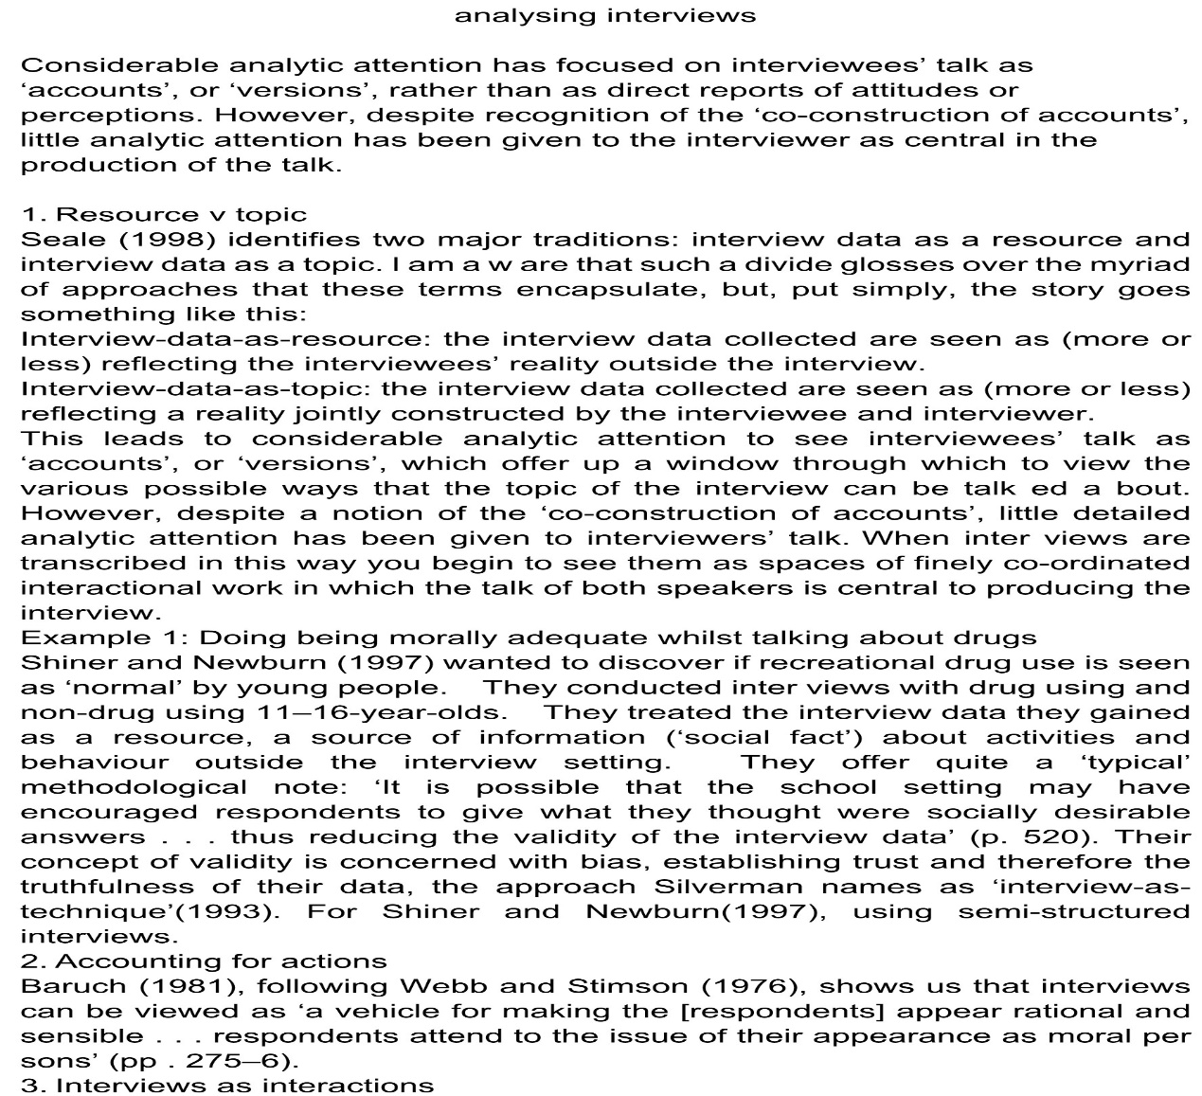


Entry 5. Focus Groups

Definitions of focus groups

Focus groups are a type of qualitative interviewing that involves group discussions moderated by a researcher on a specific topic to explore how specific groups discuss all aspects of their lives (Jawad, 2020). Focus group is a form of qualitative interview, which uses group discussion led by researchers to generate data (Given，2008). Focus groups, sometimes referred to as "focus group interviews," are group interviews that focus on specific issues, services, products, or topics by encouraging discussion among participants and sharing ideas in an open and tolerant environment (Krueger and Casey, 2009). Since the reintroduction of social science research in the mid-1980s, focus groups have become a popular method, and increasingly used in market research. As personal interviews, they can be modified in many ways to adapt to the same broad purpose. Participants can discuss topics relatively freely when they think it is appropriate, or they can use them in a more structured way, in which the interviewer or moderator plays a more active role in controlling the issues to be discussed (Bolderston et al.,2012).

How to plan and conduct focus groups
If you are running a focus group, you may be referred to as a moderator or “facilitator” to reflect the importance of increasing management team dynamics and processes (Bolderston et al.,2012). These labels emphasize the dual role of the person who manages the focus group, that is, the group is limited to the topic of discussion, generates interest in the topic and encourages discussion, while not leading the group to make some comments (Saunders et al., 2016). Choosing participants who share a common view of the topic is the most common strategy for generating a group structure that can generate positive communication (Given，2008). This strategy is usually summarized as creating homogeneous groups, which are based on participants' sharing of research topics, rather than the similarity of simple demographic characteristics. For example, in a group with power differences (which may be MRT and doctors, or MRT and patients), discussions may be affected by a group's unwillingness to disclose or talk about certain issues (Bolderston et al.,2012). Focus groups are particularly effective for people with diverse cultures, because they can take advantage of implicit shared and shared group knowledge (Kitzinger, 1995). The value of homogeneity in group formation lies in that it encourages participants to connect topics according to their similarities and differences. On the one hand, their similarities make it easier for them to share their thoughts and feelings on the research topic; on the other hand, their differences create an interesting basis to compare their respective positions on this topic. Of course, if the research design does not include the same good choice of interview questions, then it is of no value to make the appropriate choice of group composition (Given，2008). There are some concerns about the use of focus groups in qualitative research, because individual voices may be lost in groups (Bradbury, 2009). However, many authors believe that with careful guidance, they can become a valuable data collection tool (McLafferty, 2004), and also allow participants to jointly create research data (Kitzinger, 1995). Organizing a focus group requires the ability to ensure that all participants contribute equally, and group facilitation requires a specific set of skills.

Characteristics of Focus Group Interviews
Krueger (2002) listed the Characteristics of Focus Group Interviews from 4 aspects: participants (Carefully recruited, 5 to 10 people per group, 6-8 preferred, Similar types of people, Repeated groups); environment (Comfortable, Circle seating, Tape recorded) ; Moderator (Skillful in group discussions, Uses pre-determined questions, Establishes permissive environment); Analysis and Reporting(Systematic analysis, Verifiable procedures, Appropriate reporting)
Appendix 1: References

Amanda Bolderston, BSc, MSc, MRT(T), FCAMRT. (2012).Conducting a Research Interview. Journal of Medical Imaging and Radiation Sciences.
Bradbury-Jones, C., Sambrook, S., & Irvine, F. (2009). The phenomenological focus group: an oxymoron? J Adv Nurs 65, 663–671.
Caroline Jawad.(2020). Applied Qualitative Business Research. Class PPT.
Kitzinger, J. (1995). Qualitative research: introducing focus groups. BMJ 311, 299–302.
Krueger, R.A. (2002). Designing and Conducting Focus Group Interviews. Thousand Oaks, CA: Sage.
Krueger, R.A. and Casey, M.A. (2009). Focus Groups: A Practical Guide for Applied Research (4th edn). Thousand Oaks, CA: Sage.
Lisa M. Given.(2008). The SAGE Encyclopedia of Qualitative Research Methods. SAGE Publications, Inc.
McLafferty, I. (2004). Focus group interviews as a data collecting strategy. J Adv Nurs 48, 187–194.
Saunders et al. (2016). Research Methods for Business Students (7th edn). Essex: Pearson.

Appendix 2: Useful links

1. Definition of 'Focus Group'
https://en.wikipedia.org/wiki/Focus_group
2.How to Conduct Focus Groups
https://www.interaction-design.org/literature/article/how-to-conduct-focus-groups
3.Focus Groups: Features, Advantages and Disadvantages
https://content.wisestep.com/focus-groups-features-advantages-disadvantages/
4. Characteristics of Focus Group Discussions
https://yourbusiness.azcentral.com/characteristics-focus-group-discussions-12704.html
5. How to Run a Successful Focus Group
https://www.eventbrite.co.uk/blog/how-to-run-a-successful-focus-group-event-ds00/

Appendix 3:

Table 1 Characteristics of Focus Group Interviews
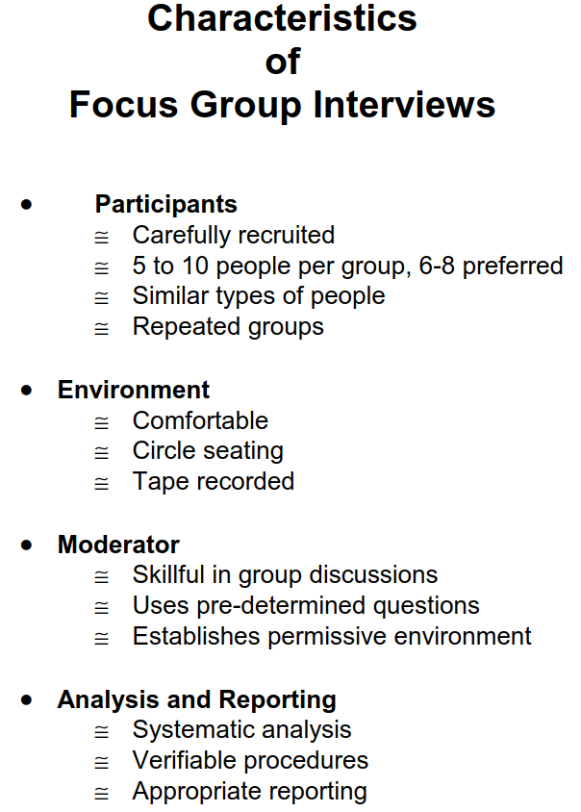
sources: from Krueger (2002)
Table 2 Moderator Skills
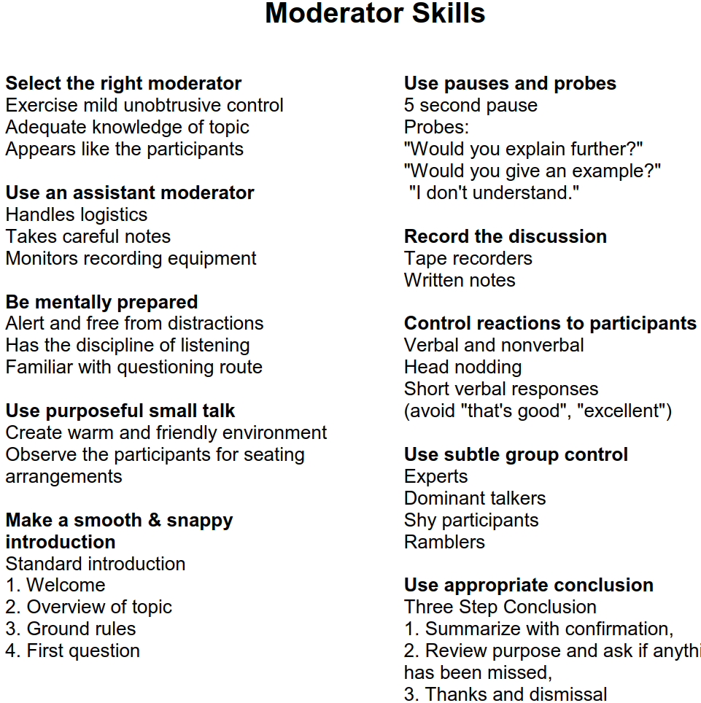
sources: from Krueger (2002)
Table 3 Bulleted Outline
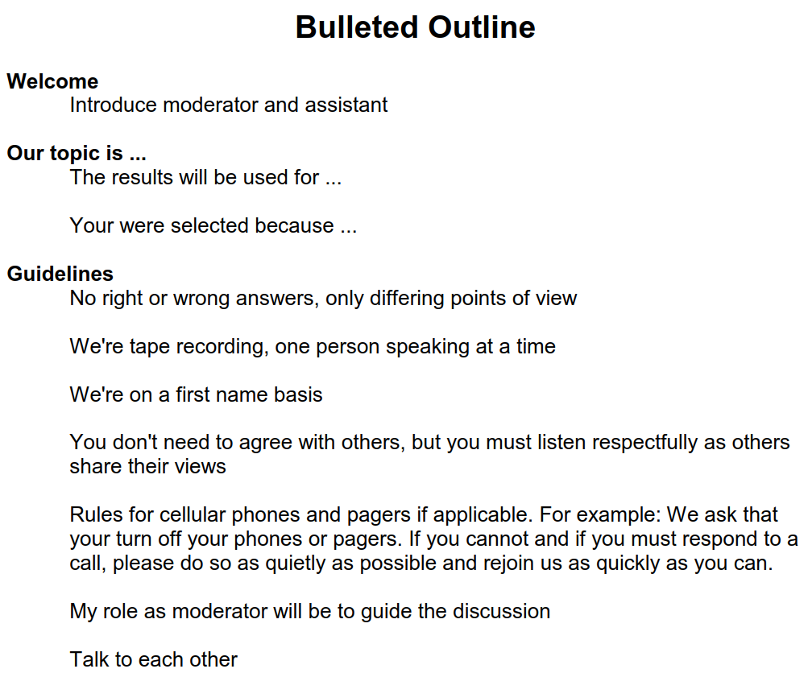
sources: from Krueger (2002)

Table 4 Beginning the Focus Group Discussion
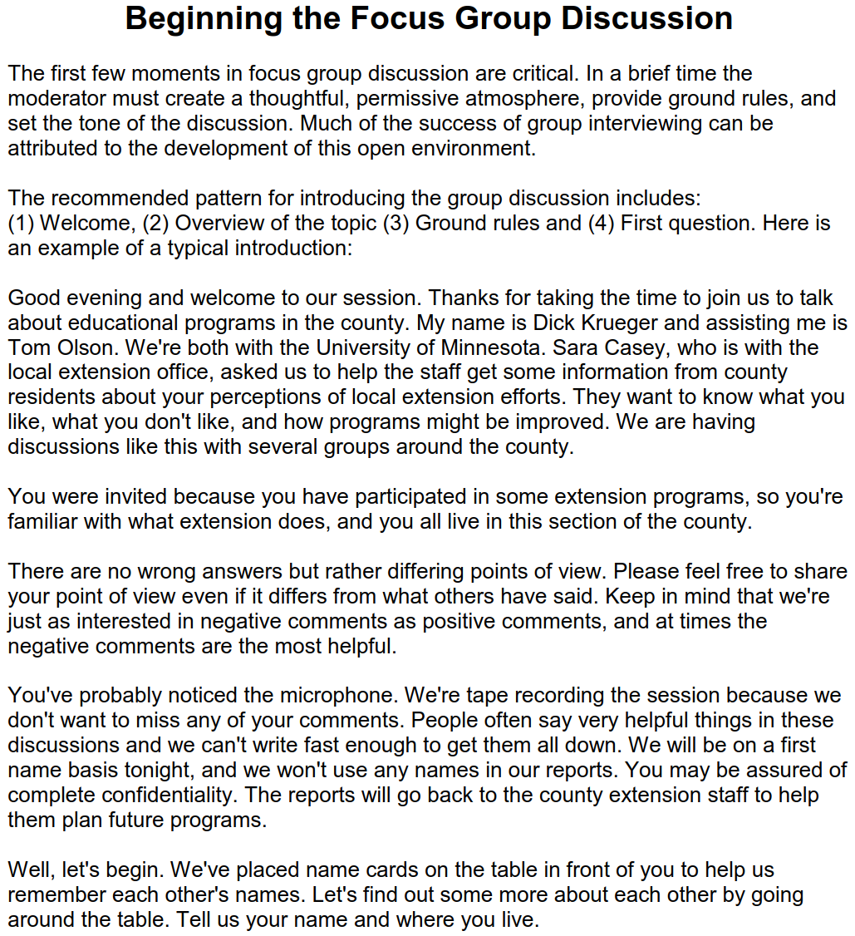
sources: from Krueger (2002)

Table 5 Recorder (Assistant Moderator) Skills
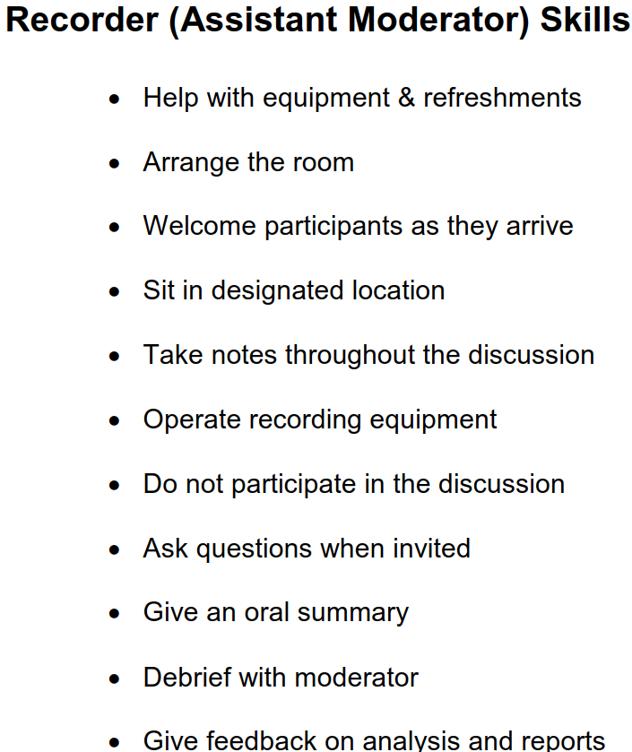
Appendix 4: Self development activities
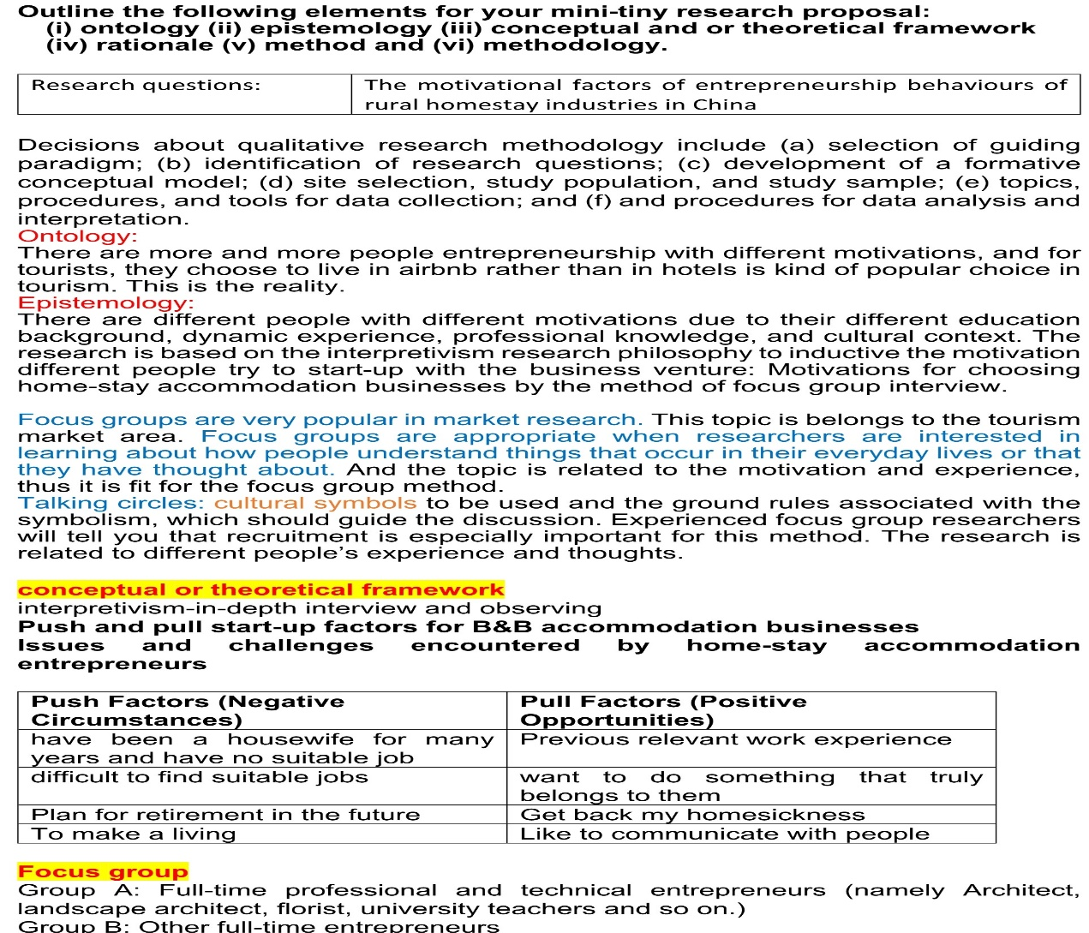
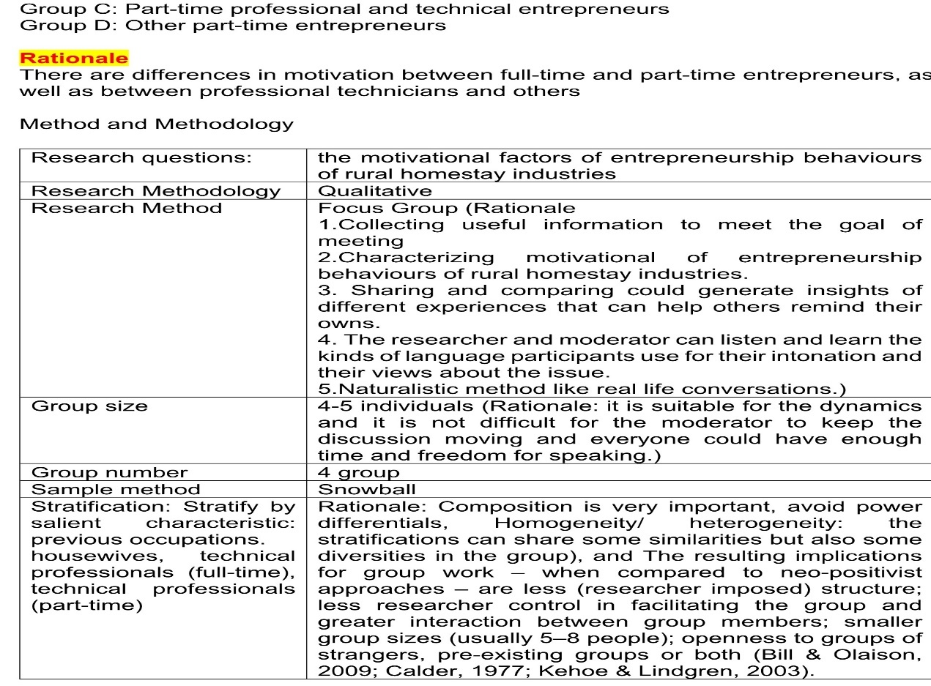

6. Data Analysis and Coding

Introduction

There are large number of data to be analyzed in every qualitative research. In the process of data analysis, qualitative researchers require connect with the theoretical framework and reflect on their own position by using new opened insights (Caroline Jawad, 2020 Class PPT). But Data analysis often involves routine, time-consuming activities. Coffey et al. (1996) point out that in the qualitative data analysis software package, the process of coding and retrieving text fragments from field notes or interview records is common. On the one hand, in order to respond to various criticisms on the performance of traditional ethnography, people favor the diversity of representational modes and devices at present. But on the other, the population of computer aided qualitative data analysis(CAQDAS) is the integration of the uniform mode (mainly grounded theory) for data analysis and representation. Lee and Fielding (1996) argue that in the literature of qualitative research on computer methods, it is difficult to distinguish emotions like those identified by Kling and Lakono. Instead of promoting orthodoxy, promoters, developers and commentators often emphasize the need for epistemological awareness and debate in using software. Digital Tools for Qualitative Research (Paulus et al. 2015) represents how technical tools support the entire research process, thus saving time and increasing robustness and depth for qualitative work. It involves using a variety of tools to support each stage of the research process, providing actual case studies from real-world research.

Three Analysis Strategies

There are three stages of data analysis in qualitative research(Creswell and Poth, 2018): preparing and organizing data, i.e., text data (e.g. transcripts) or image data (e.g. photos) for analysis; reducing the data into themes by coding and compressing the codes; presenting the data as a graph, table or discussion. Table 1 shows a typical analysis procedure, as shown in the work of three qualitative researchers. Madison (2005, 2011) proposed an interpretation framework extracted from critical ethnography. Huberman and miles (1994) adopted a systematic analysis method with a long history in qualitative research. Wolcott (1994) adopted a more traditional method to study from case study and ethnography analysis. All of these authors comment on the central steps of coding the data (reducing the data into meaningful segments and assigning names for the segments), combining the codes into broader categories or themes, and displaying and making comparisons in the data graphs, tables, and charts. These are the core elements of qualitative data analysis.

MAXQDA, ATLAS.ti, NVivo and HyperRESEARCH

These four computer software programs can help researchers systematically evaluate and interpret qualitative texts as well as develop theories and test theoretical conclusions. They all support data collecting, tagging, coding, memoing and text analyzing (Creswell and Poth, 2018). MAXQDA is the only one to provide "emoticode" functionality (see figure 1) by which you can choose symbols to describe the data, not words (Paulus et al. 2015). NVivo is the most popular computer software programs currently (Paulus et al. 2015). NVivo supports the ability to link individual units back to their original data sources. NVivo provides software tools to help researchers move from project conceptualization to project completion. Although NVivo is a software designed primarily for researchers to analyze qualitative (text and multimedia) data, it is suitable for any researcher engaged in any research project (Bazeley, 2012).

The coding process
Paulus et al. (2015) introduce in detail the stages of data analysis and the different analysis methods of different texts in the book Digital Tools for Qualitative Research (see figure 2). Creswell and Poth (2018) argue that the analysis process conforms to an outline——a data analysis spiral(moving in analytic circles instead of using fixed linear methods) (see figure 3). The analysis process includes managing and organizing data, reading and memoing emergency ideas, describing and classifying code as themes, developing and evaluating interpretation, presenting and visualizing data. For example, in the study of learning situation of students with fetal alcohol spectrum disorders, Job et al. (2013) describe the coding process of theme (fostering relationships) through analyzing 11 focus groups and three interviews (respectively with teachers, nurses and administrations). They initially name three codes (i.e., behavior, attitudes, and strategies), then expand six codes, finally reduce to two final codes (i.e., candid communication and respectful interactions) (see figure 4).

Appendix 1: References

Caroline Jawad.(2020). Applied Qualitative Business Research. Class PPT.
COFFEY, A.,HOLBROOK, B. &ATKINSON, P.1996. ‘Qualitative data analysis: technologies and representations’, Sociological Research Online1, 1.
Huberman, A. M., & Miles, M. B. (1994). Data management and analysis methods. In N. K. Denzin & Y. S. Lincoln (Eds.), Handbook of qualitative research (pp. 428–444). Thousand Oaks, CA: Sage.
Job, J., Poth, C., Pei, J., Carter-Pasula, B., Brandell, D., & MacNab, J. (2013). Toward better collaboration in the education of students with fetal alcohol spectrum disorders: Voices of teachers, administrators, caregivers, and allied professionals. Qualitative Research in Education, 2, 38–64.
John W. Creswell, Cheryl N. Poth.(2018). Qualitative Inquiry & Research Design: Choosing Among Five Approaches (Fourth Edition). SAGE Publications, Inc.
Lee, R. and Fielding, N.(1996) ‘A comment on Coffey et al’, Sociological Research On-Line1, 4.
Madison, D. S. (2005). Critical ethnography: Methods, ethics, and performance. Thousand Oaks, CA: Sage.
Pat Bazeley. (2012). Encyclopedia of Research Design. SAGE Publications, Inc.
Trena M. Paulus, Jessica N. Lester & Paul G. Dempster. (2015). Digital Tools for Qualitative Research. SAGE Publications Ltd.
Wolcott, H. F. (1994). Transforming qualitative data: Description, analysis,
and interpretation. Thousand Oaks, CA: Sage.

Appendix 2: Useful links

1.Beginners guide to coding qualitative data
https://www.youtube.com/watch?v=lYzhgMZii3o
2.Coding (social sciences)
https://en.wikipedia.org/wiki/Coding_(social_sciences)
3.Coding Qualitative Data: How to Code Qualitative Research
https://getthematic.com/insights/coding-qualitative-data/
4.Themes Don’t Just Emerge — Coding the Qualitative Data
https://medium.com/@projectux/themes-dont-just-emerge-coding-the-qualitative-data-95aff874fdce
5.Qualitative coding
https://www.cessda.eu/Training/Training-Resources/Library/Data-Management-Expert-Guide/3.-Process/Qualitative-coding

Appendix 3: Tables and figures
Table 1 General Data Analysis Strategies Advanced by Select Authors
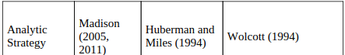
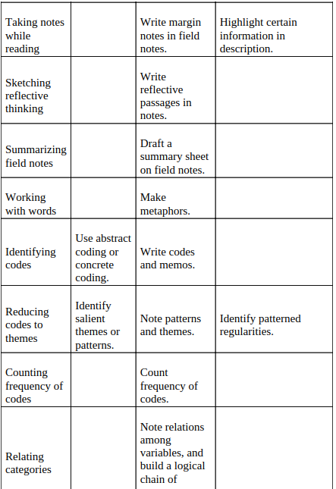
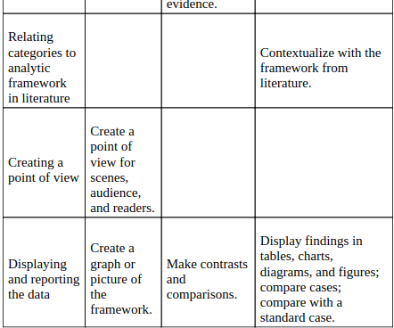
Source: (John and Cheryl, 2018)

Figure 1 MAXQDA emoticodes
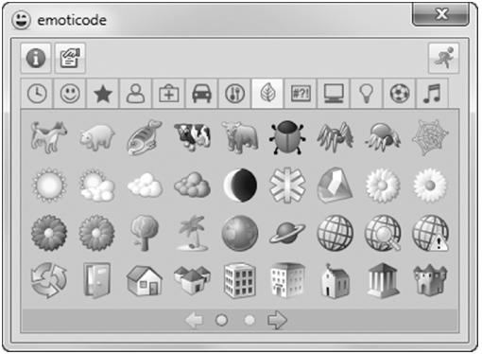
Source: Paulus et al. (2015)
Figure 2 Procedures of data analysis
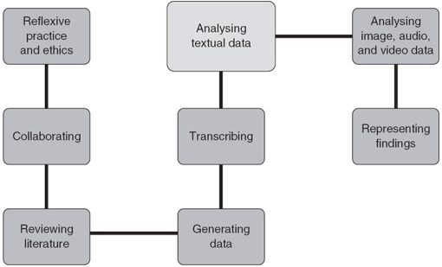
Source: Paulus et al. (2015)
Figure 3 The Data Analysis Spiral
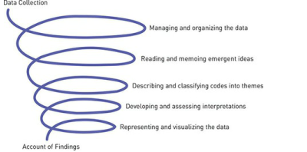
Source: Creswell and Poth ( 2018)

Figure 4 Example of Coding Procedures for Theme “Fostering Relationships”
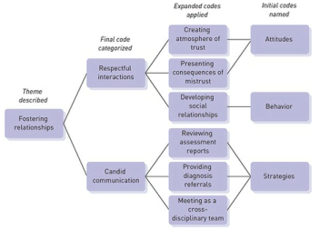
Source: Job et al. (2013).
Appendix 4: Self development activities
Watch the video, transcribe and analyse
https://www.youtube.com/watch?v=W4hBOxS0Pb0


