Explain what the ATLAS process is and use a real-life case example of your own choice. Examine how the use of the critical incident decision making was either successful or unsuccessful within a force.

Paulina Agnieszka Kazmierczak- 2005728

Table of Contents
  - Cover Page.................................................................................................1
  - Table of Contents......................................................................................2
  - Introduction...............................................................................................3
  - Main Findings.........................................................................................4-8
- What are the subtexts of ATLAS?..............................................4-6
- Real-Life Case Example …………………………...……………....7-8
- Comparison………………………………………………………....9-13
  - Conclusion………………………………………………………...................14
  - References..........................................................................................15-17
  - Appendices..............................................................................................18

Introduction-
ATLAS is an approach used in Evidence Based Policing; meaning that the police practitioners are able to use the best accurate evidence available to them to help inform of their decisions about practices and policies. They do this through; Asking, Testing, Learning, Adapting and Sharing (Analyst day What Works Centre for Crime Reduction, 2016)
Sherman, 1998 a man responsible for most of Evidence Based Policing states that "Evidence-based policing" is the use of the best available research on the outcomes of police work to implement guidelines and evaluate agencies, units, and officers. The College of Policing, 2021 states that Evidence-based policing doesn’t unfortunately always provide all the secure answers needed for the officers and staff, this is why they should apply these with caution. They need to reflect on any of their work, look at how the ‘best available’ evidence provided applies to any of their day-to-day work and lastly how their failures and successes can be something to learn from.

What are the subtexts of ATLAS?
Atlas stands for; Ask, Test, Learn, Adapt and Share.
Atlas is designed to encourage police practitioners to; “Ask questions that challenge current practices. Test and critically evaluate existing research and new ideas. Learn from existing approaches and new ideas while considering how they work in workplace practices. Adapt practices and policies using the best evidence available. Share the outcomes across the service.” (Pepper, Rogers and Martin, 2020)
The first part of the ATLAS model is Ask. Asking involves challenging any difficult questions that are proposed for example “How are we able to change this?”, you also need to start building a hypothesis around the situation you are dealing with and reflect on any current practice asking the question “why?”. At the beginning of the entire cycle, you start with asking the most important questions. These will help understand any distinct issues or any area of policing, then using any of those understandings to develop a hypothesis focused on the repercussions on having done things differently.
Secondly the next part of ATLAS is Test. Testing focuses on helping you understand if your response will attain the result that you intended for, this could be trying to stop or reduce drug use in a city. Whilst testing feedback, everything needs to be clear about how you went through with things and what type of changes you are anticipating to see and how you will record these results. Testing focuses on evaluating new ideas, hypothesis and approaches, also producing crucial evidence through doing new research and analysis. These all have to be critically reviewed and a synthesis has to be produced.
Next, the focus is on learning this is about questioning new and existing approaches actually do have the outcome we perceived that they would. We also look at the real world and think about how the policies and practices work in real situations. Failure and Success are normal processes of day to day lives so we must build an understanding of them. After introducing your thoughts and mediation you need to be prepared to calculate your end result, Timing will be absolutely crucial your measurement will be dependent on it and on how quickly you actually think your reaction will work.

Adapt is the fourth part of ATLAS, this involves looking at any current practices and policies and adapting them based on the most accessible evidence. This is done whilst monitoring any implementations of new approaches while simultaneously asking pristine questions. After measuring your after-math, adaptation should occur with your response to reflect what had happened and what you found out. If you figure out that your intervention isn’t having any effect on the situation then you should halt any other resources from being used in that way and proceed to the use the findings to develop your understanding of the issue. If, however you find out that what you’re doing is working then you should proceed to suggest trying it in other areas which are having similar issues.

Lastly, Share is the last part of ATLAS. Sharing involves sharing your ideas and findings with any others that are struggling with the same problem. Your findings, experiences, plans etc. Are important for others that want to solve the same issues. By sharing your experience, you will help others identify what they need to do and help stop using resources in the wrong way. The ATLAS model indicates that sharing happens throughout the entire process of ATLAS (College of Policing, 2021)

Real Life Incident (CASE)
James Patrick Bulger was at the time of the incident a 2-year-old boy from Kirkby Merseyside in England. On the 12th of February 1993 he was abducted and then proceeded to be tortured and killed by two 10-year-old boys called
Jon Venables and
Robert Thompson. After being led away from his mother in New Strand Shopping Centre in Bootle his body was found mutilated 2.5 miles away on a railway in Walton Liverpool, just 2 days after his abduction.
The main part starts when the two 10-year-olds were found guilty on the 24th of November 1993, making them the youngest convicted murderers in British History. Venables and Thompson were sentenced to detention at Her Majesty’s pleasure and then were released on parole, announced by the Government. The Parole Board then recommended that Venables and Thompson who were 18 at the time, should be released on life licences which was in 2001. (Bulger killers to be released on parole, 2014) In the case of Thompson and Venables, they both received new identities and lifelong anonymity. The BBC stated in 2017 that “Jon Venables was recalled to prison in 2010, after accessing images of child abuse and breaching his parole conditions by visiting Merseyside. He had also developed drug and drinking problems, started behaving anti-socially and had revealed his real identity to friends. Venables was then released again in 2013 with a second new identity.”

Nothing before the Bulger case had the police force and CID deal with under age murderers, there was no law or any procedures waiting for them to help deal with the situation. Detective Phil Roberts recalls arresting and interviewing Robert Thompson “but did not believe someone so young could commit such a horrific murder” (James Bulger detective recalls mother's scream 25 years on, 2018). Roberts wouldn’t be alone in this as stated prior none of the police officers involved in the case knew how to handle have two potential murderers on their hands.

Comparison-
Ask-
As Crime Investigation 2019, states that to ensure the boys testimonies would stand up in court, it was important that officers made the two boys understand and be very much aware of the implications of telling lies and telling the truth and know the differences between right and wrong. Specific questions were asked to prove these facts, and both Thompson and Venables passed. The officers needed to start asking challenging questions to both themselves and the suspects in this case. A hypothesis was built as at the beginning of the questioning and search for suspects no officer was aware that the killers could be children. After viewing evidence that was brought in; a video/phots (available in the Appendices) of Thompson and Venables at the time only known as Child A and Child B. The police force around Liverpool has to start asking all the important questions upfront as they were entering brand new territory with this whole investigation as no one had ever before had to interview child murder suspects before (The Investigation, 2020)
Test- As the trial of Jon Venables and Robert Thompson became a brand-new phenomenon for many people it came as a shock when both of the boys aged 11 at the time of the court hearing became the youngest convicted murderers in British history for almost 250 years. The jury at Preston Crown Court found them guilty of abduction and murder of two-year-old James Bulger. (Pilkington, 1993) The police force could have done much more with their approach to the case as even thought this was probably a first to them, it would set a stepping stone for future cases.
Learn-
Child offenders deserve anonymity so they can proceed to live a normal life after they have served their sentence. However, that all depends on whether or not they want to move on and lead a better life. Venables stated that he does not want to leave prison as he will most certainly reoffend. Pippa Goodfellow of the Standing Committee for Youth Justice, said anonymity is an important part of the rehabilitation of children who offend - and naming them as adults, especially in the age of social media, "makes it very difficult for them to put their past behind them". (Freeman-Powell, 2019) The European Convention on Human Rights enshrines the right to privacy and a family life so once they have served the sentence for their crimes, they have the right to move on this is why child criminals get life-long anonymity. (Freeman-Powell, 2019)
To this day a court order is in place which prevents the publishing of any images and/or information which claim to be Venables or Thompson. This injunction applies currently worldwide and to the internet, social media and/or any mainstream media (GOV.UK, 2020) This is to protect any people involved in the case not only Venables and Thompson but also any people that have been incorrectly identified as being any of those two men.

Many people both agree and disagree with child murderers being able to have anonymity their entire life however it is argued that any person has a right to private life. If after serving their sentence a person is identified as their younger self, they’re unable to ‘move on’ this is why many people agree that anonymity should be left on people that committed a childhood crime. However, many people disagree as if a person that did commit a crime as their younger self and still continues to commit crimes once they have been released in this case just like Venables, they do not deserve to have anonymity.
If the court hadn’t of provided the names of the two boys, many believe that they would have grown up to be very much different. This is why an understanding of how successful or unsuccessful the trial was needs to be focused on. “perhaps Britain does not treat very young criminals with the humanity that it should. But in the case of Thompson and Venables, it is arguable that the biggest mistake was made at the end of the trial in allowing them to be identified (Johnston, 2001)
Mr Justice Morland stated that “I did this because the public interest overrode the interest of the defendants. There was a need for an informed public debate on crimes committed by young children” (Venables & Anor v News Group News Papers Ltd & Ors, 2017)

Adapt-
The James Bulger case changed the face of youth justice Age of criminal responsibility in 1998 the Government abolished the principle of doli incapax This was the presumption in law that children aged under 14 did not know the difference between right and wrong and were therefore not capable of committing an offence. This presumption could be rebutted for children between the ages of 10 and 14 if the prosecution could satisfy the court that the child knew that what he was doing was seriously wrong, not “merely naughty or mischievous”. (Papamichael, 2019) This change in law now means that children that are aged over 9 can be arrested, taken to a police station, then interviewed and charged with offences that can be proven just like a normal adult. These children can now be taken to court and convicted of the crimes they committed receiving a criminal record.

Share-
Looking at what occurred and how the law changed after the Bulger Case many countries for example still disagree with how low the criminal responsibility age is. Many state that the Bulger case should not set any rules for the age of criminal responsibility. It is stated that The Bulger case was fed into a political, media and as a result of this the opinions were put on the public making them think that young offenders were; wicked, irresponsible, immoral and evil. However, these perceptions are based on an extremely rare crime that is committed by children and are invalid presumptions of an unfit system, fueling more general stereotypes and knee-jerk responses. (Creaney, Smith and Case, 2018) Even with so much evidence being proved to the British government reform is unlikely and will probably stay that way.
Even after knowing that they have shared the information of the Bulger case to different countries no country is agreeing with the statement, and won’t lower the age of criminal responsibility.

Conclusion
To conclude, the Bulger case created a big emphasis on what had to be done by the police force. Many believe that the force and the system failed James’ family but also failed Thompson and Venables in a way that cannot be reversed. If ATLAS was available at the time to be used, many things would’ve been dealt with differently and we wouldn’t still be hearing about the case in 2021.

2200

References

- BBC News. 2018. James Bulger detective recalls mother's scream 25 years on. [online]
Available at: https://www.bbc.co.uk/news/uk-wales-mid-wales-42993094
[Accessed 19 February 2021].

- Casemine.com. 2017. Venables & Anor v News Group News Papers Ltd & Ors | 9 BHRC 587 | England and Wales High Court (Queen's Bench Division) | Judgment | Law | CaseMine. [online]
Available at: https://www.casemine.com/judgement/uk/5a8ff7df60d03e7f57eb2928
[Accessed 24 February 2021].

- Coslett, P., 2006. BBC - Liverpool - History - Murder of James Bulger. [online] Bbc.co.uk.
Available at:
http://www.bbc.co.uk/liverpool/content/articles/2006/12/04/local_history_bulger_feature.shtml
[Accessed 24 February 2021].

Creaney, S., Smith, R. and Case, S., 2018. The James Bulger case should not set the age of criminal responsibility. [online] The Conversation.
Available at: https://theconversation.com/the-james-bulger-case-should-not-set-the-age-of-criminal-responsibility-91342
[Accessed 25 February 2021].

- Crime+Investigation UK. 2020. The Investigation. [online]
Available at:
https://www.crimeandinvestigation.co.uk/crime-files/james-bulger/investigation
[Accessed 24 February 2021].

- Freeman-Powell, S., 2019. Legal dilemma of granting child killers anonymity. [online] BBC News.
Available at: https://www.bbc.co.https://www.bbc.co.uk/news/uk-47721177uk/news/uk-47721177
[Accessed 19 February 2021].

- GOV.UK. 2020. Injunction relating to claimed images of Venables and Thompson. [online]
Available at: https://www.gov.uk/government/news/injunction-relating-to-claimed-images-of-venables-and-thompson
[Accessed 24 February 2021].

- Johnston, P., 2001. Analysis: Blunder was to let culprits be named. [online] The Telegraph.
Available at: https://www.telegraph.co.uk/news/uknews/1312391/Analysis-Blunder-was-to-let-culprits-be-named.html
[Accessed 24 February 2021].

- Papamichael, E., 2019. Doli incapax: why do we hold our 10 year olds to have criminal responsibility? | Hodge Jones & Allen. [online] HJA London Lawyers. Available at: https://www.hja.net/doli-incapax-why-do-we-hold-our-10-year-olds-to-have-criminal-responsibility/
[Accessed 24 February 2021].

- Pepper, I., Rogers, C. and Martin, H., 2020. Evidence based policing: a view on its development within the police service | Emerald Insight. [online] Emerald.com. Available at:
https://www.emerald.com/insight/content/doi/10.1108/JWAM-01-2020-0001/full/html
[Accessed 18 February 2021].

- Pilkington, E., 1993. Original trial reports | Special reports | guardian.co.uk. [online] Theguardian.com.
Available at: https://www.theguardian.com/uk/1993/nov/25/bulger1
[Accessed 24 February 2021].

- Sandford, D., 2017. James Bulger killer Jon Venables recalled to prison. [online] BBC News.
Available at: https://www.bbc.co.uk/news/uk-england-merseyside-42095074
[Accessed 19 February 2021].

- Sherman, L., 1998. Evidence-Based Policing. http://www.policefoundation.org.
[Accessed 18 February 2021]

- The Independent. 2014. Bulger killers to be released on parole. [online]
Available at: https://www.independent.co.uk/news/uk/crime/bulger-killers-be-released-parole-9274011.html
[Accessed 18 February 2021].

- Whatworks.college.police.uk. 2016. Analyst day | What Works Centre for Crime Reduction. [online] Available at: https://whatworks.college.police.uk/About/News/Pages/Analyst_day.aspx
[Accessed 13 February 2021].
- College of Policing, 2021. ATLAS. [online] Whatworks.college.police.uk. Available at: https://whatworks.college.police.uk/About/News/Documents/ATLAS.pdf
[Accessed 18 February 2021].

- College of Policing, 2021. What is evidence-based policing? | What Works Centre for Crime Reduction. [online] Whatworks.college.police.uk.
Available at: https://whatworks.college.police.uk/About/Pages/What-is-EBP.aspx
[Accessed 18 February 2021].

Appendices
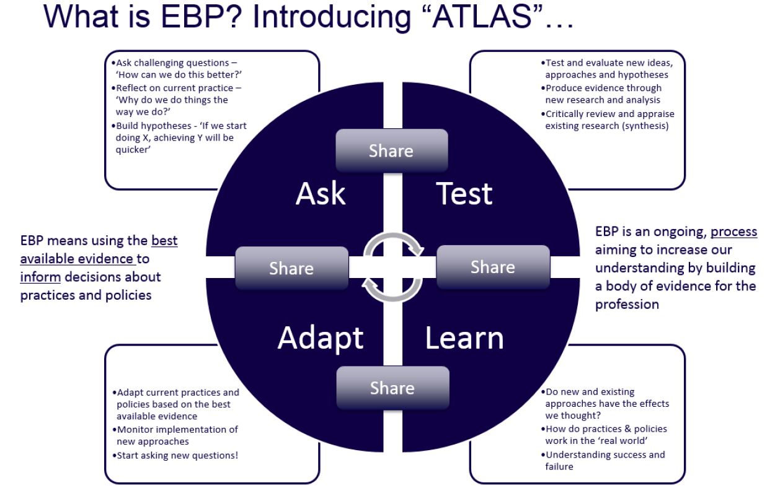
(College of Policing, 2021)



(Coslett, 2006)

