
Skills for the Workplace
Module Assignment Submission
Student Name: | Ana Maria Arcila Rengifo
Student Number: | 1714416
Module No: | BMSW5001
Module Title: | Developing Workplace Critical Thinking
Lecturer:  Date: | Dr Kenny Tang  17/08/2019

Contents
Introduction 3
Identify a management theory relevant to your role and critically assess its impact on your own beliefs, attitudes and values. 4
The impact of beliefs, attitudes and values on own workplace behaviour: 9
Apply the critical assessment of an appropriate management theory to evaluate how someone with different beliefs, attitudes and values might interpret the theory differently. 13
Conclusion 15
References 16

Introduction
Critical thinking has become one of the most important skills that should be present in an individual so that they can manage a number of staffs. This is done so that one does not completely rely on their beliefs or values but actually does the proper analysis so that proper results can be achieved. For the role of a manager, this skill is important because without it there would be no proper results achieved. The manager is one of the most important people that operate in an organization and there need to be proper characteristics that would help in influencing the workforce. There are many management theories that are present which help in assessing the beliefs, values, and attitude of managers. The organization taken for this task is Sainsbury’s which is a large supermarket chain based in London. Being a manager in such an organization is a hard task because the work is double and proper traits need to be maintained. All the factors are for making seeing what the behaviour of an individual is.
Identify a management theory relevant to your role and critically assess its impact on your own beliefs, attitudes, and values. Beliefs, values, and attitudes may have some things in common but are somewhat different from each other. It can be said that all these terms interlink with each other.

Belief: Can be described as a sense or feeling inside of a person that something is right or wrong irrespective of the fact that the belief may be irrational. There is no proof to support this type of feeling and it can be said that this a ‘gut’ feeling that one gets in a situation. This belief can either be wrong or right, but the person will always assume it to be true no matter how many proofs are shown to them. (Ciocirlan, 2017).
Values: At the standards which show what an individual’s behaviour is. Values are basically how an individual makes decisions based on what is important to them and what has been taught to them. Values of a person can reflect their beliefs as they will show what is wrong and what is right for that individual. When a person attaches themselves to something and sees that it is very important to them then it will reflect the values. Values are not just or individuals, but they are also present for organizations. The values of an organization help in seeing what the guidelines of the particular business (Schwartz, S.H., 2012).
Attitude: Of a person will show a way of expressing their beliefs and values. The attitude will result in how an individual behaves in an organization and what character traits they possess. An attitude of a person will describe how they will behave in certain situations. This term is known to be a settled belief or value about a certain aspect or belief (Hillson, & Murray-Webster, 2017).

Theoretical model:
.
Figure- Figure of Individuals behaviour
Source- By Author, 2019
From the theoretical model, it can be analysed that the behaviour of an individual often results from the three main aspects being beliefs, value, and attitude. An individual’s behaviour is made up of many factors like their personality, habits, etc. which help in showing who that person really is. The belief system is probably one of the main aspects that affect the decisions which are made. Beliefs will be in every part of the actions which is being done and also affect decisions in seeing what is wrong and what is right. Beliefs become a part of an individual’s behaviour through the experiences they go through and by reading or seeing news about a particular thing. This is then installed into the behaviour of the person from which the act in a certain situation. One thing that needs to be noted here is that if a belief were to change then there would be some parts of the person’s behaviour would change. If the core beliefs of a person are changed then there will be a major change in how the person will behave in the future (Scott, 2013).
Values: help in shaping the behaviour of an individual which by helping them define where they want to go in life. Values can be the life goals that a person wants to

achieve solve and due to this factor, it will be seen what their behaviour is whether they are slacking or working hard. It is seen that when an individual goes for an interview the managers are interested in knowing what their values, they regard the most so that their behaviour can be understood easily. For example, if a person would have a high value of honesty then they would not allow any type of corruption to happen under them. On the same side, there can be a person whose goal is to reach the highest level at any cost, and they will go any way possible for getting that position (Schwartz, S.H., 2012).
Attitude: An attitude of an individual is linked with both their values and beliefs. The attitude is one of the most prominent aspects that affect individual behaviour. This is because the attitude of a person would show on what type of behaviour, they possess like their behaviour may be aggressive in one situation and in another situation they might be calm. One thing that needs to be noted is that if a person has a bad attitude then this may affect the people around them, and they would also develop such an attitude (Lim et. al. 2017).
Being the manager at Sainsbury’s: there are many management theories that would need to be applied. Sainsbury’s is one of the largest supermarket chains that is operating in the United Kingdom. Being in the retail sector, the management theories used here would differ from the management theories that are used in other places. The theories used by the organization are based on the strategies used by it. The management theories that are being used in Sainsbury’s by the manager are as follows:
MGT theories: this report will evaluate Sainsbury’s why following theoretical One of the management theories that is used in the organization is known as the:
- Inventory management theory. This used in the organization because it will help in managing how much products are to be purchased for each supermarket. The Just-In-Time method is used in this theory so that the supply chain can run effectively. This is most helpful when there are last-minute deliveries to be decided on (Chen, &Simchi-Levi, 2012).

- Another theory that is used by the manager is the Behavioural theory of Management. This theory is selected because it deals with the behaviour of the employees. The theory is used so that the teams working in the organization would be successful. From this, there is constant knowledge and experience provided to the employees. Employee motivation is also implied in such a theory and would be helpful for the organization as there would be various employees to be dealt with. But the thing here is that every supermarket would need to have its own way to motivate the employees as each supermarket would be based in a different place (Lounsbury, & Beckman, 2015).
- The Administrative Management Theory: is also used in the organization. This theory was selected so that proper management would be maintained in the organization. If a manager does not have control over the organisation’s functions, then they will face loss. There are about 14 principles involved in this theory which help the organization personnel in doing their work. It measures their performance in which it sees what are the skills that they do not possess and makes sure to fill in this gap. The manager, with the help of this theory, can make the employees realize their roles and responsibilities towards the organization (Noe et. al. 2017).
McGregor: was the theorist of McGregor theory X and Y, which was chosen because his theory helped in defined what the attitude, belief, and values of employees are. In the theory of X, it is described for the managers who believe that the employees have little motivation and no regards for their work. The manager needs to keep on pushing such people and at the same time multitask so that positive results can be achieved. Rewards or punishment is part of theory X in order to achieved results. The manager is more of a boss than a leader as they will just keep on shouting orders for the work to get done quickly (Hattangadi, 2015).
For theory Y: managers believe that the workforce is always in a positive mood and are willing to work together for achieving better results. This would mean that the workers are self-motivated because they are happy to work in such an environment. They also view this work as growth opportunities for the workers through which they will gain new skills and attain more knowledge.

A critical assessment of your own beliefs, attitudes, and values on a particular management theory relevant to your role :
There are certain values, attitudes, and beliefs which are present in a manager that shows what their behaviour is. One of the theories that can be linked with all of these factors is the McGregor X and Y theory. This theory has the most connection with the factors mentioned because it deals with the individual’s behaviour.
Theory X: example for theory X. This theory shows that the manager's behaviour is targeted by the way they think about the employees. The managers that come under this theory are seen to believe that employees are not working as they are expected to. This shows that the manager believes that work should be the first and only priority. There should be nothing else on the employee's mind except work. This also shows that the attitude the manager is putting out is negative which may cause even the motivated employees to be demotivated. The attitude is linked with the values of the manager which are that the work should be done in the set time frame and there should be no reduction in the quality of the work. Such an example for this in the supermarket is that if employees are working at their best and the manager’s behaviour is that of according to theory X then they will have a negative impact on the work environment. But if there is a case that employees are not working up to their best potential then this theory X would be the best choice so that work performance can be increased. One of the beneficial factors that can be seen in this theory X is that there are a lot of motivational techniques which are used (Bojadziev et. al. 2016).
On the other hand, the managers from Theory Y would have different values, beliefs, and attitudes that would make their behaviour. The beliefs of managers in theory Y are that they think that the employees working in the organization are already self-motivated and do not need that much help from the managers. The values that are to be found in such managers is that their goal is to make sure that new skills and knowledge are gained by the employees in order to increase the output of the organization. Though all of this may lead to a more relaxed and friendly environment, there are some drawbacks to having such an attitude. This is that there are some employees who are present in the supermarket that is slacking off and not doing their work properly. Such employees may get away from not doing their work this resulting in demotivation for other employees as well (Hattangadi, 2015).
But being a manager that has the characteristics of both theory X and Y I would make sure that my beliefs and values are reflected in a positive way towards the employees. One way would be to use the theory Y and let the employees handle situations on their own so that employees would learn from their experiences. From theory X I would make sure that my values are achieved through positive motivational factors. This attitude would spread positivity throughout the organization hence leading to a better form of work to be done.
The impact of beliefs, attitudes, and values on own workplace behaviour:
The beliefs, attitudes and the values of the person affect the behaviour of a person its workplace. The managers are very much responsible for managing all these aspects in the organizational culture in order to enhance the working ventures of the organization (Ciocirlan, 2017).
As stated in the Kolb’s learning (David Kolb's in the year 1984) cycle that in case of a learning experience is not sufficient for the person and it is very necessary for the person to apply the experience, draw the own knowledge base and develop concepts and ideas which can be applied in the organizational ventures of the organization. According to Kolb if the reflection is not shown to the person than it would make the person to repeat the mistakes. (Tomkins and Ulus, 2016).
The beliefs of a person grow from what they see, observe, learn and read from the external sources. From all these things human beings develop an opinion about the trueness they hold. Our beliefs and view can also be strengthened by the experiences and evidence.
Being a manager in the organization it is very essential to comprehend the own beliefs and values and recognize the significance of not allowing the personal values and beliefs to affect the working with the staffs. As a manager in MNC like Sainsbury’s, it is very essential for not allowing their own values and beliefs to affect the clients and staff relationships. This makes the clients make decisions based on their own values and beliefs instead imposing personal beliefs on them as this could hamper the relationship of the firm with the customers and result in loss. Many times, it happens that the managers take care of their own attitudes without being unaware about the attitudes of the others around, but it is very essential to understand the circumstances and not allow the personal attitude and the behaviour to affect the staffs and the customers.
There are various management theories which are applied in our own work for the management of our own beliefs, values, and attitudes in the workplace, such as:
Behavioural management theory: The behavioural management theory is also called as the human relations association as it addresses the individual dimensions of work. The belief is that enhanced understanding of the human behaviour at the workplace such as the inspiration, prospect and the assemblage dynamics improves the efficiency of the person (Vasu, et. al., 2017).
The Sainsbury’s apply this theory in their working ventures as the manager it is very essential to create a safe and healthy work environment for the working of the employees and they should feel that their working, opinions and the ideas are valued by the organization in the workplace. Encouraging the staff to reflect their own behaviour and work enhances the productivity of the organization. Many managers tend to keep their employees within the vest which limits the growth potential and growth of the team as well, instead of that the managers are required to encourage the employees and provide them with the chance to enhance them improve their skills (Young, et. al., 2015).
As the manager, it would also need to be seen that growth opportunities regarding their career are provided to the employees. This is done because it will help to decrease the level of people that are leaving the organization. The other factor of this is that by giving growth opportunities to the employees the employee will set out their values to catch those opportunities and increase their level inside of the organization. By analysing the behaviour of the employees their job design can be done in that proper manner or the other way around so that candidates are selected according to the behaviour that is required for the job.
In Sainsbury’s, we managers prefer Maslow’s (Abraham Maslow,1943.) of needs theory, as it assists the managers to visualize the motivation of the workers in the place of work. It is one of the most valid theories for the management of human behaviours and the training and personal development of the employees. The Maslow’s theory of the chain of command of needs explains the responsibilities of the employers in order to make available the workplace environment to the employees that encourages the employees and provides them with the chance to fulfil their unique potential. ( Ashour, A.S. 1973.)
Maslow’s figure:
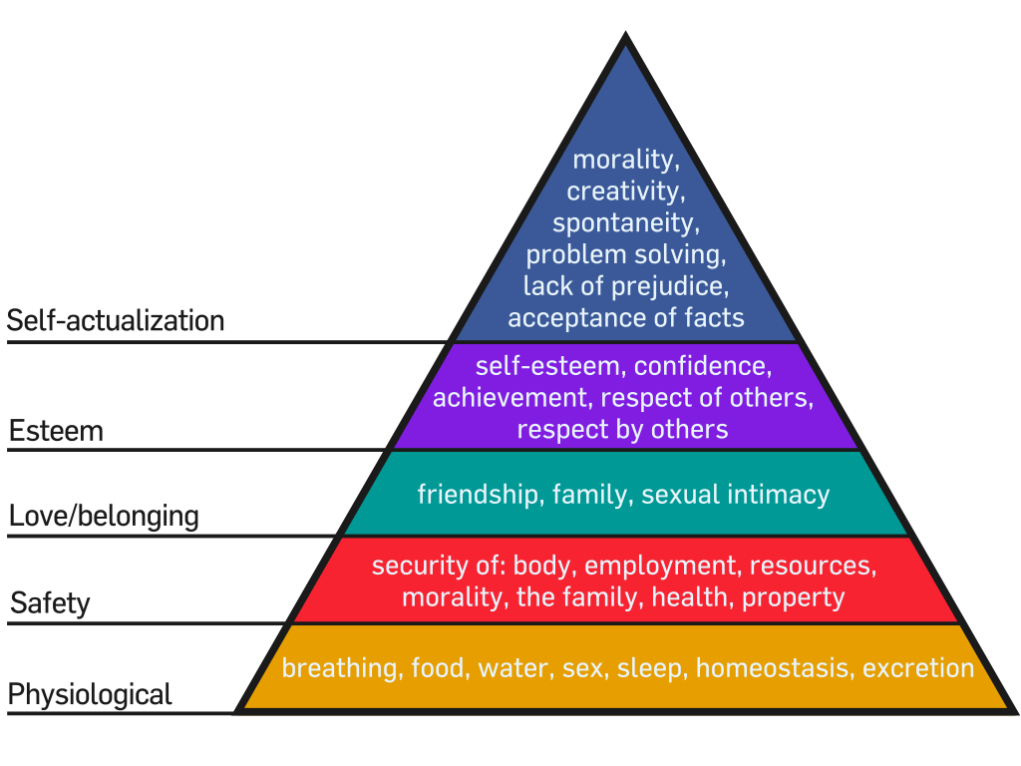

Contingency management theory: The contingency theory explains that there is no specific way to lead an organization. It all depends on the situation as what the situation demands from the managers, they are needed to do according to that. The course of actions of the leaders and the managers depends on the load of the situation they are facing.
Fred fielder’s (1958) contingency theory believes that the individuality of a head and the efficacy of a head is correlated. According to the theory, the leadership behaviour helps in certain circumstances, but the leader is needed to have a new set of ideas and concepts for every new and challenging circumstance. The contingency theory proposes three concepts that the managers and the leaders should use in the workplace like there is no single way to administer the organization, the leaders and the managers of the organization should be able to find the best and the most suitable management styles for achieve the intention and objectives of the organization at the particular circumstances and the slightest preferred co-worker (LPC) scale which method an executive leadership orientation (Manika, et. al., 2015).
As the manager of the Sainsbury’s: the above theories and concepts are very much relevant and have a positive impact on the working ventures of the organization as well as the employees. The motivation from the managers provides the employees with the chance to enhance their productivity and also their individual and professional growth increases. As the managers, these theories help us to effectively and efficiently deal with all the organizational issues and maintain a stable and getting better level of the output for the organization. The managers before analysing and applying these theories in their working ventures were very lax in managing the employees as well as were not able to bring much more profit for the organization in terms of the customer satisfaction but after the application of these theories we the managers are able to manage the employees in a better manner and able to motivate them firmly so that the employees could work in an enthusiastic manner and provide the employees with the exposure to express themselves in the working environment for better results (Ciocirlan, 2017).
- The manager should not be acting like a boss but instead, they should be working as a leader. More employees would look up to them in the way that positive influence can be generated. A leader would have the correct characteristics that would influence positive behaviour for the employees.
- The managers at Sainsbury’s provide the employees with information about the company as it is very essential for the managers to contact the employees and have an effective level of communication. The managers provide the employees with the encouragement and the credits towards their achievements and also provide the employees with the respect so that they could feel safe in the workplace and this helps the managers to encourage the employees in such a manner that they could provide the organization with the maximum output (Boehe, 2016).
- Sainsbury’s is a retail shop and thus the employees are needed to be very active in order to welcome the customers to the store and help them so that they could have great satisfaction while shopping with them.The employees in the child care areas are needed to be more enthusiastic in order to handle the customer’s kids in the shops so that they could have good experience with Sainsbury’s and for that the managers are needed to appreciate them as they are performing one of the toughest tasks for the satisfaction of the customers. The employees in the old people and payment areas are also needed to be helpful and the managers are needed to be supportive for them and should not let their personal views and beliefs to affect the nature of working of the workplace (Vasu, et. al., 2017).
McGregor X and Y Theory: By using McGregor’s X and Y theory, there are specific roles which would need to be identified. There are aspects of theory X which would help in keeping the employees up on their feet. In a supermarket, it is hard to keep all of the employees' performances high because there will be some of them who do not like working in such an establishment. To lift their spirits up, motivational factors would be used so that they could see how they can grow in their respective careers. This would help the people to have a change in their behaviour and their value would be to achieve such opportunities when provided to them. Creativity is yet another factor that can be used for the employees. If they arrange the products in a creative way or make sure that proper decoration is done during the time of different festivals (Lawter et. al. 2015).
The use of theory Y: could be done in the manner that giving opportunities to the employees so that they could realize their true potential. Realizing potential would lead to positive behaviour that would help them to take on situations on their own. It is seen that employers would want someone who can communicate and think critically. This would lead to a better work output from the employees hence directly benefiting the organization.
Drawbacks: There are drawbacks that come with this theory. One of them is that it is hard to change the behaviour of a person quickly as they are already accustomed to the way that they are working. Changing employee behaviour would not only require that opportunities are provided to them but also there would need to be other motivational factors.
- One main role of being a manager for a well-known organization like Sainsbury’s is that of creative thinking. The behaviour that is involved the manager is being that they7 will be able to solves problems in a creative way. They focus on the truth rather than making only relying on the beliefs. Proper research is done on what the truth is and then only is the action taken. There are certain standards which need to be followed like having logicalness so that it can be seen on what is right and what is wrong rather than just blindly following one's belief. The other standard is that in-depth research needs to be done in order to gain more information. If more information is gained about the situation or problem, then the results which are shown will be more accurate than before. It needs to be seen here that critical thinking is a process and not an outcome (Giauque, 2015).

Apply the critical assessment of appropriate management theory to evaluate how someone with different beliefs, attitudes, and values might interpret the theory differently.
- There are people in the world that would behave differently from the theories of management due to the fact that their beliefs, values, and attitude are different. Let’s take the example of a person that is using the Behavioural Theory of Management. In this theory, it was seen how an organisation manages the performance of employees. A person who has an attitude that does not like any employee and does not care about them then they will not worry about the performance of the employees. There are people whose values are to be at the top level of the organization. And to do this they will make sure that all of the employees are working extra hard irrespective of how they feel. This shows that the attitude of the manager is wrong and would only bring high employee turnover within the organization. There would be no sort of encouragement and the focus would only be on whether work is being done or not.
- The administrative management theory would see that all of the functions of the organization are working collaborate so that the result can be positive. If a person whose attitude is not good arrives then all of the functions would be in a mess. The values and beliefs that are possessed by such a person are not that high meaning that their beliefs can easily be changed. At one moment they may be for something and at the next moment, they would go against such a factor. (Giauque, D., 2015).
- McGregor’s theory X and Y explains perfectly how a person with different values, beliefs and attitude acts in various situations. In one situation there might be a person who does not give any attention to what is going around them and on the other hand, there is a person who is fully aware of what is going around them. Some of the individuals in this theory would apply critical thinking to get to the bottom of the problem while there might be others who just would go trust their belief and not even see what is wrong or right. (Hattangadi, V., 2015.)

Conclusion
From this report, it can be seen that values, beliefs, and attitude are the factors which make up an individual’s behaviour. There were various theories which were seen in which some were seen in relation to the role of a manager while others were seen just relating to the factors. The role of a manager helped to see how these factors affect the work which was being done and how did the role of the management theories such as McGregor’s Theory X and Y play a role in it.
The behaviour of an individual toward their work can be according to their values and beliefs but the attitude of other people may change the way an individual behaves. In conclusion, it can be said that a manager needs to have the right set of values, beliefs, and attitude in order to manage the whole realize in the correct manner. Such examples were seen in Sainsbury’s as the role of the manager required that they behave in a certain way so that work can be done in the right manner.

References
Boehe, D.M., 2016. Supervisory styles: A contingency framework. Studies in Higher Education, 41(3), pp.399-414.
Bojadziev, M., Stefanovska-Petkovska, M., Handziski, V. and Barlakoska, G., 2016. Age related preferences of leadership style: Testing McGregor’s Theory X and Y. Journal of Management Research, 8, pp.187-207.
Chen, X. and Simchi-Levi, D., 2012. Pricing and inventory management. The Oxford handbook of pricing management, pp.784-824.
Ciocirlan, C.E., 2017. Environmental workplace behaviors: Definition matters. Organization & Environment, 30(1), pp.51-70.
Giauque, D., 2015. Attitudes toward organizational change among public middle managers. Public Personnel Management, 44(1), pp.70-98.
Abraham Maslow. Theory x & theory y. International Journal of Recent Research Aspects, Ashour, A.S. (1973) ‘The Contingency Model of Leadership Effectiveness: An Evaluation’, Organizational Behavior and Human Decision Processes, 9(3): 339–55.
Hattangadi, V., 2015. Theory x & theory y. International Journal of Recent Research Aspects, 2(4), pp.20-21.
Hillson, D. and Murray-Webster, R., 2017. Understanding and managing risk attitude. Routledge.
Lawter, L., Kopelman, R.E. and Prottas, D.J., 2015. McGregor's theory X/Y and job performance: A multilevel, multi-source analysis. Journal of Managerial Issues, pp.84-101.
Lim, X.J., Cheah, J.H. and Wong, M.W., 2017. The impact of social media influencers on purchase intention and the mediation effect of customer attitude. Asian Journal of Business Research, 7(2), pp.19-36.
Lounsbury, M. and Beckman, C.M., 2015. Celebrating organization theory. Journal of Management Studies, 52(2), pp.288-308.
Manika, D., Wells, V.K., Gregory-Smith, D. and Gentry, M., 2015. The impact of individual attitudinal and organisational variables on workplace environmentally friendly behaviours. Journal of Business Ethics, 126(4), pp.663-684.
Noe, R.A., Hollenbeck, J.R., Gerhart, B. and Wright, P.M., 2017. Human resource management: Gaining a competitive advantage. New York, NY: McGraw-Hill Education.
Schwartz, S.H., 2012. An overview of the Schwartz theory of basic values. Online readings in Psychology and Culture, 2(1), p.11.
Scott, W.R., 2013. Institutions and organizations: Ideas, interests, and identities. Sage Publications.
Tomkins, L. and Ulus, E., 2016. ‘Oh, was that “experiential learning”?!’Spaces, synergies and surprises with Kolb’s learning cycle. Management Learning, 47(2), pp.158-178.

Vasu, M.L., Stewart, D.W. and Garson, G.D., 2017. Organizational Behavior and Public Management, Revised and Expanded. Routledge.
Young, W., Davis, M., McNeill, I.M., Malhotra, B., Russell, S., Unsworth, K. and Clegg, C.W., 2015. Changing behaviour: successful environmental programmes in the workplace. Business Strategy and the Environment, 24(8), pp.689-703.

