

Jamie Tavender/Rhian Pole/John Apps

Using Word – Outline Mode
1. Open Microsoft Word and create a new blank document.
2. Select the View tab on the ribbon.
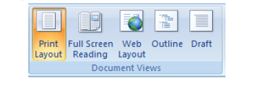
3. On the Document Views Select Outline to view the available tools.
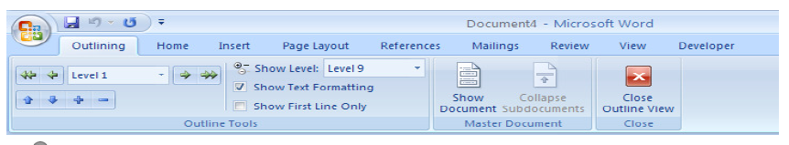
4. You will need to insert a Title page and a page for the Table of contents you can do this by clicking on the Page Layout tab select Breaks then Next Page do this for each of the pages (2 in total)

N.B Press Enter twice before selecting Next Page
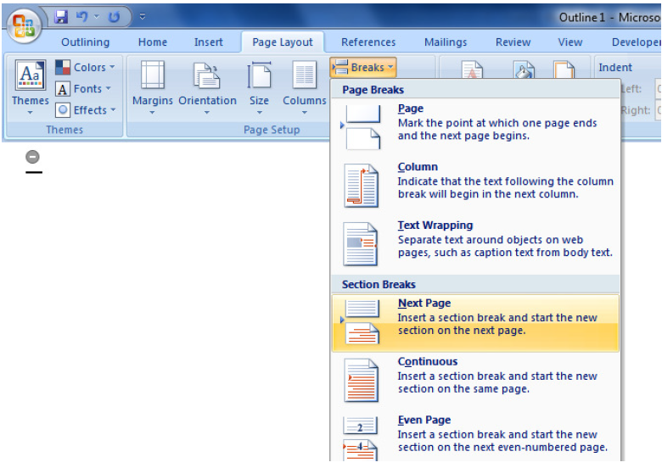
5. Return to outline mode by clicking on the Outlining tab
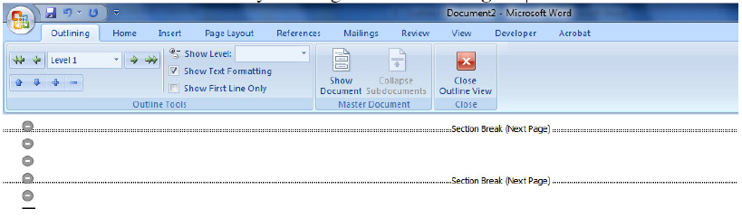
6. Type the following text (making sure that Level 1 is selected):

Executive Summary
1. Introduction
2. Main Findings
3. Conclusion
4. Recommendations
5. References
6. Appendices

These are the headings for a business report. The document should look like as shown below.
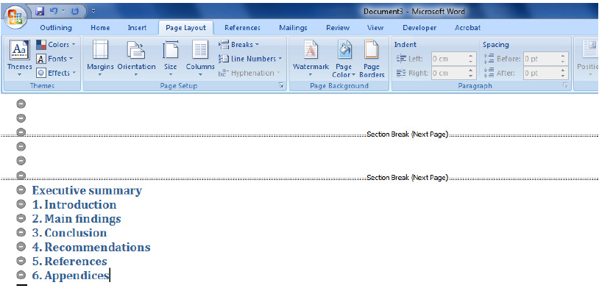
7. The Main findings have a number of sub-headings (Level 2). To add these create a blank line after the Main findings and press the green right pointing arrow  to select level 2 headings.

8. Add the following level 2 headings:

2.1 What goes in the main findings section?
2.2 How to structure your main findings
2.3 Use subheadings
2.4 Numbering sections – first subsection
2.5 Signposting

The document should look like as shown below.

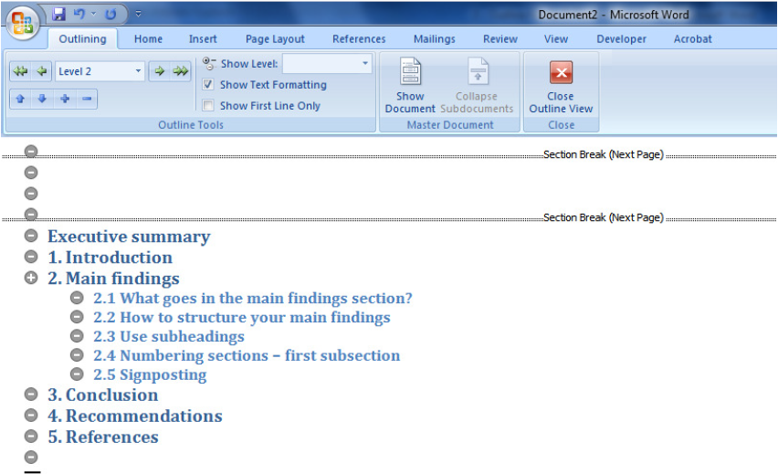

9. The Numbering section has a number of sub-sub-headings (level 3). To add these create a blank line after the Numbering section, press the green right pointing arrow  to select level 3 headings.

10. Add the following level 3 headings:

3.4.1 Second subsection

N.B you can also further subsections by selecting further levels such as level 4

3.4.1.1 Further subsections and so ...

The document should look like as shown below:

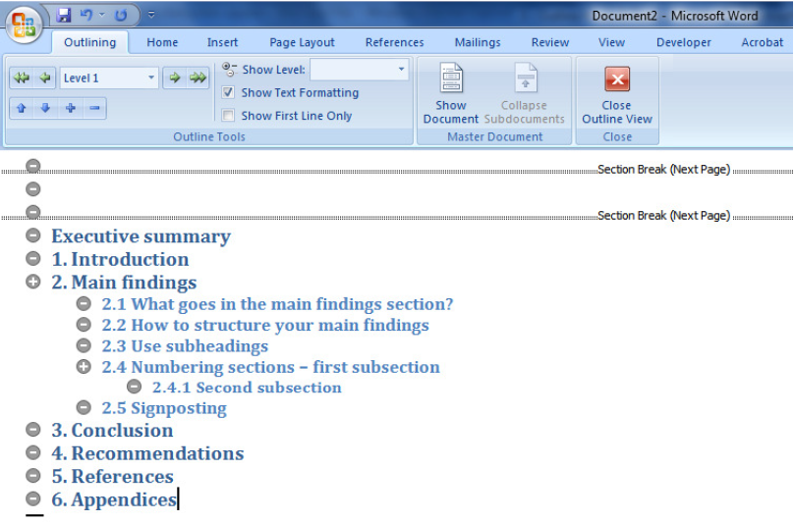

11. Please note that a plus sign indicates a level (such as numbering sections) has associated content. You can hide or display content at the lower levels by clicking on the symbol.

12. Create a blank line after Executive summary and click the double headed right facing arrow  to add Body Text.

13. Add the text shown below as the Body Text for Executive Summary:

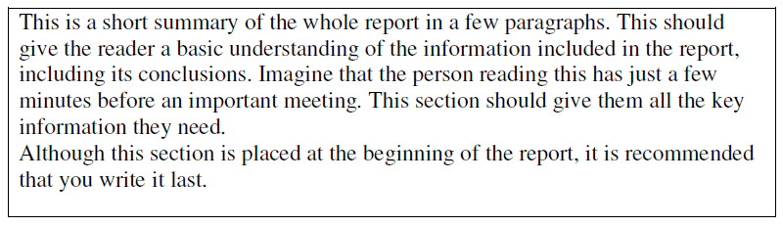

14. Add the text shown below as the Body Text for Introduction:

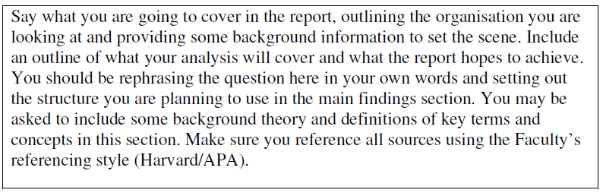

15. Add the text shown below as the Body Text for what goes in the main findings?

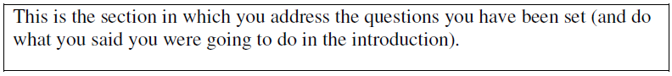

16. Add the text shown below for How to structure your main findings?

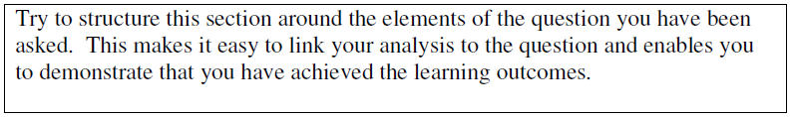

17. Add the text shown below for Use subheadings:

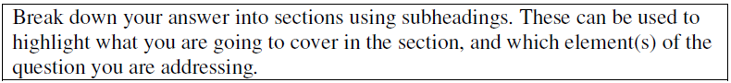

18. Add the text shown below for signposting:

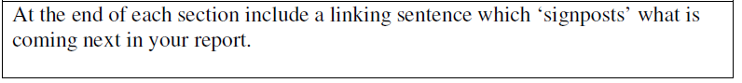

19. Add the text shown below for Conclusions:

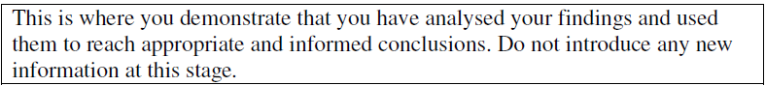

20. Add the text shown below for Recommendations:

21. Add the text shown below for References:

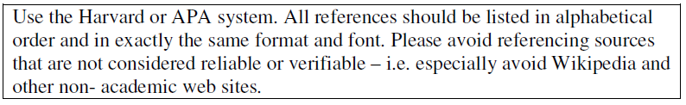

22. Add the text shown below for Appendices:

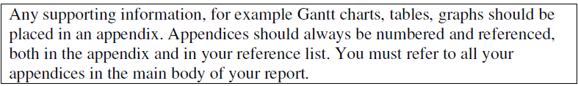

The document should look like one shown below.

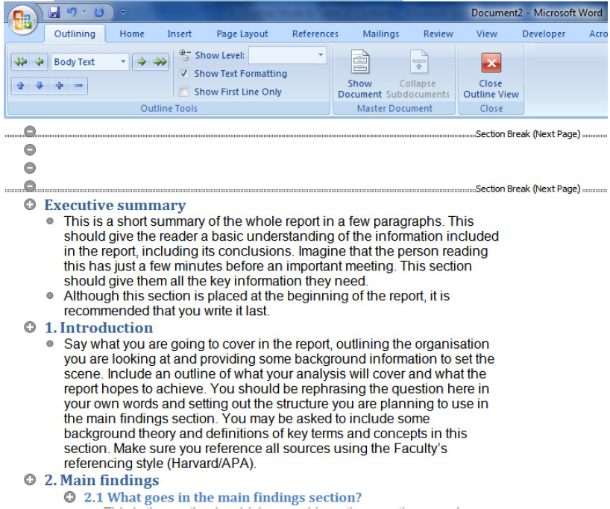
23. You need to create a new page for each of your level 1 headings (a new page is automatically created for the first heading Executive Summary) Place your cursor just before the No.2 Select the Insert tab and Click Page Break you need to do this for each of the Level 1 headings.

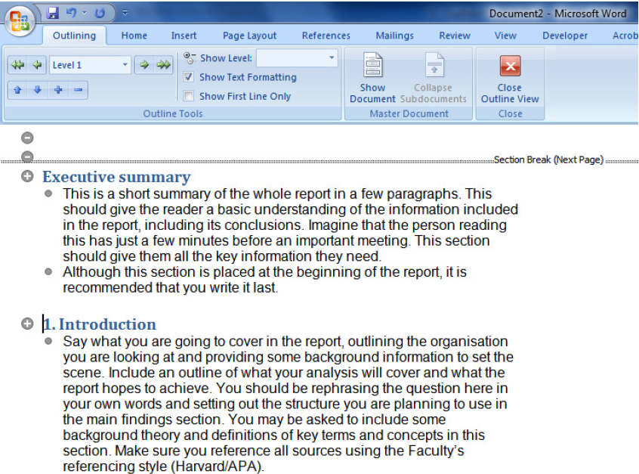

24. Return to outline mode by selecting the Outlining tab

25. Close the Outline Mode by using the 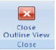 button.

You have created a basic structure for your report; you will see that the first two pages are blank to allow for a Title page and a page for your table of contents.

Using Outline Mode to Generate a Contents Page

1. Now to add the contents page!

2. Click on Page 2 and Type – Table of Contents, highlight the text Table of Contents and select an appropriate font and size

3. Click on the References tab (see below).

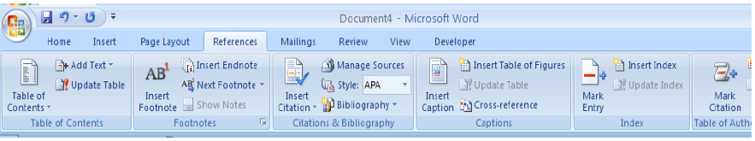

In the Table of Contents section and click on the  button and select Insert Table of contents

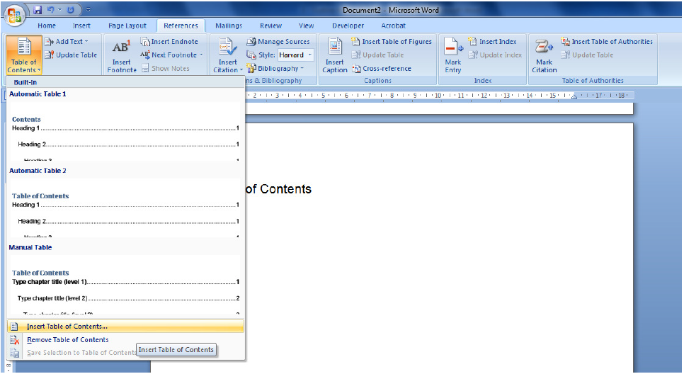

Check that all the level headings you require are selected i.e., that is three levels should be displayed. Click OK

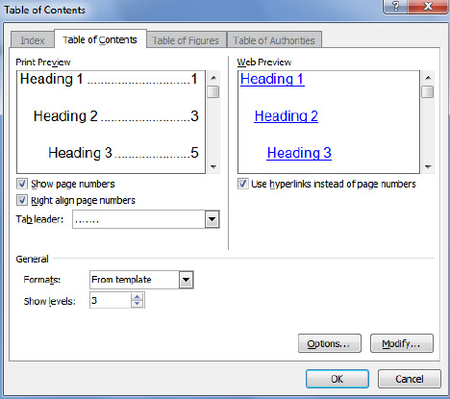

A contents page is now created with all the level headings correctly formatted and associated page numbers.

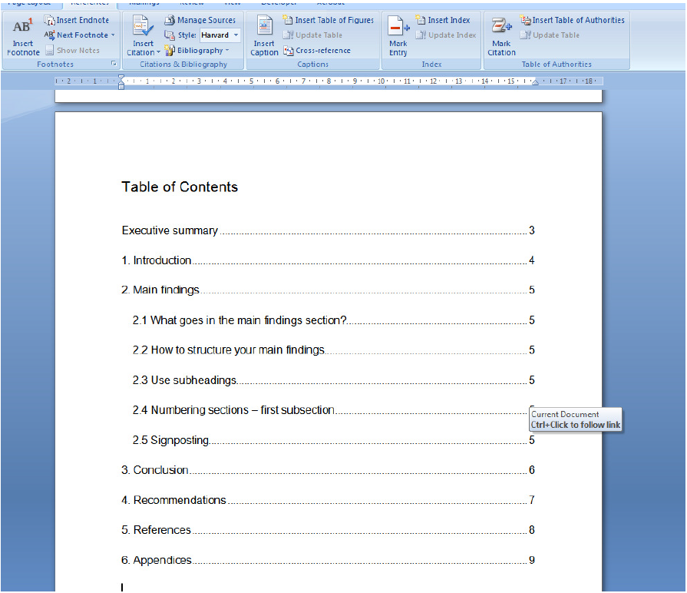
Move the Conclusion level heading using insert page break. The contents page is now out of date. This can be changed with little effort. Click inside the contents page and it will look that show below.

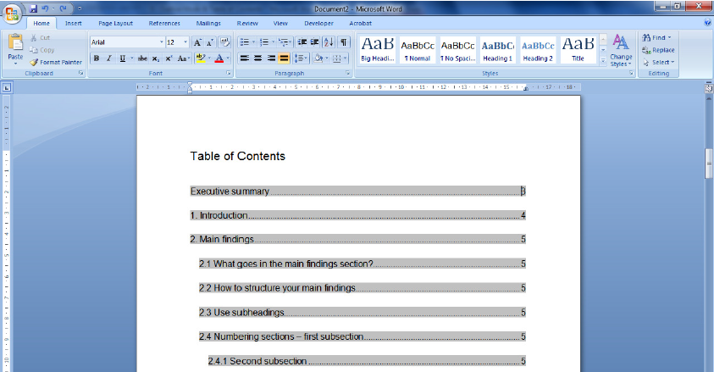

Right click and select Update field.

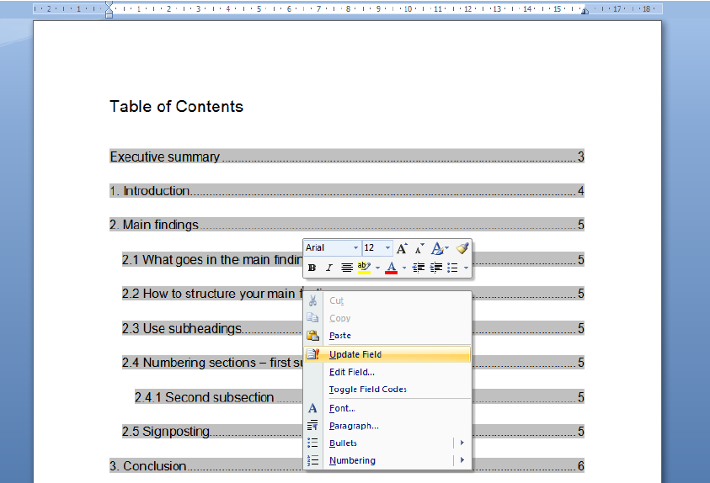

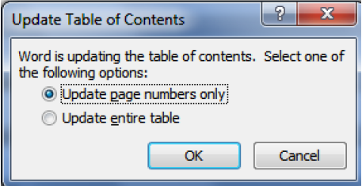

Select update page numbers as in this instance only the page numbers would have changed alternatively if you have changed any headings as well select update entire table.

The new page numbers will be displayed in the Contents Page. Note that the Conclusion is now on page 7. A benefit of using this type of contents page with a long document is that if you press the CTRL key and Click on a heading then the document will move directly to that page.

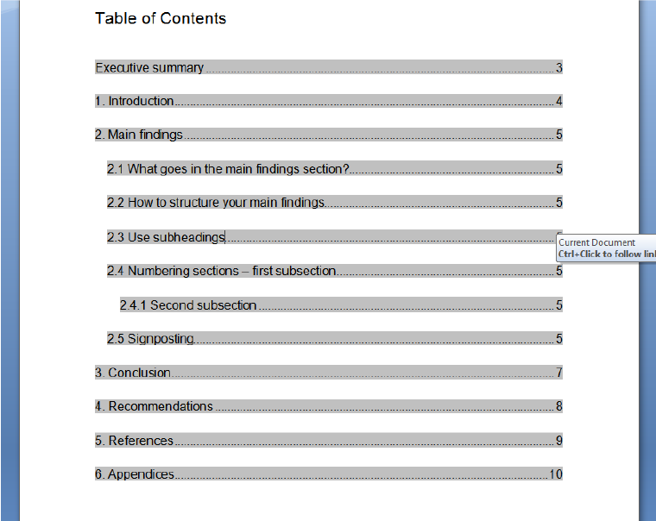

To complete the report format go to page 1 of the document and create a title page. There are two ways to create a title page.

All title pages should include the following information – All text in italics is for guidance only and should be removed before submission.

Title (replace with the report title)

Name: (Your name)
Module: (Module title)
Assessment number: (e.g. “4” for first year degree/HND/HNC, “5” for second year
“6”for final year, “7” for Master’s level)
Assessment title: The title from your assignment specification.
Lecturer: Your lecturer’s name
Submission Date: The hand in date
Word count: You must include an accurate word count

You can insert a built in cover page and edit the details to include the information above.

Click the Insert tab and select cover page a drop down box appears and you can make a selection from the many styles available.



