
fd
APPENDIX GA36a

LEVEL 4 ASSESSMENT SPECIFICATION

Student name: | Parry Phillips | Student ID number: | 2011664
Programme: | PT Engineering Portfolio
Module: | Engineering Design
Module code: | ACMA4008 | Contribution to Overall Module Assessment (%): | 50%
Lecturer: | Kevin Rogers | Internal Verifier: | Andrew Noble
Assignment Title: | Engineering Problem | Word count (or equivalent): | 2000 Words
Submission deadline: | 20/01/2025 | Return date of provisional marks & written feedback: | Within 20 working term time days of submission date
Submission method: | All written assessments, where practical and possible, must be submitted via Turnitin unless otherwise instructed by the Lecturer. (Please DO NOT put this assessment specification into Turnitin or it will match many similarities with other students’ submissions.)  Alternative submission method (if applicable):  Late submission of the assessment will result in a late penalty mark. Penalties for late submission: Up to one week late, maximum mark of 40%. Over one week late, 0%. Only the Extenuating Circumstances Panel may approve a change to submission dates.
Academic honesty / referencing: | Academic honesty is required. In the main body of your submission you must give credit to authors on whose research and ideas your work is based. Append to your submission a reference list that indicates the books, articles, etc. that you have used, cited or quoted in order to complete this assessment.
Module Learning Outcomes
(from module syllabus)
- Show a detailed knowledge and understanding of the design processes and the ability to apply them and evaluate their effectiveness; the impact of and from the environment and legislation factors on the design process and engineering companies.
- Demonstrate skills in communicating the design, material and manufacturing of products through to the preparation and reading of Engineering Drawings to BS8888 through the medium of 2D and 3D CAD tools.
- Demonstrate cognitive skills to allow choice of material and manufacturing processes to meet specific design criteria with relationship to manufacturing volume, mechanical properties, cost, dimensional accuracy and automation.
- Demonstrate key transferable skills in problem formulation and decision-making, communication and self-management skills as well as working with others.

TASK DESCRIPTION

Use of Generative AI in Assessment
(Lecturer to indicate Yes or Not against each element)

RESEARCH | For this assessment, you can use Generative AI to support you in research, including searching for bibliography, using tools to summarise, compare and interrogate materials. | Yes ☐  No ☒
STRUCTURE | For this assessment, you can use Generative AI to support you in structuring your submission, including creating a draft argument structure, identifying parts and headings, etc. | Yes ☐  No ☒
PROOFREADING | For this assessment, you can use Generative AI to check your own text/creation for grammatical and syntactical mistakes, including rephrasing of your own work within specific standards. | Yes ☒  No ☐
WRITING | For this assessment, you can use Generative AI to create text for submission. | Yes ☐  No ☒
CREATIVE | For this assessment, you can use Generative AI to create creative materials, such as images. | Yes ☐  No ☒
PROGRAMING | For this assessment, you can use Generative AI to create and check code. | Yes ☐  No ☒
NONE | For this assessment, you are not allowed to use any type of Generative AI support. This includes research support, structure support, writing/proofreading support and creative support. | Yes ☐  No ☒

The aim of this assessment is to provide students with an opportunity to experience the process of carrying out a design project. The context for the assessment is that you work as a design engineer at an automotive original equipment manufacturer (OEM). There has been an ongoing problem with a process on the production line, and your line manager has tasked you with finding a solution.

The problem is related to a tank used in an anodisation process. Several manufactured aluminium parts are anodised for aesthetic reasons and to protect the part from degradation. The process involves hoisting the parts into a stainless-steel tank which contains 30% sulphuric acid and is heated to 25 degrees Celsius. An illustration of the tank is below, note that all insulation, electrodes and heating elements have been removed for clarity.

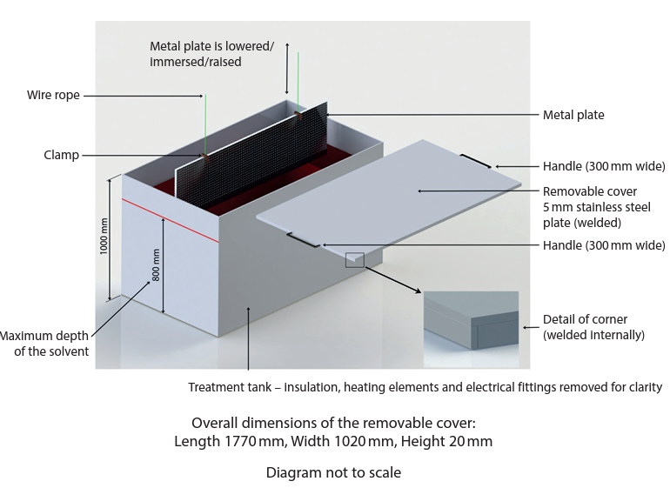

When the tank is not in use, a removeable cover (shown in the illustration) is placed on top for health and safety purposes. This cover is currently made from 5mm thick stainless steel. The cover has 2 handles on either side and requires a 2-person lift. Staff have complained that it is very challenging to place the lid on correctly and the health and safety officer has highlighted this operation as a major risk to staff. There are dozens of these tanks at your facility, and many others at the company’s other sites, so would likely require volumes in the low hundreds. Your line manager would like you to design a solution that considers:

- Must be safe to operate
- Operated by a single person
- The tank dimensions and material must remain the same, but modifications can be made
- The tank lid can be altered as the designer sees fit
- There must be clearance from above, to allow the aluminium parts to be lowered into the tank

When a material was being chosen for the tank, tests were carried out for a material comparison. The average results of these tests have been provided in the table below. This information could be summarised and used to justify material choices.

Material | Polypropylene (PP) | PVC (Polyvinyl Chloride) | Stainless Steel (SS304) | Aluminium (Al 6061)
Acid Concentration (%) | 20 | 10 | 15 | 10
Temperature (°C) | 25 | 20 | 25 | 20
Visual Inspection | No visible signs of degradation or discoloration observed after 24 hours of immersion. | Significant surface degradation and discoloration observed after 24 hours of immersion. | No visible signs of degradation or discoloration observed after 24 hours of immersion. | No visible signs of degradation or discoloration observed after 24 hours of immersion.
Weight Change (grams) | Initial: 50.0  Final: 49.9 | Initial: 60.0  Final: 55.0 | Initial: 70.0  Final: 70.1 | Initial: 45.0  Final: 45.0
Dimensional Change (cm) | Initial: 10 x 10 x 1  Final: 10 x 10 x 1 | Initial: 15 x 15 x 1  Final: 14.5 x 14.5 x 1 | Initial: 10 x 10 x 1  Final: 10 x 10 x 1 | Initial: 20 x 20 x 1  Final: 20 x 20 x 1
Tensile Strength (MPa) | Initial: 30  Final: 29 | Initial: 25  Final: 10 | Initial: 200  Final: 198 | Initial: 150  Final: 146
Hardness (HRB) | Initial: 80  Final: 79 | Initial: 70  Final: 50 | Initial: 200  Final: 198 | Initial: 120  Final: 118

You are expected to follow the stages of the product design cycle and produce a professional standard design report which includes:

- Introduction and interpretation of the client brief
- Key legislation considerations
- Specification
- Time plan for producing the product
- Relevant research
- Annotated sketches of multiple design concepts
- CAD model of the final design
- Fully dimensioned technical drawings (BS8888), with material choices and tolerances
- Manufacturing processes for each component
- A full justification for design choices
- Conclusion and further work

Engineering Design
Lecturer: Kevin Rogers
Author: Parry Phillips

Table of Figures:

Figure 1. Stainless Steel US$/KG Price 12
Figure 2. Polypropylene US$/KG Price 13
Figure 3. Results of testing Polypropylene. 13
Figure 4. Manual Handling Guidance 16
Figure 5. Pricing for sheet of Polypropylene 20

Introduction:
Engineering design is series of steps and processes that engineers utilise to create functional products to remove problems and provide continuous improvements on its predecessor and competitors. Multiple decision-making processes which involve engineering studies and data allow the designer to methodically eliminate contrasting ideas to come up with most financially suitable and effective products.

Client Brief:
As a design engineer at an automotive original equipment manufacturer, the engineer has been tasked to investigate an ongoing problem on the production line. The problem relates to a removable cover that is used to cover a tank that contains 30 percent concentration sulphuric acid which is heated and maintained at 25 degrees Celsius.

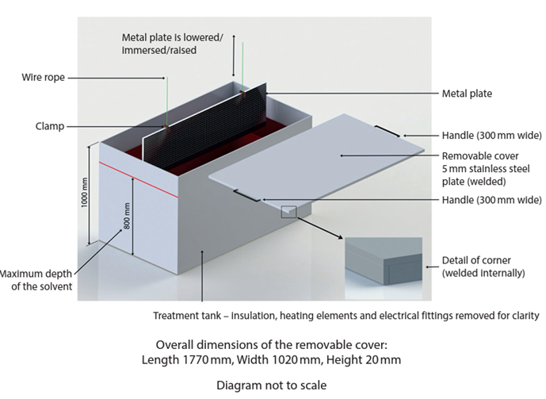

The cover is removed when adonisation of aluminium parts is carried out which is essentially, where the metal is dipped and undergoes a process and then the part is removed. The problem arises during the transition of the cover being removed and then being refitted. Due to health and safety the cover needs to remain in place when the tank is not in use. Other stipulations that the new design must incorporate are as follows.

- Must be safe to operate.
- Operated by a single person.
- The tank dimensions and material must remain the same, but modifications can be made.
- The tank lid can be altered as the designer sees fit.
- There must be clearance from above, to allow the aluminium parts to be lowered into the tank.

Legislation for guidance:
The purpose of legislation is to provide a set of rules and expected behaviours that persons and organisations should follow (National Audit Office, 2021). The legislations and regulations can be set by regulated bodies, their job is to ensure that the rules are followed by the company or persons it affects. Well established legislations have proven to increase efficiency and effectiveness in many fields of work (National Audit Office, 2021).

Many legislations will cover engineering aspects, and these will need to be adhered. The main aspects that concern designing and manufacturing a new functioning lid for the tank are safety, environmental and legal / ethical legislation.

Health and safety at work Act. 1974., this piece of legislation will highlight that the employers have a duty of care to protect you employees and others from harm (Health and Safety Executive, 2024). The new cover will have to be risk assessed to identify any new hazards that could arise from the design implementation and cause harm to persons in the workplace, measures must be implemented to reduce risks.

Due to the operation of the task involving lifting, the Manual handling at work legislation will need to be considered, any new design will have to avoid hazardous manual handling operations so far as reasonably practicable and asses the risk of injury to workers from hazardous manual handling if the lifting operation is not removed from the task (Health and Safety Executive, 2020).

Finally, the copyright, designs and patents act 1988 will need to be investigated to ensure protection of the design in a future tense but also any infringement when creating a design (GOV.UK, 2021).

Design Elimination:
Several contrasting pathways were discussed by the design engineers to ensure a thorough analysis resulting in the best option for the client.

Lighter Lid Material and two-part system
The design engineers firstly identified a simplistic design that tackled those problems identified by the client.

A lighter lid manufactured out of Polypropylene (PP) to reduce the weight of lid significantly (Protolabs, 2023) so that one person can lift the lid with ease. The lid will also have to be separated into two sections, to allow for one person to remove the lids. Each section of the lid will have handles fitted to assist lifting of the lid. A recess will be cut into the lid with a seal to reduce the likelihood of the lid falling into the tank. The seals will prevent acid vapour from escaping the tank.

Advantages of Design:
- The manufacturing of the lid design would be cheaper due to use of PP compared to previous metal of stainless steel. Prices can be seen in figure 1. and figure 2.

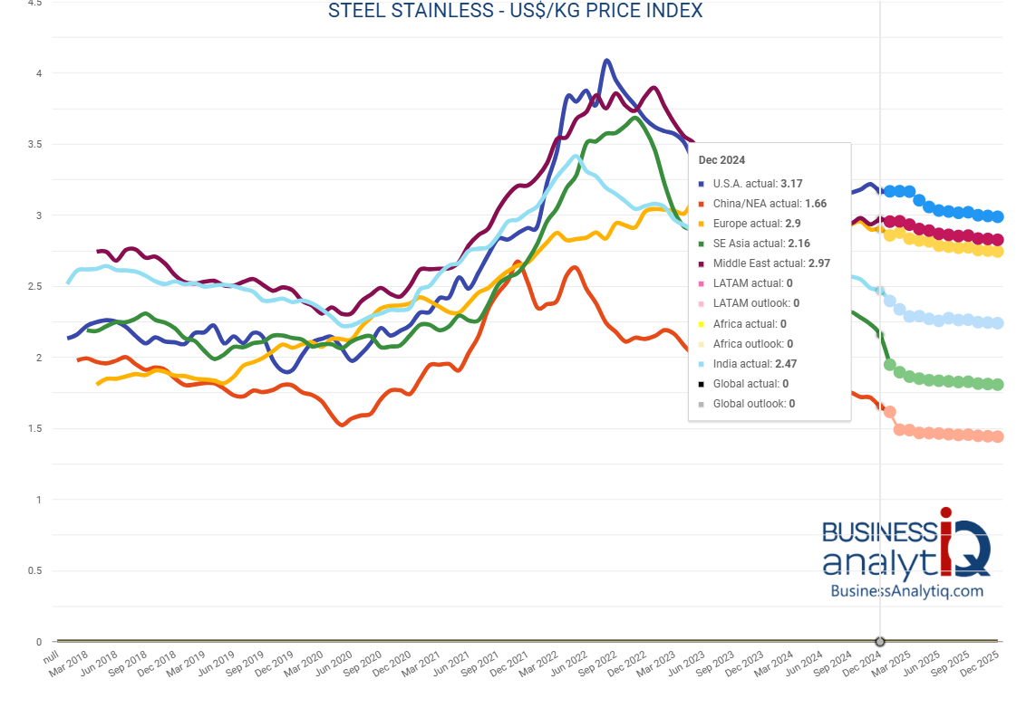
Figure 1. Stainless Steel US$/KG Price

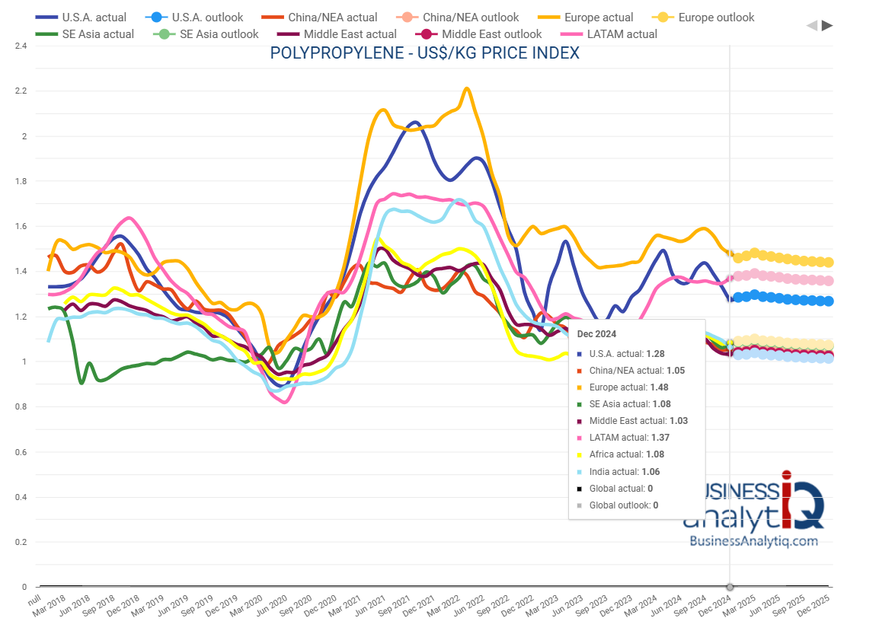
Figure 2. Polypropylene US$/KG Price

- Multiple manufacturing methods can be utilised depending on number of lids required. For low production quantity 20mm thick PP sheeting can be ordered and fabricated to size (Cut Plastic LTD, 2024). For higher production quantity extrusion could be utilised with the width and depth of the sheet matching the die and then cut to length.
- Chemical resistance of PP would ensure no degradation during the process. Other testing data was utilised and found that at 60% Sulphuric Acid at 20 degrees Celsius resulted in “negligible effect (should be suitable for all applications where these environmental conditions exist)” (Braskem S.A., 2005).
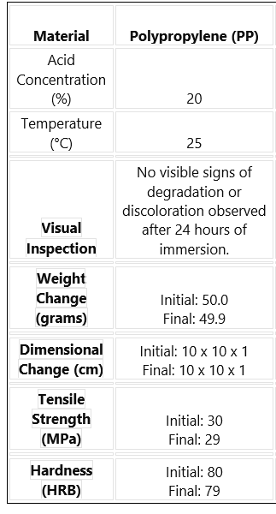
Figure 3. Results of testing Polypropylene.

- Weldability of the material to allow for PP handles to be easily attached (HYDRO PLAST, 2015).

Disadvantage of the Design:

- Lid can potentially fall into tank with human error.
- Lid separated into sections more labour for persons.
- Aesthetically a plastic lid is not as professional looking as a metal lid.
- May need to be upgraded into future due to potential of an automated system dipping system and opening lid.

One part system with hinges:

The design engineers then wanted a contrasting design that tackled those problems identified by the client.

A hinged lid with gas struts would utilise mechanical advantage to remove most of the physical work of lifting the lid. The gas struts would need to be positioned to not interfere with the dipped material. A handle would be welded to the lid to assist the operator at the start of the opening of the lid. The lid would be manufactured with stainless steel. The gas struts would need to be resistant against chemical corrosion due to sulphuric acid vapours.

Advantages of design
- Mechanical advantage provided by the gas struts leading to easy opening of the lid eliminating manual handling.
- Any liquid on the underside of the lid can run back into tank avoiding the need for drip tray.
- Stainless steel can be welded to fit the handles.
- Gas struts can be welded or fitted with a fastener.

Disadvantages of design
- Gas struts components would need to be chemically and corrosion resistant to sulphuric acid vapours, could cause failure of struts and delay process.
- High cost as many components of design.
- More maintenance due to multiple mechanical parts.
- Process likely to be made automated in near future, which would render product change.
- Small clearance (200mm) from top tank to level of acid, potential for splashed acid to damage struts.

Design Justification
The engineering team decided to proceed with the two-part polypropylene lid. The justification will follow. Weight and handling played a big role in deciding which lid system to proceed with. Polypropylene lids drastically reduce the manual handling requirements due to the weight only being approximately 8.5kg for each lid which is in line with the manual handling requirements guidance (Health and Safety Executive, 2024). Due to weight and function of the lid the hazard of crush injuries is drastically less then a heavy metal lid that relies on hinges to open which can fail if maintenance is not carried out.
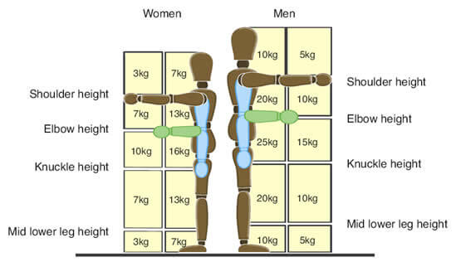
Figure 4. Manual Handling Guidance

PP has a density of approximately 900kg/m3 (K.D. Feddersen GmbH & Co. , 2023) compared to stainless steels approximate of 7500kg/m3 (TW Metals Distrubutor, 2023). The hinge system would be susceptible to localised strain on the hinges which would entail more maintenance. The PP system has only one mechanical component being the welded handles compared to multiple hinges or gas struts. Overtime due to wear, or incidents there is potential for misalignment leading to lid the not working as intended.

The material cost is between SS and PP is significant, with stainless steel costing 2.9$ per kg while PP is 1.48$ per kg. the volume of the lid is approximately 0.018m3 which would calculate to mass of steel lid to be (0.018 x 7500) 135kg compared to 17kg if the PP was in one whole section. The price can be derived from the weight, this excludes the manufacturing, machining and labour costs however the final cost will be significantly cheaper.

Specification for anodising tank with removable lid:

Requirement Specification
The purpose of the modifications to the lid and tank are to eliminate the hazard or reduce the risk of transitioning the lid on or off which has been described as ‘very difficult’ by employees and deemed as a major risk task by the health and safety officer. With the necessary modifications the transition of the lid will be safely performed by one person with ease. The tank will remain the same dimensions and material, but additional modifications will be added. The tank lid will be changed as the designer sees fit. Suitable above tank clearance will be left to ensure the aluminium parts to be dipped can be lowered into the tank.

Design Specification
To meet the requirements instructed by the company, a two-part polypropylene tank lid with handles will be installed with a recess cut to allow the lid to sit flush against the tank. This will ensure safe operation by one person due to the lightweight material and ease to carry with the handles. Depending on the required amount of tank lids will affect the manufacturing process. If less then 5 tank lids are needed, polypropylene sheets will be ordered near the dimensions of the lids and machined to length and to cut with a recess. The handles will be welded onto the lid then. This will result in a higher cost price for the customer as it is cheaper on larger scale to produce the sheets through extrusion rather than buying readymade sheets. (insert source and figures)

Technical Specification
Functional Requirements
- Two-Part Design Split the lid along its length (1770 mm) so each panel is approximately 885 mm × 1020 mm in plan.
- Each panel must be light enough for a single-person lift (target mass < 10kg)
- Each panel must have two polypropylene handles on each lid section, welded securely on top.
- A recess on the underside of each panel must align with the tank’s top flange so that the lid sits flush.
- The polypropylene grade must withstand exposure to acid fumes and normal production temperatures (~25 °C).
- Expected lid lifetime of at least 3–5 years with regular cleaning and maintenance.
- The lid should support the static weight of an operator leaning or placing tools without significant deformation.

Dimensions and Tolerances
- Overall Lid Assembly:
Length (2-panels combined): 1770 mm ± 0.5 mm
Width: 1020 mm ± 0.5 mm
Thickness: 10mm
- Individual Panel:
Length: 885 mm ± 0.5 mm
Width: 1020 mm ± 0.5 mm
Underside Recess: 5mm depth cut, 10mm cut into perimeter of lid.
- Handles:
Handles to run parallel with short edge (1020mm) Centred evenly vertically and 25% in from short edges (442.5mm)
Adequate finger clearance.
- Mass
Volume: 885mm x 1020mm x 10mm = 0.009027m3
Density = 905 kg/m3 (British Plastics Federation, 2024)
Mass = 905 x 0.009027
Mass = 8.17kg + handle mass (0.113kg x 2 handles)
Mass = 8.396kg of lid assembly

Materials and Construction
- Polypropylene Sheet
Density: ~905kg/m³
Grade: Homopolymer or copolymer PP suitable for chemical resistance; confirm with supplier.
Finish: Smooth or lightly textured surface; edges deburred or chamfered to remove sharp corners.
- Handles to be bought in stock and welded to sheet.
Visual inspection for weld checking for no porosity. Perform sample destructive tests if required.
.
Performance & Testing
- Chemical Resistance
Expose sample coupons to 30% sulphuric acid fumes for 72 hours checking for discoloration, softening, or cracking.

- Mechanical Strength
Deflection testing to be carried out by placing a uniformly distributed load of 25kg on each panel (estimated load from tools and personal leaning on tank.) The lid should not deflect more than 5mm.
Handle Pull Test: Apply a 98 N pull force on each handle to confirm weld integrity. (Estimated 10kg against gravity 9.81 m/s² = 98N)

- Dimensional Checks
Confirm recess alignment with tank top for flush seating.
Check overall tolerances to ensure minimal gaps between panels and tank edges.

- Ergonomic Trials
Have a range of users (different heights, strengths) perform lifting and placement to verify handle comfort and manageability.

Time Frame
Time frames are important as it allows the company to plan and delegate work to the team. It also can help identify the specialist work that has gone into the product helping to formulate a price.

The design process started with brainstorming different ideas, the ideas were formualted by looking at the clients briefs and thinking of contrasting solutions to coverall bases (3 days work).

Sketches were then drawn to see how the visualise the function of the lid and how it would work (2 days work).

Advantages and disadvantages were then specified for each product. (1 day)

Manufacturing methods were then identified and priced up for, including the labour. (1 day)

Decision made on the product ultising pros and cons list and pricing cost of each design. (1 day)

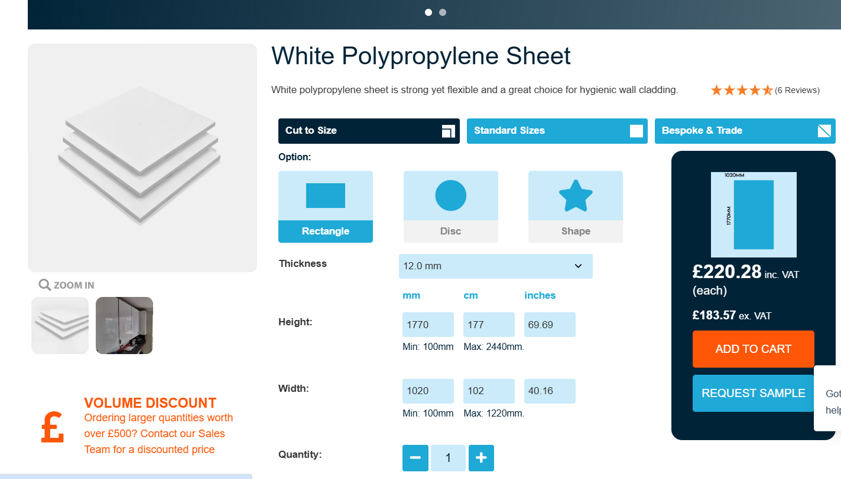
Figure 5. Pricing for sheet of Polypropylene
Technical drawings (3 days)

Material sourcing and prototyping various materials (1 week)

Testing of design (stated in the technical specifications) (3 days)

Production and delivery (2 weeks)

Machining (1 day per lid) recess cut, weld and refining edges.

Delivery (1-3 days)
Conclusion

The proposed two-part polypropylene lid is a safer, easy operation and cost-effective replacement for the existing lid. Polypropylene properties create easy lifting lids without need of mechanical advantage while not degrading in the acid conditions. The design meets health and safety requirements by eliminating manual handling risks. Its approach simplifies maintenance, cuts costs, and provides long-term durability under acidic conditions. Overall, the lid’s robust yet lightweight construction and minimal upkeep needs make it ideal for continuous use in particularly demanding and high-volume industrial anodising operations.

References
Braskem S.A., 2005. Polypropylene chemical resistance. [Online]
Available at: https://www.braskem.com.br/Portal/Principal/Arquivos/html/boletm_tecnico/PP%20Chemical%20Resistance.pdf
[Accessed 23 December 23].
British Plastics Federation, 2024. Polypropylene (PP). [Online]
Available at: https://www.bpf.co.uk/plastipedia/polymers/PP.aspx
[Accessed 04 January 2025].
Cut Plastic LTD, 2024. White Polypropylene Sheet. [Online]
Available at: https://www.cutplasticsheeting.co.uk/product/white-polypropylene-sheet/
[Accessed 28 December 2024].
GOV.UK, 2021. Copyright, Designs and Patents Act 1988. [Online]
Available at: https://assets.publishing.service.gov.uk/media/60180c2b8fa8f53fc62c5897/Copyright-designs-and-patents-act-1988.pdf
[Accessed 23 December 2024].
Health and Safety Executive, 2020. Manual handling at brief guide. [Online]
Available at: https://www.hse.gov.uk/pubns/indg143.pdf
[Accessed 22 December 2024].
Health and Safety Executive, 2024. Good handling technique. [Online]
Available at: https://www.hse.gov.uk/msd/manual-handling/good-handling-technique.htm
[Accessed 28 December 2024].
Health and Safety Executive, 2024. Managing risks and risk assessment at work. [Online]
Available at: https://www.hse.gov.uk/simple-health-safety/risk/index.htm
[Accessed 22 December 2024].
HYDRO PLAST, 2015. Butt fusion welding of polypropylene. [Online]
Available at: https://hydroplast.pk/wp-content/uploads/2019/12/butt-fusion-welding-15.pdf
[Accessed 28 December 2024].
K.D. Feddersen GmbH & Co. , 2023. Polypropylene. [Online]
Available at: https://kdfeddersen.com/en/products/polymers/polypropylene
[Accessed 29 December 2024].
National Audit Office, 2021. Principles of effective regulation. [Online]
Available at: https://www.nao.org.uk/wp-content/uploads/2021/05/Principles-of-effective-regulation-SOff-interactive-accessible.pdf
[Accessed 22 December 2024].
Protolabs, 2023. Polypropylene (PP): Understand the Key Benefits and Applications. [Online]
Available at: https://www.protolabs.com/materials/polypropylene/#:~:text=Lightweight%3A%20PP%20is%20a%20lightweight,less%20than%201%20g%2Fml.
[Accessed 15 December 2024].
TW Metals Distrubutor, 2023. Metal Weight Calculator. [Online]
Available at: https://www.twmetals.com/resources/calculators.html
[Accessed 29 December 2024].

